Accessibility to Essential Services in Sheffield: Spatial Analysis Report

1. Introduction
Access to essential services such as supermarkets and pharmacies is a fundamental component of urban livability. These services support everyday needs including food access, healthcare support, and community wellbeing. Spatial analysis of service accessibility helps identify areas with strong service provision as well as neighbourhoods that may experience limited access.
This report analyzes a map illustrating the distribution of essential services across Sheffield. The map uses Lower Layer Super Output Areas (LSOAs) to represent spatial units and shows the number of services located within each area. Understanding these spatial patterns provides insights into urban structure, service clustering, and potential inequalities in access.

2. Map Visualization
The figure below illustrates the spatial distribution of supermarkets and pharmacies within the Sheffield metropolitan area. Each purple point represents a service location, while the shaded LSOA polygons indicate the number of services present within each area.
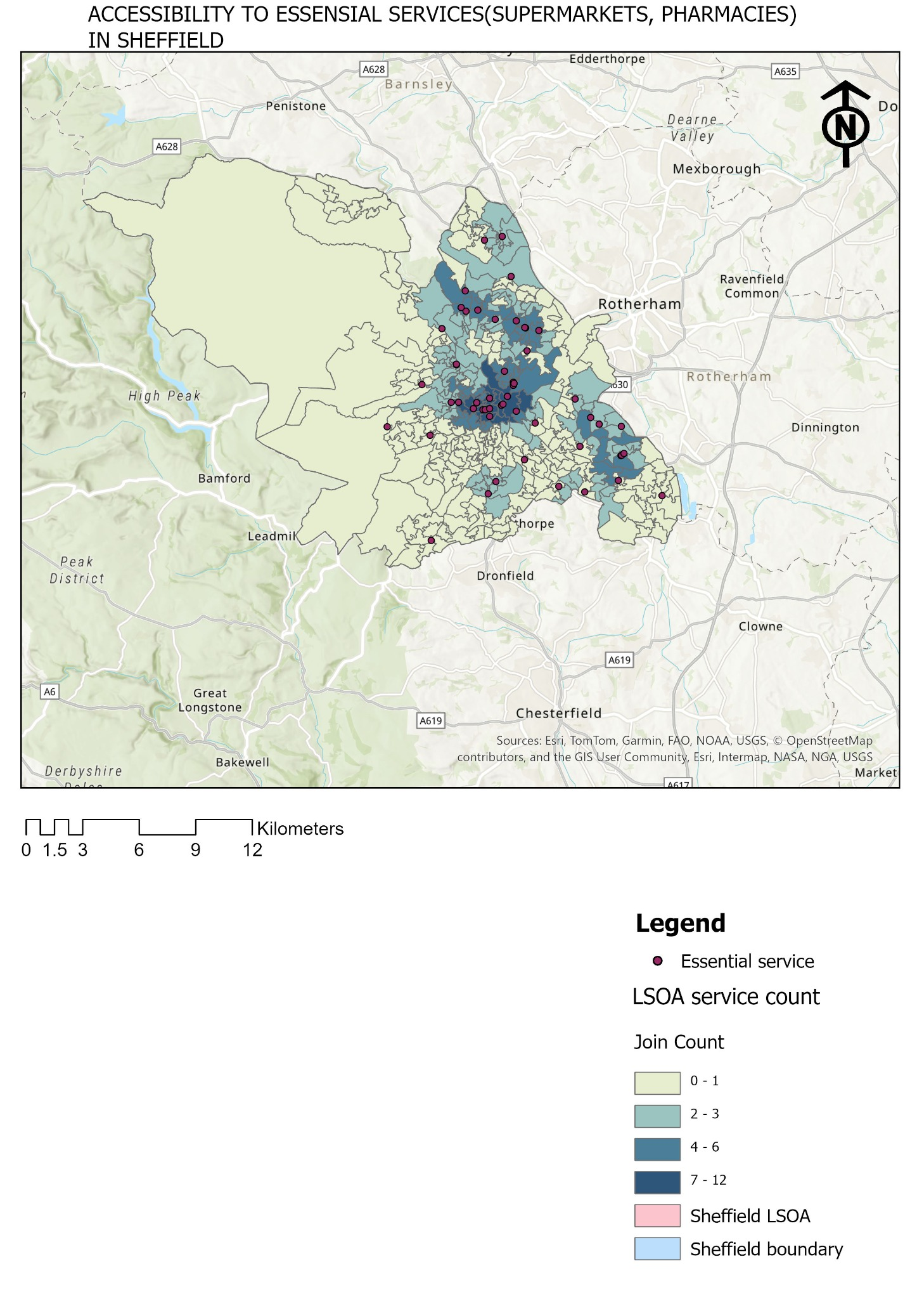

3. Map Components
The map contains several important cartographic elements including a legend, north arrow, and scale bar. The legend categorizes LSOAs into four service-count classes: 0–1 services, 2–3 services, 4–6 services, and 7–12 services. Lighter colors represent lower service counts, while darker colors indicate areas with a higher concentration of essential services.

4. Spatial Distribution Patterns
A clear spatial pattern emerges from the map. The highest concentration of services appears in central Sheffield, where multiple LSOAs fall within the highest service categories. These central areas likely correspond to the city centre and surrounding commercial districts where retail and healthcare services are concentrated.
Moving outward from the urban core, the density of services gradually decreases. Peripheral LSOAs are more frequently categorized within the lowest class (0–1 services). This pattern reflects typical urban geography, where suburban or semi-rural areas have lower commercial density.

5. Accessibility Implications
Accessibility to supermarkets and pharmacies plays a crucial role in determining residents' quality of life. Areas with multiple services benefit from shorter travel distances and increased convenience. These neighbourhoods often provide residents with multiple options for obtaining food and healthcare products.
In contrast, areas with few services may require residents to travel longer distances to reach essential facilities. This can particularly impact elderly populations, individuals without private vehicles, and low-income households. Transport infrastructure, public transit accessibility, and pedestrian connectivity are therefore important factors that influence actual service accessibility.

6. Service Clustering and Urban Structure
The clustering pattern visible in the map suggests a hierarchical structure of service distribution. The city centre functions as the primary hub, hosting the largest concentration of services. Secondary clusters appear along major urban corridors and district centres that serve surrounding neighbourhoods.
This structure is typical in many cities where planning policies encourage retail and healthcare services to locate within designated commercial centres rather than dispersing evenly across residential areas.

7. Potential Service Gaps
Several peripheral areas appear to contain only a small number of services. These zones may represent potential service gaps or emerging service deserts. Identifying such areas is important for urban planning and policy development.
Policy interventions could include encouraging new retail development, supporting community pharmacies, or improving public transport connections to major service centres.

8. Relevance to Urban Change and Gentrification
Changes in the spatial distribution of essential services can also provide insights into neighbourhood transformation processes. An increasing concentration of services often accompanies economic investment, commercial revitalization, and demographic change.
For researchers studying neighbourhood change or gentrification, tracking service density over time can function as an early indicator of urban transformation. When combined with other indicators such as housing prices, demographic shifts, and business turnover, service accessibility can help identify areas experiencing rapid change.

9. Conclusion
The map highlights clear spatial inequalities in access to essential services across Sheffield. Central urban areas benefit from a high concentration of supermarkets and pharmacies, while many peripheral neighbourhoods have limited local provision.
Understanding these patterns is important for promoting equitable urban development and ensuring that all residents can access essential services. Future research could extend this analysis using travel time modelling, network accessibility analysis, and demographic data to better understand the real accessibility experienced by residents.

