Computing_HW5_2020321163_엄상준

Eom SangJun

2020 12 8

###############  
##9.4  
###############  
set.seed(1234)  
  
##dataset  
fish <- read.table('salmon.dat', header=TRUE)  
  
##Regression Fitting  
x <- 1/fish$spawners  
y <- 1/fish$recruits  
df <- data.frame(x=x, y=y)  
rlm <- lm(y ~ x, data = df)  
  
#point estimate  
#R=s=(1-beta2)/beta1  
point_est = (1-rlm$coefficients[2])/rlm$coefficients[1]  
point_est

## x   
## 150.0976

##Bootstrapping the residuals  
error <- rlm$residuals  
y_hat <- rlm$fitted.values  
itr <- 10000  
len <- length(y_hat)  
est_list1 <- c()  
for(i in 1:itr){  
 new_error <- error[sample(1:len,len, replace=T)]  
 new_y <- y_hat + new_error  
 new_df <- data.frame(x=x, y=new_y)  
 lm_res <- lm(y ~ x, data=new_df)  
 est_list1[i] <- (1-lm_res$coefficients[2])/lm_res$coefficients[1]  
}  
  
conf_res <- quantile(est_list1,c(0.025,0.975),na.rm=T)  
sd(est_list1)

## [1] 4.011215

hist(est_list1, main='Residual Bootstrap', xlab='(1-beta2)/beta1')

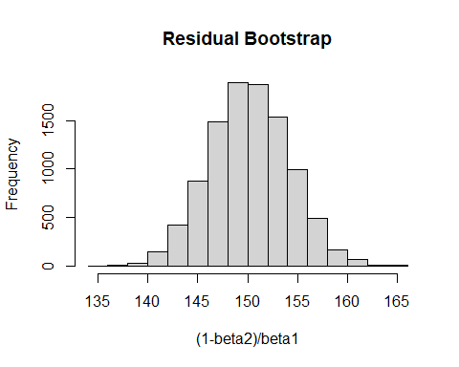

##Bootstrapping the pairs  
est_list2 <- c()  
for(i in 1:itr){  
 ind <- sample(1:len, len, replace=T)  
 new_x <- x[ind]  
 new_y <- y[ind]  
 new_df <- data.frame(x=new_x, y=new_y)  
 lm_pairs <- lm(y ~ x, data=new_df)  
 est_list2[i] <- (1-lm_pairs$coefficients[2])/lm_pairs$coefficients[1]  
}  
  
conf_pairs <- quantile(est_list2, c(0.025, 0.975), na.rm=T)  
sd(est_list2)

## [1] 3.830465

hist(est_list2, main='Pairs Bootstrap', xlab='(1-beta2)/beta1')

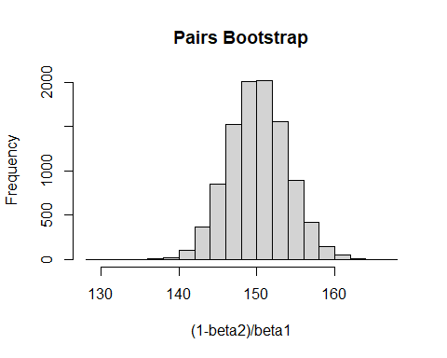

#Confidence Interval  
conf_res

## 2.5% 97.5%   
## 142.4321 158.0180

conf_pairs

## 2.5% 97.5%   
## 142.8583 157.8072

#mean and standard deviation  
mean(est_list1)

## [1] 150.1763

mean(est_list2)

## [1] 150.1353

sd(est_list1)

## [1] 4.011215

sd(est_list2)

## [1] 3.830465