Styleguide

# Fonts

Header = Montserrat

Page content = Nunito

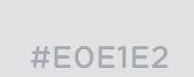

#E0E1E2



#5792D1

#373F51

https://gyazo.com/18a3f5cdbeeac23080bec066bf47fef4.png