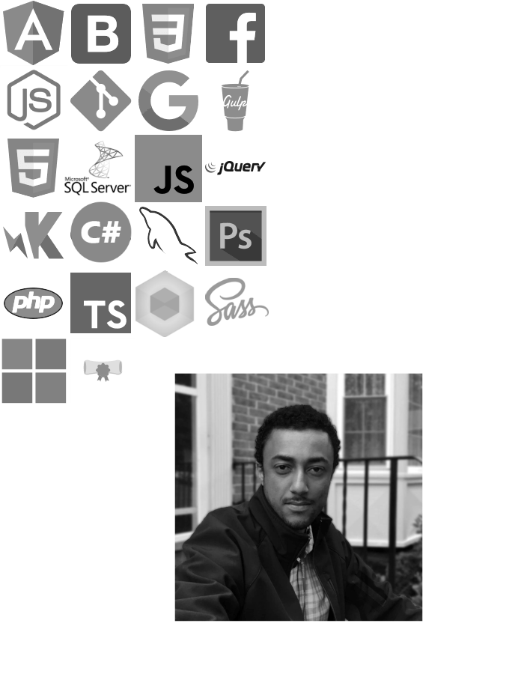

**Curriculum Vitae**

**Eskinder Getahun**

**🖂 E-Mail :eskinderget@gmail.com**

**🌎 www:**[***https://eskinderg.github.io***](https://eskinderg.github.io)

**🖁 Mobile : +251-911-184987**

*As confirmed by my portfolio content and code, I combine my knowledge, experience and skills with technology in order to develop professional and innovative web applications.*

*By following the best practices, I produce a clean code that is comprehensive and easy to maintain.*

* Full Stack Developer with 5+ years of professional experience in the design & development of web application, implementation of Object-Oriented Design (OOD) in Angular 2/4+, C# and other languages.
* Proficient in developing front-end, Single Page Application (SPA) using Angular 2/4+, HTML5, CSS3, Bootstrap, JavaScript, Typescript, and jQuery.
* Proficient in Angular 2/4+, Angular Material.
* Proficient in developing web applications using Node.js, Express.js and various MVC frameworks.
* Experience in Web API, MVC, N-Tier Architecture, Relational, and Non-Relational Database Design.
* In-depth knowledge & experience of software Design Patterns including Singleton, Prototype, Factory, and Unit of Work.
* Experience in Object-Relational Mapping (ORM) and Object-Data Modeling (ODM) using ADO.NET and Entity Framework.
* Experienced in design and implementation of Relational Database including Normalization of tables using MS SQL Server.
* Proficient in writing unit tests using NUnit and Jasmine to validate development releases with a Test-Driven Development (TDD) methodology.
* Proficient in Agile and Waterfall Software Development Life Cycle methodologies.
* Proficient in Software Configuration Management and Source Control.

# Education

* Bachelor’s (B.Sc) in Computer Science & Information Technology from the ***University of Arba-Minch, Ethiopia*** (04/2004 - 11/2008).

# Technical Skills

* **Front End Languages:** Angular 2/4+, JQuery, SAAS, CSS, Bootstrap, JavaScript.
* **Back End Languages:** C#, ASP.NET MVC, DotNet Core.
* **Testing Frameworks:** Mocha, Jasmine, Sinon.
* **Database Systems**: MySQL, MS-SQL.
* **Cloud Computing**: Amazon Web Service (AWS).
* **Code Quality:** Code Climate.
* **Application IDE**: Visual Studio, Visual Studio Code, VIM, Neovim.
* **Versioning Tool:** Git, Team Foundation Server.
* **Webservers**: Apache, http-server, IIS, ExpressJS.
* **SEO:** Google Analytics.
* Full Understanding of OOP.
* ASP.Net MVC 5 using Entity Framework and modern architectural patterns.
* RESTful API programming.

# Professional Experience

## Freelance Full Stack Developer (09/2018)

### Full Stack Web Developer

* Created SPA, user interactive (UI) web pages using web technologies like HTML5, SASS, Typescript, Angular2 and Bootstrap.
* Created and used Reducers that received Actions to modify the store State.
* Created Action dispatch to deploy Actions to add Dynamic Functionality
* Created custom NPM modules.
* Developed administrative UI Components using Angular2, Typescript and Webpack
* Used Bootstrap for Responsive Web design.
* Optimized Front-end assets for speed and performance
* Used Middleware, Redux-Promise in application to retrieve data from Back-End and to perform RESTFUL services.
* Created custom Angular Components including Breadcrumbs, Reactive Forms, Form Validators, Tabbed Components and Toggle Buttons.

## Nuaxis (09/2016 ‑ 07/2017)

### Front End Developer

* Created programs as per user / design requirements using AngularJS.
* Collaborated with cross-functional teams (DEV, UX/UI & BA) to define, design, and deliver creative digital solutions.
* Utilized, automated unit tests and integration tests for application life cycle.
* Executed Agile Development techniques.
* Utilized industry best practices to create effective business solutions for clients.
* Participated and contributed towards senior-level technology discussions.
* Created web forms using bootstrap.
* Used Git flow techniques for feature branching, merging and continuous integration.
* Implemented Google Analytics using Angularitics.
* Participated on OAuth implementation for user’s role and permissions using JWT (JSON web token).
* Created migration scripts for Postgres database systems using Sequelize ORM.
* Consumed back-end web API.
* Produced reports and statistical information for managers using code climate, mocha and other testing framework.
* Used bootstrap CSS to create, modify and update web layouts.
* Created angular 1.5 components and directives for front-end validation and routing.
* Used Node JS schema validator for backend validation.
* Performed unit and integration test for front-end and back-end systems using AngularJS and NodeJS.

## Bloomberg BNA (11/2015 ‑ 07/2016)

### Software Engineer II

* E-Commerce development using Agile methodologies.
* Full Stack web development using ASP .Net MVC, C#, Angularjs and MS-SQL.
* Provided support for intranet applications for strategic migration.
* Integrated ASP.NET MVC application with Ektron system.
* Designed modern architectural patterns for intranet systems.
* Wrote Front-end and Back-end Unit Tests for code re-factoring.
* Provided statistical information for senior managers.

## Freelance (02/2015 ‑ 11/2015)

### Freelance Web Developer

* Full Stack development using LAMP stack.
* Customized, Implemented custom WordPress themes and plugins.
* Maintained website for most up-to date technology, software, and information
* Developed and implemented mobile device responsive UI designs and back-end analytic tracking.

## Addis Ababa University, Ethiopia. (09/2013 ‑ 01/2015)

### Web Developer

* Designed visual layout of websites.
* Provided IT support for various user groups.
* Created Stored Procedures using MSSQL.
* Tested a website before it goes live and identify problems.
* Advised users on the functionality of the website.
* Changed code of an existing website using MVC, C#, Entity Framework and LINQ technologies.
* Optimized web assets for optimal speed and performance.
* Produced reports and statistical information for senior managers using various reporting tools.

## HST Consulting, Addis Ababa, Ethiopia (07/2012 - 08/2013)

### System Administrator

* Maintained configuration of network equipment’s and web services.
* Managed Active Directory Users and Computers.
* Provided support for various User.
* Produced reports and statistical information for senior managers.
* Managed network protocols, file sharing services, file backups and intranet web services.

# Trainings

## Microsoft Certified Professional (MCP).

## Microsoft Certified C# Programming Specialist.

## Cisco Certified Network Associate (CCNA) Certificate.

## Managing Microsoft Active Directory & Users.