First, erase the existing “Caliper-Automated” folder from

* Directory of the folder: C:\Users\jeanne\Documents\GitHub\
  + You can either type copy and paste on Highlighted section on the bottom picture or manually go into the folder.

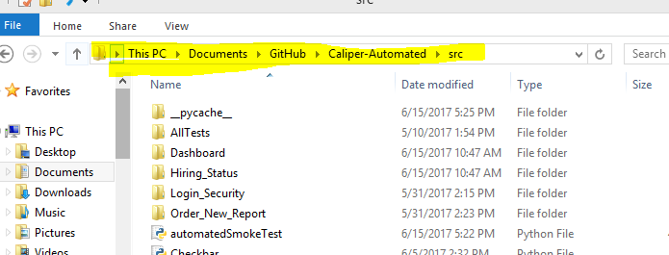

Second, open the Git Shell by looking through the application on the desktop.

Third, After open the Git Shell, type this command:

* git clone <https://github.com/esksw4/Caliper-Automated.git>

Fourth, go in to the folder called “Caliper-Automated”

* Directory of the folder: C:\Users\jeanne\Documents\GitHub\Caliper-Automated

Fifth, from that folder, you will see two folders called “Python34” and “Python-3.4.3”. Please copy and paste both folders to following directory:

* Directory to paste both folders: C:\Python34

Sixth, open up the command prompt (by clicking Windowbutton+r from the keyboard and type cmd on the opened application and hit enter)

Seventh, direct the command prompt into the following directory: C:\Users\jeanne\Documents\GitHub\Caliper-Automated\src

* Type this in command prompt: cd C:\Users\jeanne\Documents\GitHub\Caliper-Automated\src

Eighth, By typing following command to the command prompt, run the application.

* python automatedSmokeTest