

**Course Name**: Control System Design

**Course Number and Section**: **14:332:417:01**

**Project**: A Pitch Controller for a BOEING Aircraft

**Professor**: Zoran Gajic

**Date Performed**: 12/19/2016 – 12/23/2016

**Date Submitted**: 12/23/2016

**Submitted by**: Eun-Sol Kim (133000680)

GRADE: _______________

COMMENTS:

Electrical and Computer Engineering Department

School of Engineering

Rutgers University, Piscataway, NJ 08854

Department of Electrical and Computer Engineering

Rutgers University – College of Engineering

New Brunswick, NJ

Course: 14:332:418

Laboratory: Project 3: A Pitch Controller for a BOEING Aircraft

Date(s) Performed: 12/19/2016 – 12/23/2016

Date Submitted: 12/23/2016

Submitted by: Eun-Sol Kim

Teaching Assistant: Lingyi Xu

PURPOSE

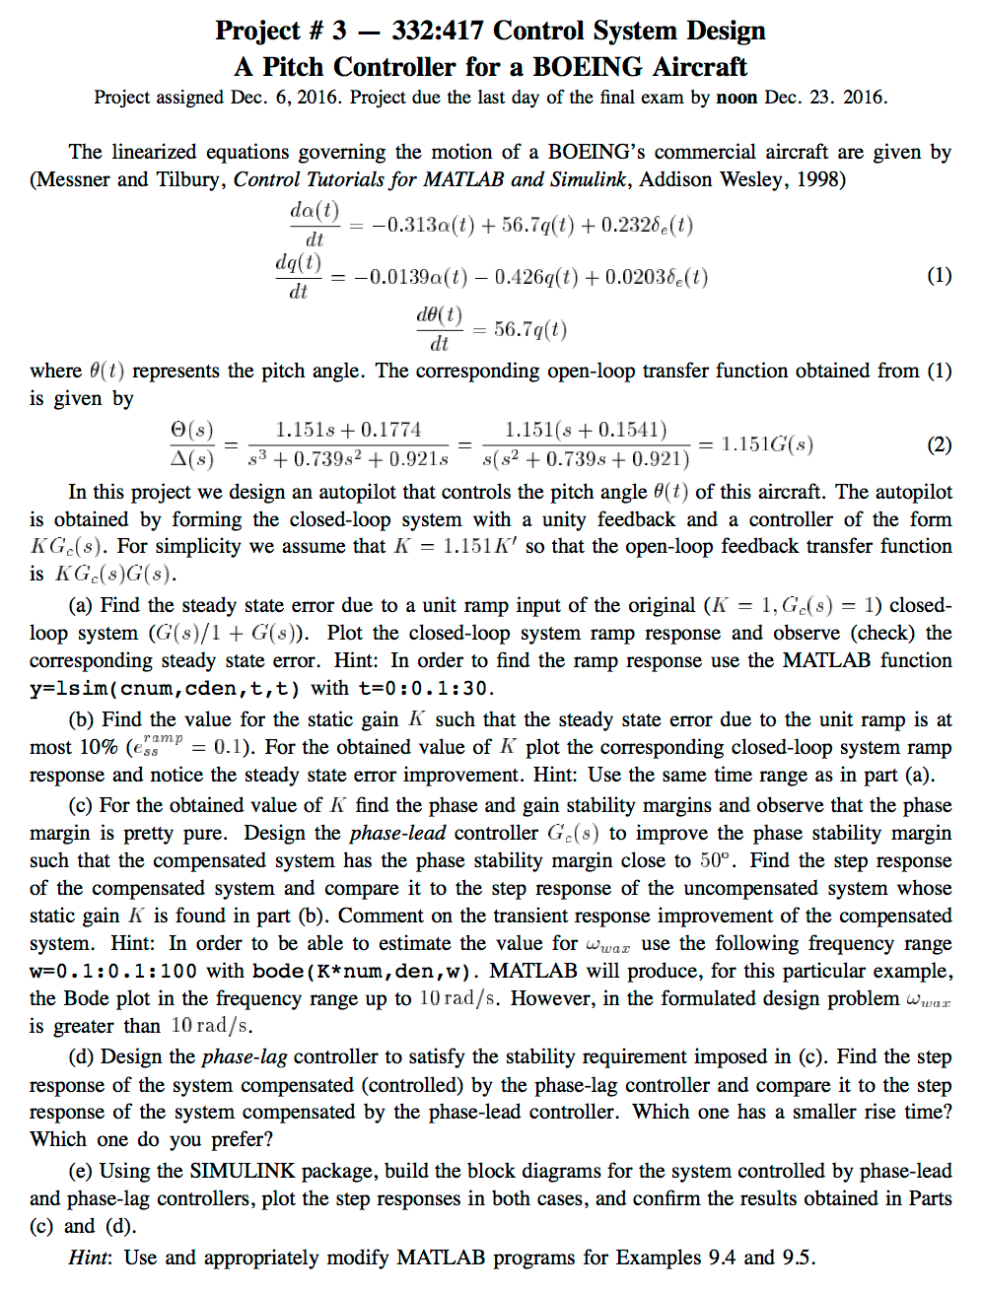

ACTIVITY #b

Phase-Lead Block Diagram:

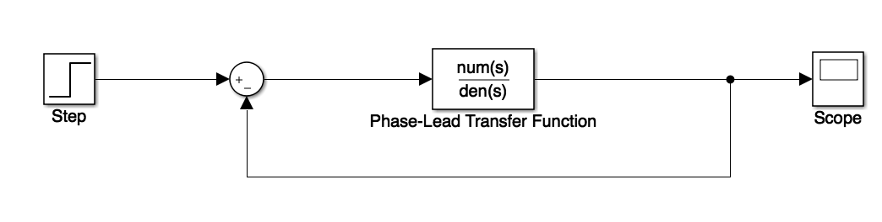

ACTIVITY #d

Phase-Lag Block Diagram:

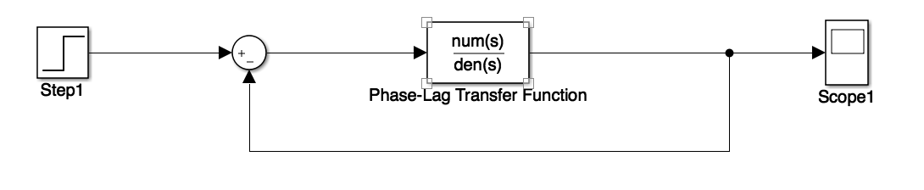

THEORY

*For this project, we have accompanied the chapter 9 concepts such as Phase-Lag compensation and Phase-Lead compensation. Given the linearized equation that governs the motion of the aircraft, we could design an autopilot that controls the pitch angle of the aircraft. We assumed that it is a unity feedback with controller equation as . By assuming that , we could find the Bode gain because . We assume that the input is unit ramp; therefore, the steady state error is Since From found K, we can find phase and gain margin stability of the system by looking at the bode plot of magnitude and phase. By finding we can calculate value of parameter a:*

*Then, we can estimate the compensator’s pole with*

*The Phase-Lag Controller and Phase-Lead Controller is formulated as follows:*

*Phase-Lead can be used in case pole 1 is larger than zero 1 and Phase-Lag can be used in case when pole1 is smaller than zero1. Phase Lead compensator is PD type wherea phase-Lag is PI type. Phase- Lag reducs the system bandwidh and steady-state error wherea Phase-Lead increases the bandwidth and increase the phase.*

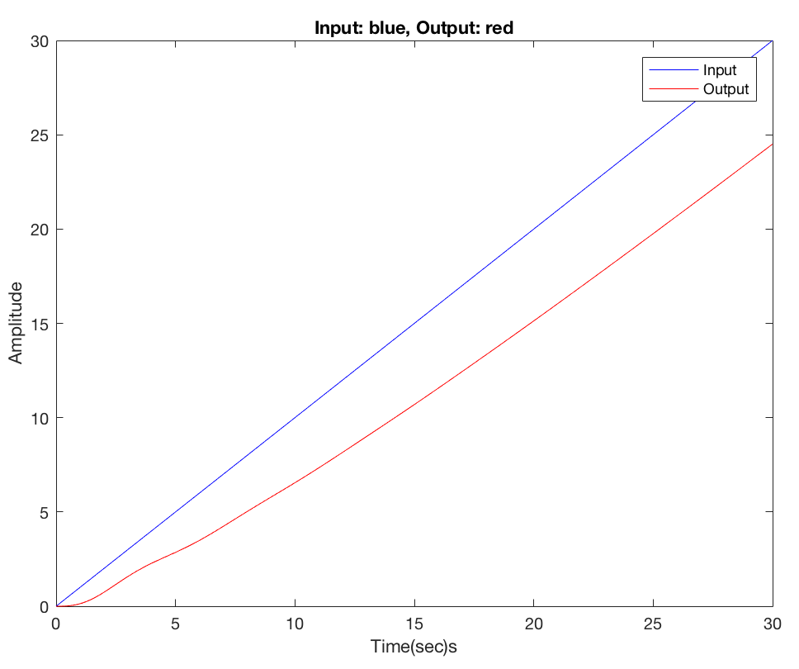DATA SECTION

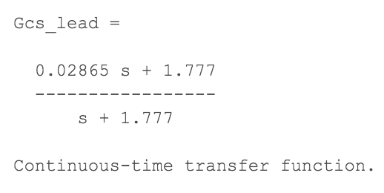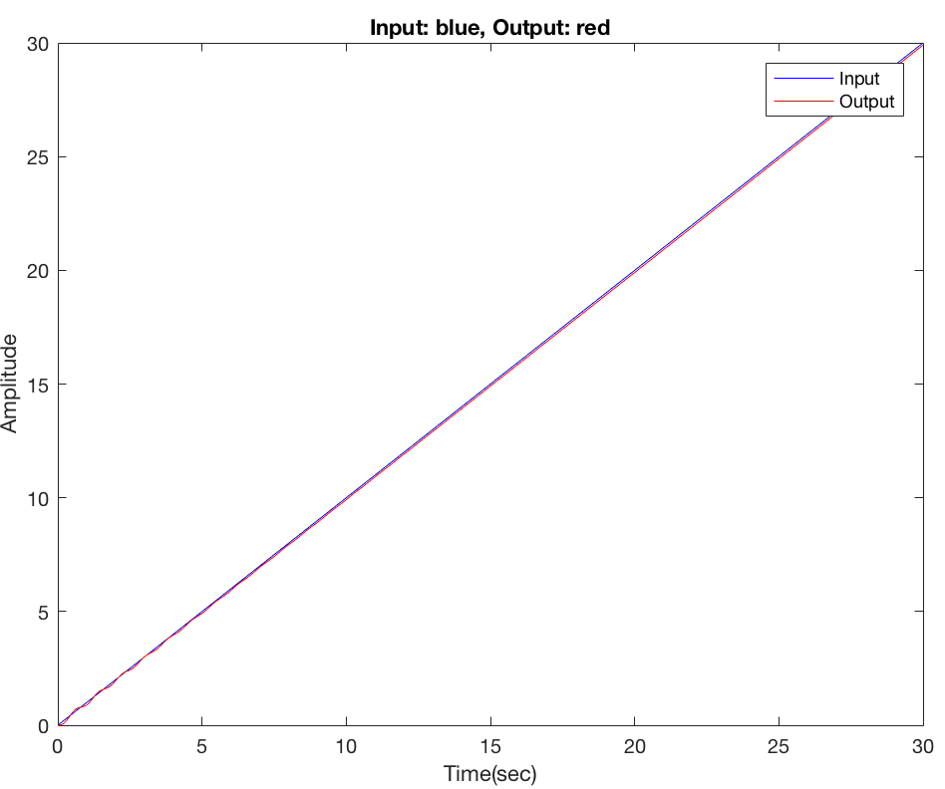

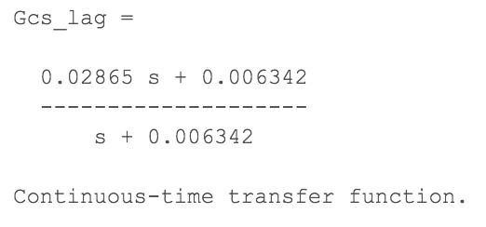

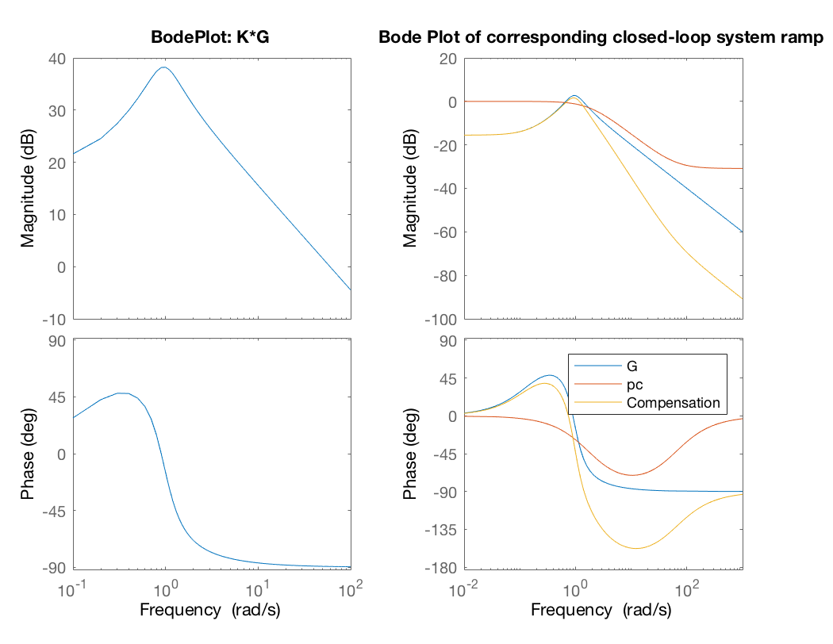

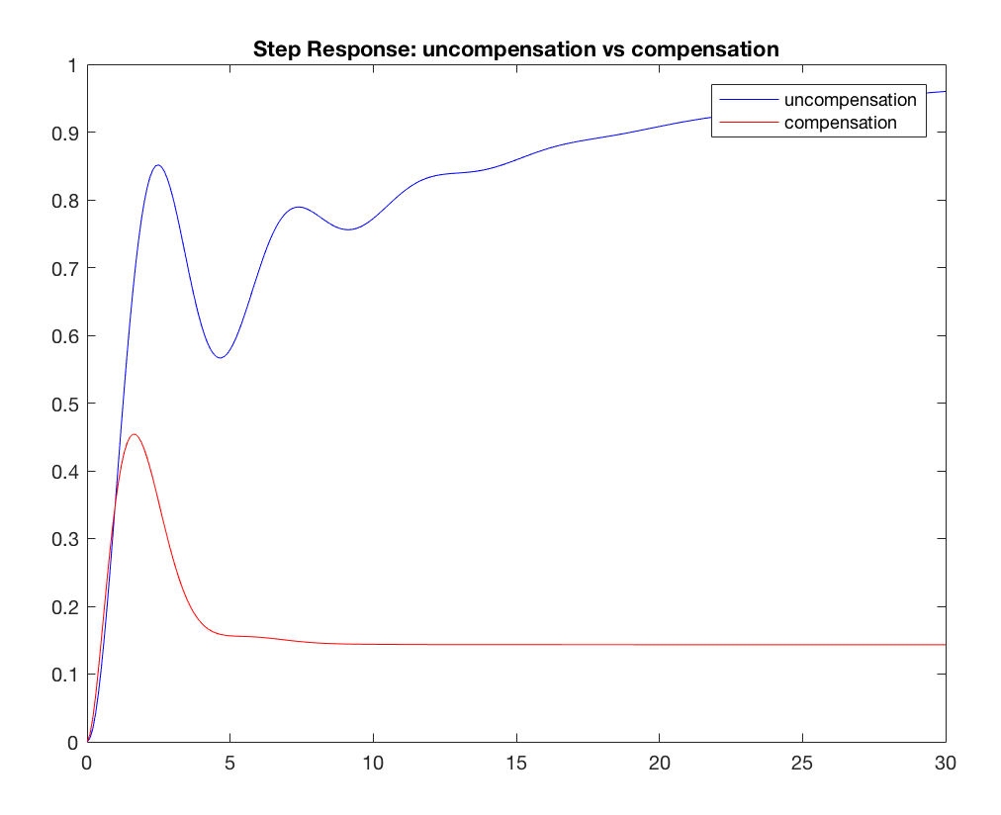

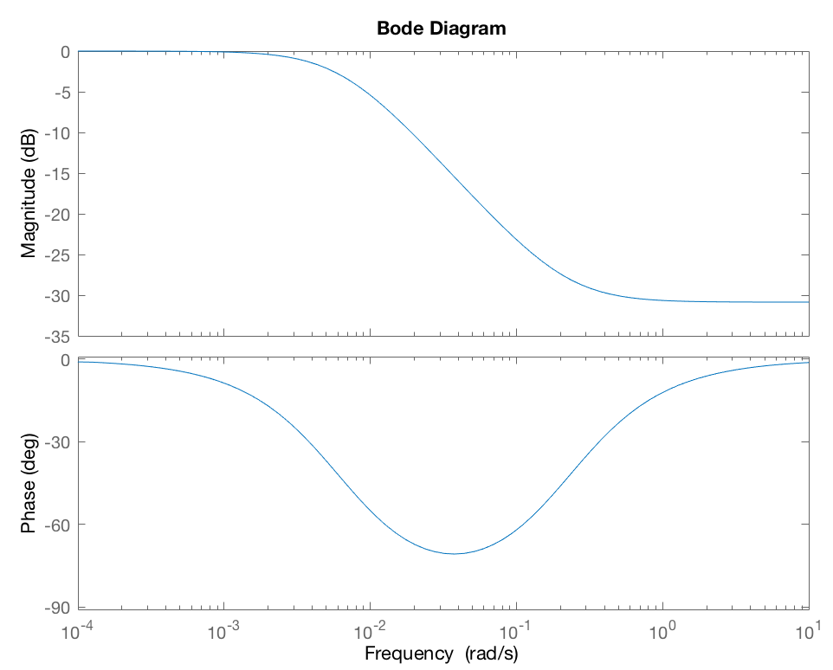

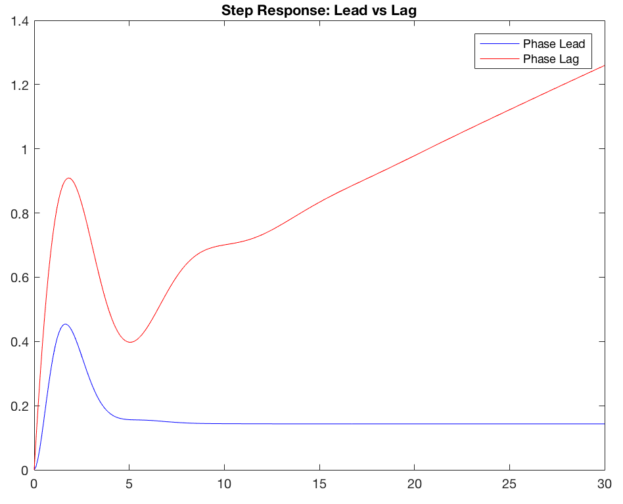

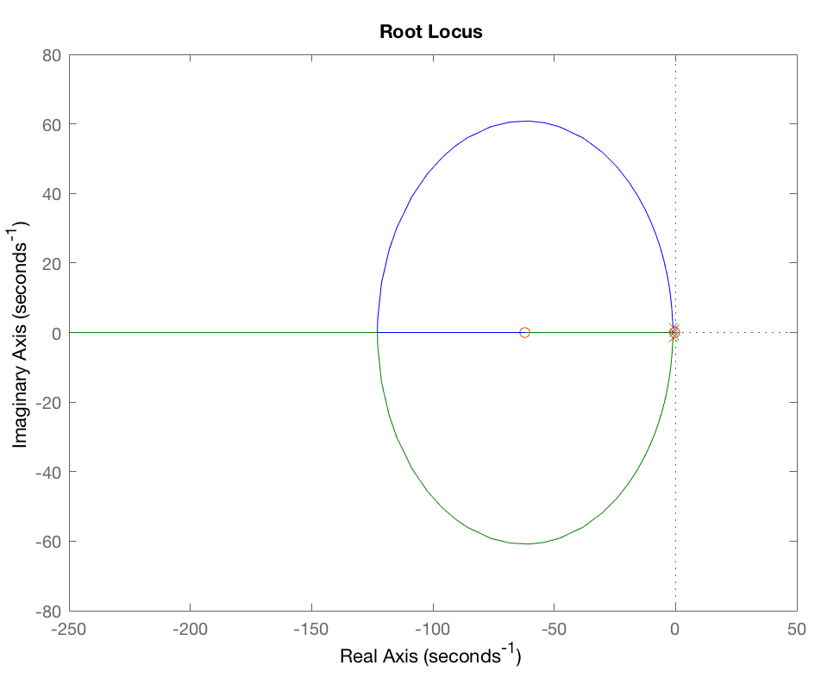

ANALYSIS

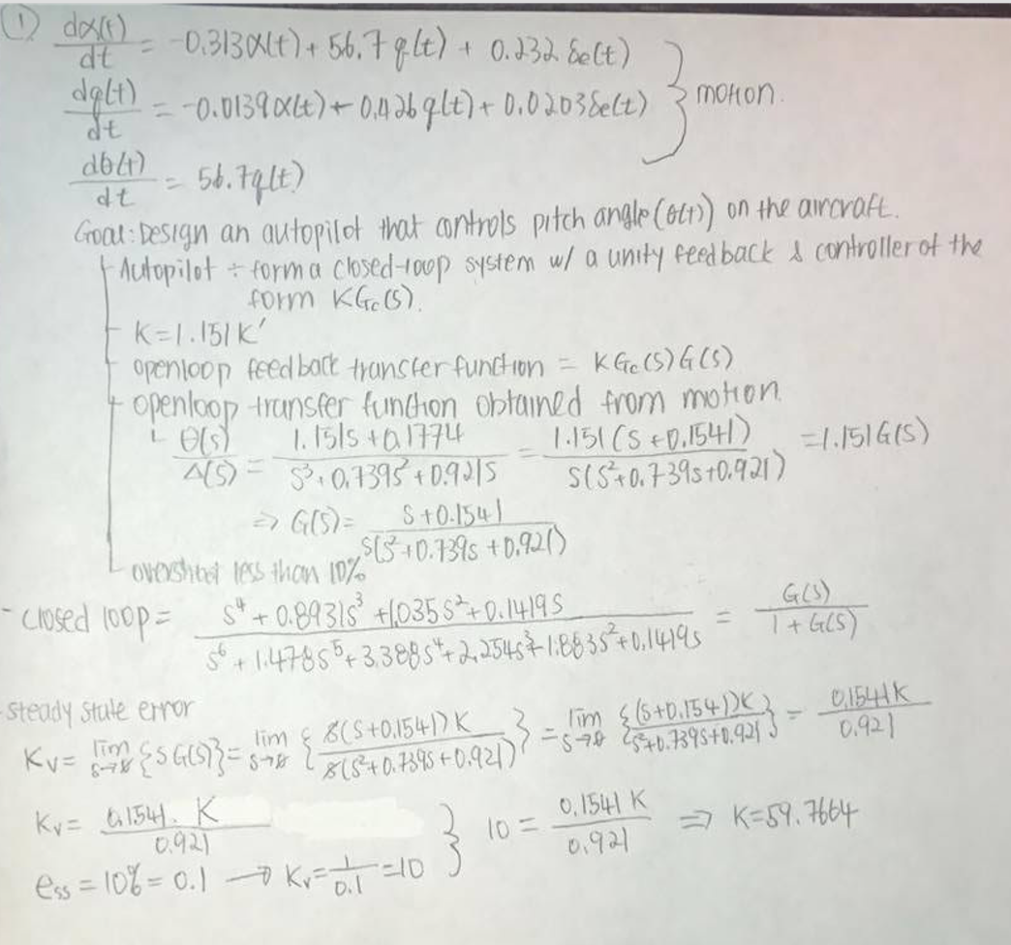

CONCLUSIONS

*The main purpose of this project is to go further explore with different types of controller: Phase-Lag Controller and Phase-Lead Controller. By doing this, I could visualize what the differences between two controllers by applying them into same model. As expected, the Phase-Lead has less rising time and settling time. Phase-Lag tend to go up ward after fall but Lead does not. Therefore, I prefer the Lead because it is stable and it shows that it is well controllable the model.*

Appendix: Matlab Code

close all;

clear;

s=tf('s');

G = (s + 0.1541) / (s*((s^2) + 0.739*s + 0.921));

opentf = 1.151*G;

oriClosedLoop = G/(1+G);

t = 0:0.1:30;

## a

%steady state error

syms s

a_G = (s + 0.1541) / (s*((s^2) + 0.739*s + 0.921));

a_Kv = limit((s*a_G));

a_ess = 1/a_Kv;

%ramp response

a_y = lsim(oriClosedLoop.Numerator{1},oriClosedLoop.Denominator{1},t,t);

figure(1),plot(t,t,'b',t,a_y,'r')

xlabel('Time(sec)s');

ylabel('Amplitude');

legend('Input','Output');

title('Input: blue, Output: red');

%Refer :http://ctms.engin.umich.edu/CTMS/index.php?aux=Extras_Ess

%Refer :http://digitalcommons.calpoly.edu/cgi/viewcontent.cgi?article=1452&context=theses

## b

b_ess = 0.1;

b_Kv = 1/b_ess;

b_zeros = roots(G.Numerator{1});

b_poles = roots(G.Denominator{1});

b_K = (-(10*prod(b_poles(2:3)))/(b_zeros));

%corresponding closed-loop system

b_Closed = b_K*G / (1 + (b_K*G));

%ramp response

b_y = lsim(b_Closed.Numerator{1}, b_Closed.Denominator{1},t,t);

figure(2),plot(t,t,'b',t,b_y,'r')

xlabel('Time(sec)');

ylabel('Amplitude');

legend('Input','Output');

title('Input: blue, Output: red');

## c

w = 0.1:0.1:100;

num = [1 0.1541];

den = [1 0.739 0.921];

figure(3);

subplot(1,2,1);

bode(b_K*num,den,w);

title('BodePlot: K*G');

[Gm_act,Pm_act,Wcg_act,Wcp_act] = margin(num,den);

phiMax = 50 - Pm_act + 10;

phiRad = (phiMax/180)*pi;

a = (1 + sin(phiRad))/(1 - sin(phiRad));

delta_G = 20 * log10(a);

subplot(1,2,2);

hold on

bode(num,den);

title('Bode Plot of corresponding closed-loop system ramp');

hold off

%constant from the book.

w_max = 10.5;

pc = w_max*sqrt(a);

numc = [a pc];

denc = [1 pc];

hold on;

bode(numc,denc);

hold off;

compNum = conv(num, numc);

compDen = conv(den, denc);

hold on;

bode(compNum, compDen);

hold off;

legend('G','pc','Compensation');

%finding closed-loop transfer function

[closedNum, closedDen] = feedback(G.Numerator{1}, G.Denominator{1},1,1,-1);

[closedNumComp, closedDenComp] = feedback(compNum,compDen,1,1,-1);

%%comments: in step response, the compensation, rising time and settling time

%%are reduced significantly.

figure(4);

ystep=step(closedNum,closedDen,t);

ystepComp_Lead = step(closedNumComp, closedDenComp,t);

plot(t,ystep,'b',t,ystepComp_Lead,'r');

%axis([0 2 0 0.5])

title('Step Response: uncompensation vs compensation');

legend('uncompensation','compensation');

s=tf('s');

Gcs_lead= (a*s + pc)/(s+pc)

## d

Wcg_new= 2.1;

% dl=b_K;

% g1 = abs(j*Wcg_new);

% g2 = abs(j*Wcg_new + b_poles(2));

% g3 = abs(j*Wcg_new + b_poles(3));

% dG = dl/(g1*g2*g3)

% mag(dG)

delta_G_new = 30.4;

a_new= 10^(delta_G_new/(-20));

zc_new = Wcg_new/10;

pc_new = a_new*zc_new;

numlag = [1 zc_new];

denlag = [1 pc_new];

newnum= conv(num,numlag);

newden = conv(den,denlag);

Gcs_lag = (a*s +pc_new)/(s+pc_new)

figure(5)

bode(Gcs_lag.Numerator{1},Gcs_lag.Denominator{1})

ystepComp_Lag = step(newnum,newden,t);

figure(6)

plot(t,ystepComp_Lead,'b',t,ystepComp_Lag,'r');

%axis([0 2 0 0.5])

title('Step Response: Lead vs Lag');

legend('Phase Lead','Phase Lag');

[closedLagNum, closedLagDen] = feedback(newnum,newden,1,1,1);

%http://ece.gmu.edu/~gbeale/ece_421/comp_freq_lag.pdf

figure(7)

rlocus(num,den);

hold on

rlocus(closedNumComp,closedDenComp);