Esther Lim

Professor Van Wart

CS130

Homework 02

**Homepage:** <https://esl8318.github.io/cs130-coursework/>

**Repository:** <https://github.com/esl8318/cs130-coursework/tree/main>

**What corrections did you have to make?**

I had to add alt text for all of the artists’ profile photos and the mini album photo on the footer and added aria labels to the previous/next song and play/stop buttons. I also had to set the document language to English.

**Will my website be usable if I turn off the CSS? Why or why not?**

It looks like it’d be very difficult to navigate the website if I turned off the CSS, since all the formatting is done through the style sheet. Although all the elements are there and you technically can access all of them, it’s difficult to understand where you’re supposed to go to find the artist you want to listen to, or find where to go to find your profile. In other words, without CSS, this website is inefficient and disorienting.

**Is my site tabbable?**

Yes.

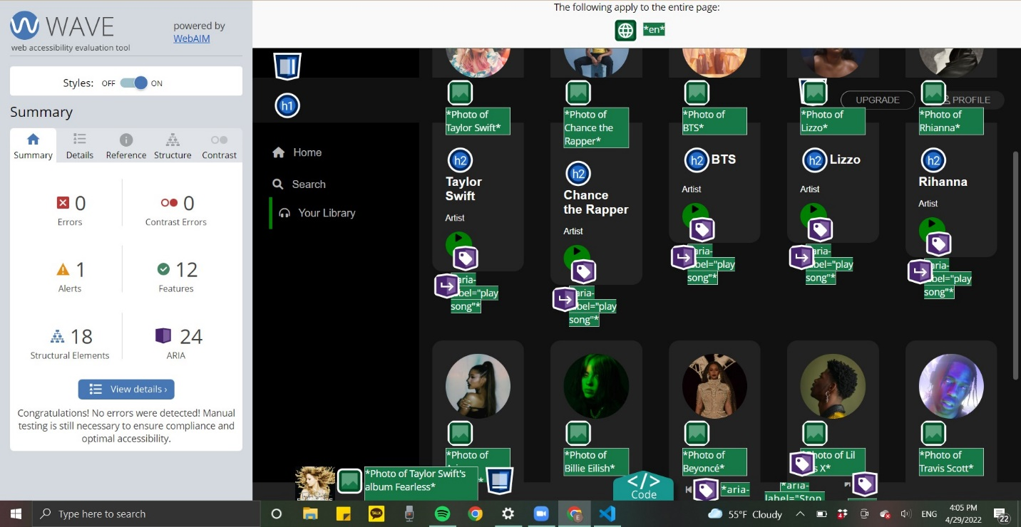

Picture of WAVE report