Basic Computer Design Using Verilog

Islam yaseen
2024

1. Abstract 3
2. Introduction 4
3. System Architecture 5
3.1 Block Diagram 5
3.2 System Overview 5
3.3 Hardware Integration and Signal Flow 6
4. Theoretical Background 6
5. Design Specifications And Requirements 7
6. Module Descriptions 7
6.1 Adder and Logic Unit 7
6.2 Control Unit 8
6.3 Decoder 3×8 10
6.4 Decoder 4×16 10
6.5 Encoder 8×3 12
6.6 Interrupt 12
6.7 MUX 16 bit 8×1 13
6.8 Top Module 13
7. Register Control Signals Logic 15
8. Simulation and Testing 16
8.1 Test Bench Setup 16
8.2 Waveform 16
8.2.1 Memory Reference Direct Operations 17
8.2.1.1 LDA 17
8.2.1.2 AND 18
8.2.1.3 ADD 19
8.2.1.4 STA 20
8.2.1.5 BSA 21
8.2.1.6 ISZ 22
8.2.1.7 BUN 23
8.2.2 Memory Reference Indirect Operations 23
8.2.2.1 LDA 24
8.2.2.2 AND 25
8.2.2.3 ADD 26
8.2.2.4 BSA 27
8.2.2.5 STA 28
8.2.2.6 ISZ 29
8.2.2.7 BUN 30
8.2.3 Register Reference Operations 30
8.2.3.1 CLA 31
8.2.3.2 CLE 32
8.2.3.3 CMA 33
8.2.3.4 CME 34
8.2.3.5 CIR 35
8.2.3.6 CIL 36
8.2.3.7 INC 37
8.2.3.8 SPA 38
8.2.3.9 SNA 39
8.2.3.10 SZE 40
8.2.3.11 HLT 41
8.3 Simulation Transcript 41
8.3.1 Memory Reference Direct Transcript 41
8.3.1.1 LDA 41
8.3.1.2 AND 42
8.3.1.3 ADD 42
8.3.1.4 STA 42
8.3.1.5 BSA (SUB-ROUTINE) 42
8.3.1.6 ISZ 43
8.3.1.7 BUN 43
8.3.2 Memory Reference Indirect Transcript 43
8.3.2.1 LDA 43
8.3.2.2 AND 43
8.3.2.2 ADD 43
8.3.2.3 43
8.3.3 Register Reference Transcript 44
8.3.3.1 44
8.4 Observations 44
9 Conclusion 44
9.1 Key Accomplishments: 44
9.2 Future Enhancements: 45

Abstract
Our team implemented a hardware system that processes instructions via a centrally orchestrated control unit and an integrated datapath. The primary objective was to showcase how these two modules, working in tandem, respond to specific input signals to carry out register transfer, arithmetic, and logic operations. Key achievements include successfully integrating various registers, a memory subsystem, an adder and logic unit, and a set of decoders and encoders that manage micro-instructions. The result is a structured design where each module interacts through a shared bus and micro-step timing sequence. The provided Verilog code serves as the foundation for our implementation, detailing the architecture and behavior of the system components.

Introduction
Modern digital systems often employ register transfer logic (RTL) principles to manage data operations systematically. This design illustrates a simplified processor-like architecture where instructions are decoded, and micro-operations are executed in predetermined steps. Our team's primary focus was on the control unit and the datapath as a cohesive module, capable of performing tasks such as addition, bitwise operations, data movement, shifting, and I/O handling. A key challenge addressed was ensuring coherent interactions between control signals and multiple hardware blocks, all driven by a sequence counter that steps through the execution process. The accompanying Verilog code demonstrates the behavior of each module and their integration.

System Architecture

3.1 Block Diagram
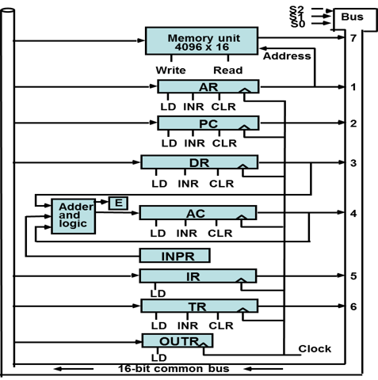

3.2 System Overview
The system centres around the control unit and the Datapath as the core module. The Datapath holds a variety of registers (PC, AR, DR, AC, IR, TR, INPR, OUTR) that communicate through a 16-bit bus. A multiplexer selects which module drives data onto that bus at any time. The memory component stores 16-bit words, addressed by the AR register, and can be either read or written based on signals from the control logic. At the heart of this operation is the control unit, which decodes instructions, orchestrates micro-operations, and manages the states of the entire system through clock cycles. The corresponding Verilog code highlights the interaction and synchronization between these components.

3.3 Hardware Integration and Signal Flow
The architecture of our system is designed to ensure efficient data processing and control.
- Integration Strategy: Components such as the control unit, datapath, and memory are interconnected through a bus system. This bus not only facilitates the transmission of data between components but also synchronizes control signals to coordinate operations across the system.
- Signal Flow: The flow of signals through the system is critical for proper operation. Control signals generated by the control unit traverse through the system, dictating the behaviour of the Datapath and other modules. For instance, control signals determine when data is written to or read from the memory, when registers should load or transfer data, and when operations should be performed by the ALU.
- Synchronization: Synchronization of signal flow is achieved through a system-wide clock that ensures all operations within the microarchitecture are performed in a step-wise and synchronized manner. The sequence counter, which generates signals from T0 through T15, ensures that every micro-operation is activated at the correct time, allowing for smooth transitions and reducing the risk of race conditions.

Theoretical Background
Register transfer logic (RTL) underpins our design. At each clock cycle, data moves between registers or is processed by an ALU. This approach ensures predictable timing and execution of micro-instructions. Instruction decoding leverages a combination of decoders and an encoder to translate opcodes into control signals. The micro-operation steps are driven by a sequence counter that produces time-step signals T0 through T15. On each time step, specific register-transfer operations are enabled, forming the basis for each instruction’s execution. Our emphasis was on the interplay between the control unit and the datapath to achieve seamless instruction execution. The accompanying Verilog implementation aligns with these theoretical principles.

Design Specifications And Requirements
Our design must:
- Support a 16-bit word size for registers and memory
- Provide a 12-bit address space for instruction and data locations
- Enable basic arithmetic and logic operations such as AND, ADD, complement, shift left, and shift right
- Handle loading data from the bus into registers
- Accommodate an 8-bit input register (INPR) and an 8-bit output register (OUTR)
- Implement a sequence counter to manage up to 16 micro-operations per instruction
- Include interrupt capability for future extensions
Assumptions and constraints include the use of a single bus for data transfers, a simple interrupt mechanism with enable/disable signals, and pre-initialized memory contents for testing. These specifications are implemented in the Verilog modules provided.

6. Module Descriptions
Each hardware block serves a specific role within the system:

6.1 Adder and Logic Unit
- Performs arithmetic and logical operations such as AND, ADD, LDA, COM, SHL, SHR, and INPR_C.
- Handles both arithmetic carry (in_E) and flag operations.
- Provides outputs directly to the accumulator (AC).
- Includes error handling for overflow and underflow scenarios.
- Refer to the accompanying logic diagram and Verilog implementation for detailed insights.
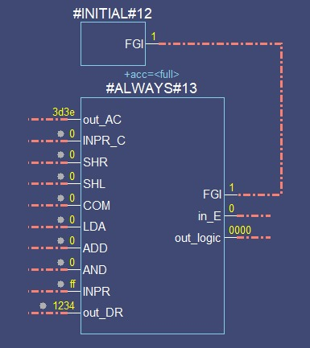
Diagram 1: Adder and Logic Unit Logic Diagram Screenshot 1: Black Box Representation of Adder and Logic Unit

6.2 Control Unit
- Decodes instructions and orchestrates micro-operations.
- Integrates with sequence counters, decoders, and encoders.
- Generates control signals for register loading, incrementing, and clearing.
- Supports interrupt handling and flag monitoring.
- Refer to the provided Verilog code for control logic implementation.
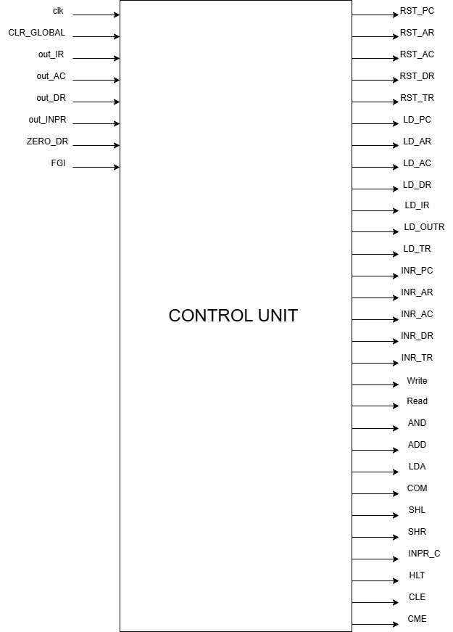

6.3 Decoder 3×8
- Converts 3-bit opcode values into 8 distinct control signals.
- Enables specific hardware operations based on the instruction type.
- Operates in tandem with the encoder and control unit.
- Verilog implementation illustrates signal mapping and priority control.
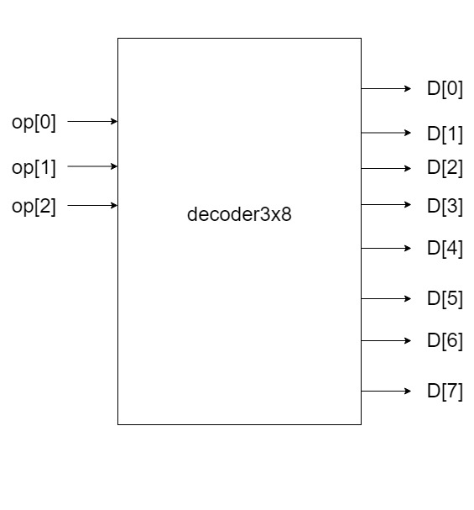

6.4 Decoder 4×16
- Expands 4-bit sequence counter values into 16 unique time-step signals.
- Drives micro-operations at each stage of instruction execution.
- Ensures proper synchronization across clock cycles.
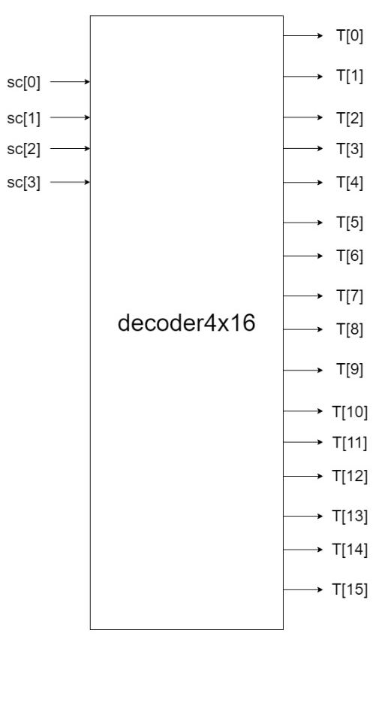

6.5 Encoder 8×3
- Encodes active control signals into a 3-bit bus selector.
- Facilitates smooth operation of the multiplexer.
- Ensures conflict-free control signal priority.
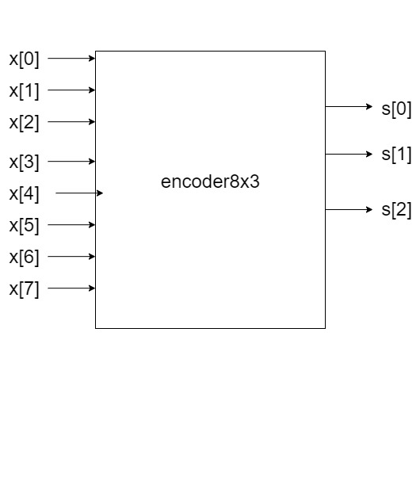

6.6 Interrupt
- Manages system interrupts and external event triggers.
- Supports interrupt enable (IEN) and disable (IOF) signals.
- Prevents system hangs through prioritized handling.

6.7 MUX 16 bit 8×1
- Selects one of eight input data sources.
- Drives selected data onto the 16-bit bus.
- Controlled by a 3-bit select signal (S) from the encoder.
- Supports flexible data routing between modules.
- Refer to the accompanying Verilog implementation for precise behavior.
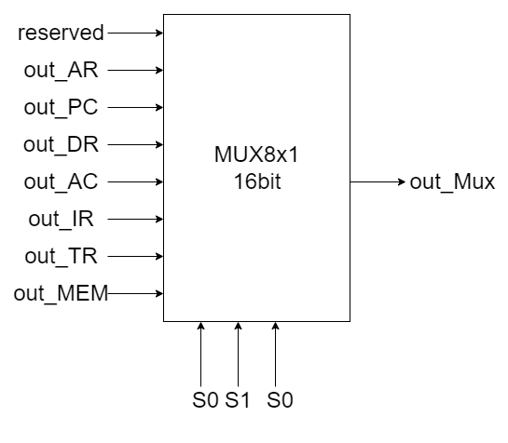

6.8 Top Module
- System Integration: The top module encapsulates the entire system, integrating the datapath with the control unit.
- Signal Propagation: Manages the propagation of signals across different modules, ensuring that each component receives the necessary controls at the right time.
- Functional Oversight: Monitors the overall functionality and interactions between the modules, verifying the synchronization and alignment of operations across the system.
- Design Insight: The Verilog implementation of the top module showcases the structural and functional connections, providing a comprehensive view of the system's operation.
- Reference: Detailed module interaction and control flow can be observed in the top module's Verilog code, which serves as the central reference point for the entire system's operation.
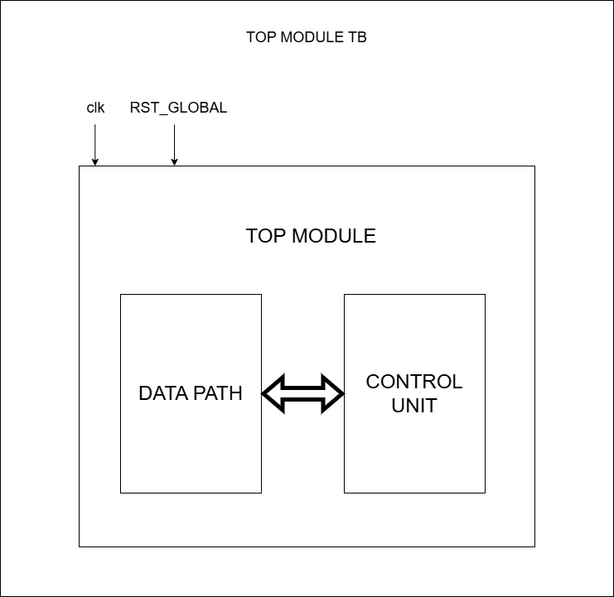

7. Register Control Signals Logic
The following table consolidates the logical expressions for each register's load, increment, and clear signals, as well as the memory's Read and Write signals:
Module | Signal | Logic Expression
PC | LD | T[4] & D[4] | D[5] & T[5]
 | INR | ~R & T[1] | R & T[2] | D[6] & T[6] & Zero_DR | r & B[4] & (~AC[15]) & T[3]
 | CLR | R & T[1]
DR | LD | T[4] & (D[0] | D[1] | D[2] | D[6])
 | INR | D[6] & T[5]
 | CLR | 0
AC | LD | (D[0] & T[5]) | (D[1] & T[5]) | (B[6] & r & T[3]) | (B[11] & p)
 | INR | r & T[3] & B[5]
 | CLR | r & B[11]
AR | LD | (~D[7] & I & T[3]) | (T[2] & ~R) | (~R & T[0])
 | INR | D[5] & T[4]
 | CLR | R & T[0]
IR | LD | ~R & T[1]
Memory | Write | D[6] & T[6] | D[5] & T[4] | D[3] & T[4] | R & T[1]
 | Read | ~D[7] & I & T[3] | D[6] & T[4] | D[2] & T[4] | D[1] & T[4] | ~R & T[1]

Simulation and Testing
To ensure that our hardware design functions as intended, we utilized a comprehensive simulation approach. Below, we describe the structure of our testing environment, the procedures followed, and the expected outcomes, along with relevant screenshots and transcripts.

8.1 Test Bench Setup
The verification of the system was carried out using a test bench named top_module_tb, which is designed to simulate the entire system's operation. This test bench initializes the top_module, sets up the clock signal, and applies initial test conditions to the inputs. Key outputs monitored include the Program Counter (PC), Accumulator (AC), Data Register (DR), Instruction Register (IR), Temporary Register (TR), Memory outputs, and the Sequence Counter (SC).
- Initial Setup: The test bench initializes all registers and memory with predefined values. The global clear signal (CLR_GLOBAL) is set at the start to reset all components to their default state.
- Clock Signal: The clock is toggled to simulate the passing of time, driving the synchronous behavior of the registers and control unit.
- Input Stimulation: Input values are provided through the outt_INPR port and the memory initialization file mem_init.txt, which loads a set of sample instructions or data into the system’s memory.

8.1.1 Memory Initialization

Purpose of Memory Initialization
Memory initialization is a critical step in ensuring predictable behavior during the system simulation. It provides the necessary starting conditions for program execution by preloading specific instructions and data values into the memory array. This initialization defines the sequence of operations, test cases, and expected outcomes during verification.

Memory Initialization File (mem_init.txt)
The memory is preloaded using a file named mem_init.txt, which follows a hexadecimal format compatible with the Verilog $readmemh function. Each memory location is assigned a specific instruction or data value, allowing precise control over the program flow and testing scenarios.
The memory contents are categorized into three key instruction types:
- Memory Reference Instructions (Direct and Indirect) – For operations involving memory reads, writes, and address modifications.
- Register Reference Instructions – For direct manipulation of internal registers like the Accumulator (AC) and flags.
- Control Instructions – For control flow operations, including branching and halting.

Memory Initialization Data
Below are the preloaded values for memory initialization, categorized by instruction type:
Memory Reference Direct Instructions:
ZZZZ // Reserved for interrupt
2096 // LDA direct (load accumulator)
0097 // AND direct
1098 // ADD direct
30bc // STA direct (store accumulator)
5063 // BSA direct (branch and save return address)
609b // ISZ direct (increment and skip if zero)
4019 // BUN direct (branch unconditionally)

Memory Reference Indirect Instructions:
a07c // LDA indirect
807d // AND indirect
907e // ADD indirect
b07f // STA indirect
d080 // BSA indirect
e081 // ISZ indirect

Register Reference Instructions:

7800 // CLA (clear accumulator)
7400 // CLE (clear E)
7200 // CMA (complement accumulator)
7100 // CME (complement E)
7080 // CIR (circulate right AC and E)
7040 // CIL (circulate left AC and E)
7020 // INC (increment AC)
7010 // SPA (skip next instr. if AC is positive)
7008 // SNA (skip next instr. if AC is negative)
7004 // SZA (skip next instr. if AC is zero)
7002 // SZE (skip next instr. if E is zero)
7001 // HLT (halt computer)
Control Instructions and Data Storage:
1098 // ADD direct
c055 // Address of PC BUN indirect
0099 // AND direct
1098 // ADD direct
c063 // Branch Address

Data Values:
a61d // Data direct
8409 // Data direct
7ba1 // Data direct
bb1a // Data direct
1234 // Data direct
7b44 // Data direct
121a // Data indirect
3ab9 // Data indirect
fa91 // Data indirect
0000 // Data indirect

Implementation in Verilog
The memory initialization is performed within the Memory_team1 module using the $readmemh function:
initial begin
$readmemh("mem_init.txt", mem); // Load memory contents from mem_init.txt
end

- Syntax Explanation:
  - mem_init.txt: The file containing the memory initialization values.
  - mem: The internal memory array defined in the module.
This command ensures the memory module starts with predefined instructions and data values, enabling consistent results across simulations.

Verification of Memory Initialization
To verify that memory initialization has been successful:
- Console Output Validation: Ensure the memory addresses contain the expected hexadecimal values during simulation startup.
- Waveform Monitoring: Use waveform viewers to confirm the correct memory read and write operations at specified clock cycles.
- Instruction Execution Check: Monitor if each instruction is fetched, decoded, and executed in the correct sequence.

8.2 Waveform
The waveforms from our simulation have been categorized into three primary scenarios for better clarity and analysis:

8.2.1 Memory Reference Direct Operations
- Description: Direct memory operations involve accessing memory locations explicitly referenced by the instruction.
- Focus Areas:
  - Accurate address loading into AR (Address Register).
  - Data movement between Memory (out_MEM) and DR (Data Register).
  - Correct control signals during read and write operations.
- Key Signals Observed: LD_AR, LD_DR, Write, Read.

8.2.1.1 LDA
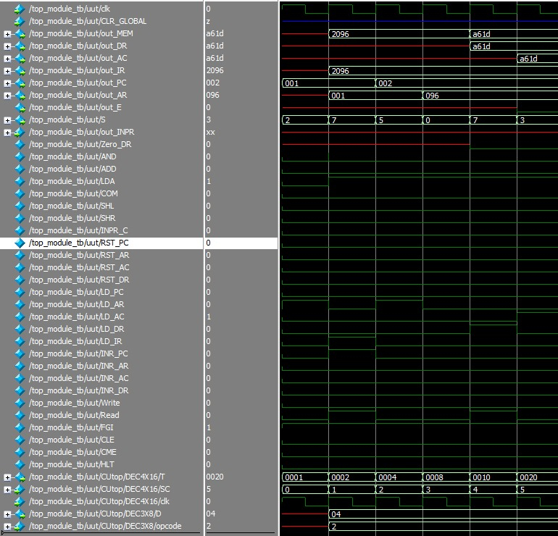

8.2.1.2 AND
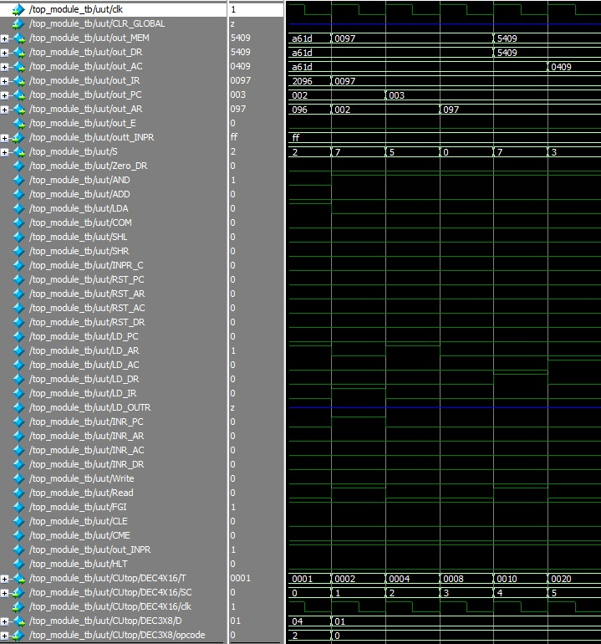

8.2.1.3 ADD
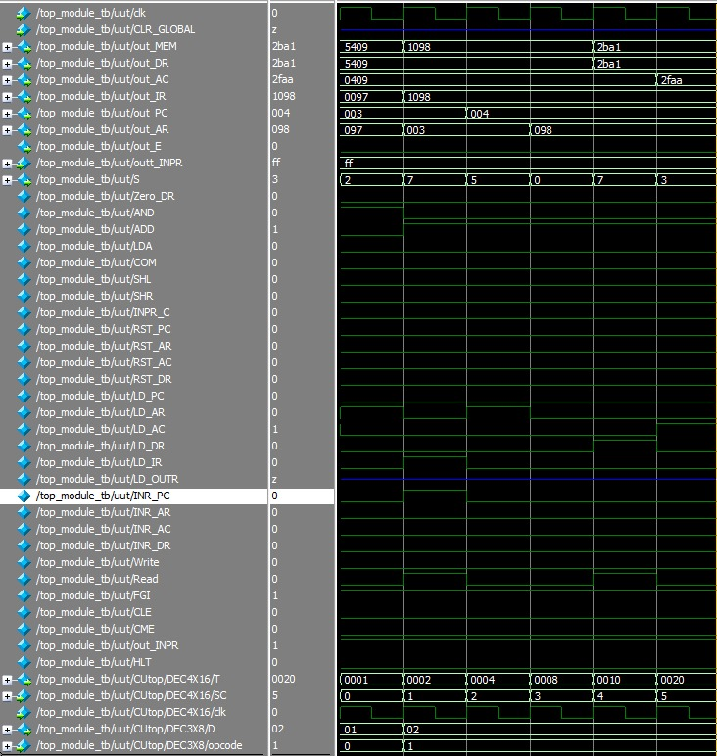

8.2.1.4 STA
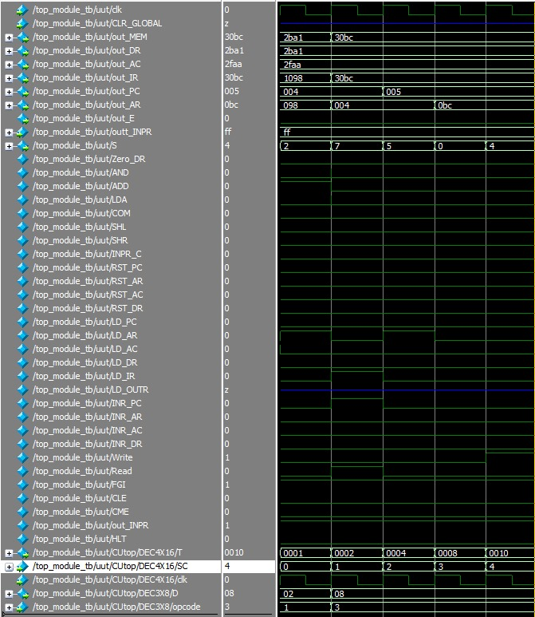

8.2.1.5 BSA
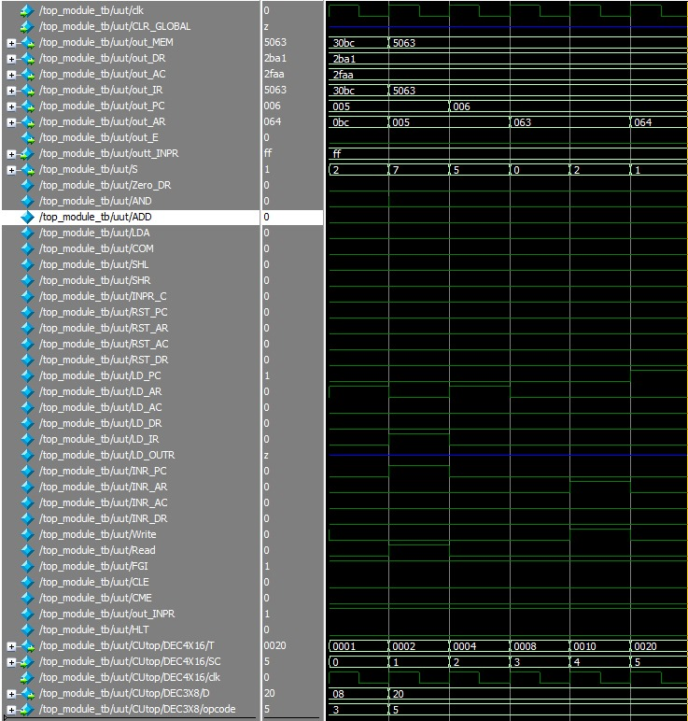

8.2.1.6 ISZ
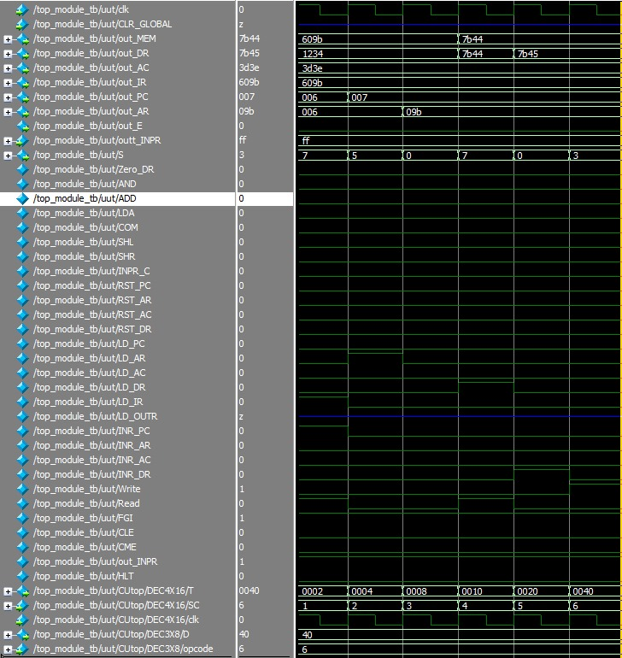

8.2.1.7 BUN
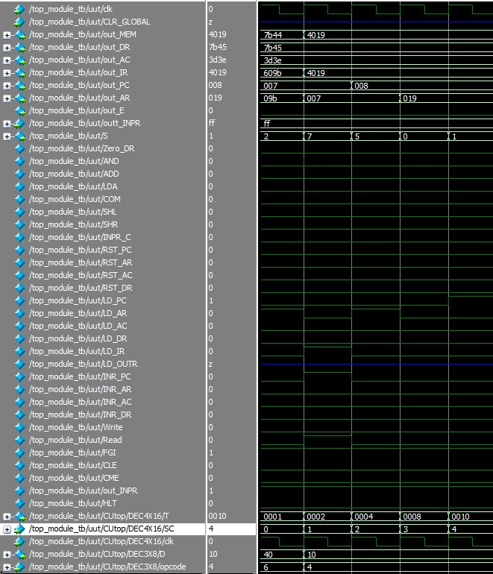

8.2.2 Memory Reference Indirect Operations
- Description: Indirect memory operations use an address stored in another memory location to access data.
- Focus Areas:
  - Proper handling of indirect addressing logic.
  - Sequential memory access via PC (Program Counter) and AR (Address Register).
  - Verification of instruction decoding and execution flow.
- Key Signals Observed: LD_PC, LD_AR, INR_PC, T[3], T[4].

8.2.2.1 LDA
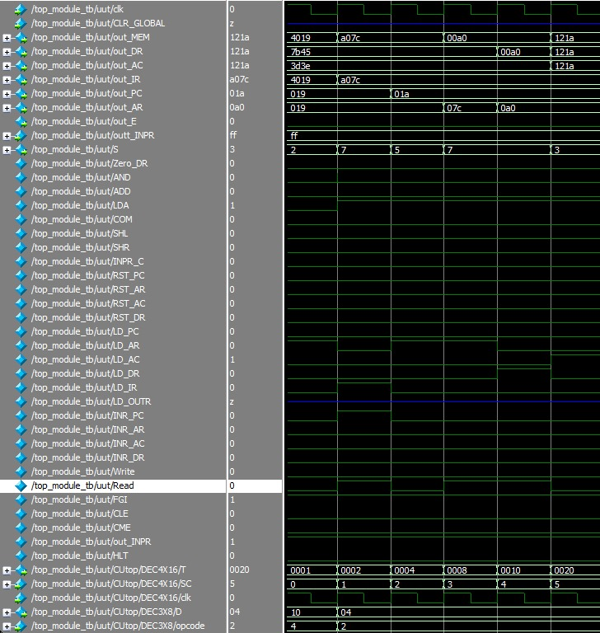

8.2.2.2 AND
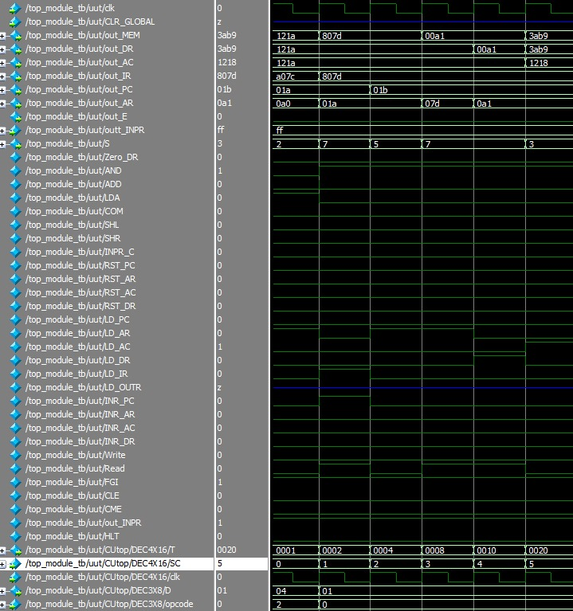

8.2.2.3 ADD
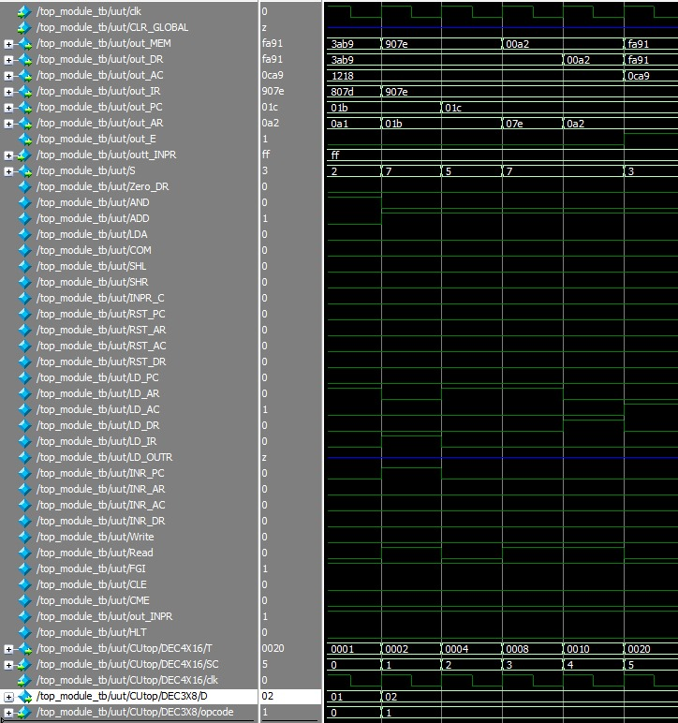

8.2.2.4 BSA
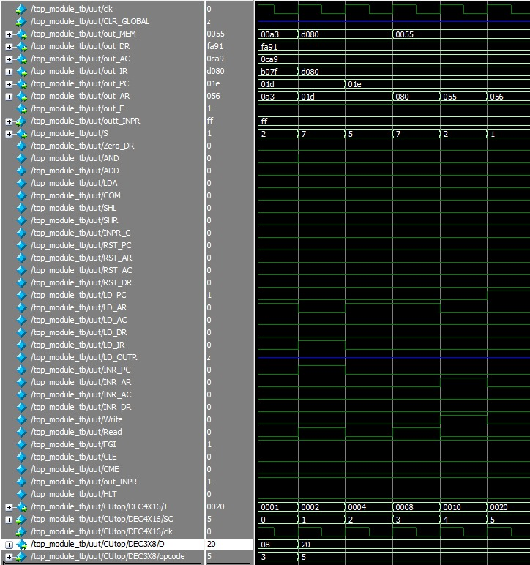

8.2.2.5 STA
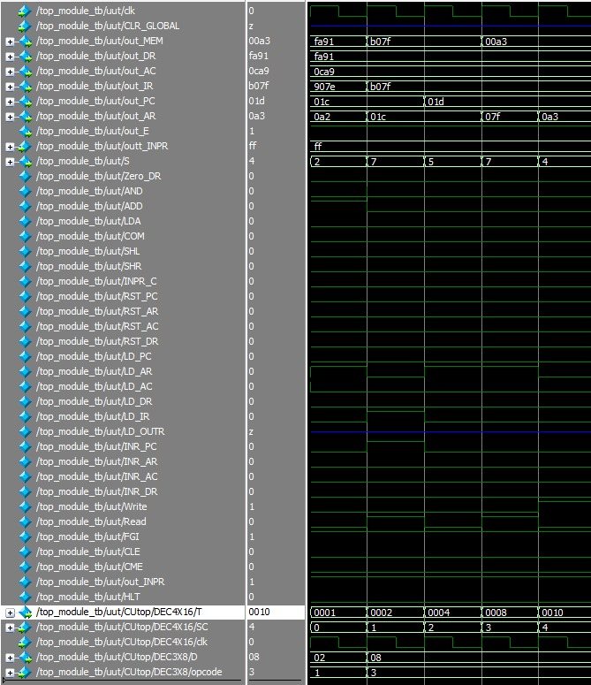

8.2.2.6 ISZ
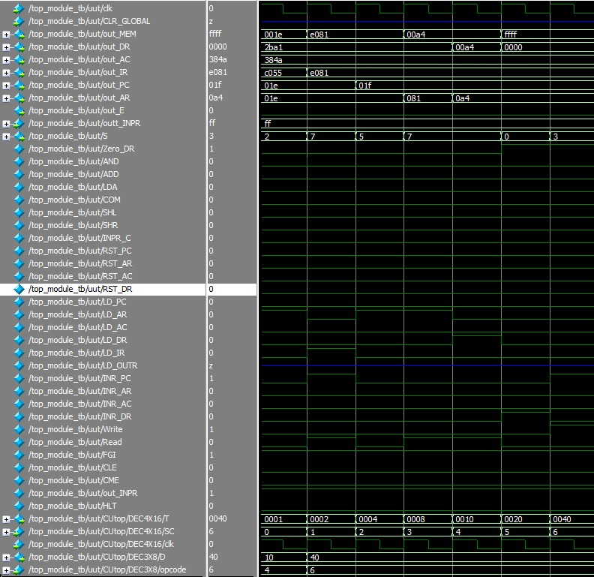

8.2.2.7 BUN


8.2.3 Register Reference Operations
- Description: These operations directly involve registers such as AC (Accumulator), DR (Data Register), and TR (Temporary Register).
- Focus Areas:
  - Arithmetic and logical operations (ADD, AND, SHR, SHL).
  - Data movement between registers.
  - Proper updates to the E (Extend Bit) and FGI/FGO flags.
- Key Signals Observed: AND, ADD, COM, SHR, SHL, INPR_C, FGI, FGO.

8.2.3.1 CLA
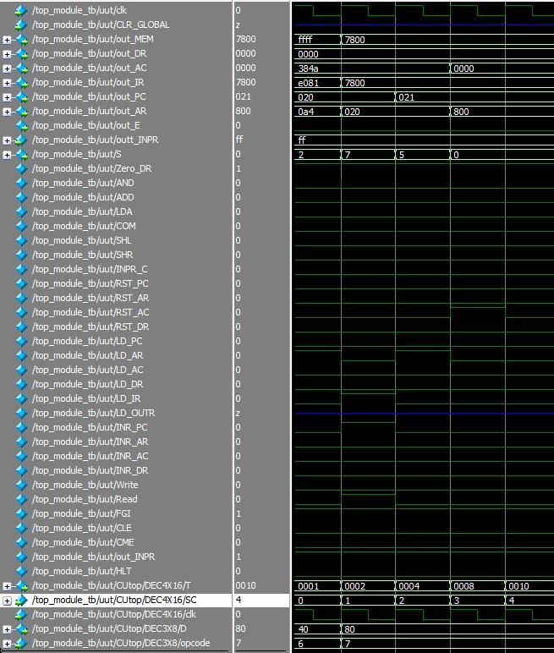

8.2.3.2 CLE
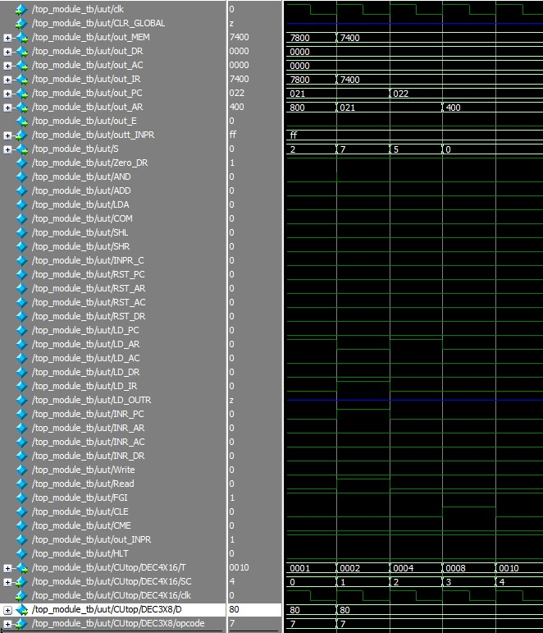

8.2.3.3 CMA
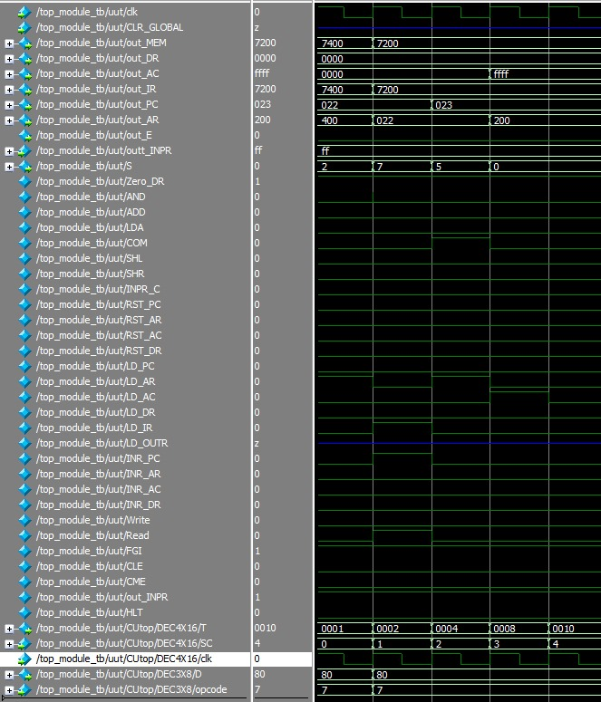

8.2.3.4 CME
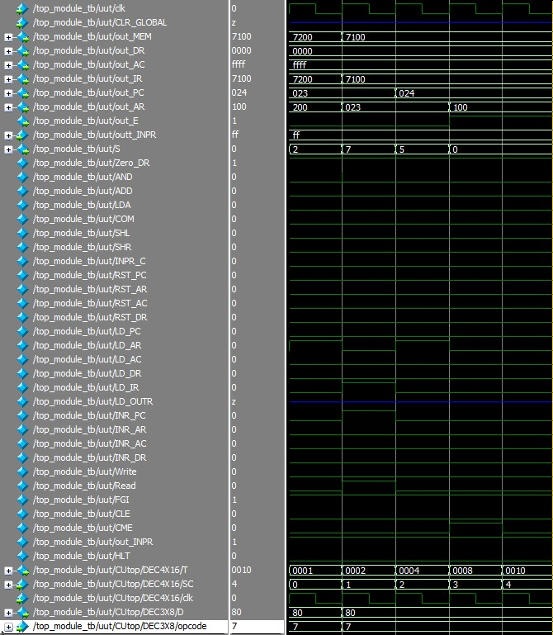

8.2.3.5 CIR
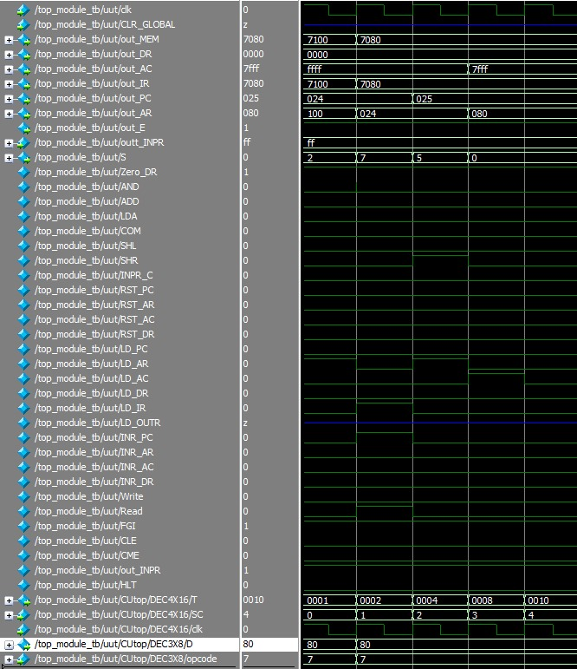

8.2.3.6 CIL

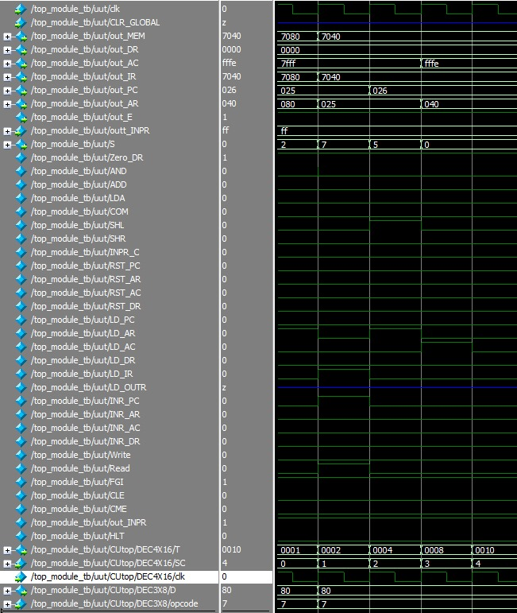

8.2.3.7 INC
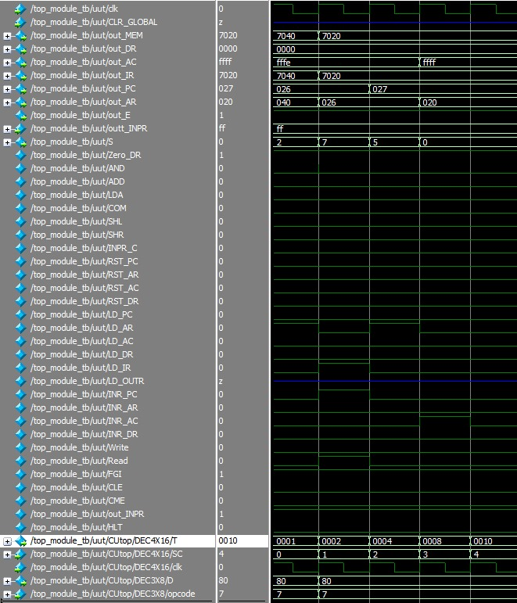

8.2.3.8 SPA
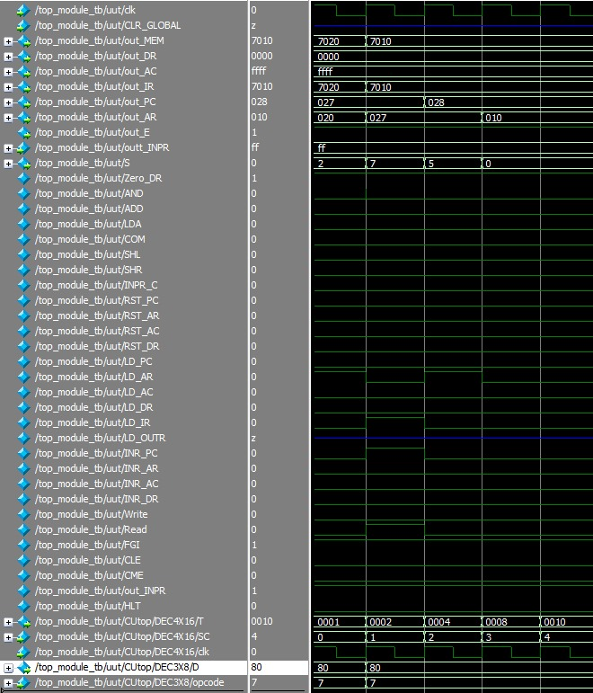

8.2.3.9 SNA

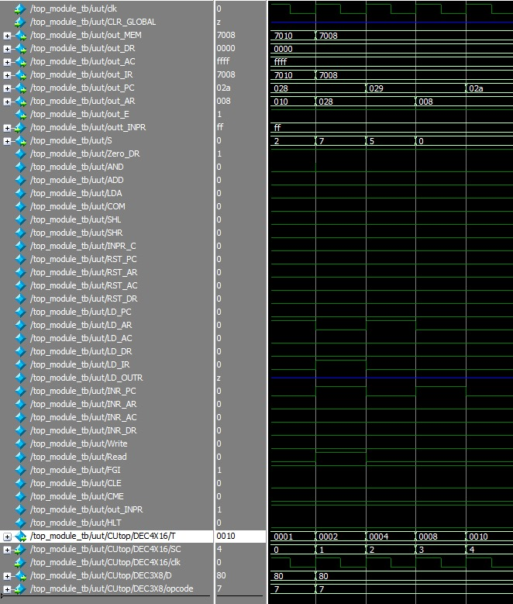

8.2.3.10 SZE
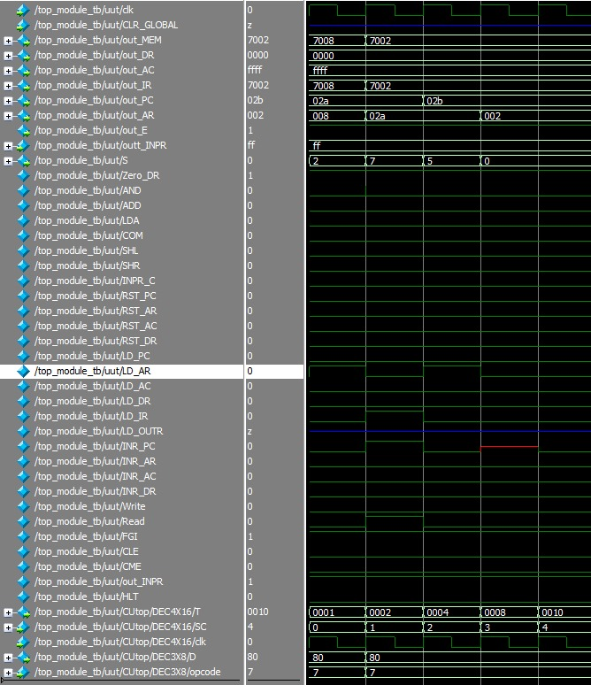

8.2.3.11 HLT
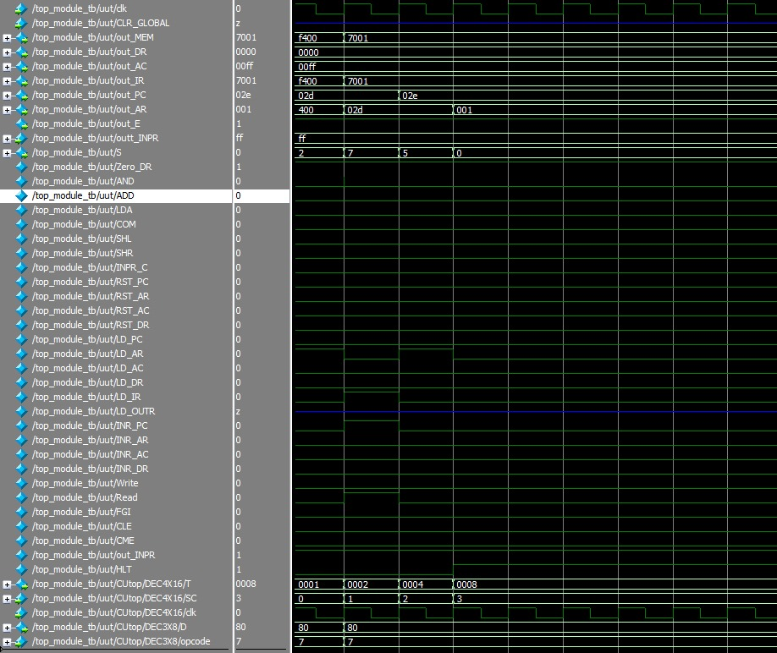

8.3 Simulation Transcript
A transcript of the simulation’s console output will be provided here, which logs the real-time changes in the state of the system components, including register values and flags like FGI or FGO. This section will validate that the system behaves as expected under various test conditions.

8.3.1 Memory Reference Direct Transcript

8.3.1.1 LDA
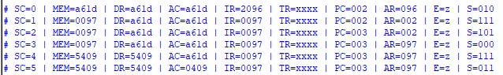

8.3.1.2 AND
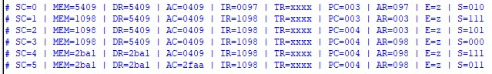

8.3.1.3 ADD


8.3.1.4 STA
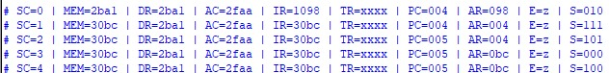

8.3.1.5 BSA (SUB-ROUTINE)
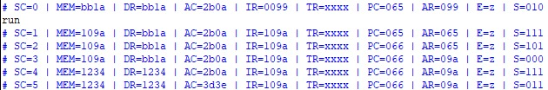
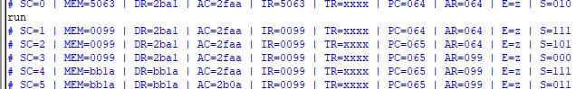
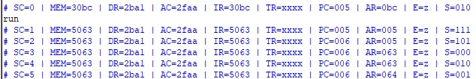
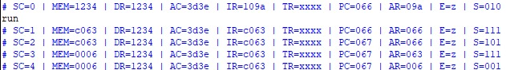

8.3.1.6 ISZ
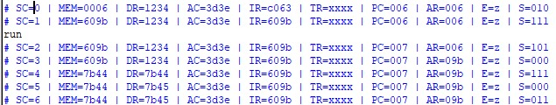

8.3.1.7 BUN
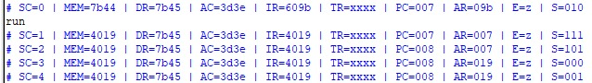

8.3.2 Memory Reference Indirect Transcript

8.3.2.1 LDA
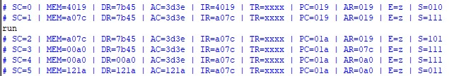

8.3.2.2 AND
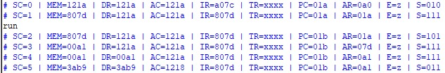

8.3.2.2 ADD
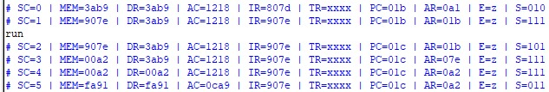

8.3.2.3 STA
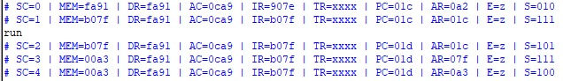

8.3.2.4 BSA
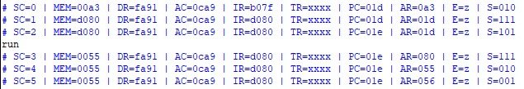
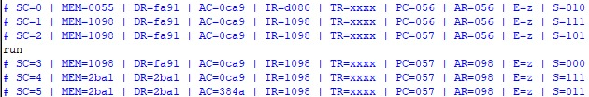
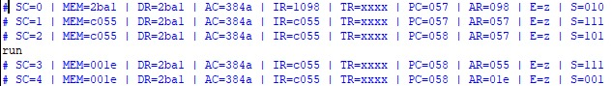

8.3.2.5 ISZ
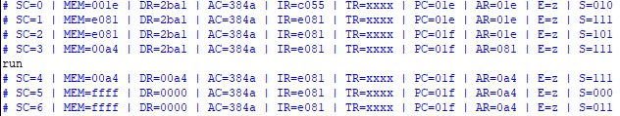

8.3.3 Register Reference Transcript

8.3.3.1 CLA
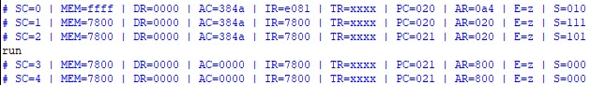

8.3.3.2 CLE
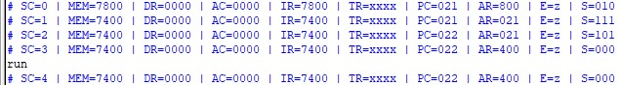

8.3.3.3 CMA
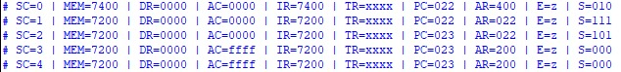

8.3.3.4 CME
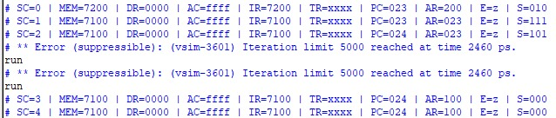

8.3.3.5 CIR
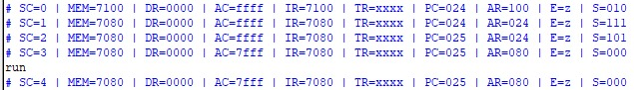

8.3.3.6 CIL
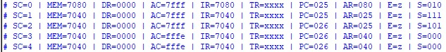

8.3.3.7 INC
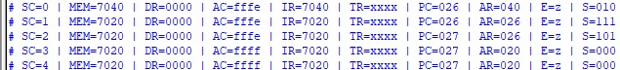

8.3.3.8 SPA
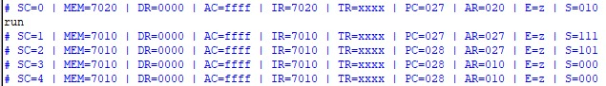

8.3.3.9 SNA
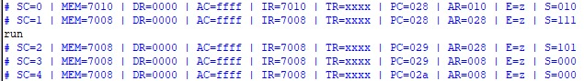

8.3.3.10 SZE
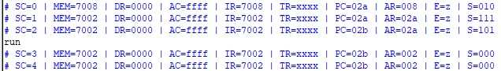

8.3.3.11 HLT

8.4 Observations
Throughout the simulation, the following observations are crucial for validating the design:
- Correctness of Operations: Each register should update according to the simulated instruction set at the correct clock cycle.
- Data Integrity: Data fetched from memory must match expected values, confirming the accuracy of memory read and write cycles.
- Signal Coherence: The control signals generated by the control unit must accurately reflect the current state of the sequence counter and the instruction register.
- Error Handling: The system should handle errors such as invalid memory access or execution of undefined instructions by setting appropriate flags or resetting the sequence counter.

9 Conclusion
This project successfully implemented a comprehensive control unit and datapath system that interacts dynamically through a central bus. The core achievement of this design was to demonstrate structured register transfer operations efficiently managed by micro-operations. Each component, from registers to logic units, functioned coherently under the orchestrated control of a finely tuned sequence counter and decoding system.

9.1 Key Accomplishments:
- Effective Register Operations: The registers were effectively utilized to hold data, instructions, and addresses, which were essential for the operation sequences.
- Dynamic Micro-Operation Management: Micro-operations were efficiently handled, ensuring operations like arithmetic calculations, data transfers, and logic manipulations occurred seamlessly within the prescribed clock cycles.
- Reliable Data Handling and Processing: The system effectively managed data flow through the bus, proving its capability in handling complex computations and data management tasks.
The design currently supports a fundamental set of operations which can serve a variety of simple computational tasks. However, the potential for scaling and enhancing this system is significant:

9.2 Future Enhancements:
- Instruction Set Expansion: Introducing more complex instructions could enhance the system’s utility, making it suitable for more comprehensive applications.
- Addressing Modes: Enhancing addressing modes would allow more complex memory interactions, improving the system’s efficiency in handling large data sets or more intricate computational models.
- Advanced I/O Interfaces: Developing more sophisticated I/O interfaces would facilitate better interaction with external systems, making the system more versatile in real-world applications.
Overall, this project not only fulfilled its initial objectives but also laid a solid foundation for advancing the capabilities of register transfer logic systems.

