VLSI documentation

islam yaseen

2022

# First we want to explain the shifter

# We design a logical shifter

# For the left shift we design it using (if else) statement

# He will see the value of j and shift the value of B depend on it .

# 

# For the right shift we also use the (if else)statement

# He will see the value of i and shift the value of A

# Depend on it .

# And we store the values in output called result

# the code work well

# 8’bit Adder we design it using this picture

# 

from (wolfam)site.

so first we design HaifAdder

recording to the functions of (Sum,Carry)

Sum= A^B.

Carry=A&B.

For the first bit only because we don’t have any cin

And we design a FullAdder

recording to the functions of (Sum,Carry)

Sum=A^B^Cin.

Carry=((A&B)|(Cin&(A&B))).

first will sum the first 2 bit from the numbers in haif adder and the Carry in wire to use it in the full adder.

then the rest of bits will sum using the fulladder

and the result will stored in output S.

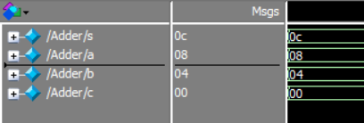

And the code work will.

For the multiblication we design the General form from the slide

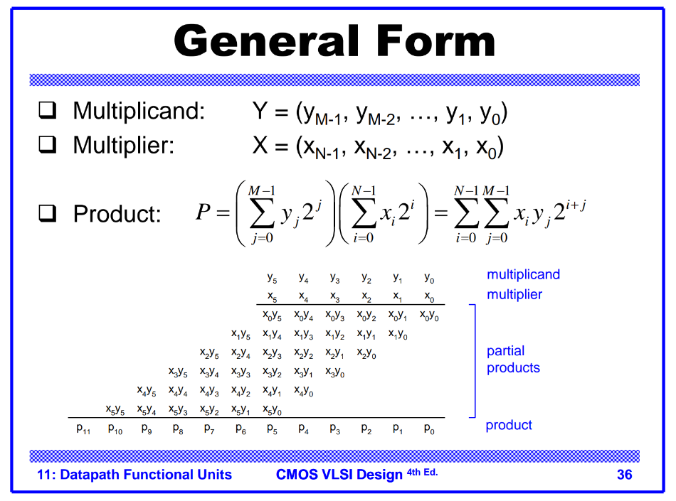

We put a 16’bit wire to stores the values

So in the wires (ww) we anding the first bit of multiplier with the all bits of multiplicand

So we use the Replication operator to copy

The bit of multiplier to become the same size as the multiplicand and stored in 16’bit wire

and for the second we shift the value 1’bit of 0 to the left and do the same Operation in anding and so on .

every one Operation of anding expect the first one we shifted the values to the left amount 1’bit of 0.

And we design a 16’bit adder to sum the values of anding and we use 16’bit wire(ws)to stored the values.

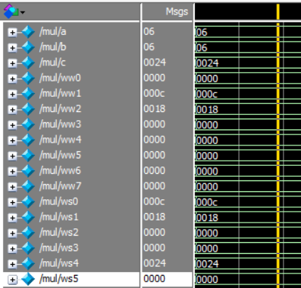

Code work well.

So this is our design.

For the testbench :

Waveform:

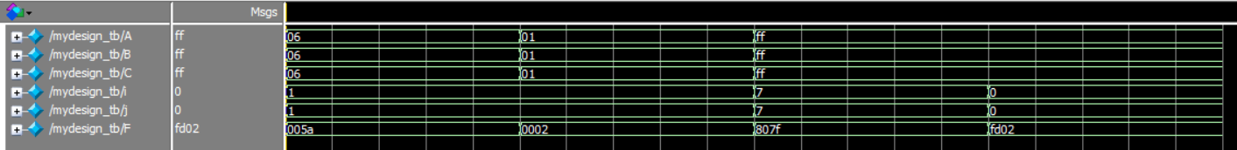

Transcript:

