**WeRateDogs**

WeRateDogs is a Twitter account that rates people's dogs with a humorous comment about the dog. These ratings almost always have a denominator of 10. The numerators, though? Almost always greater than 10. 11/10, 12/10, 13/10, etc. Why? Because "they're good dogs Brent." WeRateDogs has over 4 million followers and has received international media coverage.

By Using Python and its libraries, Data gathered from a variety of sources and in a variety of formats, assess its quality and tidiness, then clean it. Then stored data after cleaning, then make our Analyze, and then visualized it

In visualizing data, python libraries was used like Seaborn and matplotlib

**(5) Insights and (2) visualization**

**Visualization**

**For all variable appeared data frame create a grid of Axes such that each numeric variable in data will by shared across the y-axes across a single row and the x-axes across a single column. The diagonal plots are treated differently: a univariate distribution plot is drawn to show the marginal distribution of the data in each column. As Shown in this plot**

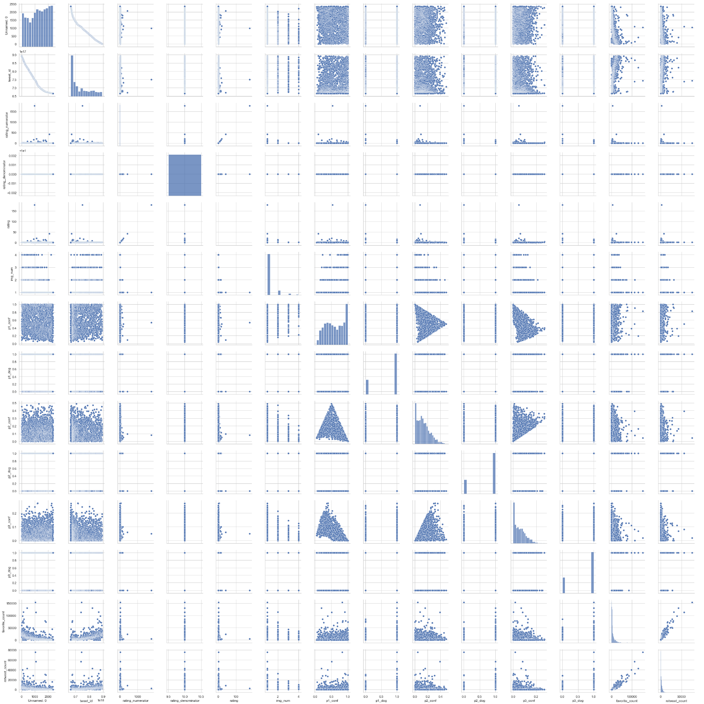

Here we different taking stage of dog as changing parameters:

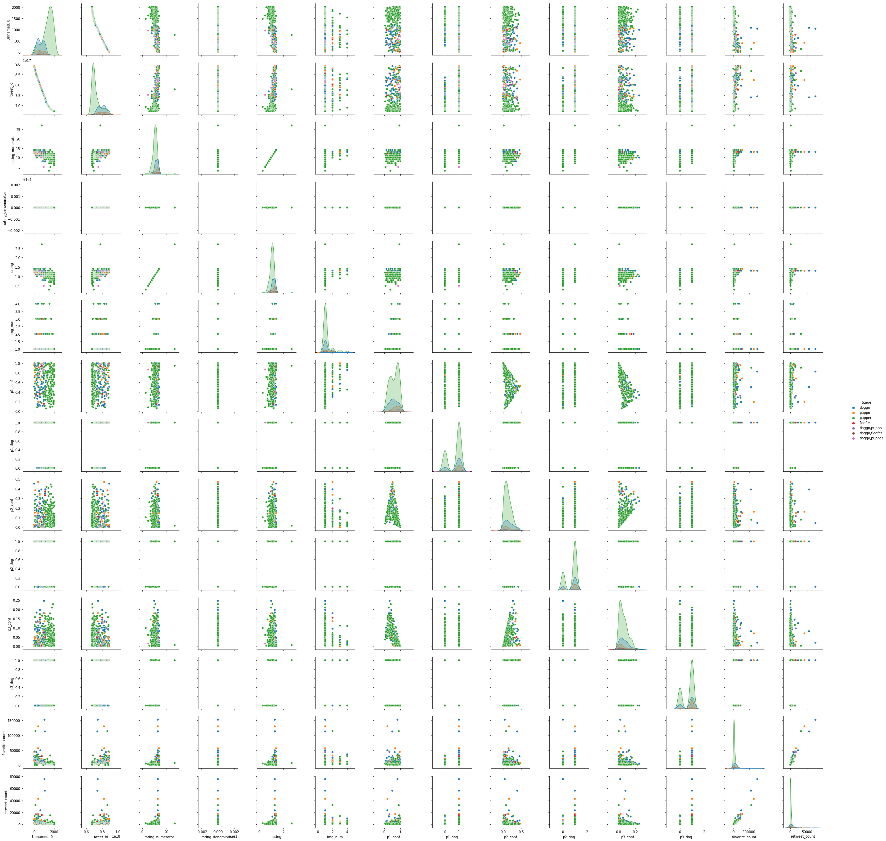

Insight Graph

Stage vs Count:

We here count stage of dog for stage: doggo, puppo, pupper, floofer, (doggo, puppo), (doggo, floofer), (doggo, pupper)

From plot appeared that Pupper is most common stage from tweets

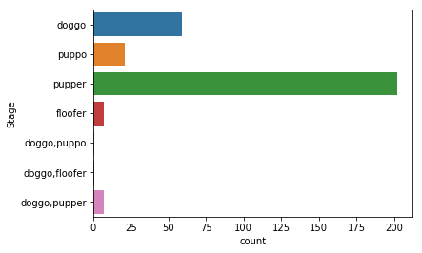

Most Common Names:

As shown from plot the most common names used are Cooper, Charle and Oliver ignoring None and a names which consider to be mistake.

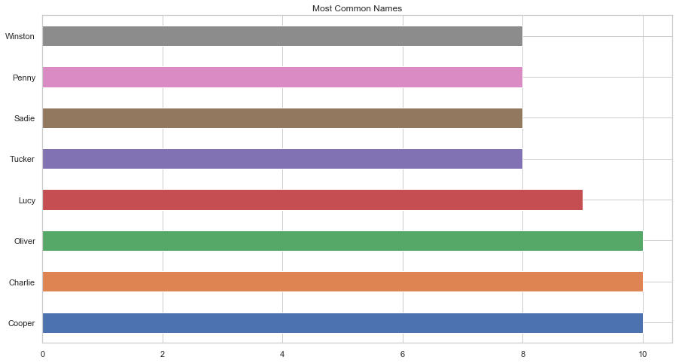

Most Common kind

As shown from plot the Most Common kind is Golden Retriever then Labrador Retriever 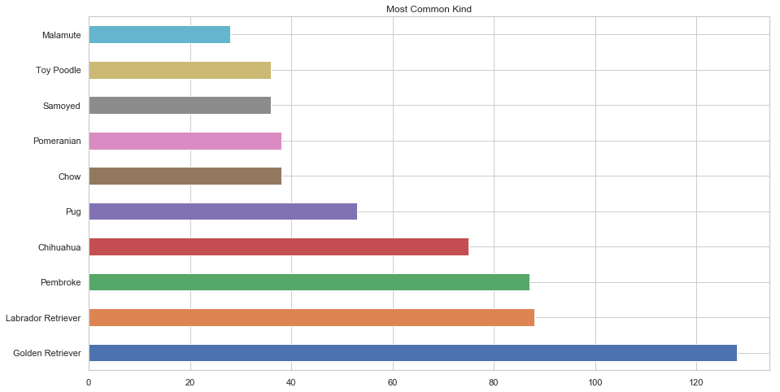

Most Given Rating

As shown from plot the Most Given Rating is 10/10 then 11/10 then 13/10 Because "they're good dogs Brent."

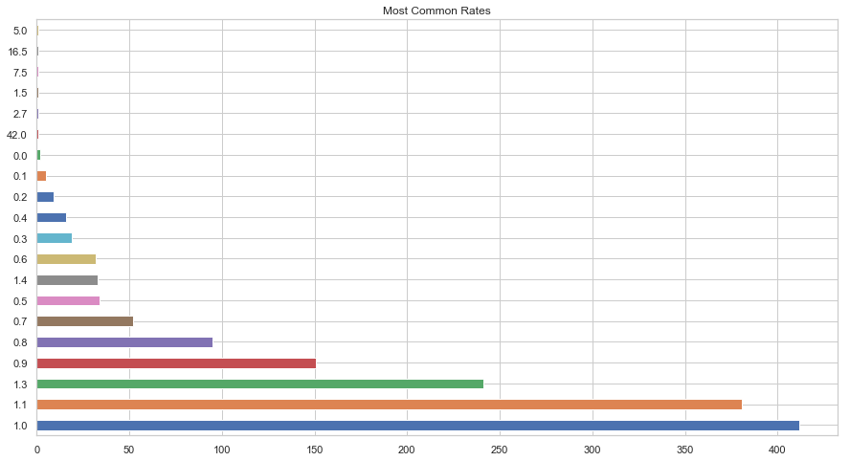

Most source

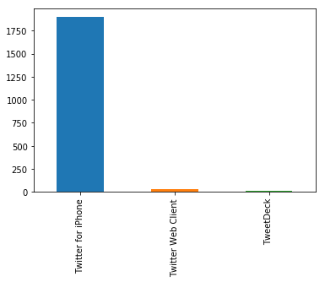As shown from plot the Most source is Twitter for Iphone then Twitter web client there is large difference between two sources