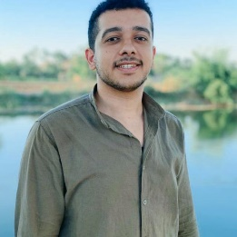C:\Users\Mohamed.basem\Desktop\Rectangle 1 copy.png

**Cairo, Egypt**

[**+20 109 5337 200**](tel:201095337200)

[**eslamboully@outlook.com**](mailto:eslamboully@outlook.com)

[**Abdelrahman Osama Ahmed**](https://www.linkedin.com/in/abdelrahman-osama-26a882171/)



Abdelrahman Osama Ahmed

**Full-Stack .NET Developer**

* **BSc Faculty of Science Mathematics and Computer Science, Menofia university.**

**Grade:** Good.

**Graduation project grade:** Excellent.

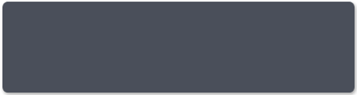

**EDUCATION**



* Experience with OOP, Data Structure, Algorithm, Design Pattern and SOLID principles.
* Experience with HTML, CSS, JavaScript, jQuery, Ajax, XML and Json.
* Experience with C#, Entity Framework, LINQ, SignalR, and Razor, ASP.Net MVC, ASP.Net Core, and ASP.Net Web API.
* Experience with PHP, Laravel, MySQL and phpMyAdmin.
* Experience with Symfony, Angular and Design Patterns.
* Experience with SQL, SQL Server, MySQL.
* Experience with Shared Hosting and Oracle Cloud.
* Experience with Docker and Containerized Application Development.
* Experience with Linux administration.
* Experience with third-party integration like Payment Gateways, Notification Gateways and SMS Gateways.
* Knowledge of SQL Views, Stored Procedure, Function.
* Knowledge of VueJS, Microservices and DDD.

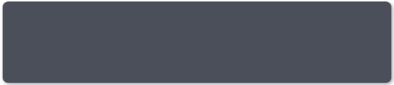

**Technical Skills**



* **Elbalto for medical services. (August 2022 - Present)**

**Mid-Senior Full-Stack Developer**

* Integrate with a third party like payment, video call, and SMS.
* Develop solutions for departments of the Egypt ministry of health.
* Serve more than 10 organizations and government agencies in different regions.
* Implement responsive web applications.
* Deploy projects with appropriate server plans.
* **Freelancing Web Projects. (February 2022 - Present)**

**Full-Stack Web Developer**

* I Excel In:
* Back-End Development.
* Front-End Development.
* Deploying Applications from scratch or changing from server to another.
* Refactoring Legacy Projects or Rewrite It from scratch.
* Working on different tasks at the same time easily.
* API Development for mobile applications.



* **Ghazal Software Solutions. (July 2021 - February 2022)**

**Full-Stack Web Developer**

* Working on developing e-commerce Websites.
* Implement, customize and Develop entities functionality, using:
* dynamics features such as Business Rules, Business Processes and Workflows.
* custom features such as JavaScript, Ajax, OData, Plugins, Custom Steps, and Webservices.
* Implement responsive web applications.
* Deploy projects with appropriate server plans.
* **Hash Studio Software Solutions. (March 2020 – July 2021)**

**Back-End Web Developer**

* Implement responsive web applications.
* Deploy projects with appropriate server plans.
* Working on warehouse applications.
* Test parts of the applications (unit testing).
* API Development for mobile applications.



**Professional Experience**



* **Social Media Hub**
* Connect and collaborate between organization members with some features like posts, comments, chat, and groups, and some internal features in it.
* **Technology used**: LINQ, Entity Framework, SignalR, ASP.Net Core MVC, ASP.Net Core API, SQL, Azure web app, Firebase, Multi Talent Structure.
* **Clients:**
  + **The General Authority for Comprehensive Health Insurance of the Egyptian Ministry of Finance.**
  + **The General Authority for Health Care of the Egyptian Ministry of Health.**
* **Tele-Medical**
* Connect doctors and patients throw the app by video, and chat services, and send medical reports.
* **Technology used**: LINQ, Entity Framework, SignalR, ASP.Net MVC 4, ASP.Net API, SQL, Web RTC, Firebase, Azure web app.
* **Clients:**
  + **Cleopatra Hospitals Group in Egypt.**
  + **Al-Tawfiq Group of Hospitals in Tunisia.**
  + **Elbalto Private Company.**
  + **SWNW Private Company.**
* **Tadween For Wholesalers and Retailers**
* Website and mobile app for wholesalers and retailers’ business.
* **Technology used**: PHP, Laravel, VueJS, MySQL, AWS Services Cloud.
* **Clients:**
  + **Tadween in UAE.**
  + **Hash studio in Egypt.**
* **Link:** [**tadween.app**](https://tadween.app)
* **BlueHouse System**
* Warehouse Management System.
* **Technology used**: C#, ASP.NET Core, SQLServer, Oracle Cloud.
* **Clients:**
  + **sellers in Egypt.**
* **Bwenoz E-Commerce System**
* Ecommerce web applications.
* **Technology used**: C#, ASP.NET Core, MongoDB, Angular, Oracle Cloud.
* **Bob Courses**
* Web Applications for courses like Udemy.
* **Technology used**: PHP, Laravel,jQuery, Javascript, MySQL.



**Projects Fields**



* **English**

**Full professional proficiency**.

* **Arabic**

**Native or Bilingual.**



**Language**



* Open source e-commerce built with symfony.
* URWay payment gateway package built with c#.
* Point of sales system built with Laravel.
* Symfony Custom Validation Library.
* Red Hat Certification Level 1.
* Red Hat Certification Level 2.
* [Github Link](https://github.com/eslamboully).



**Volunteer Projects**



**More**



**Thanks for spending your time reading my resume...**