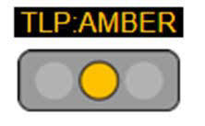**Vulnerability Advisory Report**

October 20, 2021

**Vulnerability Type:** RCE **Severity:** Critical

**CVSS:** Multiple **Base Score:** N/A

**Vulnerability Name:**

**Description:**

**Affected Syste**

**Recommended Actions:**

**References:**