
ANDALUSIA ACADEMY

Andalusia Management System
  - Power BI and Business Intelligence Handover Report
Operational System, UI Catalogue, Data Model, KPI Framework and BI Requirements

Document control | Detail
Version | 1.1
Date | 13 September 2026
Original edition | 23 August 2026 - Andalusia Management System (AMS)
Prepared for | Power BI / Business Intelligence Team
Update | Plan dashboard, Visits networking database and new screen captures

The report connects operational functionality with analytical requirements. This edition adds planning and networking workflows, their data definitions and reporting measures, while retaining the original Academy system catalogue and branding.

00 Document Control
Item | Detail
System | Andalusia Academy Work Management System
Application baseline | Source report: Revision 20.2. Additions: Plan and Visits from the local networking build.
UI baseline | Revision 19.1 Executive UI, with Revision 20.1 Program Stage Flow redesign preserved in Revision 20.2
Audience | Power BI Developers, Data Analysts, Data Engineers, BI Architects, Academy Management, Project Managers
Brand theme | Deep Navy + Terracotta + Warm Neutral, using the original Andalusia Academy logo
Confidentiality | Internal project handover

Source Basis & Traceability
This report is grounded in the current Revision 20.2 project package, the current static UI, server/database code, and the actual-render review screenshots bundled with the project. Revision 20.2 explicitly preserves the Revision 20.1 UI, Program Stage Flow redesign, themes, and branding. The screen catalogue uses the retained actual desktop renders for the unchanged workspaces and the current Revision 20.1 lifecycle render for programStageFlow.

Contents
- 01 Executive Summary & Business Objectives
- 02 Roles, Authentication & Navigation
- 03 Application UI Screen Catalogue
- 04 Program Lifecycle & Governance
- 05 Operational Data & Analytical Model
- 06 KPI Framework
- 07 Power BI Requirements & Dashboard Pages
Version 1.1 adds sections 3.23 to 3.25, networking data specifications, section 06 KPI Framework, and supplementary BI and mobile mappings.

Version 1 1 update overview
Plan and Visits extend the Academy system with an operational planning dashboard and a reusable networking database. This update connects contact people, visit history, outcomes and follow-ups to Programs and activities, and defines how the BI layer should report on them.
Update | Where to find it
Plan dashboard | Section 3.23: In progress and Upcoming lanes, summary cards, search and combined filters.
Visits networking database | Section 3.24: visit records, contact directory, contact and visit forms, follow-up behavior and validation.
Filter behavior | Section 3.25: Program and activity rules across Plan and Visits.
Data and metrics | Section 05 additions and section 06: record fields, model grain, relationships and KPI definitions.
Power BI and mobile | Section 07 additions and appendices: analytical pages, acceptance checks and responsive screenshots.

Version and access boundary
The original report documents Revision 20.2, including its authentication and role controls. The new Plan and Visits screens are captured from the local networking build, which uses a local profile and shared networking records. The original account and security descriptions remain the Revision 20.2 baseline; they do not establish that authentication or server-side networking permissions are present in the local build.
Before these additions are deployed in the Revision 20.2 environment, verify account-based access, ownership and API permissions for contacts, visits and follow-ups. Document the exact deployed application version with the BI refresh configuration.

Navigation and screenshots
Plan and Visits are added to the main application navigation and are available through the mobile navigation. Plan opens the Visits database or the visit form. Visits switches between Visit records and Contact directory. The existing weekly, monthly and quarterly Planner remains the task calendar.
Figures 33 to 39 show actual application screens using demonstration contacts and Programs. They illustrate functionality and are not Academy performance results. Original figures retain their original numbers and version context.

01

Executive Summary & Business Objectives
What the platform manages, why it exists, and where Power BI adds value.

Executive Summary
The Andalusia Academy Work Management System is an operational management platform that connects Academy Programs, lifecycle stages, Position-owned work, tasks, team workload, instructors, schedules, finances, documents, reports, approvals, and audit history. It is designed so operational work can be executed in the same environment in which management reviews readiness and controls Program progression.
The system separates operational execution from management governance. Contributors complete the work owned by their Position; the Academy Manager reviews readiness, blockers, evidence, and handoffs, and retains authority to complete lifecycle stages and close Programs. Revision 20.2 adds server-side authentication and authorization for Admin and User accounts.

Business Objectives
- Centralize Academy operational information and reduce duplicate entry across workflow and personal tasks.
- Provide end-to-end visibility from Program request through final closure.
- Make lifecycle requirements, blockers, ownership, readiness, and next actions explicit.
- Assign and monitor Position-owned tasks while keeping Program stage state distinct from personal task progress.
- Monitor team capacity, instructor readiness, delivery schedules, Program finance, documents, and management approvals.
- Provide auditable management decisions and handoffs.
- Create a reliable operational source from which historical analytics and management reporting can be built.

Where Power BI Adds Value
The operational application is optimized for current work and decisions. Power BI should complement it with historical trends, cross-Program comparison, stage aging, SLA analysis, task aging, capacity trends, Instructor utilization, delivery performance, financial variance, drill-through, forecasting, and governed executive reporting.

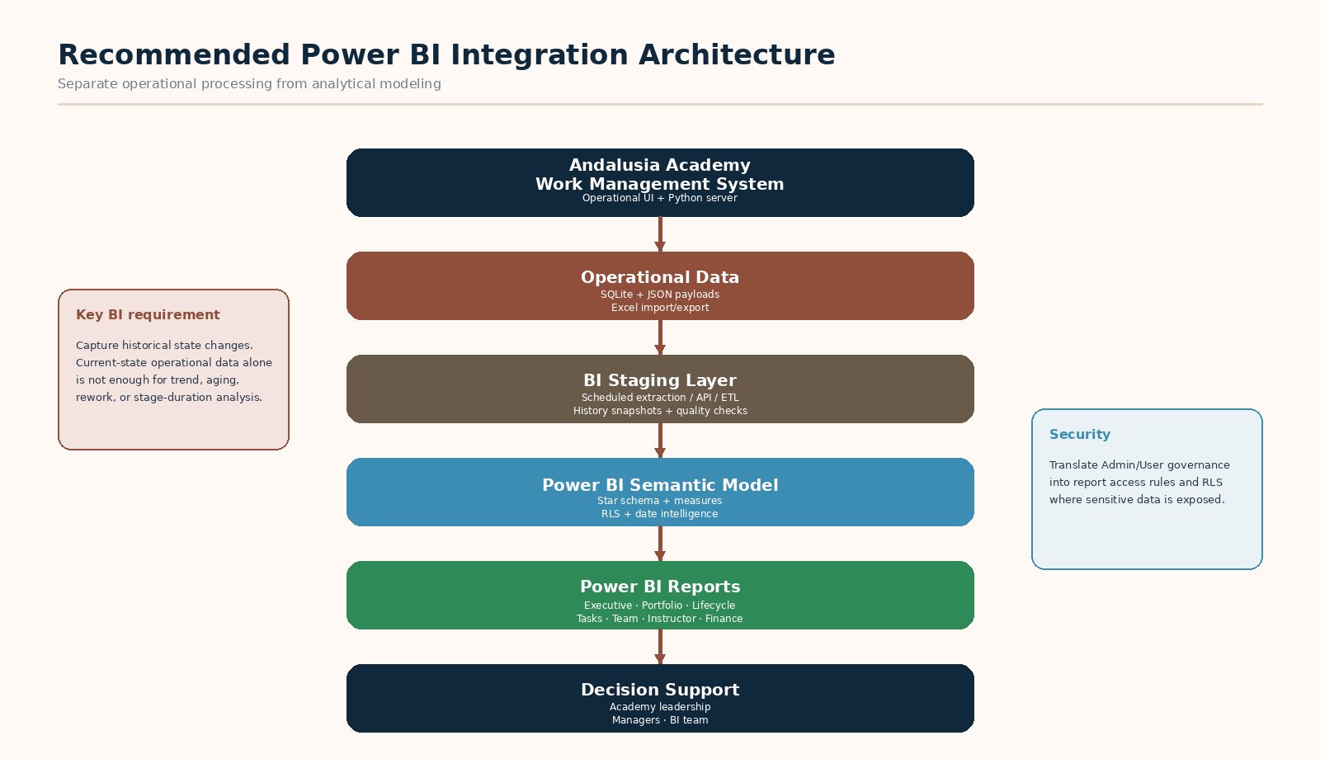
Figure 1 — Recommended operational-to-analytics architecture

02

Roles, Authentication & Navigation
How access is established and how management governance differs from contributor execution.

User Roles
Role | Primary access | Authority / restriction
Admin / Academy Manager | Manager Dashboard; Programs; Team Members; Administration; all management workspaces | Can complete lifecycle stages 1-8, assign work to others, access all-team workload and administration.
User / Contributor | My Tasks / task workspace; permitted Program work; relevant schedule/documents; profile | Completes Position-owned work but cannot advance lifecycle stages, create Programs, reassign others’ work, or change administrative configuration.

Authentication & Session Security
- Two first-run accounts are created automatically: admin (Academy Manager) and user (Program Coordinator).
- Temporary passwords are generated on first server start and must be replaced at first sign-in.
- Authentication uses an HttpOnly, SameSite=Lax session cookie with a 12-hour rolling timeout by default.
- CSRF tokens protect authenticated state-changing API requests.
- Login throttling is applied after repeated failures; logout invalidates the server session.
- Manager-only API actions are enforced server-side; a contributor cannot advance Program lifecycle stages through the API.

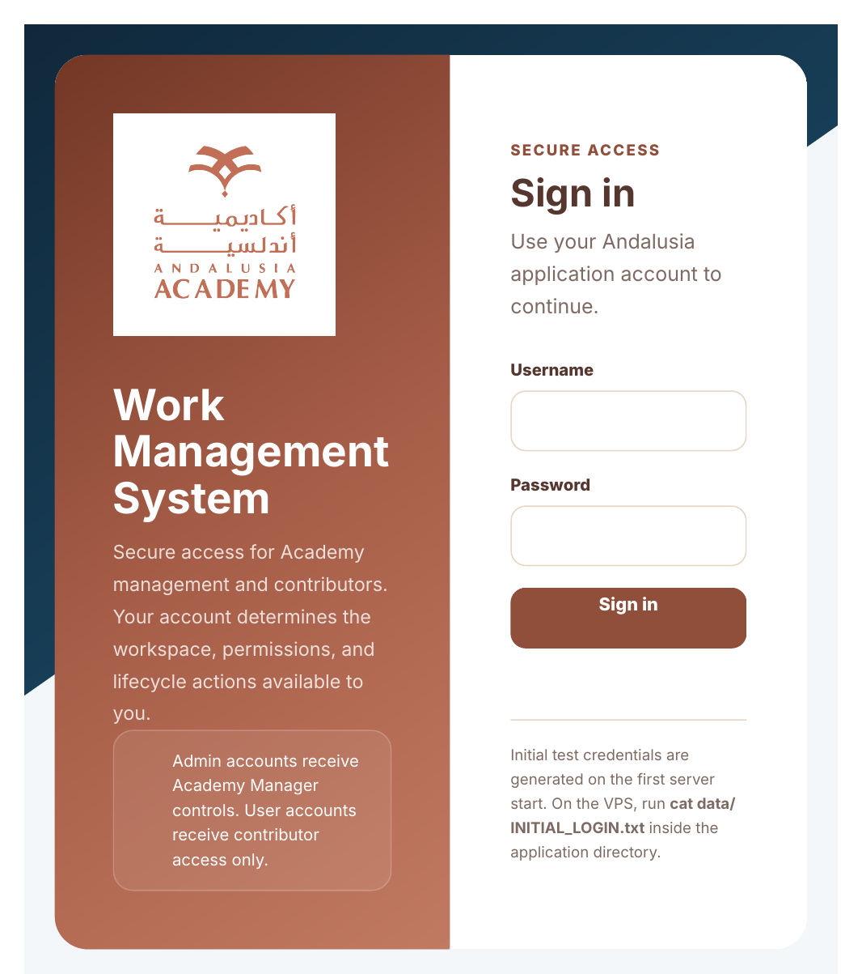
Figure 2 — Revision 20.2 Sign In screen

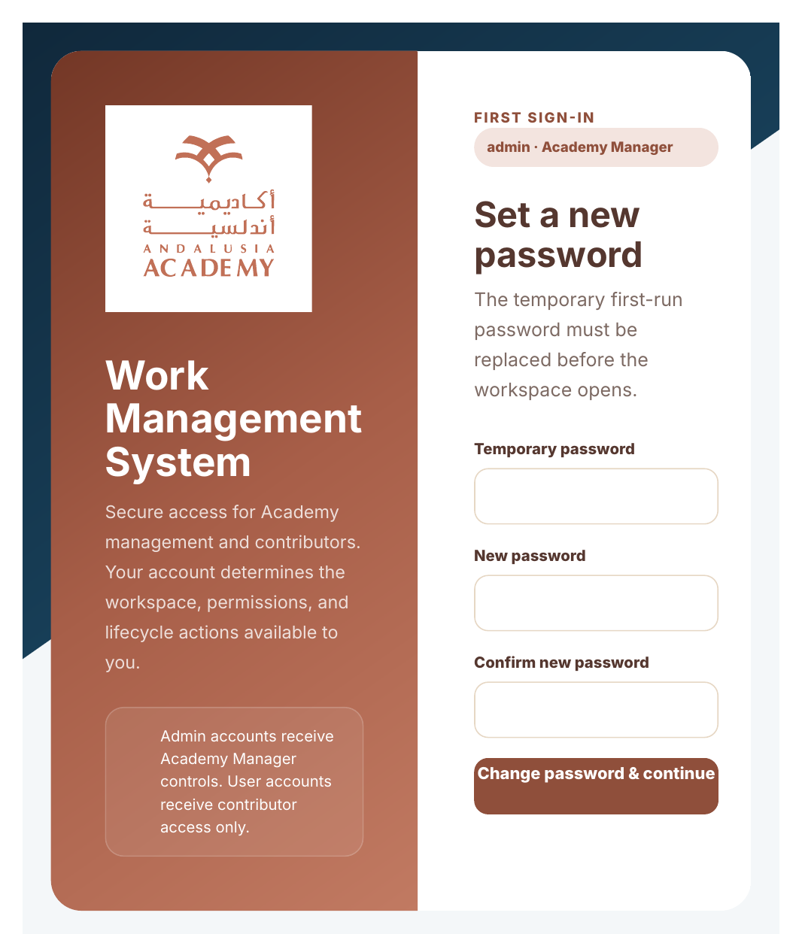
Figure 3 — Revision 20.2 mandatory first-sign-in password change

Application Navigation
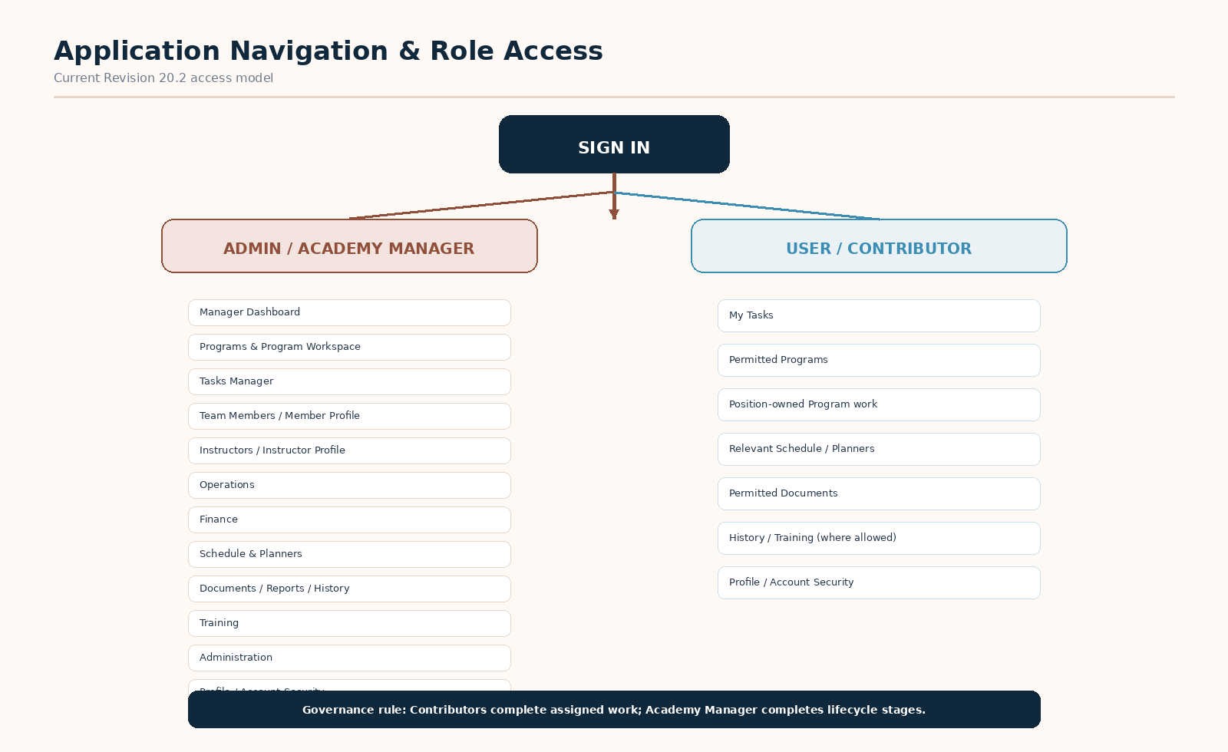
Figure 4 — Role-aware navigation map

03

Application UI Screen Catalogue
Every current navigable workspace, its operational purpose, data, actions, and Power BI relevance.
Screenshot note: Revision 20.2 preserves the Revision 20.1 UI. Revision 20.1 changed the Program Stage Flow component while preserving the surrounding Executive UI. The unchanged workspace screenshots below are the actual Revision 19.1 renders retained with the current package; Program Stage Flow and authentication are shown from the later revisions.

3.1 Manager Dashboard
Primary Role: Academy Manager
Executive command center for portfolio performance, strategic risks, decisions, and quick navigation.
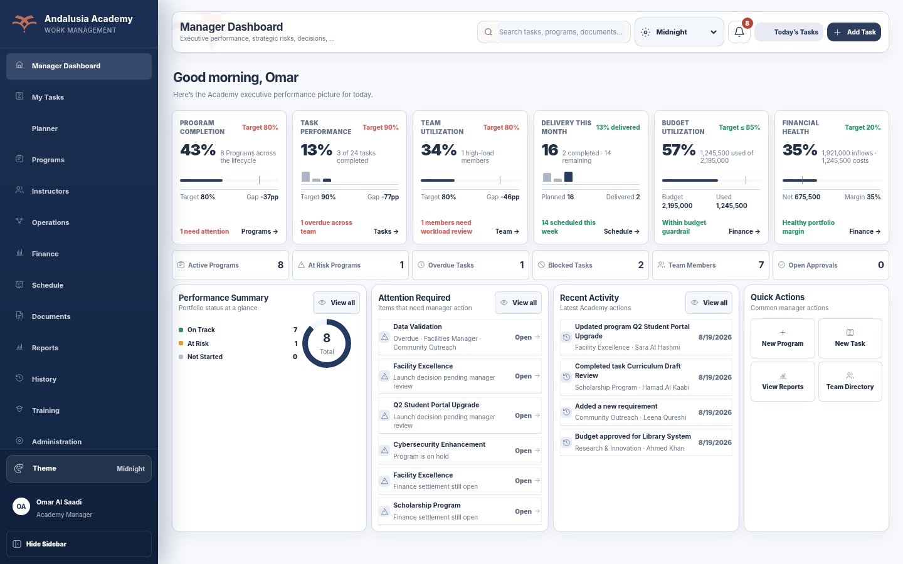
Figure 5 — Manager Dashboard - actual desktop UI
Area | Current application / BI interpretation
Key data & KPIs | Program Completion; Task Performance; Team Utilization; Delivery This Month; Budget Utilization; Financial Health; Active/At Risk Programs; Overdue/Blocked Tasks; Team Members; Open Approvals.
Main actions | Open Programs, Tasks, Team, Schedule, Finance, reports, and manager controls.
Power BI opportunity | Executive Overview; target-vs-actual trend; risk concentration; portfolio forecasting; management exceptions.

3.2 Tasks / My Tasks
Primary Role: Manager; contributor view is role-restricted
Manager view scans the whole team and task exceptions; contributor access is constrained to owned work.
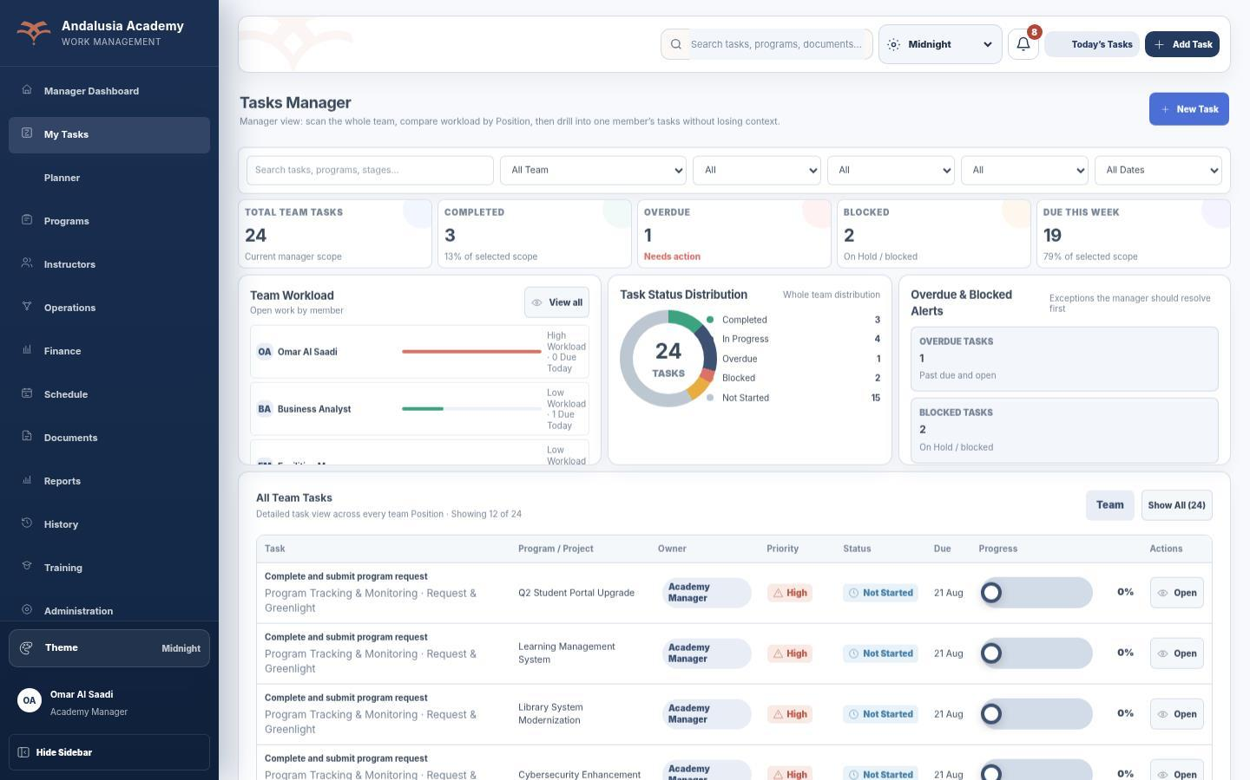
Figure 6 — Tasks / My Tasks - actual desktop UI
Area | Current application / BI interpretation
Key data & KPIs | Total team tasks; completed; in progress; overdue; blocked; due this week; workload by member; status distribution.
Main actions | Search/filter by team member, project, status, priority, due date; open task; create task (manager).
Power BI opportunity | Task performance, aging, SLA, backlog, overdue trend, workload and completion by Program/Stage/Position.

3.3 Weekly Planner
Primary Role: Both
Weekly task planning surface with current-week navigation and operational filtering.
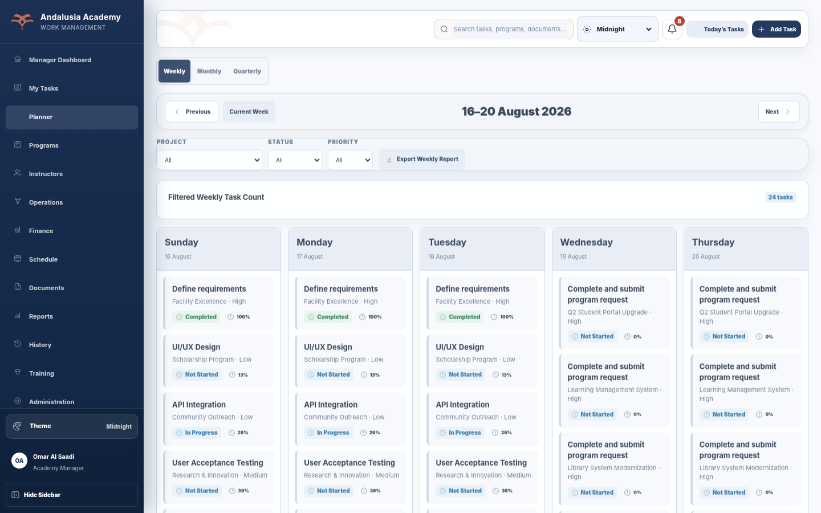
Figure 7 — Weekly Planner - actual desktop UI
Area | Current application / BI interpretation
Key data & KPIs | Filtered weekly task count; task cards by day; task progress/status.
Main actions | Navigate week; filter project/status/priority; export weekly report.
Power BI opportunity | Weekly workload trend, completion by weekday, planned-vs-completed work, capacity pattern.

3.4 Monthly Planner
Primary Role: Both
Month-based planning view for task distribution and calendar review.
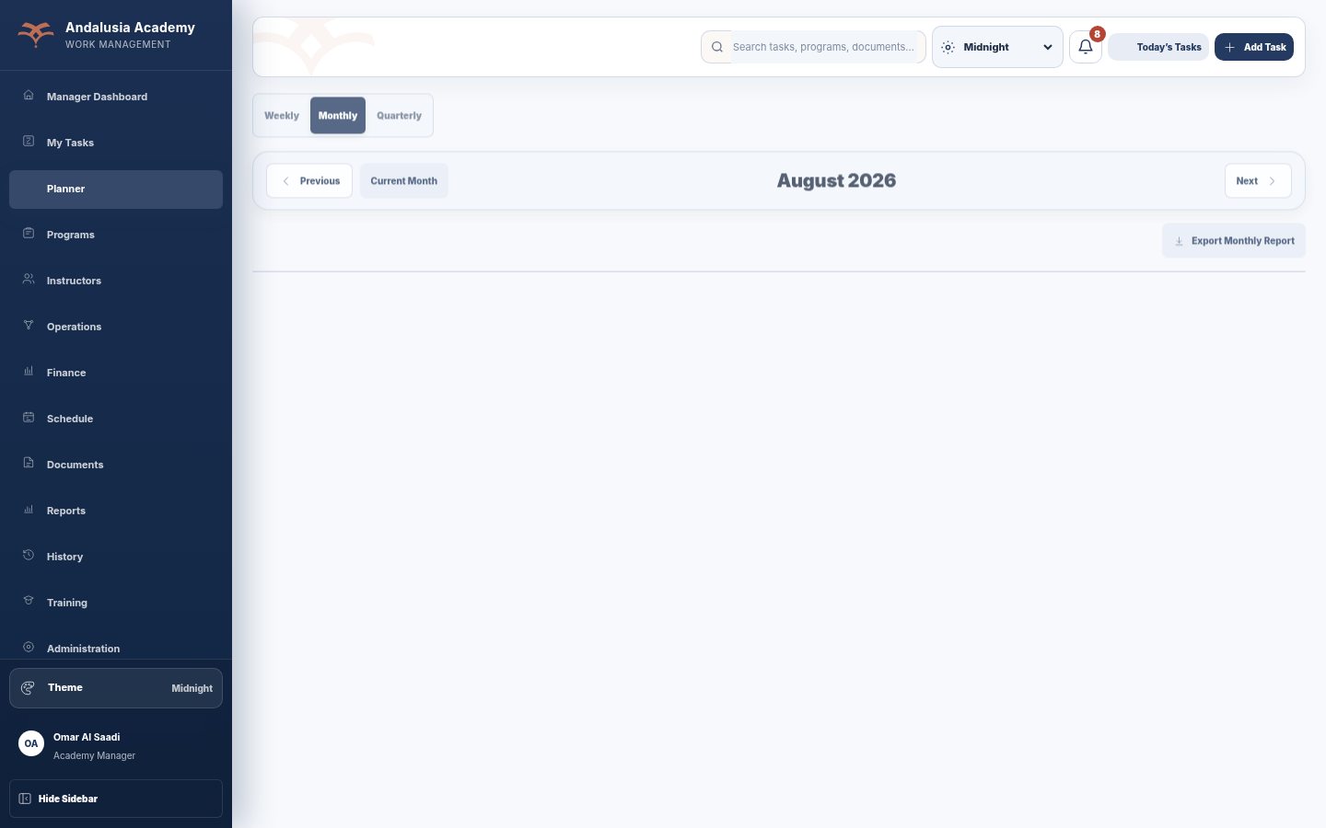
Figure 8 — Monthly Planner - actual desktop UI
Area | Current application / BI interpretation
Key data & KPIs | Tasks/events by date and month.
Main actions | Previous/current/next month; export monthly report.
Power BI opportunity | Monthly seasonality, due-date concentration, backlog movement.

3.5 Quarterly Planner
Primary Role: Both
Quarter-level view of work volume and progress across three months.
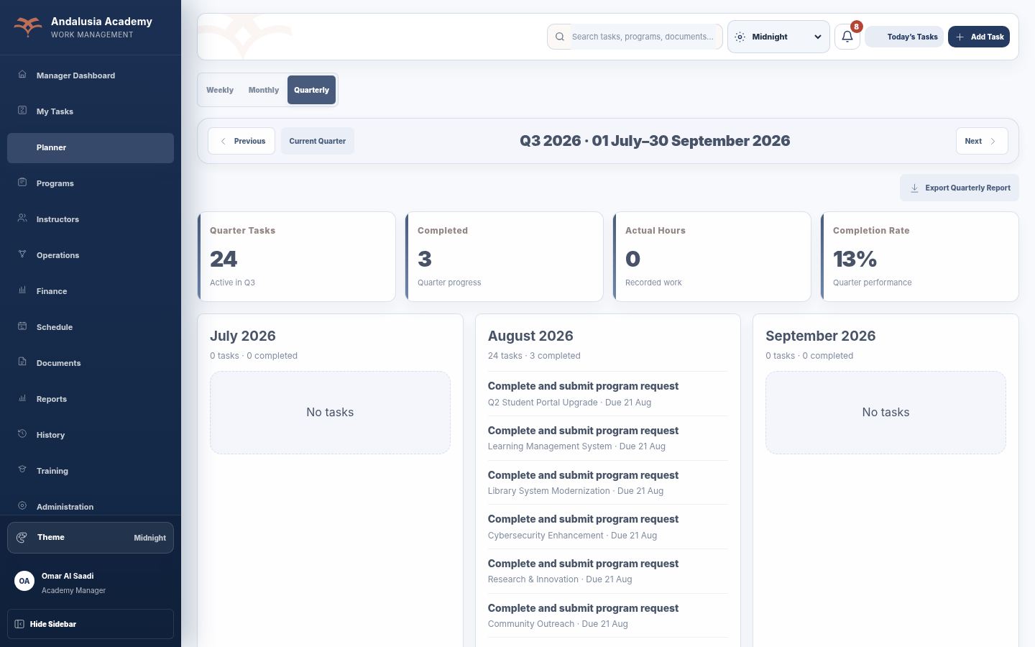
Figure 9 — Quarterly Planner - actual desktop UI
Area | Current application / BI interpretation
Key data & KPIs | Quarter tasks; completed; actual hours; completion rate.
Main actions | Navigate quarter; export quarterly report.
Power BI opportunity | Quarterly productivity, capacity, hours, completion trend and quarter-over-quarter comparison.

3.6 Programs
Primary Role: Academy Manager; permitted Program users
Portfolio management screen for status, stage, health/readiness and progress.
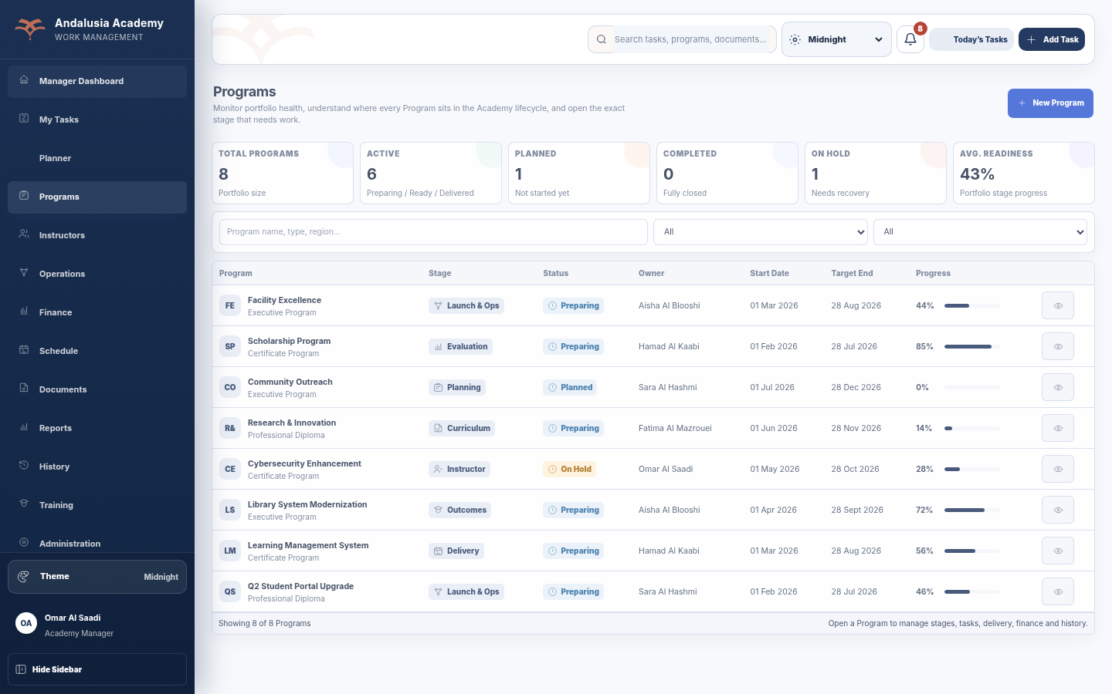
Figure 10 — Programs - actual desktop UI
Area | Current application / BI interpretation
Key data & KPIs | Total Programs; active; planned; completed; on hold; average readiness; Program stage/progress.
Main actions | Search; filter status/stage; create Program (manager); open Program Workspace.
Power BI opportunity | Program portfolio, stage distribution, aging, health trend, on-time completion, owner and risk analysis.

3.7 Program Workspace
Primary Role: Both; management controls are Admin-only
Single-Program operational workspace combining lifecycle, tasks, requirements, documents, team, budget, blockers and activity.
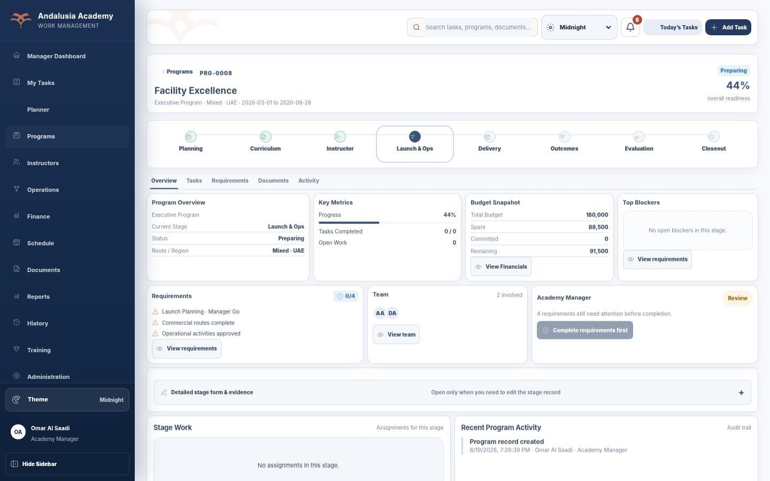
Figure 11 — Program Workspace - actual desktop UI
Area | Current application / BI interpretation
Key data & KPIs | Overall readiness; current stage; stage tasks; Program progress; budget snapshot; blockers; requirements; team.
Main actions | Inspect stage; open tasks/documents/activity; complete Position-owned work; manager completes lifecycle stage.
Power BI opportunity | Program drill-through combining stage history, task performance, delivery, Instructor, finance, blockers and decisions.

3.8 Instructors
Primary Role: Academy Manager
Instructor network directory for readiness, availability, expertise, load and Program linkage.
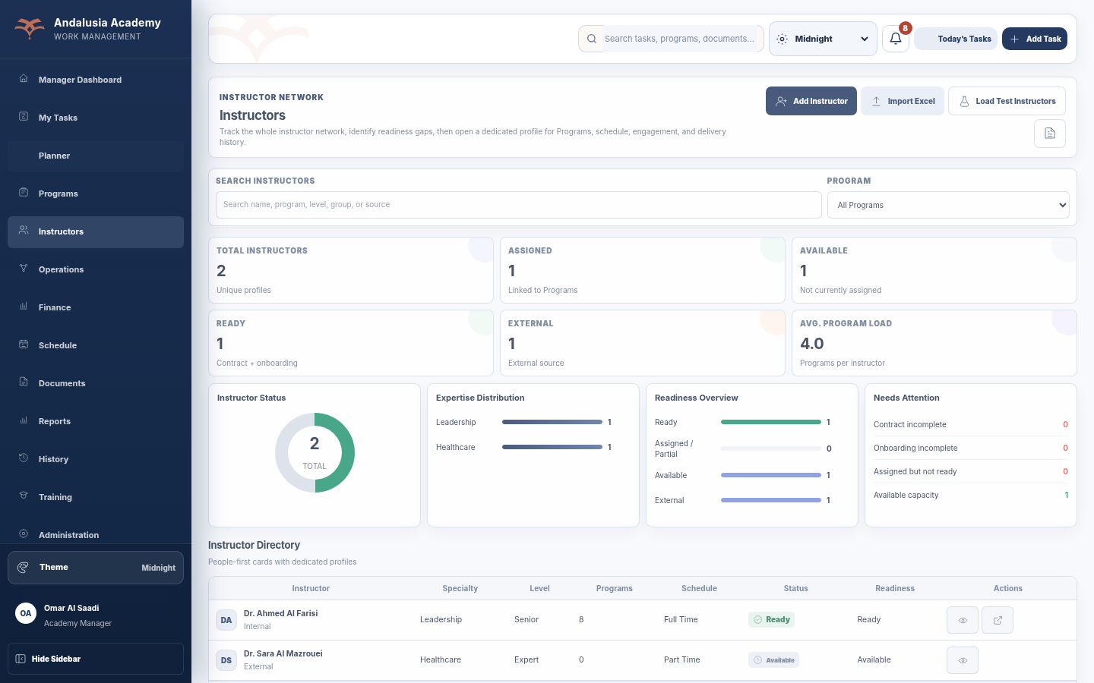
Figure 12 — Instructors - actual desktop UI
Area | Current application / BI interpretation
Key data & KPIs | Total instructors; assigned; available; ready; external; average Program load; readiness gaps.
Main actions | Search/filter; add Instructor; import Excel; load test instructors; open profile.
Power BI opportunity | Instructor utilization, specialty coverage, availability, regional coverage, Program load, readiness trend.

3.9 Instructor Profile
Primary Role: Academy Manager
Dedicated Instructor detail page across Programs, schedule, readiness and engagement history.
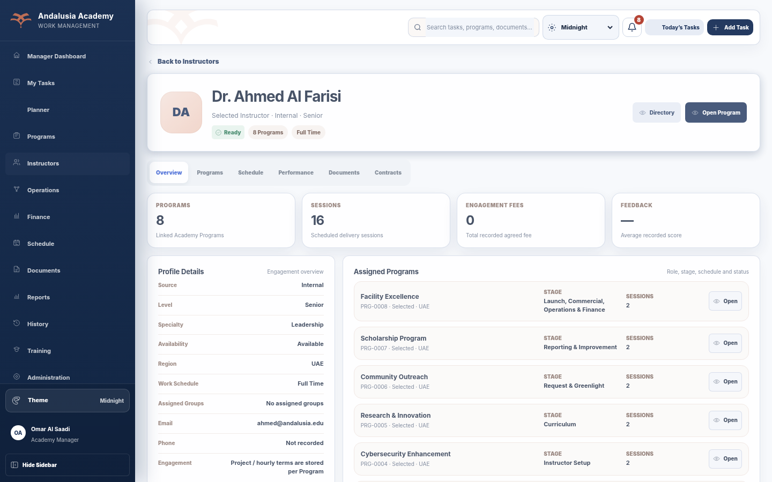
Figure 13 — Instructor Profile - actual desktop UI
Area | Current application / BI interpretation
Key data & KPIs | Linked Programs; sessions; engagement fees; feedback; readiness indicators.
Main actions | Open Program; inspect schedules, performance, documents/contracts.
Power BI opportunity | Instructor drill-through, session delivery, utilization, quality/readiness and Program contribution.

3.10 Operations
Primary Role: Position-based operational users; manager oversight
Parallel operational activities for instructor coordination, logistics, attendees and sponsorship work.
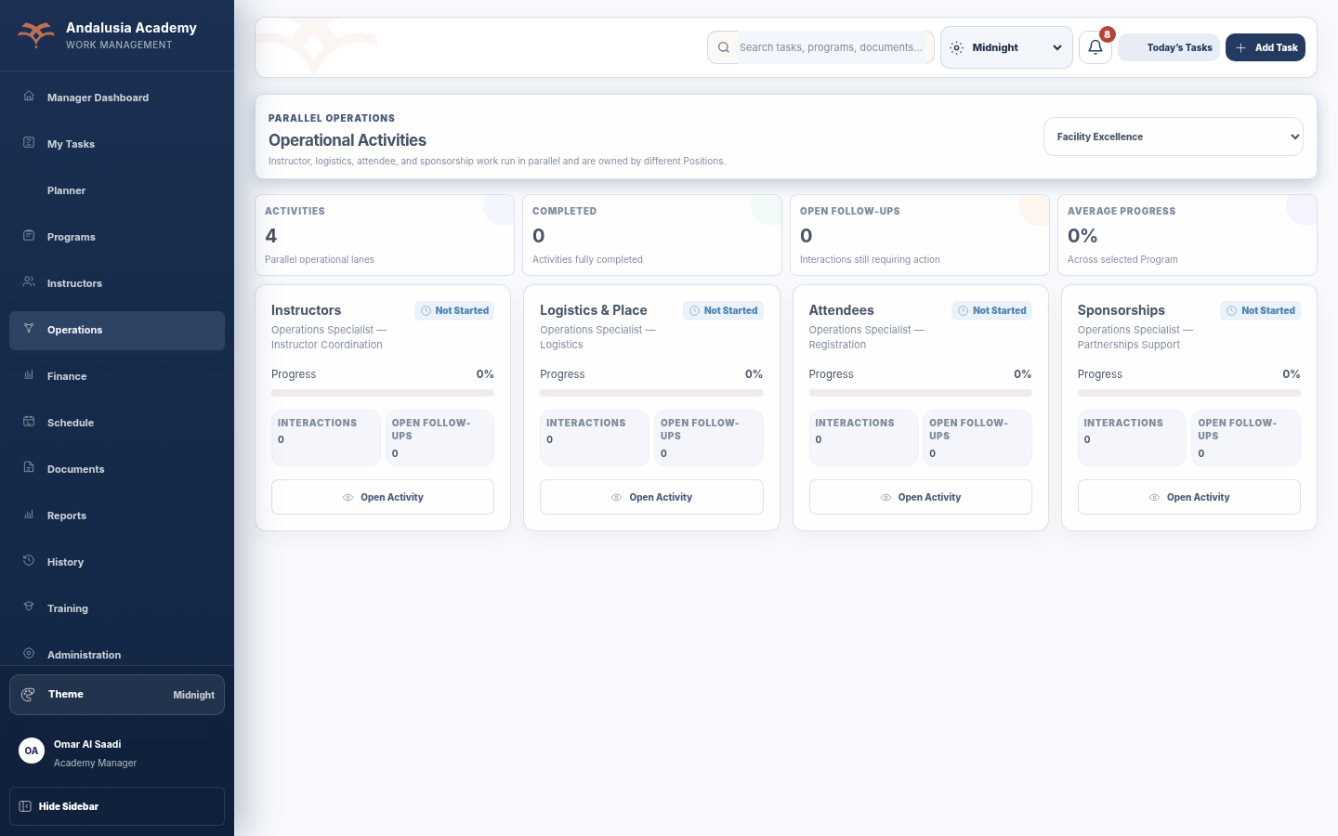
Figure 14 — Operations - actual desktop UI
Area | Current application / BI interpretation
Key data & KPIs | Activity count; completed; open follow-ups; average progress.
Main actions | Open operational lane, record follow-up/visit, update progress and evidence according to Position rules.
Power BI opportunity | Operational lane completion, follow-up aging, throughput, bottlenecks and responsibility analysis.

3.11 Finance
Primary Role: Finance roles; Academy Manager
Portfolio and Program financial performance, settlement status and closure evidence.
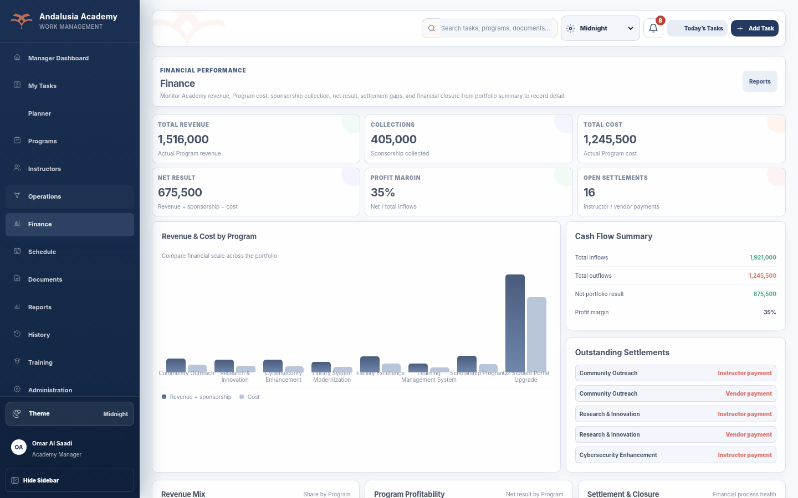
Figure 15 — Finance - actual desktop UI
Area | Current application / BI interpretation
Key data & KPIs | Total revenue; collections/sponsorship; total cost; net result; profit margin; open settlements; profitability by Program.
Main actions | Review Program finance records, settlement/closure status and evidence; open reports.
Power BI opportunity | Revenue/cost trends, profitability, budget variance, settlement aging, collections, receivables, Program financial health.

3.12 Schedule
Primary Role: Both
Delivery calendar for Academy sessions, instructor coverage and upcoming delivery.
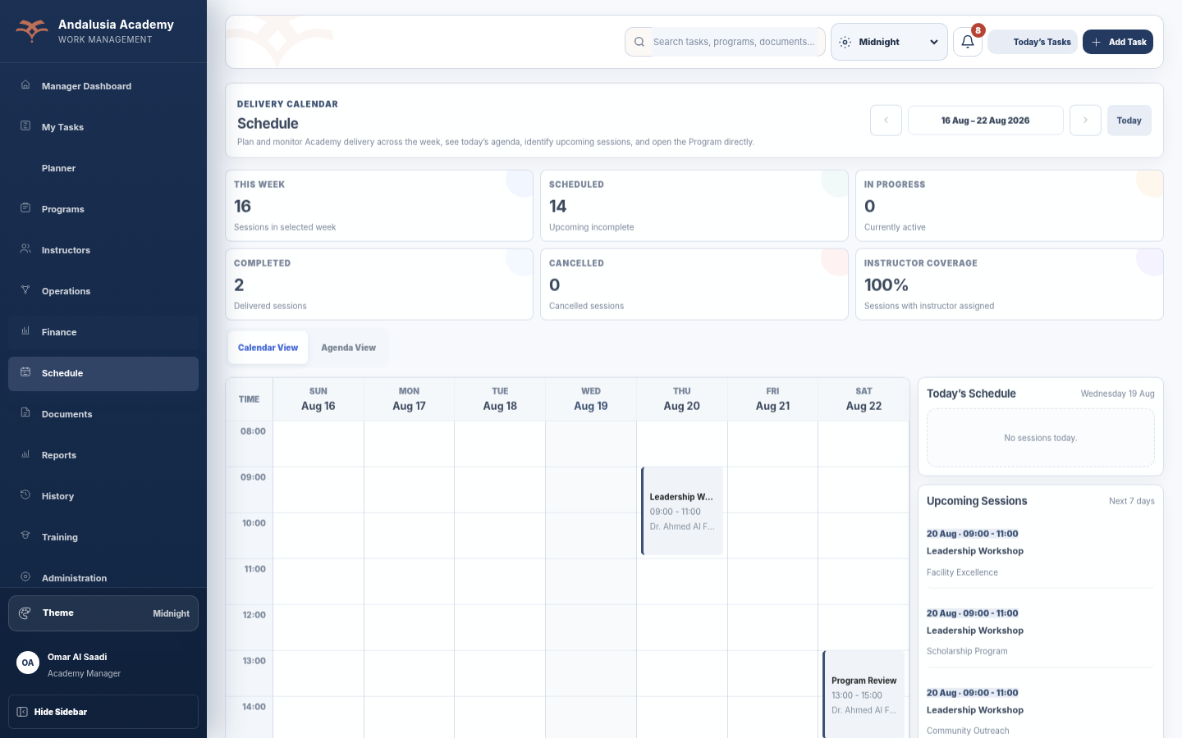
Figure 16 — Schedule - actual desktop UI
Area | Current application / BI interpretation
Key data & KPIs | Sessions this week; scheduled; in progress; completed; cancelled; Instructor coverage.
Main actions | Navigate week; switch calendar/agenda; filter planned/today; open Program/session.
Power BI opportunity | Session delivery trend, Instructor/venue utilization, cancellation, schedule adherence, delivery hours.

3.13 Documents
Primary Role: Both subject to Program permissions
Program document register for traceable references and evidence.
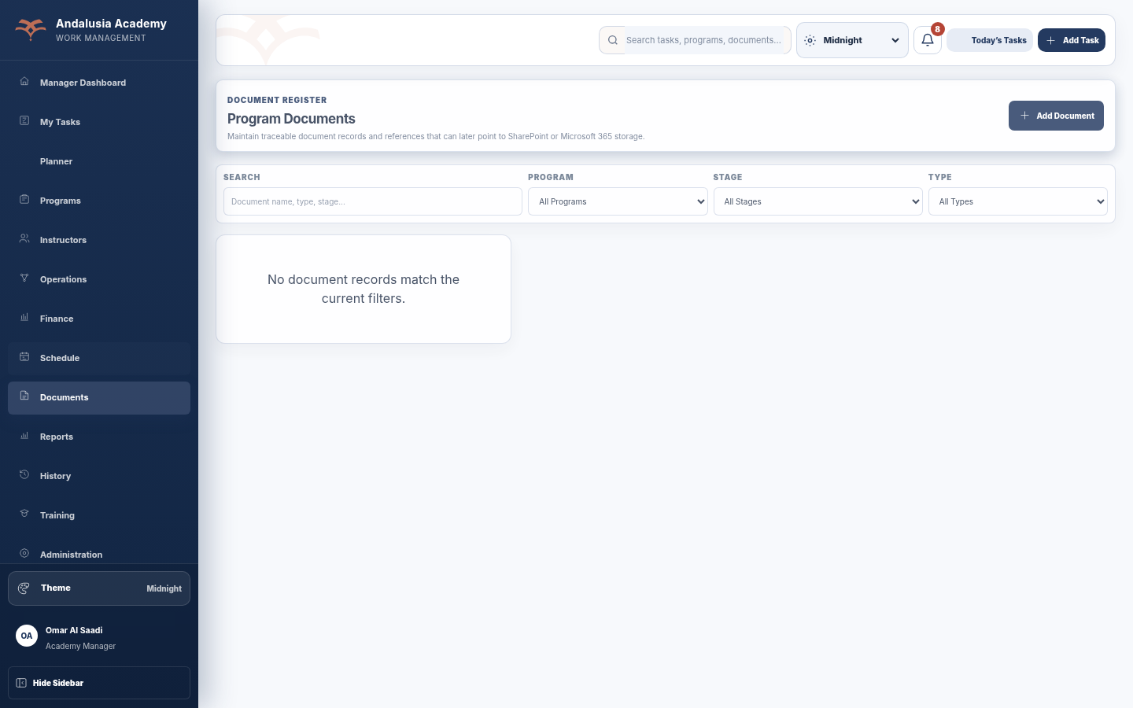
Figure 17 — Documents - actual desktop UI
Area | Current application / BI interpretation
Key data & KPIs | Document metadata by Program, Stage and Type.
Main actions | Search/filter; add document; open reference.
Power BI opportunity | Documentation completeness, evidence coverage, missing-document compliance, aging.

3.14 Reports
Primary Role: Both within role scope
Operational report generation and export surface.
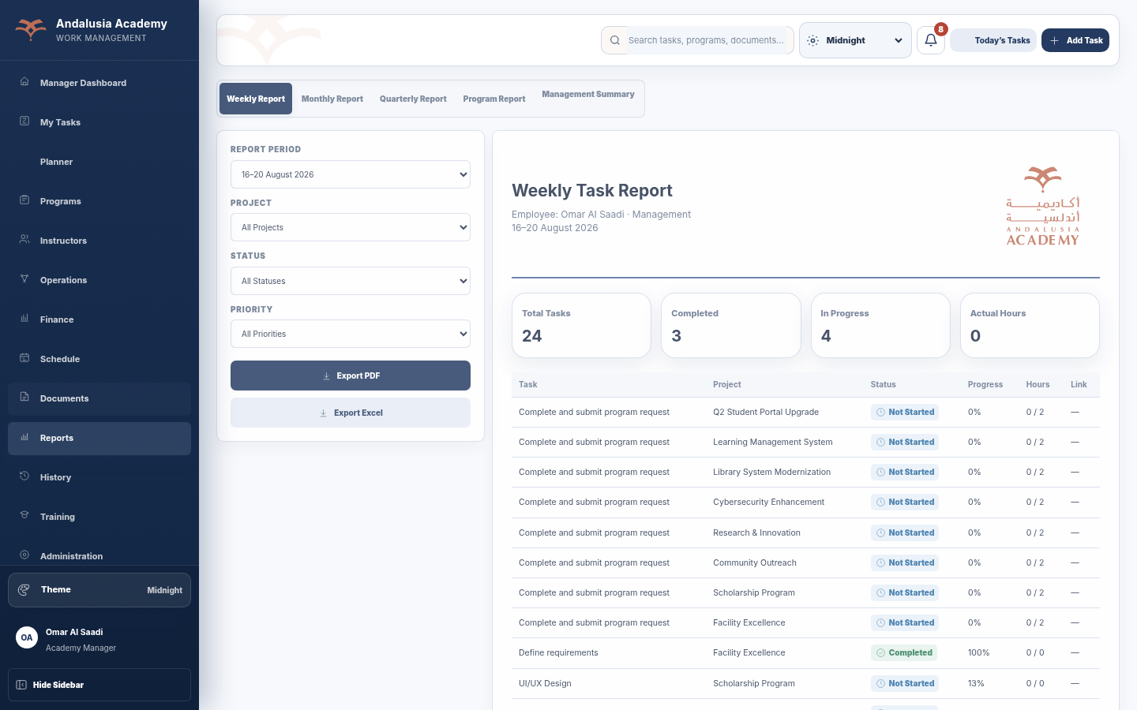
Figure 18 — Reports - actual desktop UI
Area | Current application / BI interpretation
Key data & KPIs | Weekly/monthly/quarterly/Program/management report fields and task details.
Main actions | Select report type/period/Program/status/priority; export PDF/Excel.
Power BI opportunity | Power BI can replace static analytical exports while keeping operational reports for workflow evidence.

3.15 History
Primary Role: Both within role scope
Completed/archived task history plus Program and system audit views.
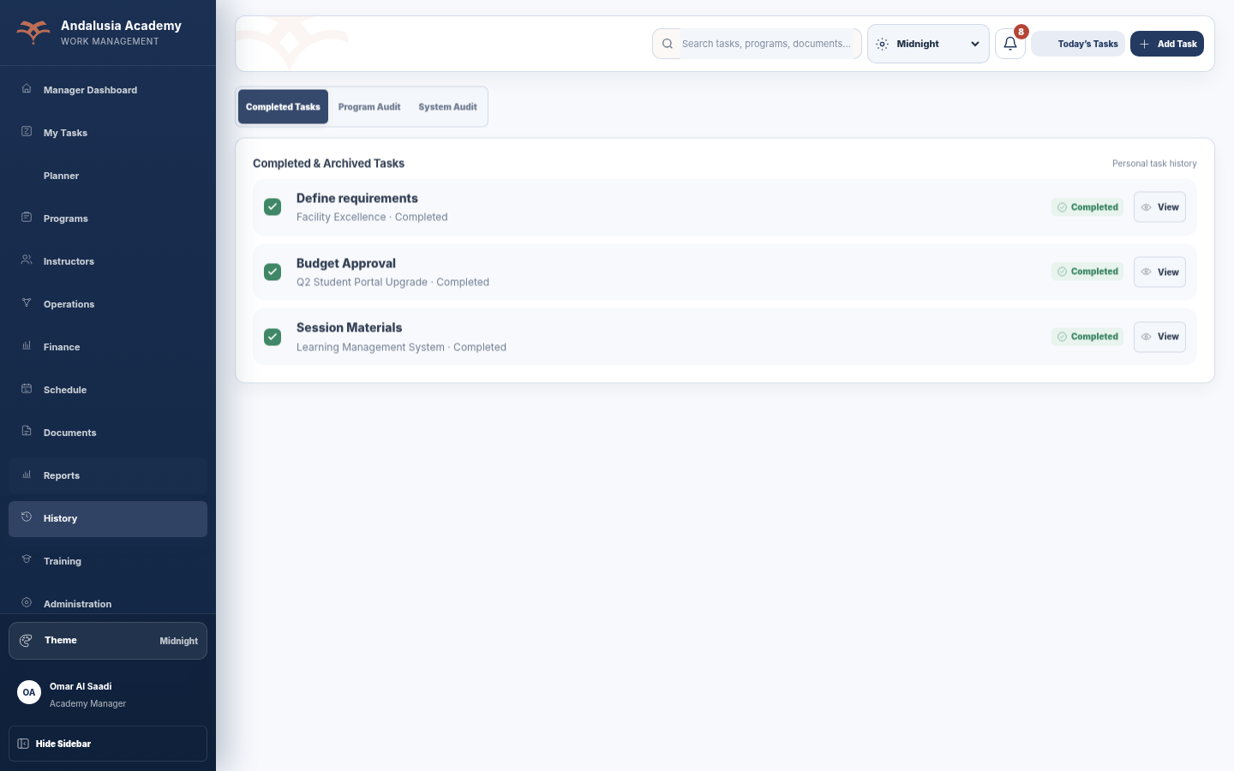
Figure 19 — History - actual desktop UI
Area | Current application / BI interpretation
Key data & KPIs | Completed tasks; Program audit events; system audit events.
Main actions | Search and filter historical records.
Power BI opportunity | Event history, change analysis, stage transition history, completion trend, audit analytics.

3.16 Training
Primary Role: Both
Isolated Academy lifecycle training mode that does not alter live operational data.
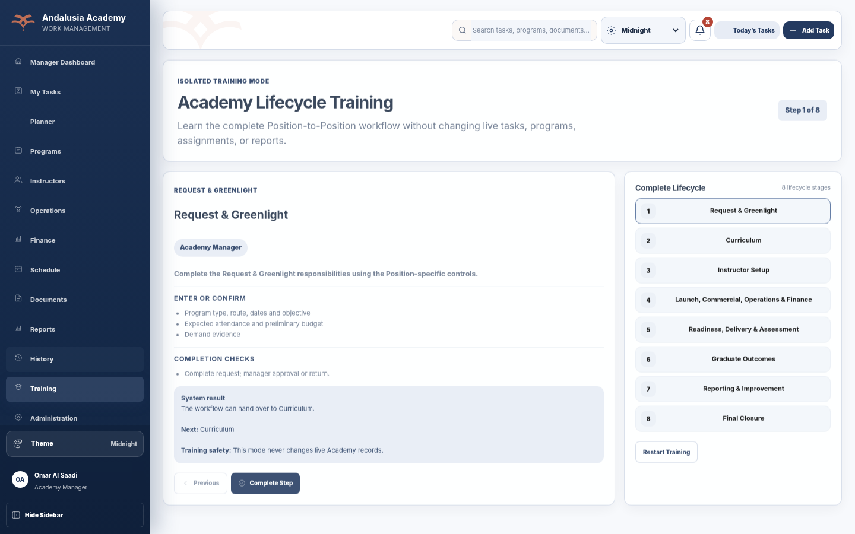
Figure 20 — Training - actual desktop UI
Area | Current application / BI interpretation
Key data & KPIs | Eight-stage training flow and step status.
Main actions | Walk through lifecycle; restart training.
Power BI opportunity | Primarily enablement; training completion telemetry could be added later if required.

3.17 Team Members
Primary Role: Academy Manager only
All-team directory with workload, task performance and capacity.
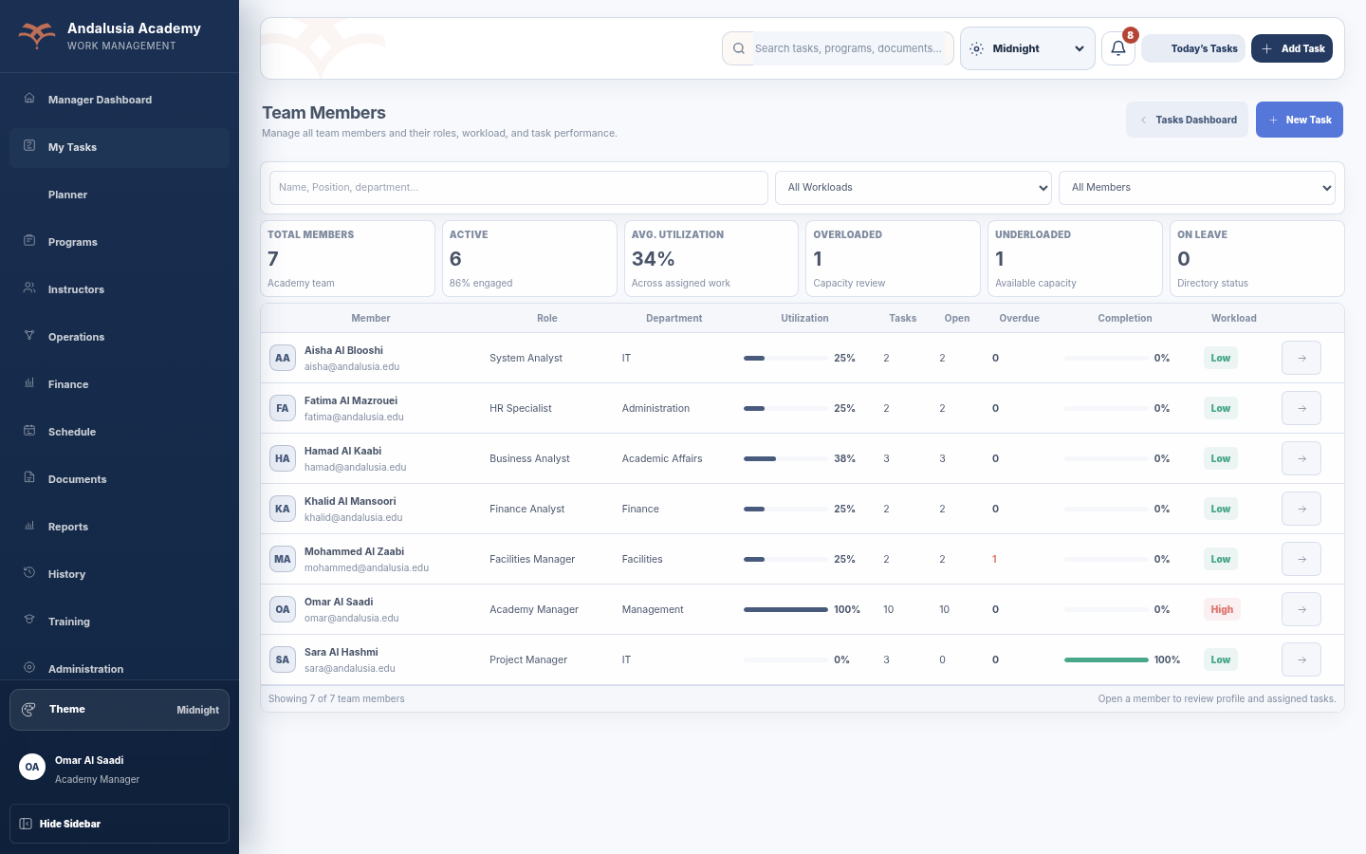
Figure 21 — Team Members - actual desktop UI
Area | Current application / BI interpretation
Key data & KPIs | Total members; active; average utilization; overloaded; underloaded; on leave; tasks/open/overdue/completion/workload per member.
Main actions | Search/filter by workload/status; open member profile; create/assign task.
Power BI opportunity | Team capacity, utilization, overload risk, completion trend, Program participation and workload balancing.

3.18 Team Member Profile
Primary Role: Academy Manager only
Drill-through employee workload and assigned task view.
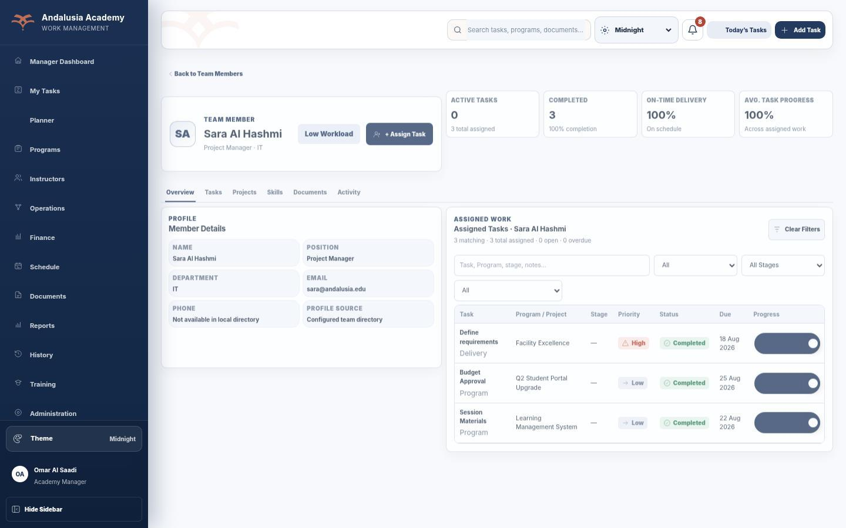
Figure 22 — Team Member Profile - actual desktop UI
Area | Current application / BI interpretation
Key data & KPIs | Active tasks; completed; on-time delivery; average progress; open/overdue/blocked workload.
Main actions | Filter assigned work by Program, Stage, Status, Priority, Due Date and Type; assign task.
Power BI opportunity | Employee workload and performance drill-through, task aging, Program mix, capacity and completion trend.

3.19 Administration
Primary Role: Academy Manager only
Configuration workspace for Position rules, workflow rules, master data, employee registry and system information.
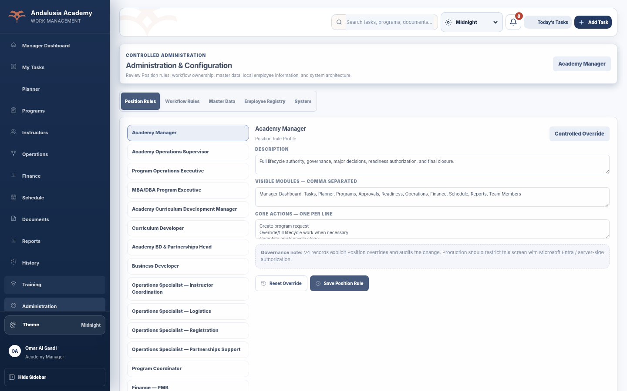
Figure 23 — Administration - actual desktop UI
Area | Current application / BI interpretation
Key data & KPIs | Configuration and governance metadata rather than operational KPIs.
Main actions | Review/edit controlled rules and master data.
Power BI opportunity | Governance/audit metadata; generally not a KPI source except configuration quality and access audit use cases.

3.20 Profile
Primary Role: Both
Employee/account profile, Position information, default view and application theme preferences.
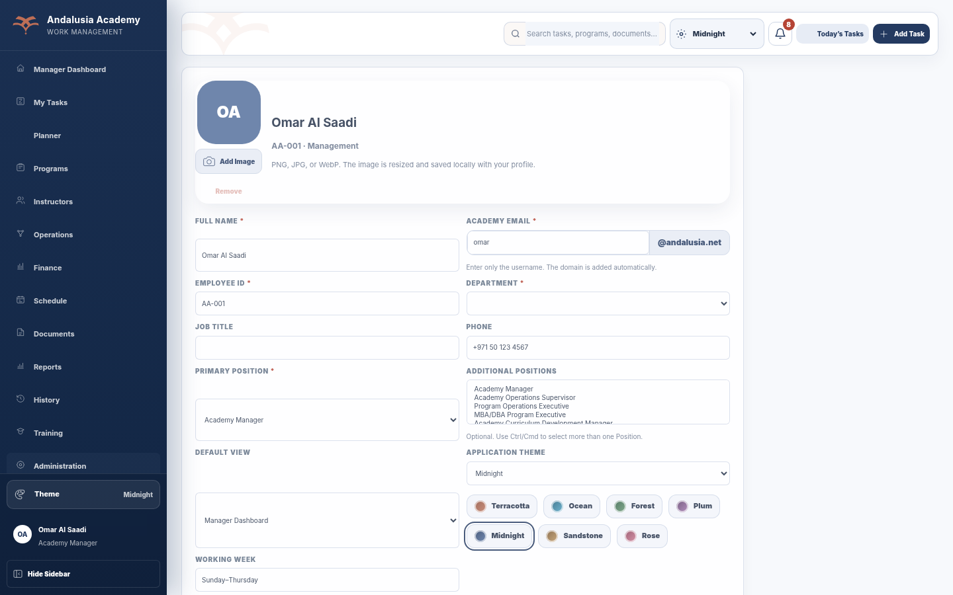
Figure 24 — Profile - actual desktop UI
Area | Current application / BI interpretation
Key data & KPIs | Identity, department, Position, contact and preference metadata.
Main actions | Update profile fields permitted by the account; select theme/default view; manage profile image.
Power BI opportunity | Employee dimension attributes and security mapping; preferences themselves are not core BI measures.

3.21 Program Lifecycle / programStageFlow
The current Program Stage Flow is a scoped lifecycle component introduced in Revision 20.1 and preserved in Revision 20.2. It separates the actual current stage from the stage selected for inspection, displays completed-stage count and overall readiness, and switches to a vertical timeline on phone/tablet portrait layouts.
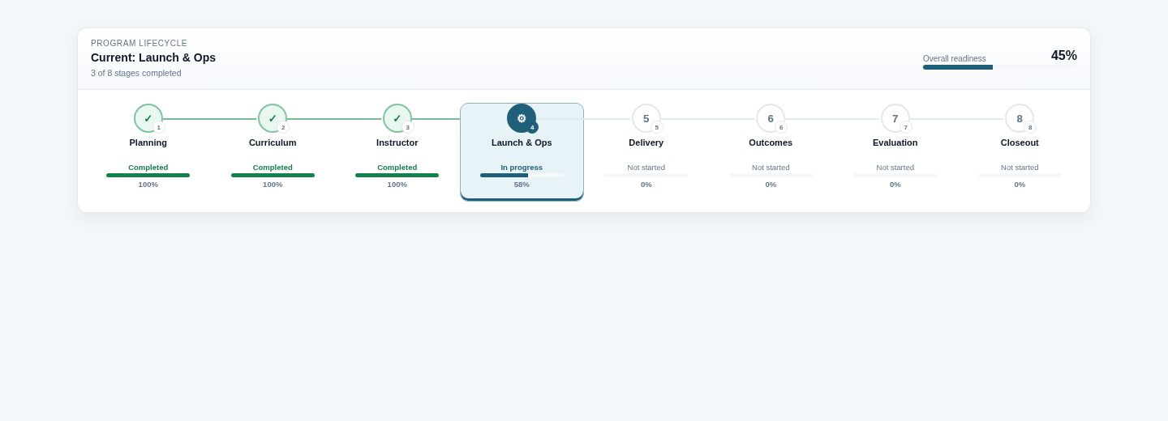
Figure 25 — Current desktop Program Stage Flow
Component behavior | BI relevance
Eight stages with Completed, Current, Selected, Pending Approval, Returned and Upcoming states; each stage carries progress and accessible state labels. | Use the same eight-stage conformed dimension in Power BI. Do not collapse the lifecycle to generic phases.
Desktop/laptop/tablet landscape uses horizontal stepper; <=820 px uses vertical timeline. | BI reports should use the same stage order for stage distribution, aging and bottleneck visuals.
Overall readiness summarizes current Program stage progress; stage click inspects details without changing actual current stage. | Separate current stage, selected/reporting context, and historical stage events in the analytical model.

3.22 Account Security
Account Security is available from the fixed sidebar after sign-in. It shows the authenticated username/access role and allows the signed-in user to change their password. Position authority remains controlled by the authenticated account rather than a browser-editable Profile Position.
Figure 26 — Password-change experience used on first sign-in; the in-app Account Security control uses the same password- update model

3 23 Plan dashboard
Plan consolidates operational activities, visits and open follow-ups into In progress and Upcoming lanes. It supports day-to-day preparation and review across Programs.
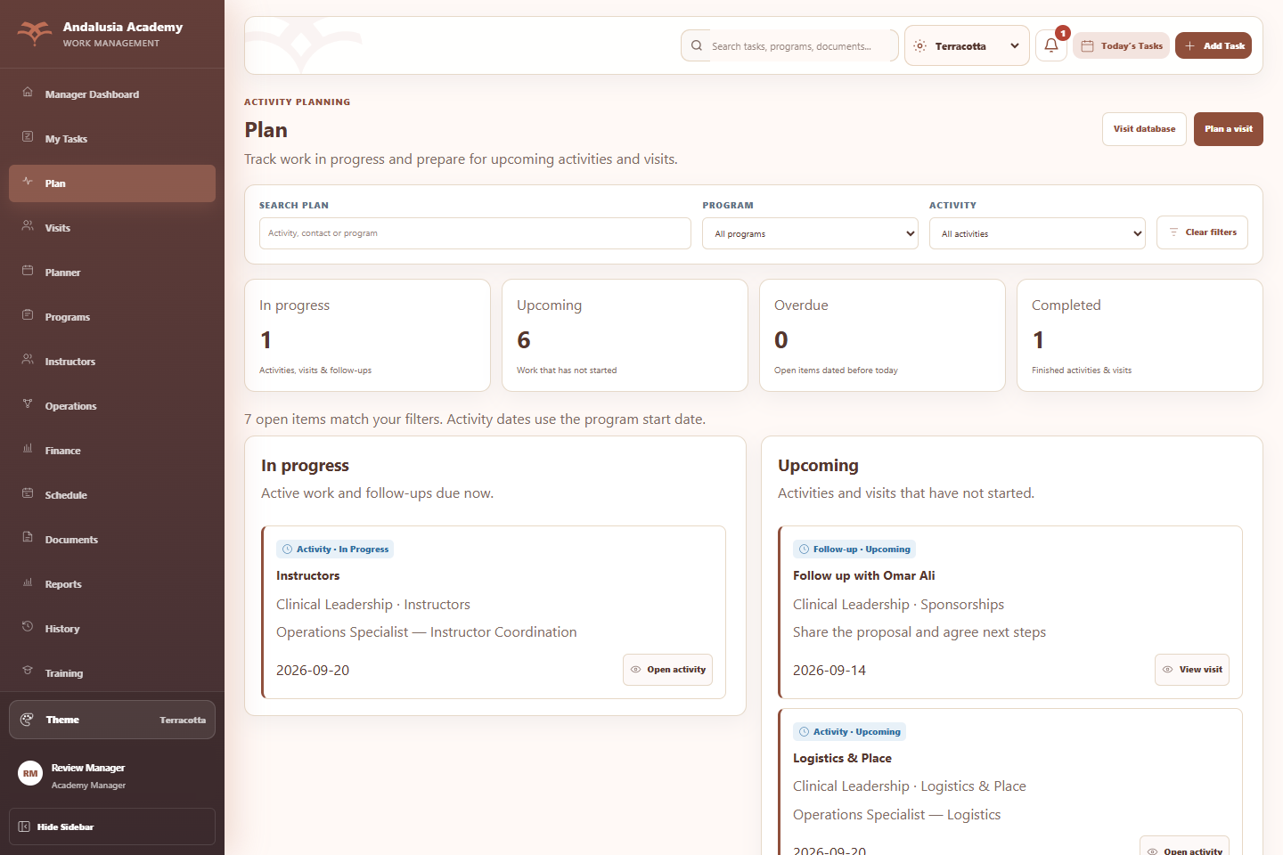
Figure 33 - Plan dashboard with In progress and Upcoming work and Program and activity filters
Summary cards. In progress and Upcoming count matching work items. Overdue counts open dated items before today. Completed counts completed activities and visits. A visit and its open follow-up are separate planning items.
Work cards. Each card shows its kind, status, title, Program, activity, contact or owner detail, and date. Cards sort by date with undated items last. Open activity navigates to the operational activity; View visit opens the networking visit form.
Quick actions. Visit database opens Visits. Plan a visit opens the visit form and carries across the selected Program and activity. If no contact exists, the contact form opens first.

3 23 Plan behavior and status rules
Source | Plan behavior
Operational activity | Not Started maps to Upcoming; In Progress remains In progress. The displayed activity date is the Program start date, not a separately maintained activity due date.
Networking visit | Uses the visit status and date entered by the user: Upcoming, In Progress, Completed or Cancelled. Dates do not automatically change the visit status.
Operational visit history | Existing operational interactions are displayed as Completed visits and open in their original activity.
Open follow-up | Created as a derived planning item when a follow-up date exists, completion is false and the visit is not Cancelled. Due today or earlier maps to In progress; a future date maps to Upcoming.
Completed follow-up | Stops appearing as an open Plan item. It is not a separate entry in the Completed card.
Overdue | An additional flag for Upcoming or In Progress items whose date is before today. It overlaps the two open lanes; it is not a third exclusive status.

Search and filters
Search matches planning titles, displayed contact or owner details, activity and Program name. Program, activity and search conditions apply together. Clear filters restores the complete view. Empty lanes show a clear no-results message.

Operational boundaries
Plan is a view of existing operational and networking records. It does not create a separate planning database or include personal tasks from the task Planner. Networking follow-ups do not create workflow assignments and do not satisfy operational evidence or stage-completion requirements. Operational follow-ups retain their existing workflow behavior.

BI interpretation
Use separate measures for activities, visits and follow-ups, then a clearly labelled combined work-item count. Retain source type and record keys so a visit and its follow-up cannot be mistaken for duplicate visits. Refresh the date comparison consistently using the approved business timezone.

3 24 Visits networking database
Visits stores interactions and their next steps alongside reusable contact people. Users can review relationships across Programs or maintain general networking visits without a Program.
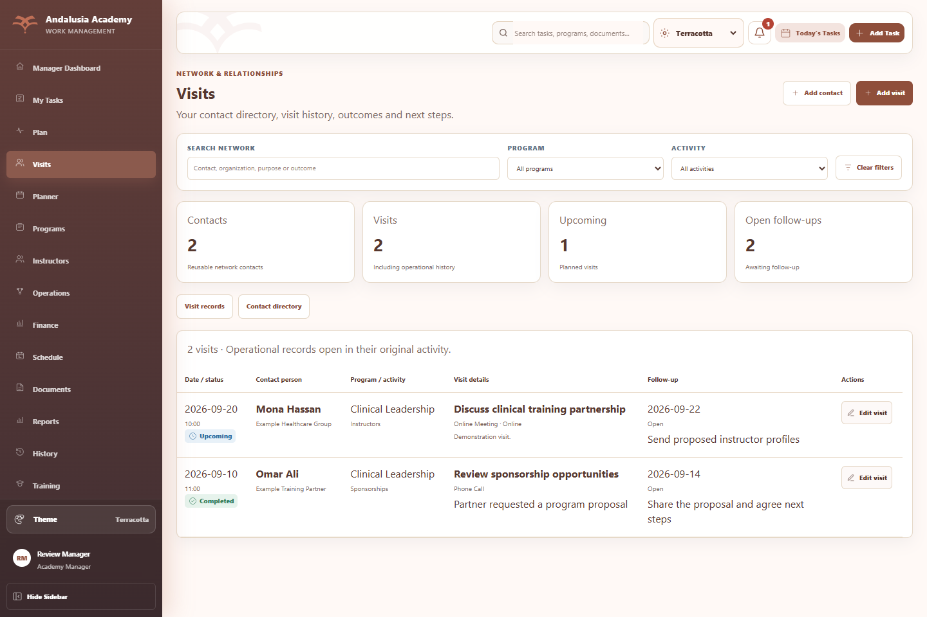
Figure 34 - Visits database with visit records, outcomes and open follow-ups
Visit records. The table displays date and time, status, contact person and organization, Program and activity, purpose, visit type, location, outcome, notes, follow-up and available action. Records sort from newest visit date to oldest.
Actions. Add contact creates a person. Add visit schedules or records an interaction. Edit visit changes a networking record. Open activity returns an existing operational interaction to its original workflow.
Summary cards. Contacts counts the matching reusable directory records. Visits counts visible visit records including operational history. Upcoming counts visible visits with that status. Open follow-ups counts dated, unfinished follow-ups on visits that are not Cancelled.
History. Selecting History in the contact directory restricts visit records to that contact and shows contact details above the table. Show all contacts’ visits removes that selection.

3 24 Contact directory
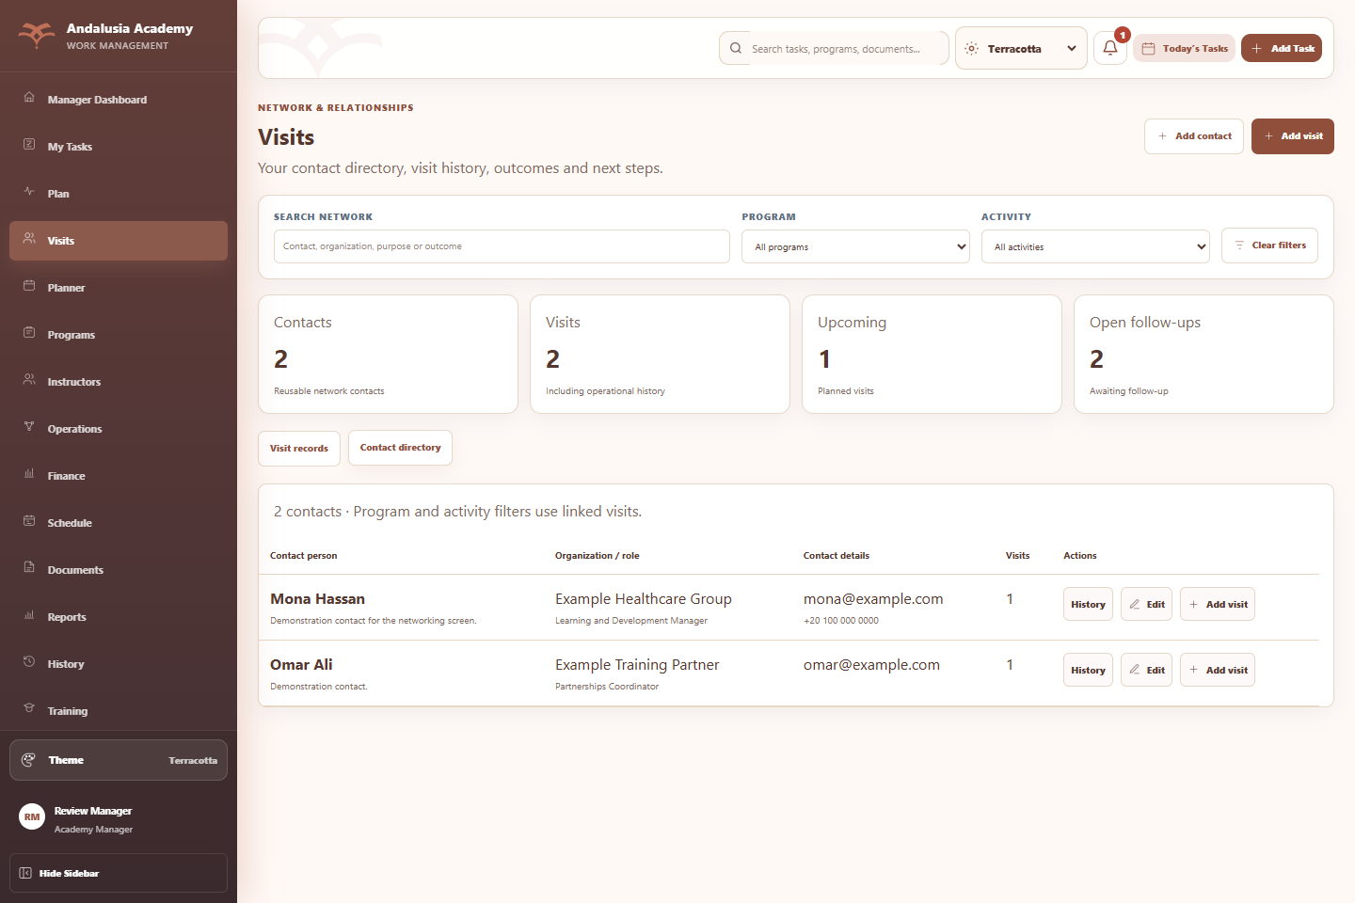
Figure 35 - Contact directory with contact details, visit counts and history actions
Reusable identity. A contact has a stable ID and can be linked to multiple visits across Programs and activities. Editing contact details updates their display on linked visits without creating a new person.
Directory actions. History shows that person’s visit records. Edit opens the contact form. Add visit opens the visit form with the person already selected. The directory visit-count column shows the person’s total linked visits, even when Program or activity filters narrow the directory.
Filtering. Program and activity filters select contacts through their linked visits. Contacts without visits appear when these filters are cleared. Directory search matches name, organization, role, email, phone and notes.
Current scope. Contact deletion, merging duplicates, bulk import and automatic deduplication are not implemented in this addition. Operational visit targets are not automatically converted into reusable contacts.

3 24 Contact form
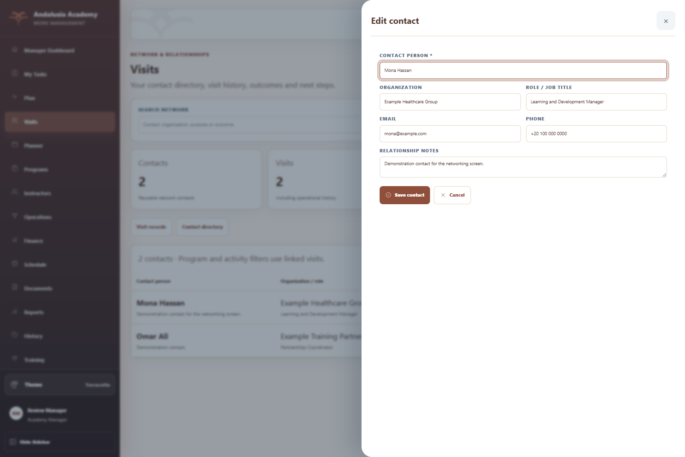
Figure 36 - Contact form for creating or editing a reusable contact person
Field | Requirement and behavior
Contact name | Required. Up to 200 characters; whitespace is trimmed.
Organization and role | Optional. Up to 200 characters each.
Email and phone | Optional. Email uses the email input validation and a 254-character limit; phone allows up to 60 characters.
Notes | Optional relationship context, up to 4,000 characters.
Save contact | Creates a stable ID and creation timestamp for a new person, or updates the existing record and update timestamp.
Cancel or close | Closes the form without saving the entered changes.

3 24 Visit form and follow ups
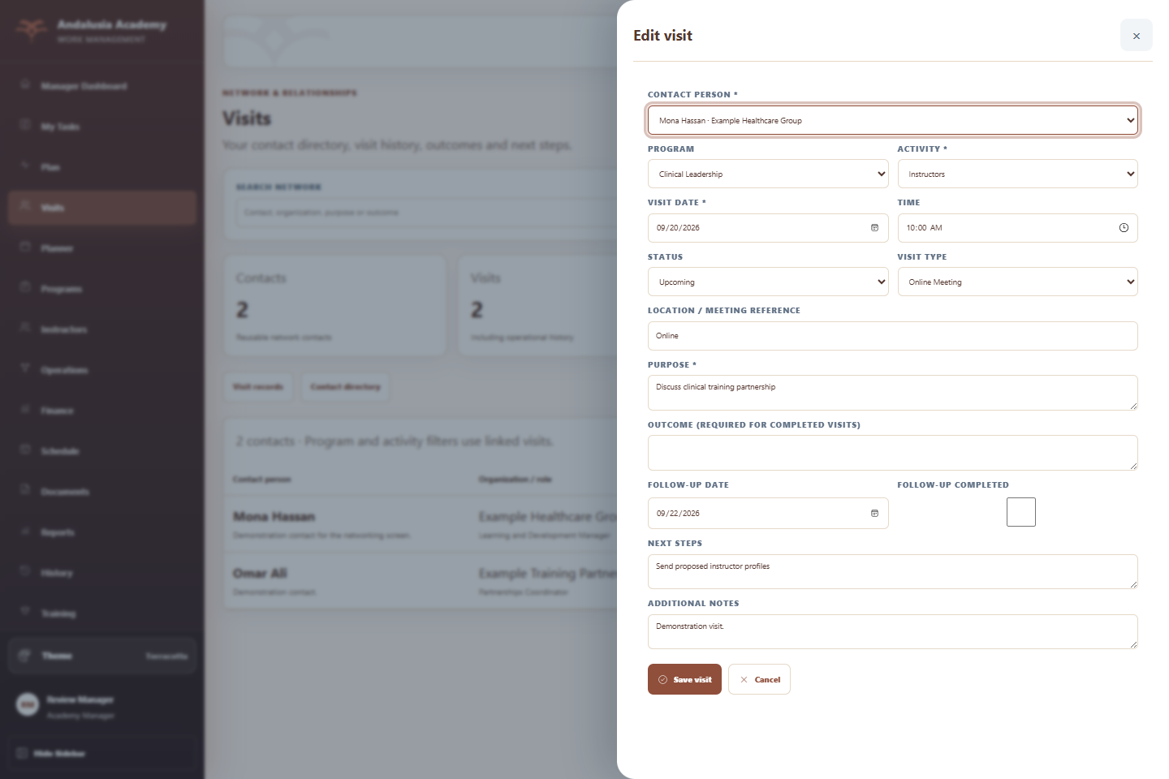
Figure 37 - Visit form with Program, activity, status, purpose, outcome and follow-up controls
Required inputs. Select an existing contact and an activity, then enter visit date and purpose. Program is optional and defaults to General networking. If selected, the Program must still exist.
Visit details. Time, location or meeting reference and additional notes are optional. Status is Upcoming, In Progress, Completed or Cancelled. Visit type is Physical Location, Online Meeting, Phone Call, Event or Email. A Completed visit requires an outcome.
Follow-up. Enter an optional follow-up date and next steps. The follow-up date must be on or after the visit date. Mark Follow-up completed when the action is finished. A Completed visit can still have an open follow-up; Cancelled visits are excluded from open follow-up counts.
Save. Valid records refresh Plan and Visits and are persisted with the application store. Missing required inputs or invalid date relationships keep the form open for correction. Updating a visit retains its ID.

3 25 Program and activity filters
Program and activity filtering is available in both new tabs. Selections narrow the displayed data and the associated summaries; users do not need separate databases for each Program.
Control or context | Expected behavior
Program | All programs removes the Program restriction. Selecting a Program filters by its stable ID.
Activity | All activities removes the activity restriction. Options include standard activities and available activity names from the selected Program and recorded visits.
Combined selection | Program AND activity AND search must all match. A matching activity under another Program is excluded.
Change Program | Rebuilds the available activity options. A selected activity is retained only while it is still an available option.
General networking | Visits without a Program appear under All programs and can still be filtered by activity.
Contact history | Further restricts the visible visit records to one contact. Clear filters also clears the selected contact history.
Clear filters | Removes text, Program and activity restrictions and refreshes the active tab.
Empty results | Shows an explicit no-results message and provides the existing clear-filter and add-record actions.

Search and count differences
Visit search matches contact name, organization, email, phone, purpose, outcome, location, notes, activity and Program name. Directory search includes the contact’s role and notes. The Contacts card follows the directory filter logic; selecting one person’s History does not change it into a count of the selected person. The application-wide search is separate and does not include networking contacts or visits.

Example
Selecting Clinical Leadership and Instructors returns only instructor-related items for that Program. A Sponsorships visit in the same Program is excluded. Changing to All activities restores it. A contact linked only to another Program is excluded from the filtered directory.

04

Program Lifecycle & Governance
The eight-stage operational model, handoff authority, blockers, and Commercial route behavior.

Eight-Stage Academy Lifecycle
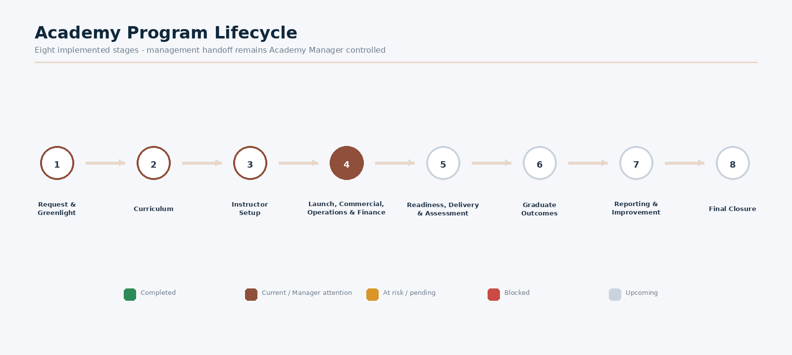
Figure 27 — Eight implemented Academy lifecycle stages
Stage | Governance summary
1. Request & Greenlight | Contributors prepare a valid request; Academy Manager approves/returns Greenlight and closes Stage 1.
2. Curriculum | Curriculum is drafted, QA’d and locked; Academy Manager finalizes Stage 2.
3. Instructor Setup | Instructor selection, engagement, contract and onboarding evidence are completed; Academy Manager finalizes Stage 3.
4. Launch, Commercial, Operations & Finance | Launch inputs, Commercial routes, Operations lanes and Finance controls run; Academy Manager records required decisions and finalizes the Stage 4 handoff.

Stage | Governance summary
5. Readiness, Delivery & Assessment | Readiness, session delivery, incidents, assessment and certification evidence are completed; Academy Manager finalizes Stage 5.
6. Graduate Outcomes | Eligible graduates/outcomes evidence or N/A basis is recorded; Academy Manager finalizes the stage.
7. Reporting & Improvement | Performance report, feedback and improvement actions are completed; Academy Manager opens Final Closure.
8. Final Closure | Academy Manager alone performs final Program closure.

Stage Completion UX & Audit Requirements
- Each stage must expose requirements, progress, missing items, blockers, ownership, readiness, completion action and next-stage information.
- When completion is unavailable, exact blockers are shown rather than relying on a disabled button alone.
- On successful completion the status, lifecycle, audit trail and next-stage work update immediately, with duplicate actions prevented.
- The Manager Control is visible only to the Academy Manager; contributors may complete their own deliverables but cannot perform the final lifecycle handoff.

Commercial Stage - B2C / B2B / Mixed
Section 4B contains explicit Commercial Completion Readiness. B2C, B2B and Mixed routes validate their relevant requirements and expose exact blockers. Valid completion activates the next operational work idempotently, so repeated completion does not create duplicate assignments.
BI opportunity
Model Commercial Type as a conformed dimension and analyze route-level cycle time, readiness, revenue, conversion and completion performance.

05

Operational Data & Analytical Model
What the application stores today and how the BI team should reshape it for analysis.

Current Operational Persistence
The Python server persists operational state in SQLite while storing flexible JSON payloads in key entity tables. The package also supports JSON store compatibility and Excel import/export. This is appropriate for the prototype but should not be copied directly into the Power BI semantic model.
Current table / source | Purpose / indexed fields
profile | Single local operational profile record in legacy store compatibility.
tasks | Task ID, status, due date, Program ID, assignment ID + JSON data payload.
programs | Program ID, status, start/end dates + JSON data payload.
assignments | Assignment ID, Program ID, owner Position, status, due date, kind + JSON data.
notifications | Target Position, read state, created time + JSON data.
audit | Program ID, timestamp + JSON event payload.
documents | Program ID, Stage, Document Type, created time + JSON data.
accounts | Username, role, display name, Position, password hash/salt, profile JSON, password-change flag.
config | Key/value JSON configuration.
Excel / CSV | Task and Instructor import/export plus report/export workflows.

Core Business Entities
Entity | Current / visible attributes relevant to BI
Program | ID, name, status, eight lifecycle stages, stage progress, owner/Position, dates, route/region, budget, finance, requirements, blockers, audit.
Program Stage | Program, stage name/order, status, progress, readiness/checks, stage ownership, completion/audit timestamps where captured.
Task / Assignment | Title/action, Program, Stage, owner Position, status, priority, due date, progress, kind/type, completion.

Entity | Current / visible attributes relevant to BI
Employee / Team Member | Name, Position, department, email/phone where configured, workload derived from owned tasks, completion/overdue metrics.
Instructor | Name, email, phone, specialty, level, source, work schedule, availability, region, notes, Program/session links.
Session | Program, date/time, Instructor, region/venue where recorded, session/status details.
Finance | Program revenue, actual cost, sponsorship/collections, budget, settlement and closure status/evidence.
Document | Program, Stage, Document Type, created date, metadata/reference.
Audit Event | Program/system action, timestamp, user/Position context and event payload.
Account | Username, role, authoritative Position, account-specific profile and access state.

05 Networking data additions
The networking extension is persisted under masterData.networking in the application configuration and JSON store. It contains contacts and visits arrays. Existing operational interactions remain inside each Program’s activity records.
Entity and grain | Stored fields
Contact One row per contact ID | id; name; organization; role; email; phone; notes; createdAt; updatedAt when edited.
Networking visit One row per visit ID | id; contactId; programId or blank; activity; date; time; status; type; location; objective; outcome; notes; followUp; followUpNotes; followUpCompleted; createdAt; createdBy; updatedAt when edited.
Operational interaction One row per source visit in a Program activity | Existing visit fields including ID, target, date, type, objective, outcome, evidence and follow-up fields. Program and activity context come from the containing record.
Plan item One derived row per activity, visit or open follow-up | Source kind and key; Program; activity; title; detail; effective status; display date. This is a derived view, not a stored Plan table.

Relationships
A contact has many networking visits through contactId. A Program has many linked networking visits through programId, while General networking visits have no Program. Operational interactions may have a free-text target without contactId; retain them as unmatched contacts until an explicit mapping is approved.

Data quality and privacy
Validate unique contact and visit IDs, existing contact references, valid optional Program references, permitted statuses, required purpose/date/activity, outcomes for completed visits and valid follow-up dates. Do not infer a unique person from name alone. Limit contact email, phone and free-text notes to approved BI audiences.

05 Networking analytical model
Model object | Grain and relationship rule
DimContact | One row per contact ID. Link to networking visits. Use an explicit unknown/unmatched member for operational targets without a mapped contact.
DimProgram and DimActivity | Reuse the Program dimension. Create a controlled activity mapping; retain raw activity labels. Use an explicit General networking member for blank Program links.
FactVisits | One row per source visit. Use a composite key including source type, Program/activity context where needed, and source ID to avoid ID collisions.
FactFollowUps | At most one current follow-up per source visit in this implementation. Store follow-up date, completed flag and source visit key; exclude Cancelled visits from the open measure.
FactPlanItems or analytical view | Union activity rows, visit rows and open follow-up rows with distinct item-type keys. Report type-specific totals alongside any combined count.
DimDate | Use visit date for visits and follow-up date for follow-up measures. Use role-playing date relationships or explicit measure logic to avoid ambiguous date slicing.
History snapshots | Add dated snapshots or change events for time-series status, overdue trends and changing contact attributes. Current-state arrays alone do not provide full history.

Refresh and reconciliation
Extract contacts and visits from the JSON configuration, flatten operational activity visits separately, then apply a shared Program and activity mapping. Preserve source type throughout transformation. Reconcile visit counts before adding follow-up rows, then validate each KPI against the application using the same filters and reference date.

Availability limits
Networking follow-ups have a completed flag but no dedicated completion timestamp. Do not publish on-time follow-up completion, historical conversion or interaction-to-revenue attribution as measured facts without adding the required event dates and business links. Do not include password hashes, salts or session secrets in the BI model.

06 KPI Framework
Each measure must declare its population, filter context, time basis and source. Current application cards are snapshots. Historical trends require dated facts, snapshots or reliable event timestamps.
Measure | Calculation and interpretation
Plan In progress | Count filtered Plan rows whose effective status is In Progress, including activities, visits and open follow-ups due today or earlier.
Plan Upcoming | Count filtered Plan rows whose effective status is Upcoming. Includes Not Started activities, Upcoming visits and future open follow-ups.
Plan Overdue | Count filtered open Plan rows with a nonblank display date before the reference date. This is a subset of In progress plus Upcoming; do not add it to those totals.
Plan Completed | Count filtered completed activities and visits. Completed follow-ups are not retained as separate completed Plan rows.
Directory contacts | Distinct stored contact IDs matching directory search and linked-visit Program/activity scope. Unvisited contacts are included only when Program/activity restrictions are cleared.
Visible visits | Count filtered networking and operational visit rows, after any selected contact-history restriction. Follow-up rows do not increase this measure.
Upcoming visits | Count visible visits with status Upcoming. Do not substitute a future-date test for the explicit status.
Open follow-ups | Count visible visits with a follow-up date, completed flag false and status other than Cancelled.
Overdue follow-ups | Proposed BI measure: open follow-ups with a due date before the agreed reference date.
Contacts with visits | Proposed BI measure: distinct contact IDs on filtered networking visits. Exclude unmatched operational targets unless mapped.

Reference date
Approve the reporting timezone and date boundary with the Academy. The local UI uses its current application date. A BI refresh must record its as-of date and apply it consistently, especially for follow-ups due today and overdue comparisons.

06 Portfolio KPI definitions and safeguards
KPI family | Definition or prerequisite
Program completion | Average Program progress across the selected portfolio. Preserve the eight-stage model and agree whether the business wants equal stage weights or another approved weighting.
Task completion | Completed task count divided by total tasks in the defined population. Do not double-count assignments and their mirrored personal tasks.
Team utilization | The local dashboard uses a workload proxy based on open work. A time-capacity utilization KPI requires available hours and assigned/planned hours; label the proxy clearly.
Delivery this month | Count sessions scheduled in the selected month. Delivered sessions must use completion status and a separately labelled measure.
Budget utilization | Actual cost divided by budget for the defined Program population. Return blank or a clearly stated exception when budget is zero.
Net result and margin | Local financial basis: revenue plus sponsorship minus cost. Margin divides net result by revenue plus sponsorship. Verify that sponsorship is not already included in revenue before loading consolidated financial facts.
Stage aging and SLA | Require stage entry/exit dates and an approved SLA calendar. Current progress or selected stage cannot substitute for elapsed duration.
On-time completion | Requires original or governed due dates and completion timestamps. A current overdue count does not prove historical on-time performance.
Targets and comparisons | Business owners must approve targets, denominators, period filters and exclusions. Fixed dashboard benchmarks are not evidence of approved targets or historical performance.

Measure acceptance
Check empty populations, zero denominators, missing dates, Cancelled visits, unlinked contacts and Programs, completed visits with open follow-ups, and overlapping overdue counts. Compare Program-only, activity-only and combined-filter totals. Display the refresh timestamp and explain any unavailable measure instead of estimating unsupported results.

07

Power BI Requirements & Dashboard Pages
Recommended analytical experiences that extend the operational application.

Recommended Power BI Pages
Power BI page | Purpose
Executive Overview | Active Programs, completion, risk, task performance, team utilization, delivery, budget and financial health with trend/variance.
Program Portfolio | Program status/stage/owner/health/progress, stage distribution, aging and completion forecast.
Lifecycle Performance | Programs by stage, average stage duration, bottlenecks, readiness, SLA and rework.
Task Performance | Open/completed/overdue/blocked, aging, completion time, performance by Program/Stage/Position.
Team Capacity | Workload, utilization, capacity, overdue tasks, completion rate, Program assignments.
Instructor Analytics | Availability, specialty, Program assignment, sessions, utilization, readiness and regional coverage.
Delivery & Schedule | Scheduled vs delivered sessions, hours, Instructor/venue utilization, cancellations and conflicts.
Finance | Revenue, cost, budget, variance, margin, collections, receivables and Program profitability.
Program Detail | Drill-through: lifecycle, stage history, tasks, blockers, Instructor, schedule, finance and audit.
Employee Detail | Drill-through: workload, Programs, tasks, on-time delivery, overdue and completion trend.
Instructor Detail | Drill-through: availability, Programs, sessions, utilization and readiness.

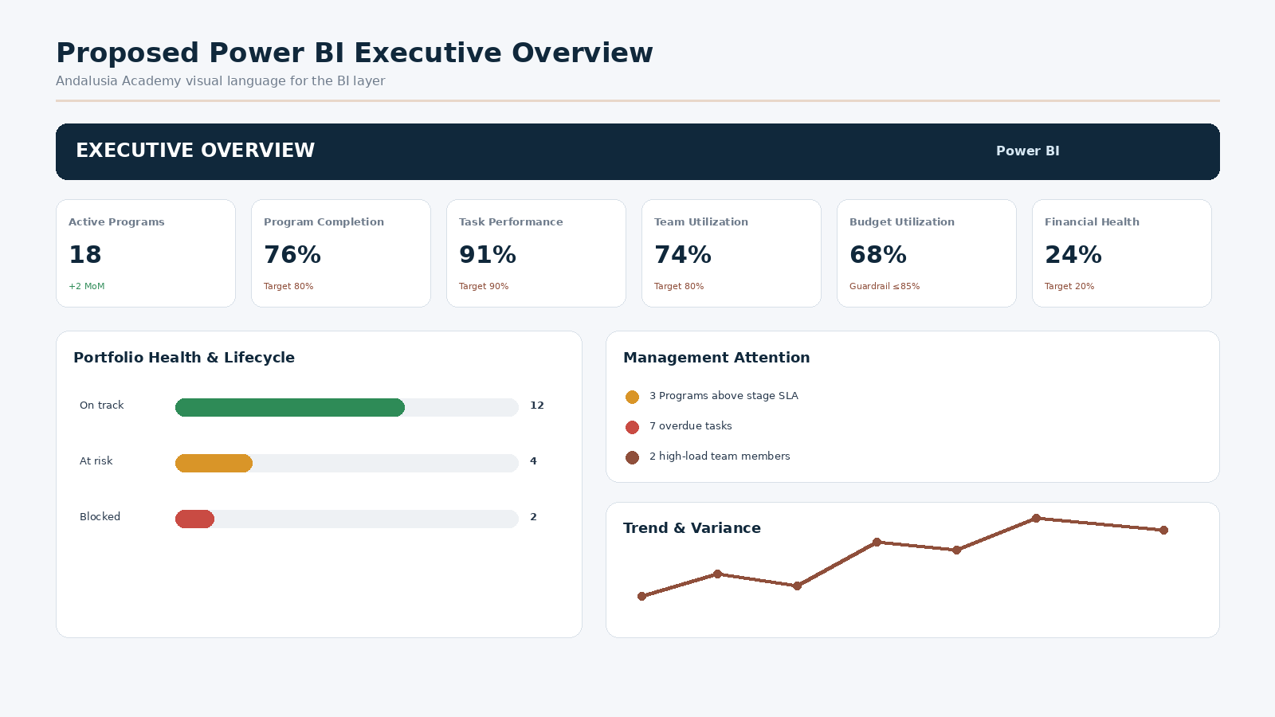
Figure 29 — Illustrative Andalusia-themed Power BI Executive Overview

Management Questions the BI Layer Must Answer
- How many Programs are active, at risk, delayed, or ready for management handoff?
- Where are Programs stuck in the lifecycle, and which stages take the longest?
- What blockers recur most often, and which Positions/Programs are affected?
- What percentage of tasks are completed on time, and how is overdue work trending?
- Which employees are overloaded or have available capacity?
- Which Instructors are available, highly utilized, or missing readiness requirements?
- Are scheduled sessions being delivered according to plan?
- Which Programs are exceeding budget or underperforming financially?
- What are collection, settlement and receivable positions over time?
- What are the major operational risks this month and how are they changing?

Andalusia Academy Power BI Theme
Role | Color | Use
Deep Navy | #17364F / #10283B | Report titles, structural anchors, navigation and fact-table emphasis.
Terracotta | #8F4F3B | Principal accent, selections, key headings and important KPI emphasis.
Terracotta Light | #F3E4DF | Selected/background accent and callouts.
Warm Off-White | #FFF9F6 | Report page background and screenshot/card surfaces.
Sand | #E8D7C9 | Borders, dividers, alternate rows and neutral structure.
Green | Semantic | Completed / healthy / positive.
Amber | Semantic | Warning / attention / at risk.
Red | Semantic | Blocked / critical / overdue / negative.
Muted Blue | Semantic | Informational / in progress / planned.

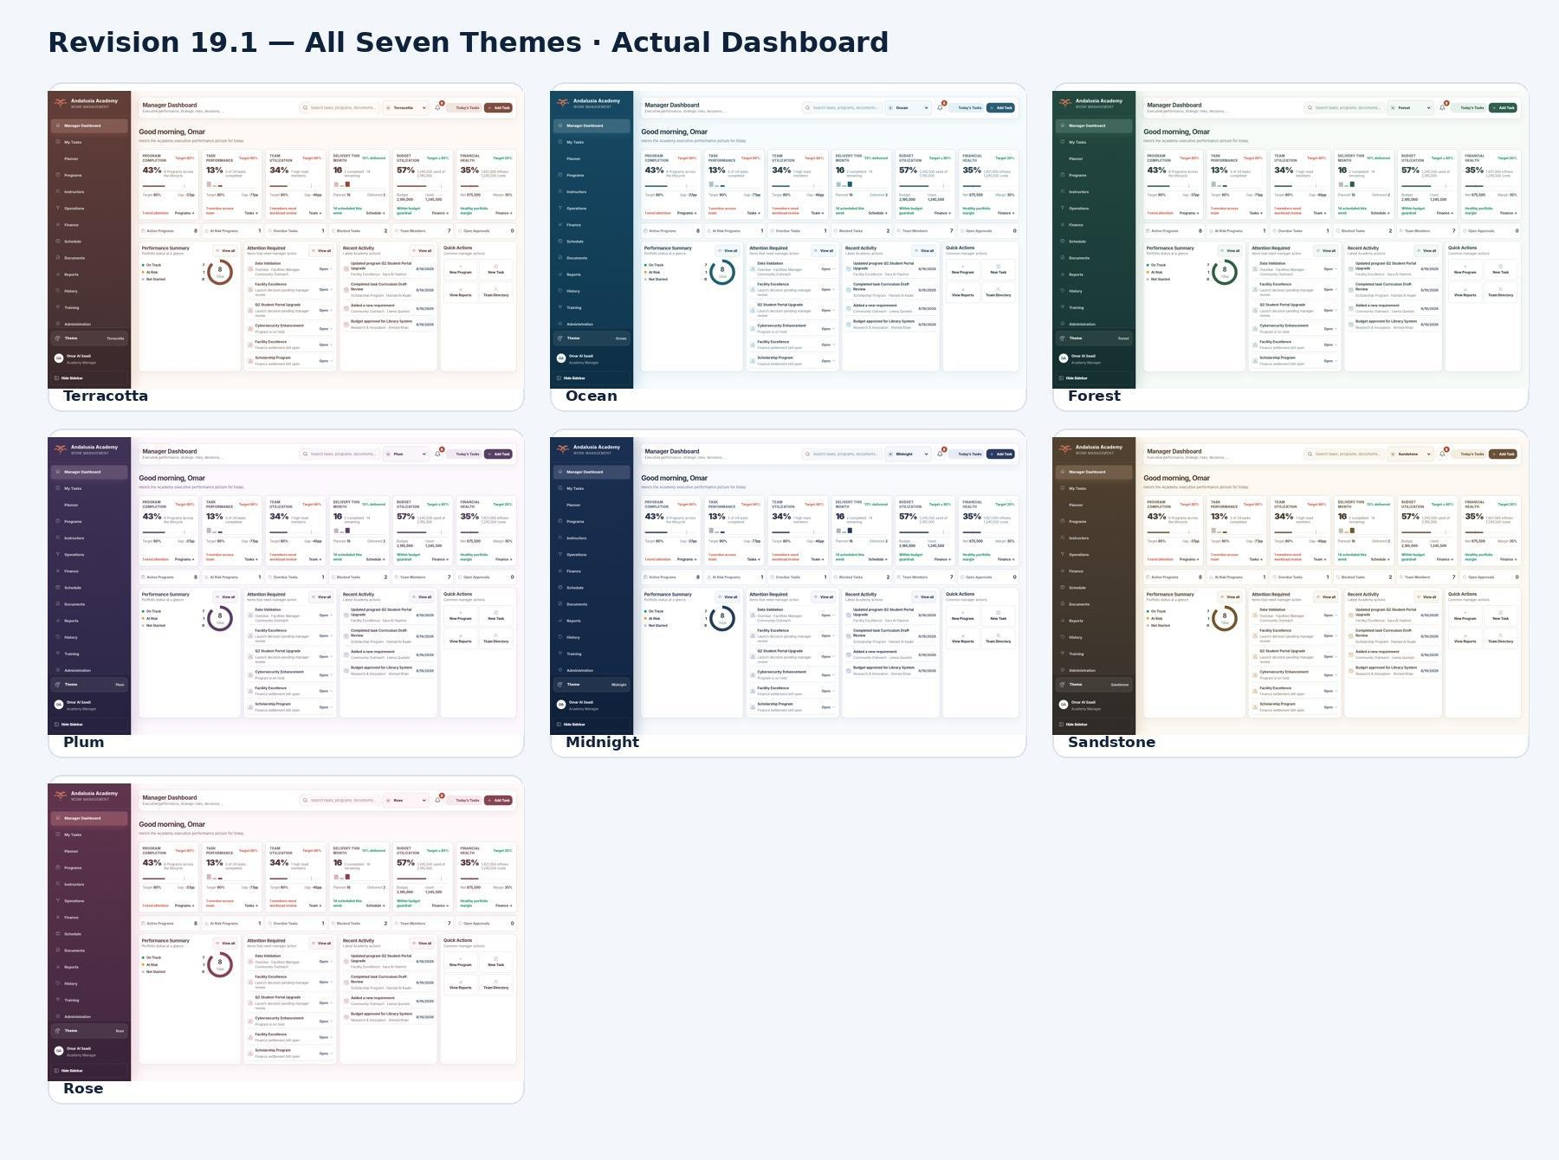
Figure 30 — Seven operational application themes; the BI report should use one consistent master theme

07 Planning and networking BI requirements
BI page | Required analytical experience
Plan and Activity Overview | Separate In progress, Upcoming, Overdue and Completed cards; activity/visit/follow-up breakdown; dated work list; Program and activity slicers; open-item aging where a valid date exists.
Visits and Networking | Visit status and type, Program/activity mix, recent interactions, upcoming visits, open/overdue follow-ups, contact and organization coverage.
Contact Detail | Contact profile within authorized scope; chronological visit history; linked Programs and activities; outcomes; next steps and unresolved follow-ups.
Operations Performance | Retain the original operational lane metrics. Clearly distinguish operational evidence visits from standalone networking visits.
Data Quality | Missing or invalid references, duplicate candidates, missing completed-visit outcomes, unavailable dates, unmapped activity labels and unmatched operational targets.

Interactions and filtering
Provide Program, activity, visit type, visit status and relevant date slicers. Contact and organization selections should filter networking facts through approved relationships. Support drill-through from a Program or contact into its visit records and follow-ups, with clear reset-filter controls and an as-of date.

Security and delivery
Apply the approved account and organizational scope to datasets and exports. Confirm whether contact details and notes belong in executive reports. Verify the new networking endpoints against the authentication-enabled target release before treating them as a secured production source.

Acceptance checks
Reconcile app and BI counts for the same Program/activity/search scope and reference date; test a General networking visit; a contact with no visits; a Completed visit with an open follow-up; and a Cancelled visit with a follow-up date. Confirm that visit totals are unchanged when the model adds follow-up facts and that operational history is counted once.

A

Appendix - Mobile & Responsive UI References
Representative responsive renders retained from the current Executive UI lineage.
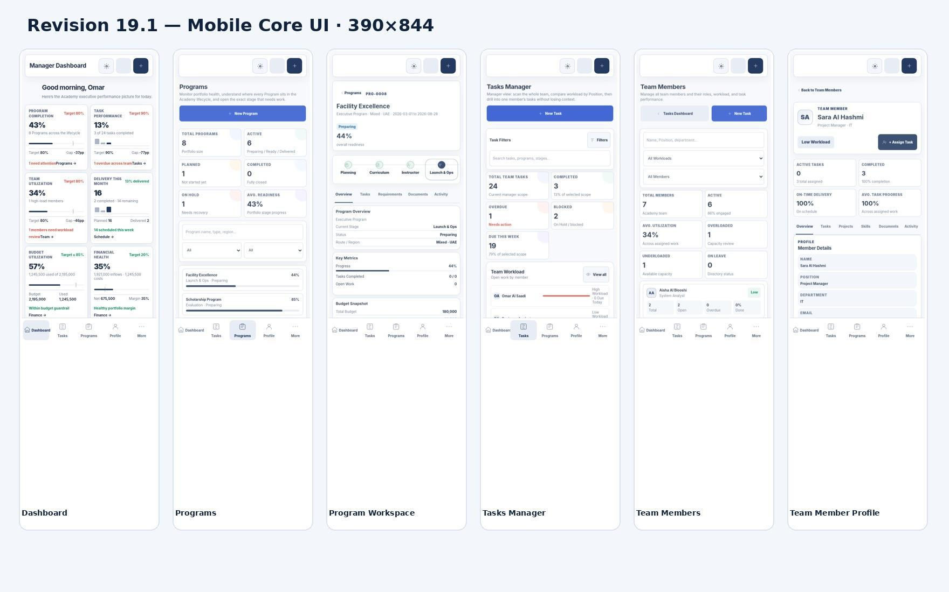
Figure 31 — Core mobile workspace review - Dashboard, Programs, Workspace, Tasks, Team and Team Member Profile

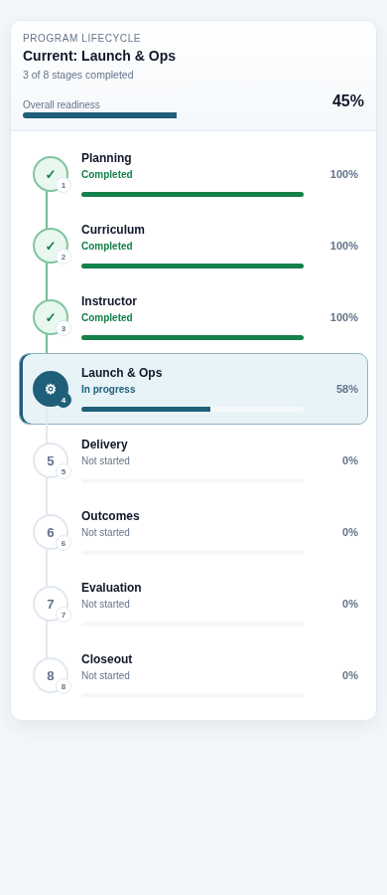
Figure 32 — Program Stage Flow vertical timeline on mobile
The application is responsive across tested widths including 390, 430, 768, 1024, 1366, 1440 and 1920 px. Dense calendars/tables may scroll internally, but root-page horizontal overflow is intentionally avoided. Touch controls are designed to remain usable on phone/tablet layouts.

A Plan and Visits mobile screens
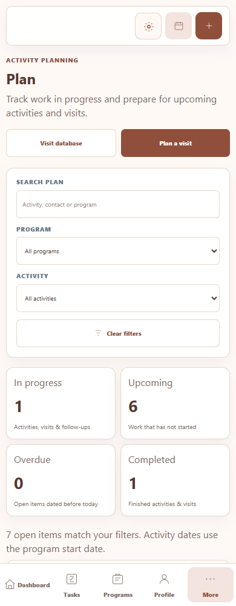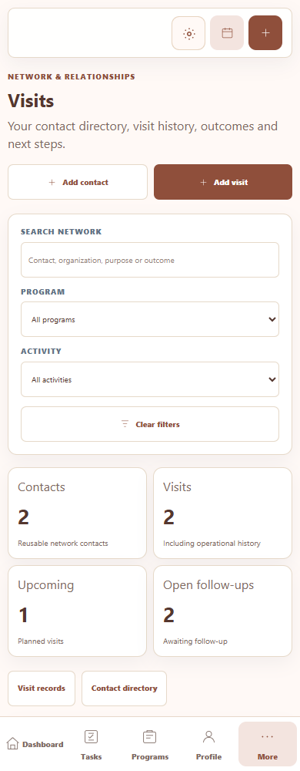
Figures 38 and 39 - Plan and Visits at a 390-pixel mobile viewport, using demonstration records
Plan stacks the summary cards and planning lanes. Visits retains the contact and visit controls with an internally scrollable records table. Program and activity filters remain available. These additions were captured at 1440-pixel desktop and 390-pixel mobile widths.

B

Appendix - UI-to-BI Mapping
Traceability from every operational screen to the recommended analytical layer.
Application Screen | Current KPI / Data | Power BI Dataset | Recommended BI Page | Priority
Sign In / Account Security | Role/account metadata | Security mapping / RLS | Security governance | Governance
Manager Dashboard | Portfolio, tasks, team, delivery, budget, finance | Programs + Stages + Tasks + Team + Sessions + Finance | Executive Overview | Critical
Tasks / My Tasks | Task status, priority, due, owner, progress | FactTasks | Task Performance | Critical
Weekly Planner | Weekly task schedule | FactTasks + DimDate | Task Performance / Capacity | Medium
Monthly Planner | Monthly task calendar | FactTasks + DimDate | Task Trend | Medium
Quarterly Planner | Quarter tasks, hours, completion | FactTasks + DimDate | Quarterly Performance | Medium
Programs | Status, stage, progress, readiness | FactPrograms + FactProgramStages | Program Portfolio | Critical
Program Workspace | Stage, tasks, blockers, team, budget, requirements | Multiple facts + Program/Stage dimensions | Program Detail | Critical
Program Stage Flow | Stage order, status, progress, readiness | FactProgramStages | Lifecycle Performance | Critical
Instructors | Availability, specialty, readiness, load | Instructor + assignments + sessions | Instructor Analytics | High
Instructor Profile | Programs, sessions, engagement, readiness | Instructor + sessions + finance linkage | Instructor Detail | High
Operations | Operational lanes, progress, follow- ups | Operational activity fact (future/derived) | Operations Performance | High
Finance | Revenue, collections, cost, net, settlements | FactFinance | Finance | Critical
Schedule | Sessions, Instructor, status, dates | FactSessions | Delivery & Schedule | High
Documents | Program/Stage document metadata | Document metadata / compliance fact | Program Detail / Compliance | Medium
Reports | Operational report selections and exports | Consumes multiple facts | Power BI report suite | High
History | Completed tasks and audit | FactTasks + Audit/Event fact | Lifecycle / Audit | High
Training | Lifecycle learning state | Optional training telemetry | Training Adoption (optional) | Low
Team Members | Utilization, workload, task counts | FactTasks + DimEmployee | Team Capacity | High
Team Member Profile | Assigned work and performance | FactTasks + DimEmployee | Employee Detail | High
Administration | Rules and master data | Dimensions / governance metadata | Data Quality / Governance | Medium
Profile | Employee/Position/Department | DimEmployee / security mapping | RLS / Employee Detail | High

B Additional UI to BI mapping
Application screen | Data and model | BI destination
Plan dashboard | Derived activity, visit and follow-up rows; Program, activity and date dimensions | Plan and Activity Overview
Visits records | FactVisits, FactFollowUps, DimContact, DimProgram, DimActivity and visit/follow-up date roles | Visits and Networking
Contact directory | DimContact and linked visits; organization and relationship role attributes | Networking coverage and Contact Detail
Contact form | Contact identity and current attributes; created/updated metadata where present | Contact data quality
Visit form | Visit status, purpose, outcome, type, dates, follow-up fields and Program/activity context | Visit performance and follow-up exceptions
Contact history | Selected contact and linked chronological interactions | Contact Detail drill-through
Program and activity filters | Shared conformed dimensions and explicit AND logic | All planning and networking analytical pages

Release verification checklist
- Create and edit a contact; confirm linked visits display the updated contact details.
- Save an Upcoming visit; complete it only after entering an outcome; verify follow-up date validation.
- Complete a follow-up and confirm it leaves the open Plan lanes and open follow-up count.
- Apply Program and activity filters together; clear filters; verify empty states and contact-history reset.
- Reload the application and restore a JSON backup in a test environment; confirm contacts and visits remain linked.
- Verify desktop and mobile navigation, form access and internal table scrolling.
- Verify authentication and authorization in the exact target release, then reconcile BI measures against that release.

