

**GROUP ASSIGNMENT – Part 1**

**TECHNOLOGY PARK MALAYSIA**

**CT042-3-1-IDB**

**INTRODUCTION TO DATABASE**

APD1F2011CS/CS(CYB)/CS(IS)/IT/SE

APU1F2011CS/CS(CYB)/CS(IS)/CS(DF)/IT/SE

**HAND OUT DATE: 18 JUNE 2021**

**HAND IN DATE: 31 JULY 2021**

**WEIGHTAGE: 40%**

**LECTURER: Ts. Dr. Shubashini Rathina Velu**

**INSTRUCTIONS TO CANDIDATES:**

**1 Submit your assignment at the administrative counter.**

**2 Students are advised to underpin their answers with the use of references (cited using the Harvard Name System of Referencing).**

**3 Late submission will be awarded zero (0) unless Extenuating Circumstances (EC) are upheld.**

**4 Cases of plagiarism will be penalized.**

**5 The assignment should be bound in an appropriate style (comb bound or stapled).**

**6 Where the assignment should be submitted in both hardcopy and softcopy, the softcopy of the written assignment and source code (where appropriate) should be on a CD in an envelope / CD cover and attached to the hardcopy.**

**7 You must obtain 50% overall to pass this module.**

**GROUP MEMBERS:**

|  |  |  |
| --- | --- | --- |
|  | **NAME** | **TP Number** |
| **G. Leader** | **ESLAM MAGDY REZK EBRAHIM HASSANIN** | **TP062816** |
| **Member** | **SEITKEREY DINMUKHAMED** | **TP057390** |
| **Member** | **MWENGU MUSENGE** | **TP062172** |

Table of Contents

1.0 Introduction 4

1.1 Malaysia’s E-Pharmacy and General Store (MEPGS): 4

1.2 Database design: 5

1.3 File-based system: 6

1.4 Database Management: 8

2.0 Business Rules and Normalization Process 9

2.1 Business Rules 9

2.2 Normalization Process 10

3.0 Entity Relationship Diagram 19

4.0 Conclusion 21

References 22

4.0 CT042-3-1 Database Systems – Workload Matrix: 24

**Table of Figures**

Figure 1: UNF Table (0) 12

Figure 2: UNF Table Same table (0) 12

Figure 3: UNF Table Same table (0) 12

Figure 4: 1NF Table (1) 13

Figure 5: 1NF Table (2) 13

Figure 6: 1NF Table Same table (2) 14

Figure 7: 1NF Table Same table (2) 14

Figure 8: 1NF Table Same table (2) 14

Figure 9: 2NF Table 15

Figure 10: 2NF Table (1) 15

Figure 11: 2NF Same Table (1) 16

Figure 12: 2NF Table 16

Figure 13: 3NF Table (1) 17

Figure 14: 3NF Table (2) 17

Figure 15: 3NF Table (3) 17

Figure 16: 3NF Table (4) 18

Figure 17: 3NF Table (5) 18

Figure 18: 3NF Table (6) 18

Figure 19: 3NF Table (7) 19

Figure 20: 3NF Table (8) 19

Figure 21: 3NF Table (9) 19

Figure 22: One to One Relationship 20

Figure 23: One to Many Relationship 20

Figure 24: Many to Many Relationship 20

Figure 25: Malaysia’s E-Pharmacy and General Store (ERD) 21

# **Introduction**

## Malaysia’s E-Pharmacy and General Store (MEPGS):

The period of self-isolation and quarantine has become a challenge for the pharmaceutical industry. The explosive demand for some categories of pharmacy products with almost complete rejection of others, panic and fear, caution and hope for an early stabilization of the situation – these problems are more or less faced by pharmacy organizations and pharmaceutical companies in many countries.

Governments began to resort to lockdowns of varying degrees in different regions in order to reduce the number of cases. They began to create rules at the legal level, such as, there can not be more than two people in the car, you can drive around 10 km from your place of residence. Against the background of an increase in the number of people infected with coronavirus and a surge of pneumonia, queues in front of pharmacies are lengthening. Desperate people are looking for medicines for sick relatives in other cities and do not always find them. And in order to send them to relatives in need, they are forced to break the law.

Because of this situation, a group of pharmacies decided to create an electric pharmacy with delivery, which would facilitate the search for medicines for those in need **b**y creating an electronic pharmacy that allows the customer to purchase his own supplies without having to leave his place of residence, and all he needs is to open the main menu of the pharmacy through the website, and then the drugs are identified and placed in the purchase basket, and then payment is made by visa card**.**

## Database design:

Database is one of the basic things that a pharmacy will need to store the required data, such as medicines, necessary information about customers and suppliers, etc., and the design of Database is divided into 8 phases, and they are (Microsoft, n.d.):

* **The purpose of creating a data storage base:**

The purpose is to create a database of medicines, members, producers, managers, feedbacks of customers etc. to create an electronic pharmacy with a strong database.

* **Cover and organize the required information:**

All information and data must be searched and organized such as the name of the medicine and the suppliers that will be dealt with to supply the medicine to customers.

* **Divide the information covered in table form:**

All information must be classified in a table, such as creating a table containing the customer ID, medicine ID and product name.

* **Convert the available information into columns:**

Transferring the data for the purpose of creating a database to columns, for example, that there must be columns with the first and last name of the customer who will buy from the pharmacy.

* **Define the primary keys:**

The primary keys must be specified for the columns, for example, if the first and last name of the customer is found in the form of columns, the primary key must be specified and the customer code is because the first and last name belongs to the customer only and nothing else.

* **Adjust the tables and the relationships between each table:**

Tables must be created and the relationships between them should be clarified in relation to the data in the tables, such as that the customer will many of medicines.

* **Analyze your design:**

The tables that have been designed must be analyzed and errors found so that the required data and forms are given.

* **Implementation of normalization rules:**

Normalization rules must be implemented to prove whether the design is true or false.

## File-based system:

A file-based system is a collection of application programs that perform services for the users wishing to access information. Each program within a file-based system defines and manages its own data. By having files stored on computers, the data could be accessed more efficiently. Disadvantages of this system are Data Redundancy: It is possible that the same information for example customer details being duplicated in different files. Data Inconsistency, which is where multiple tables within a database deal with the same data. Difficulty in Accessing Data like the reviews on the medication or the extra information. Limited Data Sharing. Integrity Problems, like primary key being null. Atomicity Problems. Concurrent Access Anomalies. Security Problems like other people being able to see other customer’s purchases. (DBMS, n.d.)

To explain it logically, there are 8 obvious disadvantages that cannot be ignored (Tutoriallink, n.d.):

* **Data redundancy:**

It can lead to an increase in data redundancy, which wastes the used memory space without any benefit, in example if there are many of ID, like 001,001,001 with the same customer’s name, like “yesla”.

* **Data inconsistency:**

The data inconsistency comes due to the redundancy problem, so this will be very clear.

* **Difficulty accessing and moving between data:**

The data is difficult to access because the developers need to create a program that moves between the files of purchases made by customers, for example, which leads to the creation of endless programs if the requirements are many.

* **Sharing of data is very limited and isolated:**

This is because files are isolated and stored in different locations. For example, I have to store purchase data in one location in .txt format, and there is the same file in another place but in a different format.

* **Integrity problems:**

The database cannot agree to a certain integrity condition, and it should not set limits on words and characters, such as that the password must contain 8 characters and the user’s name must contain 9 characters, this cannot be applied, and therefore there is no integrity in using the database.

* **Atomicity Problems:**

The data must be consistent with each other, for example, if the customer paid an amount of $100 via Visa Card, and the card has $200, the amount after payment and transfer must be $100, and if this process fails, the database must be in consistent condition.

* **Concurrent access anomalies:**

Access to data by users should happen carefully, for example if there is one drug and there are two customers who want to buy the same drug, it must be decided which of them will be able to buy that drug, but it will be difficult here because of the problems of redundancy and isolation of data-based.

* **Database security issues:**

The customer should only be able to go to the list of purchases and the things that belong to him only, and the user is prevented from opening any other list of data.

## Database Management:

The advantages of database of and DBM are data Security, Data security is a vital concept in a database. Better data integration, meaning it is easier to transition. Minimized Data, meaning limiting the data to avoid repeating the same data. Inconsistency, the system like this should know that it needs to be updated weekly by the store manager. Faster Data Access for the customers. Better decision-making, you see all the options and choose what is best for you. Simplicity, easier for the customers to use. Recovery and Backup, in case of malfunction in the system then information like store member’s feedback, information about medicines, customer registration, summary of selection and rates of medicines.

This system should be able to compile a list of medicines needed. The store manager should be able to record details of the order and medicines that have arrived. Customers should be able to register and see a summary of the selection to manage information about medicines. Store members are allowed to give feedback. (computingstudents, n.d.)

The advantages of database logical management (Ringlead, n.d.):

* **Improve data sharing and security:**

It will allow members who buy medicines to enter the list with great accuracy, high speed and a high safety rate, and make managers take more accurate and correct decisions when approving the purchase list and sending it to suppliers.

* **Accuracy in data integrity:**

There is accuracy in the integrity of the data, for example, when one of the managers enters the system, he will have a certain number to write his password and not a final number.

* **Data consistency according to regulations:**

The manager can make a comprehensive display of all the data on all the electronic pharmacy websites while maintaining the privacy of the data.

* **Increase user productivity:**

It gives users an opportunity to make quick decisions.

* **Quick of making decisions:**

The presence of complete information about the data presented in the data storage system, which gives an opportunity for the customer to make a quick decision to purchase.

# **Business Rules and Normalization Process**

## Business Rules

Business rules are one of the important things that must be applied when designing data, and in a more correct sense, it is to establish relationships between the existing data to create a correct database and also have an important role in unifying the data, and also the data is classified in terms of entities, attributes, relationships, and constraints (relationaldbdesign, n.d.).

The business Rules for the Malaysia’s E-Pharmacy and General Store:

* Producers include ProducerID, ProducerName,ProducerAddress, ProducerContact, MedicalID, and OrderID
* Medicines include MedicinesID,ProducerID, MedicinesName, Price, and Quantity
* **1 Producer have Many of Medicines**
* Medicine List Contains ProducerID, MedicineName, and Quantity
* **One Producers shows many of Medicines List**
* Ordered Medicines include OdreredMedicinesID, MedicinesID ProducerID, and ManagerID
* **Many of Ordered Medicines are received by One Producer**
* Manager includes ManagerID, ManagerName, MedicinesID, MedicinesName, ProducerID, OrderedMedicinesID, and Quantity
* **One Manager Accepts Many of MedicinesList**
* Invoice includes InoviceID, ManagerID, ManagerName, MedicineID, MedicineName, ProducerID, OrderedMedicinesID, and Quantity
* **One Invoice is accepted by One manager**
* Cashier includes of invoice ID.
* **One Invoice is accepted by Cashier**
* Receipt includes ReceiptID, OrderedMedicinedID, MedicinesID, MemberID, MedicineID
* **The Cashier sends The Receipt to many of Customers**
* Member includes MemberID, MemberName, MemberAddress, MemberContact, and Gender
* Feedback includes Rating,MemberID,and MemberName
* Cart includes Cart,OrderedMedicinesID,RecieptID,MedicinesID, and MemberID
* **Many of Members receive Many of Receipts**
* **One Member Manages One Feedback**
* **One Member use One Cart**
* **Many of Carts Show Many of Medicines**

## Normalization Process

Normalization is the process of organizing data in a database. This includes creating tables and establishing relationships between these tables according to rules made both to protect the data and to make the database more flexible by coping redundancy and inconsistent dependency. Redundant data wastes disk space and creates maintenance problems. If the data that exists in more than one place is changed then the same data in different locations should be changed as well. Inconsistent dependency, while it is intuitive for users to look in the member tables for particular member detail, inconsistent dependencies can make data difficult to find because the path to access the data might be missing or broken. A key that has more than one attributes is known as composite key. It is also known as compound key. Note: Any key such as super key, primary key, candidate key etc. (Docs microsoft, 2003)

**UNF:**

The Non-First Normal Form is the model that has many risks such as redundancy in the data or there is missing data and there is complex data in the field. It is a simple model that is subject to the normalization process to make the tables orderly (handwiki, n.d.).

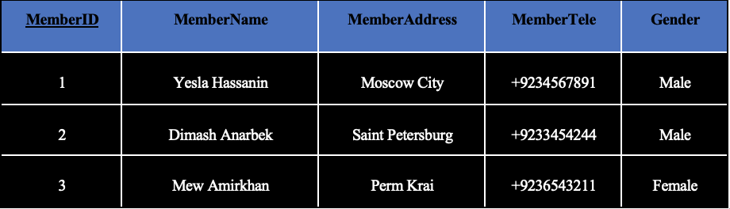

Figure 1: UNF Table (0)

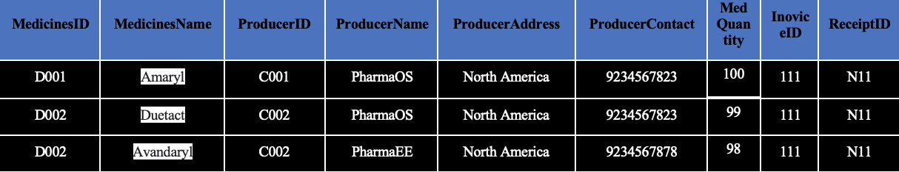

Figure 2: UNF Table Same table (0)

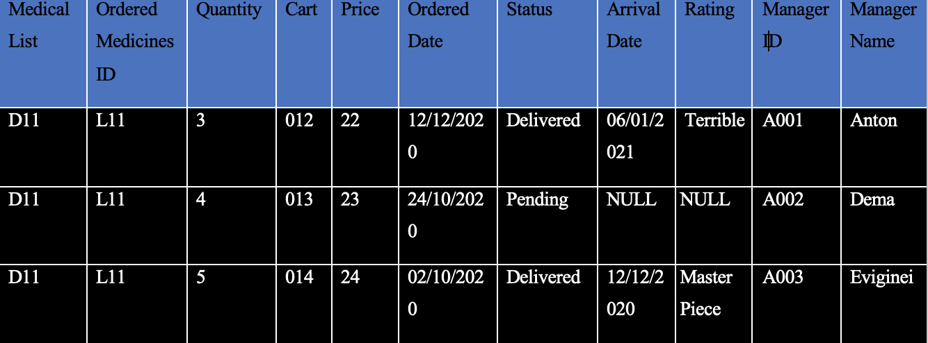

Figure 3: UNF Table Same table (0)

The table here shows that the name of the customer has a problem because he did not specify what the first and last name is, and also the dependencies did not specify who is the primary and non-primary key, and the reliability is also missing here also the numbers and the primary key of the country has not been determined yet.

**First Normalization (1NF – Remove Repeating Group):**

Tables should only have two dimensions, since one member has several pieces of information. These are listed in separate tables. Spreadsheets often use the third dimension, but tables should not. Another way to see this is with one-to –many relationships, do not put the one side and the many sides in the same table instead we create another table in first normal form by eliminating the repeating group. (Docs microsoft, 2003)

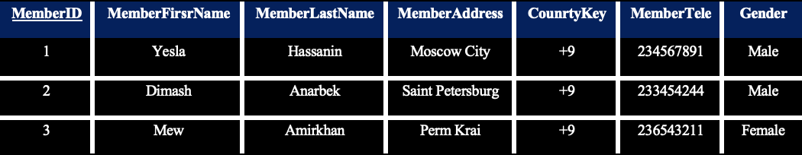

Figure 4: 1NF Table (1)

Member(**MemberID**,MemberFirstName,MemberLastName,MemberAddress,CountryKey,MemberTele,Gender)

The table here shows that it has been modified to a large extent, and the first and last name of the customer has been determined, and the customer code has been set as an initial key, and the country key has also been identified and the duplicates removed.

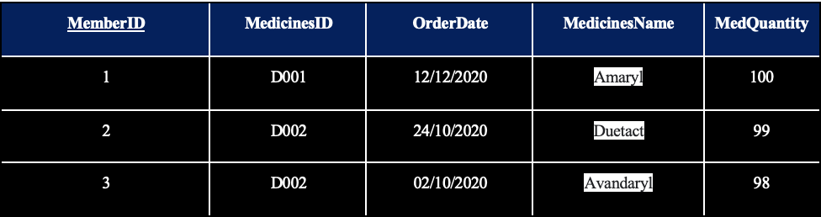

Figure 5: 1NF Table (2)

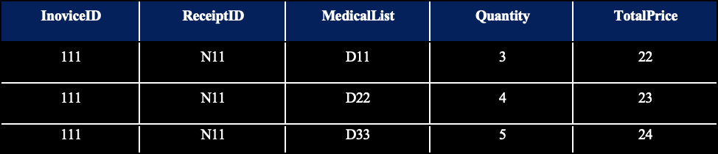

Figure 6: 1NF Table Same table (2)

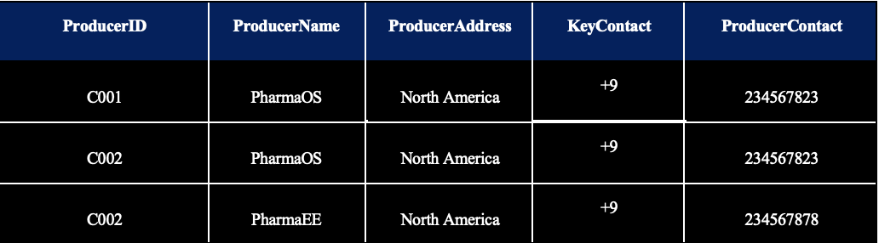

Figure 7: 1NF Table Same table (2)

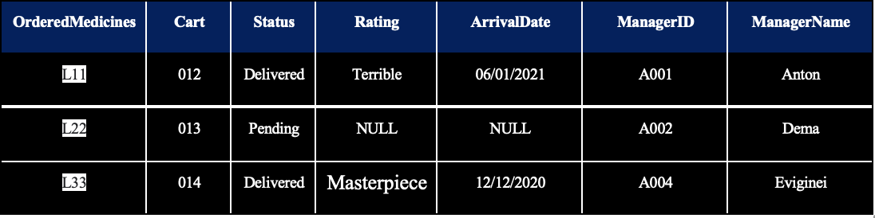

Figure 8: 1NF Table Same table (2)

Member_Medicines_Date(**MemberID,MedicinesID,OrderDate,** MedicinesName,MedQuantity,Quantity,Price,InoviceID,ReceiptID,MedicalList,OrderedMedicines,Cart,Status,Rating,ArrivalDate,ManagerID,ManagerName,ProducerID,ProducersName,ProducersAddress,ProducersContact)

In this table, the composite key has been identified for three, they are customers ID, Medicines ID, and the date the order began, and also, all lists belonging to them were selected together at once.

**Second Normalization (2NF – Remove Functional/Partial Dependency):**

The second normalization form cannot be analyzed unless the first normalization form must be analyzed. In the second normalization form, the partial dependencies are removed.

e.g. ,when A -> B, So, B depends on A and A depends on B

So, B is a foreign key when it exists in the internal table with A, but in External table of B with all functions that depend on it, B will be a primary key (sql-datatools, 2015).



Figure 9: 2NF Table

Member(**MemberID**,MemberFirstName,MemberLastName,MemberAddress,MemberTele,Gender)

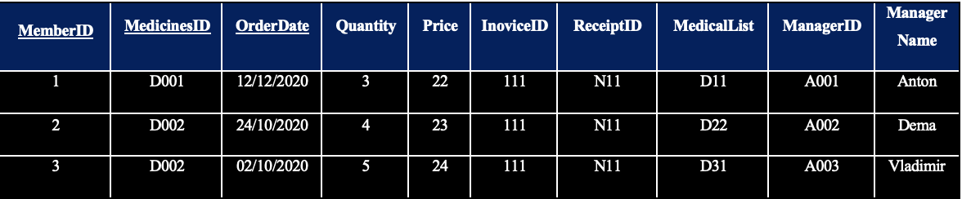

Figure 10: 2NF Table (1)

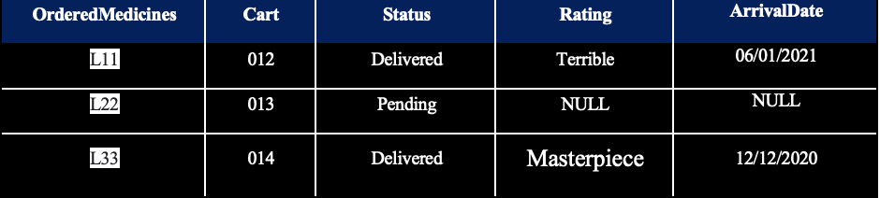

Figure 11: 2NF Same Table (1)

Member_Medicines_Date(MemberID,MedicinesID,OrderDate,Quantity,Price,ReceiptID,MedicalList,OrderedMedicines,Cart,Status,Rating,Feedback,ArrivalDate,ManagerID,MangerName)

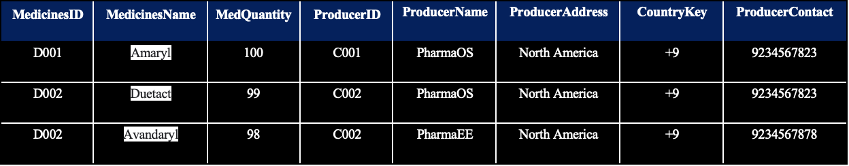

Figure 12: 2NF Table

MEDICINES(**MedicinesID**,MedQuantity,MedicinesName,ProducerID,ProducersName,ProducersAddress,CountryKey**,**ProducersContact)

In these tables, the partial dependency that falls on the customer only, the drug as well, the joint function between the customer ID, the medicine ID, and Ordered Date, taking into account the prevention of repetition, the arrangement of tables, and the identification of the primary and foreign key were determined.

**Third Normalization (3NF – Remove transitive dependency):**

A relationship is free from multiple dependencies, for attributes, non-primary properties e.g. when A B

A is Super Key

B is Primary Attribute ( Parts from Candidate Key )

And if there found A - > B - > C, So A to C ( Transitive Dependency ) (geeksforgeeks, 2019).

So, there will be find the Explanation in Table Below for 3NF:

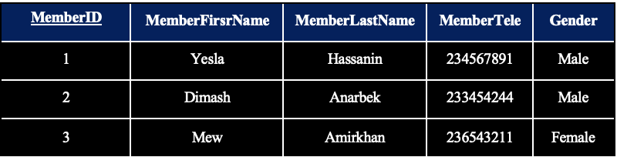

Figure 13: 3NF Table (1)

Member(**MemberID**,MemberFirstName,MemberLastName,MemberTele,Gender,MemberAddress (FK))

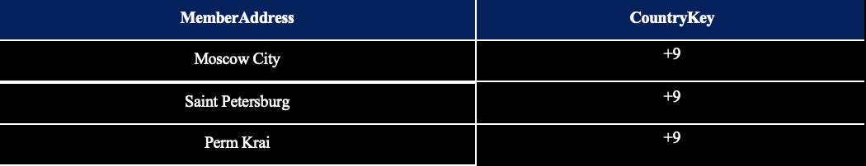

Figure 14: 3NF Table (2)

Customer_Address**(MemberAdress,**CounrtyKey)

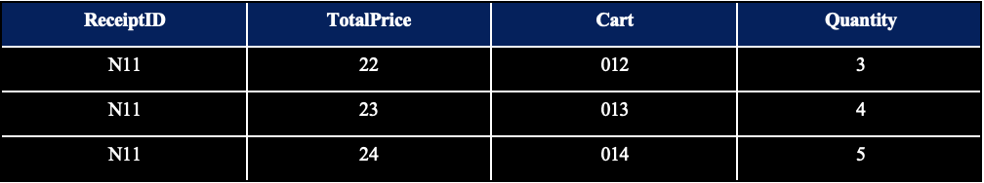

Figure 15: 3NF Table (3)

RECEIPT**(ReceiptID,**TotalPrice,Quantity,Cart)

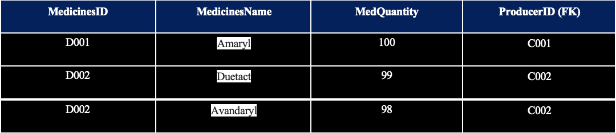

Figure 16: 3NF Table (4)

MEDICINES Details(**MedicinesID**,MedicinesName,MedQuantity,ProducerID*)

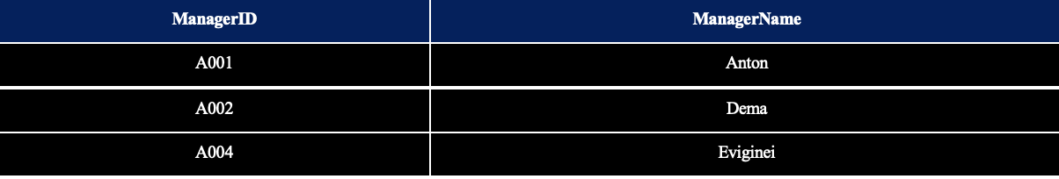

Figure 17: 3NF Table (5)

Manager(**ManagerID**,ManagerName)

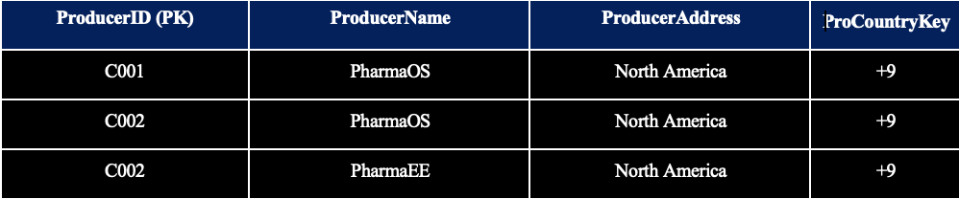

Figure 18: 3NF Table (6)

PRODUCER(**ProducerID**,ProducersName,ProducersAddress,ProCountryKey(FK))

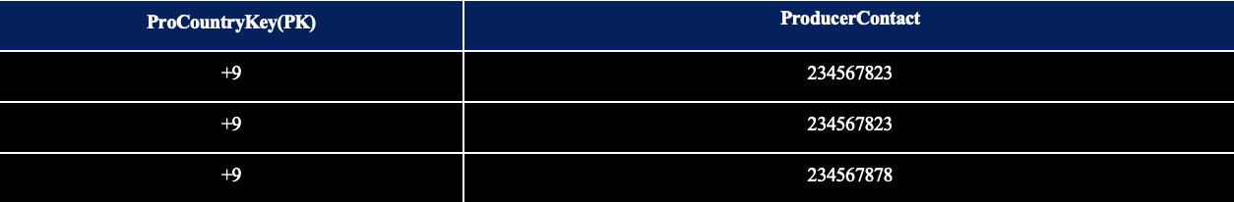

Figure 19: 3NF Table (7)

Producer_Tele_Key(**ProCountryKey**,ProducerContact)

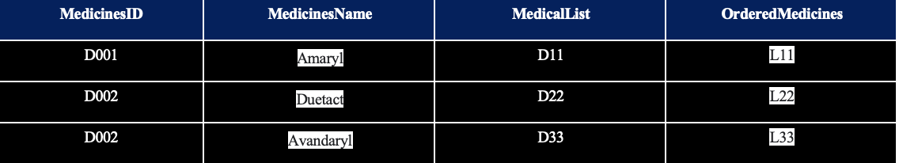

Figure 20: 3NF Table (8)

Medicines_ORDER(**MedicinesID**,MedicinesName,MidicinesList,OrderMedicine)

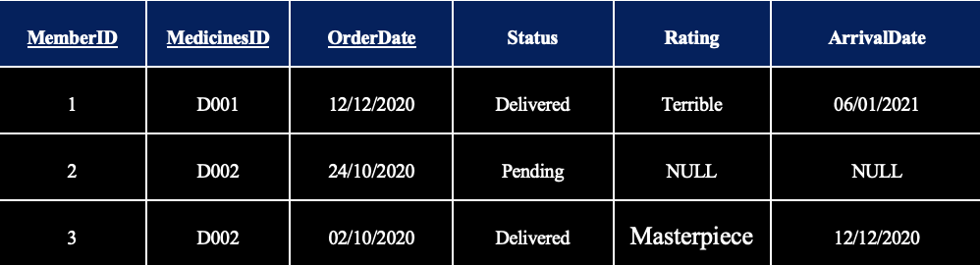

Figure 21: 3NF Table (9)

Member_Medicines_Date(**MemberID,MedicinesID,OrderDate**,Status,Rating,ArrivalDate)

In these tables, the transitive-dependency was canceled, and this process was not completed without analyzing the form of the first and second normalization, and it is clear here that the customer depends on him only the functions found at the top as well as the drug code and the product code. These are examples of canceling transitive dependencies.

# **Entity Relationship Diagram**

The ERD drawing can be converted into a database, and it consists of three:

* **Entities:** They are basic objects in an ERD diagram, and are divided into five categories: concepts, locations, roles, people, things, and concepts. For example, Medicines ID, suppliers, customers, managers, cart. We can say that the customer who wants to buy a drug from the pharmacy has registered his name in a table called customers (Uregina, n.d.).
* **Attributes:** Attributes is a concept in which entities are described. They can be in the form of tables. For example, when we say a medicine, an entity can have a code, supplier name, supplier address, and phone number.
* **Primary Key:** The primary key is the attribute that defines the table. For example, the customer code is the primary number, and it is exceptional because two customers cannot have the same code and it is difficult to be empty.
* **Foreign Key:** It is a key used to join more than two tables together and it can become a foreign key, and one table can contain more than one foreign key.
* **Relationships:** Relationships between entities are created using Crow feet symbols and are divided into three relationships:
* **One to One (1:1):** There are two entities and each of them has a single connection and that is its symbol:



Figure 22: One to One Relationship

* **One to Many (1:M):** There are two entities, one of which has a single connection and the other is a multi-connection and is symbolized by this symbol:



Figure 23: One to Many Relationship

* **Many to Many (M:M):** There are two entities, the first with multiple connections, and the other with multiple connections, and its symbol is symbolized by this symbol:



Figure 24: Many to Many Relationship

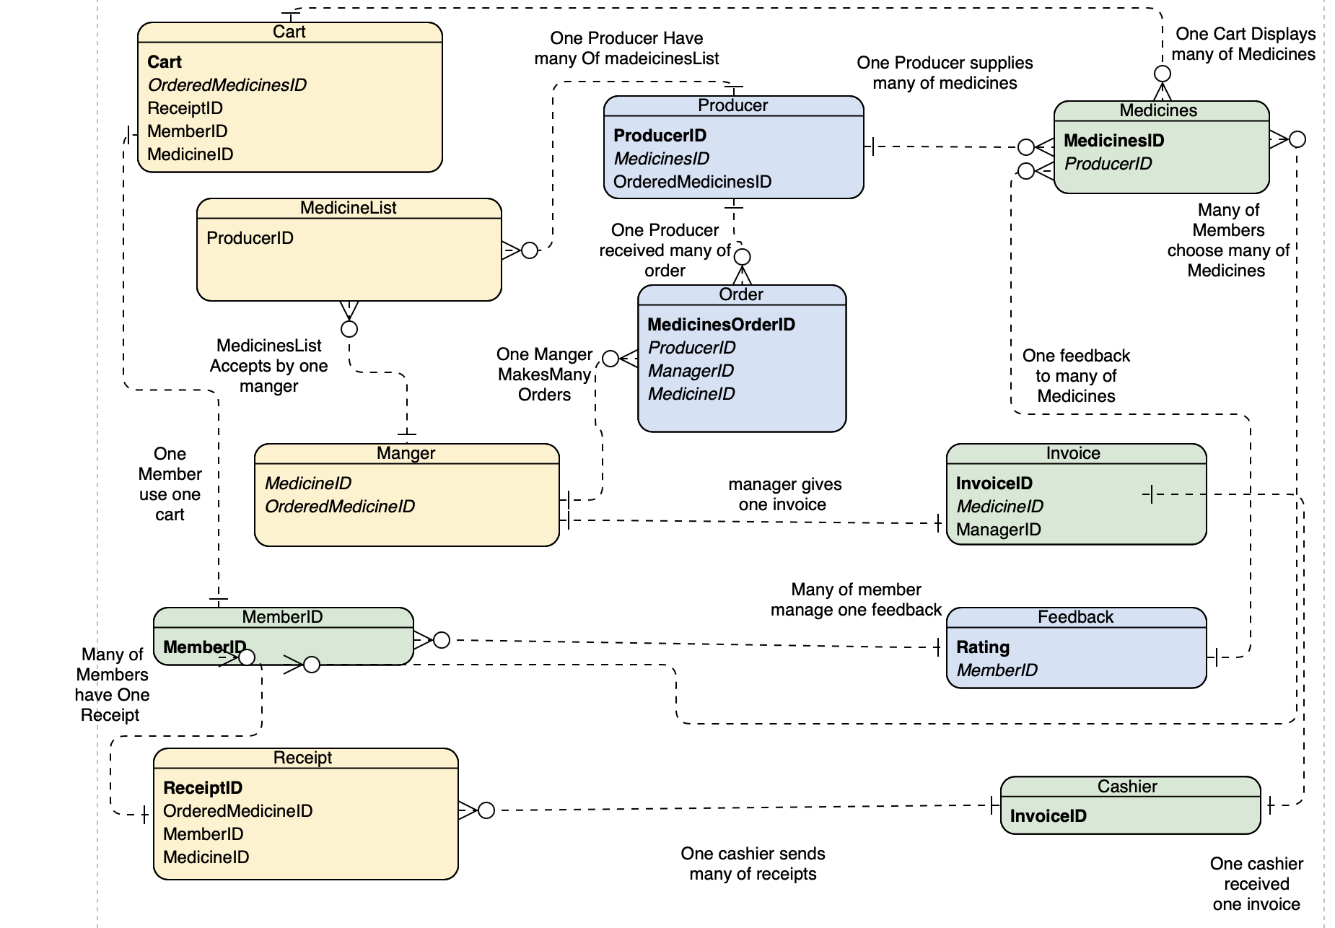

Figure 25: Malaysia’s E-Pharmacy and General Store (ERD)

# **4.0 Conclusion**

In conclusion, database implementation plan is essential for any organization that wants to boost their sales or increase their customer experience, quality Implementation planes supposed to have all the factors and the significant value towards the organization, not forgetting the requirements needed. Through the process of database normalization, we bring our schema's tables into conformance with progressive normal forms. As a result, our tables each represent a single entity and we benefit from decreased redundancy, fewer anomalies, and improved efficiency. more over the benefits are that we get overall database organization, data consistency within a database , much more flexible database design and a better handle on database security. Data normalization gets rid of several anomalies that can make analysis of the data more complicated. Some of those anomalies can crop up from deleting data, inserting more information, or updating existing information. Why do we normalize a database? Reasons include, to avoid data being replicated in various tables at the same time or unrelated product data being gathered in the same table. In addition, this technique makes it possible to make your databases more logical and natural, reducing their size and simplifying the structure to make product data easier to locate, contrast and retrieve.

# **References**

relationaldbdesign, n.d. *Database Business Rules Importance.* [Online]   
Available at: https://www.relationaldbdesign.com/database-design/module4/business-rules-importance.php  
[Accessed 17 07 2021].

computingstudents, n.d. *DATABASE AND FILE BASED SYSTEMS.* [Online]   
Available at: http://www.computingstudents.com/notes/database_systems/database_file_based_systems.php#:~:text=A%20file%20based%20system%20is,and%20manages%20its%20own%20data.&text=By%20having%20files%20stored%20on,could%20be%20accessed%20more%20efficiently  
[Accessed 16 07 2021].

DBMS, n.d. *Disadvantages and advantages of file system.* [Online]   
Available at: https://tutorialink.com/dbms/advantage-and-disadvantages-of-file-oriented-system.dbms  
[Accessed 21 07 2021].

microsoft, 2003. normalization. *description of normalization basics*, 31 07, p. 200.

Docs microsoft, 2003. *description of database normalization basics.* [Online]   
Available at: https://docs.microsoft.com/en-us/office/troubleshoot/access/database-normalization-description  
[Accessed 16 07 2021].

geeksforgeeks, 2019. *Third Normal Form (3NF).* [Online]   
Available at: https://www.geeksforgeeks.org/third-normal-form-3nf/  
[Accessed 31 07 2021].

handwiki, n.d. *Unnormalized form.* [Online]   
Available at: https://handwiki.org/wiki/Unnormalized_form  
[Accessed 19 07 2021].

sql-datatools, 2015. *SQL - Normalization: Second Normal Form (2NF).* [Online]   
Available at: http://www.sql-datatools.com/2015/06/database-normalization-second-normal.html  
[Accessed 11 07 2021].

Microsoft, n.d. *Database design basics.* [Online]   
Available at: https://support.microsoft.com/en-us/office/database-design-basics-eb2159cf-1e30-401a-8084-bd4f9c9ca1f5  
[Accessed 21 07 2021].

Anon., n.d. *Disadvantage of File-oriented system:.* [Online].

Tutoriallink, n.d. *Disadvantage of File-oriented system.* [Online]   
Available at: https://tutorialink.com/dbms/advantage-and-disadvantages-of-file-oriented-system.dbms  
[Accessed 27 07 2021].

Ringlead, n.d. *The Benefits Of Using Database Management Systems.* [Online]   
Available at: https://www.ringlead.com/blog/the-benefits-of-using-database-management-systems/  
[Accessed 26 07 2021].

# **CT042-3-1 Database Systems – Workload Matrix:**

