

**INDIVIDUAL ASSIGNMENT(*Explanation of MBOLMS)***

**CT108-3-1-PYP**

**PYTHON**

**APD1F2011CS(IS)**

**DATE ASSIGNED : 22TH JANUARY 2021**

**DEADLINE : 26TH MARCH 2021**

**MODULE CODE : CT108-3-1 -PYP**

**ASSIGNMENT : INDIVIDUAL ASSIGNMENT (EXPLANATION OF MBOLMS)**

**LECTURER : MR. TANVEER KHALEEL SHAIKH**

Table of Contents

Introduction 3

Assumption 3

Design – Pseudocode 4

Design – Flowchart 10

Sample Python code 13

Screenshot of input/output 18

Additional Feature 27

Conclusion 27

References 27

## **Introduction**

Welcome to the Bank of MBOLMS (application), the application helps the user to access full information about the existing loans, calculate their installments, and for any years the loan repayment process takes place. You can also log in to the site and inquire about bank transactions, and inquire about the dates of payment of the installments, it is also facilitated for the administrator responsible for customer data and giving orders with approval or rejection and making all of this in a simplified way through Python code.

## **Assumption**

* I assume system is able to register admin and customer
* I assume that with the help of this system user can login with ID and password
* I assume that the admin is in control of all the client's data, and the submitted requests can be approved or rejected
* I assume that the admin is the only person who can see all customer and loan transactions
* I assume that the customer can review the loan applied to him and the installment can be paid as well
* I assume that the customer can see his transactions and also see if the approval was made by the admin regarding the loan or not
* I assume that the customer can calculate the loan price, how many years of installment, and how much he pays each month
* I assume that the customer can register on the site by creating a new ID, password, email, and date of birth
* I assume that the customer can see all the loans, their features, and their price in order to choose the one suitable for them
* I assume that the customer and the admin can easily control the system by registering or returning to the main menu or the admin or customer list

## **Design – Pseudocode**

Main() Function

Begin

Declare option

Display (“WELCOME TO Malaysia Bank\nUser Type\n1. Admin\n2. Customer\n3.Exit”)

Display “Kindly enter your choice: “

Read option

If (option==1)

Get admin credentials till correct and call admin_function()

If (option==2)  
 call customer function

If (option==3)  
 exit program

End

Admin_function() Function

Begin

Declare option

Display (“Welcome Admin \1. Display New Customer’s Registration Request \n 2. Approve / Reject New Customer detail \n 3. Provide Loan detail to New Registered Customer \n 4. Search and Display all transactions of specific customer \n 5. Search and Display all transactions of specific Loan type (EL/CL/HL/PL). \n 6. Display all transaction of all customer \n 7. Display all transaction of all types of Loan \n 8. Exit”)

Display “Kindly enter your choice: “

Read option

If (option==1)

Read and display New_Customer.txt file, call admin_function()

If (option==2)  
 Read and display New_Customer.txt file

Declare and Read customerID from admin, search and display this customer from file data.

Declare and Read status from admin

If(status==’Approved’)  
 store information with status in Registered_Customer.txt.

If(status==’Rejected’)  
 store information with status in Rejected_Customer.txt.

Call admin_function()

If (option==3)  
 Read and display New_Customer.txt file

Declare and Read customerID from admin, search and display this customer from file data.

Assign random loanID to customer’s loan and validate in file.

Declare and read installmentDate from admin.

Declare and read installmentmonth from admin.

Declare and read loanterm from admin.

Declare and read loantype from admin.

Declare and read loanstatus from admin.

Store entry against customer ID in Loan_Registered_Customer.txt.

Call admin_function()

If (option==4)

Declare option  
 Display (“1. Customer ID\n2.Loan ID\n”)

Read option

If(option==1)

Declare and read customer ID

Read Loan_Registered_Customer.txt file and display customer with read customer ID else give invalid id message

If (option==2)

Declare and read loan ID

Read Loan_Registered_Customer.txt file and display customer with read loan ID else give invalid id message

Call admin_function()

If(option==5)

Declare option  
 Display (“Enter Loan Type (EL/HL/PL/CL): ”)

Read Loan_Registered_Customer.txt file and display loans of selected type

Call admin_function()

If(option==6)

Read and display Customer_Transaction.txt file

Call admin_function()

If(option==7)

Read and display Customer_Transaction.txt file

Call admin_function()

If(option==8)

Exit program

End

Customer_function() function

Begin

Declare option

Display (“WELCOME TO MBOLMS \n 1. Login (if you are registered customer) \n 2. Sign up (if you are new customer) \n 3. Back to Main Menu \n 4. Exit”)

Display “Kindly enter your choice: “

Read option

If(option==1)

Call register_customer()

If(option==2)

Call newCustomer()

If(option==3)

Call main()

If(option==4)

Exit program

End

Register_customer() function

Begin

Declare flag

Call validateUser() and set flag

If(flag==1)

Break

End

validateUser() function

Begin

Declare and read userId

Read data from Registered_User file.

If(userId)

Declare and read password

If (password)  
 read and compare data from Registered_Customer.txt

If(approved)

Call approvedCustomer()

Return true

Else

Display (“Account approval pending”)

Return false

Else

Display (“Invalid credentials, enter again”)

Return false

Else

Display (“Invalid UserID”)

Return false

End

approvedCustomer(userid) function

Begin

Declare option

Display (“Welcome to Malaysia Bank \n 1. Check Loan detail as per filled at the time of registration with Loan Instalment Date and Loan ID generated by Admin \n 2. Can pay Loan Instalment \n 3. Can view the own transactions \n 4. Can check the status of Loan \n 5. Exit”)

Display “Kindly enter your choice: “

Read option

If(option==1)

Read and display Loan_Registered_Customer.txt file for logged in customer

Call approvedCustomer(userid)

If(option==2)

Read and display Loan_Registered_Customer.txt file for logged in customer

Declare and read amount

Declare and read date

Store values in customer_transactions.txt against logged in customer

If(date==installmentDate[read from file earlier])

Write ‘Installment Paid’ in Customer_Transactions.txt file entry.

Else

Write ‘Installment Overdue’ in Customer_Transactions.txt file entry.

Call approvedCustomer(userid)

If(option==3)

Read and display Customer_Transactions.txt file for logged in customer

Call approvedCustomer(userid)

If(option==4)

Read and display Customer_Transactions.txt file for logged in customer for loan status

Call approvedCustomer(userid)

If(option==5)

Exit program

End

NewCustomer() function

Begin

Declare option

Display (“Welcome to Malaysia Bank \n 1. Check loan detail \n 2. Loan calculator for loan amount eligibility \n 3. Register with Malaysian Bank \n 4. Back to Customer Menu \n 5. Exit”)

Display “Kindly enter your choice: “

Read option

If(option==1)

Declare option1

Display (“1. Education Loan (EL) \n 2. Car Loan (CL) \n 3. Home Loan (HL) \n 4. Personal Loan (PL) \n 5. Back to New Customer Menu”)

Display “Kindly enter your choice: “

Read option1

If(option1==1)

Read and display Education_Loan.txt

If(option1==2)

Read and display Car_Loan.txt

If(option1==3)

Read and display Home_Loan.txt

If(option1==4)

Read and display Personal_Loan.txt

If(option1==5)

Call newCustomer()

If(option==2)

Declare and read loan amount

Declare and read loan term

Declare and calculate installment

Declare and calculate interestRate

Display installment and interestRate

Call newCustomer()

If(option==3)

Declare and read userID

Declare and read password

Declare and read emailID

Declare and read DOB

Write values in new_customer.txt and close file.

Call newCustomer()

If(option==4)

Call newCustomer()

If(option==5)

Exit program

End

## **Design – Flowchart**

## 

General flowchart

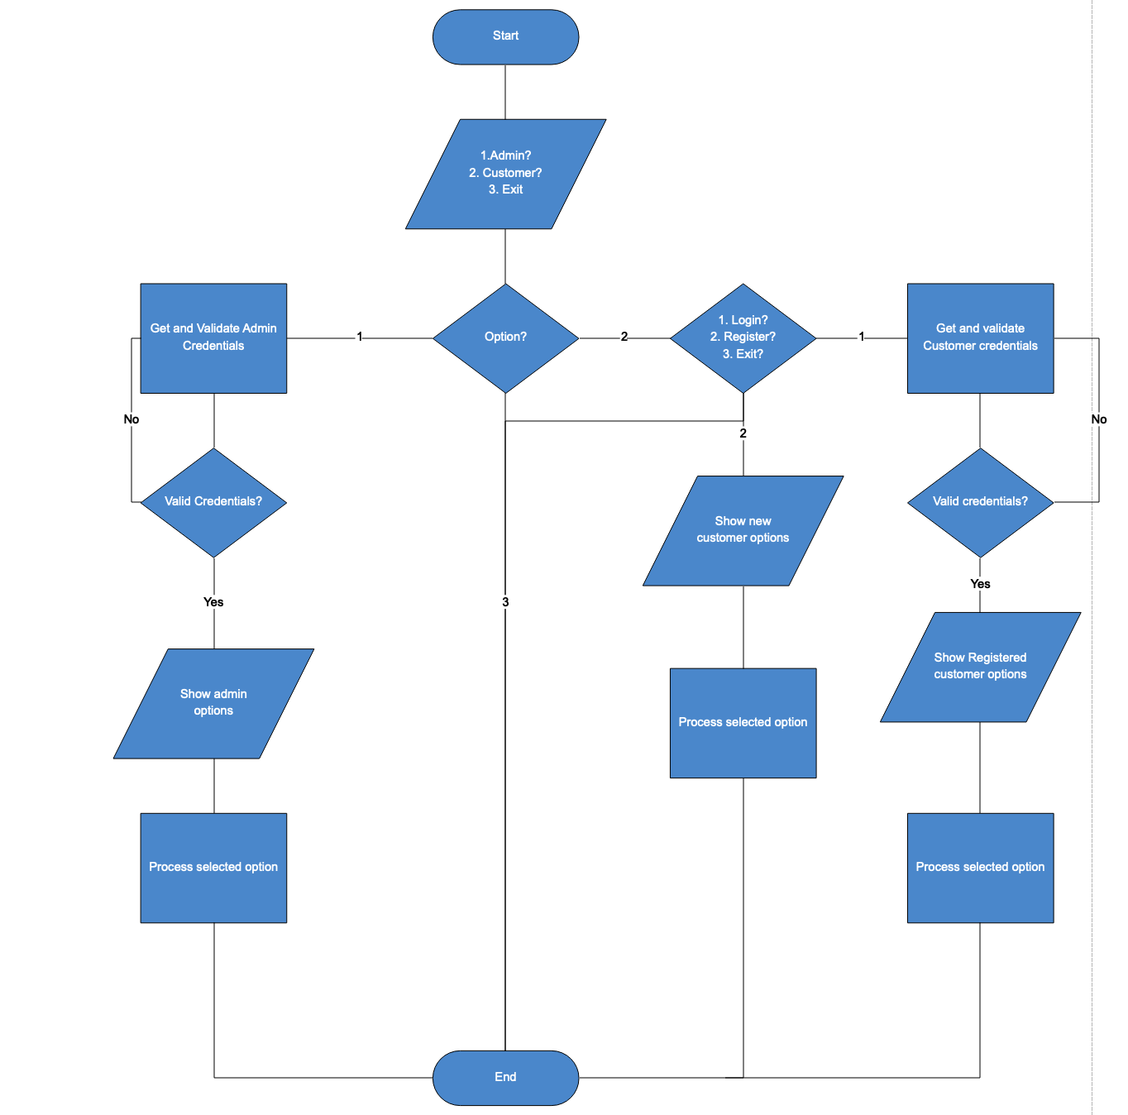

Main menu and Admin Functionalities flowchart

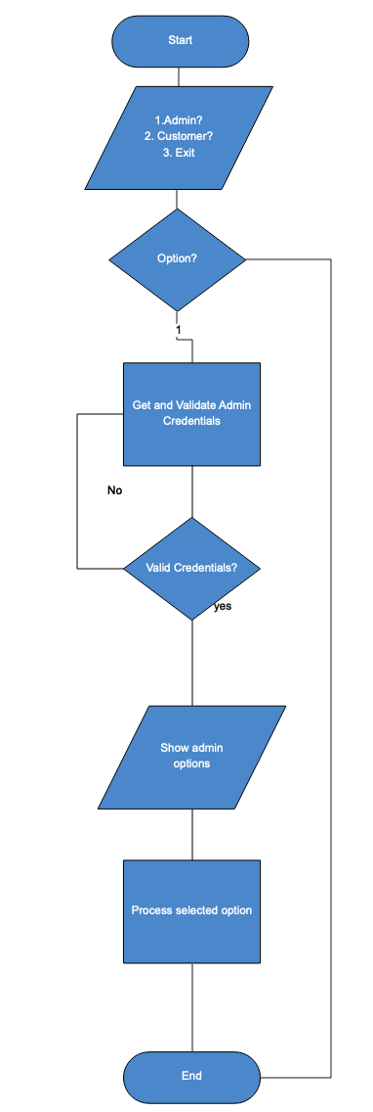

Exit and Customer Functionalities flowchart

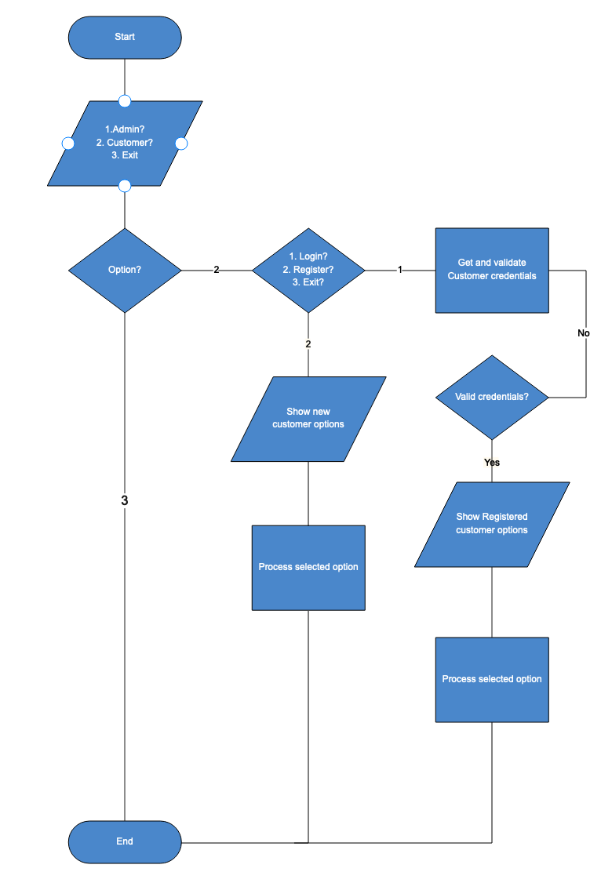

## **Sample Python code**

Import sys (System-specific parameters and functions):

This unit provides many functions that help us link variables with each other and make the code stronger than before in interaction and use, and its functions are float_repr_style It's close to stdin and stdout in C ++. (python.org, n.d.)

Import re (RegEx ):

Through this unit, we can check and match the e-mail or password in the code, and it can be applied to the forms and many things, which is an abbreviation for the word RegEx, it examines the criteria created by the programmer and can allow him to examine more and conclude greater and less similarities between the data and its distinction. (Ghazni, 2019)

Import random:

It is a unit that issues random numbers, and the number of random numbers that are produced and how much their range can be determined and used to generate random numbers or in general random numbers in the code. (tutorialspoint, n.d.)

Variable:

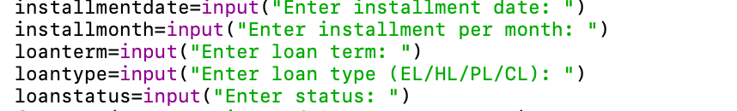

The meaning behind the variable is the input of data and it is a factor for saving the data and there is a place for it in the memory and the data is saved in it and the data is sent to the computer so that it can process it and then send it to the rest of the branches that need this variable in their operations. (guru99, n.d.)

Control structure:

* IF STATEMENT:

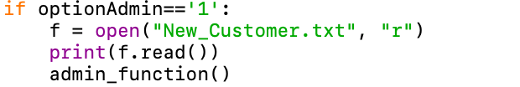

It is something that gives instructions and commands for the thing. If this thing is equal to a certain number, it must do that if it is not equal, then it must refrain from doing that and it is just laws that the programmer puts through the control structure. (wikiversity, 2021)

* IF ELSE STATEMENT:



It is used to give another command after completing the first command and it complements the IF STATEMENT.

* ELSE:



It is used for the False conditions. (w3schools, n.d.)

* NESTED IF – ELSE:

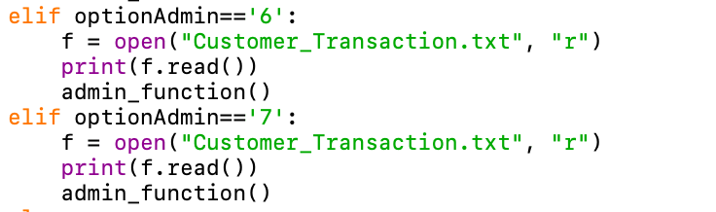

When there is more than one decision and an overlapping process, we must use an if-else rule in order to achieve more than one condition. (guru99, n.d.)

Looping structure:

* WHILE LOOP:



A while loop consists of do while and it can repeat the process in the program only once, but after that it can continue to repeat the process to the extent that the user wants, and it can stop this limit by (break) and according to the code used for the program. (wikipedia, n.d.)

* FOR LOOP:



A for loop is an iterative process to achieve a specific condition, and a counter can be used, whether by increase or decrease to achieve the desired purpose, whether by printing the thing more than once or repeating a mathematical operation more than once and there are many examples of that. (techopedia, n.d.)

LIST VARIABLE:

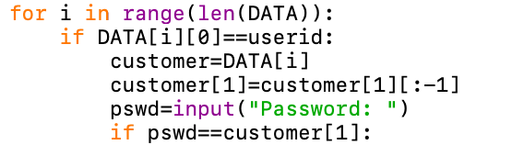

It is found in the data for Python, which is an ordered element to which things can be added or removed from things also in the sense that it is a variable and the values ​​are found inside the brackets. (Tagliaferri, 2016)

FUNCTIONS:

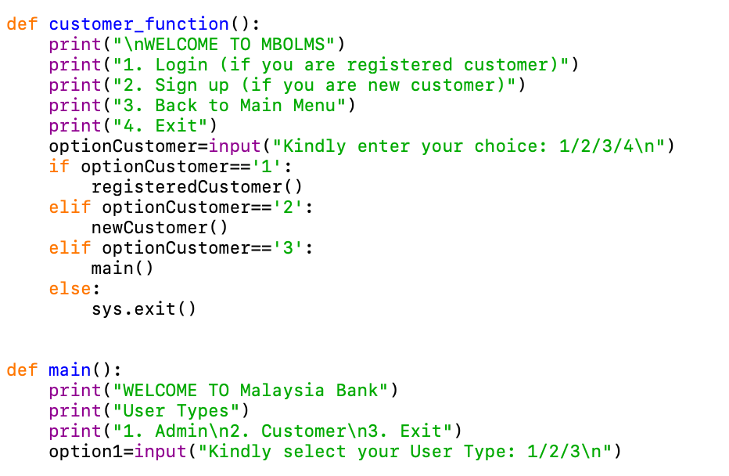

A function is a block that the functions can be linked together to facilitate the code and link all things together and facilitate the process of inputs and outputs within the code by user’s. (tutorialspoint, n.d.)

FILE:

* Read data in text file



The function gives Read() or Readlines to read the file from the inside when writing it in code, and when giving the command to print everything is done inside the file. (pythontutorial, n.d.)

* Write data from text file

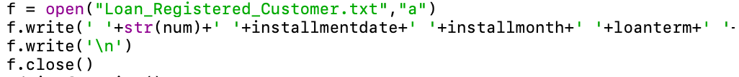

f.write is used to write inside the file by making inputs and use it in this tool and write anything we want and save it in the file with the end with f.close. (Anon., n.d.)

Search/modify data of text file:

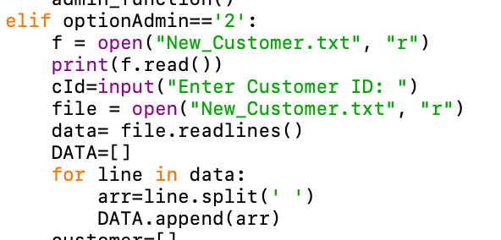

Through lists and reading files, we can search between lines and add values ​​using the loop and read inside the file with writing while specifying the location in the lists that we want to change. This is how the search and modification process takes place. (Soreq, 2021)

## **Screenshot of input/output**

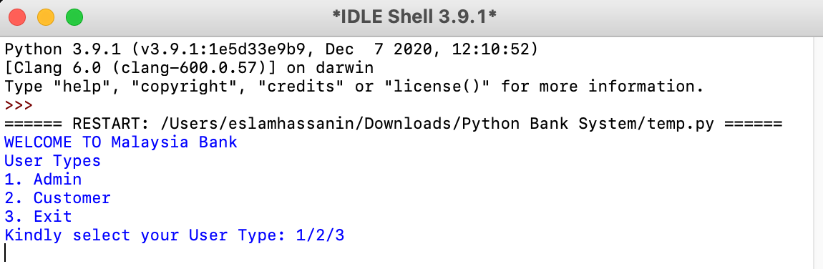

When running the program, the main menu appears with a welcome message from the bank.

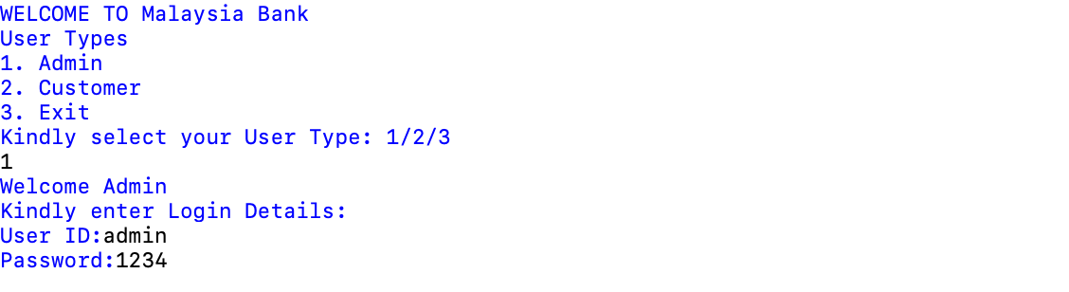

When choosing admin, a menu appears automatically to enter the admin’s ID and password.

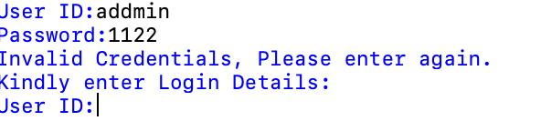

If the ID and the password are written in a wrong way, "Invalid Credentials, Please enter again" message appears, and the correct ID and password must be entered after that.

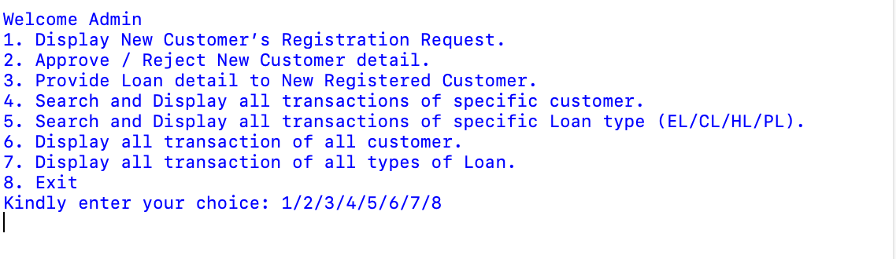

After completing the process accurately and there are no errors in the ID or the password, (8) options appear as well as shown, such as user data, modification, approval or rejection, things about transactions and loans.

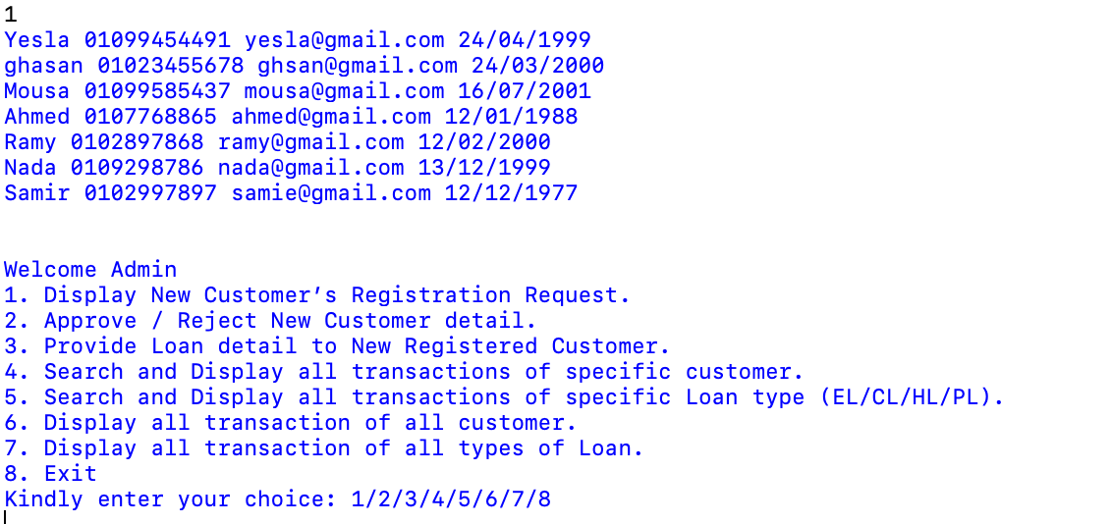 Pressing (1) number opens the bank’s registration list for customers as shown in the screenshot and then returns again to the admin list.

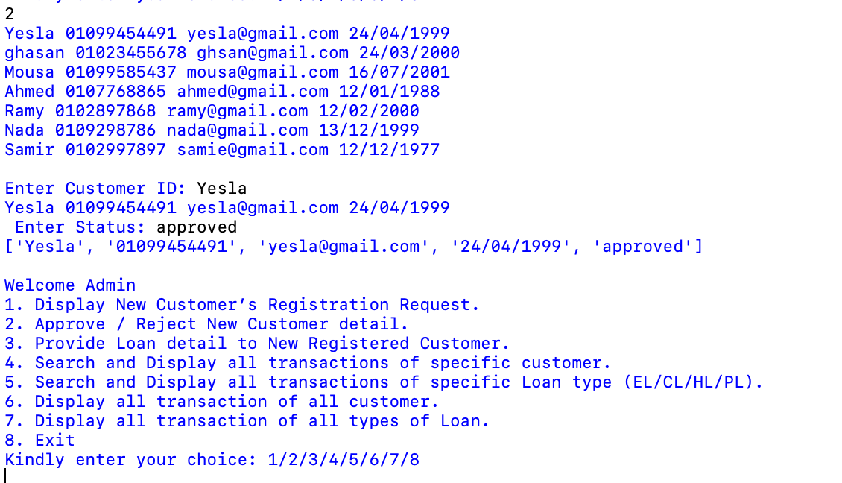

By pressing button (2), the admin can reject or accept the requests of the clients by typing their ID and then writing their status, then after that, admin can return to the list of admin again.

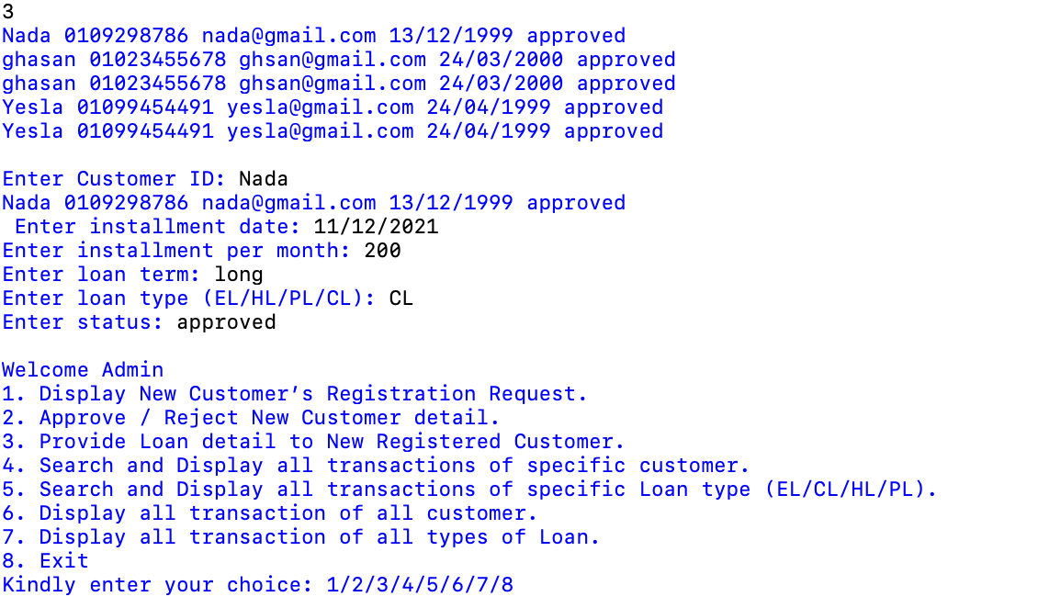

To add details to the customer’s data on loans, this is done by writing the name of the customer’s ID and writing the date of the installment and how much is paid per month and is it long or short term and the type of loan and approval or rejection of it and after that the data is saved in the files and then it is returned to the list again.

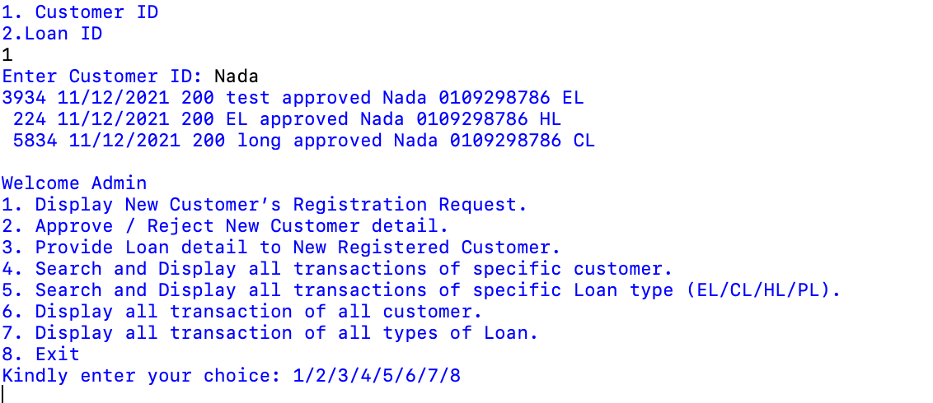

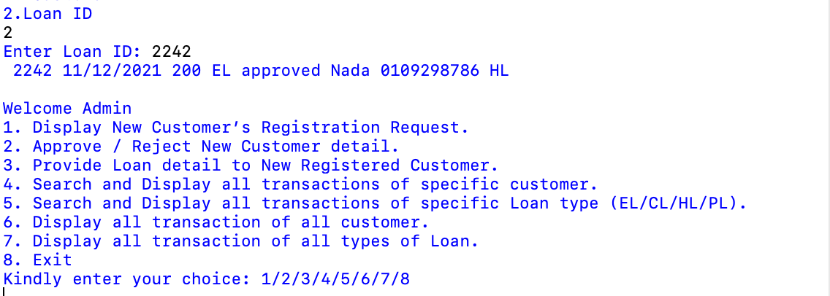

Press number (4) to search for customer transactions by the customer ID or search for the loan ID that was registered to the customer and then it is displayed on the screen and after that, it is returned to the list.

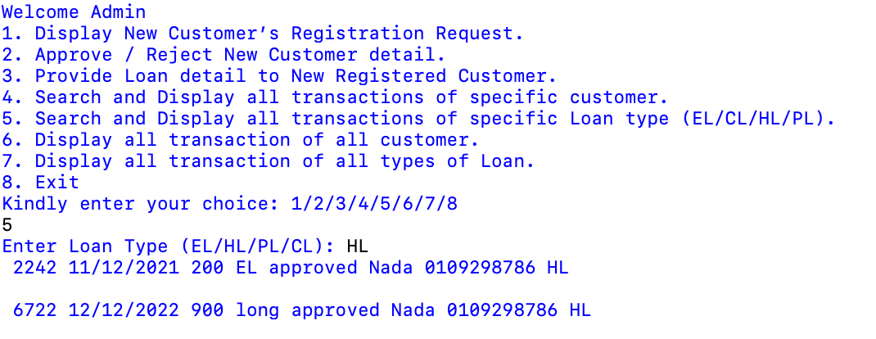 Pressing number (5) will show you a list in which you write the type of loan, and if it is available, all customers who use this loan will appear to you, and then you will return to the main list again.

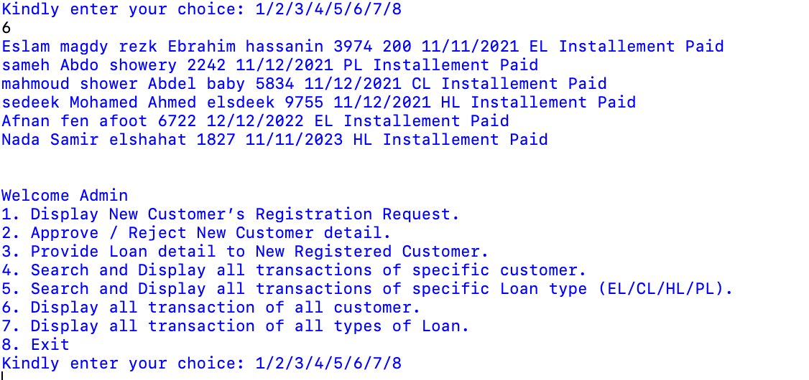 When you press number (6), all customer transfers appear, and then return to the list again, it also appears that all of them have paid the required installments.

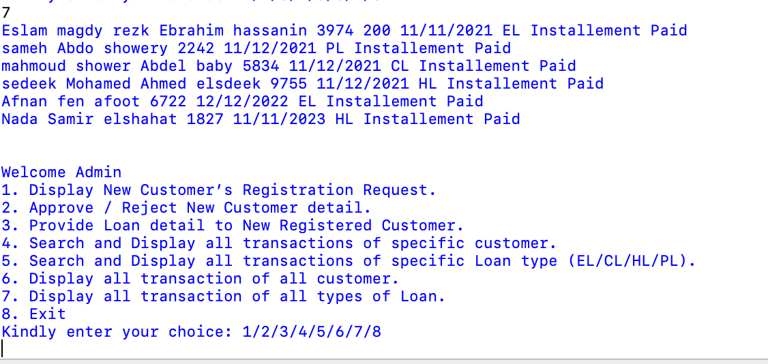 Pressing the (7) button shows you all the customers' transactions with the loan number, loan type, date and completion of payment, then return to the main menu.

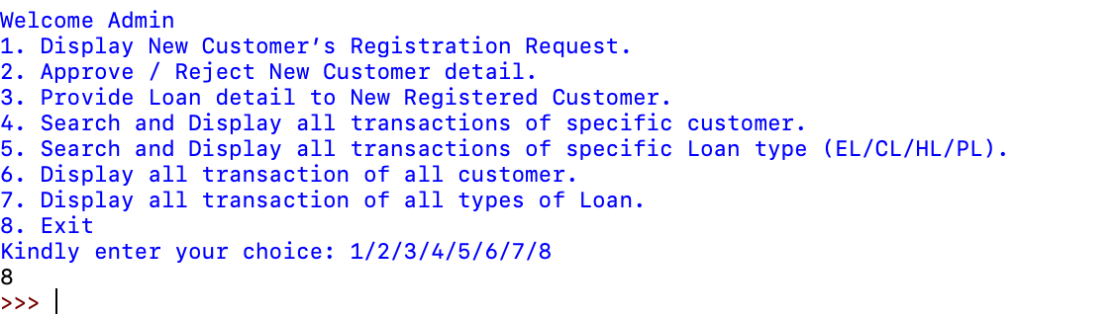 Pressing the (8) button completely exit the program.

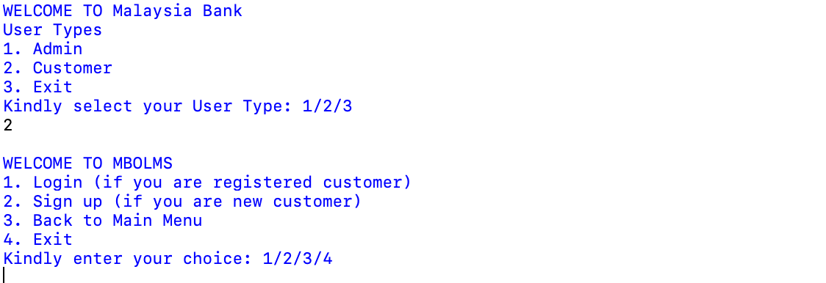

Pressing the button (2) shows us three options, the first if you are a customer with the bank, the second if you are registering with the bank and creating an account, and the last is to exit.

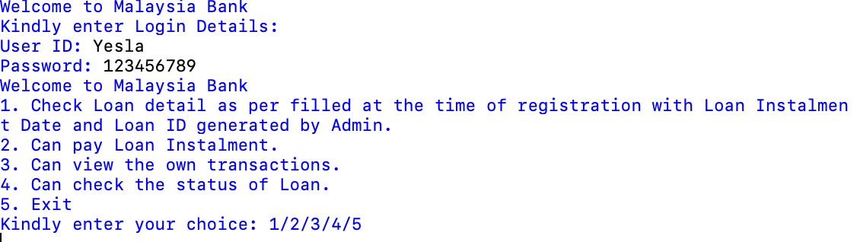

In the first option, the customer's ID and password are written and then 5 options appear, which are checking the loan details, the date and time recorded with the installment and the loan, and the ID that was registered by the admin, displaying the transaction list, paying the installment, checking the loan status, and exit is the last choice.

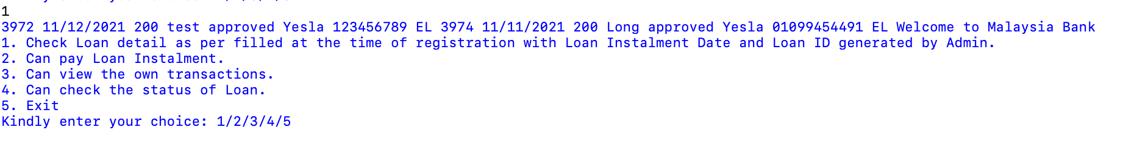

Pressing the button 1 means that all the loans that the user applied for are shown in front of him by the loan number, date and status of the application, and then it is returned again to the menu.

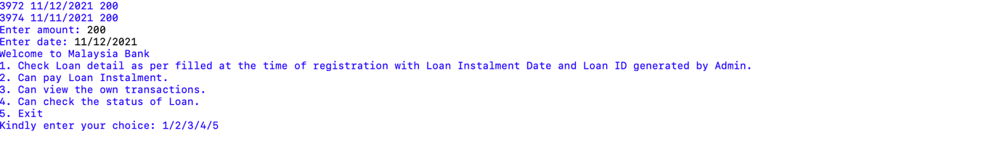 Pressing the button (2) shows all the transactions and is done for the loans that the customer paid and after that the quantity is placed and then the payment and that is recorded in the file.

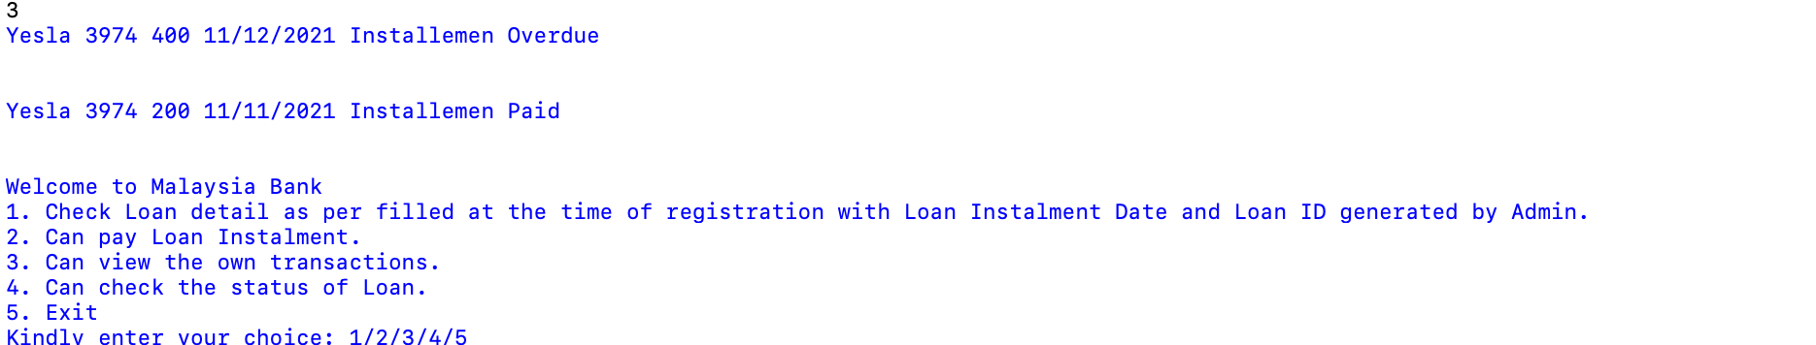

Pressing the button (3) shows the user’s transactions.

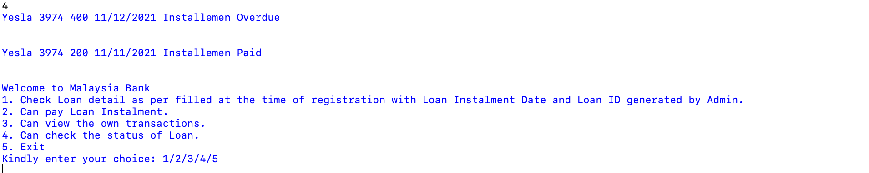

Pressing the button (4) shows the remaining amount for payment, the money that was paid, and the dues.

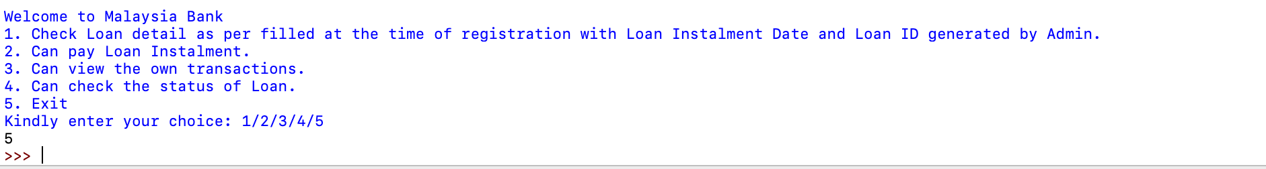

Pressing the (5) button completely exit the program.

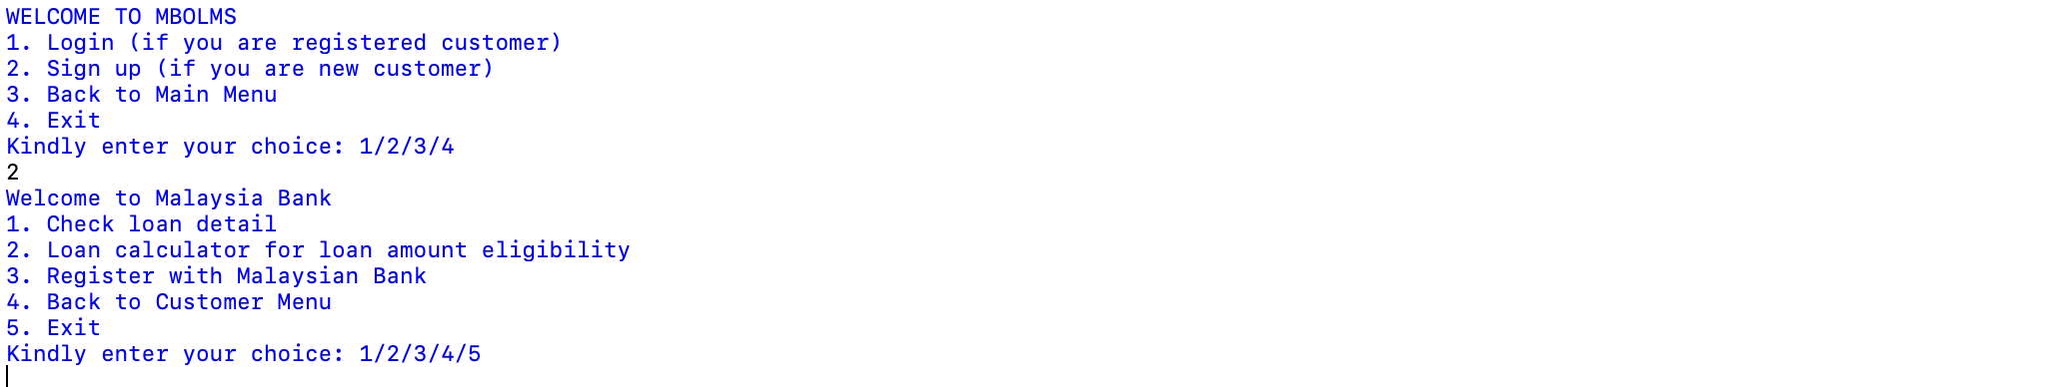

When registering on the site, we find the details about the loans and loan account for the job of eligibility and registration on the bank’s system, and you can refer to the customer menu or exit.

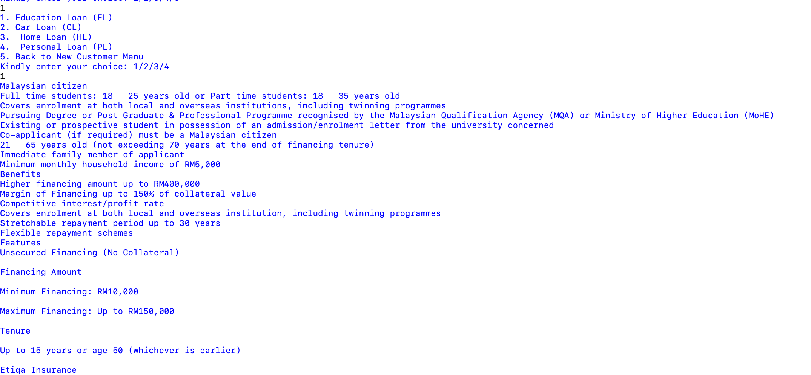

Click on the (1) button to see details about loans such as home, business or personal loan, and each loan whose information may appear like this example.

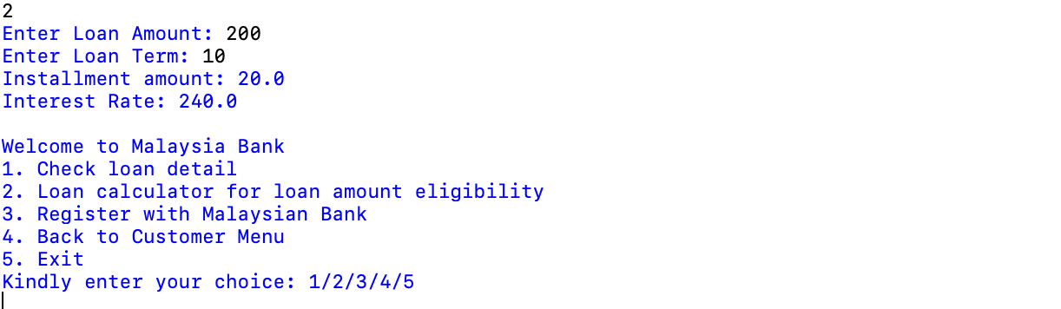

By pressing the button (2), the loan can be calculated on the required term and how much will be paid each period of time and also return to menu.

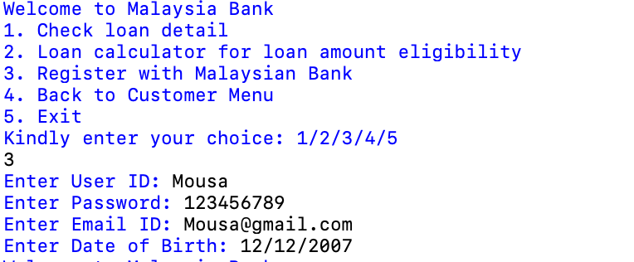

An account can be created using the button (3) by typing the ID, password, email, and date of birth and it is recorded in the file, and then the user can return or terminate the system.

## **Additional Feature**

## **Conclusion**

In summary, this is a bank system that administrators can access their own server to follow up the employee data, amend it, approve and reject when necessary, and on the other side it is the same for the customer because he can enter and know his data and requirements, know the loans and their types and costs, calculate the loan sections and how to pay, all this in a simplified Python code to facilitate the needs of workers and administrators. When dealing with transactions, the administrator can also check all the transactions that the client has made, and the client can also check his own case through if he submitted to the system itself or submitted a bank loan.

## **References**

python.org, n.d. [Online]   
Available at: https://docs.python.org/3/library/sys.html  
[Accessed 25 03 2021].

Ghazni, H., 2019. *What is RegEx Really and Important RegEx Functions.* [Online]   
Available at: https://levelup.gitconnected.com/wtf-is-regex-really-4dd563ee5ce0  
[Accessed 26 03 2021].

tutorialspoint, n.d. *Generating random number list in Python.* [Online]   
Available at: https://www.tutorialspoint.com/generating-random-number-list-in-python  
[Accessed 23 03 2021].

guru99, n.d. *Python Variables: How to Define/Declare String Variable Types.* [Online]   
Available at: https://www.guru99.com/variables-in-python.html  
[Accessed 25 03 2021].

wikiversity, 2021. *Control structures.* [Online]   
Available at: https://en.wikiversity.org/wiki/Control_structures  
[Accessed 25 03 2021].

w3schools, n.d. *The else Statement.* [Online]   
Available at: https://www.w3schools.com/js/js_if_else.asp  
[Accessed 25 03 2021].

guru99, n.d. *Nested If-else Statements.* [Online]   
Available at: https://www.guru99.com/c-if-else-statement.html  
[Accessed 25 03 2021].

wikipedia, n.d. *Do while loop.* [Online]   
Available at: https://en.wikipedia.org/wiki/Do_while_loop  
[Accessed 25 03 2021].

techopedia, n.d. *What does For Loop mean?.* [Online]   
Available at: https://www.techopedia.com/definition/19415/for-loop  
[Accessed 24 03 2021].

Tagliaferri, L., 2016. *Understanding Lists in Python 3.* [Online]   
Available at: https://www.digitalocean.com/community/tutorials/understanding-lists-in-python-3  
[Accessed 24 03 2021].

tutorialspoint, n.d. *Python - Functions.* [Online]   
Available at: https://www.tutorialspoint.com/python/python_functions.htm  
[Accessed 23 03 2021].

pythontutorial, n.d. *Python Read Text File.* [Online]   
Available at: https://www.pythontutorial.net/python-basics/python-read-text-file/  
[Accessed 25 03 2021].

Anon., n.d. *geeksforgeeks.* [Online]   
Available at: https://www.geeksforgeeks.org/reading-writing-text-files-python/  
[Accessed 24 03 2021].

Soreq, O., 2021. *Modifying Text Files Using Python.* [Online]   
Available at: https://support.sisense.com/hc/en-us/articles/360008691793-Modifying-Text-Files-Using-Python  
[Accessed 24 03 2021].