

**GROUP ASSIGNMENT**

**SYSTEM AND DATA ANALYSIS**

**CT026-3-1-SAAD**

**CASE STUDY:**

**APD1F2011/APU1F2011**

**DATE ASSIGNED : 1OJUNE 2021**

**DEADLINE : 09 AUGUST 2021**

**MODULE CODE : CT026-3-1-SAAD**

**ASSIGNMENT : SAAD GROUP ASSIGNMENT (DOCUMENTATION)**

**LECTURER : MS. SALASIAH BINTI SULAIMAN**

**GROUP MEMBERS:**

|  |  |  |
| --- | --- | --- |
| **CASE STUDY:** | **Tiptop Bakery** | **Intake: APD1F2011/APU1F2011** |
|  | **Name** | **TP Number** |
| **G. Leader** | **Eslam Magdy Rezk Ebrahim Hassanin** | **TP062816** |
| **Member** | **Dustin Agussalim** | **TP061201** |
| **Member** | **Jerry Justin** | **TP062879** |
| **Member** | **Avin Mahajan** | **TP062839** |
| **Member** | **Sundy Fhan** | **TP062917** |

Table of Contents

**Table of Figures** 2

Table of Figures (Tables) 2

Introduction 4

Problems and Proposed Solution: 5

3.2 Gantt chart: 11

3.3 Workload Matrix: 11

Feasibility Study 12

System Analysis 28

Design Diagram 29

Interface Design 32

Conclusion: 38

Data Dictionary 52

References 62

Appendices 65

Work Break Down Structure 65

## **Table of Figures**

Figure 1: System Development Lifecycle (Eby, 2017) 8

Figure 2: Design Stage (PRESENTATIONGO, n.d.) 10

Figure 3: Types of Feasibilities (freepik, n.d.) 12

Figure 4: ThinkStation P920 Tower Workstation (lenovo, n.d.) 17

Figure 5: PowerEdge T3o Mini Tower Server (dell, n.d.) 18

Figure 6: Dell Inspiron 24 5000 All-in-One with A Frame Stand (dell, n.d.) 19

Figure 7: QR Barcode Scanner (amazon, n.d.) 20

Figure 8: Mpos Support Mifire NFC (aliexpress, n.d.) 21

*Figure 9: Netgear Nighthawk WIFI Router* (centrecom, n.d.) 22

Figure 10:Schedule Feasibility 27

Figure 11: Context Diagram 29

Figure 12: Level-0 DFD diagram 30

Figure 13: ERD diagram 31

# **Table of Figures (Tables)**

Table 1: Specification of Think P920 17

Table 2: Specification of PowerEdge T30 Mini Tower Server 18

Table 3: Specification of Dell Inspiron 24 5000 All-in-One A Frame Stand 19

Table 4: QR Barcode Scanner 20

Table 5: Mpos Support Mifire NFC 21

Table 6: Netgear Nighthawk WIFI Router 22

# **Introduction**

The FiveDev is a widely developed company with remarkable successes by developing large and small companies and organizations, designing the required system, analyzing data with the highest quality and comparing it with the requirements that the organization and the company need to reduce time and increase work and production, which leads to major successes.

**Logo:**



**Vision:**

The era of handwriting is over. The world is becoming technical, so those who use technology in their work profit. Therefore, the top companies are developing themselves to be more technical than they were before. TheFiveDev combines what a company should use to develop itself and use the technology developed to achieve higher goals with the highest quality.

**Mission:**

Our mission is to enhance business growth of our customers with creative design, development and to deliver market defining high quality solutions that create value and reliable competitive advantage to customers around the globe. Delivering innovative and reliable solutions to meet our client needs with utmost quality.

**Motto:**

Creative Design. Make History.

# **Problems and Proposed Solution:**

After long research conducted by The FiveDev company, the result was that the current system "Tiptop Bakery” has many problems, including handwriting, which causes many problems, so the solution became that these problems are identified and their solutions accurately so that the error rate is prevented in the future.

**Problems:**

**Errors:** There are a lot of errors during the data registration process, and it is difficult to remember all the data because it will not be sufficiently organized, which leads to an increase in errors, also errors in the accounts when buying and selling.

**Data insecurity:** Data security is process of protecting data that is kept in database from destructive sources and to prevent unwanted actions from unwanted users. The increased use of data by organizations has both pros and cons. On one hand, it improves profitability and efficiency. On the other hand, it has result into potential security risk. Due to increase in cyberattacks data security has become an important aspect for running businesses. Data is one of the most important assets a company has. As our client Tip Top Bakery is taking their business online so it necessary to have security of their data. Data helps organization to make important decisions. Loss of information can lead to financial loss for organization, such as lost sales, fines, or monetary judgements. Also, it can cause drop in confidence of customer. Moreover, loss of data can also result in lowering the overall productivity.

**Searching for information:** A system which stores information in a filing cabinet could be a problem when searching for information. Not only it is time consuming, but it could lead to missing information when it is in a huge pile especially if it is not grouped properly. In a form of systems using hard drives or other digital storage system searching for information at the same time may not be working properly and not only that but if it is also not grouped and it mix with the other data, searching for a single information could lead to system malfunction.

**Time consuming:** There are may time consuming problems faced in a company’s information system for example searching an information. Employees spends about 30% of their work time in a day searching for information. We used to store data in a physical space like a filing cabinet. Filing cabinet is useful for storing a small amount of information but a large company has tons of information to store it might take up to a warehouse of information searching for information is not easy when it comes to physical storing spaces.

**Feedback:** Earlier, Tip Top Bakery was operating only on word-of-mouth strategy. An organization cannot solely rely on their customer recommendations to grow or even scale. This strategy can take long time to increase the sales and customer base. Secondly, it can limit the reach of organizations. It can spread misinformation. It is difficult to measure and not targeted towards specific and potential customers. One get limited in the number of potential clients.

**No Entry Protection:** The current system has a lot of randomness and lack of privacy in work or protection because the work of the employees is almost the same as the work of the manager, which is writing in the spreadsheets without organizing a system for each person with a password dedicated to arranging their work and preventing randomness.

**Lack of manpower:**

One of the problems is lack of manpower. With the increasing surge of demands and growing number of customers, Tip Top bakery must solve this urgent problem. The employees are not sufficient to handle lots of customers. With the addition of the new building, employees have more jobs and responsibilities. For instance, the cashiers must work harder since they handle larger number of transactions. The other employees are also needed to keep the store safe, tidy, clean, and running smoothly without any problems which will be harder since the store is getting bigger.

**Proposed Solutions:**

1. **Database:** The bakery system must have a dedicated database to enhance the ability to store data for the bakery in the highest efficiency.
2. **Security login:** Using security log in feature to restrict any private information in the system or damaging the system and not mixing any data from the customer and the company.
3. **Searching inside data:** Search in a quick and easy way, which is that the data is arranged alphabetically, and as soon as you search for money or names, all the data will appear to the user automatically.
4. **Online feedback:** In order to avoid the false news or gossip from damaging the reputation of the store, a system can be created where the comments and feedback are done through online platform. This way, all the comments can be reviewed by people and can be corrected if it is false information.
5. **Flexible system:**  This means a system that can do many tasks efficiently. For example, a system that allows customers to pay their bills by a QR code or through an autonomous machine. This will really help reduce the work of cashiers. This method will also be effective since it will not take much time since it is very simple and easy to understand. Customers can use their mobile phones to scan the code and pay it through online payment system. Another feature is the system allows customers to pick what they want to buy from the store online and the employee can prepare their orders before they arrive at the store. This will help reducing time for those who are busy.
6. **Firewall:** Our company use firewall to protect our clients’ data from unwanted actions. Firewalls protect data by managing network traffic. Firewall helps to reduce and eliminate unwanted users and increase the flow of legitimate audience. It helps to isolate computers and servers from internet to protect any data. It monitors all the data and keep good data flowing and blocking the bad data based on the preset’s rules. It ensures better privacy and security.
7. **Online delivery method:** Imposing a Visa Card or online payment method through the Internet to reduce congestion and pressure on the place.

**Project Planning:**

**System Development Life Cycle (SDLC):**

The life cycle is a system on which the project is built in five phases: Planning, Analysis, Design, Implementation, and Security, this period continues during the entire project implementation period, which is the system controlled by the developed company for data analysis and data design in the existing project to reach the highest levels of efficiency in implementation, so it includes many of process like waterfall and agile processes. (VERACODE, n.d.)

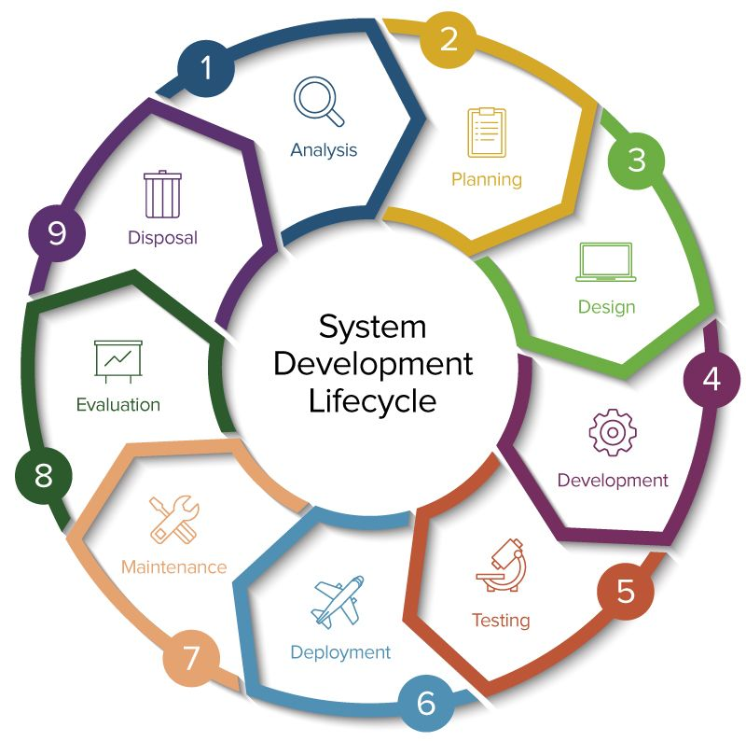

Figure 1: System Development Lifecycle (Eby, 2017)

1. **System Planning stage:** System Planning stage is where they identify whether there is a need of a new system for the problems that tip t op bakery faces. Searching for the goal and purpose of the solution and is it suitable for the company in term of the assess feasibility. After they come up with the solution next is forming a project team to carry out the task and develop the solution for Tip Top Bakery.
2. **System Analysis stage:** The purpose of system analysis is to build logical model of new system. In this phase we will conduct risk assessment and use result to prepare system for Tip Top Bakery. By analyzing requirements, we will prepare system that will support bakery business objectives. The basic aim of the project is to provide the search, delete, record and updating facilities which would be much more efficient and less time consuming. The software will allow the owners to maintain their entire record in one place which will be easy to manage. The system will help consumers to find what products Tip Top Bakery provide with. It will also reduce the risk of errors. The system will allow users to review their purchasing online. We have also added online delivery method for bakery so that consumers can order their favorite items from comfort of their home. In addition to that, login system is created for owner as well as customers so that data can be protected. Apart from that, firewall technology has been used to keep bakery site protected from unwanted actions.
3. **System Design stage:**

At this stage, the focus will be on the basic requirements of the place and the required needs that will increase the production capacity, such as network devices, computers, processor and the rest of the things, and all this comes after the planning and analysis stage, and here at this stage is the design, so here the developers are looking for the structure of the bakery and the tools required for the manager or workers. (INNOVATIVEARCHITECTS, n.d.), Also, during this process, developers work on designing a logical system and then converting it into a physical system. The focus is also on the inputs and outputs that will be used by workers and how to control all requirements, and all of this is in the form of diagrams. (NIOS, n.d.)

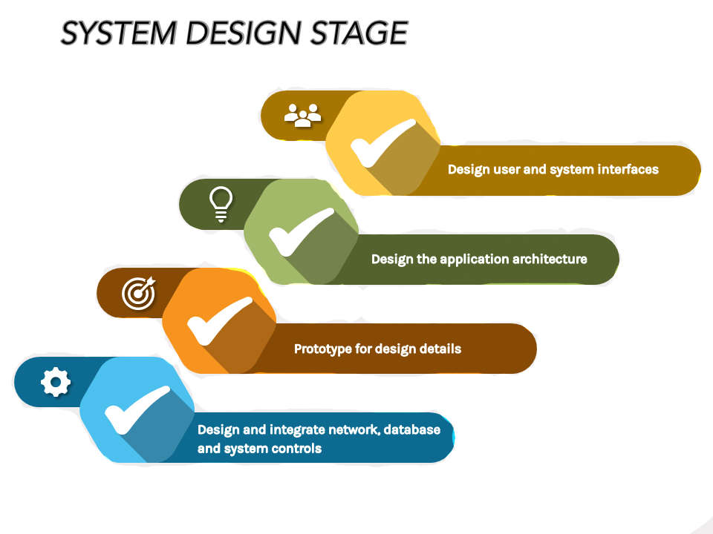

Figure 2: Design Stage (PRESENTATIONGO, n.d.)

1. **System Implementation stage:**

This stage is the fourth phase of the SDLC process. In this stage, project team actualizes the product by starting the coding process. The main objectives of this stage are the installation of the software into the environment and to make sure it runs as expected also to ensure that the software fulfil the functional requirements, business needs, and operates as discussed in the previous phases. (Ghahrai, 2018). Revisions can also be made to fix issues or bugs during the production.

1. **System Security and Support stage:**

The last stage is the SDLC is the system security and support. This stage includes the testing phase of the system created. The testing is done to check whether the system is working properly or not. If a mistake or fault is found in this stage, the system is required to be done again or recreated to fix it. After no faults are found in the testing stage, then users are trained to use the system which will later contribute to the maintenance of the system to keep the system working properly and updated according to the user demand and changes. In the case of Tiptop bakery, users or the staffs can be trained to operate the system in order to properly understand how it works and provide feedback for further updates (BETSOL, 2020).

# **3.2 Gantt chart:**

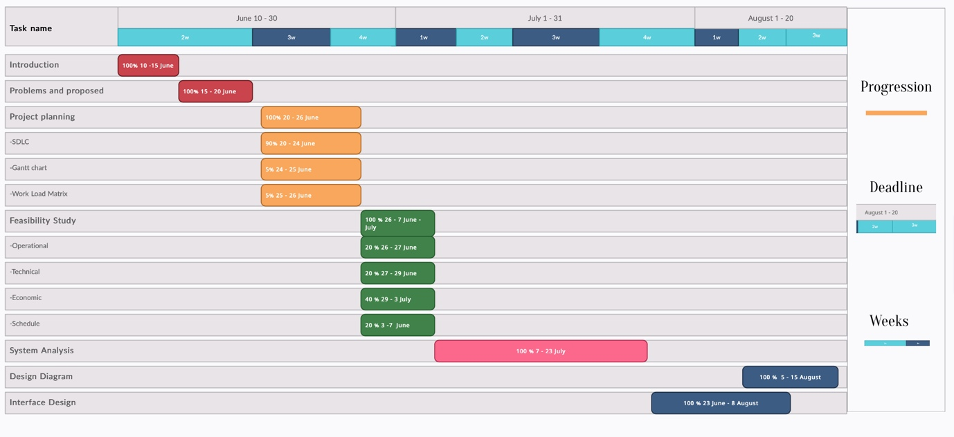

# **3.3 Workload Matrix:**

|  |  |  |  |  |  |  |  |  |  |  |
| --- | --- | --- | --- | --- | --- | --- | --- | --- | --- | --- |
|  |  |  | |  |  |  |  |  |  |  |
| **INTAKE: APD1F2011/APU1F2011** | | | **STUDENT NAME** | | **Jerry** **Justin** | **Avin** **Mahajan** | **Sundy** **Fhan** | **Dustin** **Agussalim** | **Eslam** **Magdy** **Rezk** **Ebrahim** **Hassanin** |  |  |
| **TP NO.** | | **TP062879** | **TP062839** | **TP062917** | **TP061201** | **TP062816** |  |  |
|  |  |  | |  |  |  |  |  |  |  |
| **NO** | **ASSIGNMENT COMPONENT** | | **ALLOCATED MARKS** | | **CONTRIBUTION PERCENTAGE** | **CONTRIBUTION PERCENTAGE** | **CONTRIBUTION PERCENTAGE** | **CONTRIBUTION PERCENTAGE** | **CONTRIBUTION PERCENTAGE** | **TOTAL %** |  |
| **1** | **Introduction Problem Solution Planning  Feasibility Study** | | **30** | | **15.00** | **18.00** | **18.00** | **18.00** | **31.00** | **100** |  |
| **2** | **System Analysis Design Diagram** | | **25** | | **30.00** | **0.00** | **0.00** | **30.00** | **40.00** | **100** |  |
| **3** | **Interface Design** | | **20** | | **20.00** | **20.00** | **20.00** | **20.00** | **20.00** | **100** |  |
| **4** | **Overall Documentation** | | **5** | | **10.00** | **10.00** | **10.00** | **10.00** | **60.00** | **100** |  |
|  | **Total Contribution** | |  | **19%** | **12%** | **12%** | **19%** | **38%** |  |  |
|  |  | **Signature** | |  |  |  |  |  |  |  |
|  |  |  | |  |  |  |  |  |  |  |
|  |  |  | |  |  |  |  |  |  |  |

# **Feasibility Study**

The feasibility study is a preliminary investigation, and it is decided through the decision that this project is worth developing or not, and it consists of operational, technical, economic and schedule, The feasibility study always works to improve the system and works to identify problems in their entirety instead of solving them, and this is the required task, Also, the problem that exists in the system is checked and then the appropriate solution to the problem that is found in the system, whether it exists or not. (tutorialspoint, n.d.).

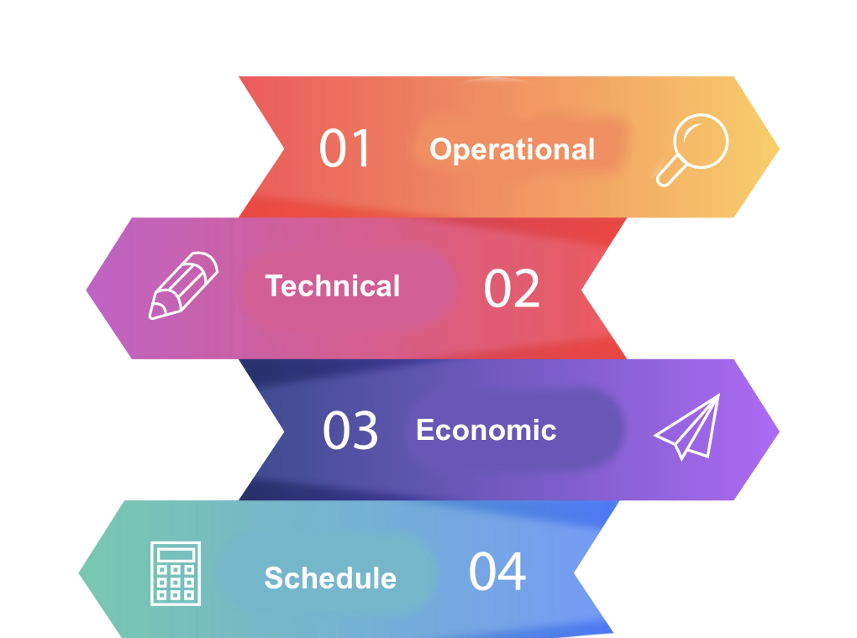

Figure 3: Types of Feasibilities (freepik, n.d.)

**Operational Feasibility study (The PIECES Framework):**

It is known that determining the size of the problem consists of several questions such as will the system be used after development? Attention is focused on internal problems and conflict between employees and how the manager deals with these problems and organizational policies within the organization. This includes how employees will accept the new developed system (science.unitn.it).

The PIECES is used to analyze the performance of the system and develop appropriate plans that help in the feasibility study to determine the tasks and objectives required for the system to develop it, and PIECES succeeded in analyzing the system data by developing a system questionnaire that reached 88 percent, which led to the user’s comfort with the system and also uses the IPA system in the calculation This also results related to the user comfort and satisfaction up to 93.71 percent. (Ahmad Fatoni, 2020)

**P (Performance):**

Performance test and how the system performs and whether it works in a high accuracy or not and is determined based on the speed and how the structures within the system work in a smooth manner through IPA includes 4 Quadrants (e3s-conferences):

Quadrants I: In the first quarter, the tools and devices that make the system work with high accuracy and speed and does not depend on the user are allocated.

Quadrants II: In the second quarter, the high performance that was applied in the first quarter appears, which leads to the user's expectation of great achievement and high efficiency provided by the project in its work.

Quadrants III: In this quarter, the user has low estimates and expectations, accompanied by performance that is not great, and his priority is weak.

Quadrants IV: In the fourth quarter, the importance of it is low, but its performance is very high.

Q1. Is the efficiency of the devices used in the Tiptop bakery system high and help the system work in rapid production?

Yes, because the devices have been developed and the user is not being written on paper, he has become writing on modern and fast devices that help him work and produce in a highly efficient manner.

Q2. What is the difference between the old and new system (Tiptop bakery) in working efficiently and which is better in terms of outputs and inputs?

The old system was very slow and did not absorb the amount of data and its production was very slow, but the new system is a hundred times faster and better in terms of working efficiently and in a high image and in terms of also production capacity due to the development of devices and linking everything to a dedicated database, which made it work efficiently and with high quality.

**I (Information):**

The main goal is to know how much and how clear the information will be generated for a single search.

* Does the current mode provide end users and managers with timely, pertinent, accurate and usefully formatted information?

Yes, the new Tip Top Bakery system has more advanced features. It has better search option and both accurate and faster result. All information is arranged and formatted precisely and user-friendly display so user can find information they need faster and clearer.

**E (Economic):**

The purpose of this study is to analyses and determine the cost/benefit of the proposed project solution to help the organization.

* Does the current mode of operation provide cost-effective information services to the business?

Yes, the system will help Tiptop-Bakery in term of cost-effective by saving times in searching information employee can give their best by doing productive work for the company and reach the set revenue instead of wasting precious time in searching information.

* Could there be a reduction in cost and / or an increase in benefits?

Yes, there will be a reduction in cost by using the new system for the TipTop Bakery and even some benefits, one of the benefits they will get is the operation time of the worker will be more efficient. Before by renting a physical room for storing the information now the system will take a small amount of spaces for storing the company information.

* Does the proposal system save more cost than older system?

The cost for making the new system sure takes a lot but after finishing the system maintaining will be easy and the cost for it not that high. But by using the new system the cost will be reduce than before using the new system it will make up for the loss from the making of the new system.

**C (Control):** The purpose of this study is to analyses and determine the control and security of the proposed project solution to help the organization.

• Does current mode of operation offer effective controls to protect against fraud?

Yes, the new system is built with latest firewall. With the help of firewall Tip Top bakery client’s data will be fully secured from unwanted action. The security will not be either too little or too strong because both can arise problems. As too little security can lead to leak in data or errors in processing data can occur. On the other hand, too much security will lead to processing delay on both client and customer side.

•Does current mode of operation guarantee accuracy and security of data and information?

Yes, the new system has special access to managers to control domain specifications. Manager can himself monitor the traffic on system and block unwanted sources which seems to be suspicious.

**E (Efficiency):** The purpose of efficiency is to figure out resources needed to operate the system.

• Do you need to hire people for new system?

No, the new system does not need any extra person to operate. It can easily be managed by the Tip Top bakery as it is very simple to use. The interface is also very simple to use. The system is user friendly, and one can understand very quickly how to operate the system. Data and information are processed in sequential way.

**S (Service):**

The service part in PIECES framework is to make sure that the service is satisfactorily provided to the customers and other parties involved and to improve the quality of the service.

* Does the current mode of operation provide reliable service?

Yes. With the addition of delivery and online payment, the service will be more reliable. Customers can pay for their goods faster and delivery is also provided for customers that are ordering through online means. Not only that, the online feedback or review can also help in finding some faults so that it can be fixed for a better service.

* Is it flexible and expandable?

Yes. With the improvement of technology, more facilities can be implemented to improve the service. For example, if the database experiences some faults or falling behind in versions, it can be easily upgraded and switched for a better one which also help in the maintenance of the system itself.

**Technical Feasibility:**

It is an analytical technical system that analyses the current system if it needs devices to help develop the system or not. It also focuses on the tools that must be updated to keep pace with technology and lead to a boom in production (tutorialpoint, n.d.).

The current system of tiptop bakery records all data in paper, and there is no means of communication or storing information accurately, and there is also no way to search for the recorded information and even if it is found, it will be false information or contains some errors and duplications, even data protection is also threatened and money is organized, so based on the place should be developed with equipment that will help it solve these problems.

Q1. Is the proposed technology or solution practical?

Yes, it is very practical and may have more development because it is similar to many international stores, and this will help the place with a good reputation due to its capabilities and method of production.

Q2. Do we currently possess the necessary technology?

Yes, because we have the latest hardware and software available, such as ThinkStation CPU and this the top of CPU, Servers, and many of devices that will help the Tiptop bakery.

Q2. –Do we possess the necessary technical expertise, and is the schedule reasonable?

Yes, we use more than one program for scheduling, setting appointments and salaries for Tiptop bakery

Q4. –If the technology is not available, can it be acquired?

Yes, you can buy it through the producing company via online or through Amazon.

**ThinkStation P920 Tower Workstation:**

ThinkStation P920 Tower Workstation will help Tiptop bakery in production and work faster because it has huge specifications like dual Intel Xeonprocessor, It will also help them to schedule data accurately without wasting time, and refer to it without losing any information or duplicating data, and it will help them to undergo a development process for the programs used by employees, because it contains 8GB Ram DDR4 and Three NVIDIA professional GPUs, so this will manage by Tiptop bakery Manager to get all details and information from other devices through the servers.

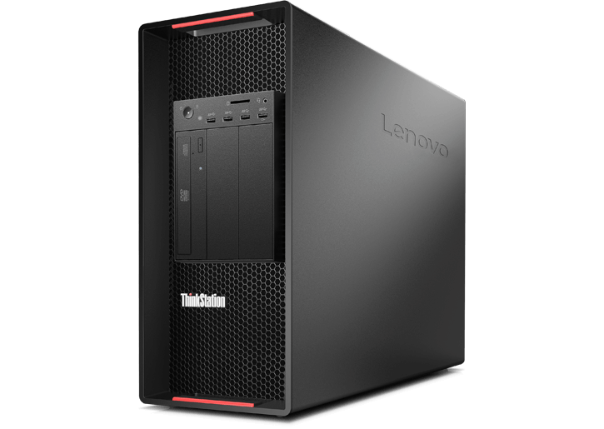

|  |  |
| --- | --- |
| **Specification** | **Cost** |
| Processor: Intel Xeon Silver 4110  OS: Windows 10 Pro 64 bits  Graphics: NVIDIA Quadro P620 2GB  Memory: 8GB DDR4 2666MHz ECC RDIMM  Hard Drive: 1 TB | **$ 2,783.42** |

Figure 4: ThinkStation P920 Tower Workstation (lenovo, n.d.)

Table 1: Specification of Think P920

**PowerEdge T30 Mini Tower Server:**

The server will help the Tiptop bakery by sharing the data and reducing the process of saving files in a quick way in the least time. It can also combine data, images, and all information about the place in more than one location. Users can also store their information centrally through disks and flash drives, and all of this will be done in a simple and fast way because this server contains high capabilities that can help the workplace by saving large data and sharing data between employees in a very accurate manner.

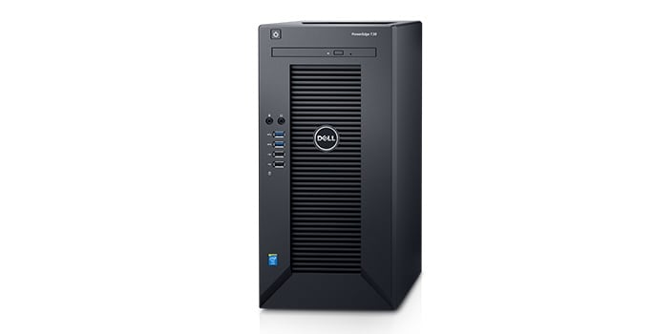

Figure 5: PowerEdge T3o Mini Tower Server (dell, n.d.)

|  |  |
| --- | --- |
| **Specification** | **Cost** |
| Processor: Intel Xeon E3-1225 v5 / Intel PentiumG4400  OS:   * Microsoft Windows Server 2012 / R2 * Red Hat Enterprise Linux * Ubuntu 14.04 /16.04   Memory: Up to 64GB DDR4 2133MT/s  Hard Drive: Up to 6 total SATA HDDs | **$ 798.98** |

Table 2: Specification of PowerEdge T30 Mini Tower Server

**Dell Inspiron 24 5000 All-in-One with A Frame Stand:**

The employees and accountants in the place will use this device to store their data, and the device is provided with a connection from the server that saves the employees’ data from data loss. On the other hand, this device contains very fast and high specifications, which leads to the prevention of work paralysis due to slow devices.

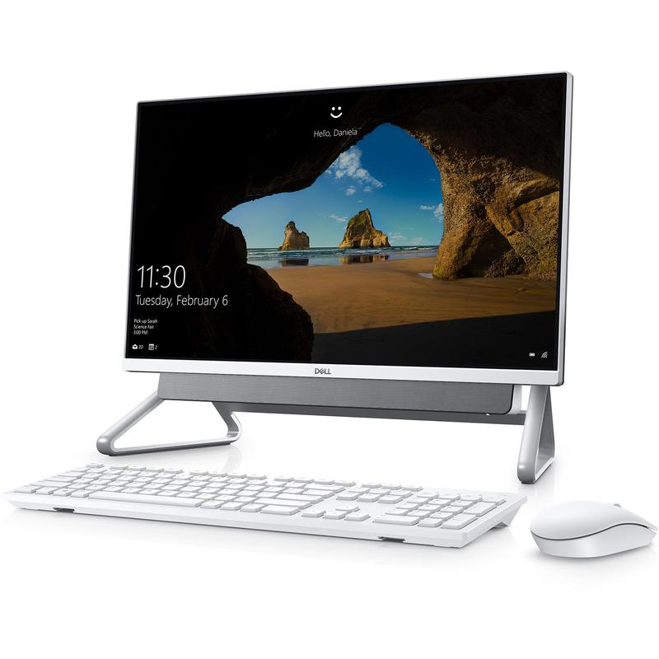

Figure 6: Dell Inspiron 24 5000 All-in-One with A Frame Stand (dell, n.d.)

|  |  |
| --- | --- |
| **Specification** | **Cost** |
| Processor: 11th Generation Intel Core i7-1165G7  OS: Microsoft Windows 10 Home 64 bit  Memory: 16GB (DDR4)  Hard Drive: 512GB SSD | **$ 1,149.99** |

Table 3: Specification of Dell Inspiron 24 5000 All-in-One A Frame Stand

**2D QR Barcode Scanner:**

Automatic barcode reader will help buyers who come to the Tiptop-bakery to buy via mobile via bar code.

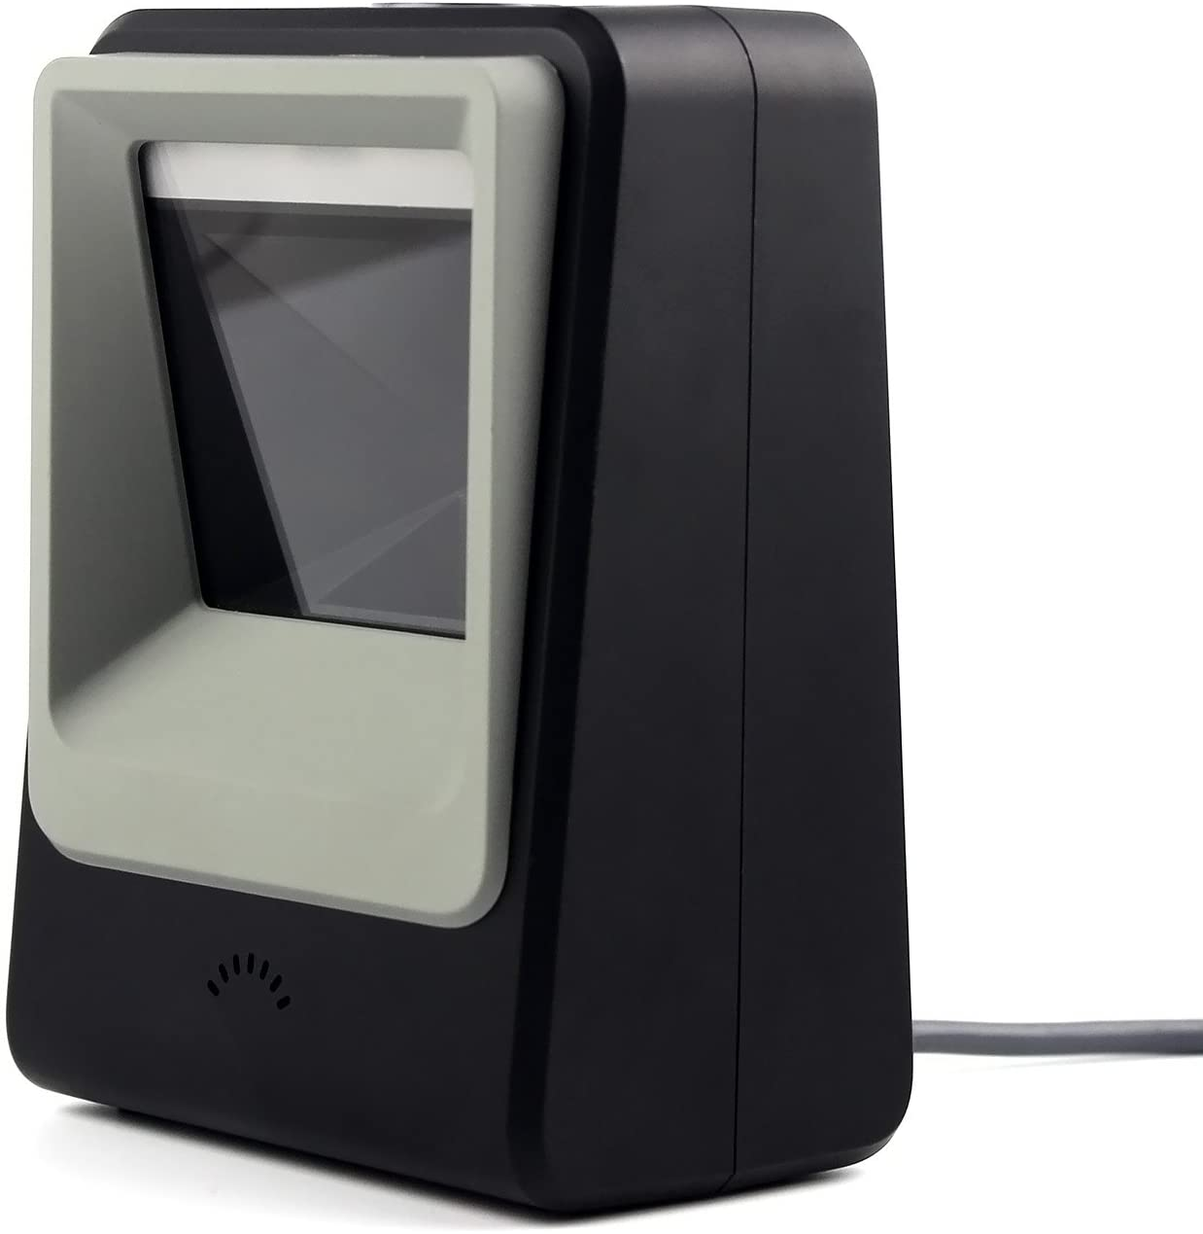

Figure 7: QR Barcode Scanner (amazon, n.d.)

|  |  |
| --- | --- |
| **Specification** | **Cost** |
| Power: Battery  Voltage: 3.7 V  Connectivity: USB | **79,99 $** |

Table 4: QR Barcode Scanner

**Mpos Support Mifire NFC:**

The swipe machine will help the Tiptop-bakery, by helping buyers pay by credit card either by NFC or manually.

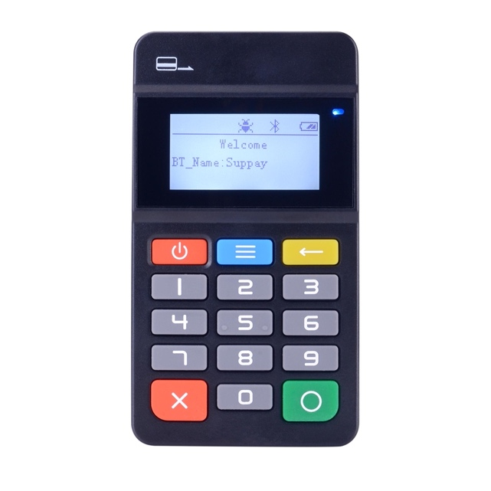

Figure 8: Mpos Support Mifire NFC (aliexpress, n.d.)

|  |  |
| --- | --- |
| **Specification** | **Cost** |
| Power: Rechargeable lithium-ion battery  Processor: 32-bits CPU  Connectivity: USB | **56,00 $** |

Table 5: Mpos Support Mifire NFC

**Netgear Nighthawk WIFI Router:**

The router will help the shop to provide it with a high speed of up to 6 GB without cutting and reduce the problem of excessive behavior and reduce the risk of behavior and the occurrence of damage to it and go to Wi-Fi technology.

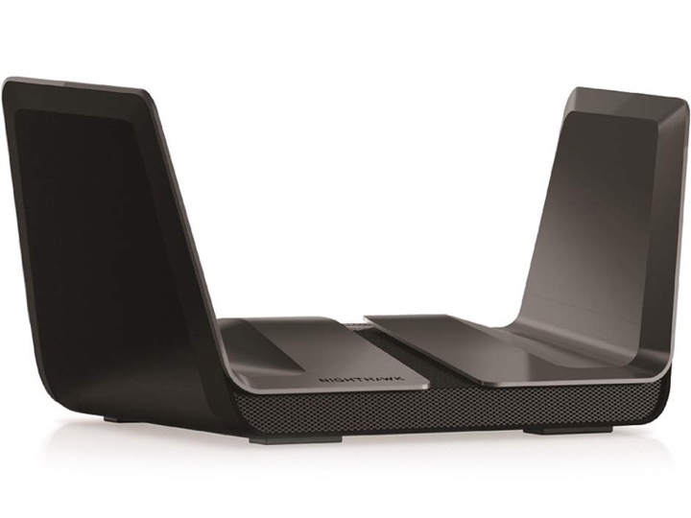

*Figure 9: Netgear Nighthawk WIFI Router* (centrecom, n.d.)

|  |  |
| --- | --- |
| **Specification** | **Cost** |
| Powerful: Quad Core Processor  Channel Support: 160 MHz  Processor boosts wireless: 1.9 GHz | **449 $** |

Table 6: Netgear Nighthawk WIFI Router

**Economic Feasibility:**

Economic feasibility is done when studying the organization’s funds and how it is controlled whether in scheduling the organization’s system or the organization’s devices and gains. Through it, full research is also done on the time taken to complete all requirements and a comprehensive study on all of this until the organization’s economic upgrade (Kumar, Feasibility Study in System Analysis & Design , 2021).

Q1. Is the predictable value of the benefits greater than projected costs of development?

Yes, the benefits are high and are estimated at a rate of 23.9 increase after 4 years.

Q2. How much the project's budget?

Estimated 80,000 $

Q3. How much is our cost?

Estimated at 6996.36 $

Q4. How much is our profit?

Profit = Budget – Cost = 80,000 – 6996.36 = 73,003.64 $

Q5. Does the organization have adequate cash flow to fund the project during the development period?

Yes, they have a surplus of about 73,000 $.

**Cost Classification:**

Cost classification is one of the important things in data analysis and it is also important in cost analysis within the organization and is divided into four sections direct/indirect, fixed/variable costs, tangible/intangible, development and operational costs.

**Direct/indirect costs:**

* Direct costs are costs that are directly assigned to development of a specific system. It can be traced to cost object which can be a product, project, or department (Spielman, 2020). Example: salaries of project team members, hardware purchase.
* Indirect costs are costs that are not directly used for system development which therefore cannot be assigned to cost object but essential to make sure management process can run smoothly. Example: salaries of network admins, rents (Spielman, 2020), and insurance expenses.

**Fixed/Variable costs: Define.**

* Fixed costs are predetermined or overhead expenses that remain same/constant and do not depend on activity level or effort throughout a specific period. Example: hardware rentals, telephone, internet costs, project team salaries, and loan payments.
* Variable costs are costs that change in a specified period and directly associated and depended to the business activity. Example: printer paper, supplies, telephone line charges.

**Tangible/Intangible Costs:**

* Tangible cost is quantifiable that is concerned with the origin and source of the work, such as costs that are paid to a particular employee or a new employee replaced instead of an old employee.
* The intangible cost is not clear enough and is such as low employee morale, which leads to an impact on the company's production (KENTON, 2021).

**Development Costs:**

These are the costs that are paid only once and will not be paid again to develop the current system, such as software purchases or hardware purchases.

|  |  |  |  |
| --- | --- | --- | --- |
| Devices Required | Quantity | Price (Per Device) | Total Price |
| ThinkStation P920 Tower Workstation | 1 | **$ 2,783.42** | **$ 2,783.42** |
| PowerEdge T30 Mini Tower Server | 1 | **$ 798.98** | **$ 798.98** |
| Dell Inspiron 24 5000 All-in-One with A Frame Stand | 2 | **$ 1,149.99** | **$ 2,299.98** |
| 2D QR Barcode Scanner | 2 | **79,99 $** | **159.98 $** |
| Mpos Support Mifire NFC | 1 | **56,00 $** | **56,00 $** |
| Netgear Nighthawk WIFI Router | 2 | **449 $** | **898 $** |
|  |  | **Total** | **6,996.36 $** |

**Operational Cost:**

Are the costs that are paid in a way or in a continuity way after the application of the system and the attachment of all requirements such as maintenance, electricity and internet subscription.

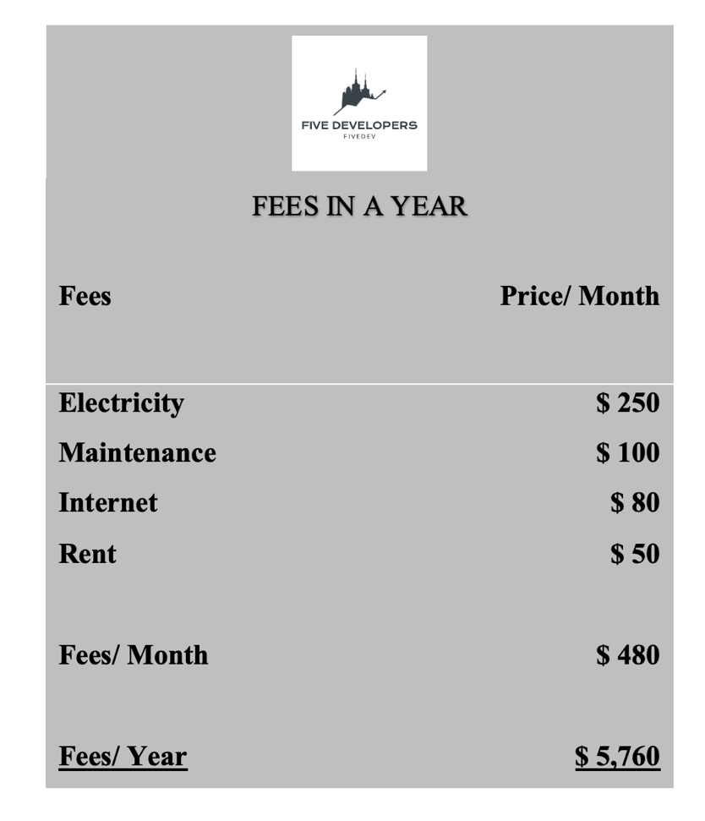

**Payback Analysis :**

|  |  |  |  |  |  |
| --- | --- | --- | --- | --- | --- |
|  | **Year 0** | **First Year** | **Second Year** | **Third Year** | **Fourth Year** |
| **Development Costs** | **6,996.36 $** | **Null** | **Null** | **Null** | **Null** |
| **Operating Cost** | **Null** | **5,760 $** | **5,760 $** | **5,760 $** | **5,760 $** |
| **Total Cost** | **6,996.36 $** | **12756.36 $** | **18516.36 $** | **24276.36 $** | **30036 $** |

**Benefit Analysis:**

The purchase price is relatively per person: 50 $

Relative number of buyers : 300 Buyers / Month

Monthly revenue: 300 x 50 = 15,000 $ Per Month

Annual revenue: 15000 x 12 = 180,000 $ Per Year

**Payback Period:**

It becomes clear to us here that the cost of the Benefits is much higher than the costs of development and the operational costs, and it also shows the great success of the Tip-top bakery in the huge annual profits.

|  |  |  |  |  |  |
| --- | --- | --- | --- | --- | --- |
|  | **Year 0** | **First Year** | **Second Year** | **Third Year** | **Fourth Year** |
| **Development Costs** | **6,996.36 $** | **Null** | **Null** | **Null** | **Null** |
| **Operating Cost** | **Null** | **5,760 $** | **5,760 $** | **5,760 $** | **5,760 $** |
| **Total Cost** | **6,996.36 $** | **12,756.36 $** | **18,516.36 $** | **24,276.36 $** | **30,036 $** |
| **Benefits** | **Null** | **180,000 $** | **180,000 $** | **180,000 $** | **180,000 $** |
| **Total Costs of Benefits** | **Null** | **180,000 $** | **360,000 $** | **540,000 $** | **720,000 $** |

**Cost-Benefit Analysis on Tip-top Bakery:**

Benefit-Cost Ratio = ∑ of all the Expected Benefits / ∑ of all the Associated Costs

So, 720,000 / 30,036 = 23.9 = Benefit-Cost Ratio

Net Present Value = ∑ of all the Expected Benefits - ∑ of all the Associated Costs

So, 720,000 – 30,036 = 689,964 $

**Schedule Feasibility:**

It is one of the most important steps to implement a successful project, which is setting a date for the end of the project, and if the time expires before the project is completed, the project will fail completely, and time is limited based on the required requirements of the organization, so it has tasks in well-established data analysis, such as ensuring the time in which the project will be implemented and whether this time is possible to complete the projects and sufficient for them or not (Kumar, Feasibility Study in System Analysis & Design, 2021). It is in the form of questions like:

Q1.When will the organization receive the project?

Estimated 8 Weeks.

Q2. What is the time required to complete the project requested by the organization?

Time needed = 7 Weeks.

Q3. If the time insufficient to complete the project, is it possible to negotiate with the organization for more time?

No, the deadline is immutable.

|  |  |
| --- | --- |
| **Tasks** | **Days** |
| Planning | 6 |
| Analysis | 16 |
| Design | 10 |
| Implementation | 16 |
| System security and support | 5 |
| **Total** | **53 (7 weeks)** |

Figure 10:Schedule Feasibility

# **System Analysis**

**Functional requirements for Tip-top Bakery:**

* The system must be able to register new customers
* The system must be able to support delivery
* The system must be able to determine the location of customers for delivery
* The system must be able to receive the feedback of customers
* The system must be able to appear all the products of Tip-top Bakery
* The system must be able to make a payment
* The system must be able to include menu for customers and staff
* The system must be able to include help chat online contact
* The system must be able to have a schedule for working time during the week

**Non-Functional Requirements for Tip-top Bakery:**

* The System irritation should not occur while the user is using the system
* The system must send notifications to users regarding the discounts and benefits that they will benefit from
* The system should be fast and suitable for all users
* The system must have no redundancy while storing data
* The system must run smoothly and with high accuracy and be friendly to the environment and the user
* The system should inform the customer about the customer’s request for assistance from the customer service that there is no repetition in waiting for roles and the matter will be more orderly

# **Design Diagram**

**Context Diagram:**

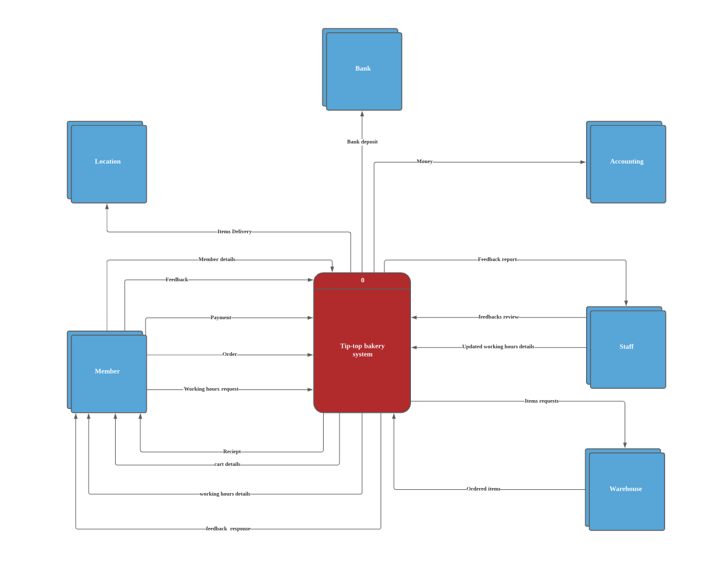

Figure 11: Context Diagram

**Level-0 DFD:**

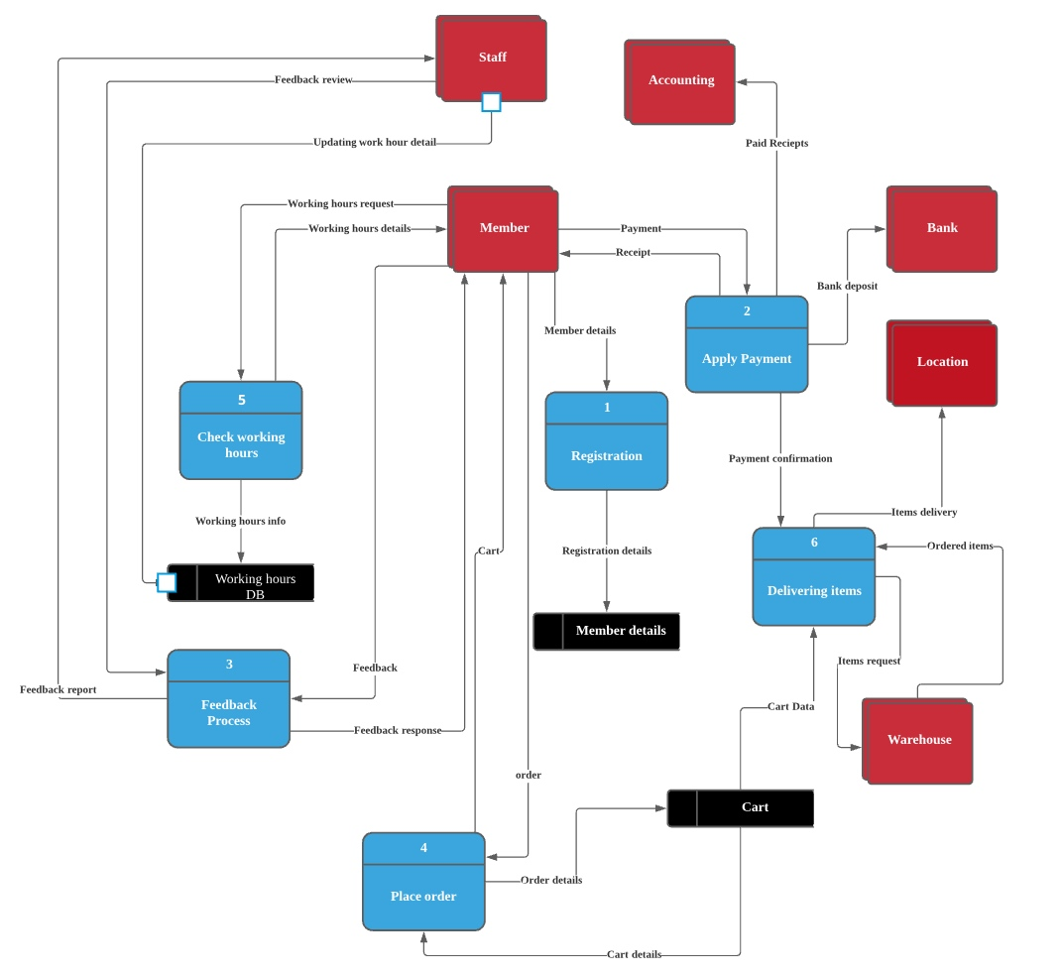

Figure 12: Level-0 DFD diagram

**ERD:**

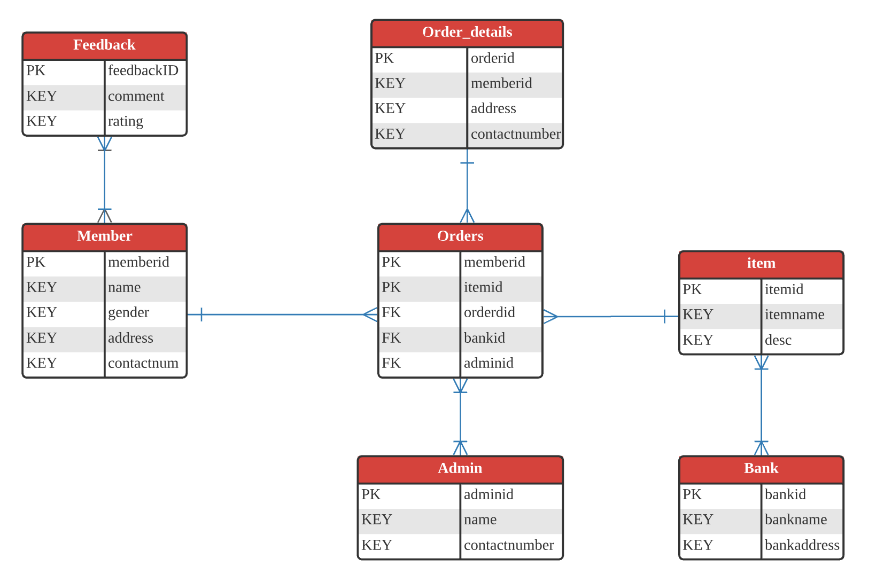

Figure 13: ERD diagram

# **Interface Design**

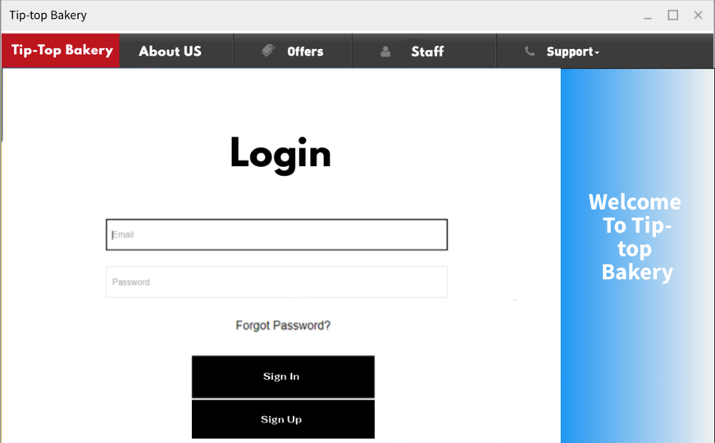

The user or customer enters the password here if he has an account and the password so that he can enter the main menu and order food.

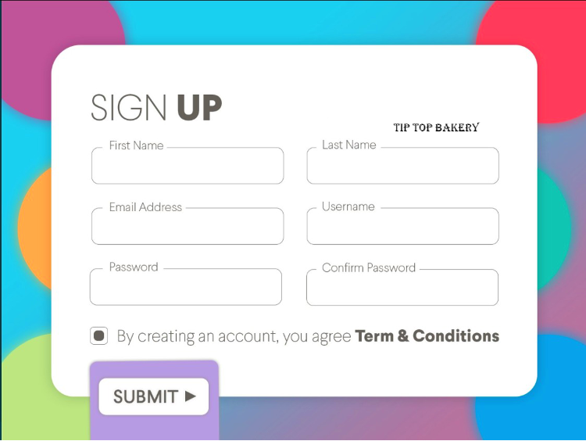

Here the user can create an account via Tip-Top bakery to be able to order food online.

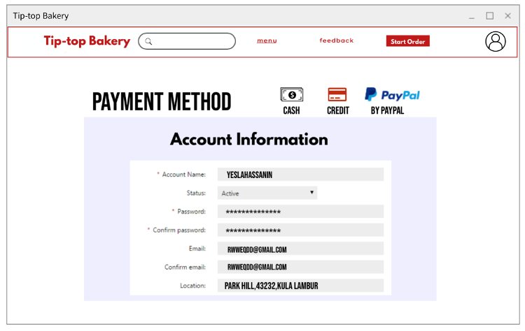

Here all the customer's data after creating his account, such as password, name, country and machine number.

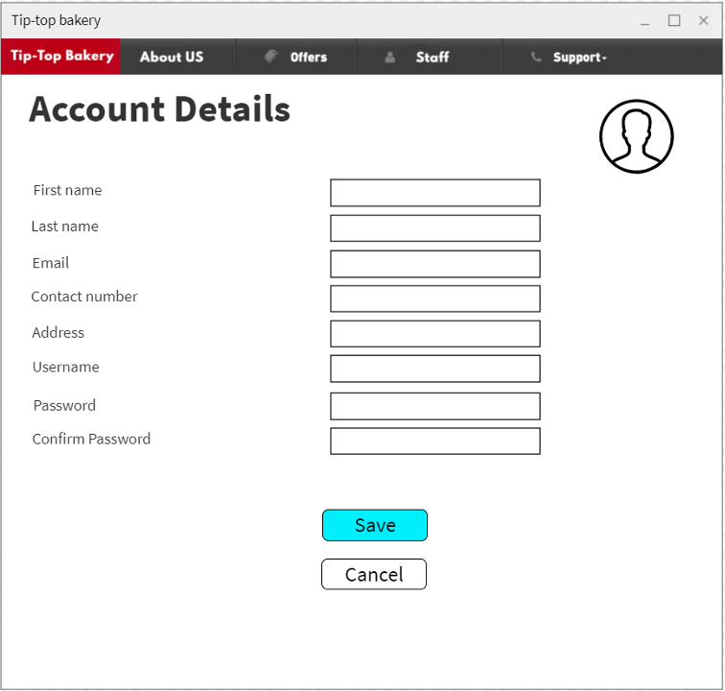

Here the user can enter all his data if he wants to modify it, and then save the data through the Save button.

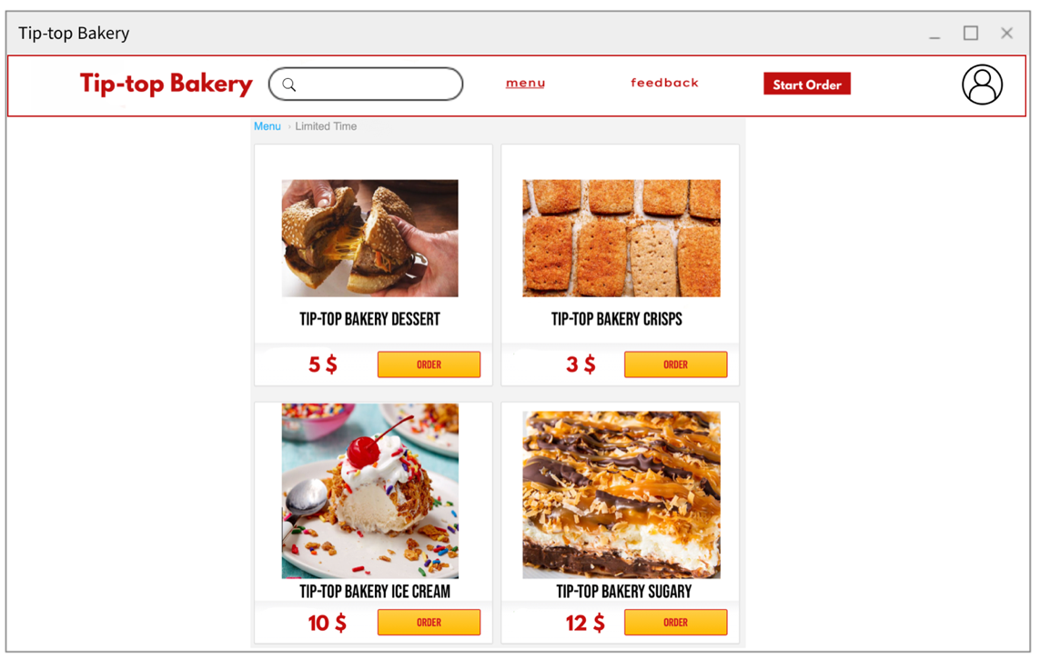

Here is the main menu that appears to the user after creating his own account, he can see the menu and order whatever he wants.

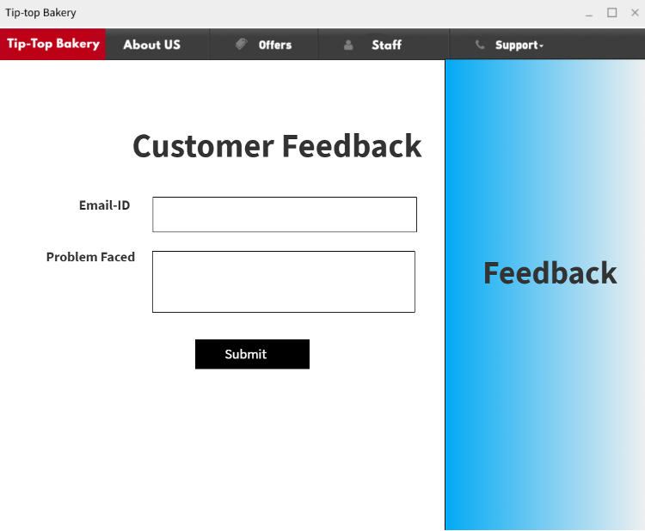

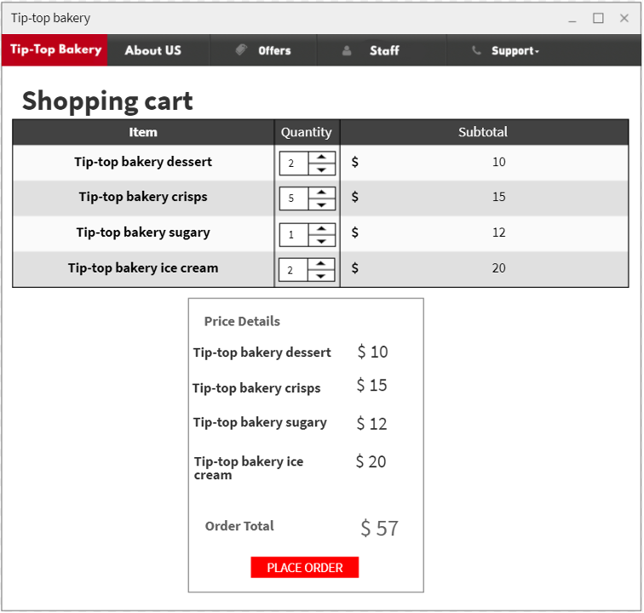

Here in the list of purchases, the customer adds what he requested, and then the system calculates all purchases and gives him the total price.

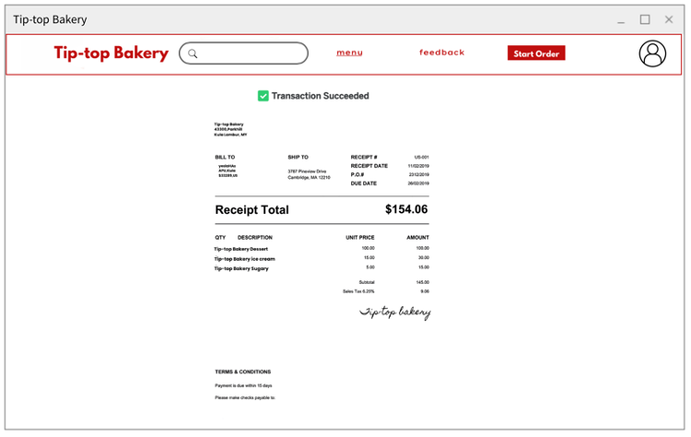

After the customer requests his order, a check for the price is sent to him.

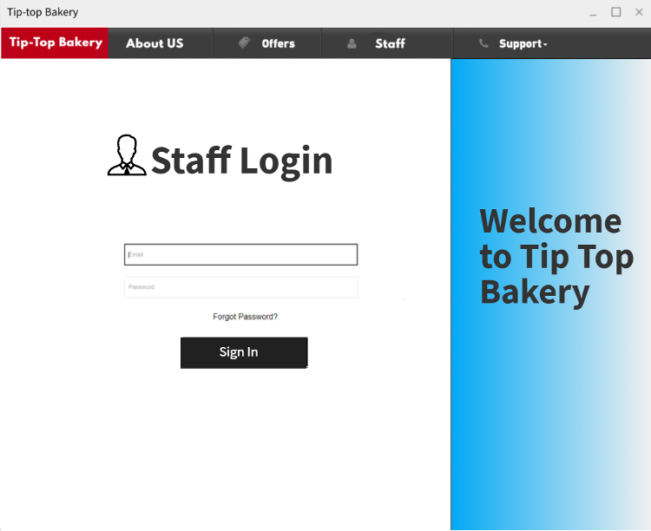

Here, the staff of the Tip-Top Bakery can enter the system and make a login.

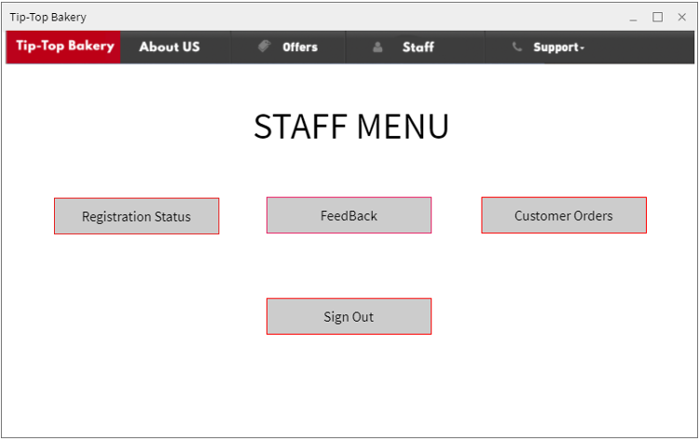

Here the worker can respond to customers and see their problems and requests and log them into the system and thus be approved or rejected.

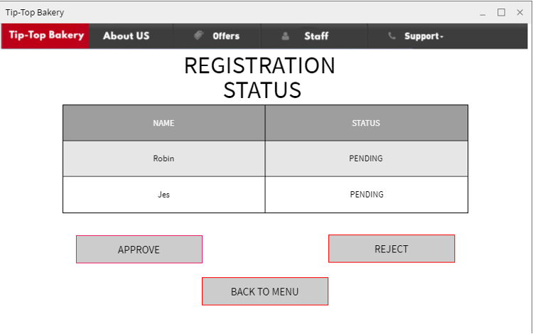

Here the worker can approve or reject the new accounts.

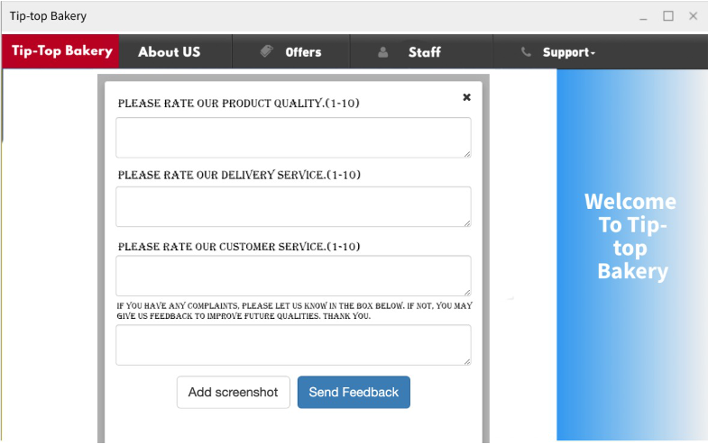

Here the products or bakery are evaluated and there is a button to add pictures.

# **Conclusion:**

The summary is how to analyze the data, and first of all, the work team must follow the rules for data analysis, which is the SDLC. Time must also be taken care of because there is no good reputation without time commitment, especially the data analysis team. Also, there must be a good design of the system and great research. Through it, the required devices and resources that will be used within the system are deduced, also, the calculations must be done accurately, whether in addition, subtraction or multiplication, and the team must be experienced in creating and designing tables in a good way. One of the great things is that the required devices and resources are selected by analyzing the data to the organization and meeting its appropriate needs, by focusing on the money and whether the organization can pay that amount or not, nothing should be random in the analysis of the data, it must be carefully and carefully Ultra, when the work team creates the interface of the system, everything must be checked, there should be no gaps, otherwise it indicates the failure of the work. The term data analysis so that there are no errors and the review must be presented with very great accuracy, whether by evaluating the storage of information or the required code or anything within the organization that is required.

**Individual components:**

**Observation (Eslam Magdy Rezk Ebrahim Hassanin TP062816):**

Observation is the observation of people of the place and through this the required information is collected, and the events and things that are found in the tip-top bakery are more closely scrutinized. It is also very important for matters that are not doubtful or unreliable because they are concerned with the most credible matters by compiling old documents or incomplete documents in order to reduce doubt in the work or question frequently by end users, which leads to the stability of the work (tutorialspoint, n.d.).

In tip-top bakery, accurate information about the workers and the system is collected and how the system and activities are conducted, monitoring and responding to people and sellers, and monitoring the work of the system well with some freedom, and its main goal is to get close to the system and the bakery in a very large way (sharma, n.d.), and there are some questions that help in the notes, including :

1. How are recordings managed within the tip-top bakery and how are they recorded?
2. In the tip-top bakery, is the use of the Internet primary or secondary?
3. Who manages the tip-top bakery organization? Who are the most sufficient people, whether workers, leaders and partners?
4. What does the new tip-top bakery do? And what kind is it a shopping platform or information about the bakery?
5. How did the tip-top bakery system start and how did it reach such a huge amount of development to this day?
6. How is customer data recorded?
7. Is there any waste of time when registering for the first time from customers or when purchasing in the tip-top bakery system?
8. If the system faces a crisis and a fall in the system, can it bear that?
9. What information is required so that the customer can register with us?
10. What is the time taken when there is pressure on the system to deliver orders?

**Advantages and disadvantages** (cse.dmu)**:**

* It provides the observer with all the information he needs for the system.
* Information is collected in a faster and more reliable way.
* Monitoring can have an effective role in verifying information through other sources and references.
* All information about the Tip-top bakery system and all information about customers and employees are collected.
* Surveillance can cause great inconvenience to the workers and the place because some are not ashamed or hate to be watched.

**DFD Level-1 (Delivering items):**

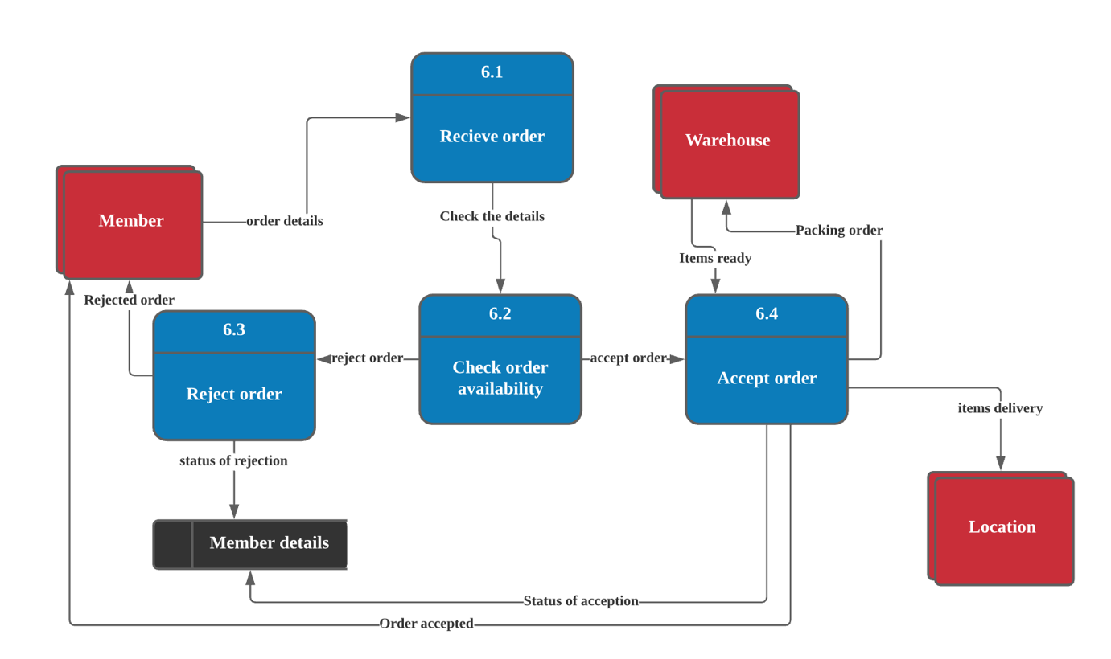

**Data Dictionary:**

**External Entities**

|  |  |
| --- | --- |
| **Name** | **Member** |
| **Description** | This entity has ability to order the items then receive the food from tip-top bakery |
| **Input data flow** | Items – Address |
| **Output data flow** | Confirmation status |
| **Name** | **Warehouse** |
| **Description** | This entity has ability to packing the order from tip-top bakery then deliver it to the Customer or member |
| **Input data flow** | Order’s information – Location details |
| **Output data flow** | Delivering order |
| **Name** | **Location** |
| **Description** | This entity means the address of the member to get the delivery from tip-top bakery |
| **Input data flow** | Item’s delivery |
| **Output data flow** | - |

**Process:**

|  |  |
| --- | --- |
| **Name** | **6.1 Receive order** |
| **Description** | Receiving the order from the member |
| **Input data flow** | Items details |
| **Output data flow** | Check the details |
| **Process Description** | begin  If (order received)  Then  Check all details  Else  Display ”you should put your order”  End if  End |
| **Name** | **6.2 Check order availability** |
| **Description** | This process checks if the availability of the order |
| **Input data flow** | Order details |
| **Output data flow** | Accept orders – Reject orders |
| **Process Description** | begin  If (the order received)  Then  Check the availability of the order  If (the details = 1)  Display ”Order Accepted”  Else  Display “Rejected order”  End if  End |
| **Name** | **6.3 Reject order** |
| **Description** | This process to reject the order |
| **Input data flow** | Reject order |
| **Output data flow** | Update member details (rejected order) – Rejected order |
| **Process Description** | Begin  If (Order = 0)  Then  Reject the order  Then  Update member details  Then  Send status to the member  Else  Display “Error”  End if  End |
| **Name** | **6.4 Accept order** |
| **Description** | This process accepts the orders from members |
| **Input data flow** | Accept order |
| **Output data flow** | Packing order |
| **Process Description** | Begin  If (order = 1)  Then  Accept order  Then packing items  Then  Send to location  Else  Display “Error”  End if  End |

**Data Flows:**

|  |  |
| --- | --- |
| **Name** | **Order Details** |
| **Description** | Send member order details to received ordered process |
| **Origin** | Member (Entity) |
| **Destination** | 6.1 Received order(process)  6.2 Process  6.3 Process  6.4 Process |
| **Data structure** | * Member name * Address * Tele * Order items |
| **Name** | **Check details** |
| **Description** | Send member details to check availability point |
| **Origin** | 6.1 Received order process |
| **Destination** | 6.2 Process |
| **Data structure** | * Member information * Ordered items |
| **Name** | **Reject order** |
| **Description** | Send incorrect information to member details |
| **Origin** | 6.2 Received order process |
| **Destination** | 6.2 Reject order process |
| **Data structure** | Incorrect information of member details or ordered items |
|  |  |
| **Name** | **Rejection status** |
| **Description** | Send incorrect information status to member details in datastore |
| **Origin** | 6.3 Rejected orders |
| **Destination** | Member details (datastore) |
| **Data structure** | Rejected information of member details or ordered items |
| **Name** | **Rejected order** |
| **Description** | Send incorrect information status to member details to member entity |
| **Origin** | 6.3 Rejected orders |
| **Destination** | Member entity |
| **Data structure** | Rejected information of member details or ordered items |
| **Name** | **Accept order** |
| **Description** | Send correct information status to accept order process |
| **Origin** | 6.2 Process |
| **Destination** | 6.4 Process |
| **Data structure** | Accepted information of member details or ordered items:   * Tele * Name * Address * items |
| **Name** | **Acceptation status** |
| **Description** | Send correct information status to member details in datastore |
| **Origin** | 6.4 accepted orders |
| **Destination** | Member details (datastore) |
| **Data structure** | Accepted information of member details or ordered items |
| **Name** | **Accepted orders** |
| **Description** | Send correct information status to member details to member entity |
| **Origin** | 6.4 Process |
| **Destination** | Member entity |
| **Data structure** | Accepted information of member details or ordered items |

|  |  |
| --- | --- |
| **Name** | **Packing orders** |
| **Description** | Packing the orders from warehouse |
| **Origin** | 6.4 Process |
| **Destination** | Warehouse entity |
| **Data structure** | * Member name * Tele * Address * Email * items |
| **Name** | **Items ready** |
| **Description** | Packing the orders from warehouse |
| **Origin** | Warehouse entity |
| **Destination** | 6.4 Process |
| **Data structure** | * Member name * Tele * Address * Email * items |
| **Name** | **Item’s delivery** |
| **Description** | Send the order to determined location |
| **Origin** | 6.4 Process |
| **Destination** | Location entity |
| **Data structure** | * Member name * Tele * Address * Email * items |

**Data Store:**

|  |  |
| --- | --- |
| **Name** | **Member details** |
| **Description** | Store information of the member and update the details of orders |
| **Input data flow** | Details of member such as Member name – tele – items – location – information about rejected or confirmation order |
| **Output data flow** | Details of member such as Member name – tele – items – location – information about rejected or confirmation order |
| **Data structure** | * Member name * Tele * Address * Email * Items * Information |

**Interview (Jerry Justin TP062879):**

Interview is one of the techniques to find information that is done through direct interaction between two or more people. It is one of the most used method to collect data from users or from the staffs. Besides that, the questions used in an interview can either be an open-ended to let the interviewee answer more freely for a broader perspective or close-ended where the answers are limited to a degree for meeting the standard.

There are some advantages in using the interview method to conduct a fact-finding process. Firstly, it can let people give their opinions easier. Some people tend to forget or have no idea on giving their opinion in the form of writing. So, by using interview, the people can explain what they want to say in a faster way. Secondly, the interviewer can ask around for more information. When conducting an interview, usually there are a set of questions prepared before the interview to set the standard for what information to collect. But, by using interview, they can add more questions that can elaborate into the answers for a better and more diverse information.

Although the use of interview method has quite a few advantages, there are also disadvantages to it. One of the disadvantages to this method is the time spent. To conduct an interview, it usually takes a lot of time to finish. After finishing the interview, interviewers need to analyze and document the answers, which can take a lot of time especially for many people. Another disadvantage is the point of view (POV) of interviewers. Every interviewer has a different kind of mindset towards a certain thing. So, it is inevitable that the document that is later produced can be different for each interviewer even though they are interviewing the same person with the same answers.

In this Tip-top bakery case, the interview can be given to the owner or to the customers. It can be conducted either through phone or face-to-face. Some questions that will be asked are:

For the owner:

1. Do you think it is fine to implement the current manual recording system later for the new delivery system?
2. What do you think about the current system’s security in recording the data?
3. How long does it take to search for a record using the current system?
4. Is it tiring to sort the data in the current system?
5. How do you handle the loss of data when using the current system?
6. Are there more features that you would like to change?
7. What kind of errors that have happened during the use of the current system?
8. How often does the error happen when using the current system?
9. How do you feel about implementing a new delivery system?
10. Do you think the budget will be enough to handle all the improvements?

**Level-1 DFD: Process 4.0 (Place order):**

**Data dictionary:**  
**External entities**

|  |  |
| --- | --- |
| **NAME** | Member |
| **DESCRIPTION** | This entity will give order and receive the cart information |
| **INPUT DATA FLOWS** | Cart |
| **OUTPUT DATA FLOWS** | Order |

**Process**

|  |  |
| --- | --- |
| **NAME** | 4.1 Receive order |
| **DESCRIPTION** | Collect order data and give order details to data store |
| **INPUT DATA FLOWS** | Order |
| **OUTPUT DATA FLOWS** | Order details |
| **PROCESS DESCRIPTION** | IF order exist  Then give order details  ELSE  Display “Order not received”  ENDIF |

|  |  |
| --- | --- |
| **NAME** | 4.2 Display cart |
| **DESCRIPTION** | Collect cart details and generate cart |
| **INPUT DATA FLOWS** | Cart details |
| **OUTPUT DATA FLOWS** | Cart |
| **PROCESS DESCRIPTION** | IF Cart details exist  Then generate Cart  ELSE  Display “Cart details not received”  ENDIF |

**Data flows**

|  |  |
| --- | --- |
| **NAME** | Order |
| **DESCRIPTION** | Order data to give order details to data store |
| **ORIGIN** | External entity Member |
| **DESTINATION** | Process 4.1 Receive order |
| **DATA STRUCTURE** | Memberid, membername, itemid, itemname, quantity |

|  |  |
| --- | --- |
| **NAME** | Order details |
| **DESCRIPTION** | Order details to store inside the data store |
| **ORIGIN** | Process 4.1 Receive order |
| **DESTINATION** | Data store Cart |
| **DATA STRUCTURE** | Memberid, membername, itemid, itemname, quantity |

|  |  |
| --- | --- |
| **NAME** | Cart details |
| **DESCRIPTION** | Cart details to generate cart data |
| **ORIGIN** | Data store Cart |
| **DESTINATION** | Process 4.2 Display cart |
| **DATA STRUCTURE** | Memberid, membername, itemid, itemname, quantity |

|  |  |
| --- | --- |
| **NAME** | Cart |
| **DESCRIPTION** | Cart data to display to external entity |
| **ORIGIN** | Process 4.2 Display cart |
| **DESTINATION** | External entity Member |
| **DATA STRUCTURE** | Memberid, membername, itemid, itemname, quantity |

**Data Store**

|  |  |
| --- | --- |
| **NAME** | Cart |
| **DESCRIPTION** | Contains all order data as cart details |
| **INPUT DATA FLOWS** | Order details |
| **OUTPUT DATA FLOWS** | Cart details |
| **DATA STRUCTURE** | Memberid, membername, itemid, itemname, quantity |

**Document Review (Sundy Fhan TP062917):**

Document Review is one of information gathering technique that aims to find out information from the existing information in the current system including reviewing existing system documentation, obtaining copies of actual forms and documents, blank copies of forms, samples of completed forms, software documentation.

In SDLC or System Development Life Cycle, document review making it easier in developing the system, using the existing source (it includes documentation, spreadsheets, presentation, image files, etc.) from the existing system of the company as a guideline in developing the database and the system.

The advantages of document review:

* Relatively inexpensive
* A good source for background information
* Guideline for new system

The disadvantages of document review:

* May be outdated
* Information may be disorganized
* Information can be incomplete or accurate

How the Document Review will be conducted:

1. Existing team will review all documents samples collected to understand on how the Tiptop Bakery operate.
2. The document will be analyzed based on questionnaire such as:
   * How the Tiptop Bakery keep the record?
   * Are there any mistakes in the hand-writing record?
   * Is the documents well organized?
   * Is the record up to date?
   * Will it be in the same format as the existing documents?
   * Will there be any changes in the form format?
   * Can we use existing document as the format?
   * How will the document be recorded?
   * Can changes be done in the document?
   * will there be a new document format?
3. Producing a summary of prioritized documents which reflects the most critical and relevant information for developing the system.

**LEVEL 1 DFD (Apply Payment):**

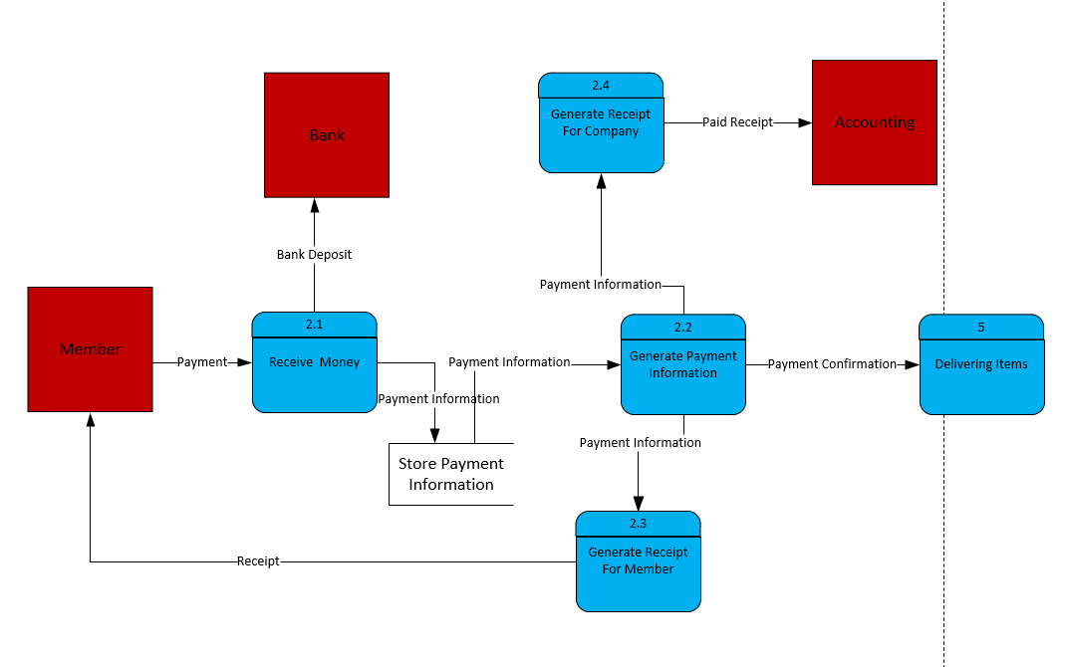

# Data Dictionary

**EXTERNAL ENTITY**

|  |  |
| --- | --- |
| NAME | Member |
| DESCRIPTION | This entity can pay and receive information to TipTop Bakery |
| INPUT DATA FLOWS | Receipt |
| OUTPUT DATA FLOWS | Payment |

|  |  |
| --- | --- |
| NAME | Bank |
| DESCRIPTION | This department will receive Money from the Company |
| INPUT DATA FLOWS | Bank Deposit |
| OUTPUT DATA FLOWS | N/A |
| NAME | Accounting |
| DESCRIPTION | This department will receive Information from company |
| INPUT DATA FLOWS | Paid Receipt |
| OUTPUT DATA FLOWS | N/A |

**PROCESS**

|  |  |
| --- | --- |
| NAME | 2.1 Receive Money |
| DESCRIPTION | Collect all payment from member and send information |
| INPUT DATA FLOWS | Payment |
| OUTPUT DATA FLOWS | Payment Information  Bank Deposit |
| PROCESS DESCRIPTION | If Payment Receive  Then Select all information  Else  Display No New Payment  End If |

|  |  |
| --- | --- |
| NAME | 2.2 Gather Payment Information |
| DESCRIPTION | Collect Information and send information |
| INPUT DATA FLOWS | Payment Information |
| OUTPUT DATA FLOWS | Payment Confirmation  Payment Information  Payment Information |
| PROCESS DESCRIPTION | If Payment Information Exist  Then Send information to Deliver Items and send information to Generate Receipt for company and to member’s process.  Else  Display No New Information  End If |

|  |  |
| --- | --- |
| NAME | 2.3 Generate Receipt for Members |
| DESCRIPTION | Collect Information and generate Receipt |
| INPUT DATA FLOWS | Payment Information |
| OUTPUT DATA FLOWS | Receipt |
| PROCESS DESCRIPTION | If Payment Information Exist  Then Generate Receipt.  Else  Display No New Information  End If |

|  |  |
| --- | --- |
| NAME | 2.4 Generate Receipt for Company |
| DESCRIPTION | Collect Information from process 4.2 and generate Receipt |
| INPUT DATA FLOWS | Payment Information |
| OUTPUT DATA FLOWS | Receipt |
| PROCESS DESCRIPTION | If Payment Information Exist  Then Generate Receipt.  Else  Display No New Information  End If |

**DATA FLOWS**

|  |  |
| --- | --- |
| NAME | Payment |
| DESCRIPTION | money that is received for information and store |
| ORIGIN | Members |
| DESTINATION | Process 4.1 Receive Money |
| DATA STRUCTURE | Membered, name, gender, address, contactnum, payment |

|  |  |
| --- | --- |
| NAME | Bank Depostit |
| DESCRIPTION | Money that is received will be deposit into bank |
| ORIGIN | Process 2.1 |
| DESTINATION | Bank |
| DATA STRUCTURE | Payment |

|  |  |
| --- | --- |
| NAME | Payment Information |
| DESCRIPTION | Information will be sent |
| ORIGIN | Process 2.1,  Data Store payment information  Process 2.2 |
| DESTINATION | Data Store Payment Information  Process 2.2  Process 2.3  Process 2.4 |
| DATA STRUCTURE | Membered, name, gender, address, contactnum, payment |

|  |  |
| --- | --- |
| NAME | Payment Confirmation |
| DESCRIPTION | Received payment information and use it as a confirmation |
| ORIGIN | Process 2.2 |
| DESTINATION | Process 5 |
| DATA STRUCTURE | Membered, name, gender, address, contactnum, payment |

|  |  |
| --- | --- |
| NAME | Receipt |
| DESCRIPTION | Sending Generated Receipt |
| ORIGIN | Process 2.3  Process 2.4 |
| DESTINATION | Members  Accounting |
| DATA STRUCTURE | Membered, name, gender, address, contactnum, payment, items |

**DATA STORE**

|  |  |
| --- | --- |
| NAME | D2 Store Payment Informatin |
| DESCRIPTION | Contains all Receiving payment information |
| INPUT DATA FLOWS | Payment information |
| OUTPUT DATA FLOWS | Payment information |
| DATA STRUCTURE | Member id, Member Name, Address, Item, Quantity, Total, payment |

**Questionnaire (Dustin Agussalim TP061201):**

The use of questionnaire method in the information gathering process enables us to obtain inputs from a large number of people which can finally be analysed for the purpose of the system development. The design and type of answers in the questionnaire hold an essential part for the success of this method. There are some benefits and setbacks of using this method. For the advantages, first, it has wide coverage. Questionnaire can be sent to many people at once. It can be sent easily and practically through links and people can access the questionnaire through those links. This way, input that can be received also increases. Second, the method requires a low budget. Since, questionnaire can be sent online via e-mail, links, and many others, the cost needed is low compared to other methods. Third, this method can also be used to gather information from people far away, so distance is not a problem. Fourth, this method can be used to get information anonymously. This means people can answer the question without feeling worried that their personal information can be leaked. This way, people can input answers comfortably and freely express themselves. Last, a questionnaire can be easily worked with. After respondents submit the questionnaire, the developer will receive written replies that have been well documented so it will be easier to analyse.

However, this method also has some disadvantages. First, it takes time to create the questionnaire. Developer has to carefully create and choose the types of question that are suitable for the questionnaire. There are some guidelines that have to be followed. For instance, the questionnaire has to be brief and user-friendly, it has to have clear instructions, it has to use simple wording as well as prevent leading questions and many others. Second, this method may be considered not important or often ignored by some people. Hence, developer will not get good response. Third, it is possible that the input is manipulated. It is difficult for the developer to check whether the respondents manipulate the answer or not unlike doing it in a face-to-face situation. Last, it is possible that the questionnaire reaches the wrong target group. Since questionnaire can be sent freely online, developer may receive unnecessary respond from the respondents.

For Tip-top bakery’s system development project, there are two ways for the questionnaire to be conducted. It will be sent online via e-mail and there will be QR code provided in the store so respondents can easily access the questionnaire using their mobile phones. The targets for this information gathering process are Tip-top bakery’s employees. The questions are as below.

1. Are you satisfied with the old system (current system)? (Yes/No).
2. Do you think the current system is sufficient to keep the business running? (Yes/No).
3. Please rate your satisfaction of the current system. (Rate 1-5).
4. How long does it take to record data manually to books and spreadsheets?
5. Please rate how effective the manual data record is. (Rate 1-5).
6. How long does it usually take to retrieve data from the records?
7. What do you like and possibly keep in the new system from the old system?
8. For the new system, what features would you like to be added?
9. Do you think the new system will be helpful for the business? (Yes/No).
10. Please rate how essential the new system is for you. (Rate 1-5).

Rating:

1= worst, 2 = quite bad, 3 = normal, 4 = pretty good, 5 = excellent

**Level 1 DFD (Feedback):**

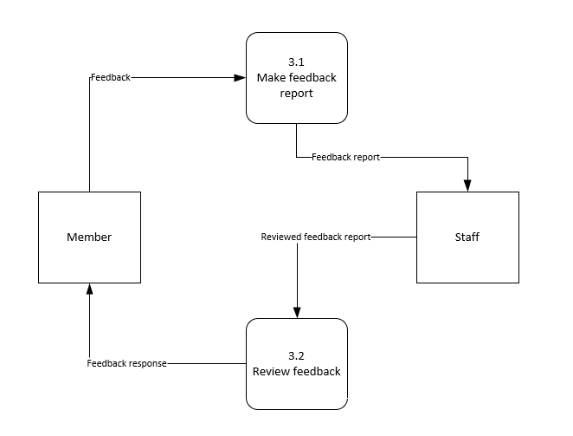

Data Dictionary

External entity

|  |  |
| --- | --- |
| NAME | Member |
| DESCRIPTION | Member submits feedback to the system and receives response |
| INPUT DATA FLOWS | Feedback response |
| OUTPUT DATA FLOWS | Feedback |

|  |  |
| --- | --- |
| NAME | Staff |
| DESCRIPTION | Staff receive feedback report from the system then review the report |
| INPUT DATA FLOWS | Feedback report |
| OUTPUT DATA FLOWS | Reviewed feedback report |

Process

|  |  |
| --- | --- |
| NAME | 3.1 Make feedback report |
| DESCRIPTION | Collect feedback from member to generate report |
| INPUT DATA FLOWS | Feedback |
| OUTPUT DATA FLOWS | Feedback report |
| PROCESS DESCRIPTION | If member submits feedback  Then generate report  Else  Display report not available  End If |

|  |  |
| --- | --- |
| NAME | 3.2 Review feedback |
| DESCRIPTION | Receive reviewed feedback report from staff then generate response to member |
| INPUT DATA FLOWS | Reviewed feedback report |
| OUTPUT DATA FLOWS | Feedback response |
| PROCESS DESCRIPTION | If staff submit reviewed feedback report  Then generate response  Else  Display response not available  End If |

Data flow

|  |  |
| --- | --- |
| NAME | Feedback |
| DESCRIPTION | Feedback that is required to make report |
| ORIGIN | External entity Member |
| DESTINATION | Process 3.1 Make feedback report |
| DATA STRUCTURE | FeedbackID, comment, rating |

|  |  |
| --- | --- |
| NAME | Feedback report |
| DESCRIPTION | Report that is required to be reviewed |
| ORIGIN | Process 3.1 Make feedback report |
| DESTINATION | External entity Staff |
| DATA STRUCTURE | FeedbackID, comment, rating |

|  |  |
| --- | --- |
| NAME | Reviewed feedback report |
| DESCRIPTION | Reviewed report that is required to make response |
| ORIGIN | External entity Staff |
| DESTINATION | Process 3.2 Review feedback |
| DATA STRUCTURE | FeedbackID, comment, rating |

|  |  |
| --- | --- |
| NAME | Feedback response |
| DESCRIPTION | Response that is given to member |
| ORIGIN | Process 3.2 Review feedback |
| DESTINATION | External entity Member |
| DATA STRUCTURE | FeedbackID, comment, rating |

**Sampling (Avin Mahajan TP062839):**

A) Sampling is a technique that qualitive researchers use to recruit participants who can provide in-depth and detailed information about the phenomenon under investigation. The main objective of sampling is to ensure representation of the overall population accurately. There are different techniques of sampling. First, Systematic sampling in this every 10th customer is selected for review. Second, Stratified sample postal codes in this five customers are selected from each of four postal codes. Third, Random Sample in this any 20 customers are selected randomly.

Advantages:

1) Sampling helps us to obtain nearly accurate results in much lesser time.

2) It saves time at great extent by reducing the volume of data.

3) With the help of sampling, we can get detailed information of data even after having small number of resources.

4) Sampling helps to not repeat the query again and again to all individual data which results in less monotony in work.

Disadvantages:

Like every coin has two sides, in the same way sampling also have its own disadvantages.

1) Selection of proper size of sample is a difficult task.

2) Improper selection of sampling techniques can result into inaccurate results.

3) Sometimes there exist a chance of biasness as choice of sampling method is a judgmental task.

B) Investigation helps organization to get in-depth and detailed information about their products and services. It helps them to know how people feel about their services and at what point they can improve themselves to provide more value to customers.

Questions:

1) Which process takes the longest time for your staff?

2) How efficient is your current system?

3) How secure is your current system?

4) What improvements or changes you want in your current system?

5) What more features you wish your current system should have?

6) How long it takes to extract data from your current system?

7) What is the task you find it to do difficult in your current system?

8) Is the interface of system is user-friendly?

9) How often the current system freezes or crash?

10) Are messages given by the system are easily understandable?

**Level 1 DFD (Check Working Hours):**

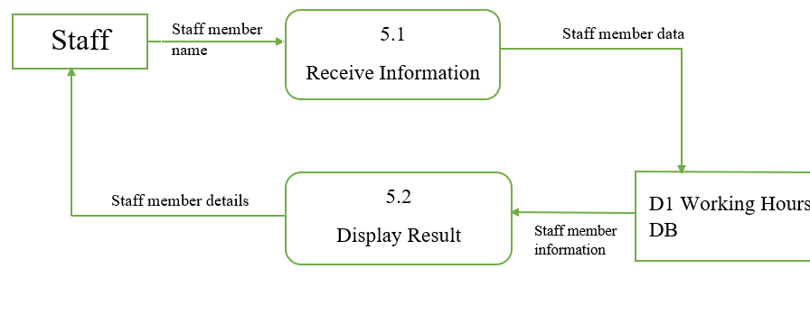

b) Data Dictionary

**EXTERNAL ENTITY**

|  |  |
| --- | --- |
| NAME | Staff |
| DESCRIPTION | This department will receive report from the system periodically |
| INPUT DATA FLOWS | Report |
| OUTPUT DATA FLOWS | N/A |

**PROCESS**

|  |  |
| --- | --- |
| NAME | 5.1 Receive Information |
| DESCRIPTION | Collect name for which working hour has to be checked |
| INPUT DATA FLOWS | Staff Member name |
| OUTPUT DATA FLOWS | Staff Member Data |
| PROCESS DESCRIPTION | If data exist in the data store  Then select all required data  Else  Display report not available  End If |

|  |  |
| --- | --- |
| NAME | 5.2 Display Result |
| DESCRIPTION | Show the working hour for the staff member name |
| INPUT DATA FLOWS | Staff Member Information |
| OUTPUT DATA FLOWS | Staff Member Details |
| PROCESS DESCRIPTION | If data exist in the data store  Then it will show the information of working hours  Else  Display report not available  End If |

**DATA FLOWS**

|  |  |
| --- | --- |
| NAME | Staff Member Name |
| DESCRIPTION | Name of the staff member |
| ORIGIN | Data Store Staff |
| DESTINATION | Process 5.1 Receive Information |
| DATA STRUCTURE | StaffID, StaffName, Working Hours |

|  |  |
| --- | --- |
| NAME | Staff Member Data |
| DESCRIPTION | Data of the staff member |
| ORIGIN | 5.1Recieve Information |
| DESTINATION | Process D1 Working Hours |
| DATA STRUCTURE | StaffID, StaffName, Working Hours |

|  |  |
| --- | --- |
| NAME | Staff Member Information |
| DESCRIPTION | Information of staff member |
| ORIGIN | Data Store D1 Working Hours |
| DESTINATION | 5.2 Display Result |
| DATA STRUCTURE | StaffID, StaffName, Working Hours |

|  |  |
| --- | --- |
| NAME | Staff Member Details |
| DESCRIPTION | Details of Staff member |
| ORIGIN | 5.2 Display Result |
| DESTINATION | Staff |
| DATA STRUCTURE | StaffID, StaffName, Working Hours |

**DATA STORE**

|  |  |
| --- | --- |
| NAME | D1 Order |
| DESCRIPTION | Contains all working hours data |
| INPUT DATA FLOWS | N/A |
| OUTPUT DATA FLOWS | Staff Member Information |
| DATA STRUCTURE | StaffID, StaffName, Working Hours |

# **References**

Eby, K. (2017, 06 27). *History and Origin of the System Development Lifecycle*. Retrieved from smartsheet: https://www.smartsheet.com/system-development-life-cycle-guide

VERACODE. (n.d.). *Systems Development Life Cycle*. Retrieved from VERACODE: https://www.veracode.com/security/what-systems-development-life-cycle

INNOVATIVEARCHITECTS. (n.d.). *The Seven Phases of the System-Development Life Cycle*. Retrieved from INNOVATIVEARCHITECTS: https://www.innovativearchitects.com/KnowledgeCenter/basic-IT-systems/system-development-life-cycle.aspx

NIOS. (n.d.). *Phases of System Development Life Cycle* . Retrieved from NIOS: http://oer.nios.ac.in/wiki/index.php/Phases_of_System_Development_Life_Cycle

PRESENTATIONGO. (n.d.). *Hexagon Checklist for PowerPoint and Google Slides* . Retrieved from PRESENTATIONGO: https://www.presentationgo.com/presentation/hexagon-checklist-powerpoint-google-slides/

Ghahrai, A. (2018, 11 07). *Software Development Life Cycle - SDLC* . Retrieved from DevQA: https://devqa.io/software-development-life-cycle-sdlc-phases/

McKinsey. (2012). *The social economy: Unlocking value and productivity through social technologies*. Retrieved June 20, 2021, from https://www.mckinsey.com/industries/technology-media-and-telecommunications/our-insights/the-social-economy

Hietala, J. (2019). *Why Do We Spend All That Time Searching for Information at Work?* Retrieved June 20, 2021, from https://www.valamis.com/blog/why-do-we-spend-all-that-time-searching-for-information-at-work

BETSOL. (2020, 12 02). *7 Stages of SDLC: How to Keep Development Teams Running*. Retrieved from BETSOL: https://www.betsol.com/blog/7-stages-of-sdlc-how-to-keep-development-teams-running/

tutorialspoint. (n.d.). *System Analysis & Design - System Planning* . Retrieved from tutorialspoint: https://www.tutorialspoint.com/system_analysis_and_design/system_analysis_and_design_planning.htm

freepik. (n.d.). Retrieved from freepik: https://www.freepik.com/free-vector/colorful-infographic-banners-set_4041732.htm

science.unitn.it. (n.d.). *Types of Feasibility.* Retrieved from science.unitn.it: http://www.science.unitn.it/~pgiorgio/db2/slides/8-feasibility.pdf

Ahmad Fatoni, K. A. (2020, 11 10). *PIECES Framework and Importance Performance Analysis Method to Evaluate the Implementation of Information Systems*. Retrieved from e3s-conferences: https://www.e3s-conferences.org/articles/e3sconf/abs/2020/62/e3sconf_icenis2020_15007/e3sconf_icenis2020_15007.html

e3s-conferences. (n.d.). *PIECES Framework and Importance Performance Analysis Method to Evaluate the Implementation of Information Systems.* Retrieved from E3S Web of Conferences: https://www.e3s-conferences.org/articles/e3sconf/pdf/2020/62/e3sconf_icenis2020_15007.pdf

Office of Financial Management. (2011). *40.40*. Retrieved July 09, 2021, from https://ofm.wa.gov/sites/default/files/public/legacy/policy/40.40.htm#:~:text=The%20purpose%20of%20an%20economic,general%20public%20as%20a%20whole.

amazon. (n.d.). *2D QR Barcode Scanner,Symcode Omnidirectional Hands-Free USB Automatic Barcode Reader for Mobile Payment Computer Screen Scan*. Retrieved from amazaon: https://www.amazon.com/Barcode-Scanner-Omnidirectional-Hands-Free-Computer/dp/B06XD8MFFC

dell. (n.d.). *Inspiron 24 5000 Silver Touch All-In-One with A-Frame Stand*. Retrieved from dell: https://www.dell.com/en-us/search/DELL%20Dell%20Inspiron%2024%205000?p=1&c=desktops&f=true&ac=categoryfacetselect

dell. (n.d.). *PowerEdge T30 Mini Tower Server*. Retrieved from dell: https://www.dell.com/ae/business/p/poweredge-t30/pd

lenovo. (n.d.). *ThinkStation P920 Tower Workstation*. Retrieved from lenovo: https://www.lenovo.com/us/en/think-workstations/thinkstation-p-series-towers/ThinkStation-P920/p/33TS3TPP920

tutorialpoint. (n.d.). *System Analysis & Design - System Planning*. Retrieved from tutorialpoint: https://www.tutorialspoint.com/system_analysis_and_design/system_analysis_and_design_planning.htm

aliexpress. (n.d.). *Ultra-thin Mini POS Machine For Store. NFC Credit Card Terminal Mobile MPOS HTY711* . Retrieved from aliexpress: https://www.aliexpress.com/item/32798466409.html

centrecom. (n.d.). *Netgear Nighthawk AX8/8-Stream AX6000 WiFi Router - RAX80* . Retrieved from centrecom: https://www.centrecom.com.au/netgearr-nighthawk-ax88-stream-ax6000-wifi-router-rax80

Kumar, A. (2021, 05 28). *Feasibility Study in System Analysis & Design* . Retrieved from freestudy: https://www.freestudy.com/feasibility-study-in-system-analysis-design/

KENTON, W. (2021, 06 30). *Tangible vs. Intangible Costs* . Retrieved from investopedia: https://www.investopedia.com/terms/t/tangible-cost.asp

Spielman, E. (2020, 06 12). *Direct Costs vs. Indirect Costs: What Are They, and How Are They Different?* . Retrieved from businessnewsdaily: https://www.businessnewsdaily.com/5498-direct-costs-indirect-costs.html

Kumar, A. (2021, 05 28). *Feasibility Study in System Analysis & Design*. Retrieved from freestudy: https://www.freestudy.com/feasibility-study-in-system-analysis-design/

tutorialspoint. (n.d.). *System Analysis & Design - System Planning* . Retrieved from tutorialspoint: https://www.tutorialspoint.com/system_analysis_and_design/system_analysis_and_design_planning.htm

sharma, p. (n.d.). *Tools of Information Gathering for System Analysis* . Retrieved from yourarticlelibrary: https://www.yourarticlelibrary.com/management/mis-management/tools-of-information-gathering-for-system-analysis/70398

cse.dmu. (n.d.). *Requirements Capture .* Retrieved from cse.dmu: http://www.cse.dmu.ac.uk/UMLISAD/chapter5/1_5_2.html

U.S Department of Health Human Services. (2021, August 18). *Data Collection Methods for Evaluation: Document Review.* Retrieved from cdc.gov: https://www.cdc.gov/healthyyouth/evaluation/pdf/brief18.pdf

bzfar77. (2020, September 29). *System analysis. Data collection methods.* Retrieved from bzfar: https://www.bzfar.org/publ/sdlc/stages_of_sdlc/data_collection_methods/47-1-0-56

# Appendices

## Work Break Down Structure

|  |  |  |
| --- | --- | --- |
| Student Name | Roles/Responsibilities | Signature |
| Eslam Magdy Rezk Ebrahim Hassanin | * Introduction * Logo * Motto * Problems * Proposed Solutions * Project Planning * Feasibility Study * Technical Feasibility * Economic Feasibility * Interface design * Design diagram * Schedule study * System analysis * Conclusion * Individual components (observation – Items delivery DFD level 1) * Proof-reading * Editing (Whole document) |  |
| Dustin Agussalim | * Problems * Proposed Solutions * Project Planning * Feasibility Study * Economic Feasibility * Interface design * Design diagram * Individual Part (Questionnaire – Feedback DFD level 1) |  |
| Avin Mahajan | * Vision * Mission * Problems * Proposed Solutions * Project Planning * Feasibility Study * Technical Feasibility * Economic Feasibility * Interface design * Individual part (Sampling - Check working hours DFD level 1) |  |
| Sundy Fhan | * Vision * Mission * Problems * Proposed Solutions * Project Planning * Feasibility Study * Economic Feasibility * Interface design * Individual part (Document Review – Apply payment DFD level 1) |  |
| Jerry Justin | * Problems * Proposed Solutions * Project Planning * Feasibility Study * Interface design * Design diagram * Individual Part (Interview – Level-1 DFD: Process 4.0 Place Order) |  |