Run the application locally with npm
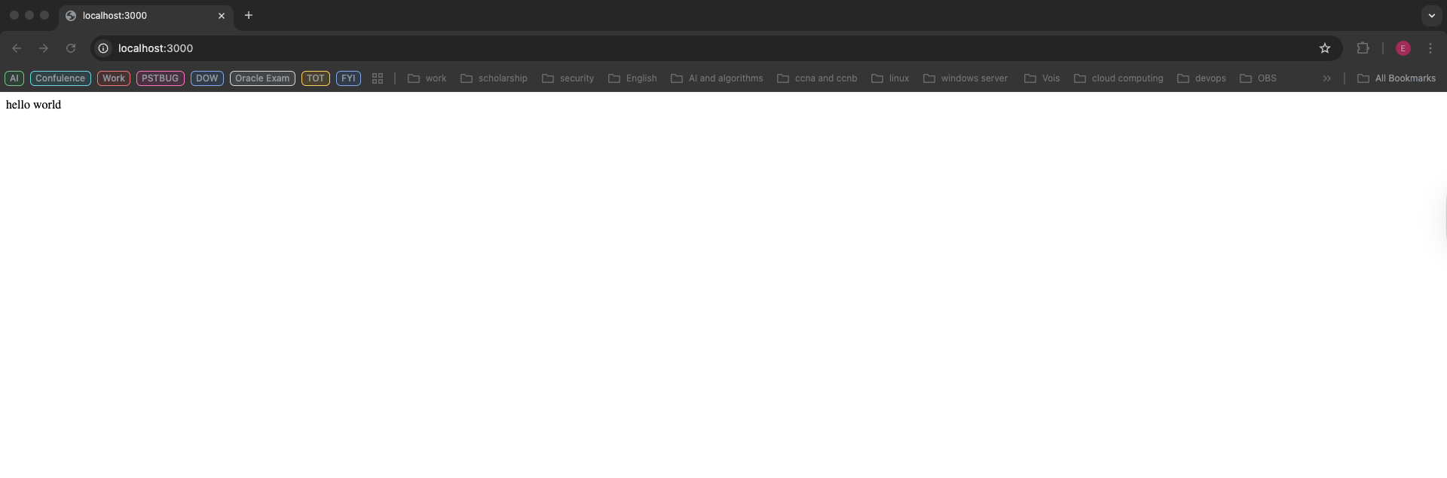
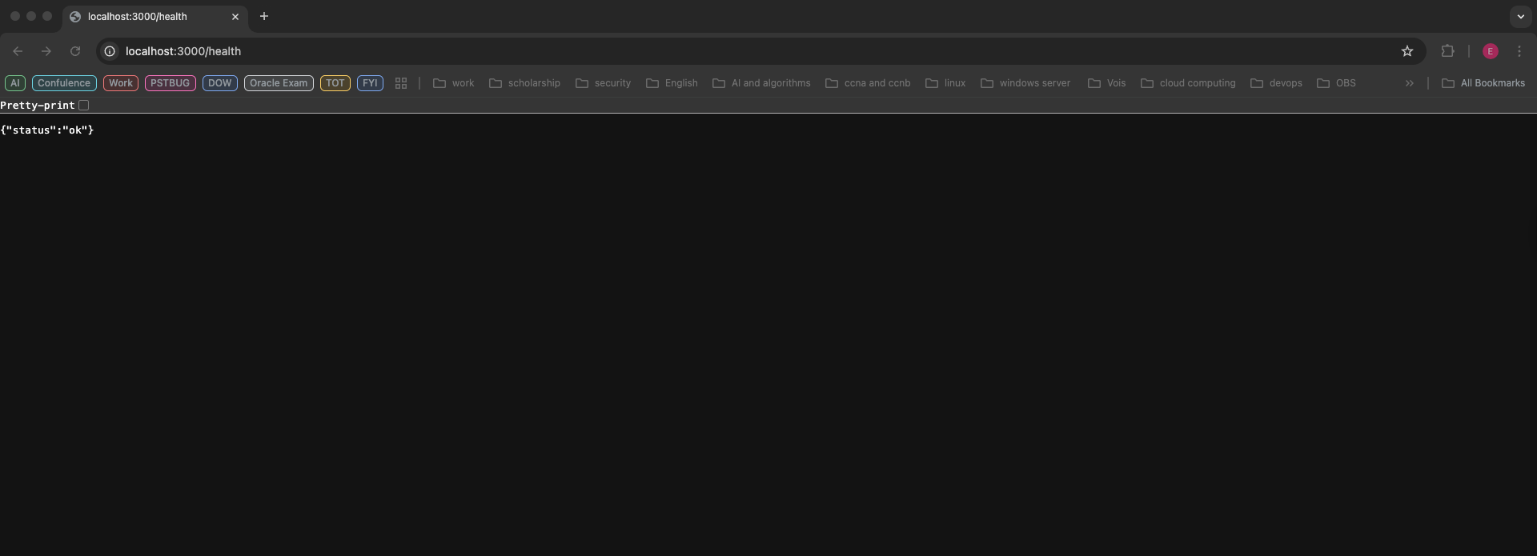
Run the application locally with Docker
1- image Build
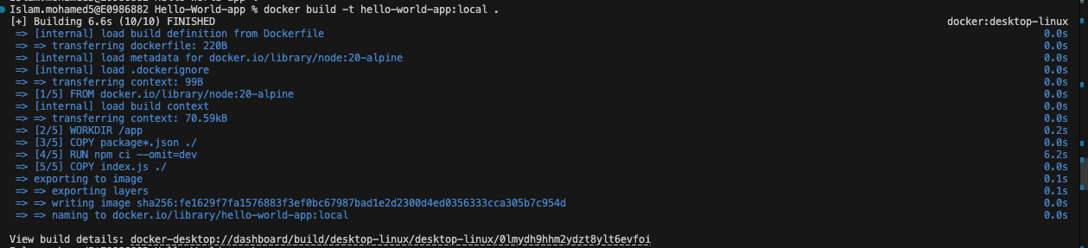
2- Run app with Docker
