

Princess Sumaya University for Technology

Amman- Jordan

Embedded systems Project: Maze solver

Abed Al-Rahman Sa'da, Islam Odeh and Obada Hattab

Dr. Talal A. Edwan

May 2017

Abstract

Two front wheeled Robot designed to solve 5x5 matrices using wall following algorithm.

Introduction and background

The idea was taken form micromouse competition (started in late 70s where small robot mice solve a 16x16 maze, the competition will be based on how much time it will take to solve the maze, the competition is popular in many countries such as UK, Japan and Korea).

Importance of our project:

Maze solving is considered to be important field in robotics and it's also involve automation and artificial intelligence, Because we wanted to challenge our self to do something new and different, in order to develop our research skills we found our project interesting to put effort on.

How it works?

In our project we designed our robot to take the right wall in its movement and in order to do so, the robot must consider the following priorities;

Turn Right if possible, If not try to walk Forward, if not try to Turn Left, if not

Rotate +180 degrees or -180 degrees (according for the left and right distance).

What is special about our project? In micromouse competition the starting and the ending point are fixed while in our project any square can be a starting point.

Components used:

PIC16F877A, H-bridge, 2xDC motors, Car chassis, 3xUltrasonic 3xInfrared sensor (Line follower), External Regulator 7805 and a Breadboard.

The software design:

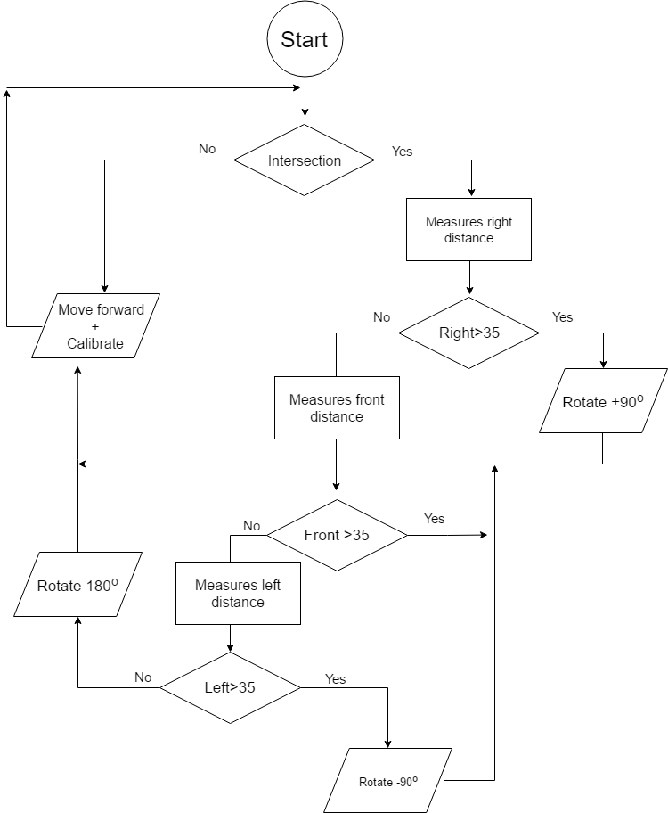

Figure 1: The flow Chart

The Electrical design:

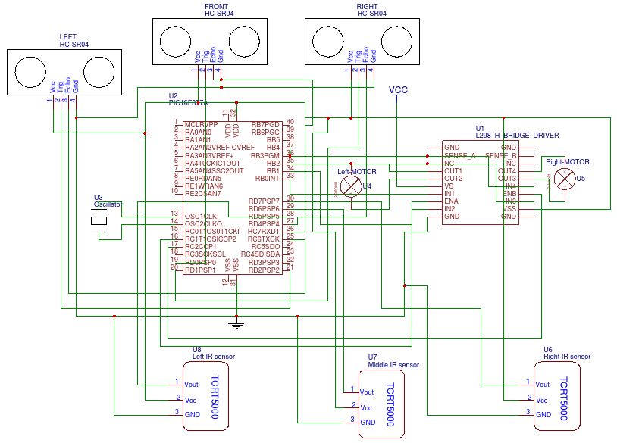

Figure 2: Schematic

Closer look to PIC:

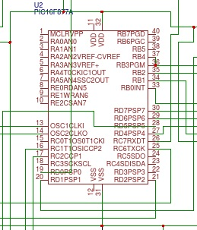

Figure 2.1: Closer look to PIC

The Mechanical design

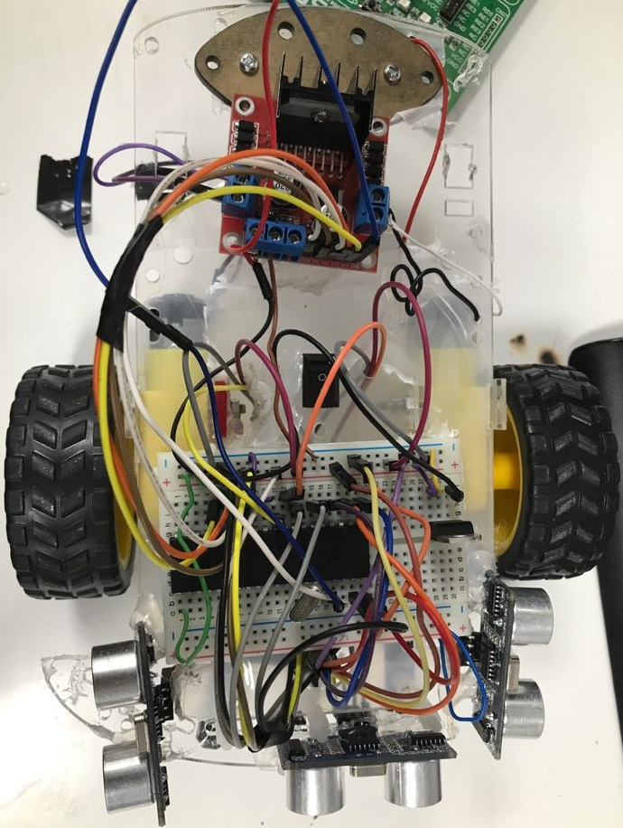

Figure 3: Mechanical design and circuit

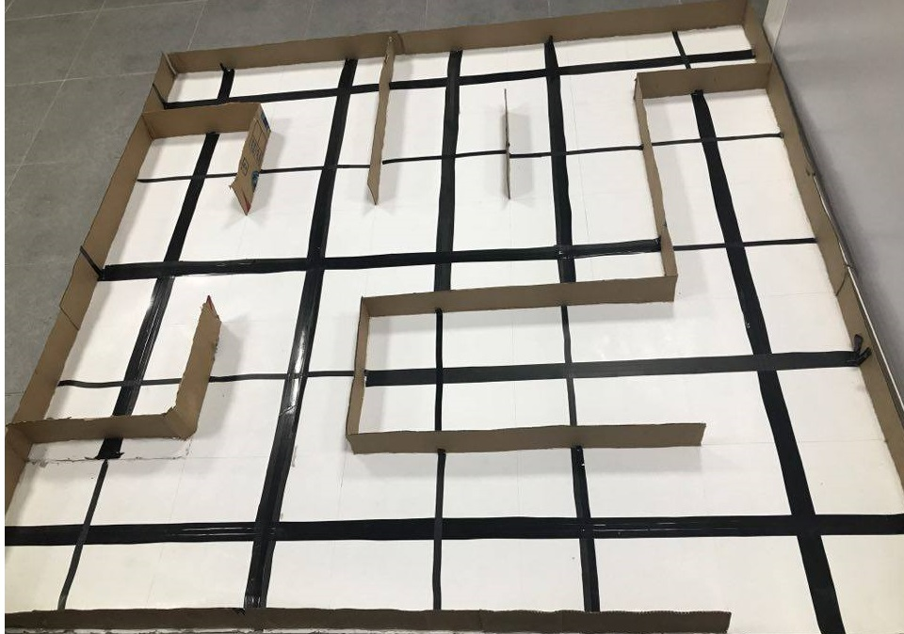

Figure 3.1: Maze

Challenges and Problems

1) Choosing suitable algorithm: other algorithms are complicated in a way that may exceed stack Level and memory size for PIC16877A micro controller.

2) Local stores:   
 a) we couldn't find short tailed 2-wheeled Robot with a better quality.

b) We were forced to use ultrasonic because we couldn't find infrared sensor with a good range and a fine price.

3) Calibration errors:

a) DC motors speed wasn't identical, so we had to use PWM library in order to match both motors, right motor was faster than left motor, the explanation behind this fact is that the right motor has smaller internal resistance (Manufacturing error), we actually tried to measure both resistances after we came up with previous conclusion and our conclusion was correct.

b) Car roller for robots end support gave us very inaccurate results, later on we replaced it with iron ball.

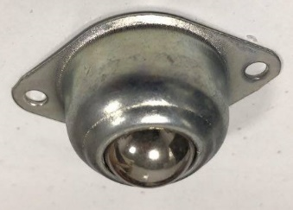 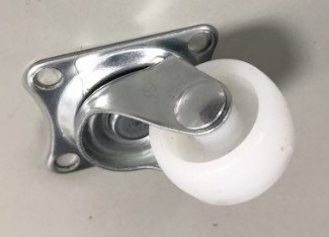 .......

4) Source: we tried to use 9V batteries but current provided by these batteries was not enough to power our system, eventually we were forced to use lab power supply.

5) Moving to maze: Measurements for rotation and PWM we did before building the maze didn't work so we had to redo our measurements.

Same goes to calibration, before building maze our calibration process went well but after scaling our results to maze scale we had to consider using other methods, infact we did mathematical functions to adjust our results correctly, calibration worked well but once it reach intersections (Cross-roads ) system goes wrong.

6) Ultrasonic: is relevant to calibration part in most of the following points:

a) We knew from course lecture that ultrasonic sensors readings will be damaged after using multiple sensors we solved this problem by leaving time delay between each reading.

b) Installing sensors on the tail created calibration errors

c) Heat affects sensors reading in a small level.

d) In general ultrasonic sensors didn't obtain accurate readings (not accurate enough for calibration) we tried to take up to 20 reading, also we had installed a fourth sensor for calibration.

Eventually ultrasonic didn't work well for calibration that's why we had to use line follower for calibration, but we kept ultrasonic for rotation detection. (This serious update was done in less than 12 hours before deadline).

Recommendations:

1) Avoid getting components from local stores but instead explore global stores for better quality and variety.

2) There are better option/options for distance measurements ultrasonic is not one of them.

Conclusion:

Competition create worriers, we must challenge our abilities in order to increase it, like our project idea which was based on challenge, it helped us to improve our skills and abilities in Robotics, Automation, Artificial Intelligence and of course in embedded systems which will leave a great impact in our future as an engineers.