# Issue Tracking System – AngularJS Practical Project

NOTIFICATIONS, SEARCH FOR TODO’s, PAGINATiON FOOTER FORM VALIDaTIONS

You are assigned to design and implement an **issue tracker system**. The system holds **projects**, which have **issues**. Each **project** has a **leader** (the person responsible for the project) , **name**, **description**, a **project key** (which should be generated by the client using the rule which is described below in the endpoints section), a set of **priorities** which the project’s issues can use and some **labels**.

Each **Issue** has a **title**, **description**, **issue key** (which is automatically generated by the system), an **assignee** (the person responsible to resolve the issue), a **status** which must follow a specific **status transition** (more on that below), a **due date**, a **priority** (which is some of the available priorities for the project), some **labels** and user-made **comments**.

A **status transition scheme** describes the workflow of an issue. See the image below for an example scheme:

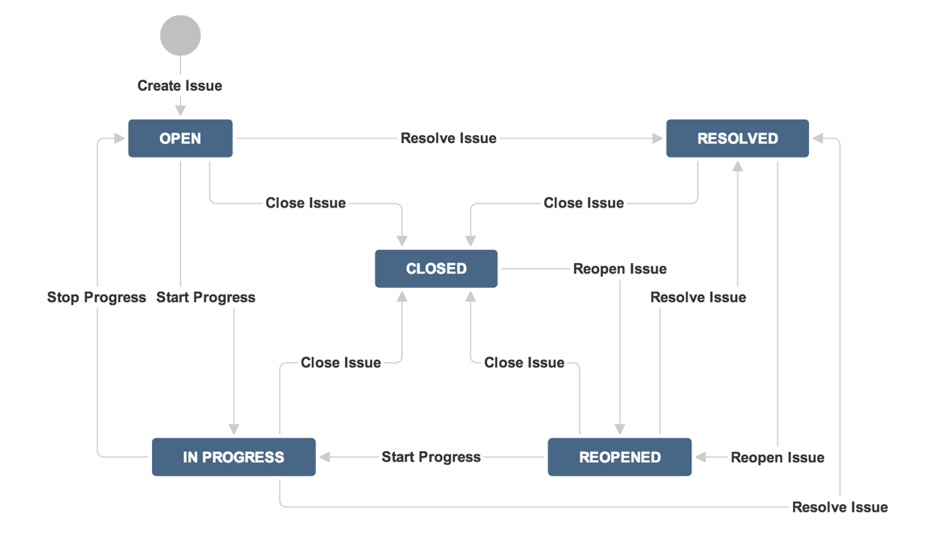

A logged in user can view the **dashboard**, which depending of his role, will consist of different elements. All users can view the assigned **issues** to them, ordered by **due date** in descending order. **Administrators** can also create or edit issues and projects.

The **project leader** can edit the project, add new issues to it and change the status of the current ones. The **issue assignee** has privileges to change the status of the issue.

Anonymous site visitors can only **login** and **register**. Logged in users can **logout**. You are given the server-side REST services to be called by your app with AJAX requests so you do not need to develop back-end.

# Backend Endpoints

### Projects

##### [GET] Projects/

* **Purpose**: Gets all projects
* **Security**:Logged in

##### [GET] Projects/?pageSize={pageSize}&pageNumber={pageNumber}&{filter}={value}

* **Purpose**: Gets projects by a given filter
* **Security**: Logged In
* **Url parameters**:
  + filter (String): the filters which you want the projects to be filtered by
    - Supports every projects property with equals, less (or equal) than, greater (or equal) than comparators (for example “Name == “SIT Project””)
    - Supports child properties (for example: “Lead.Id == “e980a9d8-53e5-4f6b-b8ae-1efec2e58938””)
    - Supports multiple criterias using “and” and “or” in between them (for example “Lead.Username == "admin@softuni.bg" or Description.Contains("test"))
  + pageSize (Int, Required): how many elements do you want the system to return
  + pageNumber (Int, Required): from which page to start (take the first pageSize * pageNumber elements)
* **Returns**: The projects with their leaders

##### [GET] Projects/{id}

* **Purpose**: Gets a project by id
* **Security**:Logged in

##### [POST] Projects/

* **Purpose**: Adds a new project with a default transition scheme which holds these statuses: Open, Closed, In Progress, Closed Progress
* **Security**: Admin
* **Body parameters**:
  + Name (Required)
  + Description (Required)
  + ProjectKey (Required): Should be generated by the first letters of the name. (Example: Project.Name = “Java Fundamentals” => Project.ProjectKey should be “JF”
  + List<Labels>: A list of labels which will be added to the project
  + List<Priorities>: A list of priorities which the project’s issues will be able to use
  + LeadId: The id of the person who will be leading the project
* **Returns**: The newly created project

##### [PUT] Projects/{id}

* **Purpose**: Edits a project by a given id
* **Security**:Admin, Lead of project
* **Body parameters**:
  + Same as **[POST] Projects/**, except for ProjectKey which cannot be edited
* **Returns**: The edited project

#### Issues

##### [GET] Projects/{id}/Issues

* **Purpose**: Gets the project’s issues by id
* **Security**:Logged in
* **Returns**: The project’s issues with their available statuses

##### [GET] Issues/?pageSize={pageSize}&pageNumber={pageNumber}&{filter}={value}

* **Purpose**: Gets issues by a given filter
* **Security**: Logged In
* **Url parameters**:
  + filter (String): the filters which you want the issues to be filtered by
    - Supports every issue’s property with equals, less (or equal) than, greater (or equal) than comparators (for example “ProjectId == 2”, “DueDate.Day >= 20”)
    - Supports child properties (as seen above: “DueDate.Day < 10”, “Project.Name” == “SIT”)
    - Supports multiple criterias using “and” and “or” in between them (for example “Priority.Name == "In Progress" or DueDate.Month == 3”)
  + pageSize (Int, Required): how many elements do you want the system to return
  + pageNumber (Int, Required): from which page to start (take the first pageSize * pageNumber elements)
* **Returns**: The issues with their available statuses

##### [GET] Issues/me?pageSize={pageSize}&pageNumber={pageNumber}&orderBy={by}

* **Purpose**: Gets the user’s currently assigned issues ordered by a given criteria
* **Security**: Logged in
* **Url parameters**:
  + orderBy (String): the property of the issue which you want the issues to be sorted by
    - Supports all issue’s properties (for example Project, IssueKey, DueDate)
    - Supports child properties (for example Project.Name will sort the issues by the name of their project)
    - Supports descending sorting, just add “desc” after the property (for example “IssueKey desc”)
    - Supports multiple criteria using comma separated syntax (for example “Project.Name desc, IssueKey, Priority.Name desc”)
  + pageSize (Int, Required): how many elements do you want the system to return
  + pageNumber (Int, Required): from which page to start (take the first pageSize * pageNumber elements)
* **Returns**: The user’s issues with their available statuses

##### [GET] Issues/{id}

* **Purpose**: Gets an issue by id
* **Security**: Logged in
* **Returns**: The requested issue with its available statuses

##### [POST] Issues/

* **Purpose**: Adds a new issue
* **Security**: Admin, Project lead
* **Body parameters**:
  + Title (String, Required)
  + Description (String, Required)
  + DueDate (DateTime, Required)
  + ProjectId (Int, Required): The issue’s project
  + AssigneeId (String, Required): The issue’s assignee
  + PriorityId (Int, Required): The priority’s id (should be one of the available priorities for the project)
  + List<Label> (Required): A list of labels for the issue
* **Returns**: The newly created issue

##### [PUT] Issues/{id}

* **Purpose**: Edits an issue by an id
* **Security**: Admin, Project lead
* **Body parameters**: Same as [POST] Issues/, except for ProjectId which cannot be edited
* **Returns**: The edited issue

##### [PUT] Issues/{id}/changestatus?statusid={statusId}

* **Purpose**: Edits an issue’s current status, only if it’s available in the status transition scheme (for example, you can’t change the status from ‘Open’ directly to ‘Stopped Progress’)
* **Security**: Admin, Issue assignee, Project lead
* **Url Parameters**:
  + statusid (Int, Required): the id of the new status
* **Returns**: The new available statuses

##### [GET] Issues/{id}/comments

* **Purpose**: Gets all the issue’s comments by a specified id
* **Security**: Logged in

##### [PUT] Issues/{id}/comments

* **Purpose**: Adds a new comment to an issue specified by id
* **Security**: Logged in user who is either a project leader or has a assigned issue in this project
* **Body parameters**:
  + Text (String, Required): The comment’s text
* **Returns**: list of all the issue’s comments

#### Labels

##### [GET] Labels/?filter={filter}

* **Purpose**: Gets all of the existing labels filtered
* **Security**:Logged in
* **Returns**: The labels with their id and name
* **Url Parameters**:
  + filter (String, Required): The starting substring for the searched labels (For example: “?filter=sof” can return “Softuni, software” and every existing label that starts with “sof”)

#### Users

##### [POST] api/Account/Register

* **Purpose**: Registers a new, non-admin, user to the system
* **Security**: None
* **Body parameters**:
  + Email (String, Required): The email for the newly registered user
  + Password (String, Required): Password
  + ConfirmPassword: The same password for confirmation
* **Returns**: Status code 200 on success

##### [POST] api/Token

* **Purpose**: Gets an authentication token from the system to later authenticate the user (client) with the requests he makes
* **Security**: None
* **Body parameters**:
  + Username (String, Required): Use the user’s email as it serves as the username in the system
  + Password (String, Required): Password
  + grant_type (String, Required): Should be always “password” in order to authenticate successfully
* **Returns**: Data with a field access_token which is the necessary token needed for authentication
* **Usage**: After getting the token you can authenticate every request made by the client by putting an “Authorization” key in the request headers with value: “Bearer {access_token}” where {access_token} is the one returned from the system.

##### [GET] Users/

* **Purpose**: Gets all of the registered users
* **Security**:Logged in
* **Returns**: The users with their id, username and whether they’re admin

##### [GET] Users/me

* **Purpose**: Gets the currently
* **Security**:Logged in
* **Returns**: The user with his id, username and whether they’re admin

##### [PUT] Users/makeadmin

* **Purpose**: Grants an user admin privileges
* **Security**: Admin
* **Returns**: Status code **200** on success
* **Body parameters**:
  + UserId (String, Required): The id of the user to be made admin

##### [POST] api/Account/Register

* **Purpose**: Registers a new, non-admin, user to the system
* **Security**: None
* **Body parameters**:
  + Email (String, Required): The email for the newly registered user
  + Password (String, Required): Password
  + ConfirmPassword: The same password for confirmation
* **Returns**: Status code 200 on success

##### [POST] api/Account/ChangePassword

* **Purpose**: Changes the current user’s password
* **Security**: Logged in
* **Body parameters**:
  + OldPassword (String, Required): The user’s current password
  + NewPassword (String, Required): New Password
  + ConfirmPassword (String, Required): Again the new password for confirmation
* **Returns**: Status code 200 on success

# Project Requirements

### Public Screens

Public screens are accessible for site visitors without login.

* **Login Screen**
  + Route: **#/**
  + **Logins an existing user**. Shows notification for success or error message.
  + After login, the user is automatically redirected to the dashboard.

5 score

* **Register User Screen**
  + Route: **#/**
  + **Registers a new user**. Shows notification for success or error message.
  + After registration, the user is automatically logged in and is redirected to the dashboard.

10 score

### User Screens

User screens are accessible for authorized users only (after login).

* **User Dashboard**
  + Route: #/
  + Includes the user’s assigned issues, ordered by due date in descending order and a panel with all the projects that you are associated with (you have an assigned issue in them or you are a project leader)

10 score

* **Project Page**
  + Route: #/projects/:id
  + Includes all the project info and all of its issues. If the user is the project’s leader he can add new issues.

10 score

* **Edit Project Page**
  + Route: #/projects/:id/edit
  + If the user is the project leader, he can access this page and edit the project.

5 score

* **Add Issue** 
  + Route: #/projects/:id/add-issue
  + A modal dialog with a form for creating a new issue. The form consists of:
    - Assignee (Drop-down with all available users)
    - Project (Drop-down with all available projects)
    - Due (Calendar)
    - Priority (Drop-down with available priorities for this project)
    - Label (Text-box which suggests already created labels by typing a substring. If the label does not exist – creates it)
    - Title (Text-box)
    - Description (Textarea)
    - Create Issue (Button)

10 score

* **Issue page**
  + Route: #/issues/:id
  + Displays the information about the issue
  + If the user is the assignee, they can see a button for changing the status using an available status (e.g. Open -> Closed).
  + If the user is the issue’s project leader they can see the edit issue button.

15 score

* **Edit Issue page**
  + Route: #/issues/:id/edit
  + The page is not visible unless the user is the issue’s project leader or assignee.
  + If the user is the assignee, they can change the status using an available status (e.g. Open -> Closed).
  + If they are the project’s leader they can edit the whole issue (including its assignee).

10 score

* **Change User Password**
  + Route: #/profile/password
  + Users should be able to **change their password** from form (contains **old password**, **new password** and **confirm new password**). Show notification for success or error message.

10 score

* **Logout**
  + Route: #/logout
  + Successfully logged in users should be able to **logout** from the app.
  + Logout shows a notification message and redirects to the Home screen.

5 score

* **Guest Authorization Checks //TODO reload SPA?????????????**
  + Anonymous site visitors (without login) should be able to access only Login and Register screens.
  + An attempt to access anonymously these screens should redirect the user to the Home screen.

10 score

Total 250 score

# Project Bonuses

### User Screens

* **Issue page**
  + Route: #/issues/:id
  + View the issue’s comments.
  + Additional field for adding comments if you are affiliated with this project (you have an issue assigned in the project or you’re the project’s leader).

20 score

* **Filtering issues in the Project Page**
  + Route: #/projects/:id
  + Make it so by default the user is showed only his assigned issues.
  + Create a filter to see all issues or specific ones based on different criterias (be creative).

20 score

### Administrator Screens

User screens are accessible for authorized users only (after login).

* **User Dashboard**
  + Route: #/
  + Same as the normal user’s dashboard. Includes two buttons for adding a new project and listing all projects.

10 score

* **Projects**
  + Route: #/projects
  + Lists all projects
  + Each project has the ability to be edited and an issue to be added to it.

10 score

* **Add Project** 
  + Route: #/projects/add
  + A modal dialog with a form for creating a new project. The form consists of:
    - Leader (Drop-down with all available users)
    - Project Key (Text-box)
    - Priorities (Text-box)
    - Label (Text-box, which suggests already created labels by typing a substring. If the label does not exist – creates it)
    - Name (Text-box)
    - Description (Textarea)
    - Create Project (Button)

15 score

* **Edit Project Page**
  + Route: #/projects/:id/edit
  + All of the functionality as the project’s leader including the ability to change the leader.

5 score

Total 80 score

NOTIFICATIONS, SEARCH FOR TODO’s, PAGINATiON FOOTER