Evan Slodysko

12 November 2022

FDN110 – Foundations of Programing

Assignment 05

**Introduction**

The purpose of Assignment 05 was to continue covering list sequences including writing to/reading from files, introducing dictionaries including writing to/reading from files, reviewing Separation of Concerns (SoC) programing pattern, and an introduction to functions, error handling, and GitHub.

**Topic 1**

This section describes the steps performed to complete Step 5 from this assignment. Step 5 asks to modify and extend the script from last week including

* Modifying the script to replace the inner data structure with dictionaries
* Format code to use list of dictionaries as a 2D table
* Adding the functionality of leading exiting data (from file)
* Adding functionality of deleting data (from program memory)

Additionally,

* The script must be saved in a specified course folder
* Run the script in Spyder and the Terminal and,
* Provide proof of the script running from both locations, and the CD Inventory.txt File created

I started by following the script template provided and identified necessary additions and modifications to make the script function as described in the assignment. Notable items include

* Adding Dictionaries - Modify 2D Data Structure for Dictionaries (a)
  + The original script created lists for Id, CD, and Artist and entered into a list (2D table of lists). This weeks script was modified for use of a list of dictionaries. An empty *dicRow* was defined which allowed users to enter values and keys for each dictionary. ID, Title and Artist were defined as keys, with user inputs assigned to values.
  + The append function was added to append *lstTbl* to add each dictionary as it is entered by the program user, creating a 2-D structure list of dictionaries
* Save to File (s)
  + The template came preloaded with script for saving dictionaries to file. The script works by opening a defined text file, using a for loop for each row (dictionary) in the l*stTbl*, converting the dictionaries into strings (CSV format) and writing the new variable *strRow* to the file and closing
* Load Inventory from File (l)
  + A script was created that first step clears previous entries in *lstTbl* using the clear function and then opens the defined objectFile that data will be loaded from
  + A for loop was added so the script will iterate through each row of strings in the text file data is being loaded from. Additional script was added to strip spaces and add commas from the variable row and assign to new variable *lstRow.*
  + Each element at a specified index (value) is then assigned to a key and built into a dictionary, *dicRow.*
  + The script then appends the newly formed dictionary to the 2D list table and the objectfile is closed
* Display Current list of Dictionaries (i)
  + The script provided was modified to include values() as the *operator loop was only printing the key of the dictionary and not the value when prompted
* Delete Entry (d)
  + Tried several different approaches to writing a script for deleting an entry but wasn’t successful. In most cases, the script developed would result in an error message or the list wasn’t deleted from the table. At the end of the CDInventory.py script are different approaches I discovered from *Python For Beginners* text or form online python resources that I attempted to use for this part of the assignment. Most attempts follow an arrangement of…
    - User defined variable for CD ID, convert ID string to integer, use for loop to iterated through each dictionary in list, and use a comparative operator to check for match. If match, use the .clear or .remove function to delete entry
    - Using the above approach but applying the del function to remove the dictionary from the list
* SoC
  + Following the prompts and the guidance provided in module 5, the script was re-arranged in a way that attempted to follow the format of SoC principle of data, processing, and presentation. The general arrangement is shown below and isn’t’ perfect due to limitations with knowledge/experience but attempts to align *Data* with Display Menu, *Processing* with Add/Save Data and *Presentation* with Display Data
    - Display Menu
      * Make selection
    - Add Data
      * Add CD, develop list of dictionaries
    - Display Data
      * Display current inventory
      * Load from file
      * Delete entry
    - Save Data
      * Save to file
    - Exit Program

Figure 1 below shows CDInventory.py script file with the results of the script displayed in the console window file. Two entries were tested.

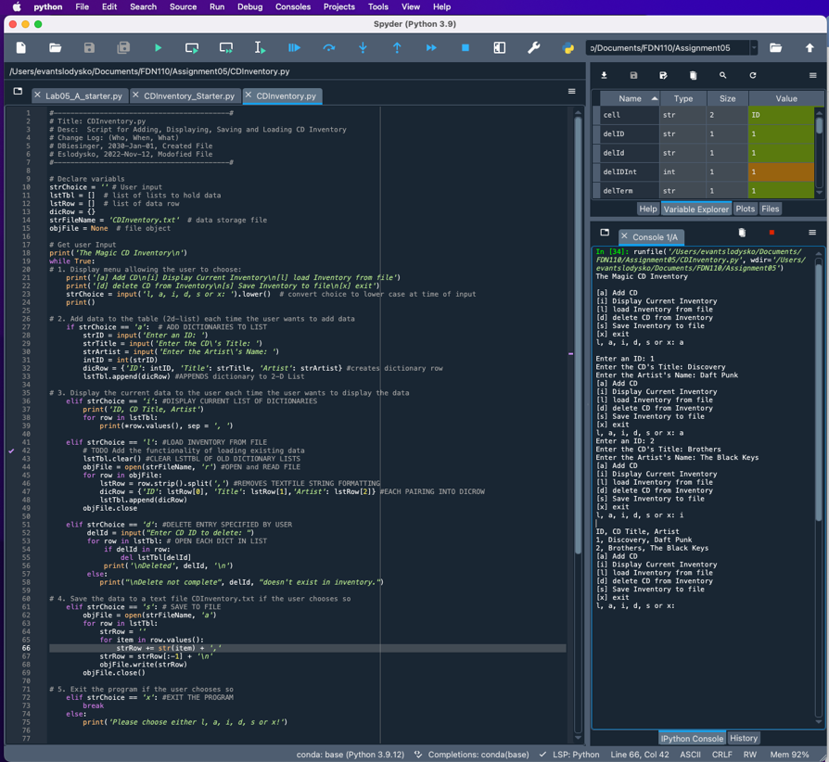

*Figure 1 – Assignment 5, Step 5. Script for entering inputs in Spyder. Script response to user input shown in the console window. In this image, two entries were added, and displayed.*

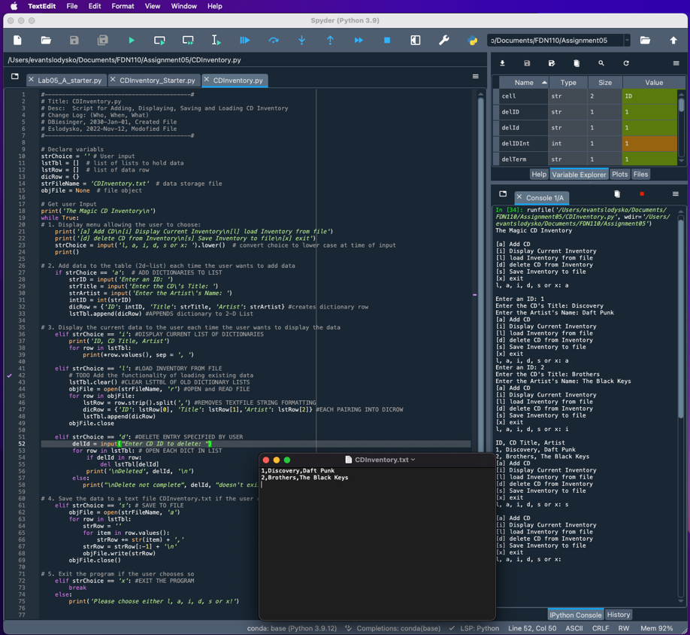

*Figure 2 – Assignment 5, step 5. Saving (appending) table entries to texfile. Note pad included to show successful appending of data in .csv formant to file*

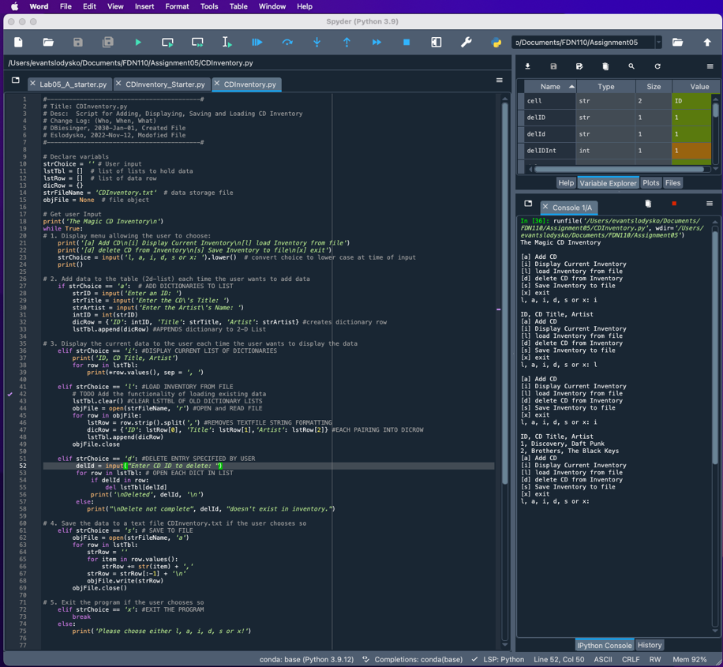

*Figure 3 – Assignment, step 5. Loading cd inventory to dictionaries in list from file*

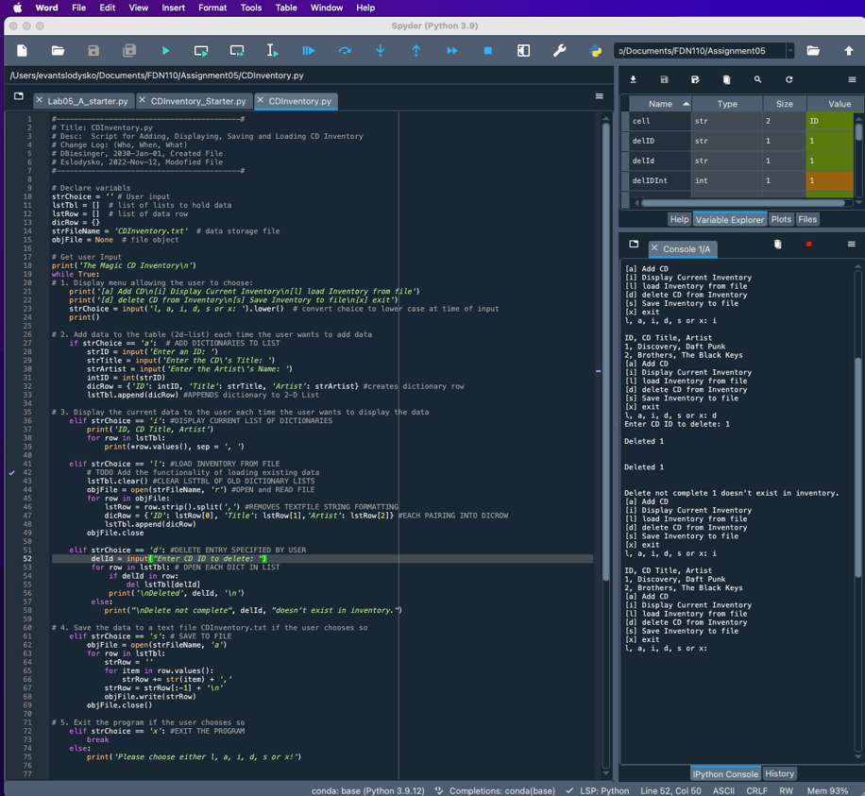

*Figure 4 – Assignment 5, step 5. Attempting to delete dictionary based on user input.*

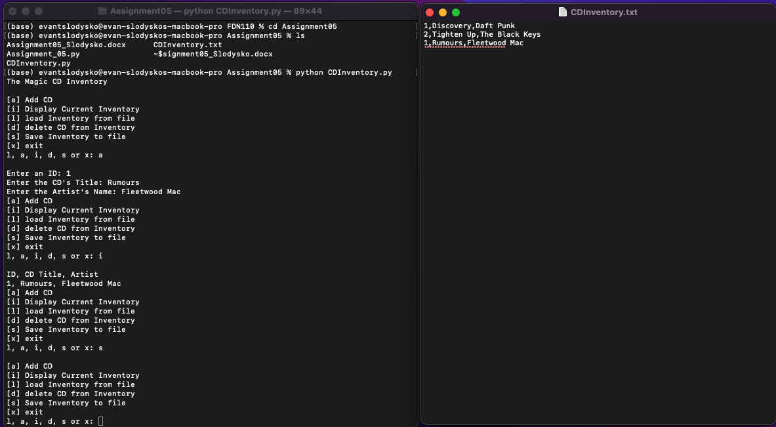

*Figure 5 – Running program from mac terminal and writing to text file.*

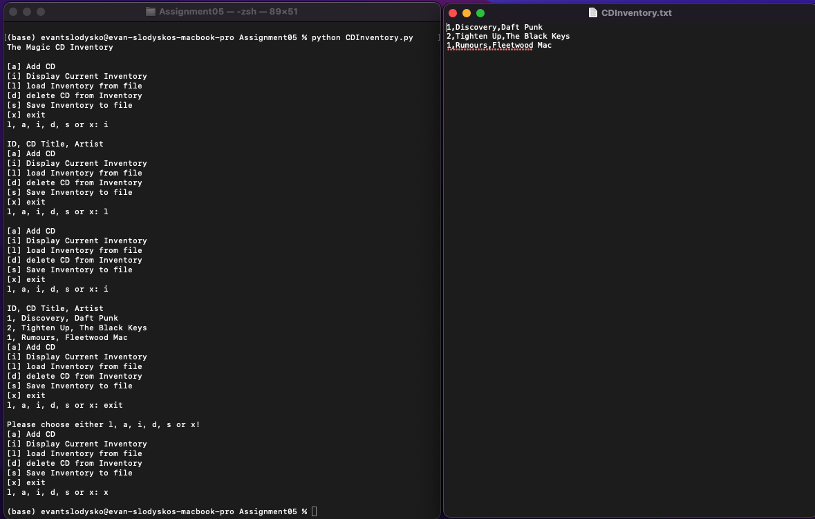

*Figure 6 – Running python script in mac terminal. Reading values from textfile.*

**Topic 2**

Once complete with creating a code per instructions, step 7 requires

* Create a GitHub account and create a repository for Assignment_05
* Upload files and commit changes
* Share link to Canvas discussion board
* Perform a peer review

A git hub account was created and a repository was created for assignment 05. The link below can be used to access the repository.

* https://github.com/eslodysko/Assignment_05

**Summary/Observations**

In this assignment we continued to expand on our working knowledge of computer programming basics including

* Using list sequences to write to / read from files
* Introducing dictionaries and understanding characteristic of dictionary keys and values
* Using dictionaries to write to / read from files
* functions associated with dictionaries (list, items, keys, values, etc.) and
* introduction to separations of concerns, functions, error handling, and GutHub

This assignment was again a noticeable shift in complexity from previous weeks. One concept from week 5 that I struggled with was writing a script for deleting an entry in the CD inventory program. I tried a few different approaches to accomplish this part of the assignment including using the .remove function, and the del function in different configurations but was not successful in getting this portion of the assignment. I tried various combinations where I setup the program with an input function to prompt the user for a value, used a for loop to iterate through the elements (dictionaries) in the 2D list and attempted to remove the entry (either remove or del). Both the textbook and online resources provided useful information and different ways to approach this problem but I believe there is something subtle missing from my script.

**Appendix**

|  |  |
| --- | --- |
| 1  2  3  4  5  6  7  8  9  10  11  12  13  14  15  16  17  18  19  20  21  22  23  24  25  26  27  28  29  30  31  32  33  34  35  36  37  38  39  40  41  42  43  44  45  46  47  48  49  50  51  52  53  54  55  56  57  58  59  60  61  62  63  64  65  66  67  68  69  70  71  72  73  74  75  76  77  78  79  80  81  82  83  84  85  86  87  88  89  90  91  92  93  94  95  96  97  98  99  100  101  102  103  104  105  106  107 | *#------------------------------------------#*  *# Title: CDInventory.py*  *# Desc: Script for Adding, Displaying, Saving and Loading CD Inventory*  *# Change Log: (Who, When, What)*  *# DBiesinger, 2030-Jan-01, Created File*  *# Eslodysko, 2022-Nov-12, Modofied File*  *#------------------------------------------#*  *# Declare variabls*  strChoice = '' *# User input*  lstTbl = [] *# list of lists to hold data*  lstRow = [] *# list of data row*  dicRow = {}  strFileName = 'CDInventory.txt' *# data storage file*  objFile = **None** *# file object*  *# Get user Input*  print('The Magic CD Inventory**\n**')  **while** **True**:  *# 1. Display menu allowing the user to choose:*  print('[a] Add CD**\n**[i] Display Current Inventory**\n**[l] load Inventory from file')  print('[d] delete CD from Inventory**\n**[s] Save Inventory to file**\n**[x] exit')  strChoice = input('l, a, i, d, s or x: ').lower() *# convert choice to lower case at time of input*  print()    *# 2. Add data to the table (2d-list) each time the user wants to add data*  **if** strChoice == 'a': *# ADD DICTIONARIES TO LIST*  strID = input('Enter an ID: ')  strTitle = input('Enter the CD**\'**s Title: ')  strArtist = input('Enter the Artist**\'**s Name: ')  intID = int(strID)  dicRow = {'ID': intID, 'Title': strTitle, 'Artist': strArtist} *#creates dictionary row*  lstTbl.append(dicRow) *#APPENDS dictionary to 2-D List*    *# 3. Display the current data to the user each time the user wants to display the data*  **elif** strChoice == 'i': *#DISPLAY CURRENT LIST OF DICTIONARIES*  print('ID, CD Title, Artist')  **for** row **in** lstTbl:  print(*row.values(), sep = ', ')    **elif** strChoice == 'l': *#LOAD INVENTORY FROM FILE*  *# TODO Add the functionality of loading existing data*  lstTbl.clear() *#CLEAR LSTTBL OF OLD DICTIONARY LISTS*  objFile = open(strFileName, 'r') *#OPEN and READ FILE*  **for** row **in** objFile:  lstRow = row.strip().split(',') *#REMOVES TEXTFILE STRING FORMATTING*  dicRow = {'ID': lstRow[0], 'Title': lstRow[1],'Artist': lstRow[2]} *#EACH PAIRING INTO DICROW*  lstTbl.append(dicRow)  objFile.close    **elif** strChoice == 'd': *#DELETE ENTRY SPECIFIED BY USER*  delId = input("Enter CD ID to delete: ")  **for** row **in** lstTbl: *# OPEN EACH DICT IN LIST*  **if** delId **in** row:  **del** lstTbl[delId]  print('**\n**Deleted', delId, '**\n**')  **else**:  print("**\n**Delete not complete", delId, "doesn't exist in inventory.")    *# 4. Save the data to a text file CDInventory.txt if the user chooses so*  **elif** strChoice == 's': *# SAVE TO FILE*  objFile = open(strFileName, 'a')  **for** row **in** lstTbl:  strRow = ''  **for** item **in** row.values():  strRow += str(item) + ','  strRow = strRow[:-1] + '**\n**'  objFile.write(strRow)  objFile.close()  *# 5. Exit the program if the user chooses so*  **elif** strChoice == 'x': *#EXIT THE PROGRAM*  **break**  **else**:  print('Please choose either l, a, i, d, s or x!')        *# DELETE ENTRY OPTIONS:*  *# delID = input('Enter ID to Remove from Inventory: ')*  *# delIDInt = int(delID)*  *# for row in lstTbl:*  *# for cell in row:*  *# if delIDInt in cell:*  *#lstTbl.remove(row)*  *#else:*  *# print(delID, 'Not sucessful')*    *# ATTEMPT 2*  *#userD = input('Enter CD ID to Delete: ')*  *# userIntD = int(userD)*  *# for row in lstTbl:*  *# if lstTbl[intID] == userIntD:*  *# row.clear()*    *# ATTEMPT 3*  *#term = input("What term do you want me to delete?: ")*  *#for dicRow in lstTbl: # OPEN EACH DICT IN LIST*  *# if term in dicRow:*  *# del lstTbl[term]*  *# print('\n Deleted', term, '\n')*  *#else:*  *# print("\nI can't complete", term, "doesn't exist.")*  *# print()*  *# print(lstTbl)*  *# print()* |

*Script used for Assignment 05. The script Syntax was highlighted using Saravji’s Hut[1]*

1. Saravji’s Hut – Accessed 2022 Nov-13