  - Supplement to
  - “Probabilities of Bleeding and Thromboembolic Events under Different Antithrombotic Regimens Following Left Atrial Appendage Occlusion”

  - Introduction
We included three studies in our analyses, i.e., ADALA, ANDES and ADRIFT. The treatments that were compared were dual antiplatelet therapy (DAPT), direct-acting oral anticoagulants (DOAC) and low dose of DOAC (LowDoseDOAC).

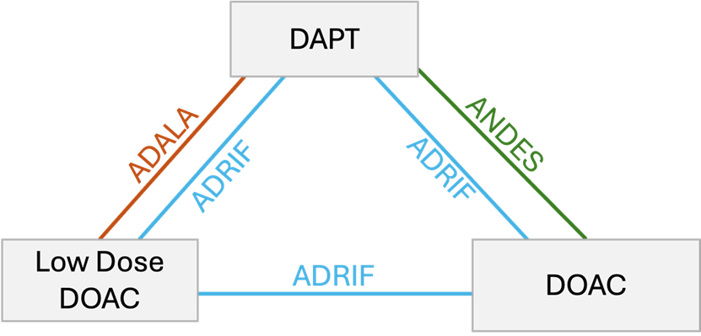

Table 1: Study designs
Study | Arm 1 | Arm 2 | Arm 3
ADALA | DAPT (n = 46) | LowDoseDOAC (n = 44)
ANDES | DAPT (n = 257) | DOAC (n = 253)
ADRIFT | DAPT (n = 33) | LowDoseDOAC (n = 37) | DOAC (n = 34)

Table 2: The full dataset
 |  |  |  |  |  |  | All bleeding (AB) |  |  | Major bleeding (MB) |  |  | Device-Related Thrombosis (DRT)
Name | arm1 | arm2 | arm3 | n_1 | n_2 | n_3 | AB_1 | AB_2 | AB_3 | MB_1 | MB_2 | MB_3 | DRT_1 | DRT_2 | DRT_3
ADALA | DAPT | LowDoseDOAC | - | 46 | 44 | - | 13 | 2 | - | 6 | 2 | - | 4 | 0 | -
ANDES | DAPT | DOAC | - | 257 | 253 | - | 64 | 44 | - | 26 | 16 | - | 9 | 2 | -
ADRIFT | DAPT | LowDoseDOAC | DOAC | 33 | 37 | 34 | 15 | 13 | 12 | 7 | 8 | 2 | 2 | 0 | 0

Table 3: Number of Events and Event Rate By Treatment across all three studies
 | DAPT | LowDoseDOAC | DOAC
All bleeding | 92 (27.4%) | 15 (18.5%) | 56 (19.5%)
Major Bleeding | 39 (11.6%) | 10 (12.3%) | 18 (6.27%)
Device-Related Thrombosis | 15 (4.46%) | 0 (0%) | 2 (0.70%)

For the two bleeding outcomes, we conducted a Network Meta-Analysis (NMA) [1], employing a Bayesian approach. We chose the odds ratio (OR) as summary measure for the treatment effects. Considering the low number of studies (N = 3) we implemented only fixed effect models. Aiming to enhance interpretability of our results, we translated all ORs into risk difference (RD) using the baseline event rate for DAPT seen in the studies (Table 3). In sensitivity analyses we also used frequentist approaches to NMA, and we applied three methods: the Inverse-Variance method (IV) [2], Mantel-Haenszel (MH) NMA [3] and Penalized Logistic Regression (PLR) NMA [4], fitted using the netmeta (version 3.2-0) [5] package in R (version 4.5.0) [6].
For the third outcome, Device-Related Thrombosis (DRT), we followed a different analytical approach. This was because, as can be seen in Table 2, there were no events across trials in the LowDoseDOAC. Furthermore, in the ADRIFT study both DOAC and LowDoseDOAC had zero events. This meant that the analysis using ORs was infeasible. For this outcome we instead fit a Bayesian model directly at the RD scale. As sensitivity analyses, we fit a frequentist NMA using at the RD scale, using the IV approach.
We assessed inconsistency locally (‘back-calculation method’) and globally (“design-by-treatment model”) under the IV analysis.
More details are provided below.

Bayesian Network-Meta Analysis on the log-odds ratio scale
Let us denote with $r_{i,k}$ the number of events observed in study $i$, treatment $k$, out of a total of $n_{i,k}$ randomized. We (arbitrarily) code DAPT as $k=1$, LowDoseDOAC as $k=2,$ and DOAC as $k=3$. Given that all studies include the reference arm (DAPT), we fit the following NMA model:
$$r_{i,k}∼Bin\left(p_{i,k},n_{i,k}\right)$$
$$logit\left(p_{i,k}\right)=u_{i}+δ_{k}$$
$$u_{i}∼N(0, 100)$$
$$δ_{k}∼N\left(0, 100\right) if k=2, 3;δ_{1}=0$$
where $u_{i}$ is the risk in DAPT in each study $i$, and $δ_{k}$ is the relative effect in terms of log-odds of treatment $k$ versus the DAPT. Consistency is embedded in the model via the parametrization of the $δ's$. The Odds Ratio that compares treatment $a$ vs treatment $b$ is evaluated as:
$$OR_{a,b}=e^{δ_{a}-δ_{b}}$$

Bayesian Network-Meta Analysis on the risk difference scale
We specify the following model:
$$r_{i,1}∼Bin\left(p_{i,k},n_{i,k}\right)$$
$$p_{i,1}∼Beta\left(0.5, 0.5\right)$$
$$p_{i,k}=p_{i,1}+RD_{k}$$
$$RD_{k}∼N(0, 0.1) if k=2, 3;{RD}_{1}=0$$

Implementation details
We ran 5 chains, 50,000 iterations each chain, after 1000 iterations as adaptation. We assessed convergence of the MCMC sampling visually via trace plots and density plots. We also evaluated the German and Rubin convergence diagnostic $\hat{R}$ [7], [8].
Translating Odds Ratios to Risk Differences
Aiming to facilitate the interpretability of our results, after estimating the ORs from the NMA model, we translated them into RDs. In more detail, $OR_{a,b}$ compares the odds of treatment $a$ versus treatment $b$. ${\hat{p}}_{1}$ is the probability of event in the DAPT ($k=1)$ treatment group, estimated as the crude event rate aggregating the three studies (see Table 3):
$${\hat{p}}_{1}=\frac{\sum_{i=1}^{N}{r_{i,1} }}{\sum_{i=1}^{N}{n_{i,1} }}$$
For the comparisons in each outcome between treatment $k$, Low Dose DOAC $(k=2)$ or DOAC $(k=3$), versus DAPT, the risk differences are evaluated as following:
$${\hat{p}}_{k}-{\hat{p}}_{1}=\frac{{\hat{OR}}_{k,1}\frac{{\hat{p}}_{1}}{1-{\hat{p}}_{1}}}{1+{\hat{OR}}_{k,1}\frac{{\hat{p}}_{1}}{1-{\hat{p}}_{1}}}-{\hat{p}}_{1}$$
For the third comparison, i.e. DOAC vs LowDoseDOAC (2 vs 3): we first estimate the probability of event in Low Dose DOAC (${\hat{p}}_{2}$) given ${\hat{p}}_{1}$ and ${\hat{OR}}_{2,1}$, as described above, and then apply the ${\hat{OR}}_{3,2}$. This procedure allows us to translate a set of consistent odds ratios into a set of consistent risk differences that correspond to a population with a fixed risk at DAPT, equal to the average risk observed in the studies.
Treatments ranking
We calculated the probability that a treatment is ranked as best, second best or worst in the network, for each outcome. We denote with $q_{k,l}=P(rank_{k}=l)$ the probability that the treatment $k$ ($k=1, 2, 3$) is ranked $l$ ($l=1, 2, 3$) from the network. We estimated this as:
${\hat{q}}_{k,l}=\frac{\sum_{u}{I(rank_{k}=l)}}{U}$,
where $I(rank_{k}=l)$ is an indicator function that is valued 1, if at the MCMC iteration $u$ the treatment $k$ is ranked $l$, 0 otherwise; $U$ is the total number of posterior samples ($U=50,000$).

Results
  - All bleedings
Events per arm in each trial
Study | DAPT | LowDoseDOAC | DOAC
ADALA | 13/46 | 2/46 | -
ANDES | 64/257 | - | 44/257
ADRIFT | 15/33 | 13/33 | 12/33

The crude event rate in the DAPT arm was 27.4%. This was used to translate all ORs into RDs.
  - Bayesian NMA
The following tables summarize the results from the Bayesian NMA in terms of OR with the 95% credible intervals (CrI).
Bayesian NMA
Pairwise Comparison | OR [95% CrI] | RD [95% CrI]
DOAC vs DAPT | 0.62 [0.41; 0.89] | -8.6% [-14.0%; -2.1%]
LowDoseDOAC vs DAPT | 0.41 [0.18; 0.77] | -14.3% [-21.0%; -4.8%]
DOAC vs LowDoseDOAC | 1.72 [0.76; 3.42] | 11.2% [-6.6%; 29.6%]

  - Frequentist NMA
The following tables summarize the results from the frequentist NMA in terms of Odds Ratio (OR) and Risk Difference (RD), with the 95% confidence intervals, computed with three different methods: Inverse Variance (IV), Mantel-Haenszel (MH) and Penalized Logistic Regression (PLR).
Frequentist NMA
 | Method | OR [95% CI]
DOAC vs DAPT | IV | 0.61 [0.41; 0.91]
 | MH | 0.61 [0.41; 0.91]
 | PLR | 0.61 [0.37; 1.02]
LowDoseDOAC vs DAPT | IV | 0.44 [0.21; 0.92]
 | MH | 0.44 [0.21; 0.92]
 | PLR | 0.40 [0.16; 1.01]
DOAC vs LowDoseDOAC | IV | 1.41 [0.65; 3.05]
 | MH | 1.41 [0.65; 3.05]
 | PLR | 1.53 [0.73; 3.21]

Bayesian Convergence Assessment

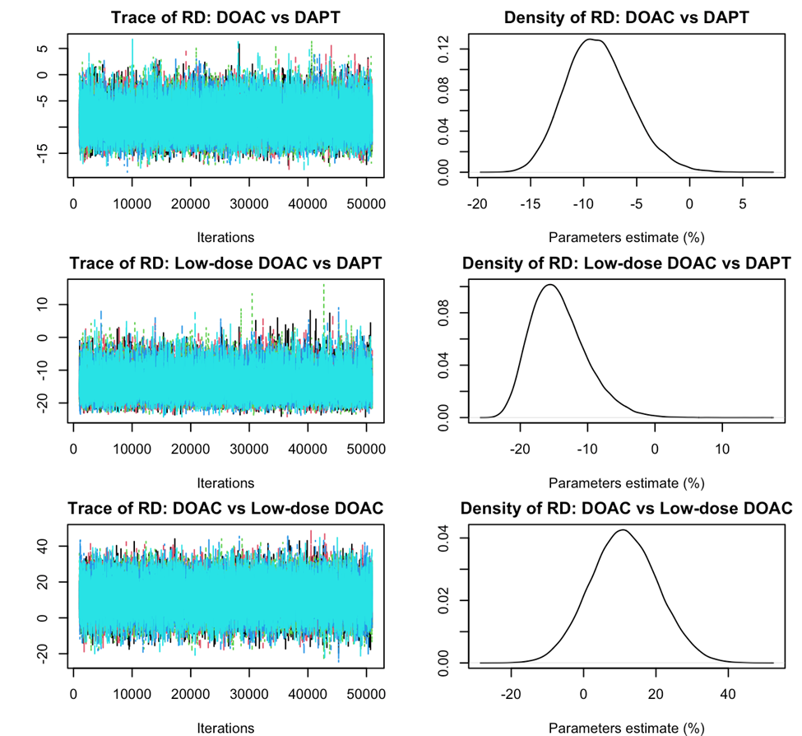
$\hat{R}$ had a value of 1.

Inconsistency Assessment
Local inconsistency
The local assessment of inconsistency of the network using the back calculation method gave the following results:
Comparison | Direct OR | Indirect OR | RoR | p-value
DOAC vs DAPT | 0.64 | 0.02 | 30.8 | 0.07
LowDoseDOAC vs DAPT | 0.41 | 0.61 | 0.67 | 0.70
DOAC vs LowDoseDOAC | 1.01 | 2.50 | 0.40 | 0.27
RoR = Ratio between direct and indirect evidence.

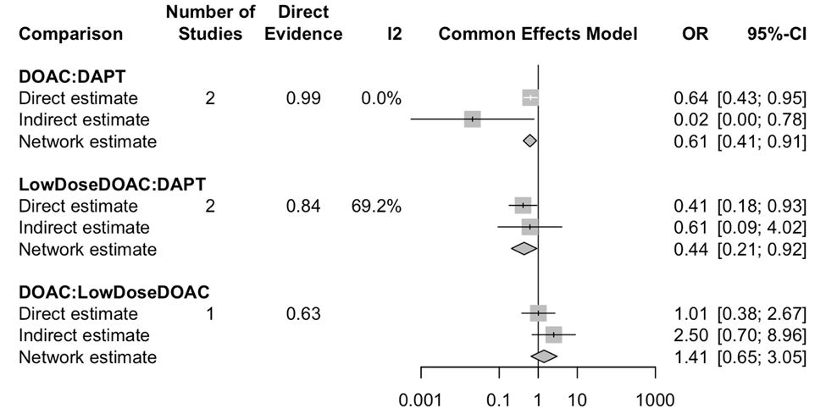
Global inconsistency
At the global level, we have the following decomposition of the variance in the network:
Source | Q | df | p-value
Total | 3.40 | 2 | 0.18
Within designs | 0.00 | 0 | --
Between designs | 3.40 | 2 | 0.18
And after the designs decomposition:
Detached Design | Q | df | p-value
Doac vs LowDoseDOAC | 0.00 | 1 | 0.96
DOAC vs DAPT | 3.25 | 1 | 0.07
DAPT vs DOAC vs LowDoseDOAC | 0.00 | 0 | --
df = degrees of freedom
In both approaches, no strong evidence of inconsistency was found.
  - Major Bleedings
Major bleedings
Study | DAPT | LowDoseDOAC | DOAC
ADALA | 6/46 | 2/46 | -
ANDES | 26/257 | - | 16/257
ADRIFT | 7/33 | 8/46 | 2/33

The crude event rate for DAPT was 11.6%. This was used to translate all ORs into RDs.
  - Bayesian NMA
The following tables summarize the results from the Bayesian NMA in terms of OR with the 95% credible intervals.
Bayesian NMA
 | OR [95% CrI] | RD [95% CrI]
DOAC vs DAPT | 0.51 [0.26; 0.87] | -5.4% [-8.3%; -1.3%]
LowDoseDOAC vs DAPT | 0.89 [0.33; 1.95] | -1.3% [-7.6%; 8.8%]
DOAC vs LowDoseDOAC | 0.68 [0.22; 1.60] | -6.9% [-20.6%; 8.5%]

  - Frequentist NMA
The following table summarizes the results from the frequentist NMA in terms of Odds Ratio (OR) and Risk Difference (RD), with the 95% confidence intervals, computed with three different methods: Inverse Variance (IV), Mantel-Haenszel (MH) and Penalized Logistic Regression (PLR).
Frequentist NMA
 | Method | OR [95% CI]
DOAC vs DAPT | IV | 0.51 [0.28; 0.93]
 | MH | 0.52 [0.28; 0.93]
 | PLR | 0.50 [0.28; 0.89]
LowDoseDOAC vs DAPT | IV | 0.84 [0.34; 2.07]
 | MH | 0.84 [0.34; 2.07]
 | PLR | 0.83 [0.35; 1.97]
DOAC vs LowDoseDOAC | IV | 0.61 [0.22; 1.69]
 | MH | 0.61 [0.22; 1.69]
 | PLR | 0.60 [0.20; 1.82]

Bayesian Convergence Assessment

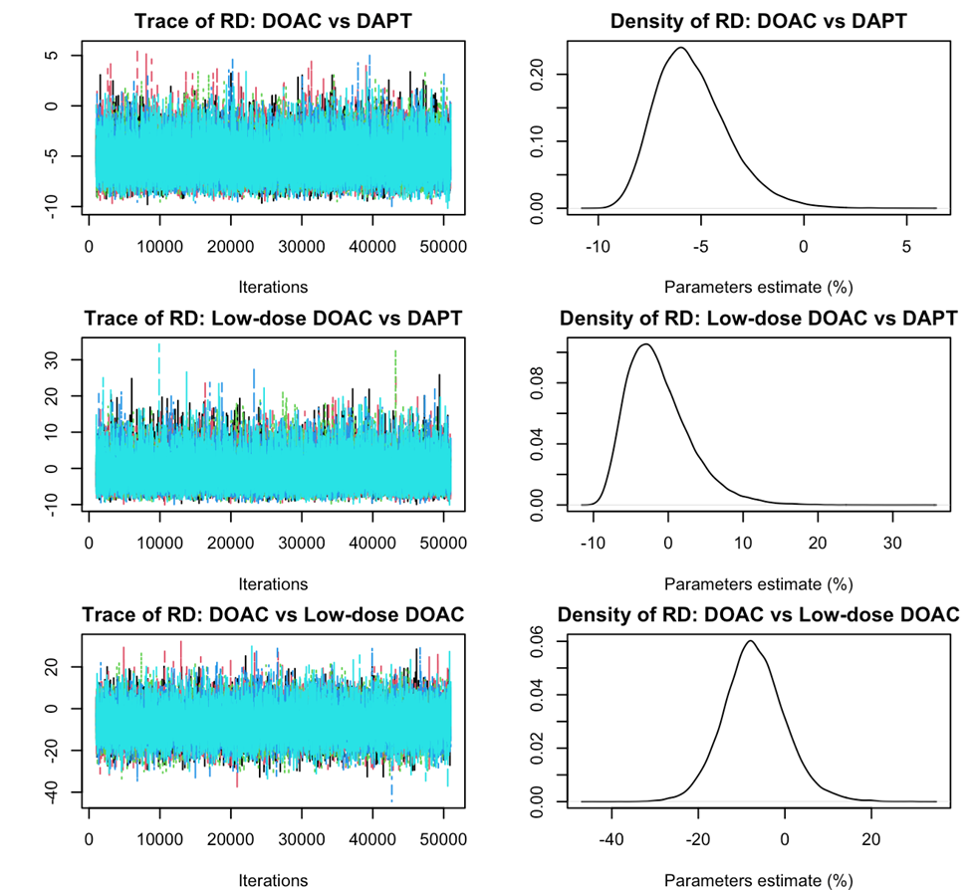
$\hat{R}$ had a value of 1.

Inconsistency Assessment
Local inconsistency
The local assessment of inconsistency of the network using the back calculation method gave the following results:
Comparison | Direct OR | Indirect OR | RoR | p-value
DOAC vs DAPT | 0.53 | 0.002 | 228 | 0.17
LowDoseDOAC vs DAPT | 0.70 | 6.10 | 0.12 | 0.20
DOAC vs LowDoseDOAC | 0.23 | 1.16 | 0.20 | 0.13
RoR = Ratio between direct and indirect evidence.
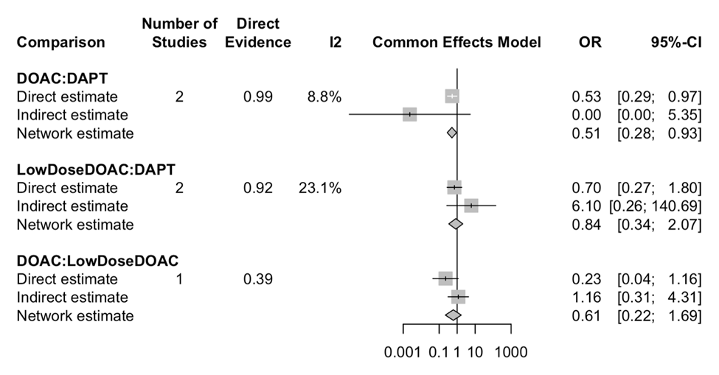
Global inconsistency
At the global level, we have the following decomposition of the variance in the network:
Source | Q | df | p-value
Total | 2.97 | 2 | 0.23
Within designs | 0.00 | 0 | --
Between designs | 2.97 | 2 | 0.23
And after the designs decomposition:
Detached Design | Q | df | p-value
Doac vs LowDoseDOAC | 1.10 | 1 | 0.30
DOAC vs DAPT | 1.30 | 1 | 0.25
DAPT vs DOAC vs LowDoseDOAC | 0.00 | 0 | --
df = degrees of freedom
In both approaches, no inconsistency was detected in the network.
  - Device-Related Thrombosis
Device-related thrombosis
Study | DAPT | LowDoseDOAC | DOAC
ADALA | 4/46 | 0/46 | -
ANDES | 9/257 | - | 2/257
ADRIFT | 2/33 | 0/33 | 0

  - Bayesian NMA
The following tables summarize the results from the Bayesian NMA in terms of RD with the 95% credibility intervals.
Bayesian NMA
 | RD [95% CrI]
DOAC vs DAPT | -4.4% [-7.1%; -2.2%]
LowDoseDOAC vs DAPT | -3.8% [-6.6%; -1.4%]
DOAC vs LowDoseDOAC | 0.6% [-0.5%; 1.9%]

  - Frequentist NMA
The following tables summarize the results from the inverse-variance frequentist NMA in terms of RD, with the 95% confidence intervals.
Frequentist NMA
 | RD [95% CI]
DOAC vs DAPT | -3.2% [-5.5%; -0.8%]
LowDoseDOAC vs DAPT | -4.9 % [-9.6%; -0.2%]
DOAC vs LowDoseDOAC | 1.7%[-2.8%; 6.2%]

Bayesian Convergence Assessment
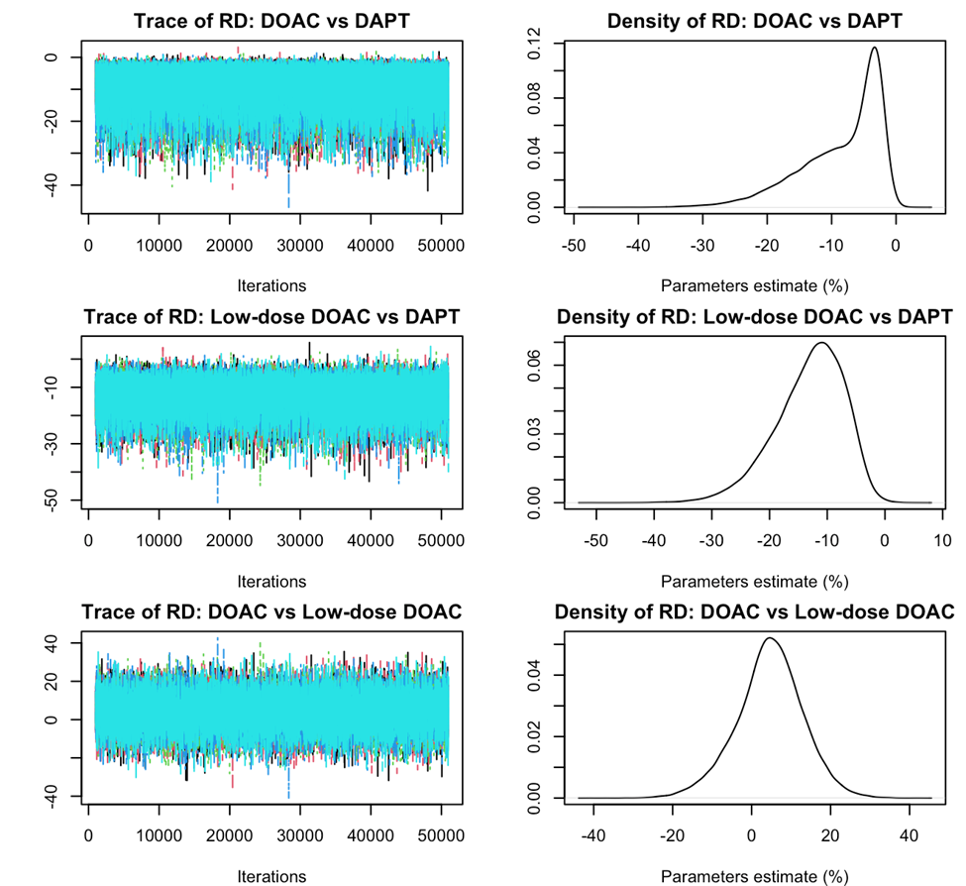
$\hat{R}$ had a value of 1.

Inconsistency Assessment
Local inconsistency
The local assessment of inconsistency of the network using the back calculation method, gave the following results:
Comparison | Direct RD | Indirect RD | Difference | p-value
DOAC vs DAPT | -0.03 | -0.09 | 0.06 | 0.33
LowDoseDOAC vs DAPT | -0.07 | -0.02 | -0.05 | 0.27
DOAC vs LowDoseDOAC | 0.00 | 0.603 | -0.06 | 0.24
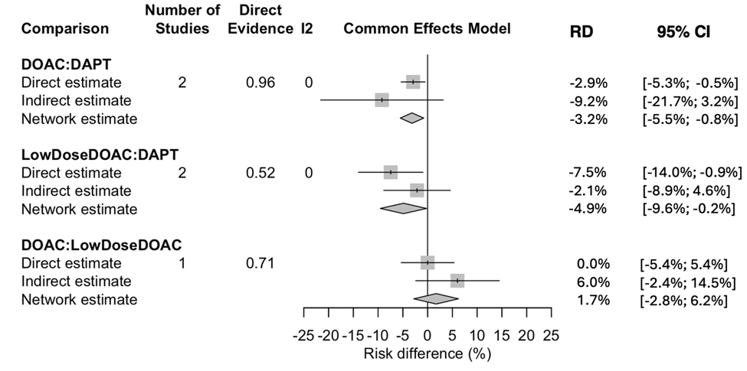
Global inconsistency
At the global level, we have the following decomposition of the variance in the network:
Source | Q | df | p-value
Total | 1.40 | 2 | 0.50
Within designs | 0.00 | 0 | --
Between designs | 1.40 | 2 | 0.50
df = degrees of freedom
And after the designs decomposition:
Detached Design | Q | df | p-value
Doac vs LowDoseDOAC | 0.16 | 1 | 0.69
DOAC vs DAPT | 0.44 | 1 | 0.51
DAPT vs DOAC vs LowDoseDOAC | 0.00 | 0 | --

In both approaches, no inconsistency was detected in the network.
Posterior distributions
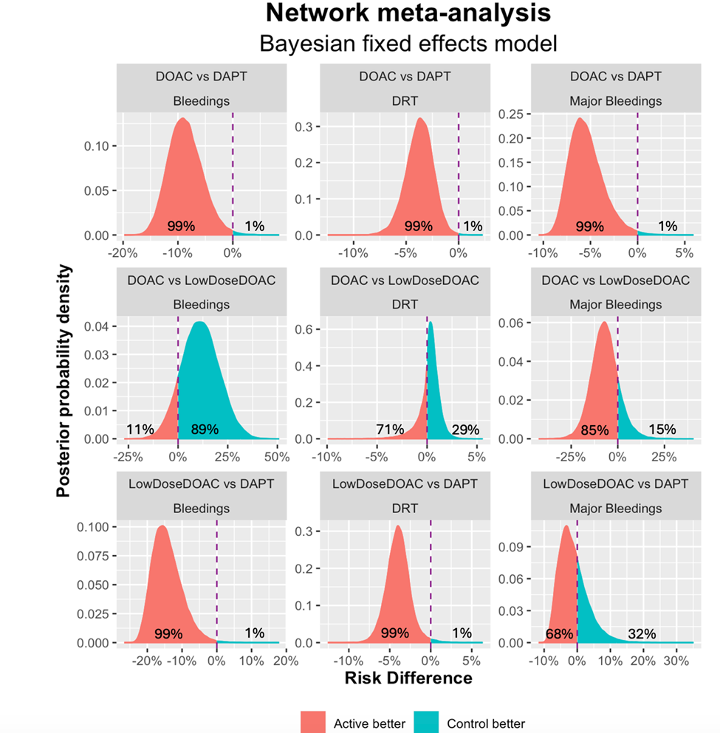

Rankograms

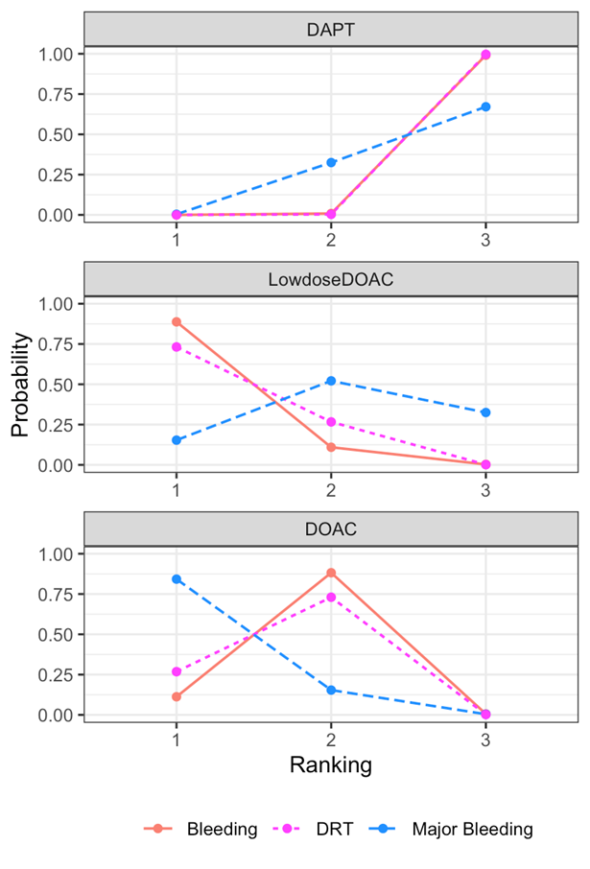

References
[1] O. Efthimiou et al., “GetReal in network meta‐analysis: a review of the methodology,” Res Synth Methods, vol. 7, no. 3, pp. 236–263, Sep. 2016, doi: 10.1002/jrsm.1195.
[2] O. Efthimiou, G. Rücker, G. Schwarzer, J. P. T. Higgins, M. Egger, and G. Salanti, “Network meta‐analysis of rare events using the Mantel‐Haenszel method,” Stat Med, vol. 38, no. 16, pp. 2992–3012, Jul. 2019, doi: 10.1002/sim.8158.
[3] T. Evrenoglou, I. R. White, S. Afach, D. Mavridis, and A. Chaimani, “Network meta‐analysis of rare events using penalized likelihood regression,” Stat Med, vol. 41, no. 26, pp. 5203–5219, Nov. 2022, doi: 10.1002/sim.9562.
[4] S. Balduzzi et al., “netmeta : An R Package for Network Meta-Analysis Using Frequentist Methods,” J Stat Softw, vol. 106, no. 2, 2023, doi: 10.18637/jss.v106.i02.
[5] R Core Team, “R: A Language and Environment for Statistical Computing,” R Foundation for Statistical Computing. [Online]. Available: https://www.R- project.org/
[6] A. Gelman and D. B. Rubin, “Inference from Iterative Simulation Using Multiple Sequences,” Statistical Science, vol. 7, no. 4, Nov. 1992, doi: 10.1214/ss/1177011136.
[7] S. P. Brooks and A. Gelman, “General methods for monitoring convergence of iterative simulations,” Journal of Computational and Graphical Statistics, vol. 7, pp. 434–455, 1998.

