Free Response Questions

Q1
a.
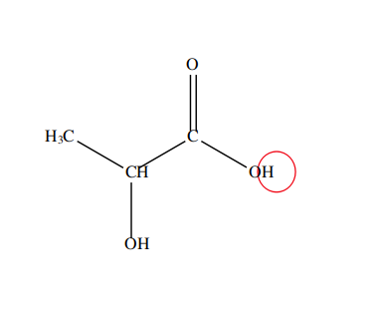

b

$$\begin{aligned}M={mol}/L \\ \\ \frac{10.22g}{40.00g/{mol}}=0.2555mol \\ \\ \frac{0.2555mol}{0.5L}=0.511M\end{aligned}$$

c.

pKa = pH at half equivalance point. 16mL of NaOH is needed to neutralize completely so 8mL is needed to reach half equivalance point, 8mL corresponds pH of 4, therfore pKa of lactic acid is approximately 4.

d.

i.
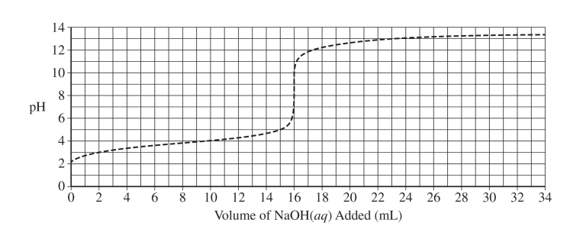

X

ii.

In diagram, 1/3 of lactic acid is neutralized. If it was completely neutralized, the volume of NaOH added would be 16 mL as it is seen at equivalence point on the plot. 1/3 of 16mL is about 5.3mL.

iii.
Amount of solute NaOH is doubled, molar concentration of NaOH is doubled. Half volume of more concentrared NaOH solution is needed to reach equivalance point.



e.

i.

$$\begin{aligned}q=c∗m∗ΔT \\ \\ m=200mL∗1.00\frac{g}{mL}=200g \\ \\ q=4.2\frac{J}{g∗}∗200g∗\left(23.2−20\right)=2.688×{10}^{3}J\end{aligned}$$

ii.

C₃H₆O₃(aq) + NaOH(aq) → NaC₃H₅O₃(aq) + H₂O(l)

Balanced reaction

$$\begin{aligned}0.1L∗0.500M=0.0500mollacticacid \\ 0.0500mol 2.688×10³J \\ \frac{2.688×10³J}{0.0500mol}=5.376×10⁴\frac{J}{mol}=−50.376\frac{kJ}{mol}\end{aligned}$$

iii.
Agree. Some of heat is lost to surrounding air, final temperature will be lower than expected, therefore it will result lower temperature change, lower heat of reaction and lower molar enthalpy.

