Reproducible and Leakage-Aware Spark ETL for MIMIC-III: Clinical Validation and Single-Host Systems Evaluation
Esma Fazilet Karagülle and Esra Odabaş Yıldırım
Atatürk University, Erzurum, Türkiye | Corresponding author: esmafazilet.karagulle17@ogr.atauni.edu.tr
Abstract—Reproducible clinical modeling depends on both clinically valid feature definitions and transparent computational execution. We developed an Apache Spark pipeline for MIMIC-III that separates two purposes often conflated in electronic-health-record processing: systems benchmarking and prediction-time feature construction. Two whole-admission outputs were used only to compare five Spark configurations on one physical host. A separate feature set used measurements from the first 48 h of intensive-care admission, excluded discharge-adjacent variables, and was evaluated for in-hospital mortality with patient-grouped splits. In a randomized, resource-capped experiment (12 paired blocks; 8 CPUs and 8 GiB), local[8] had the shortest mean runtime for the admission-level (212.5 ± 11.1 s) and six-hour-window (234.8 ± 7.3 s) workloads. All eight prespecified contrasts with local[8] remained significant after Holm adjustment; exact paired sensitivity tests gave p = 0.000488. Because standalone configurations declared six executor cores while local[8] exposed eight task threads, a supplementary equal-capacity comparison (local[6] vs. a two-worker standalone arrangement) was run in the same session; local[6] remained faster for both workloads (six-hour window: p < 0.0001; admission-level: p = 0.053). The leakage-aware cohort, redefined around each admission's first ICU stay rather than a multi-stay envelope, contained 29,886 admissions from 25,271 patients with 12.4% mortality. Gradient boosting achieved an area under the receiver-operating-characteristic curve of 0.815 ± 0.005 and an area under the precision-recall curve of 0.402 ± 0.025 in five-fold patient-grouped cross-validation; within-training-fold recalibration of the class-weighted probabilities corrected a large negative calibration intercept to 0.092 ± 0.054 and yielded a Brier skill score of 0.169 relative to a constant-prevalence baseline. These results show that co-located Spark workers do not constitute physical scale-out even after equalizing task capacity, and that computational benchmarking outputs should remain separate from prediction-time clinical features. The pipeline, configuration, aggregate results, and split diagnostics are publicly available.
Index Terms—Apache Spark, clinical data engineering, electronic health records, MIMIC-III, reproducibility, temporal data leakage.

I. INTRODUCTION
Electronic health records (EHRs) are collected for care delivery rather than analysis. Research use therefore requires cohort construction, unit harmonization, temporal alignment, missing-data handling, and explicit prediction-time boundaries. These operations determine not only computational cost but also whether downstream evaluation is clinically interpretable and free of temporal leakage [1]–[4].
Reusable pipelines such as MIMIC-Extract, FIDDLE, COP-E-CAT, and the MIMIC-IV Data Pipeline make preprocessing decisions inspectable [3]–[6]. Event-oriented frameworks and common data layers improve portability across datasets and tasks [7]–[10]. However, reporting of execution architecture remains inconsistent. In particular, multiple Spark worker processes placed on one computer are sometimes described as a cluster even though they share the same processors, memory channels, and storage device.
A second reporting problem arises when whole-admission summaries used for systems experiments are reused for early prediction. Features derived after the intended prediction time, including discharge-adjacent quantities, may yield optimistic performance. Computational reproducibility and clinical validity must therefore be designed together rather than assessed independently.
This study makes three contributions: 1) an explicit separation between benchmark-only and prediction-time feature products; 2) a randomized, fixed-resource comparison of local and co-located standalone Spark configurations using paired blocks and event-log telemetry; and 3) patient-grouped validation of a first-48-h mortality feature set with discrimination, precision-recall, Brier, and calibration measures. The objective is not to claim multi-node scaling or a state-of-the-art mortality model, but to provide an auditable methodology for resource-constrained clinical data engineering.
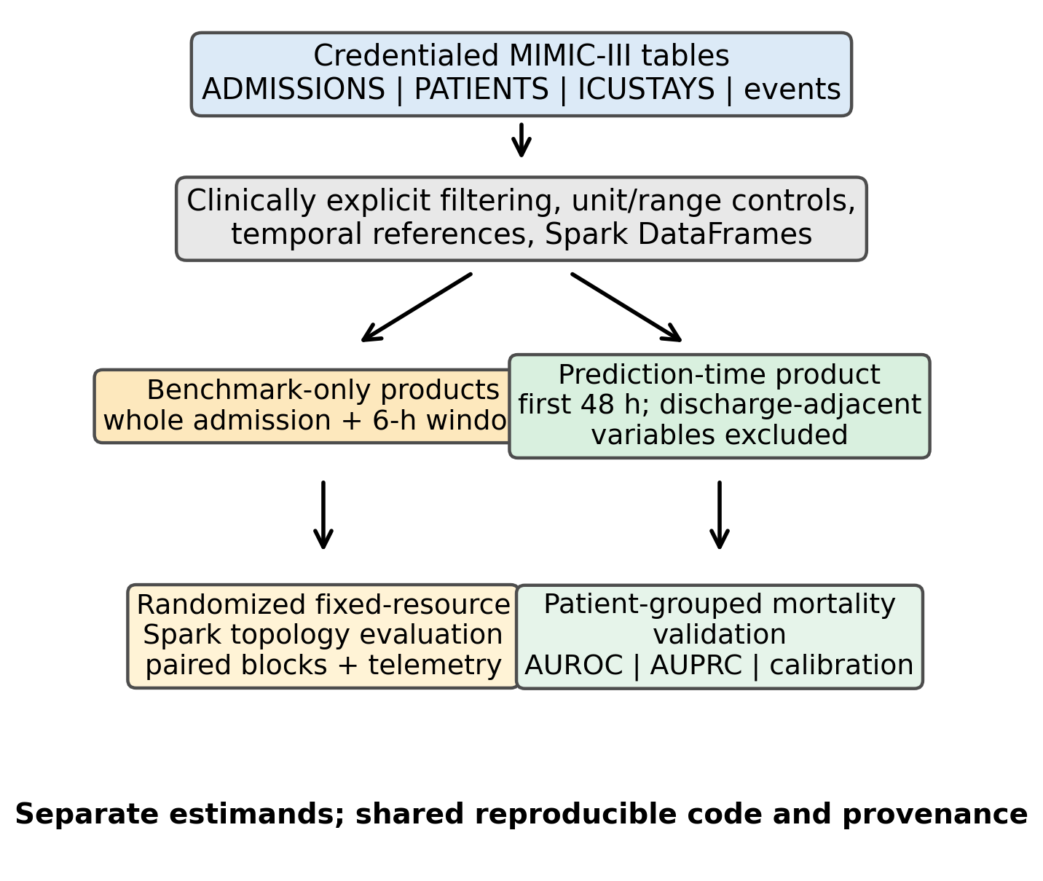
Fig. 1. Separation of systems-benchmark and prediction-time feature products.

II. RELATED WORK
MIMIC-Extract and FIDDLE provide reproducible feature extraction for structured EHR data [3], [4]. Clairvoyance integrates preprocessing and modeling for medical time series [5], whereas COP-E-CAT and the MIMIC-IV Data Pipeline emphasize configurable cleaning and cohort or task construction [6], [7]. Event Stream GPT and MEDS preserve event-time structure and promote reusable representations [8], [9]. EHRSHOT and YAIB standardize prediction tasks and evaluation workflows [10], [11]. These tools address complementary layers of reproducibility but do not experimentally isolate Spark process topology under fixed physical resources.
Quick-MIMIC directly evaluates parallel MIMIC extraction and reports sublinear gains as process count increases [12]. Its multiprocessing and message-passing implementations differ from Spark's local and driver-worker-executor process models. Systems research also shows that co-located applications may interfere through shared caches, memory, input/output, and scheduling resources [13], [14]. Such work motivates measurement but cannot determine which topology will be faster for a specific clinical ETL pipeline.
For mortality prediction, the MIMIC benchmark of Harutyunyan et al. established task definitions and temporal boundaries that reduce leakage [15]. More recent reporting guidance emphasizes patient-level separation, calibration, and explicit handling of prediction horizons [16], [17]. We use predictive modeling only as a validation target for the early-window feature product; benchmark-only whole-admission outputs are never used to support a clinical prediction claim.
The literature therefore exposes a gap between two usually separate evaluation traditions. Clinical preprocessing studies primarily document cohort and feature semantics, whereas data-engineering studies primarily report throughput or runtime. Neither form of evidence substitutes for the other. A pipeline can be computationally reproducible yet clinically invalid because its features cross the prediction boundary; conversely, a clinically defensible cohort can be difficult to reproduce when execution topology, resource limits, and intermediate products are unspecified. Our design links these traditions without treating predictive accuracy as evidence of systems scalability or systems speed as evidence of clinical validity.
Framework | Primary emphasis | Temporal task boundary | Execution evaluation
MIMIC-Extract [3] | Cohorts and representations | Task-dependent | Not topology-focused
FIDDLE [4] | Data-driven preprocessing | User-defined windows | Not topology-focused
COP-E-CAT [6] | Cleaning and organization | Configurable | Not topology-focused
MIMIC-IV pipeline [7] | Cleaning and task construction | Explicit tasks | Not topology-focused
MEDS [9] | Event-data standardization | Preserves event time | Not topology-focused
YAIB [11] | Multi-center ICU benchmarking | Standardized tasks | Model pipeline focus
Quick-MIMIC [12] | Parallel extraction | Extraction scope | Process scaling
This study | Semantics plus Spark execution | Separate 48-h product | Paired fixed-host topology
TABLE I. Positioning of the present study relative to representative reproducible clinical-data frameworks.

III. MATERIALS AND METHODS

A. Data Source and Output Semantics
MIMIC-III v1.4 was accessed through PhysioNet under its credentialing and data-use requirements [1], [2]. Inputs were locally prepared Parquet versions of ADMISSIONS, PATIENTS, ICUSTAYS, CHARTEVENTS, and LABEVENTS. The admission-level benchmark output aggregated eligible vital signs and laboratory measurements by hadm_id. The six-hour-window benchmark output summarized eligible vital-sign observations by hadm_id and window index while repeating admission-level context. Windows without eligible measurements were not emitted. These whole-admission products were used only for systems measurement.
For clinical validation, a separate early-window product retained measurements from the first 48 h after ICU admission and excluded ICU length of stay, ICU discharge time, stay count, and measurements after the cutoff. Admissions with ICU stays shorter than 48 h were excluded, so the target population is explicitly patients remaining in intensive care for at least 48 h. The outcome was in-hospital mortality. This survivor-conditioned cohort definition limits generalizability but avoids using information unavailable at the stated prediction time.
The three products answer different questions and are not interchangeable. The admission-level table is a compact stressor for joins and grouped summaries; the six-hour table increases output cardinality and repeated temporal aggregation; the 48-h table defines a prediction-time view for clinical validation. This separation is enforced in the workflow rather than left to analyst interpretation. Patient-level records are not released, and all public outputs are aggregate diagnostics compatible with the MIMIC data-use agreement.
Data product | Temporal scope | Rows | Permitted use
Admission benchmark | Eligible whole admission | 58,976 | Systems experiment only
Six-hour benchmark | Eligible whole admission by 6-h index | 1,180,395 | Systems experiment only
Early-window clinical | First 48 h after ICU admission | 29,886 | Grouped mortality validation
TABLE II. Data products, temporal semantics, and allowed inferential use.

B. Spark Execution and Experimental Design
Experiments used Spark 3.5.1 and Docker Compose on Windows 11 with 12 logical processors, 32 GiB RAM, and one NVMe solid-state drive. Spark adaptive query execution was enabled and shuffle partitions were set to eight. Local configurations used local[2], local[4], or local[8] within one Java Virtual Machine. Standalone configurations used one or two worker containers connected to a co-located Spark master. These labels describe process arrangements on one host, not separate machines.
The confirmatory experiment used 12 randomized complete blocks after one excluded warm-up block. Each block contained the five configurations for both benchmark workloads. Aggregate containers were capped at 8 CPUs and 8 GiB; standalone executors received six cores in total. The timed interval included DataFrame construction, DISK_ONLY persistence, materialization, transformations, and Parquet plus CSV output, but excluded environment provisioning and Spark shutdown. Spark event logs provided task-attributed executor CPU time, garbage-collection time, shuffle volume, task failures, and disk spill. Row counts and schemas, but not bitwise equality of every floating-point cell, were compared across configurations.
The block schedule randomized the ten workload-configuration combinations within each block to reduce systematic drift from thermal state, background activity, and cache history. The same locally stored Parquet inputs and the same physical host were used throughout. The experimental unit was one completed Spark application, while the paired block was the unit of comparison. Consequently, the 12 repetitions represent technical replications under randomized order, not independent hospitals, machines, or datasets.
Configuration | Process model | Task capacity
local[2] | One JVM | 2 threads
local[4] | One JVM | 4 threads
local[8] | One JVM | 8 threads
Standalone-1 | Master + worker + executor | 6 executor cores
Standalone-2 | Master + 2 workers + 2 executors | 6 executor cores

C. Statistical Analysis
Within each workload, local[8] was compared with the other configurations using paired t tests matched by randomized block. Holm correction was applied within workload. We report paired mean differences, 95% confidence intervals, and geometric-mean runtime ratios. Because n = 12 and some paired differences were non-normal, exact paired sign-flip/Wilcoxon tests were used as sensitivity analyses. A protocol-aligned log-runtime model included workload, configuration, their interaction, fixed block effects, and HC3 heteroskedasticity-consistent standard errors. Linear within-block run order was examined separately.
Inference was restricted to eight prespecified contrasts: four alternatives against local[8] within each of two workloads. Runtime ratios were estimated on the logarithmic scale and back-transformed. Event-log variables were summarized descriptively because the experiment was powered for elapsed-time contrasts, not for mediation analysis. We therefore avoid attributing observed overhead to a specific hardware or Java Virtual Machine mechanism.

D. Leakage-Aware Predictive Validation
The early-window cohort was split by subject_id so that no patient's admissions occurred in both training and test data. Three deliberately conventional models—logistic regression, random forest, and histogram gradient boosting—were evaluated using 30 repeated grouped holdouts and five-fold StratifiedGroupKFold cross-validation. Numeric preprocessing, 1st–99th percentile clipping, median imputation, and scaling were fitted within each training split rather than before resampling.
Logistic regression used balanced class weights, the liblinear solver, and at most 2000 iterations. Random forest used 300 trees, a minimum leaf size of two, and balanced-subsample weights. Histogram gradient boosting used a learning rate of 0.05, 300 iterations, L2 regularization of 0.01, and balanced class weights. Hyperparameters were fixed before evaluation; the study did not search for the best-performing model. Because class-weighted training systematically shifts predicted probabilities away from the true prevalence, each model's raw output was recalibrated within each training fold using sigmoid (Platt) scaling fitted with an inner 5-fold, ungrouped cross-validation; the held-out test fold was never used at this step. Outcomes included AUROC, AUPRC, Brier score, Brier skill score (relative to a constant-prevalence baseline), sensitivity, specificity, and post-recalibration calibration intercept and slope. The 0.5 threshold was retained for descriptive threshold metrics; no clinical decision threshold was optimized.
Thirty repeated 80:20 grouped holdouts (seeds 42–71) assessed sensitivity to a particular train-test partition. Five-fold grouped cross-validation provided the primary compact summary. The prevalence-matched folds contained approximately 23,908 training and 5,978 test admissions, with 20,200–20,236 training patients and 5,035–5,071 test patients. Calibration coefficients were estimated from predicted probabilities after the within-training-fold recalibration described above; they describe the recalibrated, not the native, probability scale of each baseline.

E. Feature Engineering and Quality Controls
The early-window feature matrix combined demographic variables with distributional summaries of vital signs and two laboratory-usage signals available before the 48-h cutoff. For each repeatedly measured vital sign, the pipeline derived count, mean, median, minimum, maximum, and standard deviation. Laboratory results were deliberately restricted to a count of observations and a count of values flagged outside their reference range, omitting mean/median/min/max/SD: LABEVENTS item identifiers span chemically unrelated tests (e.g., sodium, creatinine, hemoglobin, pH) with different units and reference ranges, so an itemid-unaware average of raw values has no clinical meaning. A correct fix requires joining item identifiers through D_LABITEMS, which was not available in the local extract; only the two itemid-agnostic usage signals and their missingness indicators were therefore retained. These summaries intentionally provide a transparent tabular baseline rather than a high-frequency sequence model. They do not preserve waveform morphology, treatment timing, or the order of measurements within the window.
Clinical plausibility controls were applied before aggregation to reduce the influence of unit errors and physiologically impossible values. The modeling pipeline then clipped numeric predictors at the 1st and 99th percentiles using thresholds learned from each training partition. Median imputation and standardization were likewise fitted only on training data and transferred unchanged to the corresponding test partition. This ordering prevents test-distribution information from influencing preprocessing parameters.
Quality control operated at both product and split levels. Product checks covered required columns, output schema, row counts, and successful materialization. Clinical checks documented cohort flow, class balance, feature missingness, and patient-group disjointness. The five cross-validation diagnostics and all 30 holdout diagnostics reported zero group overlap by construction. These controls verify the implemented invariants but do not independently adjudicate the clinical correctness of every MIMIC item identifier or unit mapping.

F. Reproducibility and Provenance
The public repository separates configuration, ETL logic, orchestration, statistical analysis, and report generation. The configuration records paths, Spark settings, feature definitions, and output locations; Docker Compose records the co-located standalone topology; schedules preserve randomized order and seeds; aggregate CSV files retain per-run timing and event-log summaries. The manuscript is tied to a full Git commit identifier rather than an unversioned branch, allowing later changes to be distinguished from the analyzed implementation.
Reproduction requires credentialed local access to MIMIC-III, which cannot be bundled with the code. To respect this constraint, the repository exposes scripts and non-patient-level outputs while excluding source tables and row-level clinical features. A reproducer must prepare the authorized Parquet inputs, apply the documented configuration, and execute the analysis on an environment that meets the stated software requirements. Runtime equality is not expected across hardware; the reproducible targets are pipeline semantics, scheduled conditions, diagnostic checks, and the direction and uncertainty of comparisons under a newly measured environment.

IV. RESULTS

A. Resource-Capped ETL Experiment
All 130 applications completed; event-log analyses used the 120 measured runs. Local[8] had the shortest mean timed ETL runtime for both workloads. All eight planned local[8] contrasts remained significant after Holm adjustment (all adjusted p < 0.0001). Every paired block favored local[8] in all eight comparisons, giving an exact sensitivity-test p value of 0.000488 per contrast. The workload-by-configuration interaction was significant (Wald χ²(4) = 10.77, p = 0.0293), whereas a linear run-order effect was not detected (p = 0.928).
No measured run recorded a task failure or disk spill. Mean shuffle volume was 0.009–0.012 GiB for admission-level runs and 0.131 GiB for six-hour-window runs. These observations exclude task failure and pronounced disk spill as explanations but do not identify the mechanism of the standalone overhead. Process-level input/output, memory bandwidth, CPU frequency, context switching, and driver-executor communication were not measured.
The two workloads produced identical row counts across configurations: 58,976 admission-level rows and 1,180,395 six-hour rows. The six-hour workload consistently transferred about 140.8 MB in each shuffle direction, compared with roughly 8.2–13.1 MB for the admission-level workload. Executor-run time and executor CPU time varied with process topology, but these task-attributed quantities are not directly comparable with wall-clock runtime because tasks overlap and executor accounting excludes some driver-side work. They are retained as diagnostic evidence rather than interpreted as causal components of the runtime difference.
Workload | Configuration | Runtime, s | Median, s
Admission | local[2] | 297.3 ± 11.2 | 298.6
Admission | local[4] | 237.4 ± 8.7 | 234.5
Admission | local[8] | 212.5 ± 11.1 | 211.0
Admission | Standalone-1 | 250.0 ± 6.8 | 248.1
Admission | Standalone-2 | 247.5 ± 9.5 | 246.4
6-h window | local[2] | 315.1 ± 15.3 | 312.7
6-h window | local[4] | 261.8 ± 16.0 | 257.4
6-h window | local[8] | 234.8 ± 7.3 | 233.2
6-h window | Standalone-1 | 280.2 ± 8.9 | 275.4
6-h window | Standalone-2 | 279.9 ± 13.2 | 277.3
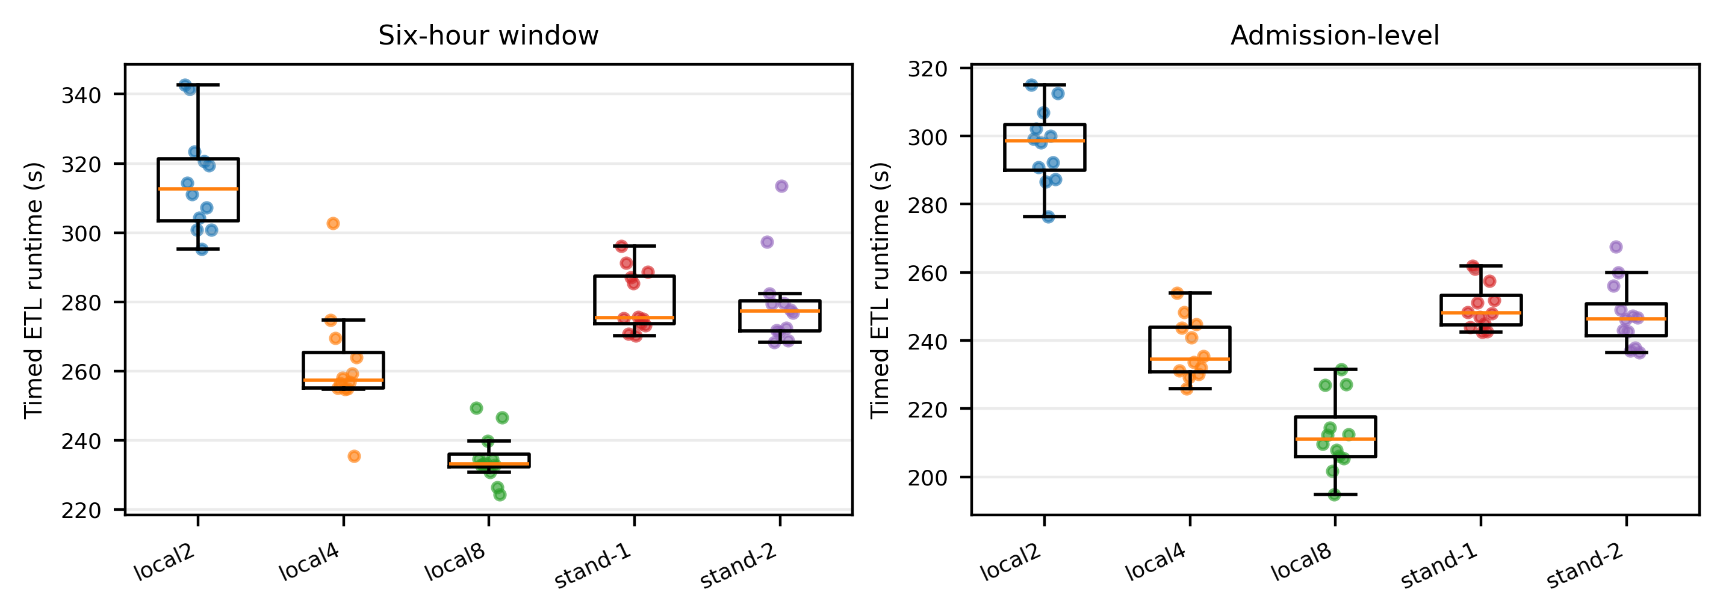
Because standalone configurations declared six total executor cores while local[8] exposed eight task threads, we ran a supplementary, same-session, block-randomized comparison of an equal-capacity local[6] configuration (six task threads in one JVM, matched to standalone's executor-core budget) against the two-worker standalone arrangement (standalone2). Local[6] and standalone2 were interleaved within each of 12 paired blocks (8 CPU/8 GiB per block) so that time-varying host load affected both arms equally. Local[6] remained faster than standalone2 for both workloads: admission-level, 238.6 ± 13.4 s vs. 278.8 ± 67.9 s (paired difference −40.2 s, 95% CI [−80.9, 0.5], geometric ratio 0.87, paired t = −2.17, p = 0.053); six-hour window, 278.8 ± 73.0 s vs. 319.7 ± 81.1 s (difference −40.9 s, 95% CI [−51.5, −30.3], ratio 0.87, paired t = −8.50, p < 0.0001). The direction was consistent across workloads, reaching significance for the six-hour window and remaining marginal for the admission-level workload at this sample size, indicating that the local[8] advantage is not attributable solely to its larger task-slot count.
Fig. 2. Runtime distributions in the randomized resource-capped experiment. Points denote individual measured runs.
Workload | Contrast | Difference, s (95% CI) | Ratio | Holm p
Admission | local[2] - local[8] | 84.7 [74.4, 95.1] | 1.40 | 6.52e-09
Admission | local[4] - local[8] | 24.9 [17.1, 32.6] | 1.12 | 2.05e-05
Admission | Stand-1] - local[8 | 37.5 [28.5, 46.5] | 1.18 | 3.55e-06
Admission | Stand-2] - local[8 | 34.9 [27.8, 42.1] | 1.17 | 1.05e-06
6-h window | local[2] - local[8] | 80.3 [70.1, 90.4] | 1.34 | 7.23e-09
6-h window | local[4] - local[8] | 26.9 [17.7, 36.2] | 1.11 | 5.14e-05
6-h window | Stand-1] - local[8 | 45.3 [41.3, 49.3] | 1.19 | 1.88e-10
6-h window | Stand-2] - local[8 | 45.1 [36.3, 53.9] | 1.19 | 4.17e-07
TABLE IV. Prespecified paired contrasts against local[8]. Positive differences favor local[8].
Workload | Config. | Tasks | Executor run, s | GC, s | Shuffle read, MiB
Admission | local2 | 160 | 552 | 17.4 | 12.1
Admission | local4 | 169 | 855 | 28.9 | 12.1
Admission | local8 | 168 | 1460 | 57.3 | 9.0
Admission | standalone1 | 164 | 1228 | 40.7 | 10.6
Admission | standalone2 | 165 | 1220 | 32.3 | 10.3
6-h | local2 | 162 | 575 | 17.9 | 134.3
6-h | local4 | 171 | 909 | 29.1 | 134.3
6-h | local8 | 180 | 1537 | 58.6 | 134.3
6-h | standalone1 | 171 | 1314 | 43.2 | 134.3
6-h | standalone2 | 171 | 1311 | 34.0 | 134.3
TABLE V. Descriptive Spark event-log telemetry (means across 12 measured runs).

B. Leakage-Aware Clinical Validation
The early-window cohort contained 29,886 admissions from 25,271 patients; mortality prevalence was 12.39%. This cohort differs from a preliminary version that defined the observation window over the multi-stay min/max envelope of each admission rather than its first ICU stay, which misclassified 534/31,252 admissions (1.7%) by including inter-stay service gaps in the eligibility window; the landmark was redefined around each admission's first icustay_id before final analysis. All five cross-validation folds had disjoint patient groups and closely matched outcome prevalence. Histogram gradient boosting had the highest discrimination: AUROC 0.815 ± 0.005 and AUPRC 0.402 ± 0.025 in five-fold grouped cross-validation. Logistic regression yielded AUROC 0.770 ± 0.014 and AUPRC 0.341 ± 0.034; random forest yielded AUROC 0.810 ± 0.007 and AUPRC 0.386 ± 0.020. Each model's raw class-weighted probabilities were recalibrated within each training fold (sigmoid/Platt scaling, 5-fold inner cross-validation, never touching the corresponding test fold) before scoring. After recalibration, gradient boosting's Brier score was 0.090 ± 0.001 — below the constant-prevalence baseline of 0.109, for a Brier skill score of 0.169 ± 0.013 — and its calibration slope and intercept were 1.065 ± 0.039 and 0.092 ± 0.054, close to the ideal values of 1 and 0. Without this recalibration step the raw class-weighted probabilities carried a large negative intercept, indicating systematic miscalibration despite useful ranking; recalibration corrects the probability level without altering rank order or AUROC/AUPRC.
Repeated grouped holdouts supported the cross-validation ordering. Gradient boosting achieved mean AUROC 0.815 (range 0.800–0.830) and mean AUPRC 0.402 (0.371–0.439); random forest achieved 0.811 (0.796–0.828) and 0.386 (0.351–0.418); logistic regression achieved 0.769 (0.749–0.787) and 0.337 (0.310–0.370). Threshold-dependent results were consistent across all three recalibrated models: at the unoptimized 0.5 threshold, sensitivity was low and specificity was high for gradient boosting (0.100 and 0.992), random forest (0.137 and 0.985), and logistic regression (0.076 and 0.991), while precision remained comparatively high (0.55–0.64) because false positives were rare. This pattern is the expected consequence of properly calibrated probabilities under 12.4% prevalence — few predictions exceed 0.5 for a minority outcome even when ranking is informative — and illustrates why AUROC alone is insufficient and why the unoptimized threshold must not be construed as a clinical operating point.
Missingness was moderate for several physiologic summaries: temperature-derived variables were missing in approximately 13.1%–13.4% of admissions, and respiratory-rate, oxygen-saturation, and mean-arterial-pressure summaries in approximately 12.4%. Random-forest importance ranked the abnormal-laboratory count, age, the laboratory-observation count, respiratory rate, temperature, oxygen saturation, and mean arterial pressure among the leading predictors. These impurity-based rankings are descriptive and neither causal nor stable explanations of mortality risk.
Model | AUROC | AUPRC | Brier | Cal. slope
Logistic regression | 0.770 ± .014 | 0.341 ± .034 | 0.096 ± .002 | 1.007 ± .100
Random forest | 0.810 ± .007 | 0.386 ± .020 | 0.092 ± .002 | 1.046 ± .032
Gradient boosting | 0.815 ± .005 | 0.402 ± .025 | 0.090 ± .001 | 1.065 ± .039
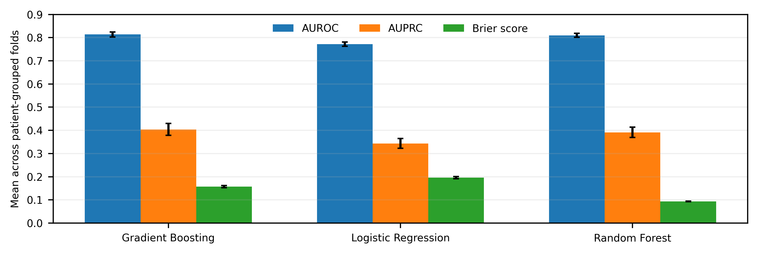
Fig. 3. Five-fold patient-grouped cross-validation results. Error bars denote standard deviations across folds; lower Brier scores are better.
Model | AUROC range | AUPRC range | Sensitivity | Specificity
Gradient Boosting | 0.800–0.830 | 0.371–0.439 | 0.100 | 0.992
Logistic Regression | 0.749–0.787 | 0.310–0.370 | 0.076 | 0.991
Random Forest | 0.796–0.828 | 0.351–0.418 | 0.137 | 0.985
TABLE VII. Thirty repeated patient-grouped holdouts; threshold metrics use 0.5 without optimization.

C. Robustness and Interpretation of Metrics
The primary and repeated-holdout estimates were closely aligned. For gradient boosting, the mean AUROC was 0.815 in both analyses (cross-validation 0.8151 vs. repeated holdout 0.8152), while mean AUPRC differed by 0.0001. Corresponding random-forest estimates differed by 0.0010 for AUROC and 0.0001 for AUPRC. This agreement indicates limited sensitivity to the particular resampling scheme used here, but it is not a substitute for temporal or external validation because every split originates from the same database and era.
The Brier score and calibration coefficients require joint interpretation even after recalibration. Gradient boosting had both the lowest Brier score and the calibration slope closest to one, consistent with its higher discrimination; random forest and logistic regression had modestly higher Brier scores and slopes further from one (0.092/1.046 and 0.096/1.007, calibration intercepts 0.071 and 0.008). All three intercepts were close to zero, indicating that within-training-fold recalibration removed the systematic level shift present in the raw class-weighted probabilities. A model can still rank admissions well while carrying residual slope miscalibration; reporting slope and intercept alongside AUROC and Brier score makes this distinction visible rather than assuming recalibration alone guarantees a decision-ready probability.
Because mortality prevalence was 12.39%, AUPRC provides a more informative view of positive-case retrieval than accuracy. The observed AUPRC values substantially exceeded the no-skill prevalence reference, and precision at the fixed 0.5 threshold was in fact comparatively high (0.53–0.64) precisely because so few admissions crossed the threshold; this reflects low recall rather than a favorable operating point. The study did not define a clinical action, relative harm of false positives and false negatives, or resource constraint. Accordingly, selecting an operating threshold, estimating net benefit, and claiming clinical usefulness would be premature.

V. DISCUSSION
The systems experiment shows that process count is not physical scale. Under a fixed single-host quota, the tested local configuration completed both clinical ETL workloads faster than the tested co-located standalone arrangements. This finding does not imply that standalone Spark is generally inferior; multi-node deployments can add hardware and have different failure, scheduling, and data-locality properties. The observed result is an implemented-topology comparison, not a causal estimate of execution mode alone, because task concurrency, Java heaps, process count, and driver workload were not perfectly equalized; a supplementary equal-task-capacity comparison (local[6] vs. two-worker standalone) found the same direction, suggesting the effect is not solely a task-count artifact.
The clinical experiment addresses a distinct validity question. Whole-admission aggregates are legitimate stressors for ETL benchmarking but are inappropriate for an early mortality claim. Constructing a separate first-48-h product, grouping splits by patient, and reporting AUPRC and calibration prevents several common forms of optimistic evaluation. The models are baselines, not clinical devices. In particular, exclusion of stays shorter than 48 h conditions the target population on survival and continued ICU presence; the results cannot be interpreted as performance at ICU admission or applied to early deaths.
Together, the two experiments support a broader principle for biomedical informatics: computational equivalence, runtime efficiency, and clinical validity are separate properties. Equal row counts and schemas do not establish numerical identity; faster execution does not validate feature semantics; and predictive discrimination does not justify a pipeline that uses future information. Reporting these layers separately makes system choices auditable and prevents performance engineering from obscuring cohort meaning.
The runtime results also clarify the appropriate interpretation of Spark terminology. A standalone master with co-located workers exercises distributed-process coordination, but it does not supply the independent processors, memory, storage, or network links associated with physical scale-out. The additional process boundaries can therefore impose serialization, scheduling, and communication costs without adding resources. Our data are consistent with that explanation, but they cannot partition the cost among these mechanisms. The defensible conclusion is narrower: under the tested quotas and implementation, local[8] was faster.
From a clinical-modeling perspective, the study demonstrates that data-product governance should precede model selection. A high-performing learner cannot repair an invalid temporal view. Conversely, a deliberately simple set of models is sufficient to test whether an early-window product carries clinically relevant signal while exposing calibration and threshold behavior. The similar AUROC estimates across repeated holdouts and grouped folds suggest that the ranking result is not driven by one split, although it remains internal validation from one historical center.
Reproducibility is implemented at four levels. Semantic reproducibility is supported by explicit feature windows and prohibited variables. Computational reproducibility is supported by versioned code, configuration, container definitions, and a pinned commit. Experimental reproducibility is supported by randomized schedules, resource caps, block identifiers, and aggregate event-log summaries. Statistical reproducibility is supported by prespecified contrasts, multiplicity correction, sensitivity tests, and split diagnostics. None of these layers removes the need for independent replication, but together they make discrepancies diagnosable.
The study is limited to one database, one host, one overnight systems campaign, one storage device, and technical rather than independent hardware replications. The benchmark output uses admission-level bounds that may span intervals between multiple ICU stays and therefore is not presented as a clinical cohort. The clinical validation lacks external validation, uncertainty intervals based on independent sites, decision-curve analysis, and post-hoc probability recalibration. Future work should use icustay_id-specific temporal logic, independent machines and days, multi-node clusters, and external datasets such as MIMIC-IV or eICU.
Threats to internal validity include residual background load and imperfect equality of executor and driver resource allocation. Threats to construct validity include using timed ETL completion as the primary systems endpoint and using survivor-conditioned in-hospital mortality as the clinical endpoint. Statistical threats include only 12 paired blocks and correlated technical repetitions; exact sensitivity tests reduce but do not eliminate this concern. External validity is limited by the Windows/Docker/one-NVMe environment, MIMIC-III's historical single-center population, and absence of prospective workflow evaluation. Clinical utility was not tested, so no claims are made regarding bedside benefit, deployment readiness, or decision support.

VI. IMPLICATIONS FOR BIOMEDICAL INFORMATICS
The first implication is that data-product names should encode intended use. Terms such as ‘feature table’ are too broad when one table includes the entire admission and another represents only information available at a clinical decision time. Assigning explicit roles—benchmark-only, exploratory, or prediction-time—reduces the chance that a convenient systems artifact is silently repurposed for modeling. Automated checks can strengthen this governance by rejecting prohibited columns and timestamps beyond the declared cutoff.
The second implication is that systems comparisons need a physical-resource statement. Reporting only Spark master URLs, executor counts, or worker counts can suggest scale-out where none exists. At minimum, studies should report host count, processor and memory limits, storage, process layout, task capacity, software versions, timed boundaries, warm-up policy, randomization, and replication unit. When configurations change several of these factors simultaneously, conclusions should refer to implemented topologies rather than an abstract execution-mode effect.
The third implication is that predictive validation should accompany, but remain conceptually separate from, ETL validation. Schema checks and reproducible execution cannot reveal whether future information entered a feature. Conversely, an acceptable AUROC does not establish that two executions produced equivalent data. Biomedical pipelines benefit from an evidence matrix in which semantic checks, computational checks, statistical checks, and clinical-model checks have distinct acceptance criteria and artifacts.
For future deployment-oriented work, the early-window product should be evaluated on an admission-time or shorter-horizon cohort that includes early deaths, followed by temporal validation and external validation on a different health system. Calibration should be reassessed and, if necessary, fitted on a dedicated calibration sample. Decision-curve analysis and workflow simulation would then be needed to determine whether any threshold offers clinical value. These steps are intentionally outside the scope of the present reproducibility and internal-validation study.

VII. VALIDITY BOUNDARIES AND REPORTING RECOMMENDATIONS
The systems and clinical components have different populations of inference. The runtime experiment concerns repeated executions of one implemented ETL pipeline on one capped host. Its uncertainty intervals quantify block-to-block technical variation under that environment; they do not quantify variation across processors, operating systems, storage devices, Spark versions, or institutions. The clinical experiment concerns eligible MIMIC-III admissions satisfying the 48-h stay criterion. Its resampling variation reflects internal patient partitions, not transportability to contemporary or external populations. Keeping these inferential populations explicit prevents a statistically precise estimate from being mistaken for a broadly general result.
Resource capping improves comparability but does not make the local and standalone conditions mechanistically identical. The local modes place task threads within one Java Virtual Machine, whereas standalone modes add master, worker, executor, and container boundaries. Executor cores were fixed at six in the standalone arrangements while local[8] exposed eight task threads; Section IV.A reports a supplementary equal-capacity comparison (local[6] vs. standalone2) that partially disentangles this confound and still favors local execution, though the admission-level contrast was only marginal at n = 12 paired blocks and the comparison shares the same host and session as the rest of the study. It therefore cannot isolate a pure communication penalty from other process-boundary costs. A future factorial study should vary process model and task capacity independently across a larger number of blocks, record processor frequency and context switches, and repeat the experiment on physically separate workers and on independent days.
Output equivalence was assessed by schema and row-count invariants plus successful downstream analyses. Floating-point aggregation can vary with partitioning and reduction order, so bitwise equality is neither assumed nor claimed. For applications in which small numerical differences alter cohort membership or clinical decisions, stronger checks are required: key-level reconciliation, tolerance-based comparisons for continuous values, exact comparisons for categorical values, and explicit investigation of unmatched records. These checks should be specified before performance measurement rather than added only after a discrepancy appears.
The 48-h cohort definition resolves one leakage problem while introducing a selection condition. Patients who die or leave intensive care before 48 h are absent, so the estimand is not mortality risk at admission. The retained cohort may be clinically more stable and may have a different severity distribution from all ICU admissions. This limitation cannot be corrected by resampling, class weighting, or calibration. It requires redefining the prediction time and reconstructing features at a horizon available for every eligible patient, for example the first 6 or 12 h, with a correspondingly explicit landmark population.
Model comparison is intentionally descriptive. The three algorithms were selected as interpretable and widely used tabular baselines, and their hyperparameters were fixed rather than optimized through nested resampling. Differences between their mean metrics should not be treated as formal pairwise superiority tests. Likewise, random-forest impurity importance is susceptible to correlated predictors and differences in feature variability. A deployment study would require nested tuning, confidence intervals for paired metric differences, external calibration assessment, clinically defined thresholds, fairness analyses across relevant subgroups, and monitoring for dataset shift.
Based on these observations, a minimum report for similar studies should contain four linked records. A semantic record should define population, index time, horizon, outcome, and forbidden future variables. A computational record should state physical hosts, quotas, storage, software versions, process topology, and timing boundaries. An experimental record should preserve randomization, warm-up rules, seeds, replications, failures, and analysis units. A validation record should document group separation, prevalence, missingness, discrimination, calibration, threshold rationale, and intended use. Publishing these records alongside aggregate outputs makes both successful replication and informative failure more likely.

VIII. CONCLUSION
A reproducible clinical data pipeline must report both what its features mean and how they were computed. In the evaluated resource-constrained environment, local[8] outperformed co-located standalone Spark configurations for two MIMIC-III ETL workloads. A separate first-48-h feature product supported patient-grouped mortality validation without reusing benchmark-only whole-admission features. The released code and aggregate diagnostics provide an auditable basis for replication, while the single-center, survivor-conditioned clinical cohort and single-host systems design define clear limits on inference.

ACKNOWLEDGMENT
The authors used OpenAI generative-AI tools for translation support and language editing. The authors verified all analyses, references, and claims and take responsibility for the final manuscript.

ETHICS AND DATA GOVERNANCE
MIMIC-III was released with approvals from the institutional review boards of Beth Israel Deaconess Medical Center and the Massachusetts Institute of Technology and with a waiver of individual informed consent for the de-identified database [1], [2]. This secondary computational analysis used the database under PhysioNet credentialing and its data-use agreement; the authors did not recruit participants, contact patients, or access direct identifiers.

DATA AND CODE AVAILABILITY
MIMIC-III cannot be redistributed. Credentialed users may obtain it from PhysioNet [2]. Source code, configuration files, aggregate tables, figures, and non-patient-level diagnostics are available at https://github.com/esma6/icu_mortality_project (commit d0e87f9696562554185b5c7949daf006ffcc75fb).

REFERENCES
[1] A. E. W. Johnson et al., “MIMIC-III, a freely accessible critical care database,” Sci. Data, vol. 3, Art. no. 160035, 2016, doi: 10.1038/sdata.2016.35.
[2] A. E. W. Johnson, T. J. Pollard, and R. G. Mark, “MIMIC-III Clinical Database (version 1.4),” PhysioNet, 2016, doi: 10.13026/C2XW26.
[3] S. Wang et al., “MIMIC-Extract: A data extraction, preprocessing, and representation pipeline for MIMIC-III,” in Proc. ACM CHIL, 2020, pp. 222–235, doi: 10.1145/3368555.3384469.
[4] S. Tang et al., “Democratizing EHR analyses with FIDDLE: A flexible data-driven preprocessing pipeline for structured clinical data,” J. Am. Med. Inform. Assoc., vol. 27, no. 12, pp. 1921–1934, 2020, doi: 10.1093/jamia/ocaa139.
[5] D. Jarrett et al., “Clairvoyance: A pipeline toolkit for medical time series,” in Proc. ICLR, 2021.
[6] A. Mandyam et al., “COP-E-CAT: Cleaning and organization pipeline for EHR computational and analytic tasks,” in Proc. ACM BCB, 2021, doi: 10.1145/3459930.3469536.
[7] M. Gupta et al., “An extensive data processing pipeline for MIMIC-IV,” Proc. Mach. Learn. Res., vol. 193, pp. 311–325, 2022.
[8] M. B. A. McDermott et al., “Event Stream GPT: A data pre-processing and modeling library for generative, pre-trained transformers over continuous-time sequences of complex events,” in Adv. Neural Inf. Process. Syst., vol. 36, 2023, pp. 24322–24334.
[9] M. B. A. McDermott et al., “MEDS—An emerging data standard and ecosystem for health AI research,” NEJM AI, vol. 3, no. 6, 2026, doi: 10.1056/AIra2501253.
[10] M. Wornow et al., “EHRSHOT: An EHR benchmark for few-shot evaluation of foundation models,” in Adv. Neural Inf. Process. Syst., vol. 36, 2023.
[11] R. van de Water et al., “Yet Another ICU Benchmark: A flexible multi-center framework for clinical ML,” in Proc. ICLR, 2024.
[12] Y. Dou et al., “Quick-MIMIC: A multimodal data extraction pipeline for MIMIC with parallelization,” Big Data Min. Anal., vol. 7, no. 4, pp. 1333–1346, 2024, doi: 10.26599/BDMA.2024.9020024.
[13] F. V. Zacarias et al., “Intelligent colocation of HPC workloads,” J. Parallel Distrib. Comput., vol. 151, pp. 125–137, 2021, doi: 10.1016/j.jpdc.2021.02.010.
[14] M. M. Alves and L. M. A. Drummond, “A multivariate and quantitative model for predicting cross-application interference in virtual environments,” J. Syst. Softw., vol. 128, pp. 150–163, 2017, doi: 10.1016/j.jss.2017.04.001.
[15] H. Harutyunyan et al., “Multitask learning and benchmarking with clinical time series data,” Sci. Data, vol. 6, Art. no. 96, 2019, doi: 10.1038/s41597-019-0103-9.
[16] G. S. Collins et al., “TRIPOD+AI statement: Updated guidance for reporting clinical prediction models that use regression or machine learning methods,” BMJ, vol. 385, e078378, 2024, doi: 10.1136/bmj-2023-078378.
[17] S. Kapoor and A. Narayanan, “Leakage and the reproducibility crisis in machine-learning-based science,” Patterns, vol. 4, no. 9, Art. no. 100804, 2023, doi: 10.1016/j.patter.2023.100804.
[18] M. Zaharia et al., “Apache Spark: A unified engine for big data processing,” Commun. ACM, vol. 59, no. 11, pp. 56–65, 2016, doi: 10.1145/2934664.
[19] Apache Software Foundation, “Submitting applications—Spark 3.5 documentation,” 2026. [Online]. Available: https://spark.apache.org/docs/3.5.8/submitting-applications.html
[20] Apache Software Foundation, “Spark standalone mode—Spark 3.5 documentation,” 2026. [Online]. Available: https://spark.apache.org/docs/3.5.6/spark-standalone.html
[21] C. Boettiger, “An introduction to Docker for reproducible research,” ACM SIGOPS Oper. Syst. Rev., vol. 49, no. 1, pp. 71–79, 2015, doi: 10.1145/2723872.2723882.
[22] M. B. A. McDermott et al., “Reproducibility in machine learning for health research: Still a ways to go,” Sci. Transl. Med., vol. 13, no. 586, eabb1655, 2021, doi: 10.1126/scitranslmed.abb1655.
[23] A. E. W. Johnson et al., “MIMIC-IV, a freely accessible electronic health record dataset,” Sci. Data, vol. 10, Art. no. 1, 2023, doi: 10.1038/s41597-022-01899-x.
[24] T. Namli et al., “A scalable and transparent data pipeline for AI-enabled health data ecosystems,” Front. Med., vol. 11, Art. no. 1393123, 2024, doi: 10.3389/fmed.2024.1393123.
[25] A. J. McMurry et al., “Cumulus: A federated electronic health record-based learning system powered by FHIR and artificial intelligence,” J. Am. Med. Inform. Assoc., vol. 31, no. 8, pp. 1638–1647, 2024, doi: 10.1093/jamia/ocae130.

