Reproducible and Leakage-Aware Spark ETL for MIMIC-III: Clinical Validation and Single-Host Systems Evaluation
Esma Fazilet Karagülle¹ and Esra Odabaş Yıldırım²
¹Department of Computer Engineering, Atatürk University, Erzurum, Türkiye (e-mail: esmafazilet.karagulle17@ogr.atauni.edu.tr). ²Department of Software Engineering, Atatürk University, Erzurum, Türkiye (e-mail: esra.odabas@atauni.edu.tr; corresponding author).
Abstract—Reliable clinical machine learning requires both reproducible data processing and features that respect the intended prediction time. This study developed and evaluated an Apache Spark pipeline for MIMIC-III that explicitly separates computational benchmarking outputs from clinically interpretable prediction-time features. Five Spark execution configurations were compared in a randomized, fixed-resource, single-host experiment using admission-level and six-hour-window workloads. Clinical validity was evaluated separately using features restricted to the first 48 h of the first intensive-care stay and patient-grouped resampling for in-hospital mortality prediction. Among the evaluated configurations, local[8] achieved the shortest mean runtime for both the admission-level (212.5 ± 11.1 s) and six-hour-window (234.8 ± 7.3 s) workloads. A supplementary equal-capacity comparison also favored local execution, although statistical evidence differed between workloads. The leakage-aware clinical cohort comprised 29,886 admissions from 25,271 patients, with an in-hospital mortality prevalence of 12.4%. Gradient boosting achieved an AUROC of 0.813 ± 0.006 and an AUPRC of 0.402 ± 0.023 in five-fold patient-grouped cross-validation. Patient-grouped probability recalibration improved calibration and produced a Brier skill score of 0.168 relative to the prevalence baseline. These findings demonstrate that co-located Spark workers should not be interpreted as physical scale-out and that benchmark-oriented aggregates must remain separate from prediction-time clinical features. The released pipeline and aggregate diagnostics support transparent and reproducible evaluation of clinical data-engineering workflows.
Index Terms—Clinical data engineering, Apache Spark, electronic health records, MIMIC-III, reproducibility, temporal data leakage.

I. INTRODUCTION
Electronic health records (EHRs) are collected for care delivery rather than analysis. Transforming them into research-ready data requires explicit cohort definitions, unit harmonization, temporal alignment, and missing-data handling [3], [4]. For prediction studies, these operations must also preserve the information boundary at the intended decision time; otherwise, future or discharge-adjacent information can produce optimistic and clinically misleading estimates [15]–[17].
Reproducible EHR pipelines have improved the transparency of cohort construction, feature extraction, and benchmark definition [3], [4], [6]–[11], [24]. A separate systems concern is often reported less precisely: software-level worker processes placed on one computer may be described as a cluster even though they share the same processors, memory channels, and storage device. Consequently, process topology and physical scale-out must be distinguished when runtime results are interpreted.
These two concerns intersect when whole-admission aggregates created to stress an ETL system are reused for early clinical prediction. Such aggregates may be computationally appropriate yet violate the prediction-time boundary. Computational reproducibility, execution efficiency, and clinical validity therefore represent distinct properties that must be evaluated with separate data products and evidence.
This study asks two linked questions: how do local and co-located standalone Spark topologies compare under fixed single-host resources, and can a separately constructed first-48-h feature product support internally valid mortality prediction without reusing benchmark-only information? The contributions are: 1) an explicit separation of benchmark and prediction-time data products; 2) a randomized, fixed-resource topology comparison using paired blocks and event-log telemetry; and 3) patient-grouped validation with discrimination, precision-recall, Brier, and calibration measures. The objective is an auditable methodology for resource-constrained clinical data engineering, not a claim of multi-node scaling or a state-of-the-art mortality model.
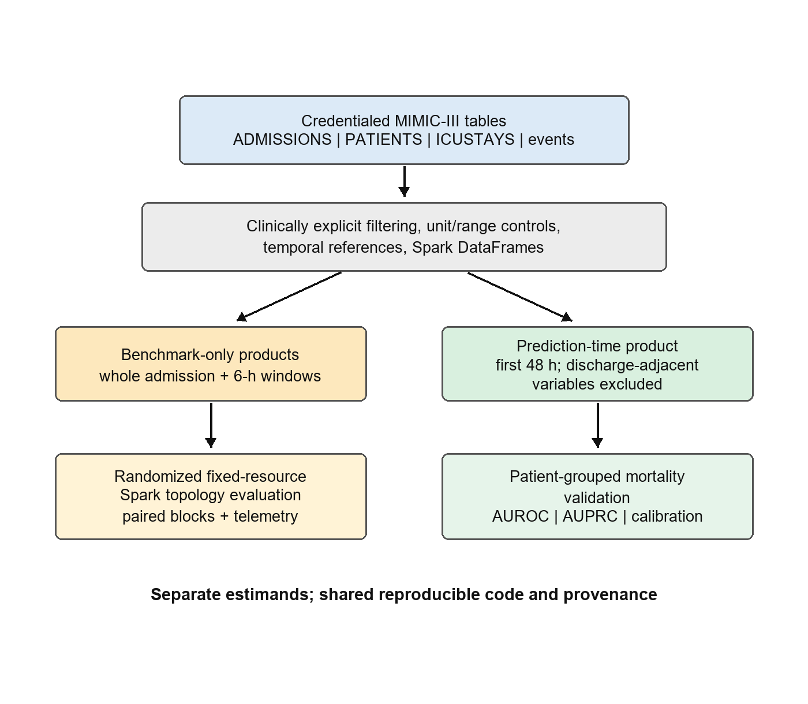
Fig. 1. Separation of systems-benchmark and prediction-time feature products.

II. RELATED WORK
MIMIC-Extract and FIDDLE provide reproducible feature extraction for structured EHR data [3], [4]. Clairvoyance integrates preprocessing and modeling for medical time series [5], whereas COP-E-CAT and the MIMIC-IV Data Pipeline emphasize configurable cleaning and cohort or task construction [6], [7]. Event Stream GPT and MEDS preserve event-time structure and promote reusable representations [8], [9]. EHRSHOT and YAIB standardize prediction tasks and evaluation workflows [10], [11]. These tools address complementary layers of reproducibility but do not experimentally isolate Spark process topology under fixed physical resources.
Quick-MIMIC evaluates parallel extraction from MIMIC using multiprocessing and message-passing implementations [12]. These implementations differ from Spark's local and driver-worker-executor process models. Systems research also shows that co-located applications may interfere through shared caches, memory, input/output, and scheduling resources [13], [14]. Such work motivates measurement but cannot determine which topology will be faster for a specific clinical ETL pipeline.
For mortality prediction, the MIMIC benchmark of Harutyunyan et al. established task definitions and temporal boundaries that reduce leakage [15]. More recent reporting guidance emphasizes patient-level separation, calibration, and explicit handling of prediction horizons [16], [17]. We use predictive modeling only as a validation target for the early-window feature product; benchmark-only whole-admission outputs are never used to support a clinical prediction claim.
The literature therefore exposes a gap between two usually separate evaluation traditions. Clinical preprocessing studies primarily document cohort and feature semantics, whereas data-engineering studies primarily report throughput or runtime. Neither form of evidence substitutes for the other. A pipeline can be computationally reproducible yet clinically invalid because its features cross the prediction boundary; conversely, a clinically defensible cohort can be difficult to reproduce when execution topology, resource limits, and intermediate products are unspecified. Our design links these traditions without treating predictive accuracy as evidence of systems scalability or systems speed as evidence of clinical validity.
Framework | Primary emphasis | Temporal task boundary | Execution evaluation
MIMIC-Extract [3] | Cohorts and representations | Task-dependent | Not topology-focused
FIDDLE [4] | Data-driven preprocessing | User-defined windows | Not topology-focused
COP-E-CAT [6] | Cleaning and organization | Configurable | Not topology-focused
MIMIC-IV pipeline [7] | Cleaning and task construction | Explicit tasks | Not topology-focused
MEDS [9] | Event-data standardization | Preserves event time | Not topology-focused
YAIB [11] | Multi-center ICU benchmarking | Standardized tasks | Model pipeline focus
Quick-MIMIC [12] | Parallel extraction | Extraction scope | Process scaling
This study | Semantics plus Spark execution | Separate 48-h product | Paired fixed-host topology
TABLE I. Positioning of the present study relative to representative reproducible clinical-data frameworks.

III. MATERIALS AND METHODS

A. Data Source and Output Semantics
MIMIC-III v1.4 was accessed through PhysioNet under its credentialing and data-use requirements [1], [2]. Inputs were locally prepared Parquet versions of ADMISSIONS, PATIENTS, ICUSTAYS, CHARTEVENTS, and LABEVENTS. The admission-level benchmark output aggregated eligible vital signs and laboratory measurements by hadm_id. The six-hour-window benchmark output summarized eligible vital-sign observations by hadm_id and window index while repeating admission-level context. Windows without eligible measurements were not emitted. These whole-admission products were used only for systems measurement.
For clinical validation, a separate early-window product retained measurements from the first 48 h after ICU admission and excluded ICU length of stay, ICU discharge time, stay count, and measurements after the cutoff. Admissions with ICU stays shorter than 48 h were excluded, so the target population is explicitly patients remaining in intensive care for at least 48 h. The outcome was in-hospital mortality. This survivor-conditioned cohort definition limits generalizability but avoids using information unavailable at the stated prediction time.
The three products answer different questions and are not interchangeable. The admission-level table is a compact stressor for joins and grouped summaries; the six-hour table increases output cardinality and repeated temporal aggregation; the 48-h table defines a prediction-time view for clinical validation. This separation is enforced in the workflow rather than left to analyst interpretation. Patient-level records are not released, and all public outputs are aggregate diagnostics compatible with the MIMIC data-use agreement.
Data product | Temporal scope | Rows | Permitted use
Admission benchmark | Eligible whole admission | 58,976 | Systems experiment only
Six-hour benchmark | Eligible whole admission by 6-h index | 1,180,395 | Systems experiment only
Early-window clinical | First 48 h after ICU admission | 29,886 | Grouped mortality validation
TABLE II. Data products, temporal semantics, and allowed inferential use.

B. Spark Execution and Experimental Design
Experiments used Spark 3.5.1 and Docker Compose on Windows 11 with 12 logical processors, 32 GiB RAM, and one NVMe solid-state drive. Spark adaptive query execution was enabled and shuffle partitions were set to eight. Local configurations used local[2], local[4], or local[8] within one Java Virtual Machine, consistent with Spark's local master syntax [18], [19]. Standalone configurations used one or two worker containers connected to a co-located Spark master under Spark's standalone deployment model [20]. These labels describe process arrangements on one host, not separate machines.
The confirmatory experiment used 12 randomized complete blocks after one excluded warm-up block. Each block contained the five configurations for both benchmark workloads. Aggregate containers were capped at 8 CPUs and 8 GiB; standalone executors received six cores in total. The timed interval included DataFrame construction, DISK_ONLY persistence, materialization, transformations, and Parquet plus CSV output, but excluded environment provisioning and Spark shutdown. Spark event logs provided task-attributed executor CPU time, garbage-collection time, shuffle volume, task failures, and disk spill. Row counts and schemas, but not bitwise equality of every floating-point cell, were compared across configurations.
The block schedule randomized the ten workload-configuration combinations within each block to reduce systematic drift from thermal state, background activity, and cache history. The same locally stored Parquet inputs and the same physical host were used throughout. The experimental unit was one completed Spark application, while the paired block was the unit of comparison. Consequently, the 12 repetitions represent technical replications under randomized order, not independent hospitals, machines, or datasets.
Configuration | Process model | Task capacity
local[2] | One JVM | 2 threads
local[4] | One JVM | 4 threads
local[8] | One JVM | 8 threads
Standalone-1 | Master + worker + executor | 6 executor cores
Standalone-2 | Master + 2 workers + 2 executors | 6 executor cores
TABLE III. Spark execution configurations and available task capacity.

C. Statistical Analysis
Within each workload, local[8] was compared with the other configurations using paired t tests matched by randomized block. Holm correction was applied within workload. We report paired mean differences, 95% confidence intervals, and geometric-mean runtime ratios. Because n = 12 and some paired differences were non-normal, exact paired sign-flip/Wilcoxon tests were used as sensitivity analyses. A protocol-aligned log-runtime model included workload, configuration, their interaction, fixed block effects, and HC3 heteroskedasticity-consistent standard errors. Linear within-block run order was examined separately.
Inference was restricted to eight prespecified contrasts: four alternatives against local[8] within each of two workloads. Runtime ratios were estimated on the logarithmic scale and back-transformed. Event-log variables were summarized descriptively because the experiment was powered for elapsed-time contrasts, not for mediation analysis. We therefore avoid attributing observed overhead to a specific hardware or Java Virtual Machine mechanism.

D. Leakage-Aware Predictive Validation
The early-window cohort was split by subject_id so that no patient's admissions occurred in both training and test data. Three deliberately conventional models—logistic regression, random forest, and histogram gradient boosting—were evaluated using 30 repeated grouped holdouts and five-fold StratifiedGroupKFold cross-validation. Numeric preprocessing, 1st–99th percentile clipping, median imputation, and scaling were fitted within each training split rather than before resampling.
Logistic regression used balanced class weights, the liblinear solver, and at most 2000 iterations. Random forest used 300 trees, a minimum leaf size of two, and balanced-subsample weights. Histogram gradient boosting used a learning rate of 0.05, 300 iterations, L2 regularization of 0.01, and balanced class weights. Hyperparameters were fixed before evaluation; the study did not search for the best-performing model. Because class-weighted training systematically shifts predicted probabilities away from the true prevalence, each model's raw output was recalibrated within each training fold using sigmoid (Platt) scaling fitted with an inner 5-fold cross-validation itself grouped by subject_id (StratifiedGroupKFold), so a patient's admissions cannot span the inner model-fitting and calibration folds either; the held-out outer test fold was never used at this step. Outcomes included AUROC, AUPRC, Brier score, Brier skill score (relative to a constant-prevalence baseline), sensitivity, specificity, and post-recalibration calibration intercept and slope. The 0.5 threshold was retained for descriptive threshold metrics; no clinical decision threshold was optimized.
Thirty repeated 80:20 grouped holdouts (seeds 42–71) assessed sensitivity to a particular train-test partition. Five-fold grouped cross-validation provided the primary compact summary. The prevalence-matched folds contained approximately 23,908 training and 5,978 test admissions, with 20,200–20,236 training patients and 5,035–5,071 test patients. Calibration coefficients were estimated from predicted probabilities after the within-training-fold recalibration described above; they describe the recalibrated, not the native, probability scale of each baseline.

E. Feature Engineering and Quality Controls
The early-window feature matrix combined demographic variables with distributional summaries of vital signs and two laboratory-usage signals available before the 48-h cutoff. For each repeatedly measured vital sign, the pipeline derived count, mean, median, minimum, maximum, and standard deviation. Laboratory results were deliberately restricted to a count of observations and a count of values flagged outside their reference range, omitting mean/median/min/max/SD: LABEVENTS item identifiers span chemically unrelated tests (e.g., sodium, creatinine, hemoglobin, pH) with different units and reference ranges, so an itemid-unaware average of raw values has no clinical meaning. A correct fix requires joining item identifiers through D_LABITEMS, which was not available in the local extract; only the two itemid-agnostic usage signals and their missingness indicators were therefore retained. These summaries intentionally provide a transparent tabular baseline rather than a high-frequency sequence model. They do not preserve waveform morphology, treatment timing, or the order of measurements within the window.
Clinical plausibility controls were applied before aggregation to reduce the influence of unit errors and physiologically impossible values. The modeling pipeline then clipped numeric predictors at the 1st and 99th percentiles using thresholds learned from each training partition. Median imputation and standardization were likewise fitted only on training data and transferred unchanged to the corresponding test partition. This ordering prevents test-distribution information from influencing preprocessing parameters.
Quality control operated at both product and split levels. Product checks covered required columns, output schema, row counts, and successful materialization. Clinical checks documented cohort flow, class balance, feature missingness, and patient-group disjointness. The five cross-validation diagnostics and all 30 holdout diagnostics reported zero group overlap by construction. These controls verify the implemented invariants but do not independently adjudicate the clinical correctness of every MIMIC item identifier or unit mapping.

F. Reproducibility and Provenance
The public repository separates configuration, ETL logic, orchestration, statistical analysis, and report generation. The configuration records paths, Spark settings, feature definitions, and output locations; Docker Compose records the co-located standalone topology; schedules preserve randomized order and seeds; aggregate CSV files retain per-run timing and event-log summaries. Containerized specifications can improve computational reproducibility [21], while explicit release of code, configuration, and evaluation artifacts addresses recognized reproducibility deficiencies in health machine learning [22]. The manuscript is tied to a full Git commit identifier rather than an unversioned branch, allowing later changes to be distinguished from the analyzed implementation.
Reproduction requires credentialed local access to MIMIC-III, which cannot be bundled with the code. To respect this constraint, the repository exposes scripts and non-patient-level outputs while excluding source tables and row-level clinical features. A reproducer must prepare the authorized Parquet inputs, apply the documented configuration, and execute the analysis on an environment that meets the stated software requirements. Runtime equality is not expected across hardware; the reproducible targets are pipeline semantics, scheduled conditions, diagnostic checks, and the direction and uncertainty of comparisons under a newly measured environment.

IV. RESULTS

A. Resource-Capped ETL Experiment
All 130 applications completed; event-log analyses used the 120 measured runs. Local[8] had the shortest mean timed ETL runtime for both workloads. All eight planned local[8] contrasts remained significant after Holm adjustment (all adjusted p < 0.0001). Every paired block favored local[8] in all eight comparisons, giving an exact sensitivity-test p value of 0.000488 per contrast. The workload-by-configuration interaction was significant (Wald χ²(4) = 10.77, p = 0.0293), whereas a linear run-order effect was not detected (p = 0.928).
No measured run recorded a task failure or disk spill. Mean shuffle volume was 0.009–0.012 GiB for admission-level runs and 0.131 GiB for six-hour-window runs. These observations exclude task failure and pronounced disk spill as explanations but do not identify the mechanism of the standalone overhead. Process-level input/output, memory bandwidth, CPU frequency, context switching, and driver-executor communication were not measured.
The two workloads produced identical row counts across configurations: 58,976 admission-level rows and 1,180,395 six-hour rows. The six-hour workload consistently transferred about 140.8 MB in each shuffle direction, compared with roughly 8.2–13.1 MB for the admission-level workload. Executor-run time and executor CPU time varied with process topology, but these task-attributed quantities are not directly comparable with wall-clock runtime because tasks overlap and executor accounting excludes some driver-side work. They are retained as diagnostic evidence rather than interpreted as causal components of the runtime difference.
Workload | Configuration | Runtime, s | Median, s
Admission | local[2] | 297.3 ± 11.2 | 298.6
Admission | local[4] | 237.4 ± 8.7 | 234.5
Admission | local[8] | 212.5 ± 11.1 | 211.0
Admission | Standalone-1 | 250.0 ± 6.8 | 248.1
Admission | Standalone-2 | 247.5 ± 9.5 | 246.4
6-h window | local[2] | 315.1 ± 15.3 | 312.7
6-h window | local[4] | 261.8 ± 16.0 | 257.4
6-h window | local[8] | 234.8 ± 7.3 | 233.2
6-h window | Standalone-1 | 280.2 ± 8.9 | 275.4
6-h window | Standalone-2 | 279.9 ± 13.2 | 277.3
TABLE IV. Timed ETL runtime by workload and Spark configuration.
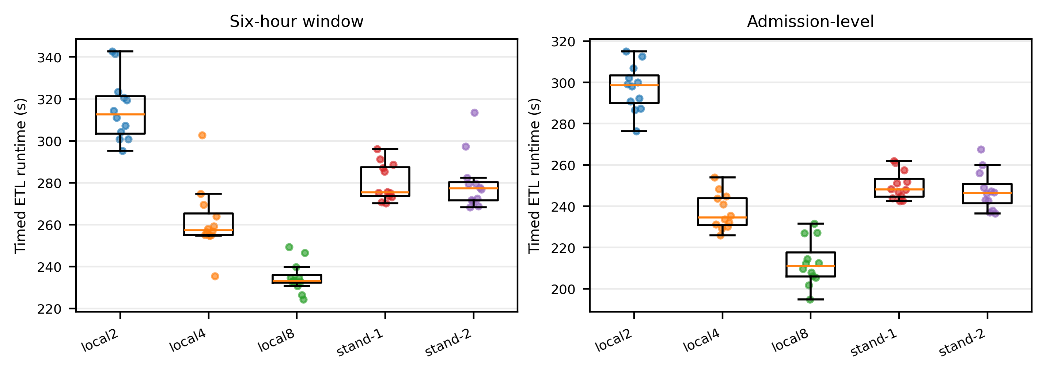
Fig. 2. Runtime distributions in the randomized resource-capped experiment. Points denote individual measured runs.
Because standalone configurations declared six total executor cores while local[8] exposed eight task threads, we ran a supplementary, same-session, block-randomized comparison of an equal-capacity local[6] configuration (six task threads in one JVM, matched to standalone's executor-core budget) against the two-worker standalone arrangement (standalone2). Local[6] and standalone2 were interleaved within each of 12 paired blocks (8 CPU/8 GiB per block) so that time-varying host load affected both arms equally. Local[6] remained faster than standalone2 for both workloads: admission-level, 238.6 ± 13.4 s vs. 278.8 ± 67.9 s (paired difference −40.2 s, 95% CI [−80.9, 0.5], geometric ratio 0.87, paired t = −2.17, p = 0.053); six-hour window, 278.8 ± 73.0 s vs. 319.7 ± 81.1 s (difference −40.9 s, 95% CI [−51.5, −30.3], ratio 0.87, paired t = −8.50, p < 0.0001). The direction was consistent across workloads, reaching significance for the six-hour window and remaining marginal for the admission-level workload at this sample size, indicating that the local[8] advantage is not attributable solely to its larger task-slot count.
Workload | Contrast | Difference, s (95% CI) | Ratio | Holm p
Admission | local[2] - local[8] | 84.7 [74.4, 95.1] | 1.40 | 6.52e-09
Admission | local[4] - local[8] | 24.9 [17.1, 32.6] | 1.12 | 2.05e-05
Admission | Standalone-1 − local[8] | 37.5 [28.5, 46.5] | 1.18 | 3.55e-06
Admission | Standalone-2 − local[8] | 34.9 [27.8, 42.1] | 1.17 | 1.05e-06
6-h window | local[2] - local[8] | 80.3 [70.1, 90.4] | 1.34 | 7.23e-09
6-h window | local[4] - local[8] | 26.9 [17.7, 36.2] | 1.11 | 5.14e-05
6-h window | Standalone-1 − local[8] | 45.3 [41.3, 49.3] | 1.19 | 1.88e-10
6-h window | Standalone-2 − local[8] | 45.1 [36.3, 53.9] | 1.19 | 4.17e-07
TABLE V. Prespecified paired contrasts against local[8]. Positive differences favor local[8].
Workload | Config. | Tasks | Executor run, s | GC, s | Shuffle read, MiB
Admission | local2 | 160 | 552 | 17.4 | 12.1
Admission | local4 | 169 | 855 | 28.9 | 12.1
Admission | local8 | 168 | 1460 | 57.3 | 9.0
Admission | standalone1 | 164 | 1228 | 40.7 | 10.6
Admission | standalone2 | 165 | 1220 | 32.3 | 10.3
6-h | local2 | 162 | 575 | 17.9 | 134.3
6-h | local4 | 171 | 909 | 29.1 | 134.3
6-h | local8 | 180 | 1537 | 58.6 | 134.3
6-h | standalone1 | 171 | 1314 | 43.2 | 134.3
6-h | standalone2 | 171 | 1311 | 34.0 | 134.3
TABLE VI. Descriptive Spark event-log telemetry (means across 12 measured runs).

B. Leakage-Aware Clinical Validation
The early-window cohort contained 29,886 admissions from 25,271 patients, with 12.39% in-hospital mortality. All five cross-validation folds had disjoint patient groups and closely matched outcome prevalence. Gradient boosting achieved AUROC 0.813 ± 0.006 and AUPRC 0.402 ± 0.023; logistic regression achieved 0.770 ± 0.014 and 0.341 ± 0.034; and random forest achieved 0.809 ± 0.006 and 0.386 ± 0.021, respectively. After within-training-fold patient-grouped recalibration, gradient boosting had a Brier score of 0.090 ± 0.001, a Brier skill score of 0.168 ± 0.012 relative to the prevalence baseline of 0.109, a calibration slope of 1.068 ± 0.035, and a calibration intercept of 0.099 ± 0.053.
Repeated grouped holdouts supported the cross-validation ordering. Gradient boosting achieved mean AUROC 0.816 (range 0.800–0.833) and mean AUPRC 0.404 (0.375–0.445); random forest achieved 0.810 (0.795–0.828) and 0.386 (0.355–0.416); and logistic regression achieved 0.768 (0.749–0.787) and 0.337 (0.311–0.370). At the unoptimized threshold of 0.5, sensitivity remained low and specificity high for gradient boosting (0.098 and 0.992), random forest (0.137 and 0.985), and logistic regression (0.074 and 0.991). These threshold-dependent metrics are descriptive; no clinical operating point was selected.
Missingness was moderate for several physiologic summaries: temperature-derived variables were missing in approximately 13.1%–13.4% of admissions, and respiratory-rate, oxygen-saturation, and mean-arterial-pressure summaries in approximately 12.4%. Random-forest importance ranked the abnormal-laboratory count, age, the laboratory-observation count, respiratory rate, temperature, oxygen saturation, and mean arterial pressure among the leading predictors. These impurity-based rankings are descriptive and neither causal nor stable explanations of mortality risk.
Model | AUROC | AUPRC | Brier | Cal. slope
Logistic regression | 0.770 ± .014 | 0.341 ± .034 | 0.096 ± .002 | 1.010 ± .097
Random forest | 0.809 ± .006 | 0.386 ± .021 | 0.092 ± .002 | 1.046 ± .027
Gradient boosting | 0.813 ± .006 | 0.402 ± .023 | 0.090 ± .001 | 1.068 ± .035
TABLE VII. Five-fold patient-grouped cross-validation metrics after patient-grouped recalibration.
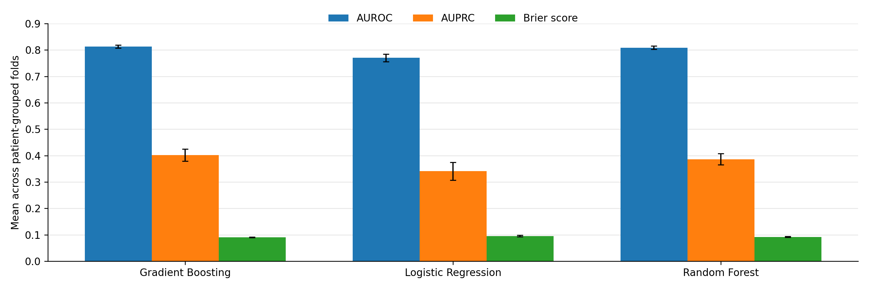
Fig. 3. Five-fold patient-grouped cross-validation results, after within-training-fold, patient-grouped recalibration (Section III.D). Error bars denote standard deviations across folds; lower Brier scores are better.
Model | AUROC range | AUPRC range | Sensitivity | Specificity
Gradient Boosting | 0.800–0.833 | 0.375–0.445 | 0.098 | 0.992
Logistic Regression | 0.749–0.787 | 0.311–0.370 | 0.074 | 0.991
Random Forest | 0.795–0.828 | 0.355–0.416 | 0.137 | 0.985
TABLE VIII. Thirty repeated patient-grouped holdouts; threshold metrics use 0.5 without optimization.

C. Robustness Analyses
The primary and repeated-holdout estimates were similar. For gradient boosting, mean AUROC was 0.813 in five-fold cross-validation and 0.816 in repeated holdouts, while mean AUPRC was 0.402 and 0.404, respectively. Random-forest AUROC was 0.809 and 0.810, and AUPRC was 0.386 under both resampling summaries.
After recalibration, mean Brier scores were 0.090 for gradient boosting, 0.092 for random forest, and 0.096 for logistic regression. Calibration slopes were 1.068, 1.046, and 1.010, respectively, and mean calibration intercepts ranged from 0.014 to 0.099.
All three AUPRC estimates exceeded the no-skill prevalence reference of 0.124. No decision threshold, net benefit, or clinical action was prespecified; clinical utility was therefore not evaluated.

V. DISCUSSION
The principal systems finding is that process count is not equivalent to physical scale. Under the tested single-host quotas, local execution was faster than the co-located standalone arrangements for both workloads. The equal-capacity comparison showed the same direction, although the admission-level contrast remained marginal. This result applies to the implemented topologies and does not imply that standalone Spark is generally inferior, particularly in multi-node environments that add independent hardware and data locality.
The clinical analysis addresses a different validity question. Whole-admission aggregates are legitimate systems stressors but inappropriate for an early prediction claim. Separating the first-48-h product, grouping splits by patient, and evaluating calibration as well as discrimination reduced several sources of optimistic internal validation. The resulting models remain baselines rather than clinical devices, and the exclusion of stays shorter than 48 h prevents interpretation at ICU admission or application to early deaths.
Together, the experiments show that computational equivalence, runtime efficiency, and clinical validity must be reported separately. Equal schemas and row counts do not prove numerical identity; faster execution does not validate feature semantics; and predictive discrimination does not justify the use of future information. The study's main contribution is therefore methodological: it links systems evidence to explicit clinical data-product semantics without treating either as a substitute for the other.
The event-log findings are compatible with overhead from additional process boundaries, scheduling, and communication, but the experiment cannot partition the runtime difference among these mechanisms. The defensible conclusion is limited to the tested quotas and implementation.
From a clinical-modeling perspective, data-product governance should precede model selection. Similar AUROC estimates across grouped folds and repeated holdouts suggest that ranking performance was not driven by a single split; however, calibration, threshold behavior, and the survivor-conditioned cohort show why internal discrimination alone is insufficient for deployment.
Reproducibility is implemented at four levels. Semantic reproducibility is supported by explicit feature windows and prohibited variables. Computational reproducibility is supported by versioned code, configuration, container definitions, and a pinned commit. Experimental reproducibility is supported by randomized schedules, resource caps, block identifiers, and aggregate event-log summaries. Statistical reproducibility is supported by prespecified contrasts, multiplicity correction, sensitivity tests, and split diagnostics. None of these layers removes the need for independent replication, but together they make discrepancies diagnosable.
The study is limited to one database, one host, one overnight systems campaign, one storage device, and technical rather than independent hardware replications. The benchmark output uses admission-level bounds that may span intervals between multiple ICU stays and therefore is not presented as a clinical cohort. The clinical validation lacks external validation, uncertainty intervals based on independent sites, and decision-curve analysis. Future work should use icustay_id-specific temporal logic, independent machines and days, multi-node clusters, and external datasets such as MIMIC-IV [23] or eICU.
Threats to internal validity include residual background load and imperfect equality of executor and driver resource allocation. Threats to construct validity include using timed ETL completion as the primary systems endpoint and using survivor-conditioned in-hospital mortality as the clinical endpoint. Statistical threats include only 12 paired blocks and correlated technical repetitions; exact sensitivity tests reduce but do not eliminate this concern. External validity is limited by the Windows/Docker/one-NVMe environment, MIMIC-III's historical single-center population, and absence of prospective workflow evaluation. Clinical utility was not tested, so no claims are made regarding bedside benefit, deployment readiness, or decision support.

VI. IMPLICATIONS FOR BIOMEDICAL INFORMATICS
The first implication is that data-product names should encode intended use. Terms such as ‘feature table’ are too broad when one table includes the entire admission and another represents only information available at a clinical decision time. Assigning explicit roles—benchmark-only, exploratory, or prediction-time—reduces the chance that a convenient systems artifact is silently repurposed for modeling. Automated checks can strengthen this governance by rejecting prohibited columns and timestamps beyond the declared cutoff.
The second implication is that systems comparisons need a physical-resource statement. Reporting only Spark master URLs, executor counts, or worker counts can suggest scale-out where none exists. At minimum, studies should report host count, processor and memory limits, storage, process layout, task capacity, software versions, timed boundaries, warm-up policy, randomization, and replication unit. When configurations change several of these factors simultaneously, conclusions should refer to implemented topologies rather than an abstract execution-mode effect.
The third implication is that predictive validation should accompany, but remain conceptually separate from, ETL validation. Schema checks and reproducible execution cannot reveal whether future information entered a feature. Conversely, an acceptable AUROC does not establish that two executions produced equivalent data. Biomedical pipelines benefit from an evidence matrix in which semantic checks, computational checks, statistical checks, and clinical-model checks have distinct acceptance criteria and artifacts.
For future deployment-oriented work, the early-window product should be evaluated on an admission-time or shorter-horizon cohort that includes early deaths, followed by temporal validation and external validation on a different health system. Calibration should be reassessed and, if necessary, fitted on a dedicated calibration sample. Decision-curve analysis and workflow simulation would then be needed to determine whether any threshold offers clinical value. These steps are intentionally outside the scope of the present reproducibility and internal-validation study.

VII. LIMITATIONS AND REPORTING RECOMMENDATIONS
The systems and clinical components have different populations of inference. The runtime experiment concerns repeated executions of one implemented ETL pipeline on one capped host. Its uncertainty intervals quantify block-to-block technical variation under that environment; they do not quantify variation across processors, operating systems, storage devices, Spark versions, or institutions. The clinical experiment concerns eligible MIMIC-III admissions satisfying the 48-h stay criterion. Its resampling variation reflects internal patient partitions, not transportability to contemporary or external populations. Keeping these inferential populations explicit prevents a statistically precise estimate from being mistaken for a broadly general result.
Resource capping improves comparability but does not make the local and standalone conditions mechanistically identical. The local modes place task threads within one Java Virtual Machine, whereas standalone modes add master, worker, executor, and container boundaries. Executor cores were fixed at six in the standalone arrangements while local[8] exposed eight task threads; Section IV.A reports a supplementary equal-capacity comparison (local[6] vs. standalone2) that partially disentangles this confound and still favors local execution, though the admission-level contrast was only marginal at n = 12 paired blocks and the comparison shares the same host and session as the rest of the study. It therefore cannot isolate a pure communication penalty from other process-boundary costs. A future factorial study should vary process model and task capacity independently across a larger number of blocks, record processor frequency and context switches, and repeat the experiment on physically separate workers and on independent days.
Output equivalence was assessed by schema and row-count invariants plus successful downstream analyses. Floating-point aggregation can vary with partitioning and reduction order, so bitwise equality is neither assumed nor claimed. For applications in which small numerical differences alter cohort membership or clinical decisions, stronger checks are required: key-level reconciliation, tolerance-based comparisons for continuous values, exact comparisons for categorical values, and explicit investigation of unmatched records. These checks should be specified before performance measurement rather than added only after a discrepancy appears.
The 48-h cohort definition resolves one leakage problem while introducing a selection condition. Patients who die or leave intensive care before 48 h are absent, so the estimand is not mortality risk at admission. The retained cohort may be clinically more stable and may have a different severity distribution from all ICU admissions. This limitation cannot be corrected by resampling, class weighting, or calibration. It requires redefining the prediction time and reconstructing features at a horizon available for every eligible patient, for example the first 6 or 12 h, with a correspondingly explicit landmark population.
Model comparison is intentionally descriptive. The three algorithms were selected as interpretable and widely used tabular baselines, and their hyperparameters were fixed rather than optimized through nested resampling. Differences between their mean metrics should not be treated as formal pairwise superiority tests. Likewise, random-forest impurity importance is susceptible to correlated predictors and differences in feature variability. A deployment study would require nested tuning, confidence intervals for paired metric differences, external calibration assessment, clinically defined thresholds, fairness analyses across relevant subgroups, and monitoring for dataset shift.
Based on these observations, a minimum report for similar studies should contain four linked records. A semantic record should define population, index time, horizon, outcome, and forbidden future variables. A computational record should state physical hosts, quotas, storage, software versions, process topology, and timing boundaries. An experimental record should preserve randomization, warm-up rules, seeds, replications, failures, and analysis units. A validation record should document group separation, prevalence, missingness, discrimination, calibration, threshold rationale, and intended use. Publishing these records alongside aggregate outputs makes both successful replication and informative failure more likely.

VIII. CONCLUSION
A reproducible clinical data pipeline must report both what its features mean and how they were computed. In the evaluated resource-constrained environment, local[8] outperformed co-located standalone Spark configurations for two MIMIC-III ETL workloads. A separate first-48-h feature product supported patient-grouped mortality validation without reusing benchmark-only whole-admission features. The released code and aggregate diagnostics provide an auditable basis for replication, while the single-center, survivor-conditioned clinical cohort and single-host systems design define clear limits on inference.

ACKNOWLEDGMENT
The authors used OpenAI generative-AI tools for translation support and language editing. The authors verified all analyses, references, and claims and take responsibility for the final manuscript.

FUNDING
This research received no external funding.

CONFLICT OF INTEREST
The authors declare no conflict of interest.

ETHICS AND DATA GOVERNANCE
MIMIC-III was released with approvals from the institutional review boards of Beth Israel Deaconess Medical Center and the Massachusetts Institute of Technology and with a waiver of individual informed consent for the de-identified database [1], [2]. This secondary computational analysis used the database under PhysioNet credentialing and its data-use agreement; the authors did not recruit participants, contact patients, or access direct identifiers.

DATA AND CODE AVAILABILITY
MIMIC-III cannot be redistributed. Credentialed users may obtain it from PhysioNet [2]. Source code, configuration files, aggregate tables, figures, and non-patient-level diagnostics are available at https://github.com/esma6/icu_mortality_project (commit 6fe3460679acea2eafe494025a3ab81050b6bd1d).

REFERENCES
[1] A. E. W. Johnson et al., “MIMIC-III, a freely accessible critical care database,” Sci. Data, vol. 3, Art. no. 160035, 2016, doi: 10.1038/sdata.2016.35.
[2] A. E. W. Johnson, T. J. Pollard, and R. G. Mark, “MIMIC-III Clinical Database (version 1.4),” PhysioNet, 2016, doi: 10.13026/C2XW26.
[3] S. Wang et al., “MIMIC-Extract: A data extraction, preprocessing, and representation pipeline for MIMIC-III,” in Proc. ACM CHIL, 2020, pp. 222–235, doi: 10.1145/3368555.3384469.
[4] S. Tang et al., “Democratizing EHR analyses with FIDDLE: A flexible data-driven preprocessing pipeline for structured clinical data,” J. Am. Med. Inform. Assoc., vol. 27, no. 12, pp. 1921–1934, 2020, doi: 10.1093/jamia/ocaa139.
[5] D. Jarrett et al., “Clairvoyance: A pipeline toolkit for medical time series,” Cambridge Apollo Repository, 2021, doi: 10.17863/CAM.70020.
[6] A. Mandyam et al., “COP-E-CAT: Cleaning and organization pipeline for EHR computational and analytic tasks,” in Proc. ACM BCB, 2021, doi: 10.1145/3459930.3469536.
[7] M. Gupta et al., “An extensive data processing pipeline for MIMIC-IV,” Proc. Mach. Learn. Res., vol. 193, pp. 311–325, 2022.
[8] M. B. A. McDermott et al., “Event Stream GPT: A data pre-processing and modeling library for generative, pre-trained transformers over continuous-time sequences of complex events,” in Adv. Neural Inf. Process. Syst., vol. 36, pp. 24322–24334, 2023, doi: 10.52202/075280-1057.
[9] M. B. A. McDermott et al., “MEDS—An emerging data standard and ecosystem for health AI research,” NEJM AI, vol. 3, no. 6, 2026, doi: 10.1056/AIra2501253.
[10] M. Wornow et al., “EHRSHOT: An EHR benchmark for few-shot evaluation of foundation models,” in Adv. Neural Inf. Process. Syst., vol. 36, 2023, doi: 10.52202/075280-2933.
[11] R. van de Water et al., “Yet Another ICU Benchmark: A flexible multi-center framework for clinical ML,” in Proc. ICLR, 2024.
[12] Y. Dou et al., “Quick-MIMIC: A multimodal data extraction pipeline for MIMIC with parallelization,” Big Data Min. Anal., vol. 7, no. 4, pp. 1333–1346, 2024, doi: 10.26599/BDMA.2024.9020024.
[13] F. V. Zacarias et al., “Intelligent colocation of HPC workloads,” J. Parallel Distrib. Comput., vol. 151, pp. 125–137, 2021, doi: 10.1016/j.jpdc.2021.02.010.
[14] M. M. Alves and L. M. A. Drummond, “A multivariate and quantitative model for predicting cross-application interference in virtual environments,” J. Syst. Softw., vol. 128, pp. 150–163, 2017, doi: 10.1016/j.jss.2017.04.001.
[15] H. Harutyunyan et al., “Multitask learning and benchmarking with clinical time series data,” Sci. Data, vol. 6, Art. no. 96, 2019, doi: 10.1038/s41597-019-0103-9.
[16] G. S. Collins et al., “TRIPOD+AI statement: Updated guidance for reporting clinical prediction models that use regression or machine learning methods,” BMJ, vol. 385, e078378, 2024, doi: 10.1136/bmj-2023-078378.
[17] S. Kapoor and A. Narayanan, “Leakage and the reproducibility crisis in machine-learning-based science,” Patterns, vol. 4, no. 9, Art. no. 100804, 2023, doi: 10.1016/j.patter.2023.100804.
[18] M. Zaharia et al., “Apache Spark: A unified engine for big data processing,” Commun. ACM, vol. 59, no. 11, pp. 56–65, 2016, doi: 10.1145/2934664.
[19] Apache Software Foundation, “Submitting applications—Spark 3.5 documentation.” [Online]. Available: https://spark.apache.org/docs/3.5.8/submitting-applications.html. Accessed: Aug. 26, 2026.
[20] Apache Software Foundation, “Spark standalone mode—Spark 3.5 documentation.” [Online]. Available: https://spark.apache.org/docs/3.5.6/spark-standalone.html. Accessed: Aug. 26, 2026.
[21] C. Boettiger, “An introduction to Docker for reproducible research,” ACM SIGOPS Oper. Syst. Rev., vol. 49, no. 1, pp. 71–79, 2015, doi: 10.1145/2723872.2723882.
[22] M. B. A. McDermott et al., “Reproducibility in machine learning for health research: Still a ways to go,” Sci. Transl. Med., vol. 13, no. 586, eabb1655, 2021, doi: 10.1126/scitranslmed.abb1655.
[23] A. E. W. Johnson et al., “MIMIC-IV, a freely accessible electronic health record dataset,” Sci. Data, vol. 10, Art. no. 1, 2023, doi: 10.1038/s41597-022-01899-x.
[24] T. Namli et al., “A scalable and transparent data pipeline for AI-enabled health data ecosystems,” Front. Med., vol. 11, Art. no. 1393123, 2024, doi: 10.3389/fmed.2024.1393123.

