PICK Tool

Test plan

Version 1.0

4/16/2020

**Document Control**

**Approval**

The Guidance Team and the customer shall approve this document.

**Document Change Control**

|  |  |
| --- | --- |
| Initial Release: | 1.0 |
| Current Release: | 1.0 |
| Indicator of Last Page in Document: | & |
| Date of Last Review: | 04/15/20 |
| Date of Next Review: | 04/17/20 |
| Target Date for Next Update: | 04/24/20 |

**Distribution List**

This following list of people shall receive a copy of this document every time a new version of this document becomes available:

**Guidance Team Members:** Dr. Steve Roach, Jake Lasley

**Customer:** Army Research Lab which consists of Herandy Denisse Vazquez, Baltazar Santaella, Vincent Fonseca, Oscar Perez, and Florencia Larsen.

**Software Team Members:** Zayra Padilla, Erik Macik, Priscilla Mendoza, Jose Lujan, Michael Contreras

**Change Summary**

The following table details changes made between versions of this document

|  |  |  |  |
| --- | --- | --- | --- |
| Version | Date | Modifier | Description |
| 1.0 | 4/15/2020 | Team | Worked on Sections 1-4 |
|  |  |  |  |
|  |  |  |  |

Note: The template presented in this document was taken from:

Donaldson, S., and S. Siegel, *Successful Software Development*. Upper Saddle River, NJ: Prentice Hall, 2001, pp. 321-323.

Note: The template presented in this document was taken from: Donaldson, S., and S. Siegel, *Successful Software Development*. Upper Saddle River, NJ: Prentice Hall, 2001, pp. 321-323 and modified by Humberto Mendoza and Steve Roach.

Supplementary information is from:

Pfleeger, S. *Software Engineering, Theory and Practice*. Upper Saddle River, NJ: Prentice Hall, 1998, p. 365.

**Table of Contents**

**DOCUMENT CONTROL II**

**Approval ii**

**Document Change Control ii**

**Distribution List ii**

**Change Summary ii**

**1.** **INTRODUCTION 1**

**1.1.** **Purpose 1**

**1.2.** **Scope 1**

**1.3.** **System Overview 1**

**1.4.** **Suspension and Exit Criteria 1**

**1.5.** **Document Overview 1**

**1.6.** **References 1**

**2.** **TEST ITEMS AND FEATURES 2**

**3.** **TESTING APPROACH 3**

**4.** **TEST XX 4**

**4.1.** **Test <<test id>> 4**

**5.** **USER INTERFACE TESTING 5**

**6.** **TEST SCHEDULE 6**

**7.** **OTHER SECTIONS 7**

**8.** **APPENDIX 8**

# Introduction

## Purpose

The purpose of the Test Plan document is to provide detailed information on the testing approach and schedule conducted for the PMR Insight Collective Knowledge Tool (PICK) system. The purpose of this document is to verify the functionality of the PICK system according to the requirements specified by the client, using a system test plan that describes the system from the customer’s point of view.

## Scope

The project software version encompassed by the test plan will be PICK version 1.0, which represents the latest released version.

## System Overview

The Lethality, Survivability, and HSI Directorate (LSH) recognizes the complexity and the time it takes to analyze the applicable logs, observation notes, and other artifacts gathered from an adversarial assessment from the red, blue, and white teams and generate a report that represents the events that took place during the adversarial assessment. They want a system that would aid their analysts in correlating red team’s activities to blue team’s responses and represent the events that took place during an adversarial assessment graphical.

The testing approach that will be implemented is Black-box testing. This approach will examine the functionality of the PICK tool system without focusing on its internal structure. This method of test will be applied primarily to the acceptance level of software testing, also referred to as user acceptance testing.

## Suspension and Exit Criteria

The suspension and exit criteria implemented for the test plan will be applied as follows:

* + Suspension criteria:

## All test cases will be executed.

## Test cases that would prevent further testing and enforce fixing problems before going forward are:

* + - * Invalid directories - If the directories provided are invalid and there is no location to draw out log files and the whole process still begins, testing must be suspended until this flaw is fixed.
      * Uncleansed/Unvalidated log files – If log files are ingested before being cleansed, validated and transcribed, testing must be suspended until this flaw is fixed.
  + Exit criteria:
    - Critical tests must pass – 100% passing rate
    - Non-critical tests – at least 90% must pass

## Document Overview

The remainder of the Test Plan document is comprised of the following sections:

Section 2 – Test Items and Features, describes the test items and the features to be tested.

Section 3 – Testing Approach, describes the approach to be used to test the system.

This description includes specifying the types of tests to be performed.

Section 4 – Test, this area provides general notes concerning the test procedure.

Section 5 – User Interface Testing, this section focuses on the interaction between the user and the system.

Section 6 – Test Schedule, specifies the schedule for testing activities.

Section 7 – Other Sections, other sections that may appear in a test plan.

Section 8 – Appendix, might provide explicit directions for analysis of output.

## References

There are no references.

# Test Items and Features

<< This section describes the test items (e.g., components, classes, functions or methods) and the features to be tested. It may also list features not to be tested. A class diagram is useful. A table of features is useful. >>

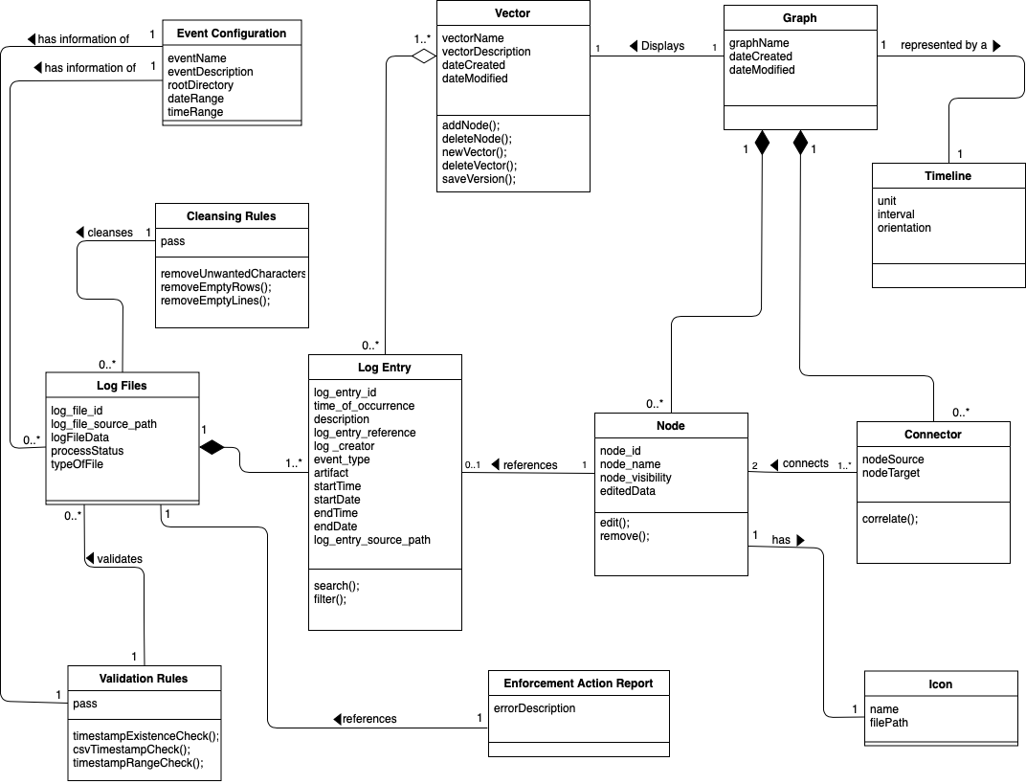

*Figure 1. PICK Tool Class Diagram*

The test items such as classes to be tested are shown in Figure 1, which depicts the PMR Insight Collective Knowledge Tool Class Diagram. The features that will be tested are:

* Creating a new event
* Adding the directories of each team (Red, Blue and White)
* Verify that the user can start the ingestion of log files after providing directories
* Adding new icons
* Searching for significant log entries
* Filtering by different criteria (team, start timestamp and end timestamp)
* Creating a new Vector
* Adding a new node
* Adding a relationship between nodes
* Removing a node
* Removing a relationship between nodes

# Testing Approach

The testing approach that will be implemented is Black-box testing. This approach will examine the functionality of the PICK system without focusing on its internal structure. This method of test will be applied primarily to the acceptance level of software testing, also referred to as user acceptance testing.

|  |  |  |
| --- | --- | --- |
| **Team Configuration Test Suite** | | |
| Description of Test Suite | This test suite tests the functionality of the Configurations window focusing on the Team Configuration tab. | |
| **Test Case Identifier** | **Objective** | **Criticality** |
| Team1 | Establish Connections | **Critical** |

|  |  |  |
| --- | --- | --- |
| **Event Configuration Test Suite** | | |
| Description of Test Suite | This test suite tests the functionality of the Configurations window focusing on the Event Configuration tab. | |
| **Test Case Identifier** | **Objective** | **Criticality** |
| Event1 | Create new event with given criteria. | **Critical** |
| Event2 | Obtain files within the given start and end timestamp range. | **Critical** |

|  |  |  |
| --- | --- | --- |
| **Directory Configuration Test Suite** | | |
| **Description of Test Suite** | This test suite tests the functionality of the Configurations window focusing on the Directory Configuration tab. | |
| **Test Case Identifier** | **Objective** | **Criticality** |
| Directory1 | Ingest files from the directory. | **Critical** |

|  |  |  |
| --- | --- | --- |
| **Vector Configuration Test Suite** | | |
| **Description of Test Suite** | This test suite tests the functionality of the Configurations window focusing on the Vector Configuration tab. | |
| **Test Case Identifier** | **Objective** | **Criticality** |
| Vector1 | Create a vector with name and description. | **Critical** |
| Vector2 | Edit vector. | **Critical** |

|  |  |  |
| --- | --- | --- |
| **Icon Test Suite** | | |
| **Description of Test Suite** | This test suite tests the functionality of the Configurations window focusing on the Icon Configuration tab. | |
| **Test Case Identifier** | **Objective** | **Criticality** |
| Icon1 | Create an icon that includes an image. | **Critical** |
| Icon2 | Delete icon from the Icon Table. | **Critical** |

|  |  |  |
| --- | --- | --- |
| **Enforcement Action Report Test Suite** | | |
| **Description of Test Suite** | This test suite tests the functionality of the Enforcement Action Report. | |
| **Test Case Identifier** | **Objective** | **Criticality** |
| EAR1 | Find errors in log file | **Critical** |
| EAR4 | Cancel Ingestion of selected log file. | **Critical** |

|  |  |  |
| --- | --- | --- |
| **Search/Filter Suite** | | |
| **Description of Test Suite** | This test suite tests the functionality of the Search/Filter Log Entries Window. | |
| **Test Case Identifier** | **Objective** | **Criticality** |
| S/F1 | Search/Filter by given criteria | **Critical** |
| S/F2 | Associate selected log entry to vector | **Critical** |

|  |  |  |
| --- | --- | --- |
| **Graph Test Suite** | | |
| **Description of Test Suite** | This test suite tests the functionality of the Graph window where a user can edit the graph. | |
| **Test Case Identifier** | **Objective** | **Criticality** |
| Graph1 | Export the graph as an image file. | **Critical** |
| Graph2 | Create a new node | **Critical** |
| Graph3 | Remove a node | **Critical** |
| Graph4 | Add connector to parent and child node | **Critical** |
| Graph5 | Edit an existing node | **Critical** |

# Directory Configuration Test Suite

The purpose of this section is to:

* document test input, specific test procedures, and outcomes.
* establish test methods,
* explain the nature and extent of each test

## 4.1 Test Directory1

**Objective:** Obtaining Root Directory.

**Notes**: PICK System must be running for testing

|  |  |  |  |  |  |  |
| --- | --- | --- | --- | --- | --- | --- |
| **Test No.:** Directory1 | | | | **Current Status:** Passed | | |
| **Test title:** Ingest Files from the directory. | | | | | | |
| **Testing approach:** Acceptance Testing | | | | | | |
| **STEP** | **OPERATOR ACTION** | **PURPOSE** | | | **EXPECTED RESULTS** | **COMMENTS** |
| 1 | Begin testing with the PICK system on the Configurations window inside the Directory tab. | Initial Condition to allow analyst to enter directories needed for the ingestion process. | | | Root directory input box is empty.  Red team folder input box empty.  Blue team input box is empty.  White team input box is empty.  “Start Ingestion” button is enabled. |  |
| 2 | Analyst clicks on the browse button and selects the root folder. | Ensure the system receives a valid folder containing directories for each team. | | | Root directory input box will hold the root folder directory. |  |
| 3 | Analyst clicks on the browse button and selects the red team folder. | Ensure the system receives a valid red team folder with log files that will be ingested. | | | Red team folder input box will contain the red team folder directory. |  |
| 4 | Analyst clicks on the browse button and selects the blue team folder. | Ensure the system receives a valid blue team folder with log files that will be ingested. | | | Blue team folder input box will contain the blue team folder directory. |  |
| 5 | Analyst clicks on the browse button and selects the white team folder. | Ensure the system receives a valid white team folder with log files that will be ingested. | | | White team folder input box will contain the white team folder directory. |  |
| 6 | Analyst clicks “Start Ingestion” button. | Ensure that the ingestion process begins. | | | All folder directories are saved to MongoDB. The ingestion process of log files will begin. |  |
| **Concluding Remarks:** | | | | | | |
| **Testing Team:**  Team 11 - V&V | | | **Date Completed:**  04/15/2020 | | | |

# User Interface Testing

<<This section focuses on the interaction between the user and the system. For testing the user interface, consider the following traits:

* Consistent terminology, shortcut keys, menu selections, and presentation
* Correct language, spelling, and grammar.
* Flexibility in navigation between windows and interface elements.
* Error handling that will inform the user of critical operations.
* Follows standards and guidelines such as placement of scroll bars, windows, and menu items.

This section could be integrated into Section 4.

>>

# Test Schedule

The table below shows the test schedule that Team 11 will be following for the test plan process. The start date for testing is scheduled for November 20 and the target date to complete the tests is set to December 1. A team member will be responsible for conducting one of the tests as described in each test suite.

|  |  |  |  |
| --- | --- | --- | --- |
| **Task** | **Date** | **People** | **Description** |
| Directory1 | T.B.D | TBD | Ingest Files from the directory. |
|  |  |  |  |
|  |  |  |  |
|  |  |  |  |
|  |  |  |  |
|  |  |  |  |
|  |  |  |  |
|  |  |  |  |
|  |  |  |  |

# Other Sections

<< Other sections that may appear in a test plan (but not required for this course) are:

* Test Management Requirements: how testing is to be managed; a delineation of responsibilities of each project organization involved with testing
* Staffing and training needs: delineate the responsibilities of those individuals who are to perform the testing, level of skill required, and training to be provided
* Environmental Requirements: describe the hardware (including communication and network equipment) needed to support testing; describe configuration of hardware components on which software and database to be tested are to operate.
* Software Requirements: describe the software needed to support testing; include the software code and databases that are object of the testing. Also include software tools such as compilers, CASE instruments and simulators that are needed to model the user’s operational environment.
* Risk and contingencies
* Cost: include an estimate of costs.
* Approvals
* Test Deliverables

>>

# Appendix

<< possibly more readable to put the expected output here and refer to it in the previous sections. Might also provide explicit directions for analysis of output, if it’s easier to read as an appendix or if analysis is post execution. >>

&