PHD THESIS WORKING ROUND 1
Sensor-based Recyclables Collection Planning
Methodology audit and data-grounded work plan

Esmaeil Keyvanloo · Rio Maior case study
Prepared with the project knowledge base (Brain) as source of truth
August 2026 · Report R1-01

Contents
Contents i
Tables, figures and equations ii
Abbreviations iii
Executive summary iv
1. Problem and context 1
1.1 The operational problem 1
1.2 Research question and scope 1
2. Data foundation 2
2.1 What exists 2
2.2 Known defects and their consequences 2
2.3 Spatial picture 3
3. The proposed methodology, explained 5
3.1 Demand estimation by regression 5
3.2 Monte Carlo scenario generation 5
3.3 The p-median family 5
3.4 Why this chain is reasonable 6
4. Audit findings 7
4.1 The regression, as currently fitted, has failed — and the failure is informative 7
4.2 The demand indicator deserves to be the thesis's centrepiece, not a preprocessing step 7
4.3 The optimisation: sound design, unusable implementation 7
4.4 The stochastic model is the right contribution — if its inputs are honest 8
4.5 Residual data risks 8
4.6 Verdict 8
5. Conclusion 10
6. Recommendations 11
7. References 12
8. Appendix A — Operational parameters from public sources 13
9. Appendix B — Data acquisition guide: who to ask, what to request 14
C.1 Valorsul, S.A. — operator of the Oeste selective collection (primary target) 14
C.2 Câmara Municipal de Rio Maior — Divisão de Ambiente / Serviços Urbanos 14
C.3 Sensor supplier (via Valorsul; identity in procurement records) 15
C.4 National authorities and public repositories (no request letter needed) 15
10. Appendix C — Reproducibility 17

Update fields in Word (Ctrl+A, F9) to populate contents and page numbers.

Tables, figures and equations
Table i — List of tables
# | Title
1 | Datasets available to the thesis
2 | Defect register and modelling consequences
3 | Valorsul Oeste fleet, 2013 snapshot
4 | Prioritised recommendations
5 | Abbreviations and Portuguese terms
6 | Data to request from Valorsul
7 | Data to request from the municipality
8 | Data to request from the sensor supplier
9 | Public sources to harvest directly
Table ii — List of figures
# | Title
1 | Thesis pipeline from data to optimisation
2 | Recyclables container network, Rio Maior study area
3 | Population distribution and container network
4 | Sensor coverage of the mapped container network
Equations (1)–(7) define the location models; (8)–(9) the demand regression.

Abbreviations
Term | Meaning
BGRI | Base Geográfica de Referenciação de Informação (INE census geography)
CBD | Central business district (city centre)
CTRO | Centro de Tratamento de Resíduos do Oeste, Cadaval (Valorsul)
CVRP | Capacitated vehicle routing problem
EVPI | Expected value of perfect information
IRP | Inventory routing problem
MIP | Mixed-integer programme
OSM | OpenStreetMap
SAA | Sample average approximation
VIF | Variance inflation factor
VSS | Value of the stochastic solution
Ecoponto | Street recycling site (PT); typically blue, yellow and green containers
Enchimento | Fill level (PT), the fill column in both CSV files
Freguesia | Civil parish (PT administrative unit)

Executive summary
This report audits the methodology proposed for the PhD thesis Sensor-based Recyclables Collection Planning and grounds it in the data that actually exist for Rio Maior. Three findings drive everything else. First, the operational context is now documented. Rio Maior's ecoponto network is served by Valorsul within its 14-municipality Oeste system. Every collection circuit starts and ends at the CTRO facility in Cadaval, 23 km southwest of the city, outside the study area. Fleet composition, shift times, circuit periodicities and the driver fill-recording procedure are all recoverable from public sources, so the routing extension is no longer blocked by missing operational facts. Second, the demand model in its current form does not work. The bin-level regression fitted to 452 containers explains 1.3 % of the variation in demand, and its overall F-test (p = 0.95) cannot reject the hypothesis that the predictors explain nothing at all. This is not a small weakness; demand estimation feeds every optimisation stage downstream. The cause is identifiable and repairable: a static, cross-sectional specification is being asked to explain a dynamic quantity, and the response variable itself is built on trip-level weights that cannot be attributed to single containers. The sensors, the thesis's own subject, provide the repair. Third, the optimisation chain (deterministic capacitated p-median as baseline, stochastic scenario-based p-median as the main model) is methodologically sound, standard in the literature, and defensible before a jury. The existing Mosel implementation, however, is a synthetic proof of concept with ten invented population centres; it must be rebuilt on the real network before any thesis claim rests on it. The report explains each method in plain terms, states the audit verdict with its evidence, and closes with a prioritised list of eleven recommendations. The single most important one: rebuild the demand model at the container-day level with sensor-derived fill rates as the response, and only then re-run the location models.

1. Problem and context

1.1 The operational problem
Recyclable waste in Rio Maior is deposited by citizens at ecopontos, street sites holding, in the usual case, three 2.5 m³ containers: blue for paper and card, yellow for packaging, green for glass. Collection is performed by Valorsul, the concession holder for Lisbon North and the Oeste region, using predefined closed circuits: a truck leaves the CTRO treatment centre in Cadaval, empties the containers of one material type along its route, and returns to CTRO to be weighed and unloaded. The weakness of this arrangement is that circuits run on fixed periodicities while container filling does not. A 2014 study of the same system found circuits for paper running every 9.3 days on average and glass every 20.5 days, with fill levels recorded only as a driver's five-point visual estimate at the moment of collection. The result is the familiar pair of failures: trucks visiting containers that are nearly empty, and containers overflowing before their scheduled visit. WSmartRoute+ project data for a comparable operator found roughly half of rural containers below 25 % fill at the moment of collection. Between 2020 and 2024, fill-level sensors were installed in a pilot subset of Rio Maior's containers. The thesis asks what this new information stream is worth: specifically, whether container locations — decided years ago on judgement — can be re-optimised now that actual demand per site can be measured rather than assumed.

1.2 Research question and scope
The core of the thesis is strategic: estimate waste generation per site from sensor and collection data, then locate containers optimally against that demand under both deterministic and uncertain formulations. Routing (VRP/IRP) and scheduling are extensions, activated only if operational data prove sufficient; the thesis stands without them. This scope was fixed at the proposal defence and is treated here as binding. One boundary condition matters and is easy to get wrong: collection circuits serve containers inside and outside the urban study area in the same trip, and the depot itself lies outside it. Any routing analysis must model this explicitly. Clipping routes at the study-area border would fabricate distances and invalidate comparisons with real operations.

2. Data foundation

2.1 What exists
Table 1 — Datasets available to the thesis
Dataset | Content | Size | Confirmed semantics
Sensor readings CSV | Raw fill-level time series, 2020–2024 | 1,048,575 rows, 344 containers | Fill percentage; raw, unprocessed
Collection records CSV | Driver-recorded fills + trip data | 264,817 rows, 816 containers | 0/25/50/75/100 visual scale at collection; trip-level km and kg
Municipal GIS | Containers (464), BGRI 2021 census polygons (222), land use, buildings, boundary, CBD | file geodatabase | EPSG:3763 after harmonisation
Public operational sources | Depot, fleet, circuits, policy | — | Valorsul + IST dissertation (Lopes, 2014)

2.2 Known defects and their consequences
Table 2 — Defect register and modelling consequences
ID | Defect | Consequence
D1 | Sensor file truncated at exactly the Excel row limit (1,048,576); no re-export possible | The 344 sensor containers are an arbitrary subset of ≈800; coverage must be validated spatially, and the truncation disclosed as an inclusion criterion
D2 | `idrecolha` duplicates the fill value in 90.8 % of sensor rows | Sensor file carries no usable collection identifier; collection events must come from the driver file
D3 | Every sensor container's maximum reading is 82–84, never higher | The stated 0–100 % range is not what the data show; treat 82–84 as effective full, or rescale; unresolved with the data provider
D4 | 96,832 negative readings (9.2 %), in two distinct patterns (−1…−9 and −89…−116) | Removed as errors per author ruling; counts must be reported in the thesis
D5 | Trip weight cannot be attributed to single containers | Container-level demand in kg cannot come directly from `Peso total`; it must be constructed (Section 4.2)
D6 | Only 193 of the 464 GIS-mapped containers appear in the sensor data; 151 sensor containers have no GIS match | Spatial joins will silently lose containers; the match key set must be reconciled before modelling
D7 | BGRI polygons sum to 37,548 residents against a 2021 municipal population near 21,000 | The census layer likely contains duplicated or out-of-area subsections; must be resolved before population-weighted demand is computed

2.3 Spatial picture
Three maps accompany this report. The container network map shows the 464 mapped sites concentrated in the urban core, with glass containers dispersed furthest into the periphery. The population map overlays the BGRI 2021 subsections; the visual correspondence between population mass and container density is good in the centre and weaker in the northern parishes. The sensor-coverage map is the important one: sensor-equipped containers cluster in and around the urban core, which is consistent with the pilot's stated design but means peripheral demand will be estimated, not measured.
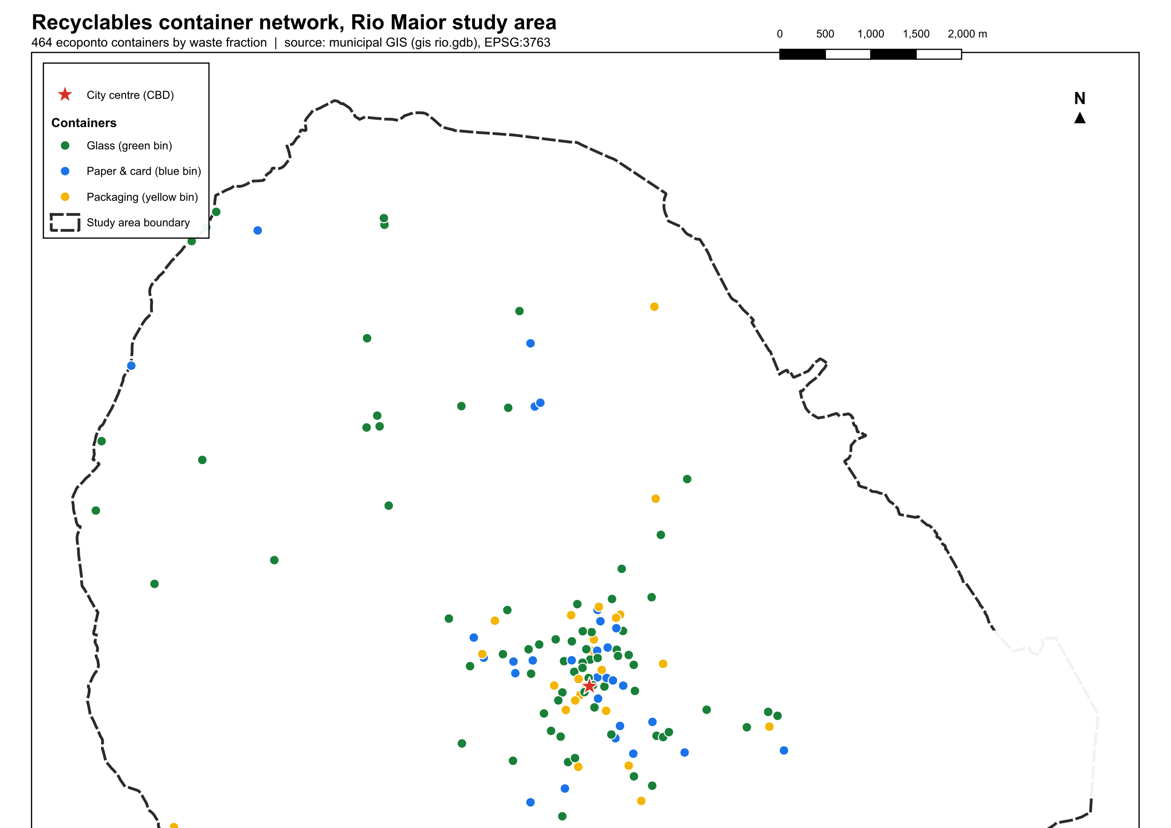
Figure 2 — Recyclables container network, Rio Maior study area. 464 mapped sites by waste fraction; municipal GIS, EPSG:3763.
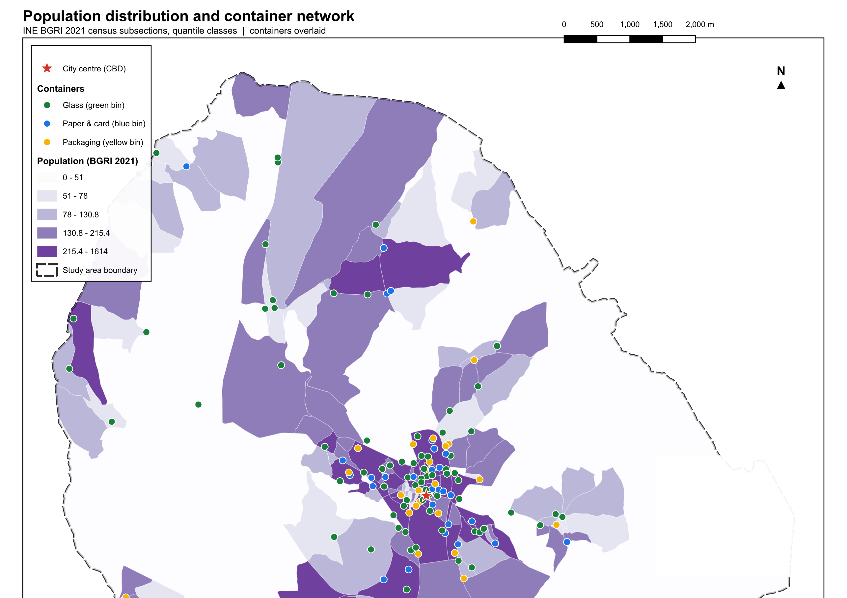
Figure 3 — Population distribution (INE BGRI 2021, quantile classes) with the container network overlaid.
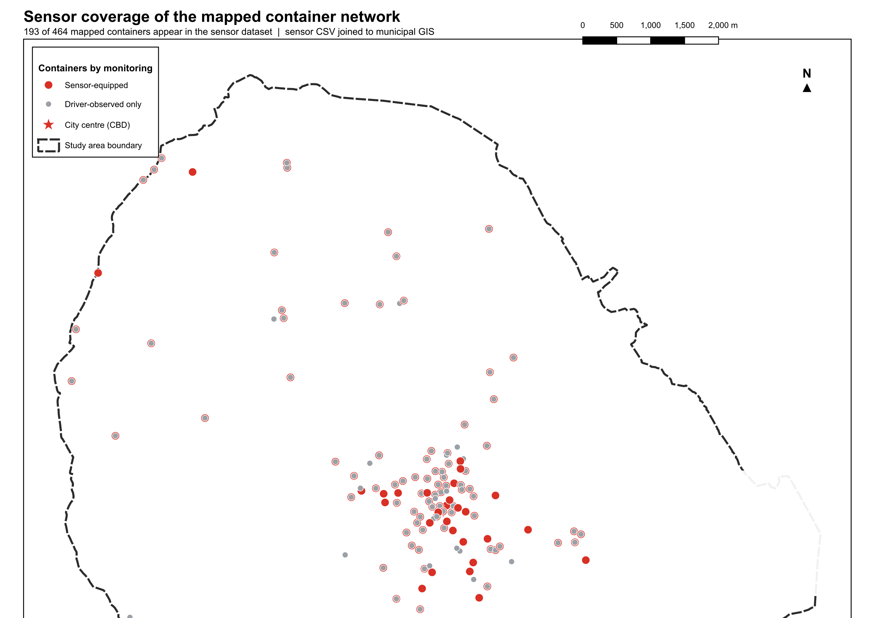
Figure 4 — Sensor coverage: 193 of 464 mapped containers appear in the sensor dataset (defect D6).

3. The proposed methodology, explained
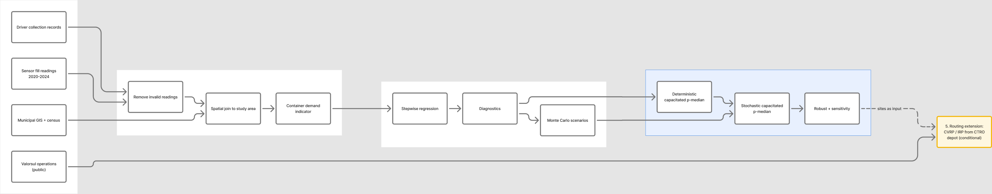
Figure 1 — Thesis pipeline from data to optimisation. Blue: core scope. Yellow: conditional routing extension.

3.1 Demand estimation by regression
The idea: waste generated at a container site should be predictable from its surroundings: how many people live nearby, what the land around it is used for. Fit a linear model of demand on such covariates, and the fitted equation can estimate demand anywhere, including candidate sites that hold no container today. That transferability is the whole point: the optimisation needs demand estimates for locations that have no measurement history. Stepwise regression automates covariate selection: variables enter or leave the model one at a time according to a criterion (typically AIC or a p-value threshold) until no move improves it. It is convenient and widely taught, but it has known pathologies (inflated apparent significance, instability of the selected set under resampling), and juries know them too. Section 4.1 returns to this.
$logY_{i} = ln( 1 + {kg}_{i} )$ (8)
$logY_{i} = β_{0} + β_{pop} {Pop}_{i} + \sum_{k}{}β_{k} {Pct}_{k,i} + ε_{i}$ (9)
Equation (8) defines the log response used in the current fit; (9) its linear specification on buffered population and land-use shares. Section 4.1 examines what happened when this was estimated.

3.2 Monte Carlo scenario generation
Demand is not one number per site; it varies by season, weekday and behaviour. The Monte Carlo step acknowledges this by drawing many plausible demand vectors, called scenarios, from the distributions fitted to the data (for example, from the regression's predictive distribution, or from empirical residuals). Each scenario is one possible future. A set of a few hundred scenarios, each with a probability weight, becomes the input to the stochastic optimisation.

3.3 The p-median family
The p-median problem places p facilities among m candidate sites to minimise the total demand-weighted distance between users and their nearest open facility. It is the standard model for locating recycling drop-off points because its objective — accessibility — is exactly what determines whether citizens use the containers at all. The deterministic capacitated formulation used as the baseline is:
$min Z = \sum_{i∈I}{}\sum_{j∈J}{} w_{i} d_{ij} x_{ij}$ (1)
subject to
$\sum_{j∈J}{}x_{ij} = 1 ∀ i ∈ I$ (2)
$x_{ij} ≤ y_{j} ∀ i ∈ I, j ∈ J$ (3)
$\sum_{j∈J}{}y_{j} = p$ (4)
$\sum_{i∈I}{}w_{i} x_{ij} ≤ Q_{j} y_{j} ∀ j ∈ J$ (5)
$x_{ij} , y_{j} ∈ \{0, 1\}$ (6)
Here wᵢ is the demand at point i, dᵢⱼ the distance from i to candidate site j, yⱼ = 1 if site j is opened, and xᵢⱼ = 1 if demand point i is assigned to site j. Constraint EQ-2 forces every demand point to be served; EQ-3 forbids assignment to closed sites; EQ-4 fixes the number of open sites; EQ-5 caps each site's load at its container capacity Qⱼ. The stochastic version replaces the single demand vector with the scenario set from Section 3.2. Locations are first-stage decisions, fixed before demand is known, while assignments become second-stage decisions that may differ per scenario:
$min \sum_{s∈S}{}p_{s} \sum_{i∈I}{}\sum_{j∈J}{}{w^{s}}_{i} d_{ij} {x^{s}}_{ij} with y_{j} shared across scenarios$ (7)
The solution is a single set of locations that performs well on average across all scenarios, rather than optimally for one guess. Standard diagnostics, the value of the stochastic solution (VSS) and the expected value of perfect information (EVPI), quantify whether the added machinery bought anything; a thesis should report both. A robust variant replaces the probability-weighted average with protection against worst cases within an uncertainty set. It answers a different question ("how bad can it get" rather than "what is best on average") and serves as a benchmark on the same scenario data.

3.4 Why this chain is reasonable
The architecture (measure, model demand, locate deterministically, then under uncertainty) is coherent and matches how the location literature actually progressed. The p-median choice is conservative in the best sense: fifty years of theory, exact solvability at this instance size, and an objective a jury understands. The stochastic extension is where the scientific contribution lives, because it uses precisely the information sensors add: the per-site variability of waste arrival, which fixed-schedule planning has never been able to observe.

4. Audit findings

4.1 The regression, as currently fitted, has failed — and the failure is informative
The current model regresses log-transformed mean daily kilograms per container (N = 452) on buffered population and land-use shares. The output is unambiguous: R² = 0.013, adjusted R² below zero, no individually significant predictor, and an overall F-test p-value of 0.95. Multicollinearity is ruled out (all VIF ≈ 1.0). The predictors are simply unrelated, in cross-section, to the response. Three causes, all fixable: The response variable is built on unattributable weights. Mean kg/day per container cannot be derived from Peso total, which is a trip total across ~80 containers (D5). If the response was constructed by dividing trip weights across containers, it contains mostly allocation noise, and no spatial covariate will ever explain it. The unit of analysis discards the signal. A cross-sectional model averages away exactly the variation (weekday, season, events) that drives waste generation. The regression's own documentation concedes this in its interpretation section. The data are a panel: 344 containers × up to four years of readings. Modelling at container-day level with temporal covariates is the natural specification, with the static spatial variables entering as container-level effects. One covariate is suspicious on its face. The population coefficient of −6.4 × 10⁻⁷ with a standard error three times larger suggests a units or construction error in Pop_100m; a 100 m buffer population should be a number in the tens to hundreds, and its coefficient should not be nine orders of magnitude below the intercept. The repair uses the thesis's own instrument. Sensor readings give fill level over time per container; the slope between collections is a fill rate. Multiplied by container volume and a fraction-specific bulk density, and calibrated so that summed container masses match the trip weigh-ins at CTRO (a mass-balance constraint the data support), this yields a defensible container-level demand series: measured, not allocated. The regression then has a real response, and its purpose sharpens: transfer measured demand to unmeasured locations. On stepwise selection itself: use it, if at all, only as a screening step. Report an information-criterion path or a LASSO fit with cross-validation alongside, and validate on held-out containers. A jury member who asks "why should we trust stepwise p-values?" must receive a better answer than convention.

4.2 The demand indicator deserves to be the thesis's centrepiece, not a preprocessing step
The construction in 4.1, from sensor fill rates through bulk density to mass-balance calibration against weighbridge totals, is itself a contribution: it is precisely the "assessment of driver-based vs sensor-based fill information" chapter promised in the proposal, and it produces the demand input every later model needs. Treating it as a first-class chapter both strengthens the thesis narrative and de-risks the timeline: it is publishable even if the stochastic optimisation runs long. The driver records enable the comparison directly: the five-point driver scale and the sensor reading exist for the same containers at collection moments. Agreement analysis (confusion matrices, systematic bias by fraction and area type) answers a question the 2014 operational literature explicitly flagged, fill-level uncertainty, with data that did not exist then.

4.3 The optimisation: sound design, unusable implementation
The existing Mosel model is a correct-in-structure capacitated p-median with compatibility constraints. It is also a toy: ten invented population centres, eight invented sites, Euclidean distances on arbitrary coordinates, fabricated generation rates, and a bin-type set that includes METALICO, a type the municipal data explicitly mark "do not use". Nothing computed from it can appear in the thesis. What must change for the real instance: - Demand points: BGRI subsection centroids (after resolving D7) or building centroids aggregated to a walkable grid — not ten points. - Candidate sites: the 464 mapped locations plus, if the thesis wants relocation freedom, a candidate grid along the road network. - Distances: network distances (walking for the citizen-to-container objective), not Euclidean. The road network is absent from the GIS and must be sourced from OpenStreetMap. - Units: demand and capacity in the same currency (kg/week or L/week per fraction), with capacity derated by the observed effective-full ceiling (D3). - Scale: with ~200 demand points, ~500 sites and three fractions, the MIP has on the order of 3 × 10⁵ binaries — well within Xpress's reach with standard tightening (closest-assignment cuts, variable fixing by distance radius). Two benchmarking additions cost little and buy jury credibility: solve the uncapacitated p-median as a bound, and compare against the current layout (the "do nothing" solution) so every improvement claim has a baseline.

4.4 The stochastic model is the right contribution — if its inputs are honest
Scenario-based two-stage stochastic programming is the standard, defensible way to inject demand uncertainty into location, and the sensor data genuinely support it: per-container demand distributions are observable, including their seasonality. Three requirements keep it honest: - Scenario provenance: scenarios must come from the fitted demand model's uncertainty (parameter + residual), not from arbitrary ±X % perturbations. Monte Carlo is the sampler, not the model. - Stability: report in-sample and out-of-sample stability of the solution as scenario count grows (sample average approximation practice), so the chosen scenario count is a result, not a guess. - Value metrics: report VSS and EVPI. If VSS is near zero, say so — that is a finding about this system, not a failure of the thesis. The robust variant is optional; if kept, a budget-of-uncertainty (Γ-robust) formulation on the same scenario statistics is the cleanest benchmark and requires no new data.

4.5 Residual data risks
D1 (truncation) is permanent: the thesis must state the 344-container subset as an inclusion criterion and check its spatial balance. D3 (the 82–84 ceiling) needs one email to the sensor provider; failing that, rescaling to per-container maxima is defensible and must be documented. D6 (GIS/sensor mismatch) and D7 (census overcount) are reconciliation tasks that block the real optimisation instance and should be closed first.

4.6 Verdict
The methodology chain — demand estimation, deterministic baseline, stochastic main model — is appropriate, standard, and defensible, and no stronger alternative is available that the data would support. The current executions of its first and third stages are not usable: the regression must be re-specified at container-day level on a sensor-derived response, and the optimisation must be re-instantiated on real geography. Neither repair changes the thesis's architecture; both are scoped, mechanical, and within reach of the data in hand. The single scientific risk that remains is D3: until the fill-level ceiling is explained, every quantity derived from sensor readings carries a calibration caveat.

5. Conclusion
The thesis is in better shape than its current artefacts suggest. Its architecture is sound and its data, defects and all, are sufficient for the core scope. The operational unknowns that seemed to block the routing extension are now documented from public sources. What stands between the present state and a defensible thesis is not a redesign but two rebuilds: a demand model that uses the sensors as its response rather than decoration, and an optimisation instance built on the real map. The audit found nothing that requires new data collection for the core scope, and one question (the sensor ceiling) that requires a single answer from the data provider.

6. Recommendations
Table 4 — Prioritised recommendations
# | Priority | Action
1 | Critical | Rebuild the demand variable from sensor fill rates with mass-balance calibration against CTRO weigh-ins
2 | Critical | Re-specify the regression at container-day level with temporal covariates; validate on held-out containers
3 | Critical | Reconcile container ID sets across sensor, driver and GIS data (D6) before any spatial modelling
4 | Critical | Resolve the 82–84 ceiling with the provider; otherwise rescale and document (D3)
5 | High | Resolve the BGRI population overcount (D7); recompute demand weights
6 | High | Rebuild the p-median instance on real geography with OSM network distances
7 | High | Add the current layout as the baseline alternative in all optimisation comparisons
8 | High | Implement SAA stability checks, VSS and EVPI for the stochastic model
9 | Medium | Replace pure stepwise selection with an information-criterion or LASSO path plus holdout validation
10 | Medium | Write the driver-vs-sensor agreement analysis as a first-class chapter
11 | Medium | Keep routing conditional; if activated, model boundary-crossing circuits from CTRO explicitly

7. References
Daskin, M. S. (2013). *Network and Discrete Location: Models, Algorithms, and Applications* (2nd ed.). Wiley.
Hakimi, S. L. (1964). Optimum locations of switching centers and the absolute centers and medians of a graph. *Operations Research*, 12(3), 450–459.
Birge, J. R., & Louveaux, F. (2011). *Introduction to Stochastic Programming* (2nd ed.). Springer.
Lopes, D. M. T. (2014). *Otimização da recolha seletiva na Valorsul: estudo de cenários alternativos*. MSc dissertation, Instituto Superior Técnico, Universidade de Lisboa.
Valorsul, S.A. Recolha seletiva — áreas de negócio. valorsul.pt (accessed 2026-08-09).
Valorsul, S.A. Instalações — CTRO. valorsul.pt/pt/contactos/instalacoes (accessed 2026-08-09).
INE (2021). Base Geográfica de Referenciação de Informação (BGRI), Censos 2021.
Author's thesis project document, proposal, defence materials and Rio Maior field survey (project archive, 2025–2026).

8. Appendix A — Operational parameters from public sources
Table 3 — Valorsul Oeste fleet, 2013 snapshot (Lopes, 2014, Table 3)
Vehicles | Role | Body | Volume | Payload
3 × MAN 18.284 LK | Collection (glass) | No compactor | 20 m³ | 15,000 kg
2 × Volvo FM9 (2005) | Collection | Compactor, Ampliroll | 20 m³ | 13,945 kg
5 × MAN TGM 18.280 | Collection | Compactor | 20 m³ | 5,580 kg
2 × Volvo FM9 (2009) | Collection | Compactor, rear-load | 15 m³ | 4,465 kg
2 × light trucks | Ecoponto maintenance | Open box | — | ≈2,500–2,800 kg
Depot and destination: CTRO, Estrada Nacional 361-1, km 14, Vilar, Cadaval (39.188989, −9.148423). Circuits: 82 predefined (26 paper, 26 plastic/metal, 30 glass); Monday–Friday, two shifts (05:00–12:30, 15:00–22:30); mean periodicity 9.3 / 8.3 / 20.5 days for paper / packaging / glass. Driver fill scale: vazio, menos de meio, meio, mais de meio, cheio — the 0/25/50/75/100 encoding in the collection CSV. The 2026 Valorsul site reports 21 collection vehicles and ≈24,000 containers across the network.

9. Appendix B — Data acquisition guide: who to ask, what to request
Requests are grouped by authority, ordered by expected yield. Priority A items unblock thesis components now; B items enrich the cost, environmental and routing analyses; C items are context. Requests to Valorsul and the sensor supplier are best routed through the supervisor under the WSmartRoute+ project relationship; municipal requests can cite Portugal's access-to-documents law (Lei n.º 26/2016, LADA) if a formal channel is needed.

C.1 Valorsul, S.A. — operator of the Oeste selective collection (primary target)
Table 6 — Data to request from Valorsul
Pri | Item | Detail to specify | Thesis use
A | Untruncated sensor export | Full 2020–2024 readings for all ≈800 sensor containers, CSV/Parquet direct from database, not Excel | Repairs D1; doubles the demand sample
A | Sensor system documentation | Sensor make/model, measurement principle, mounting geometry, error-code table, calibration procedure | Resolves D3 (82–84 ceiling) and D4 (negative codes)
A | Circuit definitions for Rio Maior | Current circuit list with container sequence, periodicity, material type; the 2023 versions if archived | Routing baseline; reconstructs Summer-2023 routes
A | Trip logs linked to weighbridge | Per idrecolha: date, route code, vehicle, driver-recorded fills, net weight at CTRO báscula | Mass-balance calibration of the demand variable
A | Container asset register | All Rio Maior containers with ID, matrícula, type, volume, install/removal dates, sensor yes/no | Reconciles the 344/464/816 ID mismatch (D6)
B | Current fleet specification | Vehicle list with body type, volume, payload, year; assignment to circuits | CVRP capacities; updates the 2013 snapshot
B | Fuel consumption records | L/100 km per vehicle or per circuit, ideally monthly | Cost model; carbon footprint of current vs optimised routes
B | Vehicle maintenance records | Frequency, downtime, cost per vehicle-year | Operating-cost model; fleet availability constraint
B | Crew and shift structure | Teams per shift, working-time rules, overtime policy | Route duration constraints
B | Collection costs | €/tonne or annual cost breakdown for selective collection (fuel, labour, maintenance, tolls) | Cost–benefit chapter
C | Contamination rates by fraction | Rejected material share at CTRO sorting per circuit or municipality | Quality dimension of container placement
C | Historical overflow complaints | Date, location, fraction | Validation of the stochastic model's overflow predictions

C.2 Câmara Municipal de Rio Maior — Divisão de Ambiente / Serviços Urbanos
Table 7 — Data to request from the municipality
Pri | Item | Detail to specify | Thesis use
A | Municipal container registry | All ecoponto sites with coordinates, installation year, ownership (municipal vs Valorsul) | Candidate-site set; cross-check of the 464 GIS bins
A | PAPERSU / municipal waste plan | Current plan with targets, planned container investments, service standards | Constraints and policy targets for the optimisation
B | Urban waste collection schedules | Undifferentiated + selective calendars by parish/zone, if the municipality holds them | Context for citizen deposit behaviour; scheduling layer
B | Road restrictions for heavy vehicles | Weight/height limits, one-ways, pedestrian zones in the urban core | Network model for routing
B | Urban development plans (PDM extracts) | Approved allotments, expected population growth areas | Future-demand scenarios for the stochastic model
C | Street cleaning and complaint records | Overflow or littering complaints near ecopontos | Placement quality evidence
C | Tourism and events calendar | Fairs, festivals, sports events with expected attendance | Temporal covariates for demand regression

C.3 Sensor supplier (via Valorsul; identity in procurement records)
Table 8 — Data to request from the sensor supplier
Pri | Item | Detail to specify | Thesis use
A | Technical datasheet | Measurement range, resolution, blind zone (dead band) near the sensor face | The 82–84 ceiling is very likely the ultrasonic blind zone; this is the document that proves it
A | Error-code dictionary | Meaning of −1…−9 and −89…−116 style readings | Turns D4 from deletion into documented filtering
B | Calibration and drift policy | Factory calibration, temperature compensation, expected drift | Measurement-error term for the demand model
C | Battery and transmission logs | Reporting frequency vs battery state | Explains gaps in the reading series

C.4 National authorities and public repositories (no request letter needed)
Table 9 — Public sources to harvest directly
Source | What to take | Thesis use
ERSAR — annual RASARP indicators | Quality-of-service indicators for waste systems, per operator and municipality | Benchmarking; service-standard justification
APA — RARU annual reports | Municipal waste production and recycling rates, Oeste region time series | Demand trends; PERSU 2030 targets as constraints
INE — BGRI 2021 official download | Authoritative census subsection polygons and population counts | Fixes D7; demand weights
INE — municipal statistics | Population projections, tourism overnight stays for Rio Maior | Long-run demand scenarios
IPMA — climate normals and daily series | Temperature, precipitation for Santarém/Rio Maior | Temporal covariates in the container-day regression
OpenStreetMap | Road network with speeds and restrictions | Network distances for p-median and routing
EMEP/EEA emission factor guidebook | Heavy-duty vehicle CO₂ and pollutant factors by Euro class | Carbon footprint of current vs optimised operations
Sociedade Ponto Verde — annual reports | Packaging flows and financial compensation values (Valor Ponto Verde) | Revenue side of the cost–benefit analysis
Pordata | Municipal socio-economic indicators | Regression covariates; context chapter
Two practical notes. First, request machine-readable formats explicitly (CSV, GeoPackage, Excel as a last resort) and the associated data dictionary in the same email; a second round-trip costs weeks. Second, log every request and response in the project decision log, because data provenance will be examined at the defence.

10. Appendix C — Reproducibility
Every figure in this report traces to the project knowledge base. Row counts and container populations: SQL against Brain/03_db/duckdb/rio.duckdb (tables raw_sensors, raw_collections, geo_*). Defect evidence: Brain/02_notes/data_quality/csv-first-pass-profile.md and Brain/06_manifest/logs. Regression figures: Brain/01_sources/thesis/regression-output.md (pages 19–22). Maps: QGIS 3.44 project over Brain/03_db/geo/rio_maior.gpkg, exported through the thesis layout template. Interview rulings: Brain/00_canon/data/data-dictionary.md; scope decisions: Brain/00_canon/decisions/ADR-001.

