Sensor-based Recyclables Collection Planning
Report R2-01
Driver and Sensor Records: Description, Reconciliation, and Fitness for Analysis
The two operational CSV files of the Rio Maior container network

Esmaeil Keyvanloo
PhD working repository · Working round W2
13 August 2026

Table of contents
Table of contents 2
List of tables 3
List of figures 3
Contractions and abbreviations 4
Executive summary 5
1. What each file is 6
2. Reconciliation 6
2.1 One registry, two instruments 6
2.2 Where they disagree: measurement, not geography 7
2.3 The glass problem 9
2.4 Collection-event and route evidence 10
3. Fitness for the next analyses 10
Conclusion 11
Recommendations 11
References 11
Appendices 12
Appendix A — Reproducibility 12
Appendix B — Monthly row counts 12

List of tables
Table 1 — The shared 19-column schema and what each parameter carries
Table 2 — Headline comparison of the two files
Table 3 — Container population reconciliation
Table 4 — Fill-value semantics by source
Table 5 — Waste-fraction composition of each container population
Table 6 — Collection-event evidence in the driver file
Table 7 — Fitness of each variable for the next analyses

List of figures
Figure 1 — Sensor fleet inside the driver census (map W2-M1)
Figure 2 — Containers by waste fraction (map W2-M2)
Figure 3 — Mean sensor fill per container (map W2-M3)
Figure 4 — Share of driver estimates equal to zero (map W2-M4)

Contractions and abbreviations
Term | Meaning
BGRI | Census geography of INE (2021 subsections)
cid | Container identifier (idcontentor)
CE / CP | Route-code prefixes: circuito de embalagens / de papel
D1…D7 | Defect register of report R1-01
Driver file | Enchimentos_com_Recolhas[RioMaior].csv — 264,817 rows
Sensor file | Enchimentos_de_Sensores[RioMaior].csv — 1,048,575 rows
Ecoponto | Portuguese three-fraction recycling point (amarelo, azul, verde)
TM06 | ETRS89 / Portugal TM06, EPSG:3763

Executive summary
The two CSV files describe the same physical container network from two instruments: the driver’s eye and the mounted sensor. Reconciling them container by container gives a clean result. The 344 sensor-file containers are a strict subset of the 816 in the driver file; for every shared identifier the coordinates, container type, volume, and waste fraction agree exactly, with zero metres of offset. There is one master registry behind both exports. All 816 containers fall inside the municipality, so no spatial filtering is needed.
The two instruments measure differently, and that difference is the raw material of a thesis chapter. Drivers record a four-point visual scale where 55% of entries are zero. Sensors record a near-continuous value 2.55 times a day, capped at 82–84 rather than 100 for every container regardless of geometry — proof that the unit is not verified percent (defect D3) — with 9.2% of readings negative.
Coverage is uneven where it hurts. Glass has 258 containers in the driver census and two in the sensor file. Whether that reflects instrumentation policy or the Excel truncation (D1) cannot be decided from the data; the re-export request settles it either way. Route evidence exists but is thin: 92 route codes on 8.6% of driver rows, with the fraction encoded in the prefix (CE packaging, CP paper) and no glass circuit at all.
The pair supports three analyses immediately: a driver-versus-sensor information comparison on the 344 shared containers, demand estimation from sensor fill rates on the same set, and network-wide siting on all 816 locations — with glass modelled from driver data alone.

1. What each file is
Both files export the same 19-column, semicolon-delimited schema; they differ only in which instrument produced the fill value and which containers appear. Table 1 records the meaning and observed behaviour of every parameter.
Column | Carries | Behaviour observed
idcontentor / Matricula | Container id and plate | One-to-one in both files; join key. 816 and 344 distinct values respectively.
Tipo / Volume | Model (OVO, TITAN, VRL, AMBI…) and nominal litres (2500–5000) | Identical across files for shared cids.
description | Waste fraction | Three values; drives the ecoponto colour and the route prefix.
Distrito…Localidade | Administrative placement | Constant Distrito/Concelho; 10 freguesias; Localidade free-text, sparsely filled.
Latitude / Longitude | Container position, WGS 84 | Stable per cid; identical across files; all inside the municipality.
Data da leitura | Reading timestamp | Jan 2020 – Apr 2024 in both; sensor cadence 2.55/day/container.
Enchimento | Fill value | Driver: {0,25,50,75,100} plus −1. Sensor: 0–84 plus negatives. Units differ; see Table 4.
idrecolha | Collection-event id | Meaningful in the driver file (9,984 events). In the sensor file it duplicates Enchimento in 90.8% of rows — defect D2; unusable.
Rota | Route code | Driver file only: 92 codes on 8.6% of rows. Prefix encodes fraction (CE/CP). Empty for sensors.
Data de início / fim | Collection start/end | Populated only alongside Rota.
Km totais / Peso total | Route-run totals | On 23% of driver rows; weight repeats per container within a run (mean 2,806 kg, median 2,360) — route totals, not per-container weights.
Table 1 — The shared 19-column schema and what each parameter carries.
 | Driver file | Sensor file
Rows | 264,817 | 1,048,575 (Excel limit — truncated, D1)
Distinct containers | 816 | 344
Period | 2020-01-02 to 2024-04-29 | 2020-01-01 to 2024-04-30
Fill scale | Quartiles {0,25,50,75,100} | Near-continuous 0–84
Invalid fills | 249 rows of −1 (0.1%) | 96,832 negative rows (9.2%)
Inside municipality | 816 of 816 | 344 of 344
Table 2 — Headline comparison of the two files.

2. Reconciliation

2.1 One registry, two instruments
Joining on idcontentor left nothing ambiguous. Every sensor container exists in the driver census; none exists only on the sensor side. For all 344 shared identifiers the median coordinates agree to the millimetre, and type, volume, and fraction match on every single container. The files are two views of one asset register, so any per-container quantity computed from one can be attached to the other without fuzzy matching.
Population | Containers | Share
Driver census (total) | 816 | 100%
Instrumented (both files) | 344 | 42.2%
Driver-only | 472 | 57.8%
Sensor-only | 0 | 0%
Coordinate offset, shared cids | 0.0 m (all 344) | —
Type / volume / fraction mismatches | 0 | —
Table 3 — Container population reconciliation.
The 464-point geodatabase layer sits between the two: all 464 of its containers appear in the driver census, and 193 of them carry sensors. It is best read as a snapshot of the active network on one 2020 date, not a third population.
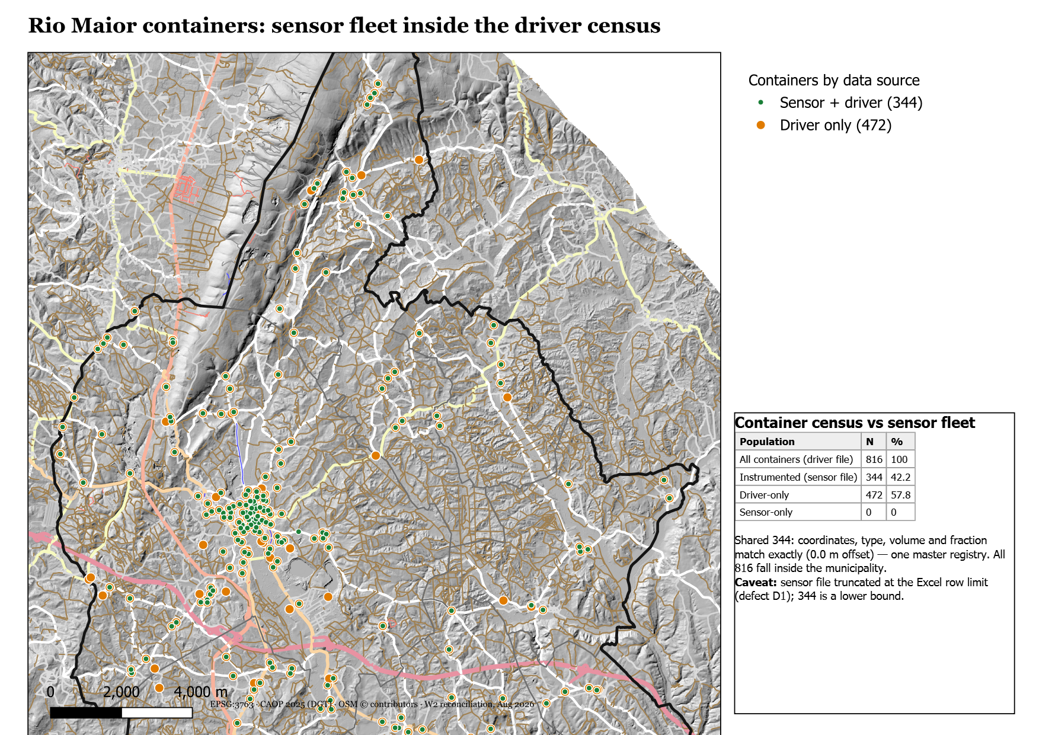
Figure 1 — Sensor fleet inside the driver census (map W2-M1).

2.2 Where they disagree: measurement, not geography
Property | Driver | Sensor | Consequence
Scale | 5 values | 85 values (0–84) | Driver data is ordinal; sensor data is near-continuous.
Ceiling | 100 reachable | 82–84, never 100 | Unit unverified (D3); treat as monotone index until the interview.
Zeros | 54.7% of rows | 12.2% of rows | Drivers report empty by default; sensors see partial fills.
Negatives | 0.1% | 9.2%, two clusters (−1…−9 and −89…−116) | Two sensor failure modes; must be filtered, not clamped.
Cadence | At collection visits | 2.55/day scheduled | Sensors support rate estimation; drivers only event snapshots.
Table 4 — Fill-value semantics by source.
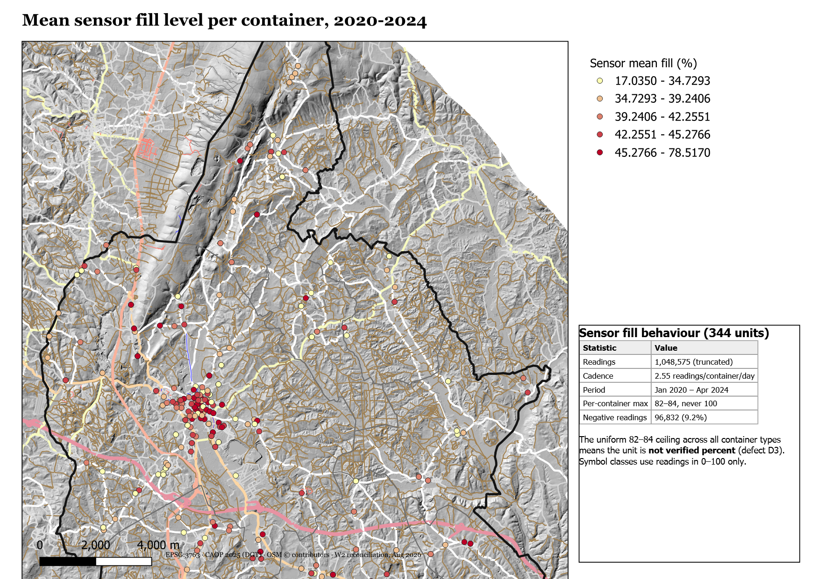
Figure 3 — Mean sensor fill per container, instrumented set (map W2-M3).
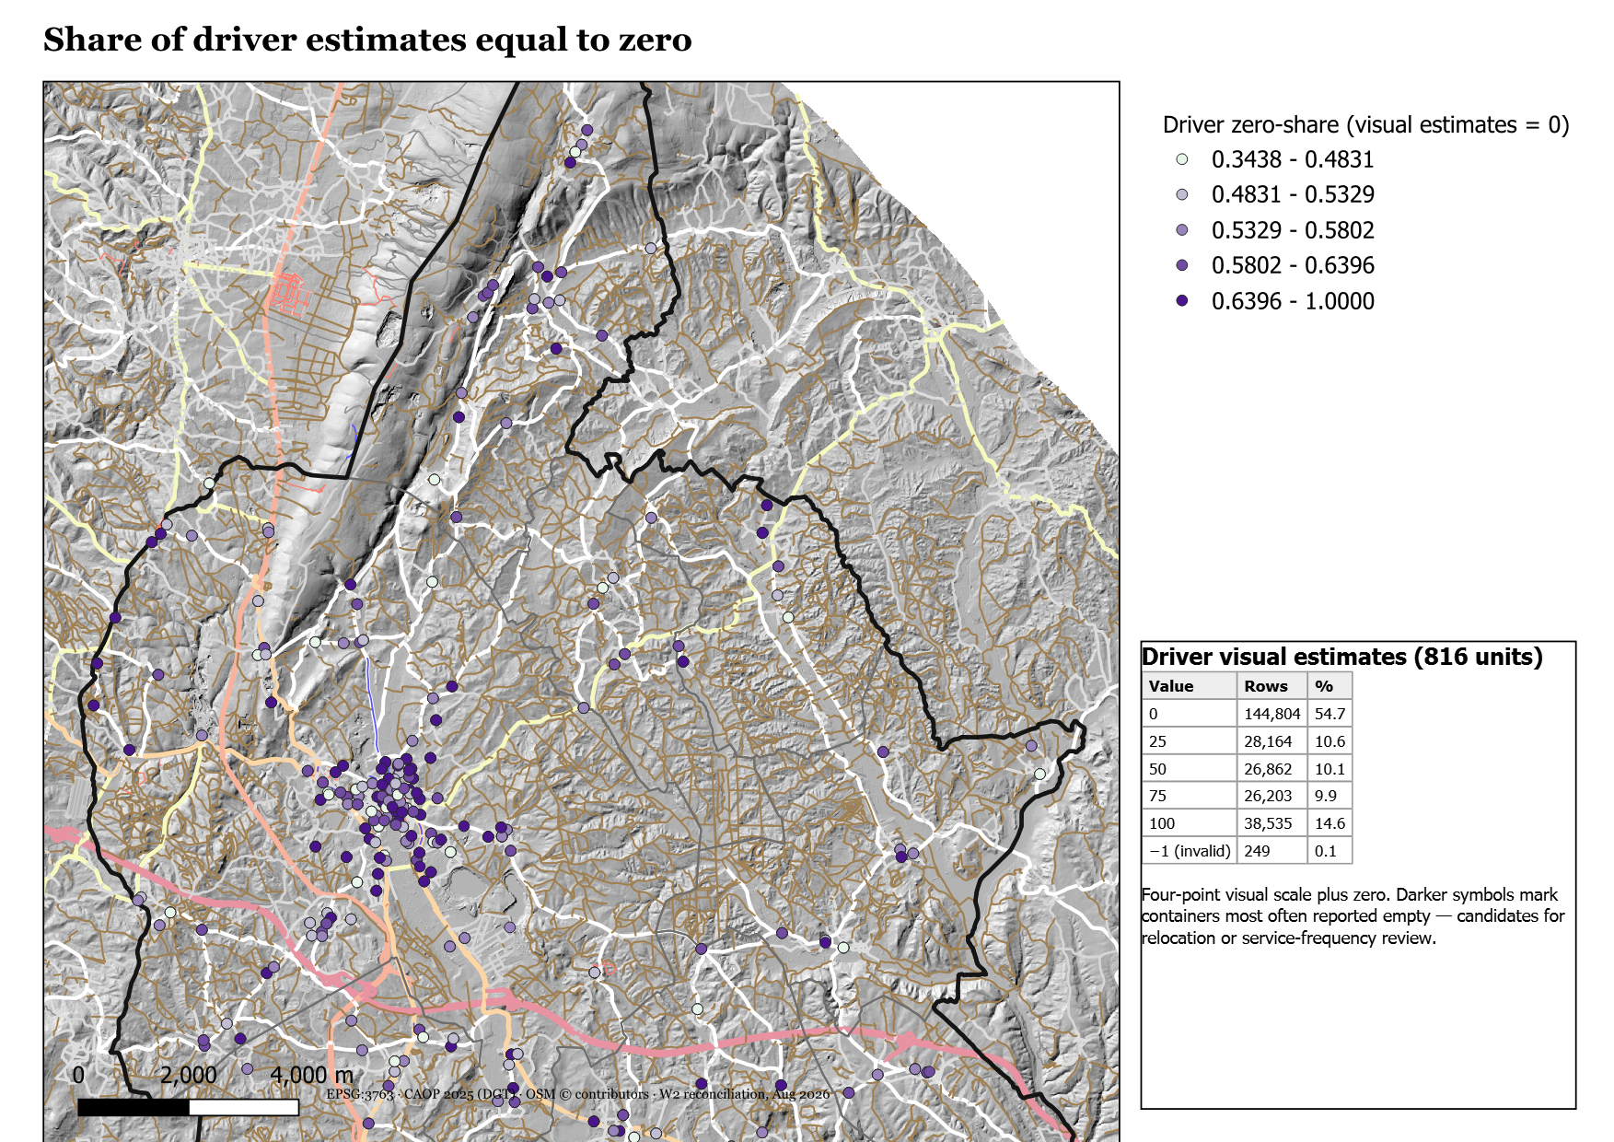
Figure 4 — Share of driver estimates equal to zero (map W2-M4).

2.3 The glass problem
Fraction | Driver containers | Sensor containers
Embalagens de papel e cartão (azul) | 280 | 173
Mistura de embalagens (amarelo) | 278 | 169
Embalagens de Vidro (verde) | 258 | 2
Table 5 — Waste-fraction composition of each container population.
Glass drops from a third of the census to two instrumented containers. The truncation defect D1 removed whole containers, so the sensor file cannot say whether glass was ever instrumented at scale. Until the re-export answers that, every sensor-based result excludes glass, and the thesis should say so plainly.
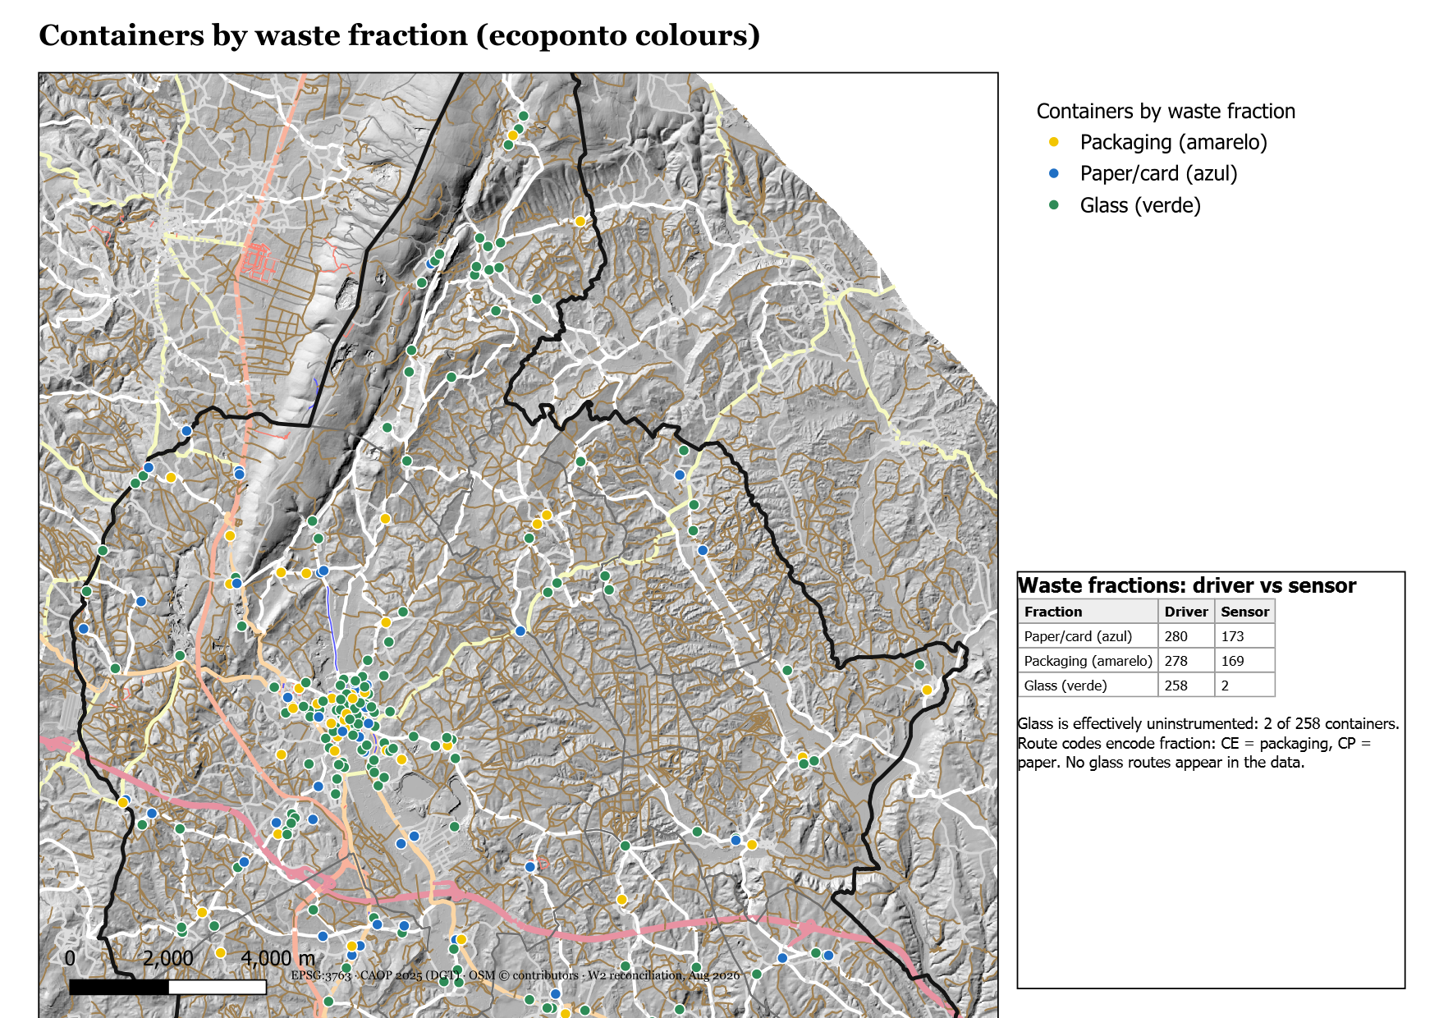
Figure 2 — Containers by waste fraction, ecoponto colours (map W2-M2).

2.4 Collection-event and route evidence
Evidence | Extent | Reading
idrecolha events | 9,984 distinct, on 23% of rows | Genuine collection events with start/end timestamps.
Route codes | 92 distinct, on 8.6% of rows | CE = packaging, CP = paper; paired numbering (CE13/CP13). No glass circuits.
Weights | 60,912 rows; mean 2,806 kg per run | Route-run totals; usable for tonnage checks, not per-container demand.
Kilometres | With weights | Same granularity; route-run distance totals.
Table 6 — Collection-event evidence in the driver file.

3. Fitness for the next analyses
Variable | Fit for | Not fit for
Sensor fill series (344 units) | Fill-rate (demand) estimation; service-level simulation; driver-comparison chapter | Absolute volume claims until D3 unit is resolved; glass
Driver quartile series (816 units) | Network-wide relative demand; glass demand; validation of sensor-derived rates | Continuous rate estimation; fine temporal dynamics
Container registry (816 locations) | p-median demand points and candidate sites; distance matrices on the OSM graph | —
idrecolha + weights | Tonnage sanity checks; per-run productivity | Per-container weights (not recorded)
Rota codes | Partial circuit reconstruction; validation target once operator GPS arrives | Complete route recovery (8.6% coverage)
Table 7 — Fitness of each variable for the next analyses.
The practical sequencing follows from Table 7. Fill-rate estimation runs on the 344 instrumented containers and transfers to the 472 driver-only ones through covariates (fraction, volume, freguesia, surrounding population from BGRI 2021). Glass demand comes from driver quartiles alone. Siting uses all 816 locations regardless of instrument.

Conclusion
The reconciliation removes a risk the audit had left open: the two files might have described different networks, mismatched positions, or duplicate registries. They do not. One registry, exact coordinate agreement, a strict subset relation, and full containment in the municipality mean the join is safe and the spatial base is settled.
What the files cannot do is also now precise. The sensor unit is unproven, glass is invisible to sensors, routes are one-twelfth documented, and the sensor file remains a truncated export. None of this blocks the demand model; all of it shapes how results must be phrased and what the operator request has to deliver.

Recommendations
- Adopt the reconciled layer — W2/02_data_work/containers_reconciled.geojson (816 points, per-container statistics attached) becomes the canonical container dataset; promote it to Brain/03_db.
- Run demand estimation on the 344 — with fill treated as a monotone index, negatives filtered by failure mode, and the 82–84 ceiling handled as censoring until the unit interview.
- Model glass from driver data — quartile-based rates for 258 containers; state the instrument openly in the chapter.
- Use the 472 driver-only containers as the transfer test — predict their driver-observed behaviour from sensor-trained models plus covariates; this is the honest out-of-sample check.
- Keep Rota rows aside as validation — when operator GPS arrives, the 22,674 coded rows anchor circuit reconstruction.
- Re-raise the D1 re-export — every glass and truncation question in this report dissolves if the full export lands.

References
- DATA/XLS/Enchimentos_com_Recolhas[RioMaior].csv and Enchimentos_de_Sensores[RioMaior].csv — source files (parquet mirrors in Brain/03_db).
- Report R1-01 — Methodology Audit: defect register D1–D7.
- Report R1-02 — GIS and Spatial Data Inventory.
- W2/01_scripts/reconcile_csv.py and W2/02_data_work/reconcile_stats.json — all figures in this report.
- INE BGRI 2021 (GIS_DATA/02_census_population) — covariate source for the transfer model.

Appendices

Appendix A — Reproducibility
- Analysis: python W2/01_scripts/reconcile_csv.py (DuckDB + spatial extension).
- Statistics: W2/02_data_work/reconcile_stats.json.
- Maps: QGIS layouts W2-M1…M4, exported 300 dpi to W2/03_outputs/maps; each carries an HTML statistics box.
- Report build: node W2/01_scripts/build_report_r201.js.

Appendix B — Monthly row counts
Driver rows hold near 60–70 thousand per year with 2024 partial to April. Sensor rows rise from 108 thousand (2020) to 373 thousand (2023) within the truncated file — the growth is confounded with D1 and must not be read as fleet expansion.

