
Farhad Esmaeili
Full Stack .Net Developer

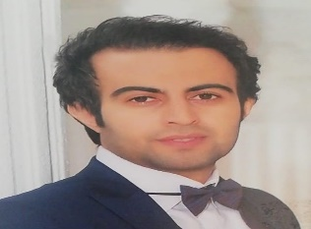

Expert in C#, .Net, and T-SQL with database analysis and design with 8+ years of experience programming and developing. Strong in design and integration problem-solving skills.

EXPERIENCE

SENIOR FULL-STACK DEVELOPER- EGHTESAD E NOVIN BANK 2020(JUL)-PRESENT

SENIOR FULL-STACK DEVELOPER, Golrang Industrial Group 2016(MARCH)-2020(JUL)

ACADEMIC
Bachelor of Science,
- Computer Science, Amirkabir University of Technology, Tehran, Iran
High School,
- National Organization for Development of Exceptional Talents, Ardabil, Iran

CONTACT

Email: esmaili.farhad67@gmail.com
Phone: (+98) 938 253 7319
Address: Unit 1, No 7, Behesht sq., Tehran Province, Tehran, Iran.
LinkedIn: https://www.linkedin.com/in/farhad-esmaeili-50328915a
github: https://github.com/esmaeilifarhad





 SENIOR FULL-STACK DEVELOPER, Golrang Industrial Group 2016(MARCH)-2020(JUL)
Clean / Onion Architecture
Design Patterns
Optimize Code
OOP
SOLID
CRUD /
OAuth2
Jwt
Identity

.Net Core / ASP.Net / C#
Web API(Swagger/jwt)
Signal R
Sharepoint / Nintex /Powerform
………………………………….….
Microservices, RabbitMQ
……………………………………..
Sql Server / T-SQL / ADO .net
Dapper
Entity Framework / Linq
Mongo
Redis
……………………………………..
React
Html
Css
Bootstrap
Ecmascript
Jquery
Java Script
…………………….………………
Agile
Scrum
Tfs
GitHub
SKILLS:
CONCEPTS:

