https://www.youtube.com/watch?v=10-985vXR6Y

Task.WaitAll Method

Waits for all of the provided Task objects to complete execution.
منتظر می ماند تا تمام اشیاء Task ارائه شده اجرا شوند.
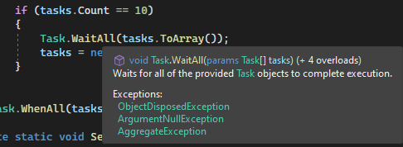
3
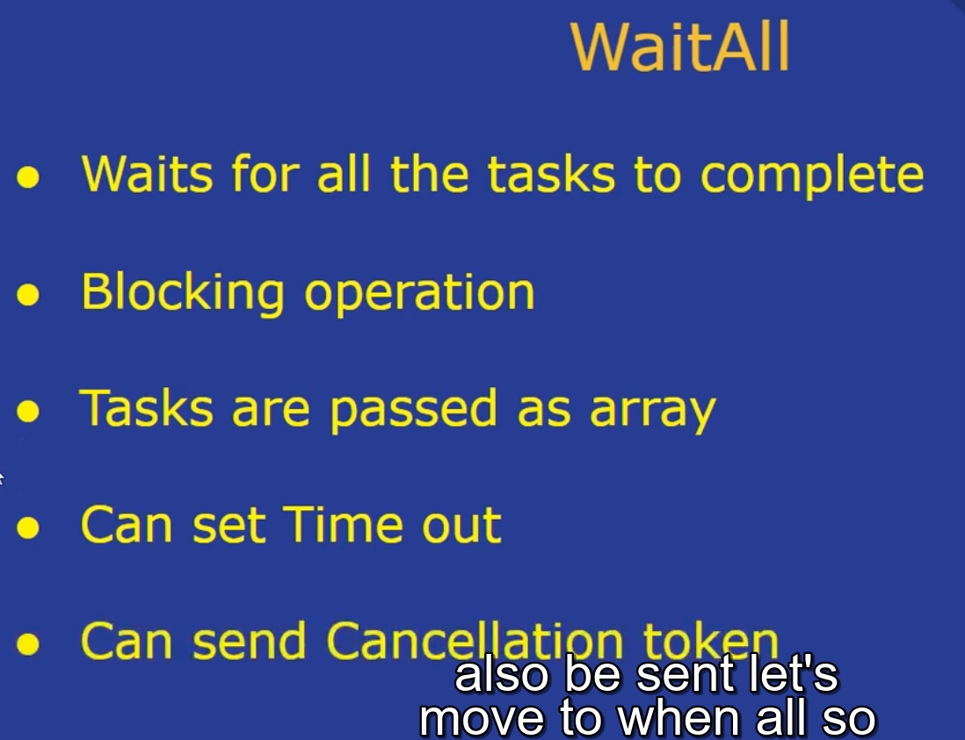

……………………………………………………………………..

Task.WhenAll Method

Creates a task that will complete when all of the supplied tasks have completed.
وظیفه ای را ایجاد می کند که با تکمیل تمام وظایف ارائه شده تکمیل می شود.
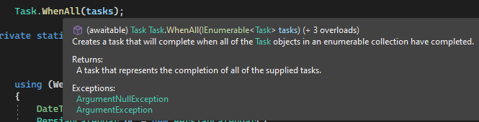

.
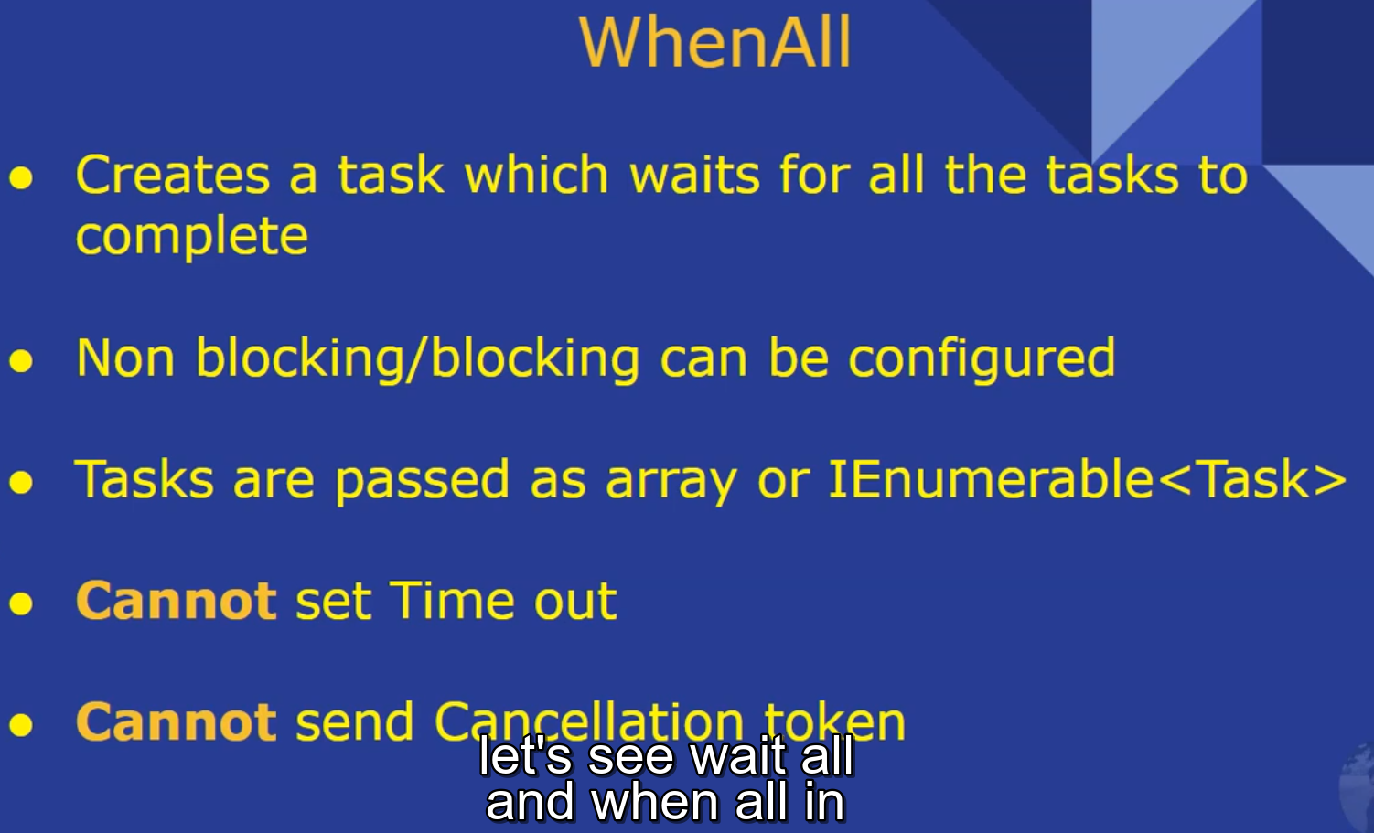
…………………………

مثال آقای حبیبی

using ENB.Sayah.Models;
using System;
using System.Collections.Generic;
using System.Globalization;
using System.Linq;
using System.Threading.Tasks;
using System.Web;

namespace ENB.Sayah.Code
{
public static class Engine
{
public static void Send()
{
DateTime start = DateTime.Now;

int takeCount = 10000;
int skipCount = 0;
List<Task> tasks = new List<Task>();

List<t06_AddAccountOwner> list = null;
using (Web_Sayah_DBEntities db = new Web_Sayah_DBEntities())
{
list = db.t06_AddAccountOwner.AsNoTracking().Where(x=>x.ActionDate==null).ToList();
}

TimeSpan elapsed = DateTime.Now.Subtract(start);

SayahService.SayahServiceClient client = new SayahService.SayahServiceClient();
client.ClientCredentials.UserName.UserName = "sayah1055";
client.ClientCredentials.UserName.Password = "4H0NV334HWD0-";
System.Net.ServicePointManager.SecurityProtocol = System.Net.SecurityProtocolType.Tls12;

foreach (var item in list)
{
if (skipCount > list.Count)
break;

var subList = list.Skip(skipCount).Take(takeCount).ToList();
skipCount += takeCount;

if (subList.Count > 0)
{
var task = Task.Factory.StartNew(() => SendingJob(subList, client));
tasks.Add(task);
}

if (tasks.Count == 10)
{
Task.WaitAll(tasks.ToArray());
tasks = new List<Task>();
}
}

Task.WhenAll(tasks);
}

private static void SendingJob(List<t06_AddAccountOwner> lst_AddAccountOwner, SayahService.SayahServiceClient client)
{

using (Web_Sayah_DBEntities db = new Web_Sayah_DBEntities())
{
DateTime thisDate;
PersianCalendar pc = new PersianCalendar();
string Time = null;

SayahService.boolResponse res = null;
foreach (var obj in lst_AddAccountOwner)
{
try
{
//var aao =
t06_AddAccountOwner aao = db.t06_AddAccountOwner.Find(obj.Id);
//Set customer object
SayahService.Customer customer = new SayahService.Customer();
customer.CustomerType = aao.CustomerType;
customer.NationalCd = aao.NationalCode.ToString().PadLeft(10, '0');
customer.LegalId = aao.LegalId;
customer.ShahabCd = aao.ShahabCd;
customer.Sex = aao.Sex;
customer.SpecialCases = aao.SpecialCases;
//send Data to CB
res = client.AddAccountOwner("55", aao.FollowCode, customer);
thisDate = DateTime.Now;
aao.ActionDate = (pc.GetYear(thisDate)).ToString("0000") + (pc.GetMonth(thisDate)).ToString("00") + (pc.GetDayOfMonth(thisDate)).ToString("00");

if (!res.HasError)
aao.HassError = false;
else
{
aao.HassError = true;
for (int j = 0; j < res.Errors.Count(); j++)
{
db.Errors.Add(new Errors()
{
ErrorCd = res.Errors[j].ErrorCd,
ErrorDsc = res.Errors[j].ErrorDsc,
MethodTypeId = "6",
MethodId = (aao.Id).ToString()
});
}
}

db.SaveChanges();
}
catch (Exception ex)
{
}

}
}
}
}
}

