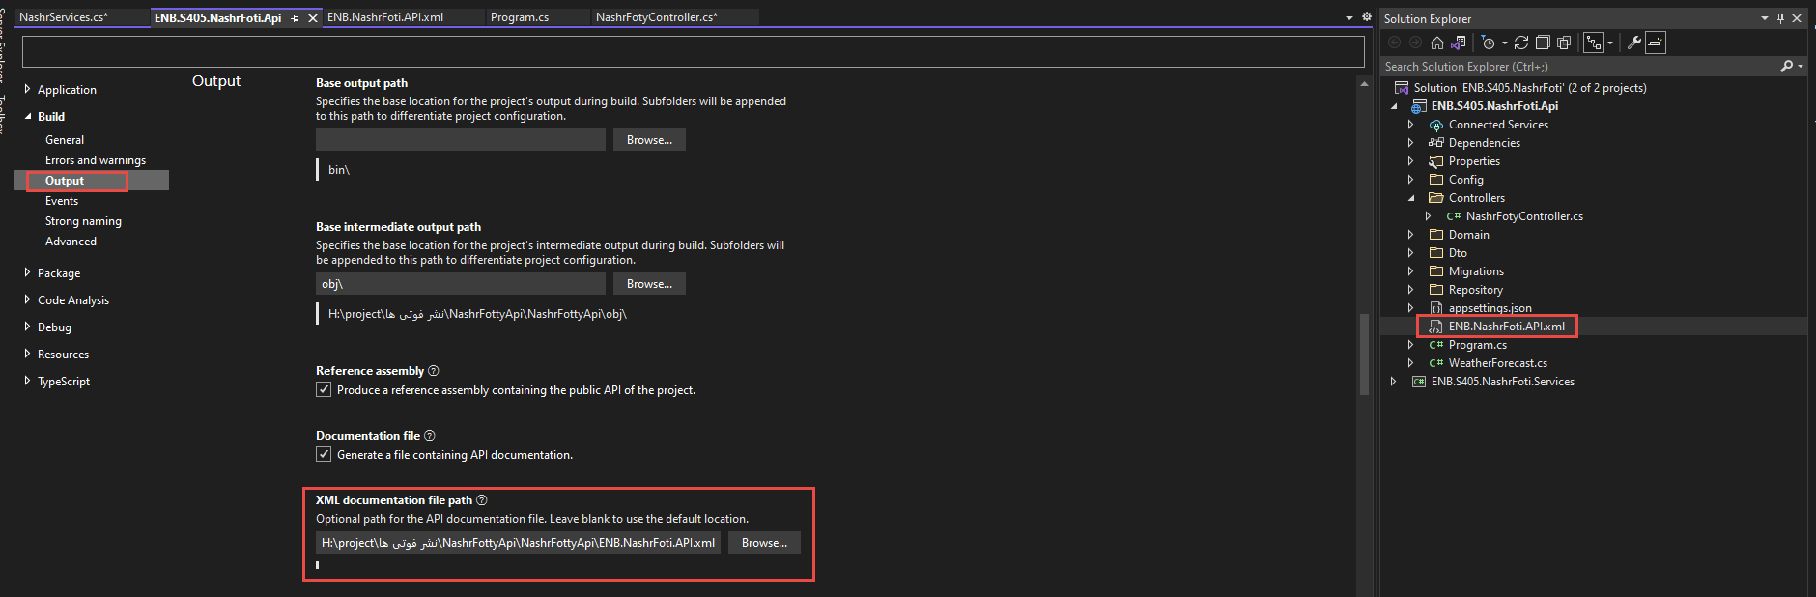
.
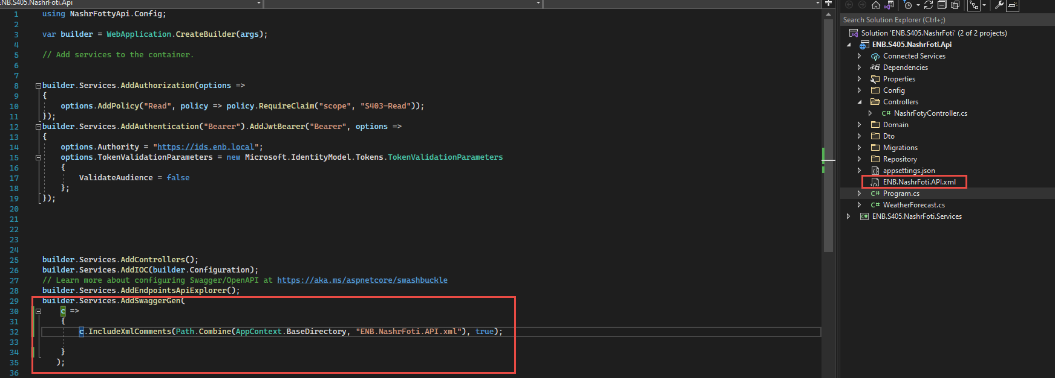
..........
builder.Services.AddSwaggerGen(
c =>
{
c.IncludeXmlComments(Path.Combine(AppContext.BaseDirectory, "ENB.NashrFoti.API.xml"), true);

}
);
........



