HARAMAYA UNIVERSITY
COLLEGE OF COMPUTING AND INFORMATICS
DEPARTMENT OF INFORMATION SCIENCE

PROJECT PROPOSAL ON
WEB-BASED CITIZEN COMPLAINT AND SERVICE REQUEST
MANAGEMENT SYSTEM FOR ADAMA CITY ADMINISTRATION
Prepared By:
Name ID
________________________________ ........................ ______________
Host Company: - Adama City Administration Science and Technology Office.
The Practical Attachment document submitted to Information Science Department.
Advisor: ________________________________
Submission Date: ____________________
Haramaya, Ethiopia

Declaration
I hereby declare that this project proposal, titled "Web-Based Citizen Complaint and Service Request Management System for Adama City Administration", is my original work. It has been prepared as part of the academic requirements of Haramaya University, College of Computing and Informatics, Department of Information Science under the guidance of my advisor.
I further declare that:
- This work has not been submitted, in whole or in part, for any other degree, diploma, or academic award at this or any other institution.
- All sources of information used in this document have been properly acknowledged through citations and references.
- The system design, documentation, and implementation described herein represent work carried out by me, except where otherwise stated.
-- | --
Name | ____________________
ID | __________
Signature | ______________________________
Date | ____________________

Acknowledgement
First and foremost, I would like to thank Almighty God for the strength, guidance, and opportunity to complete this project proposal.
I express sincere gratitude to my advisor for continuous guidance, constructive feedback, and encouragement throughout the preparation of this document and the development of the system.
I also thank the instructors and staff of the Department of Information Science, College of Computing and Informatics, Haramaya University for the knowledge and support provided during the course of study.
Special appreciation is extended to Adama City Administration Science and Technology Office as the host organization for this work, and to colleagues, classmates, and family members who offered advice, motivation, and moral support.
Finally, I acknowledge all authors, developers, and organizations whose published works, documentation, and open-source tools contributed to the completion of this proposal.

Abstract (Executive Summary)
Municipal complaint and service request handling in Adama City Administration has traditionally relied on paper-based processes and office visits. This approach causes delays, weak record keeping, limited status tracking, and reduced transparency between citizens and responsible departments.
This project proposes and implements a Web-Based Citizen Complaint and Service Request Management System to digitize submission, assignment, tracking, and reporting of citizen cases. The system supports three roles: Citizen, Administrator, and Department Officer. Citizens can register, submit categorized complaints and service requests (with optional photo evidence), and track progress using unique reference numbers. Administrators manage users and departments, assign work, update status, and generate reports. Officers process assigned tasks within their department scope and add resolution notes.
The solution is built with the MERN stack (MongoDB, Express.js, React, Node.js), using JWT authentication and role-based access control. Status history and in-app notifications improve accountability and communication. The expected outcome is a centralized, transparent, and more efficient channel for municipal service delivery for Adama City Administration.
Keywords: citizen complaint, service request, e-governance, Adama City Administration, MERN, role-based access control

Table of contents
Declaration i
Acknowledgement ii
Abstract (Executive Summary) iii
List of Acronyms iv
CHAPTER ONE: INTRODUCTION 1
1.1 Background of the Study 1
1.2 Problem Statement 2
1.3 Objectives 2
1.3.1 General Objective 2
1.3.2 Specific Objectives 2
1.4 Scope of the Project 3
1.4.1 In Scope 3
1.4.2 Out of Scope 3
1.4.3 Distinction: Complaint vs Service Request 3
1.5 Limitations 4
1.6 Literature Review and Related Work 4
CHAPTER TWO: SYSTEM REQUIREMENTS AND DESIGN 5
2.1 Proposed System 5
2.1.1 Citizens Can 5
2.1.2 Administrators Can 5
2.1.3 Department Officers Can 6
2.2 Actors of the System 6
2.2.1 Citizen 6
2.2.2 Administrator 6
2.2.3 Department Officer 6
2.3 Functional Requirements 7
2.3.1 Complaint Categories (Predefined) 7
2.3.2 Service Types (Predefined) 7
2.3.3 Status Values 7
2.3.4 Status Transition Rules (Implemented) 8
2.4 Non-Functional Requirements 8
2.4.1 Security 8
2.4.2 Performance 8
2.4.3 Reliability 9
2.4.4 Usability 9
2.4.5 Scalability 9
2.4.6 Maintainability 9
2.5 System Architecture 10
2.6 Use Case Diagram 10
2.7 Entity-Relationship Diagram 11
2.8 Data Flow Diagram (Level 0) 12
2.9 System Workflow 12
2.10 Technology Stack and Development Tools 13
2.11 Database Design 13
2.11.1 Collections Overview 13
2.11.2 Users Collection 14
2.11.3 Departments Collection 14
2.11.4 Complaints Collection 14
2.11.5 Service Requests Collection 15
2.11.6 Status Histories Collection 15
2.11.7 Notifications Collection 15
CHAPTER THREE: METHODOLOGY AND PROJECT PLAN 16
3.1 Methodology 16
3.2 Project Timeline 17
3.2.1 Gantt Chart 17
3.3 Testing Strategy 18
3.3.1 Sample Test Cases 18
3.4 Deployment Plan 19
3.4.1 Environment Setup 19
3.4.2 Deployment Architecture 19
3.4.3 Deployment Steps 20
3.4.4 Minimum Server Requirements 20
CHAPTER FOUR: RESULTS AND DISCUSSION 21
4.1 Results 21
4.1.1 Public Portal and Authentication 21
4.1.2 Citizen Modules 22
4.1.3 Officer Modules 23
4.1.4 Administrator Modules 24
4.2 Discussion 25
4.3 Expected Benefits 26
4.3.1 For Citizens 26
4.3.2 For Adama City Administration 26
4.4 Expected Outcome 27
4.5 Future Enhancements 27
CHAPTER FIVE: CONCLUSION 28
References 29
Document Revision History 30

List of Acronyms
Acronym | Full Form
AM | Amharic
API | Application Programming Interface
CORS | Cross-Origin Resource Sharing
CRUD | Create, Read, Update, Delete
CSS | Cascading Style Sheets
DFD | Data Flow Diagram
EN | English
ER | Entity-Relationship
FK | Foreign Key
FR | Functional Requirement
GIS | Geographic Information System
HTML | HyperText Markup Language
HTTP | HyperText Transfer Protocol
HTTPS | HyperText Transfer Protocol Secure
ID | Identifier
JSON | JavaScript Object Notation
JWT | JSON Web Token
MERN | MongoDB, Express.js, React, Node.js
ODM | Object Document Mapper
OM | Afaan Oromo
PK | Primary Key
RBAC | Role-Based Access Control
REST | Representational State Transfer
SLA | Service Level Agreement
SMS | Short Message Service
SPA | Single-Page Application
SSL | Secure Sockets Layer
UAT | User Acceptance Testing
UI | User Interface
UK | Unique Key
URL | Uniform Resource Locator
VPS | Virtual Private Server
XSS | Cross-Site Scripting

CHAPTER ONE: INTRODUCTION

1.1 Background of the Study
Adama City Administration provides various municipal services to citizens. Citizens often need to submit complaints regarding public services such as road maintenance, waste management, water supply, street lighting, and other community-related issues. In addition, citizens may request different municipal services from the city administration.
Currently, many complaints and service requests are handled manually through paper-based processes or office visits. This leads to:
- Delays in service delivery
- Poor record management
- Limited tracking capabilities
- Reduced transparency between citizens and administration
To address these challenges, a web-based system is proposed to allow citizens to submit complaints and service requests online, track their progress in real time, and receive feedback from responsible departments.

1.2 Problem Statement
The existing complaint and service request management process faces several challenges:
- Manual handling of complaints and requests
- Difficulty in tracking complaint status
- Delayed response from responsible departments
- Lack of centralized data storage
- Poor communication between citizens and city administration
- Limited reporting and monitoring capabilities
- Inefficient record management
- No audit trail for status changes
- No standardized categories for complaints and service types

1.3 Objectives

1.3.1 General Objective
To develop a web-based citizen complaint and service request management system for Adama City Administration that improves transparency, efficiency, and accountability in municipal service delivery.

1.3.2 Specific Objectives
- To provide online citizen registration and secure authentication
- To enable citizens to submit complaints electronically with categories and optional attachments
- To enable citizens to submit service requests electronically with predefined service types
- To provide complaint and request tracking functionality with status history
- To provide role-based administrative and department dashboards
- To improve communication through in-app notifications
- To generate reports and statistics for decision-making
- To maintain centralized, searchable records of complaints and requests
- To support department-based assignment and processing workflows

1.4 Scope of the Project

1.4.1 In Scope
- User registration and login (JWT authentication)
- Complaint submission with category, location, and optional photo upload
- Service request submission with service type and description
- Status tracking with history (Pending, In Progress, Resolved, Rejected, Closed)
- Role-based access: Citizen, Administrator, Department Officer
- User management (Administrator: view users, activate/deactivate)
- Department management (Administrator: list and add departments)
- Complaint/request assignment to departments and optional officers
- Search and filter submissions (admin lists; citizens view their own)
- In-app notifications on assignment and status changes
- Role-specific dashboards with summary statistics
- In-app report summaries (counts by status, category, department)
- Activity/audit log for administrative actions
- Multi-language guest/public UI (English, Amharic, Afaan Oromo)
- Success feedback (submission popup; action toasts)

1.4.2 Out of Scope
- Online payment processing
- Advanced GIS mapping and interactive maps
- SMS and email notifications (planned as future enhancements)
- Email password reset / email verification (Phase 2)
- Native mobile applications (web-responsive only in this phase)
- Full user/department CRUD (edit/delete), submission delete, and report export
- JWT refresh tokens, API rate limiting, and list pagination (planned hardening)

1.4.3 Distinction: Complaint vs Service Request
Aspect | Complaint | Service Request
Purpose | Report a problem or failure in existing service | Request a new or additional municipal service
Examples | Broken streetlight, garbage not collected, water leak | Request waste bin, street cleaning, permit inquiry
Typical flow | Report → Investigate → Fix | Request → Review → Fulfill

1.5 Limitations
- Requires internet access; citizens without connectivity must still use offline channels
- Initial deployment assumes manual setup of departments and officer accounts by administrators
- File uploads limited to images (including JPEG, PNG, WebP, GIF) up to 2 MB per attachment
- Guest/public UI is localized (EN/AM/OM); some authenticated screens remain primarily English
- Password reset via email is not implemented in Phase 1 (demo “forgot password” message only)
- No integration with existing legacy paper records
- Performance targets assume moderate concurrent usage (up to 500 simultaneous users)

1.6 Literature Review and Related Work
Several municipal and e-governance systems demonstrate the value of digital complaint management:
System / Study | Approach | Relevance
FixMyStreet (UK) | Web-based geo-tagged reporting | Shows citizen-driven reporting improves response times
311 Systems (USA) | Centralized non-emergency service requests | Model for categorization and department routing
Ethiopian e-Service initiatives | Government digital transformation | Aligns with national push for digital public services
CRM-based municipal portals | Role-based dashboards and ticketing | Supports assignment, tracking, and reporting workflows

Gap identified: Adama City Administration lacks a dedicated, centralized web platform that connects citizens, administrators, and department officers with transparent status tracking and reporting. This project fills that gap using a modern MERN stack suitable for rapid development and scalability.

CHAPTER TWO: SYSTEM REQUIREMENTS AND DESIGN

2.1 Proposed System
The proposed system is a web-based application accessible through modern browsers. It follows a three-tier architecture: React frontend, Node.js/Express API, and MongoDB database.

2.1.1 Citizens Can
- Create accounts and manage profiles (name, phone)
- Log in securely with JWT-based sessions
- Submit complaints with category, description, location, and optional photo
- Submit service requests with service type and description
- View and track status of all their submissions (with reference ID)
- Receive in-app notifications when status changes
- View their own submissions from the citizen dashboard

2.1.2 Administrators Can
- View users and activate/deactivate accounts
- Add departments and view department list
- View all complaints and service requests (search/filter)
- Assign submissions to departments and optionally to officers
- Reject pending submissions; resolve/close in-progress items
- View report summaries and dashboard analytics
- Monitor system activity via audit logs

2.1.3 Department Officers Can
- View personally assigned items and unassigned items in their department queue
- Start work (Pending → In Progress)
- Add resolution notes
- Mark tasks as Resolved or Closed (officers cannot reject)
- View officer dashboard statistics

2.2 Actors of the System

2.2.1 Citizen
Responsibilities: Register account, log in, submit complaints and service requests, view status, update profile, receive notifications.

2.2.2 Administrator
Responsibilities: View and activate/deactivate users, add departments, assign submissions, update/reject statuses, view report summaries, monitor system activities.

2.2.3 Department Officer
Responsibilities: View assigned work and department queue, process complaints and requests, update progress, add notes, mark tasks resolved or closed. Each officer belongs to one department (e.g., Water, Roads, Sanitation). Officers cannot reject submissions.

2.3 Functional Requirements
ID | Requirement | Description
FR-01 | User registration | Citizens register with full name, email, phone, and password
FR-02 | User login | Authenticate with email and password; receive JWT token
FR-03 | Profile management | Update name and phone; view account role
FR-04 | Complaint submission | Submit with title, description, category, location, optional attachment
FR-05 | Service request submission | Submit with service type, description, optional location
FR-06 | Status tracking | View current status and full status history timeline
FR-07 | Dashboard | Role-specific dashboards with counts and recent items
FR-08 | User management | Admin lists users and activates/deactivates accounts
FR-09 | Department management | Admin lists and adds departments
FR-10 | Assignment | Admin assigns submission to department; optional officer
FR-11 | Report summaries | View counts by status, category, and department
FR-12 | Search | Admin search/filter by reference ID, keyword, and status
FR-13 | Notifications | In-app notifications on assignment and status change
FR-14 | Audit log | Record who changed status and when
FR-15 | Success feedback | Confirm successful submissions and admin/officer actions

2.3.1 Complaint Categories (Predefined)
Road Maintenance, Waste Management, Water Supply, Street Lighting, Drainage, Public Safety, Noise Pollution, Other.

2.3.2 Service Types (Predefined)
Waste Collection Request, Street Cleaning, Water Connection Inquiry, Public Facility Access, General Information, Other.

2.3.3 Status Values
Status | Description
Pending | Submitted; awaiting review or sitting in a department queue
In Progress | Assigned to an officer and being processed
Resolved | Issue addressed or service fulfilled
Rejected | Invalid or out of scope (admin only)
Closed | Closed without further action

2.3.4 Status Transition Rules (Implemented)
Role | From | Allowed next statuses
Officer | Pending | In Progress
Officer | In Progress | Resolved, Closed
Admin | Pending | Rejected
Admin | In Progress | Resolved, Closed, Rejected
Admin | Resolved | Closed

Assignment note: Routing to a department only keeps status Pending. Assigning (or claiming) an officer moves the item to In Progress.

2.4 Non-Functional Requirements

2.4.1 Security
- Password hashing with bcrypt (never store plain text)
- JWT authentication with configurable expiration (no refresh tokens in Phase 1)
- Role-based access control (RBAC) on API routes and frontend routes
- HTTPS in production
- Input validation and sanitization (prevent XSS, injection)
- Secure file upload validation (type and size; max 2 MB)
- Rate limiting on login and submission endpoints (planned hardening)

2.4.2 Performance
- API response time under 2 seconds for typical requests
- Indexed database queries on status, citizenId, departmentId, createdDate
- List pagination (planned; Phase 1 returns role-scoped full lists)

2.4.3 Reliability
- Consistent operation with structured error handling
- Automated MongoDB backups (daily in production)
- Graceful degradation when optional features (e.g., file upload) fail

2.4.4 Usability
- Responsive design for desktop and mobile browsers
- Clear navigation and accessible forms with validation messages
- Consistent UI patterns across citizen, admin, and officer interfaces
- Success popups/toasts after key actions
- Multi-language support on the public guest experience (EN/AM/OM)

2.4.5 Scalability
- Stateless API design for horizontal scaling
- MongoDB Atlas replica sets as user base grows

2.4.6 Maintainability
- Modular code structure (routes, controllers, models, middleware)
- API exercises via HTTP client tools (e.g., Postman / Thunder Client)
- Version control with Git and GitHub

2.5 System Architecture
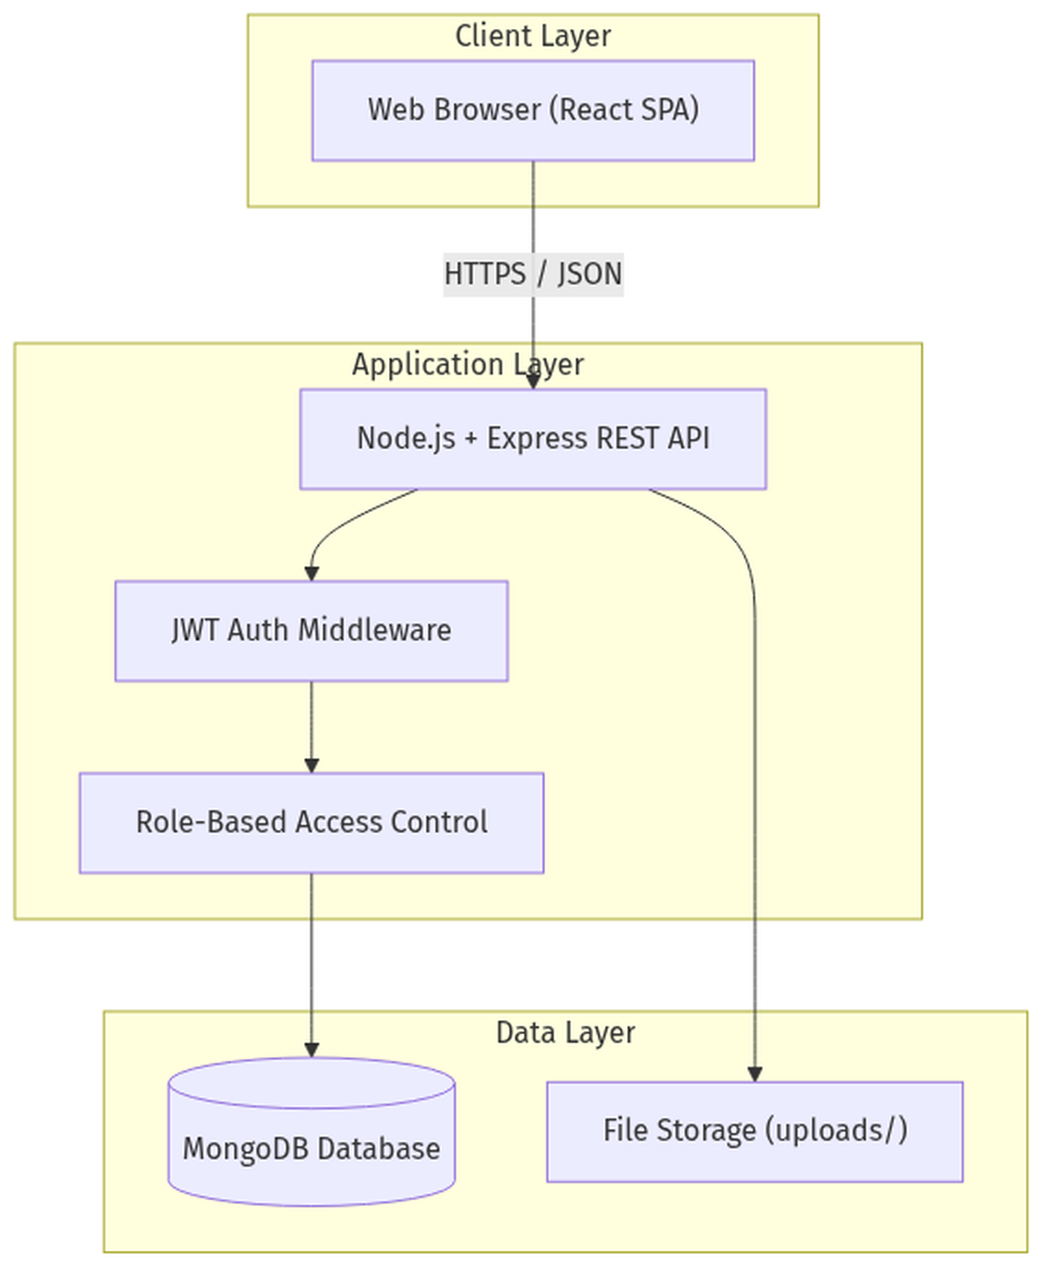
Figure: System Architecture

2.6 Use Case Diagram
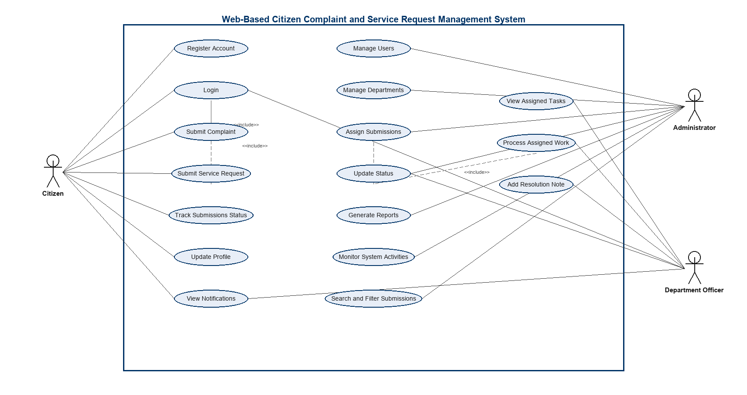
Figure: Use Case Diagram

2.7 Entity-Relationship Diagram
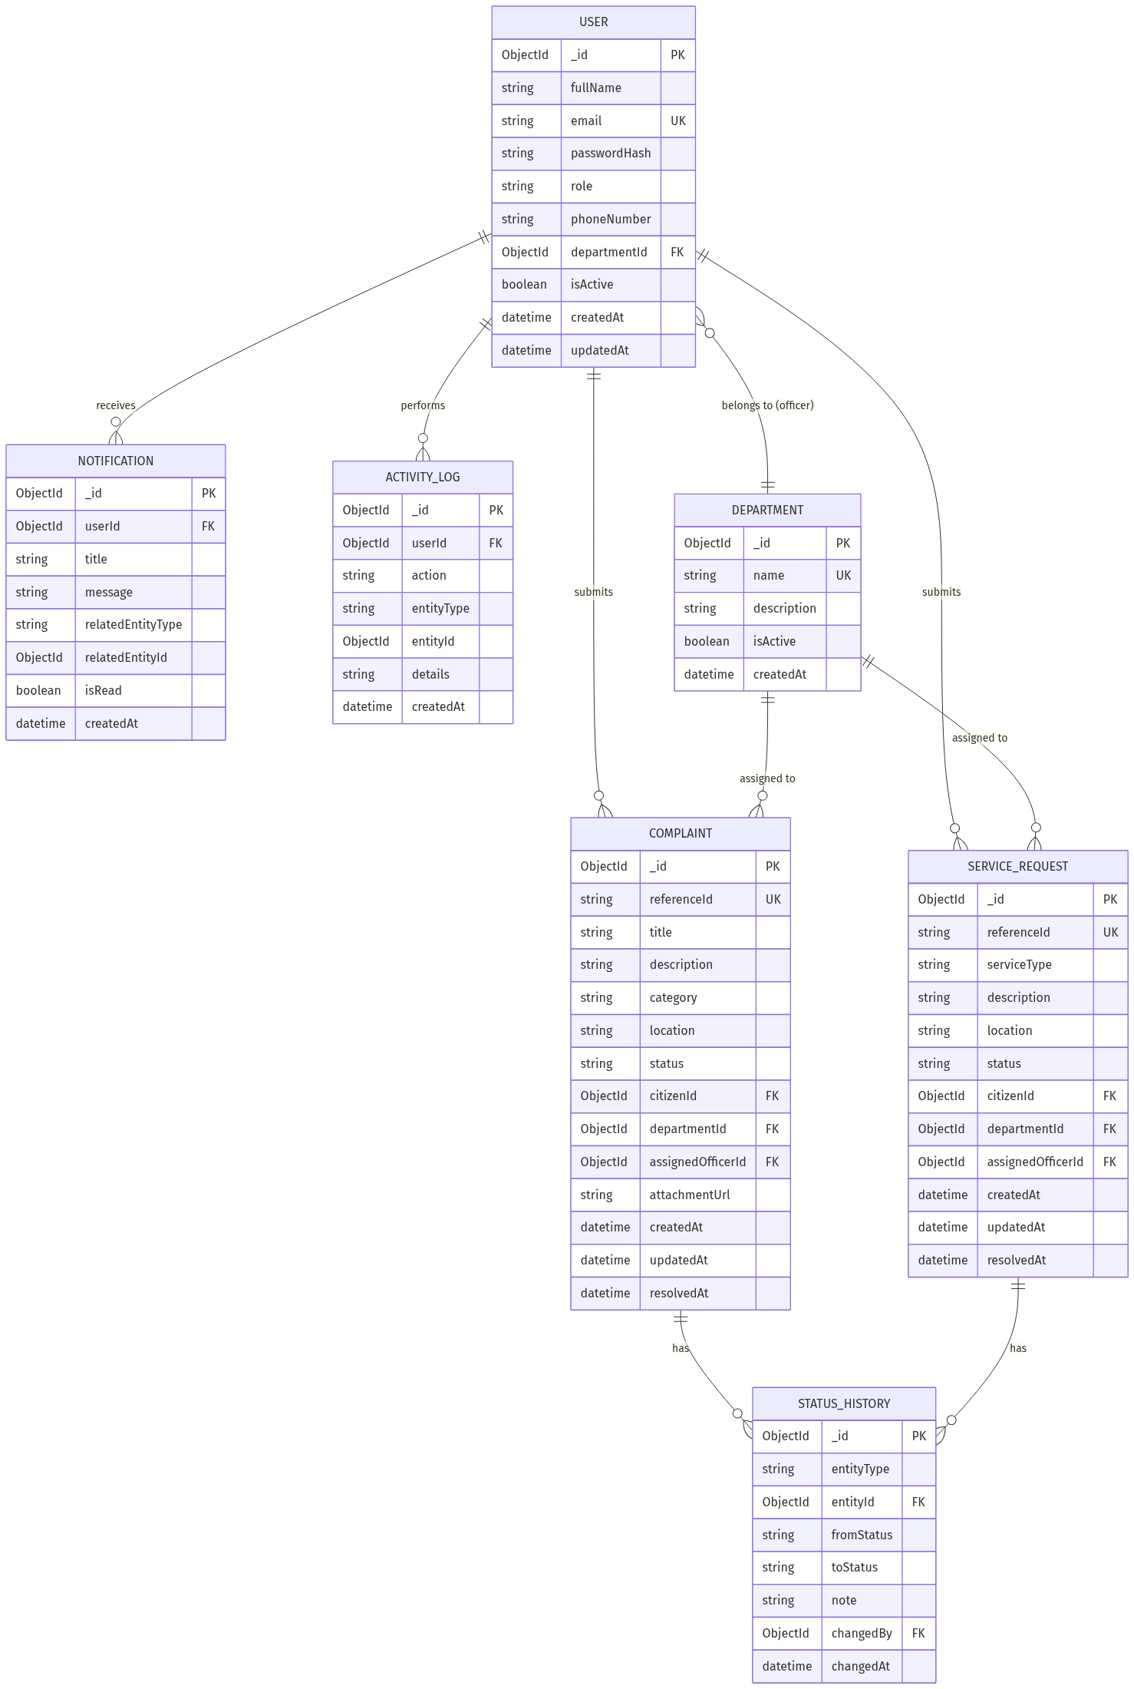
Figure: Entity-Relationship Diagram

2.8 Data Flow Diagram (Level 0)
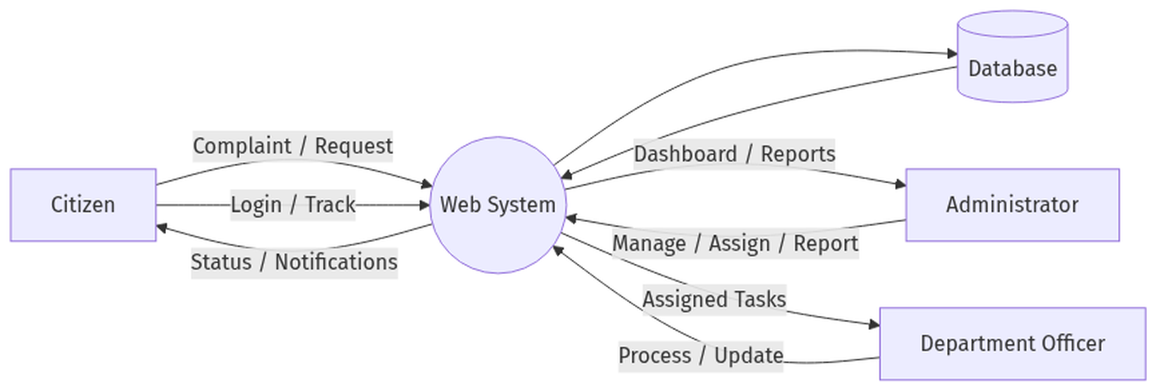
Figure: Data Flow Diagram (Level 0)

2.9 System Workflow
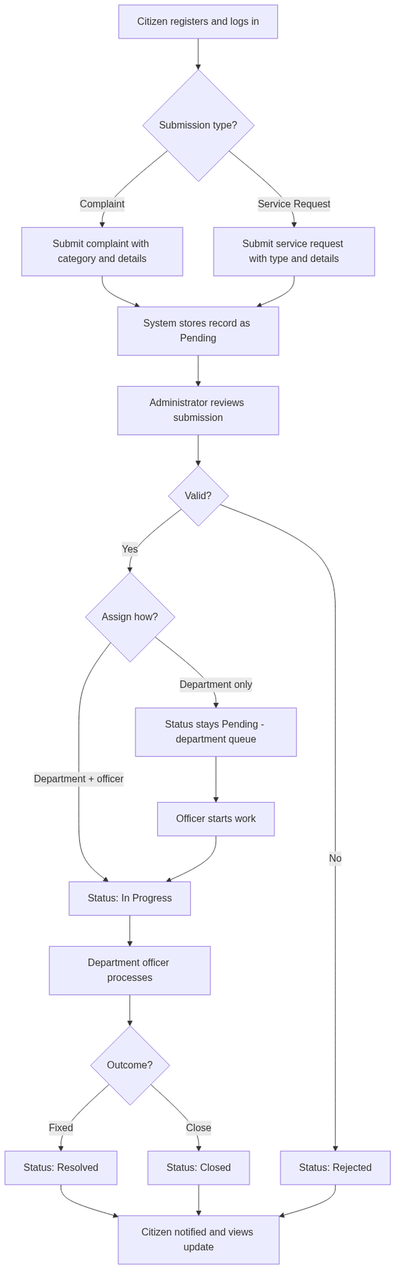
Figure: System Workflow
Step-by-step:
- Citizen registers an account and logs into the system.
- Citizen submits a complaint or service request.
- System generates a unique reference ID (e.g., CMP-2026-0001) and stores the record as Pending.
- Administrator reviews the submission.
- Administrator either rejects it, routes it to a department queue (Pending), or assigns an officer (In Progress).
- Department officer processes the request (start work if still pending) and may add resolution notes.
- Officer sets Resolved or Closed; admin may also reject in-progress items.
- Status history and audit log are recorded; citizen views progress and notifications.

2.10 Technology Stack and Development Tools
Layer | Technology | Purpose
Frontend | React.js (Vite), HTML5, CSS3, JavaScript | Single-page user interface
UI / Client | React Router, native fetch | Routing and API communication
Backend | Node.js, Express.js, Helmet | REST API server
Database | MongoDB Atlas (or local), Mongoose | Document storage and ODM
Authentication | JWT, bcrypt | Secure sessions and password hashing
Validation | express-validator | Request validation
File Upload | multer | Complaint image attachments
i18n | Custom language context | English, Amharic, Afaan Oromo (guest UI)
Development | Visual Studio Code, Git, GitHub | Coding and version control

Note on database choice: MongoDB supports flexible schemas for complaints and requests. Relational integrity is enforced at the application layer via Mongoose references. PostgreSQL is a viable alternative if strict relational reporting is required later.

2.11 Database Design

2.11.1 Collections Overview
Collection | Purpose
users | All system users (citizens, admins, officers)
departments | Municipal departments
complaints | Citizen complaint records
serviceRequests | Citizen service request records
statusHistories | Status change audit trail
notifications | In-app user notifications
activityLogs | Administrative action logs

2.11.2 Users Collection
Field | Type | Description
_id | ObjectId | Primary key
fullName | String | User full name
email | String | Unique email (login)
passwordHash | String | Bcrypt-hashed password (not plain text)
role | Enum | citizen, admin, officer
phoneNumber | String | Contact number
departmentId | ObjectId | FK to departments (officers only)
isActive | Boolean | Account enabled/disabled
createdAt | Date | Registration date
updatedAt | Date | Last profile update

Indexes: email (unique), role, departmentId

2.11.3 Departments Collection
Field | Type | Description
_id | ObjectId | Primary key
name | String | e.g., Water Supply, Roads
description | String | Department description
isActive | Boolean | Active flag
createdAt | Date | Created date

Indexes: name (unique)

2.11.4 Complaints Collection
Field | Type | Description
_id | ObjectId | Primary key
referenceId | String | Human-readable ID (e.g., CMP-2026-0001)
title | String | Short title
description | String | Full description
category | Enum | Predefined category
location | String | Address or area description
status | Enum | pending, in_progress, resolved, rejected, closed
citizenId | ObjectId | FK to users
departmentId | ObjectId | FK to departments
assignedOfficerId | ObjectId | FK to users (optional)
attachmentUrl | String | Optional photo path
resolutionNote | String | Officer/admin resolution text
createdAt | Date | Submission date
updatedAt | Date | Last update
resolvedAt | Date | Resolution timestamp

Indexes: referenceId (unique), citizenId, departmentId, status, createdAt

2.11.5 Service Requests Collection
Field | Type | Description
_id | ObjectId | Primary key
referenceId | String | e.g., SRV-2025-0001
serviceType | Enum | Predefined service type
description | String | Request details
location | String | Optional location
status | Enum | Same as complaints
citizenId | ObjectId | FK to users
departmentId | ObjectId | FK to departments
assignedOfficerId | ObjectId | FK to users (optional)
resolutionNote | String | Resolution text
createdAt | Date | Submission date
updatedAt | Date | Last update
resolvedAt | Date | Resolution timestamp

Indexes: referenceId (unique), citizenId, departmentId, status, createdAt

2.11.6 Status Histories Collection
Field | Type | Description
_id | ObjectId | Primary key
entityType | Enum | complaint, serviceRequest
entityId | ObjectId | FK to complaint or request
fromStatus | String | Previous status
toStatus | String | New status
note | String | Optional comment
changedBy | ObjectId | FK to users
changedAt | Date | Timestamp

2.11.7 Notifications Collection
Field | Type | Description
_id | ObjectId | Primary key
userId | ObjectId | FK to users
title | String | Notification title
message | String | Notification body
relatedEntityType | String | complaint / serviceRequest
relatedEntityId | ObjectId | Related record ID
isRead | Boolean | Read flag
createdAt | Date | Created timestamp

Indexes: userId, isRead, createdAt

CHAPTER THREE: METHODOLOGY AND PROJECT PLAN

3.1 Methodology
This project follows an Agile-inspired iterative development approach suited for a academic/software engineering project:
Phase | Activities
1. Requirements | Gather requirements, define scope, document actors and use cases
2. Design | Architecture, ER diagram, API design, UI wireframes
3. Implementation | Backend API first, then frontend integration, feature by feature
4. Testing | Unit, integration, and user acceptance testing
5. Deployment | Deploy to staging, then production server
6. Documentation | User manual, API docs, final report

Development order (recommended):
- Project setup and database models
- Authentication and user management
- Complaint and service request create/list APIs
- Assignment and status workflow
- Notifications and audit log
- Dashboard and reports
- Testing and deployment

3.2 Project Timeline
Estimated duration: 12 weeks
Implementation status (as of July 2026): Core MERN features delivered (API, role UIs, Atlas DB, photo upload, guest i18n). Remaining work focuses on hardening, email features, and production deployment.
Week | Phase | Tasks | Deliverables
1 | Planning | Finalize requirements, proposal, ER diagram | Approved proposal
2 | Design | UI wireframes, API specification, DB schema | Design documents
3 | Setup | Init React + Node + MongoDB, Git repo, folder structure | Project scaffold
4 | Backend Core | Auth (JWT), user model, department model | Working login/register API
5 | Backend Features | Complaint and service request APIs | Create/list endpoints
6 | Backend Workflow | Assignment, status history, notifications | Workflow APIs
7 | Frontend Core | Login, register, citizen dashboard | Citizen UI shell
8 | Frontend Citizen | Submit complaint/request, track status | Citizen features complete
9 | Frontend Admin | Admin dashboard, user/dept management, assignment | Admin UI complete
10 | Frontend Officer | Officer dashboard, process assigned items | Officer UI complete
11 | Testing | Manual/API testing, UAT, bug fixes | Test report
12 | Deployment | Deploy backend and frontend, documentation, final report | Live system + report

3.2.1 Gantt Chart
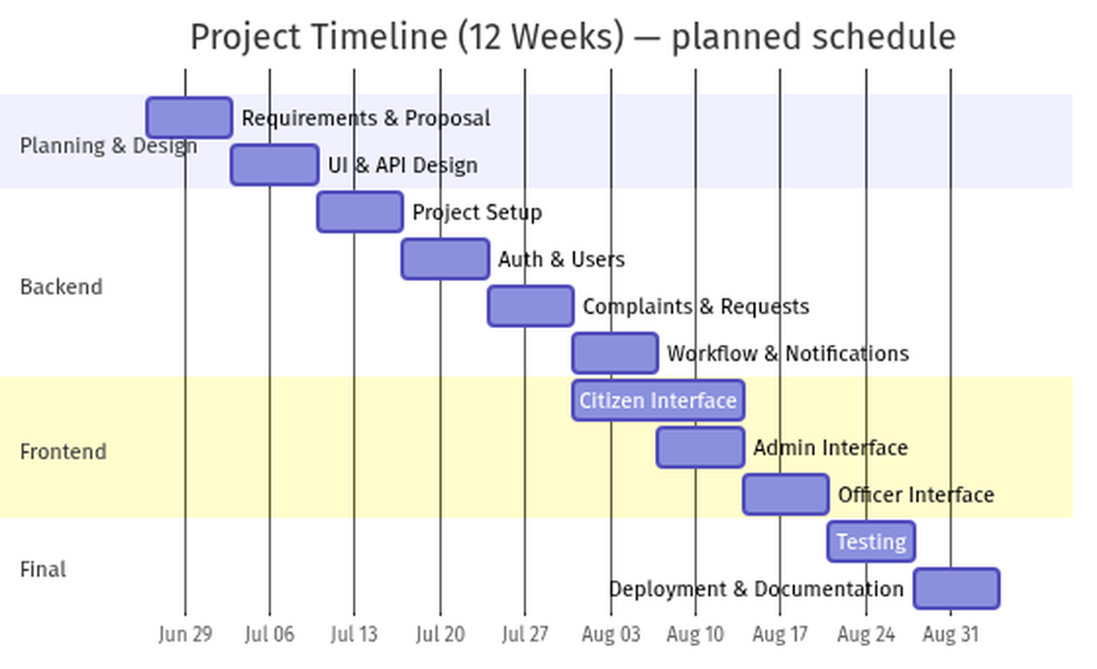
Figure: Project Timeline (Gantt Chart)

3.3 Testing Strategy
Test Type | Scope | Tools / Method
Unit Testing | Models, utilities, validation logic | Manual / planned Jest
API Integration Testing | REST endpoints, auth, RBAC | HTTP client (Postman / Thunder Client)
Frontend Testing | Component rendering, form validation | Manual browser testing
Security Testing | Auth bypass, role escalation, input injection | Manual + API client
User Acceptance Testing (UAT) | End-to-end citizen, admin, officer flows | Test cases with stakeholders

3.3.1 Sample Test Cases
ID | Scenario | Expected Result
TC-01 | Citizen registers with valid data | Account created; can log in
TC-02 | Citizen submits complaint | Record saved as Pending with reference ID; success popup shown
TC-03 | Admin routes complaint to department only | Status stays Pending; appears in department queue
TC-04 | Admin assigns complaint to an officer | Status In Progress; officer sees item
TC-05 | Officer marks complaint resolved | Status Resolved; citizen notified
TC-06 | Officer tries to reject a complaint | Not allowed (admin-only)
TC-07 | Officer tries to access admin routes | Redirected / forbidden
TC-08 | Admin searches complaint by reference ID | Correct record returned

3.4 Deployment Plan

3.4.1 Environment Setup
Environment | Purpose
Development | Local machine (localhost)
Staging | Pre-production testing on cloud VPS
Production | Live system for Adama City Administration

3.4.2 Deployment Architecture
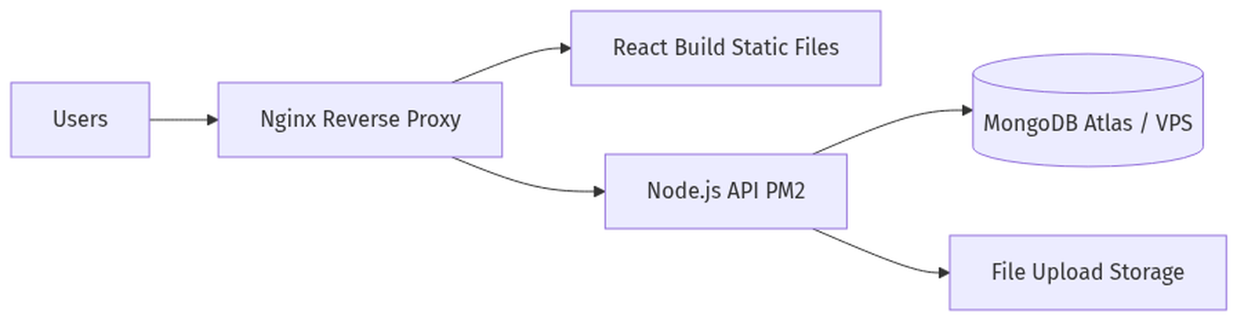
Figure: Deployment Architecture

3.4.3 Deployment Steps
- Configure environment variables (.env): Atlas credentials (MONGODB_USER, MONGODB_PASSWORD, MONGODB_CLUSTER, MONGODB_DB) or MONGODB_URI, plus JWT_SECRET, PORT, CLIENT_ORIGIN
- Build React frontend: npm run build
- Deploy API with PM2 or similar process manager
- Serve frontend static files via Nginx
- Enable HTTPS with SSL certificate (Let's Encrypt)
- Configure daily MongoDB backups
- Seed initial admin account and default departments
- Whitelist production server IP in MongoDB Atlas Network Access

3.4.4 Minimum Server Requirements
- 2 GB RAM, 2 vCPU VPS (or MongoDB Atlas free tier for development)
- Ubuntu 22.04 LTS or similar
- Node.js 18+ LTS

CHAPTER FOUR: RESULTS AND DISCUSSION
This chapter presents the implemented Adama City Citizen Portal and discusses how the results address the problem statement and objectives defined earlier. Screenshots were captured from the working MERN application (React frontend, Express API, MongoDB).

4.1 Results
The system was developed and tested successfully for the three primary roles: Citizen, Department Officer, and Administrator. Core features—registration/login, complaint and service-request submission, tracking, assignment, notifications, reporting, and activity logging—are operational in the development environment.

4.1.1 Public Portal and Authentication
The public landing page introduces the portal, supports multi-language selection (English / Amharic / Afaan Oromo), and guides citizens toward registration or login. Authentication screens provide secure sign-in and account creation with role-aware access.
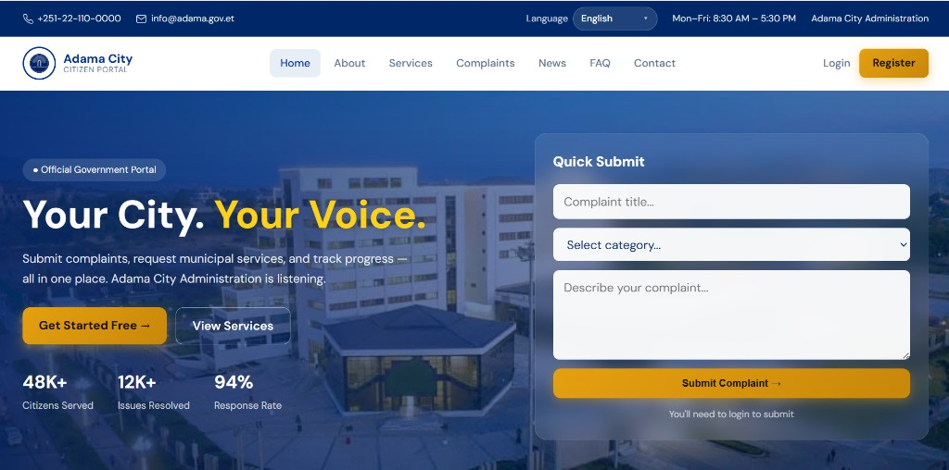
Figure 4.1: Public landing page (guest portal)
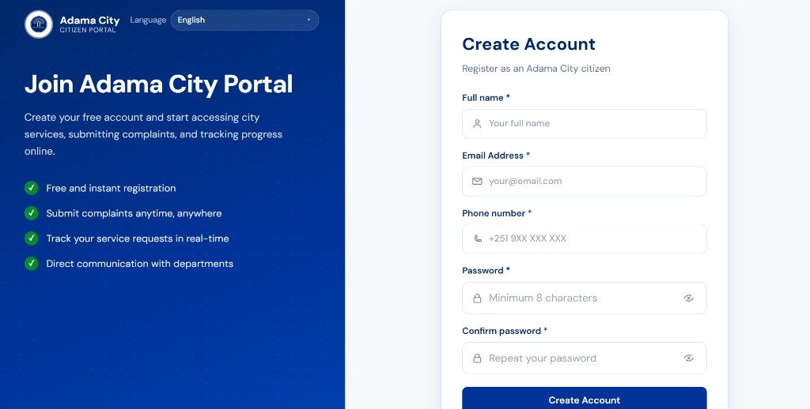
Figure 4.2: Citizen registration (Create Account)
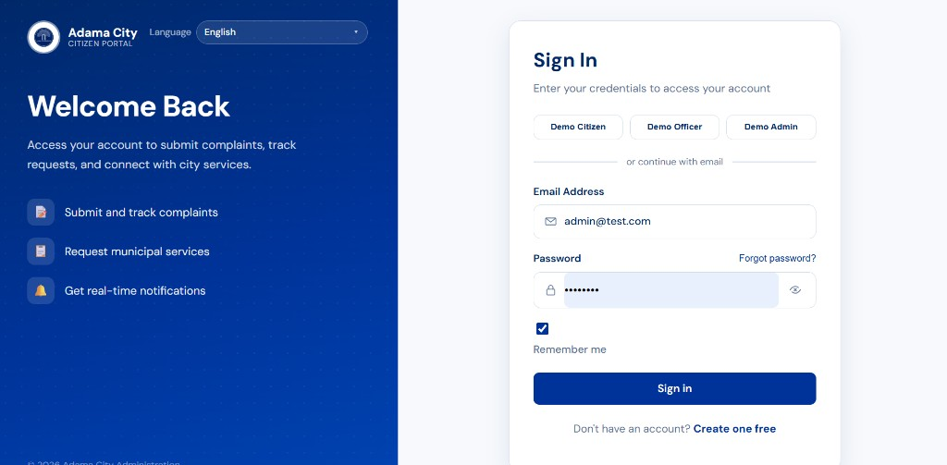
Figure 4.3: Sign-in page with JWT-based authentication

4.1.2 Citizen Modules
After login, citizens access a personalized dashboard showing submission counts by status, then can file complaints or service requests and track them under My Submissions.
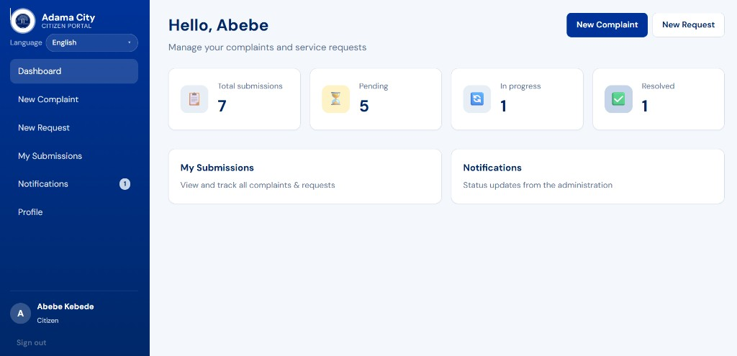
Figure 4.4: Citizen dashboard with submission summary cards
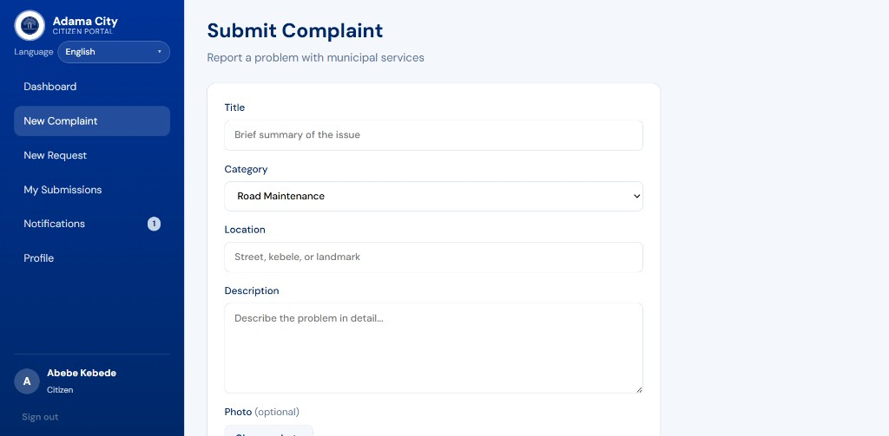
Figure 4.5: Submit Complaint form (category, location, description, optional photo)
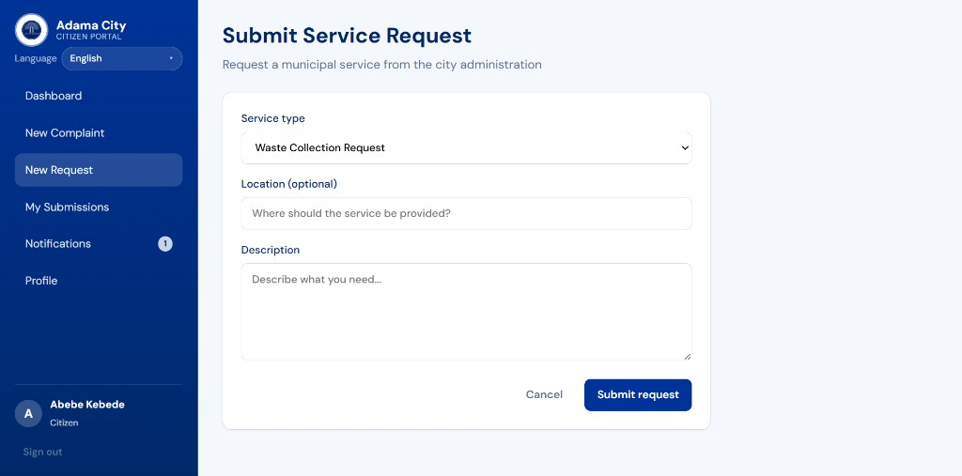
Figure 4.6: Submit Service Request form
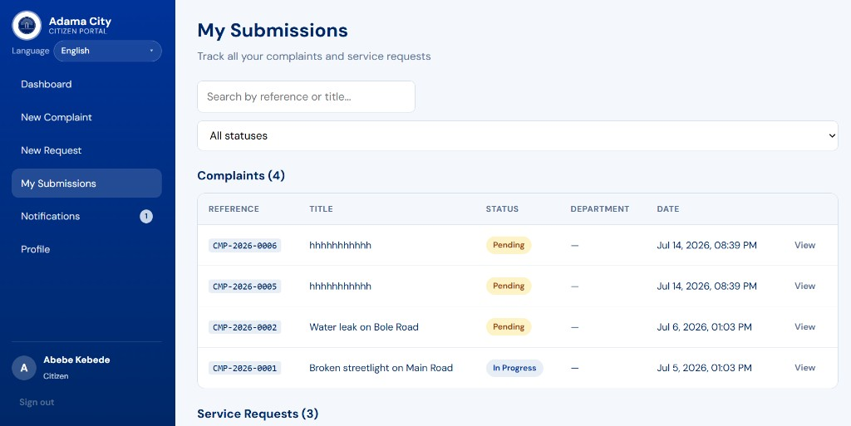
Figure 4.7: My Submissions — complaints and service requests with reference IDs and status badges

4.1.3 Officer Modules
Department officers receive a focused workspace for assigned work and in-app notifications when administrators assign complaints or requests.
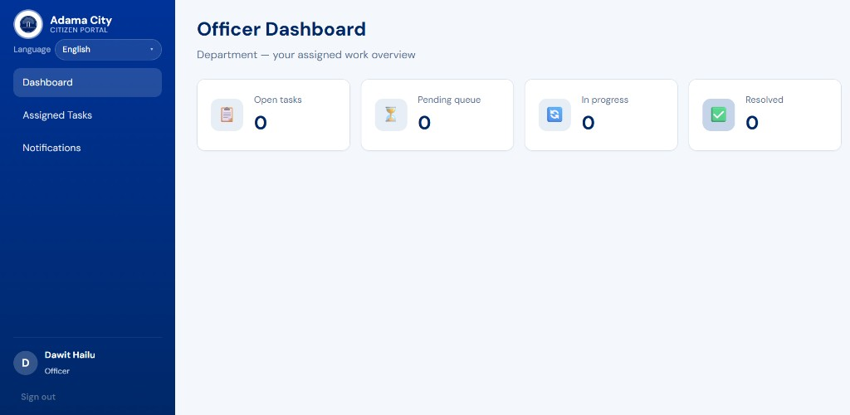
Figure 4.8: Officer dashboard (open / pending / in progress / resolved counters)
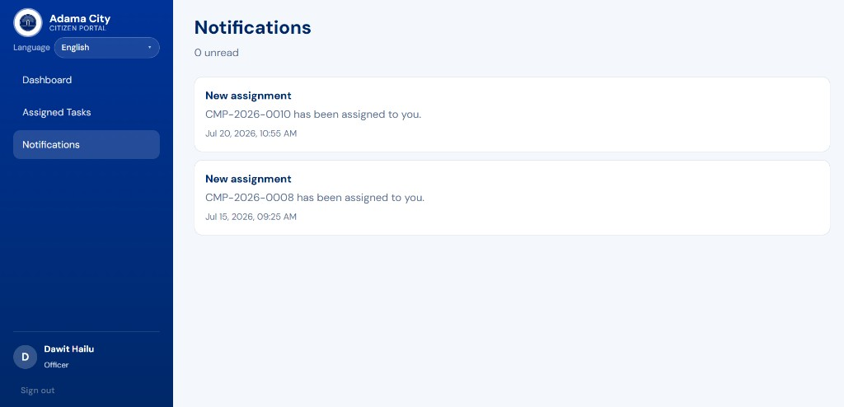
Figure 4.9: Officer notifications for new assignments (e.g., CMP-2026-0010)

4.1.4 Administrator Modules
Administrators oversee city-wide activity: dashboard metrics, complaint and service-request management, user activation, department routing, summary reports, and an audit activity log.
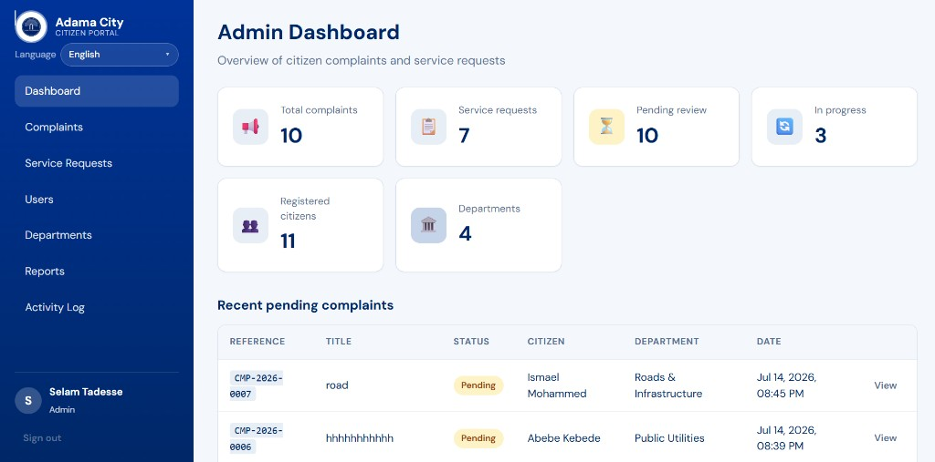
Figure 4.10: Admin dashboard overview (complaints, requests, citizens, departments)
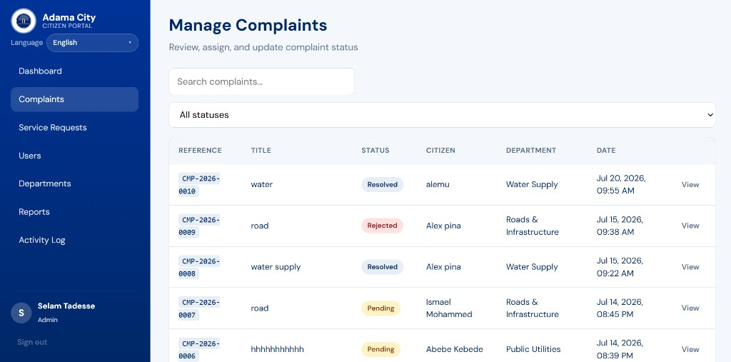
Figure 4.11: Manage Complaints — search, filter, assign, and update status
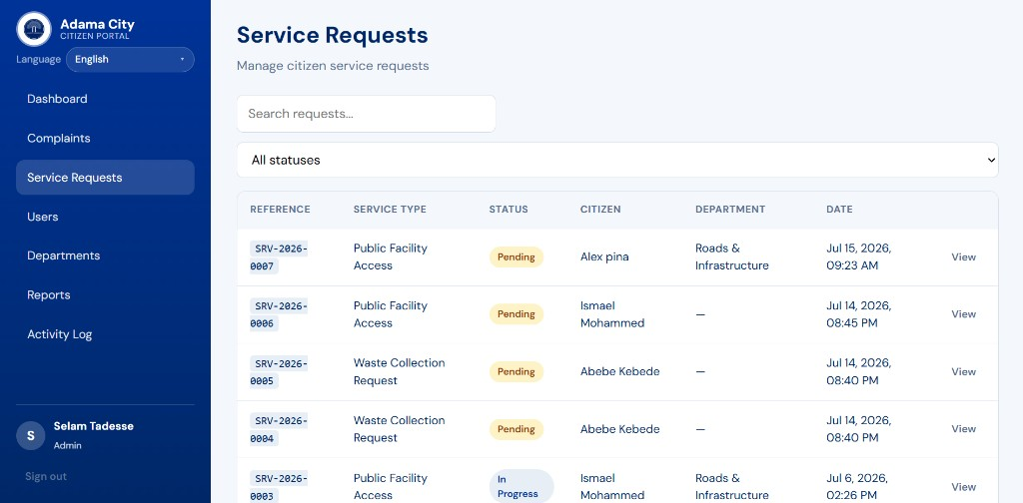
Figure 4.12: Service Requests management list
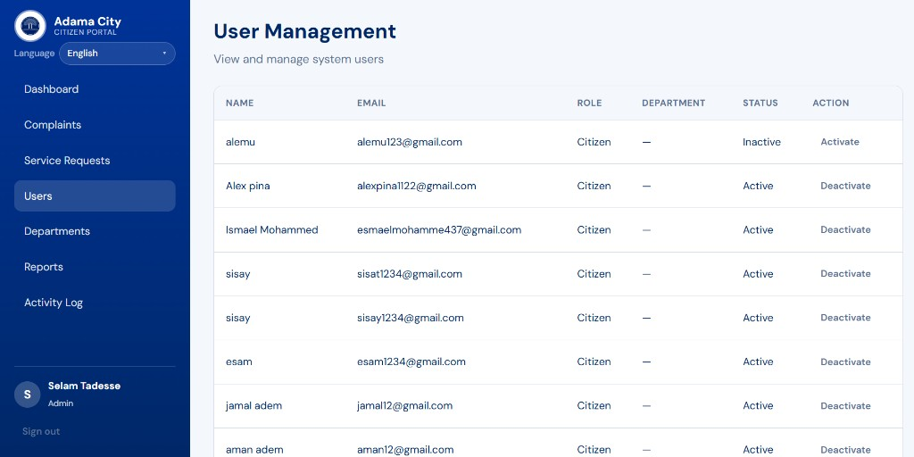
Figure 4.13: User Management — activate / deactivate citizen accounts
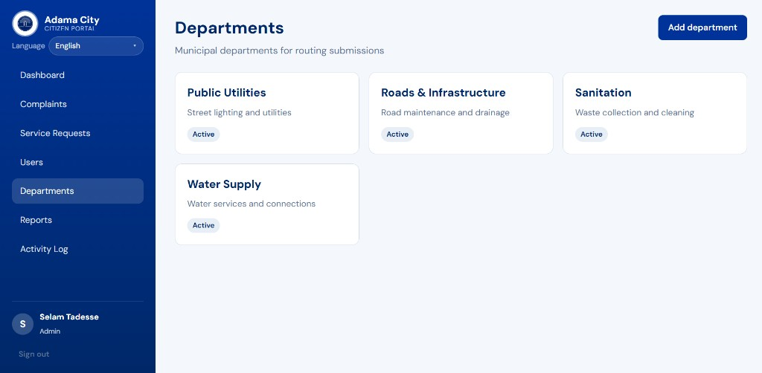
Figure 4.14: Departments used for routing submissions
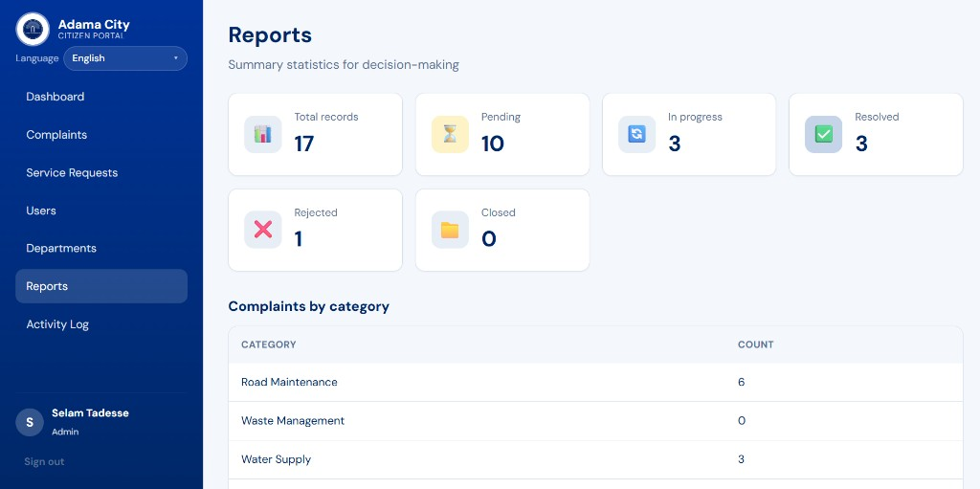
Figure 4.15: Reports — status totals and complaints by category
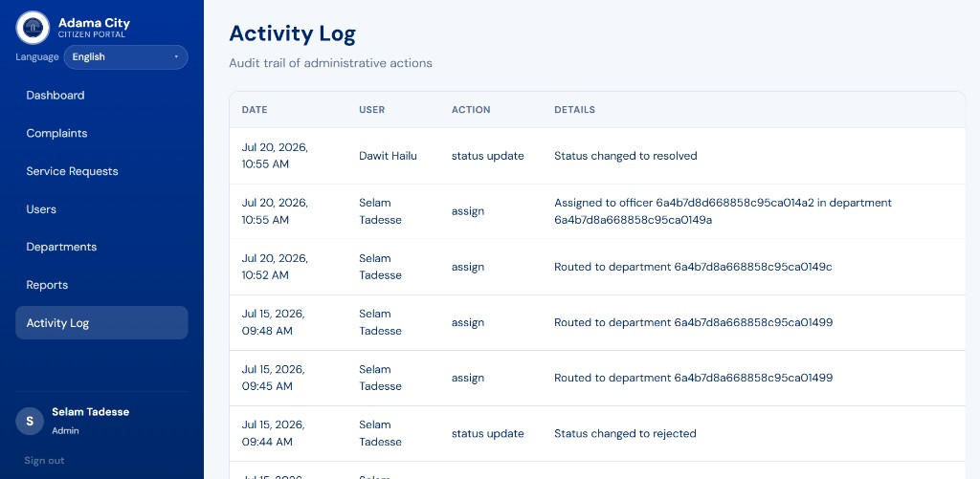
Figure 4.16: Activity Log — audit trail of assignments and status updates

4.2 Discussion
The implemented results demonstrate that a centralized web portal can replace fragmented, paper-based complaint and service-request handling for Adama City Administration.
Alignment with objectives. Citizens can register, submit categorized complaints and service requests, and track progress using unique reference IDs (e.g., CMP-2026-0001, SRV-2026-0007). Administrators can assign work to departments/officers, update statuses, and monitor performance through reports. Officers receive assignment notifications and process department-scoped work. These outcomes match the functional requirements defined in Chapter Two.
Transparency and accountability. Color-coded status badges (Pending, In Progress, Resolved, Rejected) and the activity log provide a visible audit trail. This directly addresses the earlier problems of weak tracking and limited accountability.
Role-based design. Separate dashboards for Citizen, Officer, and Admin enforce RBAC with JWT authentication. Citizens see only their submissions; officers see assigned tasks; admins see city-wide data and user/department controls.
Reporting for decision-making. The Reports module aggregates totals by status and category (e.g., Road Maintenance as a frequent complaint type in the sample data). This supports planning and departmental prioritization.
Remaining gaps. Some pending items remain unassigned until an administrator routes them (empty Department fields). Advanced features such as SMS/email alerts, GIS maps, and production-scale deployment were intentionally out of scope for this phase, as noted in Chapters One and Four. Sample/test titles in development data also indicate the need for continued validation and user training before full rollout.
Overall, the prototype confirms technical feasibility of the MERN-based solution and shows measurable progress toward transparent, trackable municipal service delivery.

4.3 Expected Benefits

4.3.1 For Citizens
- Easy online complaint and request submission
- Faster access to municipal services
- Transparency in service delivery
- Real-time status tracking and notifications

4.3.2 For Adama City Administration
- Improved centralized record management
- Better monitoring and departmental accountability
- Faster response to citizens
- Improved service quality through data-driven decisions
- Reports for planning and resource allocation

4.4 Expected Outcome
The project will deliver a fully functional web-based system for managing citizen complaints and service requests. The system will:
- Connect citizens, administrators, and department officers on one platform
- Provide transparent status tracking with audit history
- Generate reports for monitoring and decision-making
- Serve as a foundation for future enhancements (SMS, mobile app, GIS)

4.5 Future Enhancements
- SMS notifications for status updates
- Email notifications and password reset via email
- Native mobile application (Android / iOS)
- GIS integration for map-based complaint location
- Advanced analytics dashboard with charts, date filters, and export
- Full CRUD for users and departments; submission edit/delete where appropriate
- API pagination, rate limiting, and JWT refresh tokens
- Broader i18n coverage for authenticated dashboards
- Citizen feedback and satisfaction rating after resolution
- SLA tracking and escalation rules
- Integration with existing government systems

CHAPTER FIVE: CONCLUSION
This project designed and implemented a Web-Based Citizen Complaint and Service Request Management System for Adama City Administration to replace fragmented, paper-based processes with a centralized digital portal.
The system meets the stated objectives by enabling citizens to register, submit categorized complaints and service requests, and track status through unique reference numbers; enabling administrators to manage users and departments, assign work, update status, and generate reports; and enabling department officers to process assigned tasks and record resolution notes. JWT authentication and role-based access control protect resources according to user roles, while status history and in-app notifications improve transparency and accountability.
Implementation with the MERN stack demonstrated technical feasibility and practical value for municipal service delivery. Remaining limitations—such as SMS/email alerts, GIS mapping, and advanced analytics—are documented as future enhancements and do not prevent the current system from delivering core complaint and service-request workflows.
In conclusion, the project provides a working foundation for transparent, trackable, and more efficient citizen–administration interaction in Adama City, and it supports further improvement as the host organization adopts and expands the platform.

References
- FixMyStreet. Report, view, or discuss local problems. mySociety. https://www.fixmystreet.com/
- IBM. Entity-Relationship Modeling. Software Engineering best practices.
- MongoDB Inc. MongoDB Documentation. https://www.mongodb.com/docs/
- Express.js. Web framework for Node.js. https://expressjs.com/
- React. A JavaScript library for building user interfaces. https://react.dev/
- OWASP. Authentication Cheat Sheet. https://cheatsheetseries.owasp.org/
- Ethiopian Ministry of Innovation and Technology. Digital Ethiopia 2025 (e-governance context).
- Sommerville, I. Software Engineering (10th ed.). Pearson — requirements and testing methodologies.
- JWT.io. JSON Web Token Introduction. https://jwt.io/introduction
- Adama City Administration. Municipal service delivery context (local organizational reference).

Document Revision History
Version | Date | Changes
1.0 | Initial | Original PDF proposal
2.0 | June 26, 2025 | Added ER diagram, timeline, literature review, methodology, testing, deployment, expanded DB schema, use cases, architecture, limitations, references; merged duplicate sections; clarified complaint vs service request
2.1 | July 28, 2026 | Aligned docs with implemented system: status transition rules, Atlas env, Vite/fetch, photo upload (2 MB), guest i18n, corrected FR/scope/limitations/test cases; removed unimplemented password-reset/Axios claims; updated use case diagram
2.2 | July 28, 2026 | Added Declaration and Acknowledgement sections
2.3 | July 28, 2026 | Expanded Table of Contents to include all subtopics
2.4 | July 28, 2026 | Added List of Acronyms
2.5 | July 28, 2026 | Added page numbers: Roman numerals for preface, Arabic for main body
2.6 | July 28, 2026 | Added Haramaya University cover page; personal details left blank for completion
2.7 | July 28, 2026 | Reorganized body into CHAPTER ONE–SIX with hierarchical section numbering
2.8 | July 28, 2026 | Added CHAPTER SIX: Results and Discussion with implementation screenshots; renumbered benefits to CHAPTER SEVEN
2.9 | July 28, 2026 | Condensed document into four chapters (Introduction; Requirements and Design; Methodology; Results and Discussion)
2.10 | July 28, 2026 | Aligned Table of Contents to academic style (dot leaders, hierarchy indent, Roman/Arabic page markers)
2.11 | July 29, 2026 | Added Abstract (Executive Summary); updated cover host-company / Practical Attachment wording; department name to Information Science
2.12 | July 29, 2026 | Added CHAPTER FIVE: Conclusion; updated Table of Contents

End of Proposal

