MIS 308 Data Science Project Report
Customer Churn Prediction using Telco Customer Churn Dataset
Team Members: Esma Eren - Student ID: [Add Student ID]
Course: MIS 308 Data Science
Submission Deadline: 24 May 2026

1. Project Title
Customer Churn Prediction using Telco Customer Churn Dataset

2. Introduction
Customer churn is an important business problem for subscription-based companies. Predicting churn allows companies to identify customers who are likely to leave and take preventive actions such as personalized offers, loyalty programs, contract upgrades, or customer support improvements. The aim of this project is to analyze customer data and develop machine learning classification models to predict whether a customer is likely to leave the service.

3. Datasets Used
The dataset used in this project is the Telco Customer Churn dataset. It contains customer demographic information, account details, subscribed services, payment information, and churn status. The original dataset includes 7043 rows and 21 columns. After converting TotalCharges to numeric format and removing 11 rows with missing TotalCharges values, the cleaned dataset was used for model development.

4. Data Preprocessing
The customerID column was removed because it does not provide predictive information. The TotalCharges column was converted from object type to numeric type. Missing values in TotalCharges were handled by removing the related rows. The target variable Churn was encoded as 0 and 1. Categorical variables were transformed using one-hot encoding, and numerical variables were scaled using standardization. Two additional features were created: AvgChargesPerTenure and TenureGroup.

Dataset Variables
Variable | Description
customerID | Unique customer ID, removed before modeling
gender | Customer gender
SeniorCitizen | Whether customer is senior citizen
Partner | Whether customer has a partner
Dependents | Whether customer has dependents
tenure | Number of months customer stayed
Contract | Contract type
PaymentMethod | Payment method
MonthlyCharges | Monthly charge amount
TotalCharges | Total charge amount
Churn | Target variable: whether customer left

5. Exploratory Data Analysis
The EDA section examines the churn distribution and relationships between churn and important customer attributes such as contract type, payment method, tenure, and monthly charges.

Churn Distribution
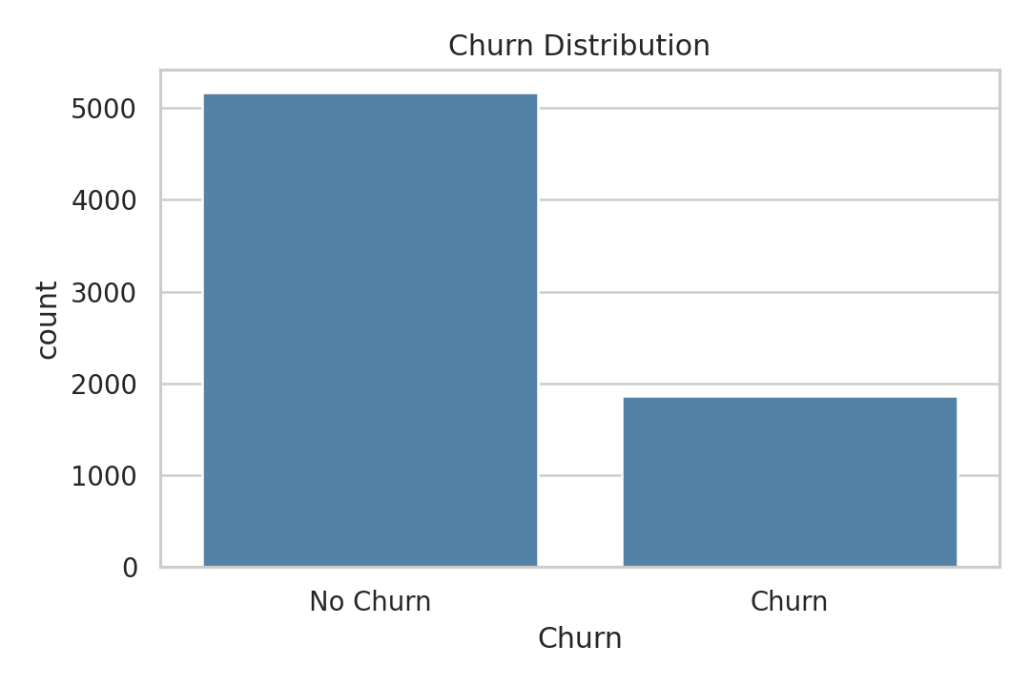
The dataset is imbalanced because the number of non-churn customers is higher than churn customers. Therefore, precision, recall, F1-score, and ROC-AUC should be considered in addition to accuracy.

Churn by Contract Type
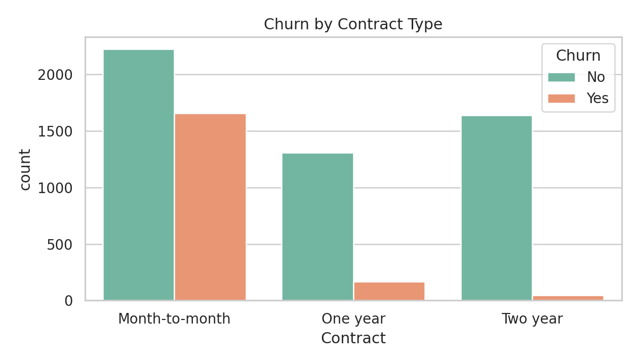
Month-to-month contract customers show a higher churn tendency compared to customers with one-year or two-year contracts.

Churn by Payment Method
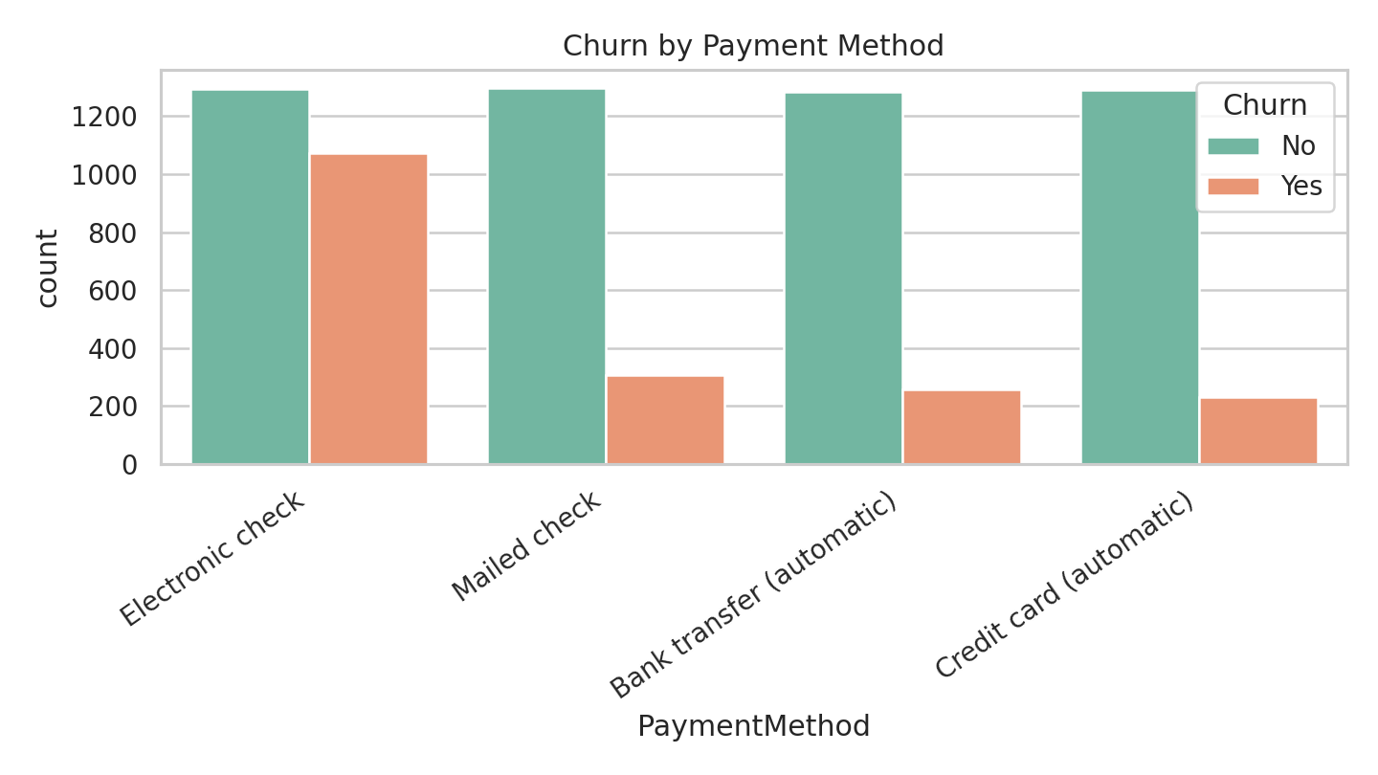
Customers using electronic check payment method appear to have a higher churn tendency.

Tenure Distribution by Churn
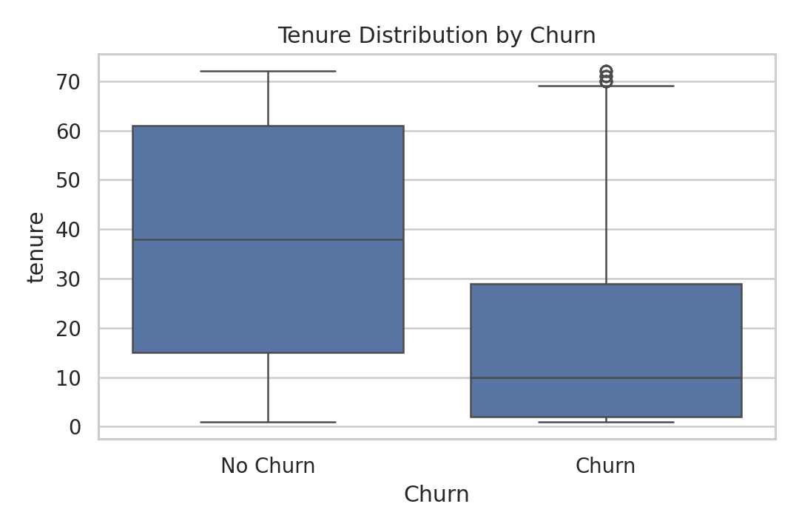
Customers with lower tenure are more likely to churn. Long-term customers seem more loyal.

Monthly Charges by Churn
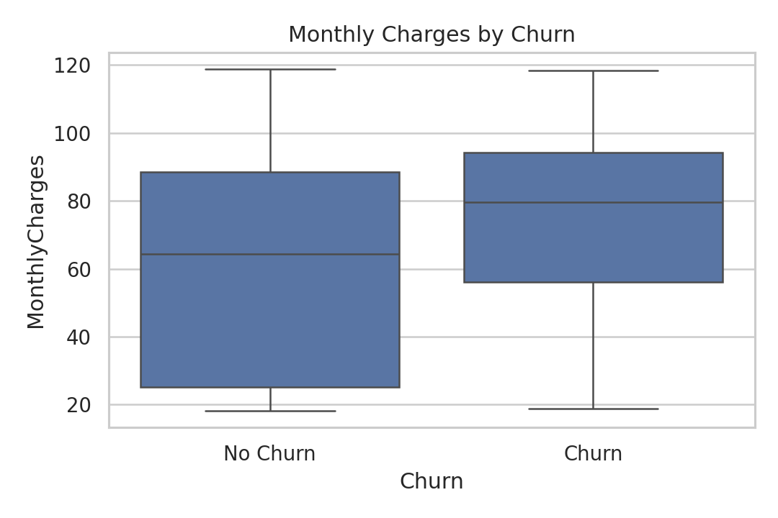
Customers who churn tend to have relatively higher monthly charges.

6. Developed Data Science Algorithms
The following machine learning classification algorithms were implemented and compared:
Algorithm | Description
Logistic Regression | A baseline and interpretable classification model.
Decision Tree Classifier | A rule-based model that splits customers based on feature values.
Random Forest Classifier | An ensemble model that combines multiple decision trees to improve generalization.
K-Nearest Neighbors Classifier | A distance-based classification algorithm that assigns labels based on neighboring observations.

7. Success Metrics
The models were evaluated using accuracy, precision, recall, F1-score, ROC-AUC, and confusion matrix. Since churn prediction is a business-oriented classification problem, F1-score and recall are especially important because the company wants to identify customers who are likely to leave.
Metric | Explanation
Accuracy | Overall correct prediction ratio.
Precision | Among customers predicted as churn, the percentage that actually churned.
Recall | Among actual churn customers, the percentage correctly detected.
F1-score | Balance between precision and recall.
ROC-AUC | Ability of the model to separate churn and non-churn classes.
Confusion Matrix | Detailed view of correct and incorrect predictions.

8. Results
Model | Accuracy | Precision | Recall | F1 Score | ROC-AUC
Random Forest | 0.758 | 0.530 | 0.778 | 0.631 | 0.836
Logistic Regression | 0.730 | 0.495 | 0.789 | 0.608 | 0.837
Decision Tree | 0.711 | 0.475 | 0.802 | 0.596 | 0.811
KNN | 0.792 | 0.615 | 0.578 | 0.596 | 0.819
The best model in this run was selected as Random Forest based on F1-score and ROC-AUC. The final model was evaluated using a confusion matrix and ROC curve.

Confusion Matrix and ROC Curve
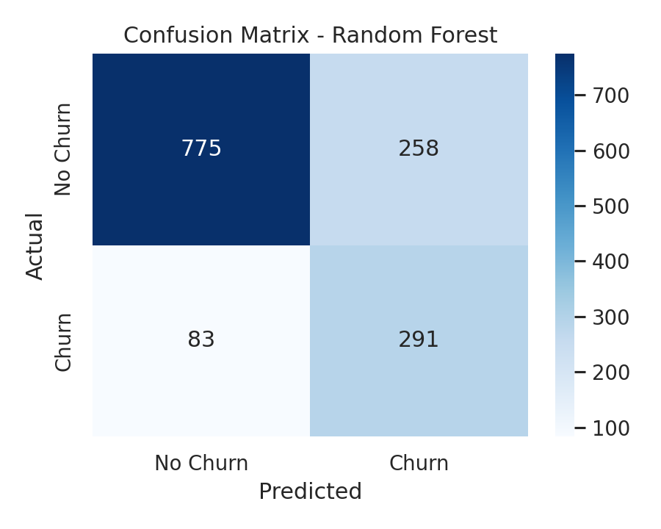
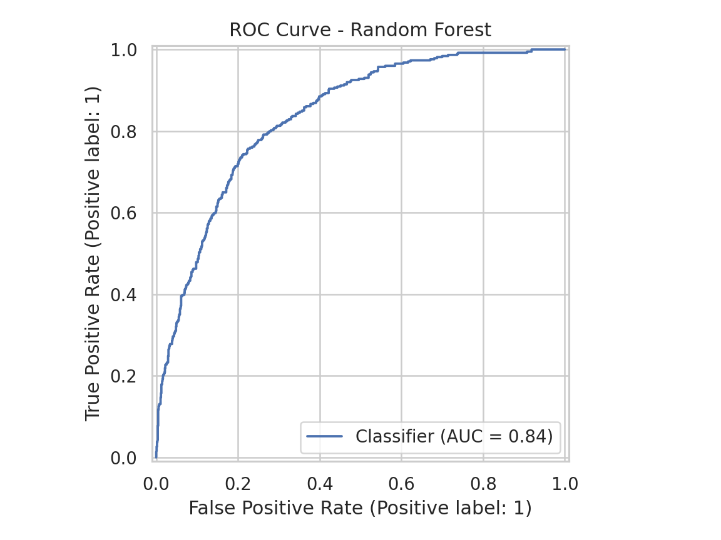

9. Business Insights
- Short-term customers have higher churn risk.
- Month-to-month contract customers are more likely to churn.
- Electronic check payment method is associated with higher churn tendency.
- Higher monthly charges may increase churn probability.
- The company can use churn predictions to target high-risk customers with retention campaigns.

10. Conclusion
This project developed and compared multiple classification models to predict customer churn. The results showed that machine learning models can be used to identify customers with high churn risk. The analysis also showed that contract type, tenure, monthly charges, and payment method are important factors related to customer churn. The project can be further improved by hyperparameter tuning, cross-validation, and deploying the best model with a Streamlit or Gradio user interface.

11. Project Links
GitHub Repository Link: [Add your GitHub link]
Kaggle Notebook Link: [Add your Kaggle link]
Streamlit/Gradio Application Link: [Optional - Add your UI link]

