Software Design Document (SDD)
Cover
Field | Value
Project | Department Course Timetable Management System
Document | Software Design Document
Version | v1
Related SRS version | v1
Date | 05.11.2026
Team number | [Team XX]
Member 1 | Esma Çalış · esmaesss - https://github.com/esmaesss
Member 2 | Çağatay Temel · Cagatackle - https://github.com/Cagatackle
Repository | https://github.com/esmaesss/SENG-271
Revision History
Version | Date | Author(s) | Summary of changes
v1 | 05.11.2026 | Esma Çalış, Çağatay Temel | Initial class diagram and scheduling flowchart
v2
Final

1. Introduction
This document describes how the Department Course Timetable Management System is organized: its classes, the data structures behind them, the automatic scheduling algorithm, the conflict handling and the console user interface. It is based on SRS v1 and uses the requirement IDs (FR-xx), hard constraints (HC-xx) and soft constraints (SC-xx) defined there.

2. System Overview
The program is divided into five parts. The classes of the scheduling part do not read files or print text, and the classes of the user interface part do not contain scheduling rules; this keeps each class small and testable.
Part | Classes | Responsibility
User interface (menu and screens) | Main, ConsoleMenu | Starts the program, shows the main menu (Screen 1), reads the coordinator’s input, validates menu choices and calls the other parts.
Input (reading and validating files) | DataLoader, DataStore | DataLoader reads and validates the four input files and reports problems as warnings; DataStore holds all loaded courses, instructors, rooms and special requests and creates the sessions.
Domain model (courses, instructors, rooms, sessions, time slots) | Course, Instructor, Room, Session, TimeSlot, Assignment, SpecialRequest, Timetable, and the enumerations RoomType, SessionType, ProblemType, RequestType, Priority | Represent the real-world objects and answer simple questions about themselves (availability, suitability, overlap). Timetable stores the assignments.
Scheduling (algorithm and constraint checks) | Scheduler, ConstraintChecker, Violation, SchedulingProblem, SchedulingReport, TimetableEditor | Scheduler runs the automatic algorithm; ConstraintChecker contains every hard and soft constraint check; Violation, SchedulingProblem and SchedulingReport carry the results; TimetableEditor performs manual changes with the same checks.
Output (timetables, reports, email draft) | TimetablePrinter, EmailDraftGenerator | Format and print the timetable grid, session lists, unscheduled sessions and warnings; save them to files; generate and save the classroom request email.

3. UML Class Diagram
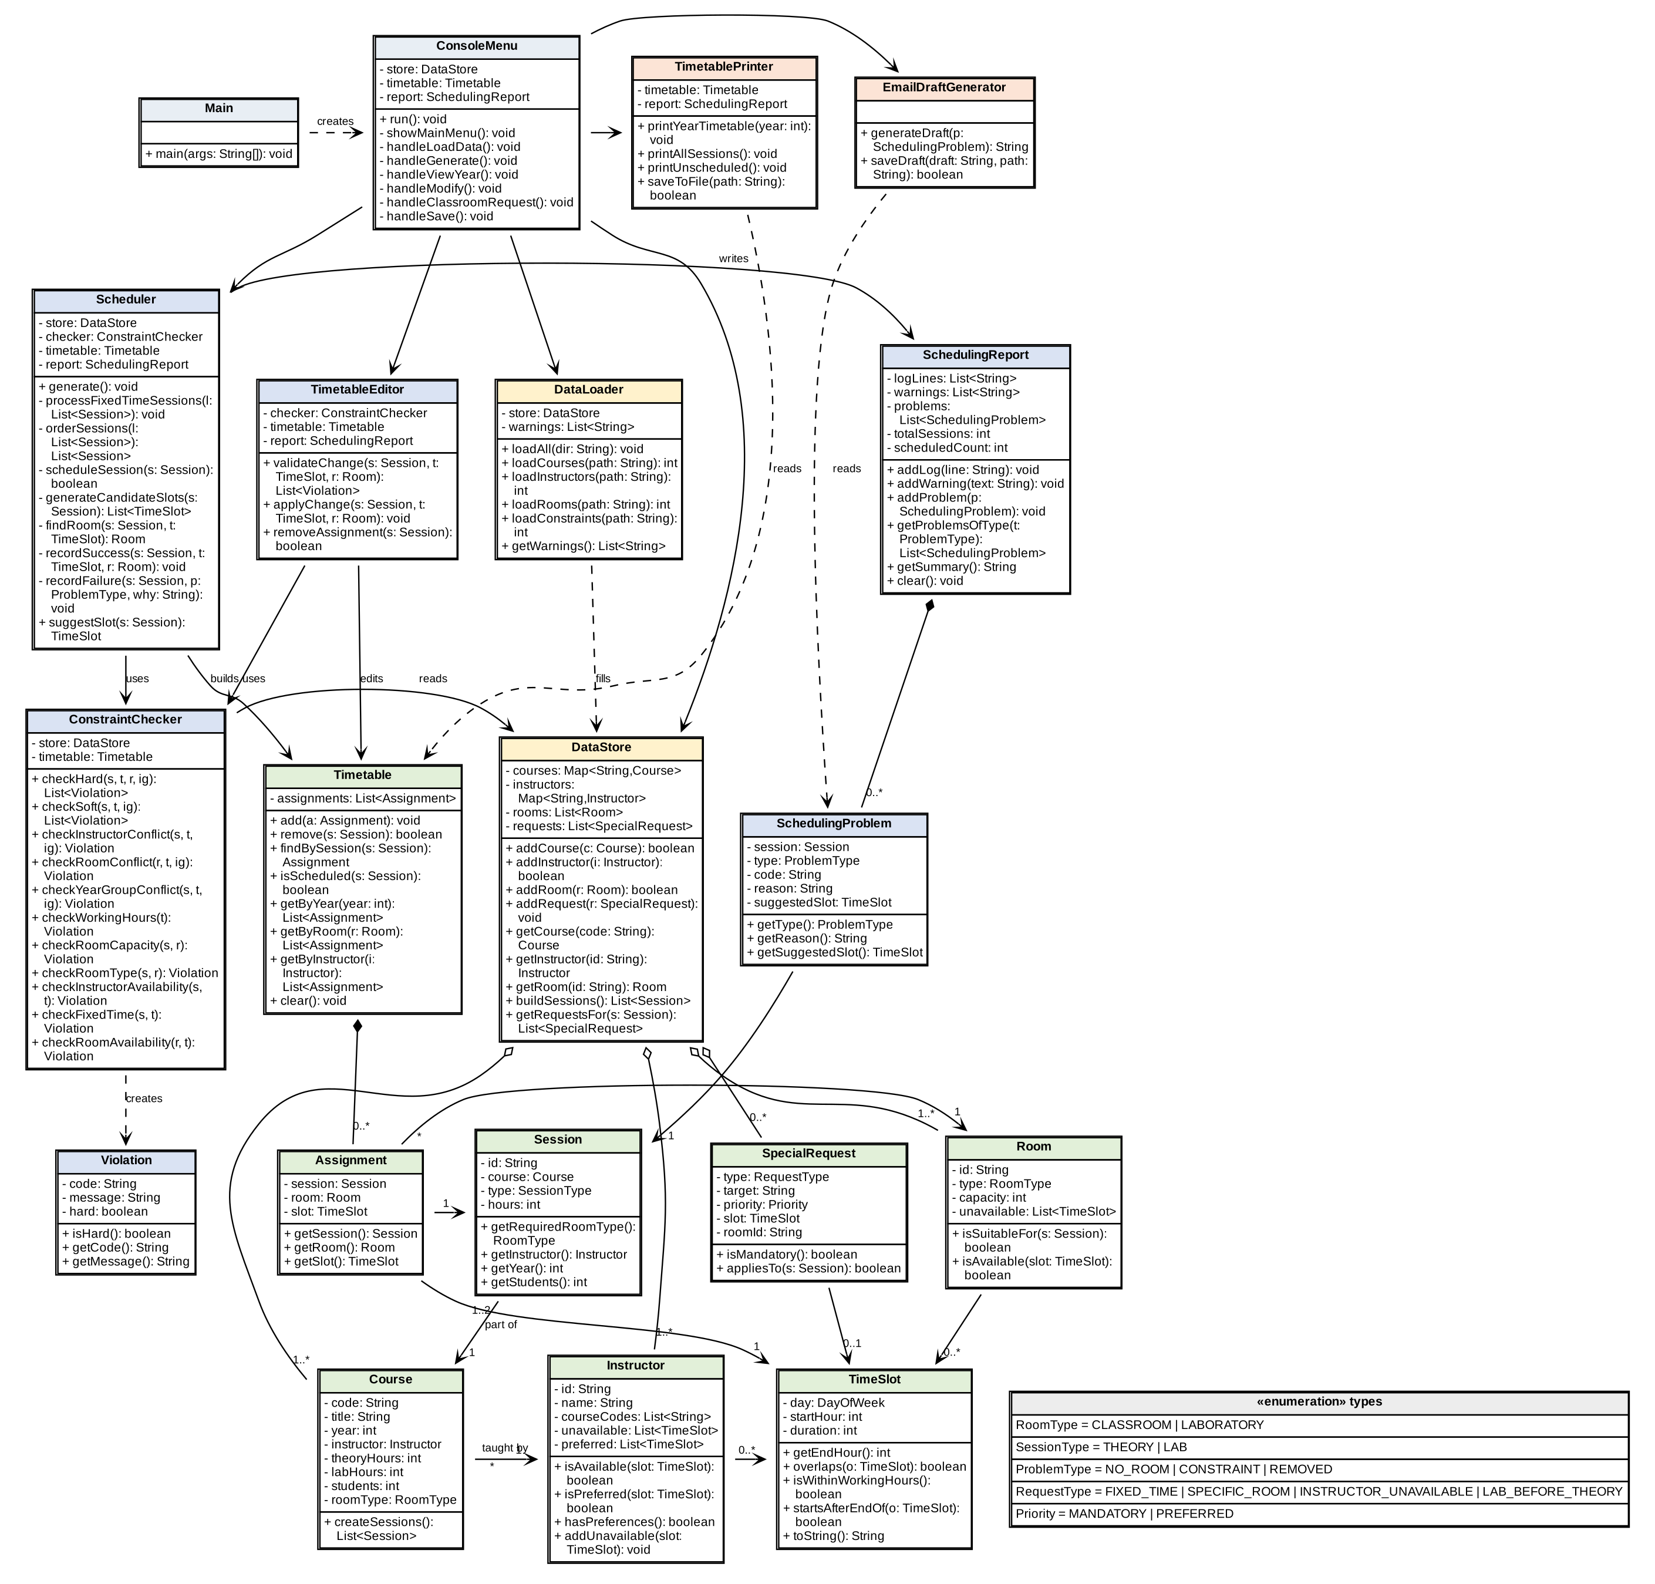
Tool used: Graphviz (DOT) · Source file: docs/design/class_diagram.dot (high-resolution image: docs/design/class_diagram.png). Colors: yellow = input, green = domain model, blue = scheduling, orange = output. Trivial getters and setters are not shown. A filled diamond is composition, an empty diamond is aggregation, a dashed arrow is a dependency; the class that runs the scheduling algorithm is Scheduler.

Checklist for the class diagram (to be re-checked against the Java code of every version):
☑ Every main class is shown, named exactly as in the Java code
☑ Important attributes have a type and visibility, e.g. - capacity: int
☑ Main methods have parameters and a return type, e.g. + isAvailable(slot: TimeSlot): boolean (the ConstraintChecker methods use short parameter names: s = Session, t = TimeSlot, r = Room, ig = session to ignore)
☑ Relationships between classes are drawn, with multiplicities
☑ The class that runs the scheduling algorithm is identifiable (Scheduler)
☑ The diagram is readable when printed on one A4 page

4. Class Descriptions
Class | Responsibility (one sentence) | Key attributes | Key methods | Related classes
Main | Entry point; creates the ConsoleMenu and starts it. | – | main(args) | ConsoleMenu
ConsoleMenu | Shows the main menu, reads and validates the user’s input and calls the other classes for each option. | store, timetable, report | run, showMainMenu, handleLoadData, handleGenerate, handleViewYear, handleModify, handleClassroomRequest, handleSave | DataLoader, DataStore, Scheduler, TimetableEditor, TimetablePrinter, EmailDraftGenerator
DataLoader | Reads the four input files, validates every record and collects warnings with file name and line number. | store, warnings | loadAll, loadCourses, loadInstructors, loadRooms, loadConstraints, getWarnings | DataStore
DataStore | Holds all loaded data, refuses duplicate identifiers, looks up objects by id and creates the sessions of all courses. | courses, instructors, rooms, requests | addCourse, addInstructor, addRoom, addRequest, getCourse, getInstructor, getRoom, buildSessions, getRequestsFor | Course, Instructor, Room, SpecialRequest, Session
Course | Stores one course and splits it into its theory and laboratory sessions. | code, title, year, instructor, theoryHours, labHours, students, roomType | createSessions | Instructor, Session
Instructor | Stores one instructor and answers whether he or she is available or prefers a time slot. | id, name, courseCodes, unavailable, preferred | isAvailable(slot), isPreferred(slot), hasPreferences, addUnavailable(slot) | TimeSlot, Course
Room | Stores one classroom or laboratory and answers whether it can host a given session. | id, type, capacity, unavailable | isSuitableFor(session), isAvailable(slot) | Session, TimeSlot, Assignment
Session | Represents one teaching block (e.g. SENG201-L) that has to be scheduled. | id, course, type, hours | getRequiredRoomType, getInstructor, getYear, getStudents | Course, Assignment, SchedulingProblem
TimeSlot | Represents a period on one day (day, start hour, duration) and compares periods. | day, startHour, duration | getEndHour, overlaps(other), isWithinWorkingHours, startsAfterEndOf(other), toString | Instructor, Room, Assignment, SpecialRequest
Assignment | Connects a session with its room and time slot. | session, room, slot | getSession, getRoom, getSlot | Session, Room, TimeSlot, Timetable
SpecialRequest | Stores one request from constraints.txt, with its priority. | type, target, priority, slot, roomId | isMandatory, appliesTo(session) | DataStore, TimeSlot
Timetable | Stores all assignments and answers questions about them (by session, year group, room, instructor). | assignments | add, remove, findBySession, isScheduled, getByYear, getByRoom, getByInstructor, clear | Assignment, Scheduler, ConstraintChecker
Scheduler | Runs the automatic scheduling algorithm: orders sessions, searches slots and rooms, records successes and failures. | store, checker, timetable, report | generate, processFixedTimeSessions, orderSessions, scheduleSession, generateCandidateSlots, findRoom, recordSuccess, recordFailure, suggestSlot | DataStore, ConstraintChecker, Timetable, SchedulingReport
ConstraintChecker | Contains all hard-constraint (HC-01 to HC-09, MR-01) and soft-constraint (SC-01 to SC-03) checks. Used by the Scheduler and by the TimetableEditor. | store, timetable | checkHard, checkSoft, checkInstructorConflict, checkRoomConflict, checkYearGroupConflict, checkWorkingHours, checkRoomCapacity, checkRoomType, checkInstructorAvailability, checkFixedTime, checkRoomAvailability | DataStore, Timetable, Violation
Violation | Describes one broken constraint (code, message, hard or soft). | code, message, hard | isHard, getCode, getMessage | ConstraintChecker
SchedulingProblem | Describes one unscheduled session: problem type, constraint code, reason and suggested slot. | session, type, code, reason, suggestedSlot | getType, getReason, getSuggestedSlot | Session, SchedulingReport, EmailDraftGenerator
SchedulingReport | Collects the log lines, warnings and unscheduled sessions of one generation run and gives the summary. | logLines, warnings, problems, totalSessions, scheduledCount | addLog, addWarning, addProblem, getProblemsOfType, getSummary, clear | SchedulingProblem, Scheduler, TimetablePrinter
TimetableEditor | Performs manual changes and removals; validates every change with the ConstraintChecker before it is applied. | checker, timetable, report | validateChange, applyChange, removeAssignment | ConstraintChecker, Timetable, SchedulingReport
TimetablePrinter | Prints the year timetables (grid), the session list, the unscheduled sessions and warnings, and saves them to files. | timetable, report | printYearTimetable, printAllSessions, printUnscheduled, saveToFile | Timetable, SchedulingReport
EmailDraftGenerator | Builds the classroom request email text for a NO ROOM problem and saves it to a file. | – | generateDraft, saveDraft | SchedulingProblem
Enumerations | Fixed value sets: RoomType (CLASSROOM, LABORATORY), SessionType (THEORY, LAB), ProblemType (NO_ROOM, CONSTRAINT, REMOVED), RequestType (FIXED_TIME, SPECIFIC_ROOM, INSTRUCTOR_UNAVAILABLE, LAB_BEFORE_THEORY), Priority (MANDATORY, PREFERRED). | – | – | Room, Course, Session, SchedulingProblem, SpecialRequest

5. Design Decisions
Question | Our decision | Why
How is a course split into sessions (theory and laboratory blocks)? | Course.createSessions() creates at most two Session objects: one theory block (id = code + "-T", hours = theoryHours) and one laboratory block (id = code + "-L", hours = labHours). A block is created only if its hours are greater than 0. A block is one indivisible unit. | SRS §3.3 requires every block to be scheduled completely in consecutive slots. Treating a block as one object makes the slot search simple and lets theory and laboratory be scheduled separately (needed for SC-01).
How is a time slot represented (day, start hour, length)? | TimeSlot has a day (java.time.DayOfWeek, MONDAY–FRIDAY), a startHour (9–16) and a duration in hours. Two slots overlap if they are on the same day and a.start < b.end and b.start < a.end. The slot is not changed after creation. | One small class is used for assignments, unavailability, preferences and requests, so all comparisons use the same overlaps() method. Whole hours match the one-hour scheduling unit.
How is the timetable stored (per year group, per room, per instructor)? | Timetable keeps one ArrayList<Assignment>. getByYear, getByRoom and getByInstructor filter this list. | There is only one place to change, so year, room and instructor views can never become inconsistent after a manual modification. The data is small (about 10–100 sessions), so scanning is fast enough.
How are instructor and room availability stored? | Instructor and Room each have a List<TimeSlot> unavailable and isAvailable(slot) returns false if the slot overlaps any entry. "Available only on days X" and mandatory instructor-unavailable requests are converted to unavailable slots when the file is read. Preferred times are a List<TimeSlot> preferred in Instructor. | One mechanism for all kinds of unavailability keeps HC-07 and HC-09 to a single check each.
How are special requests represented and marked as mandatory or preferred? | SpecialRequest has a RequestType, a target (session id or course code), a Priority enum (MANDATORY or PREFERRED), an optional TimeSlot and an optional room id. DataStore.getRequestsFor(session) returns the requests of a session. | The priority is a property of the request, so the same class and the same loading code serve all four request types. Scheduler and ConstraintChecker only ask isMandatory().
How are hard constraints checked (one method per constraint, one checker class, …)? | One class, ConstraintChecker, has one method per constraint (checkInstructorConflict … checkRoomAvailability), each returning a Violation or null. checkHard() calls all of them and returns the list of violations. Scheduler and TimetableEditor both call checkHard(). | One method per constraint gives clear error messages and an easy mapping HC-xx → method (Section 6.4). Sharing the class guarantees that manual changes use the same checks as automatic scheduling (SRS §3.9).
How are input errors detected and reported? | DataLoader parses every line inside a try/catch (NumberFormatException, missing fields, unknown ids). A bad record is skipped and a warning "file, line N: reason -> action" is added to a list. A missing file is detected before reading (Files.exists / IOException) and reported as an error. No exception reaches ConsoleMenu. | SRS NFR-01: the program must never crash on input errors, and the coordinator needs the line number to fix the file.
Which collections (arrays, ArrayList, HashMap, …) are used, and for what? | ArrayList: rooms, requests, assignments, sessions, warnings, violations, unavailable/preferred slots (ordered, iterated). LinkedHashMap<String, Course> and <String, Instructor>: lookup by id in file order. String[] from String.split(): fields of an input line. String[][] (8 rows × 5 columns): the grid of the year timetable in TimetablePrinter. HashMap<String,Integer>: counting rejection reasons in Scheduler. | Simple collections from the introductory course are enough; maps give fast lookup by id; a 2D array matches the shape of the printed grid.

6. Automatic Scheduling Algorithm

6.1 Strategy
The algorithm is a simple rule-based, first-fit algorithm without backtracking. It is implemented in the class Scheduler.
Question | Answer
In what order are sessions processed? | First all fixed-time sessions (mandatory FIXED_TIME requests), because their time cannot move. Then all other sessions ordered by (1) expected number of students, largest first, because large classes have the fewest suitable rooms; (2) course code; (3) theory block before laboratory block, so that the theory block of a course is placed before its laboratory block (SC-01). The order is fixed, so the result is repeatable.
How are candidate time slots selected? | For a session of h hours the candidates are all start hours from 09:00 to 17:00 − h on Monday to Friday, in day order and hour order. A preferred fixed-time request puts its slot first. The list is then split in two parts: slots that satisfy the soft constraints SC-01 to SC-03 come first, all other slots follow. Hard constraints are not used to filter the list, so that every rejection can be counted and explained.
How are suitable rooms selected? | For a slot, the rooms with the required type and with capacity ≥ number of students are collected and sorted by capacity, smallest first (best fit; large rooms stay free for large classes). A mandatory room request reduces the list to that one room; a preferred room request puts it first. The first room that is free and available is used.
How are scheduling constraints checked? | For every candidate slot the slot constraints are checked first: HC-04, HC-08, HC-07, HC-01, HC-03. For every candidate room the room constraints follow: HC-05, HC-06, MR-01, HC-09, HC-02. All checks are methods of ConstraintChecker; an assignment is recorded only when the list of hard violations is empty. Soft constraints (checkSoft) are evaluated for the chosen slot and produce warnings.
How are conflicts handled, and which alternatives are tried in what order? | If a slot constraint fails, the next candidate slot is tried. If no room is valid in a slot, the next slot is tried. Inside a slot, if a room fails, the next room is tried. The order is: all rooms of one slot, then the next slot; slots that satisfy the soft constraints before the others. Already scheduled sessions are never moved.
When does the algorithm decide that a session cannot be assigned? | (a) Immediately, if no room of the store has the required type and capacity (NO ROOM, HC-05/HC-06). (b) When all candidate slots have been tried without success. The problem is NO ROOM if at least one slot passed all slot constraints but every suitable room was busy or unavailable; otherwise it is CONSTRAINT and the most frequent violated constraint is the reason. (c) For a fixed-time session, if its fixed slot fails with every room.

6.2 Flowchart
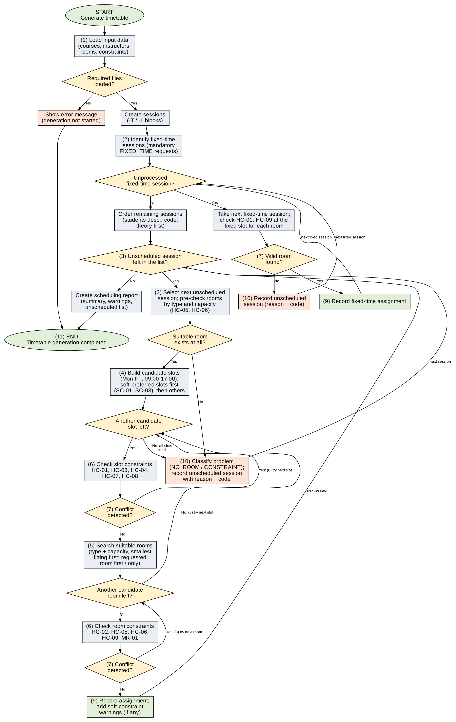
Tool used: Graphviz (DOT) · Source file: docs/design/flowchart.dot. Oval = start/end, rectangle = process, diamond = decision. The numbers (1)–(11) refer to the checklist below.

Elements of the flowchart:
☑ 1. Loading input data
☑ 2. Identifying fixed-time sessions
☑ 3. Selecting an unscheduled session
☑ 4. Searching for an available time slot
☑ 5. Searching for a suitable room
☑ 6. Checking scheduling constraints
☑ 7. Detecting conflicts
☑ 8. Trying alternatives
☑ 9. Recording successful assignments
☑ 10. Reporting unscheduled sessions
☑ 11. Completing the timetable generation process

6.3 Pseudocode (optional)
generate():
report.clear(); timetable.clear()
sessions = store.buildSessions()
fixed = sessions that have a mandatory FIXED_TIME request
FOR EACH s IN fixed:
slot = requested slot of s
room = findRoom(s, slot) // checks HC-01..HC-09, MR-01
IF room != null THEN recordSuccess(s, slot, room)
ELSE recordFailure(s, type, reason) // NO_ROOM or CONSTRAINT
FOR EACH s IN orderSessions(sessions - fixed):
scheduleSession(s)

scheduleSession(s):
IF no room has type == s.requiredType AND capacity >= s.students THEN
recordFailure(s, NO_ROOM, "HC-05/HC-06"); RETURN false
roomBlocked = false; counts = empty map
FOR EACH slot IN generateCandidateSlots(s): // soft-preferred slots first
v = hard violations of slot (HC-04, HC-08, HC-07, HC-01, HC-03)
IF v is not empty THEN counts[v.code]++; CONTINUE // next slot
room = findRoom(s, slot)
IF room == null THEN roomBlocked = true; CONTINUE // next slot
recordSuccess(s, slot, room) // + soft warnings
RETURN true
IF roomBlocked THEN recordFailure(s, NO_ROOM, "rooms busy/unavailable")
ELSE recordFailure(s, CONSTRAINT, most frequent code in counts)
RETURN false

findRoom(s, slot):
rooms = rooms with right type and capacity, smallest capacity first
apply mandatory room request (only that room) or preferred room (first)
FOR EACH r IN rooms:
IF checkRoomAvailability(r, slot) == null AND checkRoomConflict(r, slot) == null THEN RETURN r
RETURN null

6.4 Where Each Hard Constraint Is Checked
ID | Constraint | Checked in (Class.method) | Code version
HC-01 | Instructor conflict | ConstraintChecker.checkInstructorConflict (called by ConstraintChecker.checkHard) | planned for Code v3
HC-02 | Room conflict | ConstraintChecker.checkRoomConflict (called by ConstraintChecker.checkHard) | planned for Code v3
HC-03 | Year-group conflict | ConstraintChecker.checkYearGroupConflict (called by ConstraintChecker.checkHard) | planned for Code v3
HC-04 | Working hours | ConstraintChecker.checkWorkingHours (called by ConstraintChecker.checkHard) | planned for Code v3
HC-05 | Room capacity | ConstraintChecker.checkRoomCapacity (called by ConstraintChecker.checkHard) | planned for Code v3
HC-06 | Room type | ConstraintChecker.checkRoomType (called by ConstraintChecker.checkHard) | planned for Code v3
HC-07 | Instructor availability | ConstraintChecker.checkInstructorAvailability (called by ConstraintChecker.checkHard) | planned for Code v4
HC-08 | Fixed-time requirements | ConstraintChecker.checkFixedTime (called by ConstraintChecker.checkHard) | planned for Code v5
HC-09 | Room availability | ConstraintChecker.checkRoomAvailability (called by ConstraintChecker.checkHard) | planned for Code v4
MR-01 | Mandatory room request | ConstraintChecker.checkHard (room part) and Scheduler.findRoom | planned for Code v5
Plan: Code v1 = skeleton with empty check methods; Code v3 = HC-01 to HC-06 and the first scheduling algorithm; Code v4 = HC-07, HC-09 and complete working algorithm; Code v5 = HC-08, MR-01, special requests, manual modification.

6.5 Known Limitations
The algorithm may leave a session unassigned although a valid timetable exists:
- No backtracking: once a session is placed, it is never moved. An early placement can block a later session; a complete search (or swapping sessions) could have found a solution.
- Fixed processing order: the heuristic "large classes first" is only a guess. A different order can schedule more sessions; the algorithm does not try other orders.
- First fit: the first valid slot is taken, not the best one. A day-by-day search tends to fill Monday and Tuesday first.
- Best-fit room choice: the smallest fitting room is taken. This may occupy a room that a later session with the same size needs at exactly that time.
- Soft constraints in two passes only: the algorithm does not compare how bad several soft violations are; it accepts the first valid slot of the second pass.
- Reason of failure is approximate: the reported constraint is the most frequent rejection, which is a hint, not a proof that no solution exists. The classification NO ROOM can depend on earlier placements.
- One block per kind: a course has at most one theory and one laboratory block per week; splitting a block over several days is not supported.

7. Conflict Detection and Handling
Problem | Detected in (Class.method) | What the algorithm does | What the user sees
Instructor or room already busy in the slot | ConstraintChecker.checkInstructorConflict (HC-01), checkRoomConflict (HC-02) | Rejects the candidate; tries the next room in the same slot, then the next slot. | On success "(after N rejected attempts)" in the [OK] line. If nothing works: [FAIL] with HC-01/HC-02 in the unscheduled list.
Year-group overlap | ConstraintChecker.checkYearGroupConflict (HC-03) | Rejects the slot; tries the next slot. | Same as above; unscheduled list shows problem type CONSTRAINT and HC-03.
No room with enough capacity or the right type | Scheduler.scheduleSession (pre-check with Room.isSuitableFor); ConstraintChecker.checkRoomCapacity (HC-05), checkRoomType (HC-06) | Stops at once; records the session as NO_ROOM. | [FAIL] "HC-05: no laboratory with capacity >= 70"; listed as NO ROOM in option 5 with the hint to use the classroom request (option 7).
Fixed-time request violates a hard constraint | Scheduler.processFixedTimeSessions → ConstraintChecker.checkHard / checkFixedTime (HC-08) | Tests only the fixed slot (all suitable rooms); if it fails, no alternative slot is searched; the session stays unscheduled. | [FAIL] "Fixed time Fri 09:00-12:00 violates HC-07 …"; problem type CONSTRAINT; the coordinator must change the request or the instructor data.
Soft-constraint violation | ConstraintChecker.checkSoft (SC-01, SC-02, SC-03), called from Scheduler.generateCandidateSlots and TimetableEditor.validateChange | Soft-clean slots are tried first; a slot with a soft violation is accepted only if no soft-clean slot is valid. | [WARN] line during generation and an entry in "Soft-constraint warnings" (option 5). In a manual change: warning and question "Apply the change anyway?".
Mandatory specific room not usable | Scheduler.findRoom; ConstraintChecker.checkRoomConflict / checkRoomAvailability | Only the requested room is tried in every slot; if it is never free, the session becomes NO_ROOM. | [FAIL] "MR-01 requested room B202 is busy or unavailable"; offered for a classroom request.
Manual change violates a hard constraint | TimetableEditor.validateChange → ConstraintChecker.checkHard | Rejects the change; the timetable is not modified. | "[X] HC-02 Room conflict … Modification REJECTED. The current assignment is kept."

8. User Interface Design
Menu option | What it does | Requirement IDs | Class.method called
1. Load input data | Reads the four files, shows the number of records per file and the warnings. | FR-01, FR-03, FR-04, FR-05, FR-02, FR-06, FR-09 | ConsoleMenu.handleLoadData → DataLoader.loadAll
2. Generate timetable automatically | Runs the algorithm; shows one line per session and the summary. | FR-18, FR-19, FR-20, FR-21, FR-28, FR-29 | ConsoleMenu.handleGenerate → Scheduler.generate
3. View timetable by year group | Asks for the year (1–4), shows the grid, session details and unscheduled sessions of that year. | FR-41, FR-56 | ConsoleMenu.handleViewYear → TimetablePrinter.printYearTimetable
4. View all scheduled sessions | Lists all assignments. | FR-42 | ConsoleMenu.run → TimetablePrinter.printAllSessions
5. View unscheduled sessions and warnings | Lists unscheduled sessions by problem type and the soft-constraint warnings. | FR-43, FR-57, FR-40 | ConsoleMenu.run → TimetablePrinter.printUnscheduled
6. Modify / remove an assignment | Changes day, start time and room of a session (after hard-constraint check) or removes the assignment. | FR-44, FR-45, FR-46, FR-47, FR-48, FR-49 | ConsoleMenu.handleModify → TimetableEditor.validateChange / applyChange / removeAssignment
7. Generate classroom request email | Lists NO ROOM sessions, shows the draft for the selected one and saves it on request. | FR-50, FR-51, FR-52, FR-53, FR-54, FR-55 | ConsoleMenu.handleClassroomRequest → Scheduler.suggestSlot, EmailDraftGenerator.generateDraft / saveDraft
8. Save timetable to file | Saves the timetables, lists and warnings to output/timetable.txt and .csv. | FR-58, FR-59 | ConsoleMenu.handleSave → TimetablePrinter.saveToFile
0. Exit | Ends the program. | FR-60, FR-61, FR-62 | ConsoleMenu.run

9. Requirements Traceability
First version of the table (all statuses are "planned"). Test cases TC-01 to TC-18 are defined at the end of this section; the expected and actual results are recorded in the test results table of the project.
Requirement | Implemented in (Class.method) | Test case(s) | Status (planned / implemented / tested)
HC-01 | ConstraintChecker.checkInstructorConflict | TC-02 | planned
HC-02 | ConstraintChecker.checkRoomConflict | TC-03 | planned
HC-03 | ConstraintChecker.checkYearGroupConflict | TC-04 | planned
HC-04 | ConstraintChecker.checkWorkingHours | TC-16 | planned
HC-05 | ConstraintChecker.checkRoomCapacity | TC-05 | planned
HC-06 | ConstraintChecker.checkRoomType | TC-17 | planned
HC-07 | ConstraintChecker.checkInstructorAvailability | TC-06 | planned
HC-08 | ConstraintChecker.checkFixedTime | TC-07 | planned
HC-09 | ConstraintChecker.checkRoomAvailability | TC-15 | planned
SC-01 | ConstraintChecker.checkSoft | TC-08 | planned
SC-02 | ConstraintChecker.checkSoft | TC-14 | planned
SC-03 | ConstraintChecker.checkSoft | TC-14 | planned
FR-01 | DataLoader.loadCourses | TC-01, TC-12 | planned
FR-02 | DataLoader.loadCourses / loadInstructors / loadRooms / loadConstraints | TC-12 | planned
FR-03 | DataLoader.loadInstructors | TC-12 | planned
FR-04 | DataLoader.loadRooms | TC-12 | planned
FR-05 | DataLoader.loadConstraints | TC-07, TC-12 | planned
FR-06 | DataLoader.loadAll | TC-12 | planned
FR-07 | DataLoader.loadCourses / loadRooms | TC-12 | planned
FR-08 | DataLoader.loadCourses / loadConstraints | TC-12 | planned
FR-09 | ConsoleMenu.handleLoadData | TC-12 | planned
FR-10 | DataStore.addCourse / addInstructor / addRoom | TC-12 | planned
FR-11 | DataLoader.loadCourses / loadRooms / parseTimeSlot | TC-12 | planned
FR-12 | ConsoleMenu.handleLoadData; DataStore.clear | TC-12 | planned
FR-13 | Course (constructor); DataStore.addCourse | TC-01 | planned
FR-14 | Course.createSessions; DataStore.buildSessions | TC-01 | planned
FR-15 | Instructor (constructor); DataStore.addInstructor | TC-06 | planned
FR-16 | Room (constructor); DataStore.addRoom | TC-05 | planned
FR-17 | SpecialRequest (constructor); DataStore.addRequest | TC-07 | planned
FR-18 | ConsoleMenu.handleGenerate; Scheduler.generate | TC-01 | planned
FR-19 | Scheduler.processFixedTimeSessions | TC-07 | planned
FR-20 | Scheduler.orderSessions | TC-01 | planned
FR-21 | Scheduler.scheduleSession; generateCandidateSlots; findRoom | TC-01 | planned
FR-22 | ConstraintChecker.checkHard | TC-02, TC-03, TC-04, TC-14 | planned
FR-23 | Scheduler.scheduleSession | TC-09 | planned
FR-24 | Scheduler.generateCandidateSlots; TimeSlot | TC-01 | planned
FR-25 | Scheduler.generateCandidateSlots; ConstraintChecker.checkSoft | TC-08 | planned
FR-26 | Scheduler.recordSuccess; Timetable.add | TC-01 | planned
FR-27 | Scheduler.recordFailure; SchedulingReport.addProblem | TC-10 | planned
FR-28 | SchedulingReport.addLog / getSummary | TC-01 | planned
FR-29 | ConsoleMenu.handleGenerate; Timetable.clear | TC-01 | planned
FR-30 | Scheduler.generate | TC-01 | planned
FR-31 | DataLoader.loadConstraints; SpecialRequest.isMandatory | TC-07 | planned
FR-32 | ConstraintChecker.checkFixedTime; Scheduler.processFixedTimeSessions | TC-07 | planned
FR-33 | Scheduler.findRoom | TC-09 | planned
FR-34 | DataLoader.loadConstraints; Instructor.addUnavailable | TC-06 | planned
FR-35 | ConstraintChecker.checkSoft | TC-08 | planned
FR-36 | Scheduler.recordFailure | TC-07 | planned
FR-37 | ConstraintChecker (checkInstructorConflict … checkRoomAvailability) | TC-02, TC-03, TC-04, TC-05, TC-06, TC-15, TC-17 | planned
FR-38 | Scheduler.recordFailure | TC-10, TC-11 | planned
FR-39 | SchedulingProblem (code, reason) | TC-10 | planned
FR-40 | SchedulingReport.getProblemsOfType | TC-11 | planned
FR-41 | TimetablePrinter.printYearTimetable | TC-01 | planned
FR-42 | TimetablePrinter.printAllSessions | TC-01 | planned
FR-43 | TimetablePrinter.printUnscheduled | TC-10 | planned
FR-44 | TimetableEditor.applyChange | TC-13 | planned
FR-45 | TimetableEditor.validateChange; ConstraintChecker.checkHard | TC-13 | planned
FR-46 | TimetableEditor.validateChange | TC-13 | planned
FR-47 | ConstraintChecker.checkSoft; ConsoleMenu.handleModify | TC-13 | planned
FR-48 | TimetableEditor.removeAssignment | TC-13 | planned
FR-49 | TimetableEditor.applyChange | TC-13 | planned
FR-50 | ConsoleMenu.handleClassroomRequest | TC-11 | planned
FR-51 | EmailDraftGenerator.generateDraft | TC-11 | planned
FR-52 | Scheduler.suggestSlot | TC-11 | planned
FR-53 | EmailDraftGenerator.generateDraft | TC-11 | planned
FR-54 | EmailDraftGenerator.saveDraft | TC-11 | planned
FR-55 | ConsoleMenu.handleClassroomRequest | TC-11 | planned
FR-56 | TimetablePrinter.printYearTimetable | TC-01 | planned
FR-57 | TimetablePrinter.printUnscheduled | TC-10 | planned
FR-58 | TimetablePrinter.saveToFile | TC-01 | planned
FR-59 | TimetablePrinter.saveToFile; EmailDraftGenerator.saveDraft | TC-11 | planned
FR-60 | ConsoleMenu.run; showMainMenu | TC-18 | planned
FR-61 | ConsoleMenu.handle… methods | TC-18 | planned
FR-62 | ConsoleMenu.run | TC-18 | planned
Test cases
ID | Scenario | Expected result
TC-01 | Successful automatic assignment | Sessions are placed; timetable shown
TC-02 | Instructor scheduling conflict (HC-01) | Second session of the same instructor is not placed at the same time
TC-03 | Classroom scheduling conflict (HC-02) | Same room is not used twice at the same time
TC-04 | Year-group scheduling conflict (HC-03) | Sessions of one year group never overlap
TC-05 | Insufficient classroom capacity (HC-05) | Room is rejected; NO ROOM if no other room fits
TC-06 | Unavailable instructor (HC-07) | Slot is rejected
TC-07 | Fixed-time course requirement (HC-08) | Session placed at the fixed time, or reported if invalid
TC-08 | Laboratory scheduling preference (SC-01) | Lab after theory; warning only if impossible
TC-09 | Alternative room or time slot selected | Second room or slot is used after a conflict
TC-10 | Unscheduled course session | Session remains unassigned with reason
TC-11 | Classroom request email generation | Draft shown and saved to output/
TC-12 | Invalid input data | Warning with file and line; program continues
TC-13 | Manual timetable modification | Invalid change rejected; valid change applied
TC-14 | Multiple simultaneous constraints | All hard constraints respected in the result
TC-15 | Room unavailability (HC-09) | Unavailable room is not used in its blocked period
TC-16 | Working hours (HC-04) | No session ends after 17:00
TC-17 | Room type mismatch (HC-06) | Classroom is never used for a laboratory block
TC-18 | Menu input handling | Invalid choice rejected; menu shown again

10. Changes from the Previous Version
Element | Change | Reason

AI-Use Declaration
Tool | Used for | How we checked the result
Claude (Anthropic AI assistant) | Drafting the class structure, the diagram sources (Graphviz), the algorithm description and the tables of this document. | Both members checked every class, relationship and algorithm step against the project description and the SRS, and corrected the result where needed. Actively chatted with ai and made edits on the docs manually.

