Code & Name of the Course | 1413002043 Blockchain Systems
Lecturer | Prof. Dr. Vedat COSKUN
Name & Lastname | Esmanur Türkmen
Student ID | 210504025
URL of Your Project | https://esmanurturkmen21.github.io/FreshChain/history.html
Admin Account | 0x39541ABAd55472B6AB3d23c8bEf3Dd4f7e5d8889(Account1)
Producer Account | 0xE0E494CA79B8dbc7F632EdB8FC68BE57bdFd569E(Account2)
Transporter Account | 0x2a2b4E2B55B1e84a3111f7Ee1eBAde4F49A70EA5(Account3)
Distributer Account | 0xf3E9Cf95f1D4Ed1F52Caeb0F2F168A50D29d3381(Account4)
Retailer Account | 0x31587F2523BdDc73487Bf9642C733134E7e69861(Account5)
Project Details (Version 2)
Your report must be written in a clear, structured, and explanatory manner. Instead of only listing headings, each part of the report must explain what you designed, how it works, and why it was designed that way. The following sections describe the minimal content is expected in each part of the report, but you can extend as you wish. This report is not a simple description or a copy of code. You are expected to explain, justify, and demonstrate understanding of your design decisions.
A. Project Description
Explain what your project is, what problem it solves, and how the system is designed conceptually.
You must begin by introducing the FreshChain project and clearly explaining its purpose. Describe what food traceability means, why it is important, and how blockchain technology helps ensure transparency, immutability, and trust in a supply chain scenario. The explanation should be understandable to someone who is not familiar with your project.
You must then describe the overall system architecture at a conceptual level. Explain how the frontend application, smart contract, blockchain network, public history page, and QR code mechanism work together as a complete system. This explanation should clarify the difference between Web3-based interactions (actors using MetaMask) and Web2-based public access (customers viewing history without login).
Next, you must explain all actors and roles in the system. Clearly describe the responsibilities and permissions of Admin, Producer, Transporter, Distributor, Retailer, and Customer. You must explain which roles are allowed to write data to the blockchain and which roles are read-only, and why this distinction exists.
You must include use case diagram and explanations that explain how the system is used. These use cases must be supported by diagrams (such as UML use case diagrams or equivalent) and textual explanations. Each use case should describe who performs an action, what action is performed, and what the result is (for example, creating a batch, transferring ownership, or viewing history).
You must also include sequence diagrams that explain the flow of operations over time. At minimum, one sequence diagram must explain the lifecycle of a batch from Producer to Retailer, and another must explain the customer verification process using TrackID and QR code.
Finally, you must explain the data model of the system. Describe how batches are represented, how sensor data is stored, and how ownership and inspection status are associated with a batch. This section should explain the logical structure of the data, not just list variables.
A.1 Project Overview and Motivation
FreshChain aims to provide a reliable end-to-end traceability solution that combines blockchain security with practical usability. The primary motivation of the project is to eliminate trust issues inherent in centralized traceability systems and to empower consumers with direct access to verifiable product information.
By recording batch creation, ownership changes, environmental sensor data, and inspection results on the blockchain, FreshChain ensures that all supply chain events are permanently preserved. At the same time, the system is designed so that customers do not need a wallet, account, or blockchain expertise to verify a product. Instead, they can simply scan a QR code or enter a TrackID to retrieve the complete product history.
This approach reflects real-world requirements, where transparency, data integrity, and ease of access are equally important.

A.2 Conceptual System Architecture
The FreshChain system consists of five main components that operate together as an integrated architecture:
Frontend Web Application (Web3 Dashboard)
The frontend dashboard is used by authorized supply chain actors, including Admin, Producer, Transporter, Distributor, and Retailer. Users connect their MetaMask wallets and initiate blockchain write operations through this interface. Each write operation requires explicit MetaMask confirmation, ensuring accountability and non-repudiation.
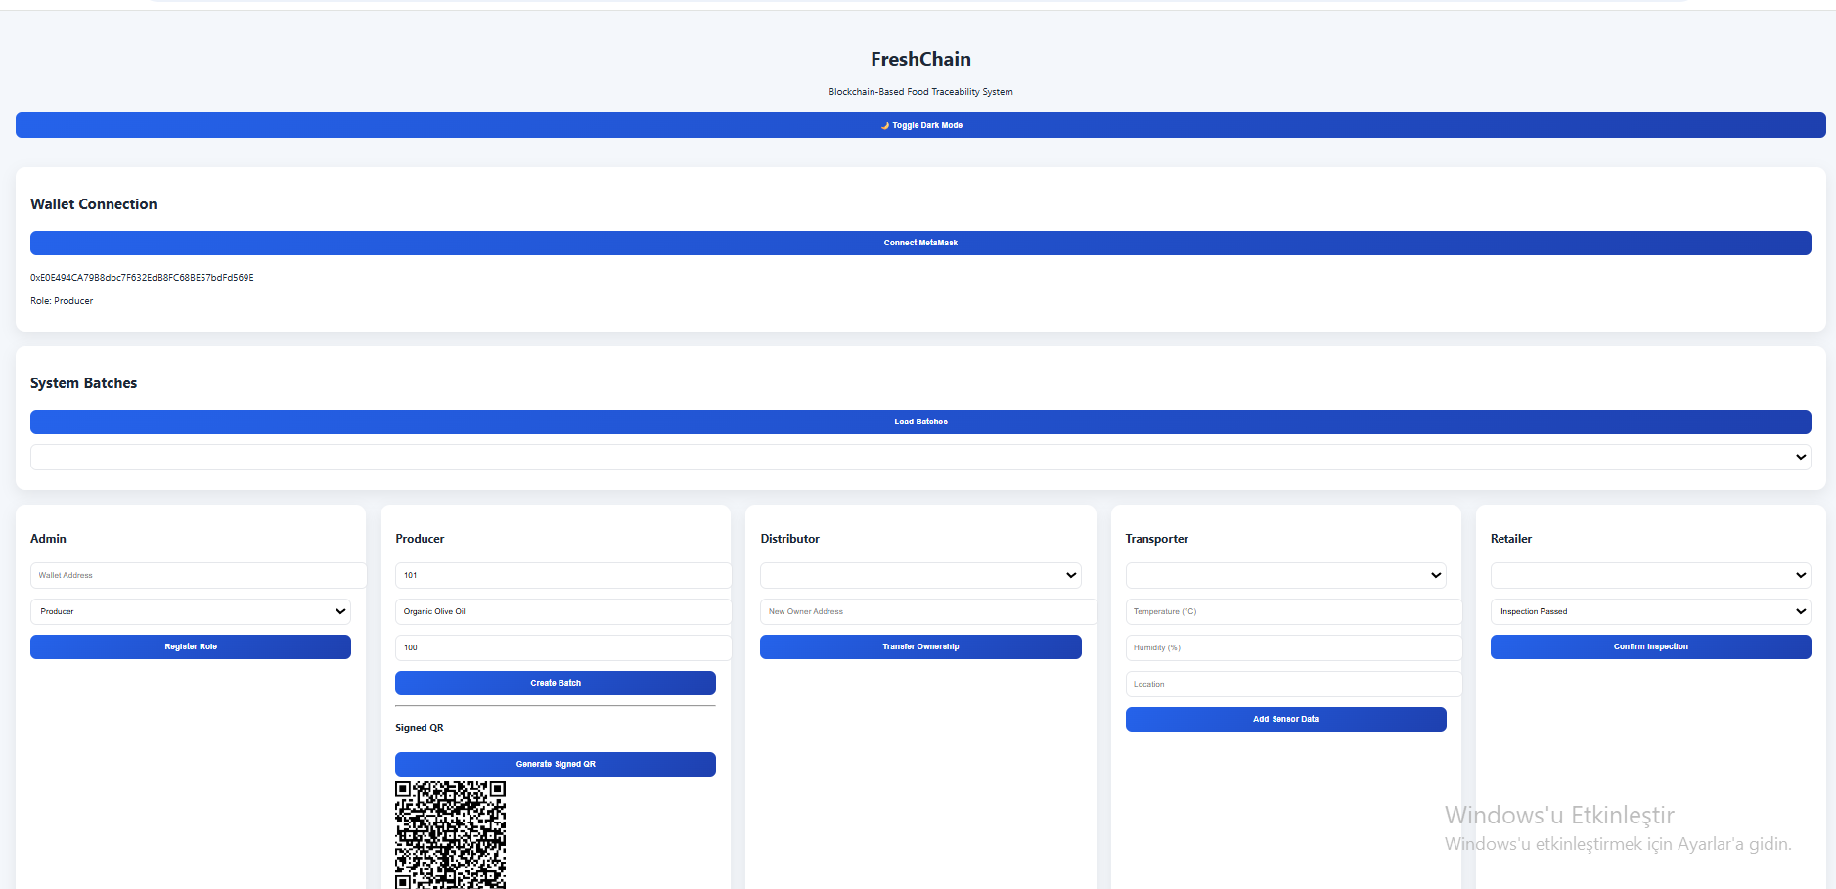

Smart Contract (FreshChain.sol)
The smart contract implements the core business logic of the system. It manages product batches, ownership transfers, sensor data recording, inspection results, and role-based access control. All permission checks are enforced at the blockchain level, preventing unauthorized actions regardless of frontend behavior.
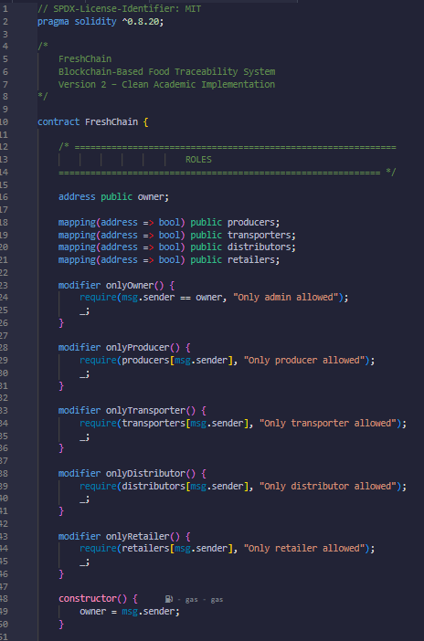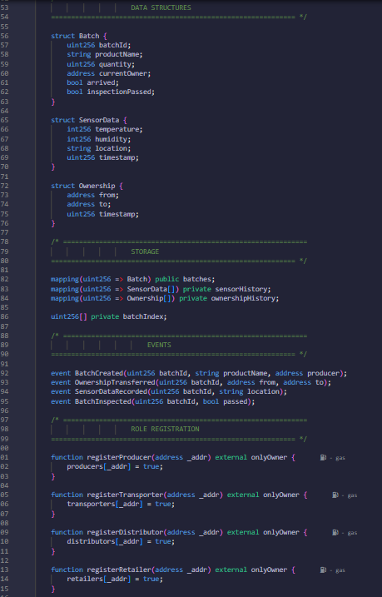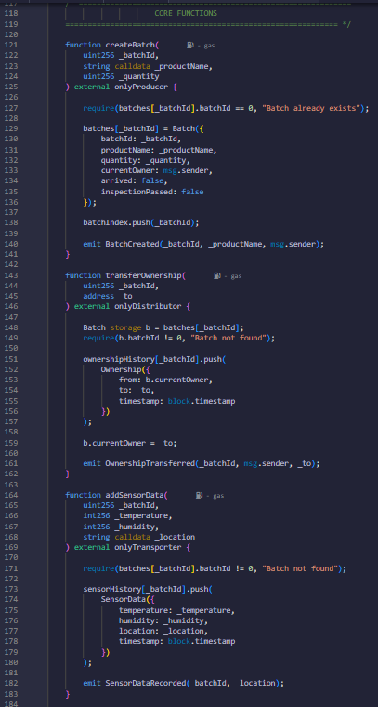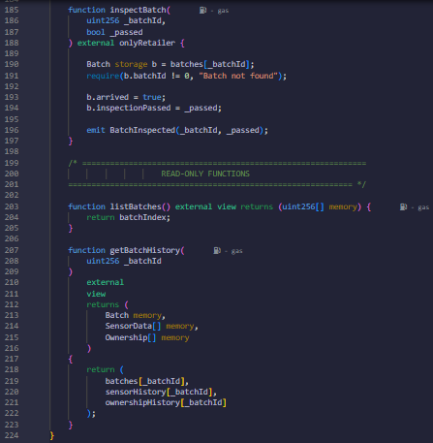
Blockchain Network (Ethereum Sepolia Test Network)
The Ethereum Sepolia network serves as the decentralized ledger where all supply chain data is stored. Transactions are immutable, timestamped, and publicly verifiable.
Public Product Verification Interface
This component allows customers to view product history in a read-only manner. It interacts with the blockchain using view functions and does not require authentication or wallet connection. This design ensures accessibility while preventing unauthorized data modification.
QR Code Mechanism
Each product batch is associated with a QR code that encodes its unique TrackID. Scanning the QR code opens the public verification page and automatically retrieves the corresponding batch history, enabling fast and intuitive mobile access.
The architecture clearly separates Web3-based interactions (authorized users writing data using MetaMask) from Web2-style public access (customers reading data without login), ensuring both security and usability.
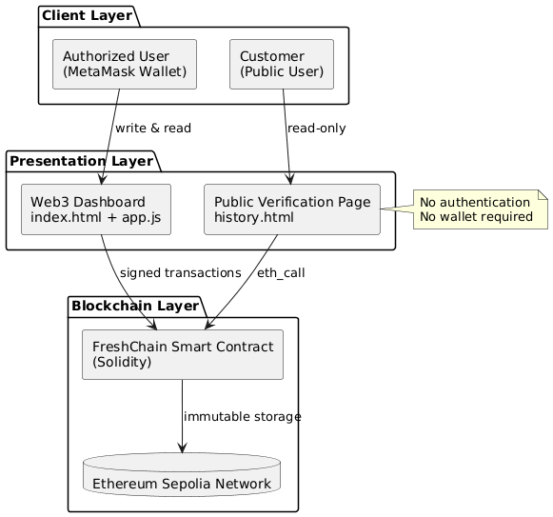
Figure A.1 – FreshChain Conceptual System Architecture
Figure A.1 illustrates the conceptual architecture of the FreshChain system, showing how the Web3 frontend, smart contract, blockchain network, public verification interface, and QR code mechanism interact as an integrated food traceability solution.
A.3 Actors and Roles
FreshChain defines the following actors, each with clearly separated responsibilities:
Admin
The Admin is responsible for registering supply chain participants and assigning roles. This role has full system privileges and establishes trust boundaries within the system.
Producer
The Producer initiates the product lifecycle by creating new product batches. Each batch includes a batch ID, product name, and quantity, representing the origin of the product.
Transporter
The Transporter records environmental conditions such as temperature, humidity, and location during transportation. This data helps ensure food safety and quality monitoring.
Distributor
The Distributor manages ownership transfers between supply chain actors. Each ownership change is recorded immutably on the blockchain.
Retailer
The Retailer performs the final inspection of a batch and records whether it passes quality control. This marks the end of the operational lifecycle.
Customer (Public User)
The Customer has read-only access to product history using TrackID or QR code. Customers do not require authentication or a wallet and cannot modify blockchain data.
Only authorized roles are allowed to write data to the blockchain, while customers are restricted to read-only access. This distinction preserves data integrity and prevents unauthorized modifications.
A.4 Use Case Diagrams and Explanations
The FreshChain system supports the following core use cases:
Register Role
Actor: Admin
Description: The admin assigns a specific role to a wallet address.
Result: The address gains role-based permissions.
Create Batch
Actor: Producer
Description: A new product batch is created and recorded on the blockchain.
Result: The batch becomes traceable from its origin.
Transfer Ownership
Actor: Distributor
Description: Ownership of a batch is transferred to another actor.
Result: Ownership history is permanently updated.
Record Sensor Data
Actor: Transporter
Description: Environmental conditions are recorded during transportation.
Result: Sensor data is stored immutably.
Inspect Batch
Actor: Retailer
Description: The batch is inspected and approved or rejected.
Result: Inspection status is permanently recorded.
View Product History
Actor: Customer
Description: The customer views full product history using TrackID or QR code.
Result: Transparent verification without authentication.
The use case diagram visually separates administrative, operational, and public actions, clearly demonstrating access boundaries.
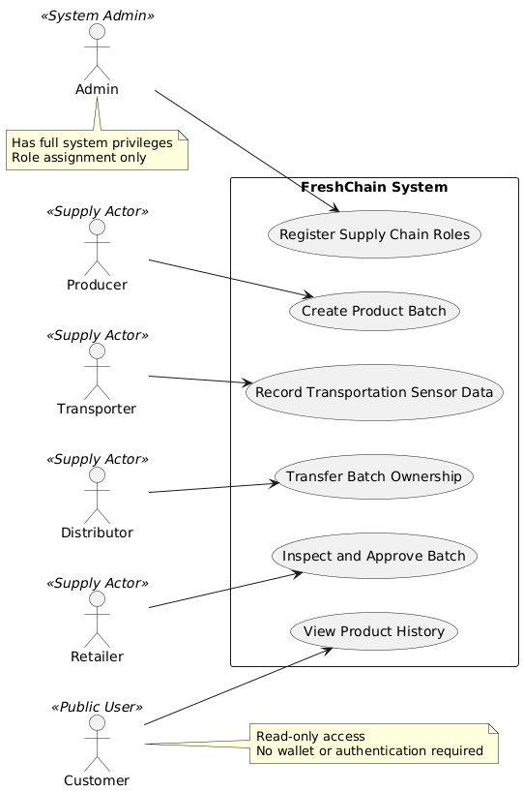
Figure A.4 – FreshChain Use Case Diagram
Figure A.4 presents the use case diagram of the FreshChain system, illustrating the interactions between system actors and core functionalities, including batch creation, ownership transfer, sensor data recording, inspection, and public history viewing.

A.5 Sequence Diagrams
Two primary sequence flows are defined:
Batch Lifecycle Sequence
The Producer creates a batch, the Distributor transfers ownership, the Transporter records sensor data, and the Retailer performs inspection. Each step results in a smart contract function call and a blockchain transaction requiring MetaMask confirmation.
Customer Verification Sequence
The Customer scans a QR code or enters a TrackID. The public verification interface calls a read-only smart contract function and displays the product history without requiring authentication or wallet interaction.
Read-only operations do not require wallet signatures, while write operations always require MetaMask confirmation.
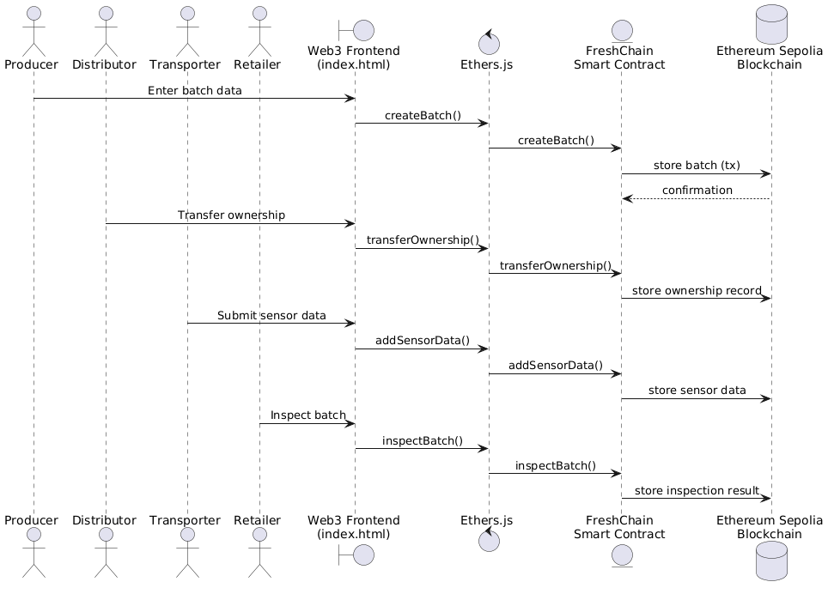
Figure A.5a – Batch Lifecycle Sequence Diagram
Figure A.5a illustrates the sequence of interactions representing the lifecycle of a product batch, from creation by the Producer to final inspection by the Retailer, with all actions recorded as blockchain transactions.
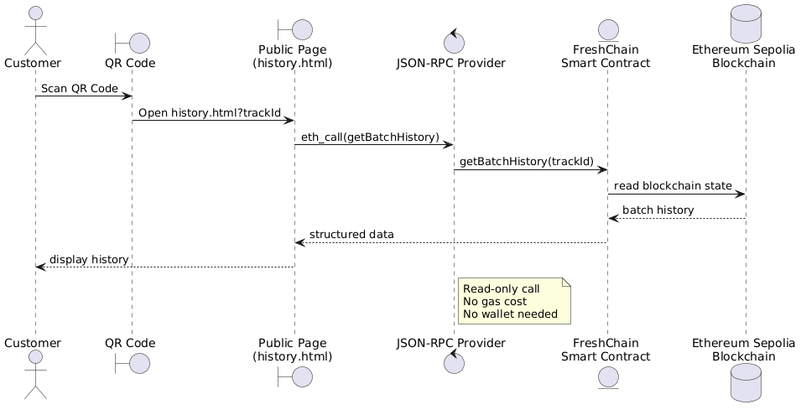
Figure A.5b – Customer Verification Sequence Diagram
Figure A.5b shows the customer verification process, where a TrackID or QR code is used to retrieve product history through a read-only blockchain call without requiring authentication or wallet connection.

A.6 Data Model Explanation
The FreshChain data model is designed to support complete and immutable traceability. Each product batch is represented as a structured entity containing a batch ID, product name, quantity, current owner address, inspection status, and arrival status.
Sensor data is stored as a list of records, each containing temperature, humidity, location, and timestamp. Ownership history is represented as a sequence of transfer records, each including source address, destination address, and timestamp.
This data model ensures that every supply chain event is logically associated with its corresponding batch and permanently preserved on the blockchain.
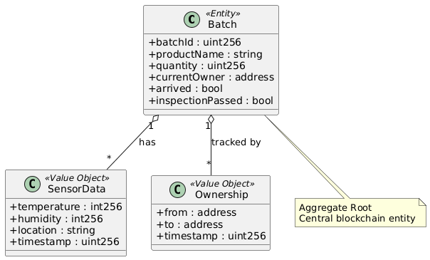
Figure A.6 – FreshChain Data Model Diagram
Figure A.6 presents the data model of the FreshChain system, illustrating how product batches, sensor data, and ownership records are structured and logically related to ensure complete traceability.
A.7 Batch Lifecycle State Diagram
The Batch Lifecycle State Diagram presents the behavioral view of a product batch in the FreshChain system, illustrating how a batch progresses through different states based on blockchain events and role-based actions.
A batch enters the Created state when the Producer registers it on the blockchain using the createBatch function. After ownership is transferred by the Distributor through transferOwnership, the batch moves to the In Transit state, indicating its movement through the supply chain. During transportation, the Transporter records environmental conditions via addSensorData, transitioning the batch into the Monitored state.
At the final stage, the Retailer performs quality inspection using the inspectBatch function, moving the batch to the Inspected state. Depending on the inspection result, the batch reaches either the Approved state, indicating suitability for sale, or the Rejected state, indicating a quality issue.
All state transitions are triggered by explicit smart contract function calls and are immutably recorded on the blockchain, ensuring transparency, traceability, and resistance to tampering throughout the batch lifecycle.
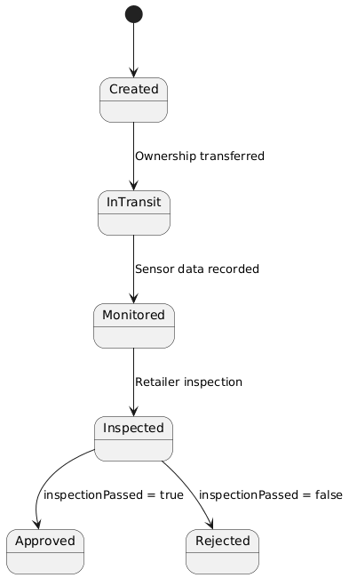
Figure A.7 illustrates the state transitions of a product batch throughout its lifecycle, showing how blockchain events and role-based actions drive progression from batch creation to final approval or rejection.

B. Project Usage (User’s Manual)
Explain how the system is used from the perspective of users in different roles. It must be written so any reader can follow it step by step without guessing.
You must explain how a user logs into or accesses the system. Describe how wallet connection works, how the system detects the user’s role, and how the interface changes based on that role. You must clearly state that the admin account is predefined, the password is fixed, and credentials are auto-filled so that the instructor only needs to press buttons.
You must explain how participants are registered by the admin and how this affects system access. Then, explain how a producer creates a product batch, what information is entered, and what happens on the blockchain when a batch is created.
You must explain how batches are listed using the LIST BATCHES function and clearly describe the mandatory predefined batches that must appear. You must explain how QR codes are generated and when they become visible in the interface.
You must explain ownership transfer in practical terms: who transfers to whom, when, and why. Then explain how environmental values such as temperature, humidity, and location are recorded by the transporter.
You must explain the retailer’s final inspection step and how inspection results affect the batch status.
Finally, you must explain QR-based product history viewing in detail. Describe how a customer enters a TrackID, presses GET HISTORY, sees the full history together with a QR code, and how scanning this QR code with a phone camera opens the same history page in mobile Chrome without requiring login or MetaMask.
B.1 System Access and Wallet Connection
Authorized users access the system through a web browser and connect their MetaMask wallet by pressing the “Connect MetaMask” button. The system automatically detects the wallet address and determines the user’s role, which is displayed on the interface.
The admin account is predefined, and all role assignments are performed through button-based actions.
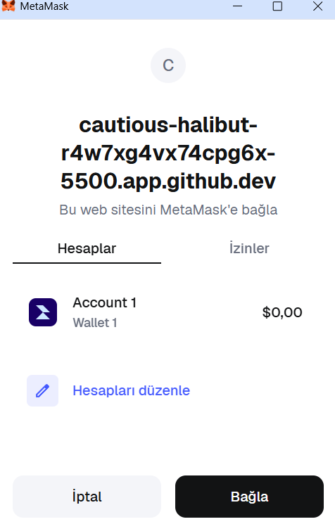
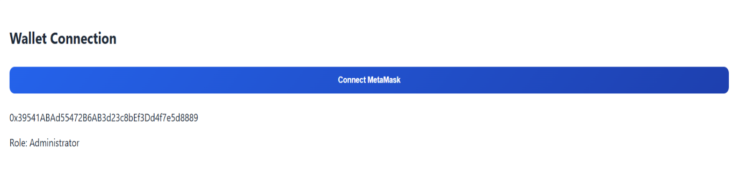

Figure B.1 – Wallet Connection and Role Detection

B.2 Role Registration
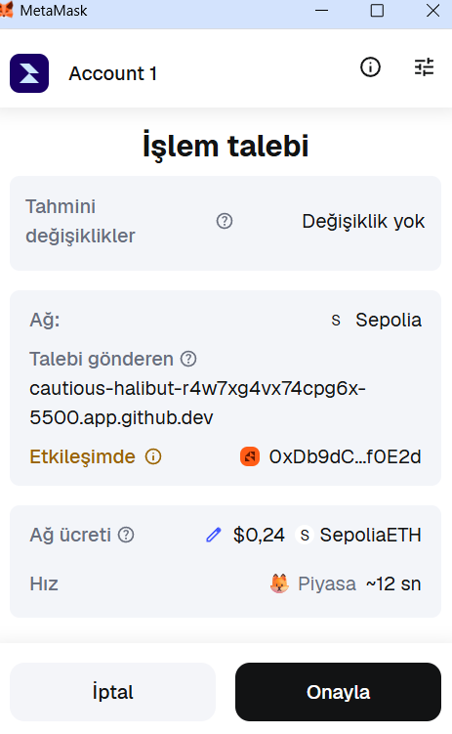
The admin enters a wallet address, selects a role, and registers the participant. The registered participant immediately gains access to role-specific system functions.

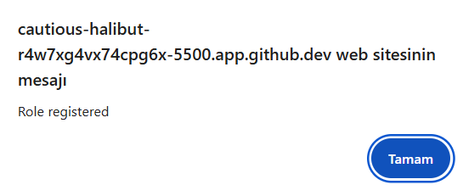
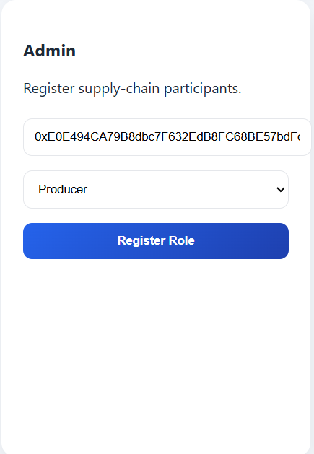
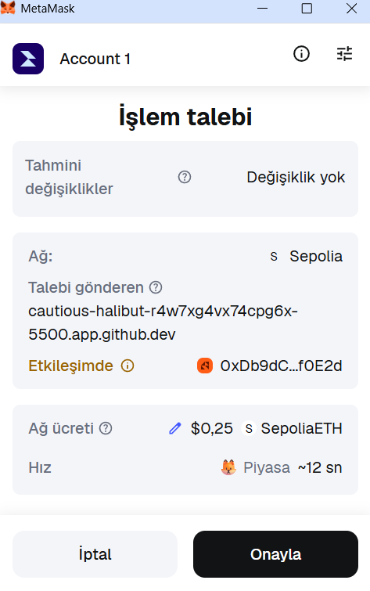
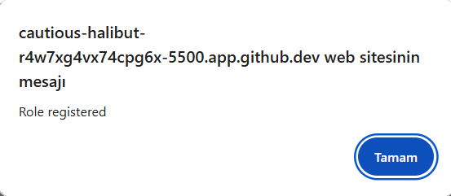
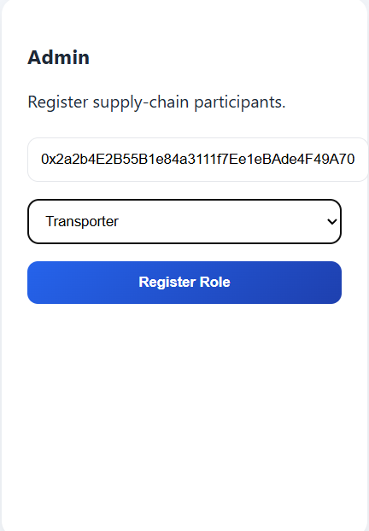

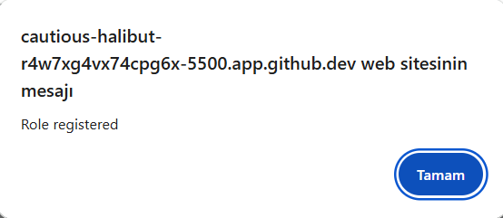
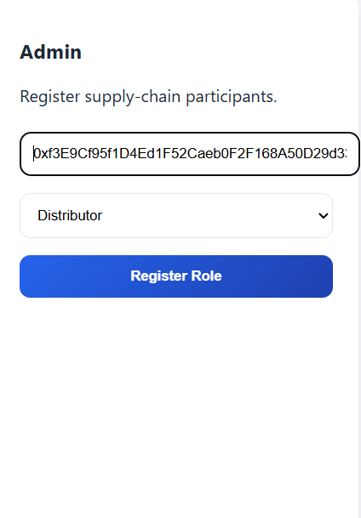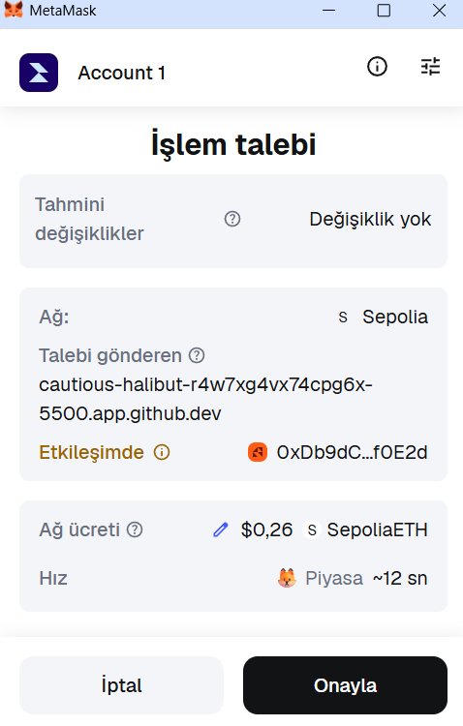

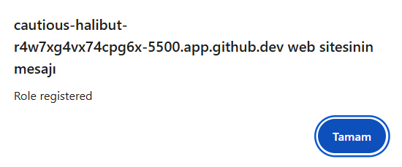
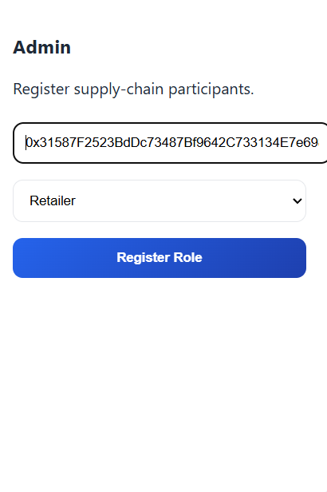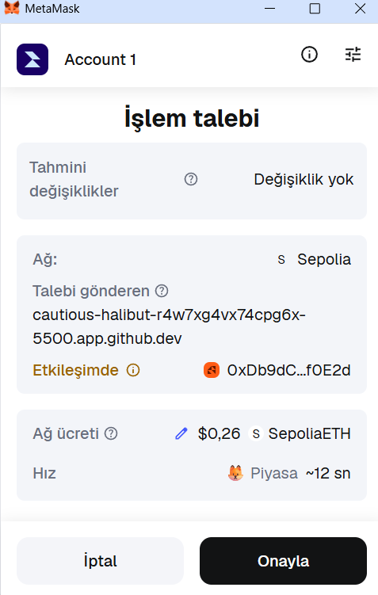
Figures B.2 – Admin Role Registration Interface

B.3 Batch Creation
The producer enters batch ID, product name, and quantity, then creates a batch. The batch is recorded on the blockchain and becomes visible in the system batch list.
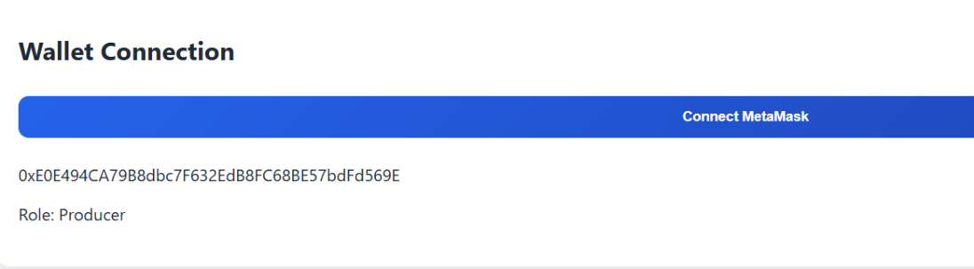
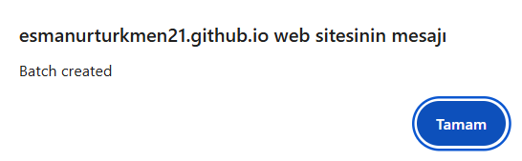
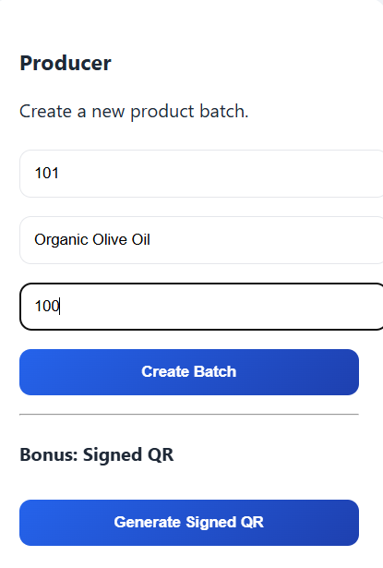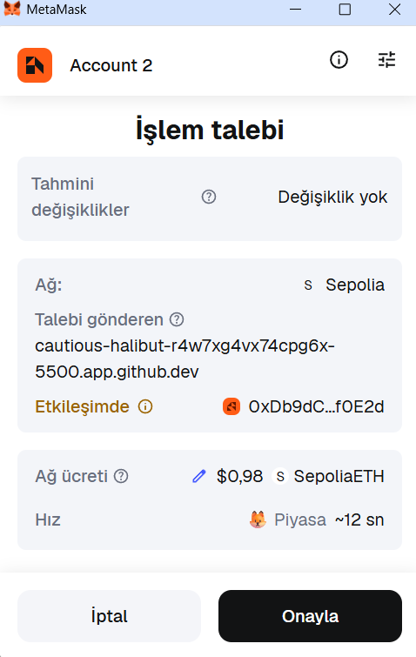
Figures B.3 – Batch Creation Interface

B.4 Listing Batches and QR Generation
The “Load Batches” function retrieves all existing batch IDs from the blockchain and populates selection menus. The producer can generate a QR code for a batch.
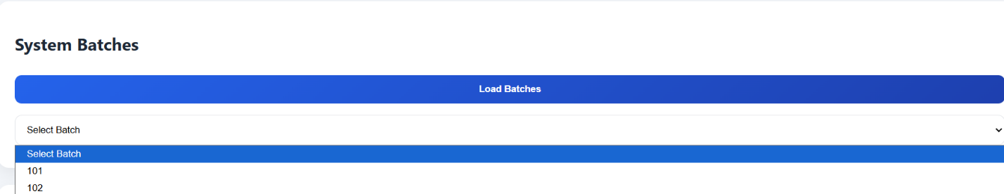
QR codes do not store data themselves; they only encode the TrackID, ensuring that all information is always retrieved directly from the blockchain.

Figure B.4a Batch Listing
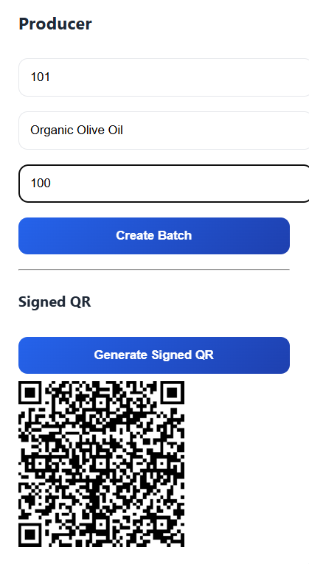
Figure B.4b QR Generation

B.5 Ownership Transfer and Sensor Data Recording
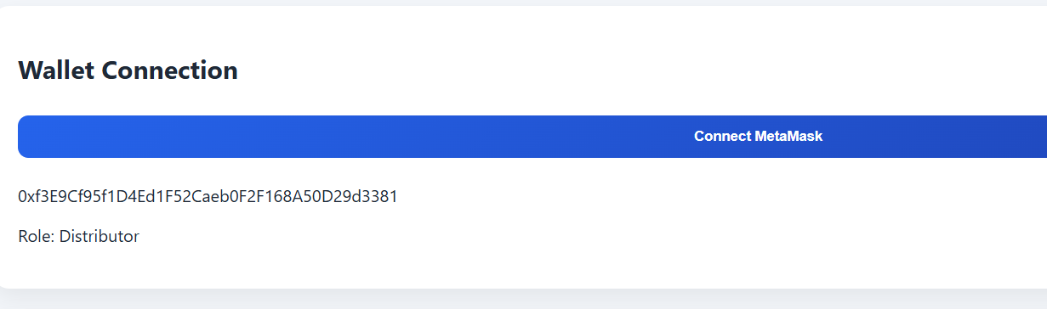
The distributor transfers batch ownership to another participant. The transporter records temperature, humidity, and location data during transportation. Each action creates a blockchain transaction.

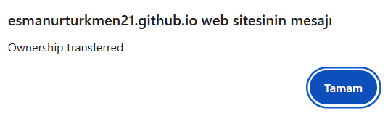
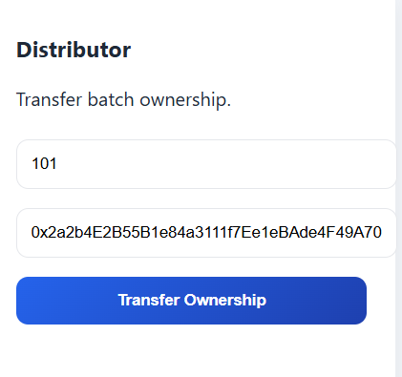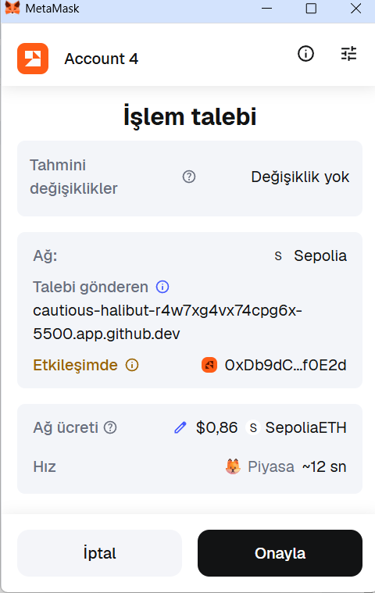
figures B.5a – Ownership Transfer
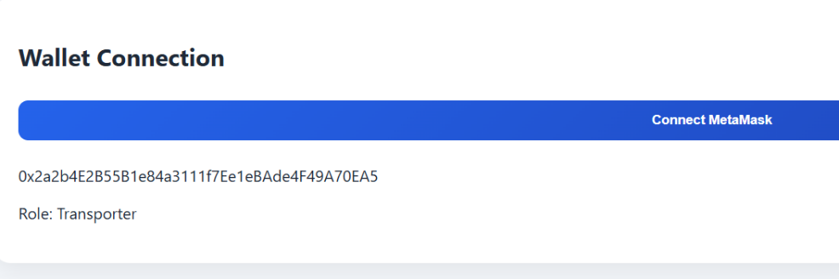
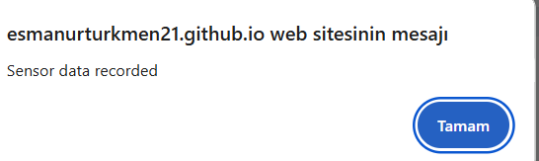
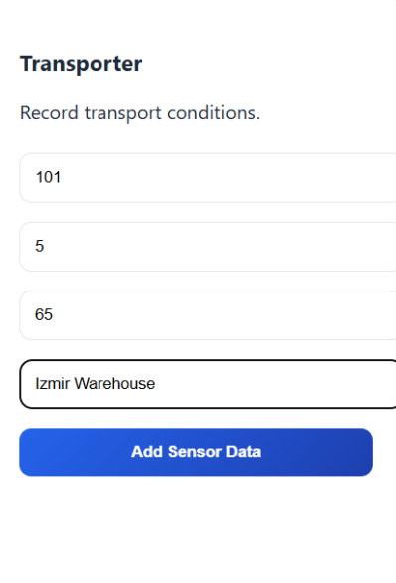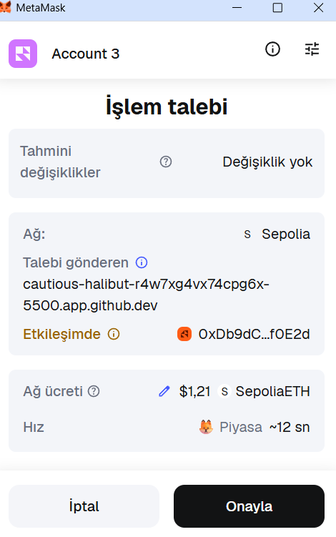
figures B.5b – Sensor Data Recording

B.6 Retail Inspection
The retailer confirms whether the batch passes inspection. This result affects the final batch status.
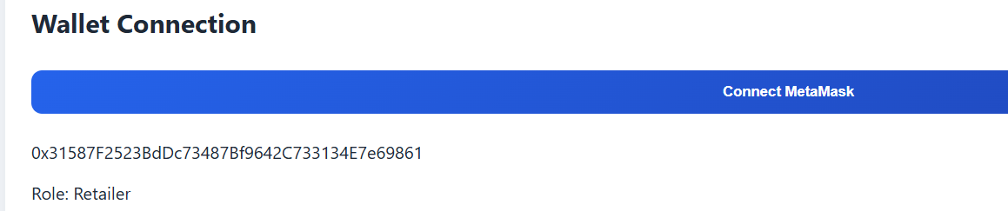

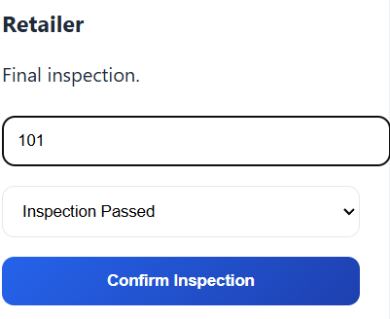

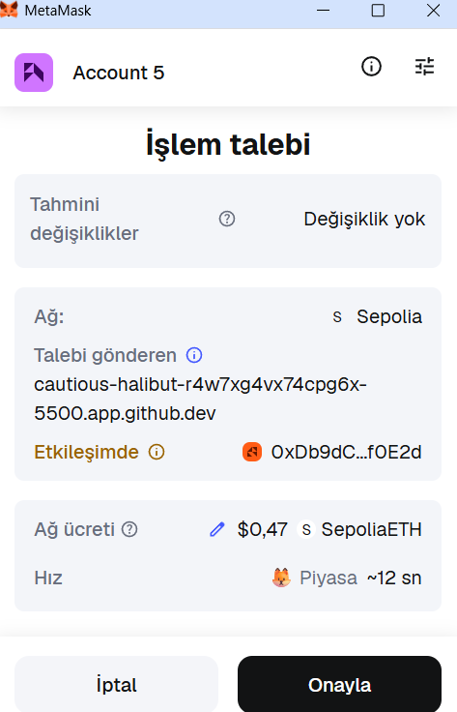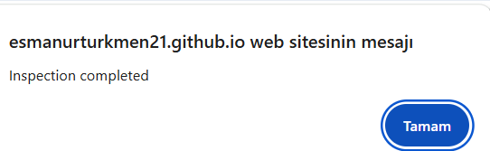
Figures B.6 – Retail Inspection Interface

B.7 Public Product Verification
Customers select a batch ID or enter a TrackID and press “Get History.” The system displays the complete blockchain history. Scanning the QR code with a mobile device opens the same history view in a browser without requiring MetaMask or login.
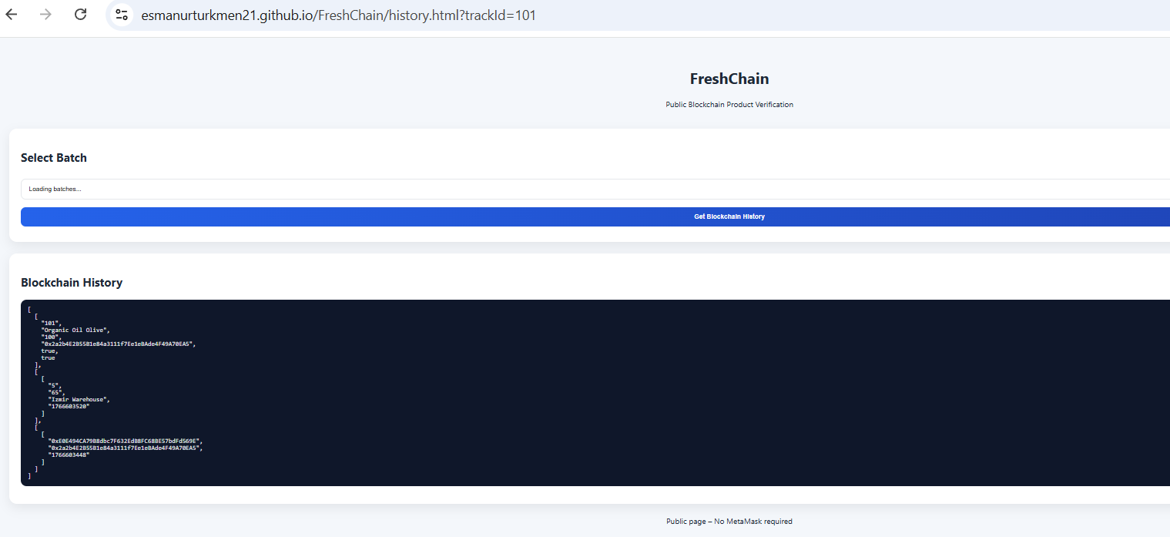
Figure B.7 – Public Product Verification Page
C. Project Technical Details (Programmer’s Manual)
Explain how the system is implemented technically and is intended for a developer or evaluator.
You must explain the component architecture of the system, describing how frontend files, smart contracts, blockchain network, and public history pages are connected. This explanation must be supported by a component diagram and a clear textual explanation.
You must explain the technical sequence of operations for key processes such as batch creation, ownership transfer, sensor data recording, and history retrieval. This section focuses on how functions interact and how data flows through the system.
You must explain the activity flow of the application, describing how user actions in the UI trigger smart contract calls and how results are displayed.
You must also explain the GitHub repository structure. Describe the purpose of each main folder and file (frontend, smart contract, documentation, history page, etc.) and explain how the Word document is integrated into the repository.
C.1 Component Architecture
The FreshChain system is implemented as a modular architecture consisting of frontend components, a blockchain smart contract, a public verification interface, and a version-controlled GitHub repository. Each component has a clearly defined responsibility and communicates with others through well-defined interfaces.
The frontend web application is implemented using HTML, CSS, and JavaScript. It provides the main user interface for authorized supply chain actors. The frontend uses the Ethers.js library to communicate with the blockchain through JSON-RPC calls. MetaMask is used as a wallet provider to sign and authorize write transactions.
The smart contract, written in Solidity, is deployed on the Ethereum Sepolia test network. It defines all business logic, including batch management, role-based access control, ownership transfers, sensor data recording, and inspection handling. The smart contract acts as the single source of truth for supply chain data.
The public verification interface is a separate web page designed for customers. It operates in read-only mode and retrieves data using smart contract view functions. This interface does not require authentication or wallet connection and is typically accessed via a QR code containing a TrackID.
The GitHub repository hosts all project artifacts, including source code, frontend files, smart contract files, and the project report. This structure allows the system to be easily evaluated, maintained, and extended.
Figure C.1 – Component Diagram of the FreshChain System
Figure C.1 illustrates the technical component architecture of the FreshChain system, showing how frontend components, the smart contract, blockchain network, and public verification page are connected.

C.2 Technical Operation Flow
The FreshChain system follows a clear and consistent technical operation flow based on user-triggered events and smart contract interactions.
When an authorized user performs an action in the frontend interface, a corresponding JavaScript function is executed. This function calls a smart contract method through Ethers.js. If the operation modifies blockchain state (such as creating a batch or transferring ownership), MetaMask prompts the user to sign the transaction. After confirmation, the transaction is sent to the Ethereum network and permanently recorded.
Read-only operations, such as retrieving batch history, use smart contract view functions. These operations do not require gas fees or wallet signatures and can be executed directly through JSON-RPC calls.
Key technical flows include:
Batch Creation
The Producer enters batch information in the frontend. A JavaScript function calls the createBatch smart contract method. MetaMask requests signature approval, and the transaction is recorded on the blockchain.
Ownership Transfer
The Distributor selects a batch and a new owner address. The frontend calls the transferOwnership function, resulting in an immutable ownership record.
Sensor Data Recording
The Transporter records temperature, humidity, and location data. This data is sent to the addSensorData function and stored on-chain with a timestamp.
History Retrieval
The public interface or dashboard calls the getBatchHistory view function. The blockchain returns structured batch, sensor, and ownership data, which is then displayed to the user.
This separation between write and read operations ensures security, efficiency, and clarity in system behavior.

C.3 Activity Flow
The activity flow of the FreshChain application begins with user interaction at the frontend and ends with data visualization or blockchain state updates.
- The user interacts with the UI by clicking a button or submitting a form.
- The frontend validates input values and triggers the appropriate JavaScript function.
- For write operations, Ethers.js forwards the request to MetaMask for signature approval.
- Once approved, the transaction is sent to the blockchain and mined.
- The frontend waits for transaction confirmation.
- Upon confirmation, the UI is updated to reflect the new system state (e.g., updated batch list or confirmation message).
For read-only operations, the flow is shorter. The frontend directly calls a view function and updates the UI with the returned data without waiting for blockchain confirmations.
This activity flow ensures a responsive user experience while maintaining blockchain security guarantees.
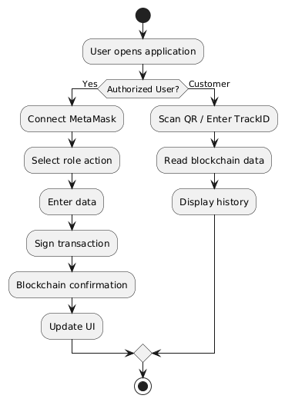
Figure C.3 – Activity Diagram
Figure C.3 presents the activity flow of the FreshChain application, illustrating how user actions trigger smart contract calls and how results are returned and displayed in the user interface.

C.4 GitHub Repository Structure
The FreshChain project is organized in a flat and transparent GitHub repository structure to simplify deployment, evaluation, and maintenance. Instead of separating frontend and public interfaces into multiple subfolders, all web-related files are placed at the root level of the repository. This design choice improves clarity and allows the application to be directly hosted using GitHub Pages without additional configuration.
The repository is structured as follows:
Root Directory ( / )
The root directory contains all frontend and public-facing web files.
- index.html implements the main Web3 dashboard used by authorized supply chain actors.
- app.js contains the JavaScript logic for interacting with the smart contract using Ethers.js, including wallet connection, role-based actions, and transaction handling.
- style.css defines the visual design and layout shared across all web pages.
- history.html implements the public product verification interface. This page operates in read-only mode and allows customers to view product history using a TrackID or QR code without authentication.
Placing these files at the root level allows GitHub Pages to serve both the main dashboard and the public verification page directly, simplifying deployment and evaluation.
contracts/
This folder contains the Solidity smart contract source code.
- FreshChain.sol defines the complete blockchain logic of the system, including batch management, role-based access control, sensor data recording, ownership transfers, and inspection handling.
This separation ensures that blockchain logic is clearly isolated from frontend implementation.
report/
This folder contains the project documentation.
- The final project report (Word or PDF format) is stored in this directory and is version-controlled alongside the source code.
Keeping the report within the repository ensures consistency between implementation and documentation and allows evaluators to easily access both.
This repository structure prioritizes simplicity, ease of deployment, and readability. It allows evaluators to quickly understand how the system is organized, how the frontend connects to the smart contract, and how public verification is supported without unnecessary complexity.

