同步容器类
Vector、HashTable

线程安全实现方式
将他们的状态封装起来，所有的公开方法都进行同步，每次仅有一个线程能访问它的状态

并非绝对线程安全
示例代码中同时多个线程对Vcetor的元素进行删除和获取。
- VectorHandler
package com.yangkl.concurrent.container;
import java.util.Vector;
/**
* Created by asus on 2018/1/22.
*/
public class VectorHandler {
private Vector vector = new Vector<String>();
public VectorHandler(Vector vector) {
this.vector = vector;
}
public void removeLast() {
int size = vector.size();
vector.remove(size - 1);
}
public void getLast() {
int size = vector.size();
vector.get(size - 1);
}
}

- 测试类VectorTest
package com.yangkl.concurrent.container;
import java.util.Vector;
/**
* Created by asus on 2018/1/22.
*/
public class VectorTest {
public static void main(String[] args) {
for (int i = 0; i < 100000; i++) {
VectorHandler vectorHandler = createVectorHandler();
new Thread(new ThreadA(vectorHandler)).start();
new Thread(new ThreadB(vectorHandler)).start();
if (i % 1000 == 0) {
System.out.println("current i = " + i);
}
}
}
private static VectorHandler createVectorHandler() {
Vector vector = new Vector<String>(5);
for (int i = 0; i < 10; i++) {
vector.add(i + "");
}
VectorHandler vectorHandler = new VectorHandler(vector);
return vectorHandler;
}
}
class ThreadA implements Runnable {
private VectorHandler vectorHandler;
public ThreadA(VectorHandler vectorHandler) {
this.vectorHandler = vectorHandler;
}
@Override
public void run() {
vectorHandler.getLast();
}
}
class ThreadB implements Runnable {
private VectorHandler vectorHandler;
public ThreadB(VectorHandler vectorHandler) {
this.vectorHandler = vectorHandler;
}
@Override
public void run() {
vectorHandler.removeLast();
}
}
- 运行结果
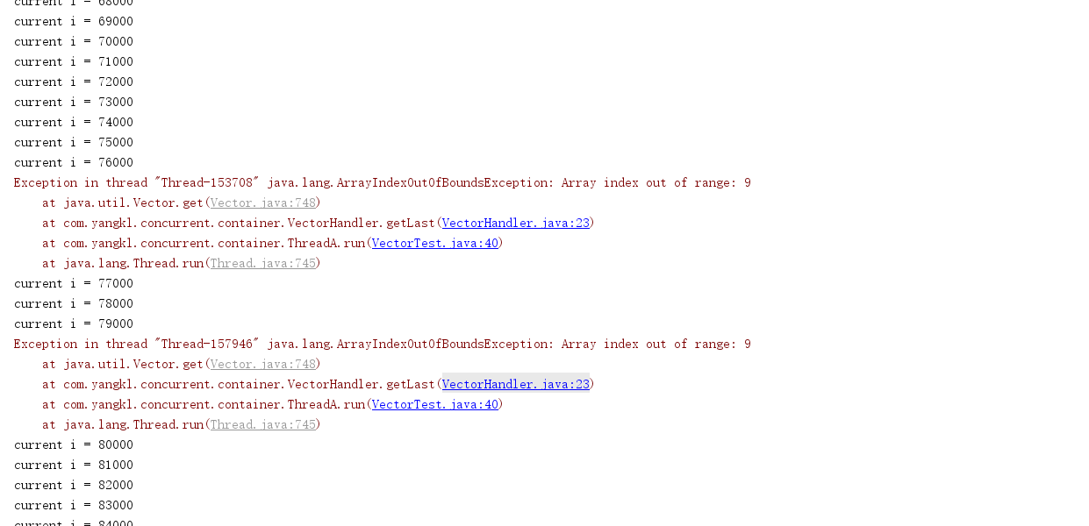
- 结果分析
大部分情况下都可以正常运行，部分线程会出现异常。

如何实现线程安全
添加额外的同步机制
VectorHandler
package com.yangkl.concurrent.container;
import java.util.Vector;
/**
* Created by asus on 2018/1/22.
*/
public class VectorHandler {
private Vector vector = new Vector<String>();
public VectorHandler(Vector vector) {
this.vector = vector;
}
public void removeLast() {
synchronized (vector){
int size = vector.size();
vector.remove(size - 1);
}
}
public void getLast() {
synchronized (vector){
int size = vector.size();
vector.get(size - 1);
}
}
}

