MSBD566 – Predictive Modeling and Analysis
Name: Esmeralda Garcia
Date: October 22, 2025
Assignment: Final Project

Project Description
This project builds upon an earlier analysis that utilized logistic regression for cancer drug response. In this project, I developed a more advanced machine learning pipeline for the Kaggle Genomics of Drug Sensitivity in Cancer (GDSC) dataset. The goal of the project is to classify each drug-cell line pair into one of three categories: Very Potent, Average Sensitivity, or Resistant, based on biological and experimental features.

Understanding drug sensitivity is critical in precision oncology because predicting how different cancer cell types respond to specific therapies can guide treatment selection and drug development. By comparing the traditional linear model of logistic regression with a more flexible nonlinear model like a neural network, this project evaluates whether deep learning methods can improve predictive accuracy in this complex biological context.

Data Description
The dataset, Genomics of Drug Sensitivity in Cancer (GDSC), used for this midterm project was downloaded from Kaggle. It contains information related to the different drug response of almost 1000 human cancer cell lines. The cell lines were exposed to almost 300 different anti-cancer drugs, the combinations resulted in over 240,000 individual observations. The target of interest in the dataset is LN_IC50 which would tell us if the various cell lines are sensitive to the drug administered. Cancer cell lines were exposed to the drug for 72 hours and its viability was then measured.
Variables in my data:

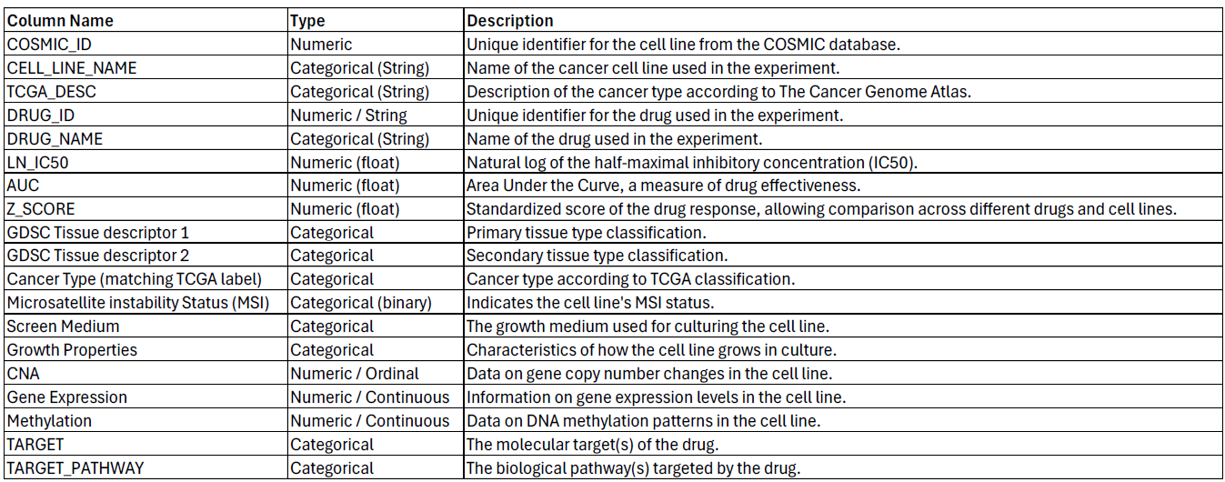
I selected the target to be the original LN_IC50 variable. This variable was categorized into three biologically meaningful categories:
Category | LN_IC50 Range | Meaning
Very Potent | < 0 | Highly sensitive
Average Sensitivity | 0 – 2.3 | Moderate Response
Resistant | > 2.3 | Low Sensitivity

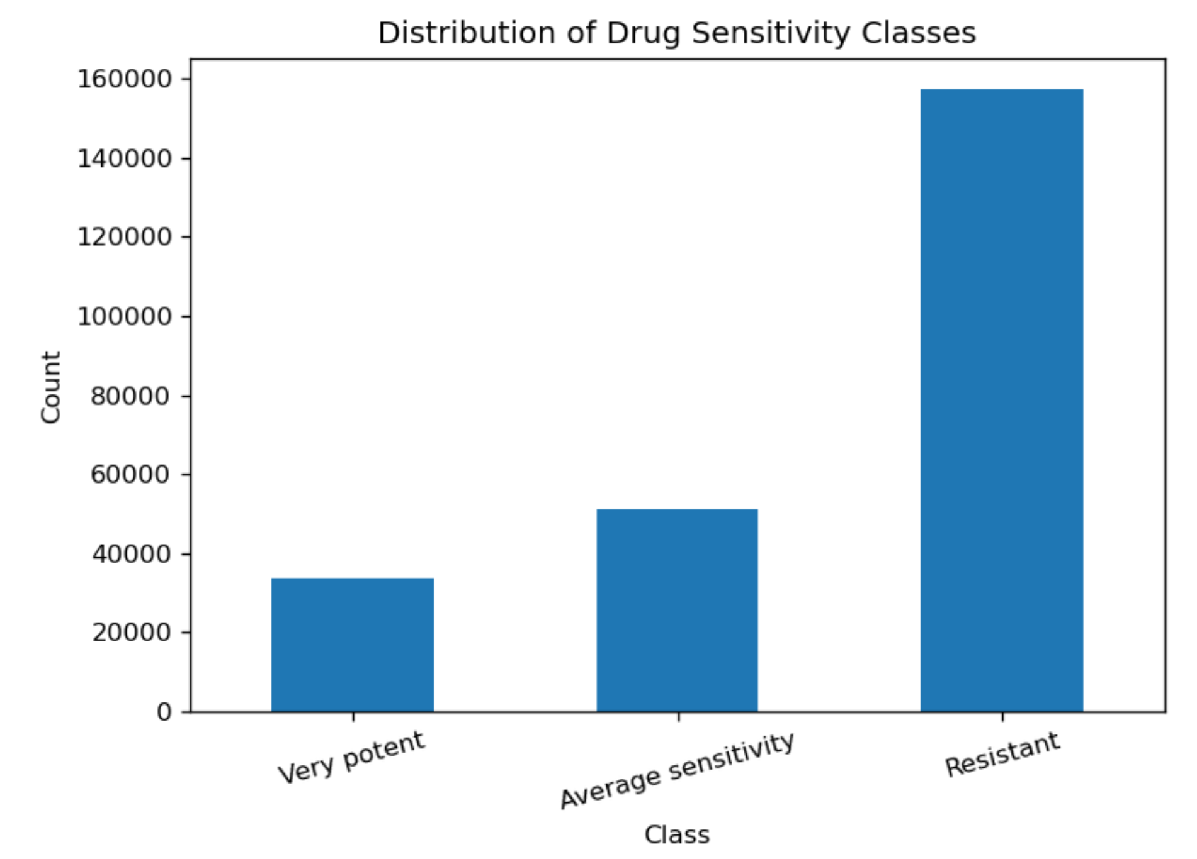
Figure 1. Distribution of the three drug sensitivity classes. The dataset is highly imbalanced, with Resistant samples dominating the observations.
The dataset contained some missing values, mainly in the cancer cell type. To simplify preprocessing, rows with any missing values in selected features were removed, resulting in a clean dataset for my training and evaluation.
The limitation of this data set is that the results reflect that observed in vitro and not with actual patients. Results will absolutely vary in the context of the human body and other biological processes involved.

Method and Analysis
For this project, I applied a combination of Principal Component Analysis (PCA) for numeric feature reduction and a multilayer neural network classifier for predicting drug sensitivity categories. The modeling pipeline included:
- Data preprocessing
  - Removal of rows missing LN_IC50
  - Creating a 3-class target variable (Very Potent, Average Sensitivity, Resistant)
  - Median imputation for numeric variables (AUC and Z_SCORE)
  - Most-frequent imputation for categorical variables
  - Standardization of numeric features before PCA
  - One-hot encoding of categorical variables
- Dimensionality reduction
  - PCA applied to numeric variables
- Neural network modeling
  - Two hidden layers (64 and 32 neurons, ReLU activation)
  - Dropout layers for regularization
  - Softmax output layer for multiclass classification
  - Training using categorical cross-entropy loss
- Performance evaluation
  - Accuracy, precision, recall, and F1-score
  - Confusion matrices to visualize model behavior
  - Comparison with baseline logistic regression model
The methods were selected because of the nature of the dataset and the complexity of the biological relationships.
PCA was an important component of the preprocessing pipeline because the numeric features in the AUC and Z_SCORE features can contain measurement noise. These two numeric features capture patterns in drug response, but they may overlap in the kind of variance they explain. By applying PCA, the original numeric values was transformed into a smaller set of principal components that now represent the most meaningful variation in the data. This transformation helps emphasize large-scale biological trends while reducing the influence of noise. PCA also provides a more compact numerical representation that can simplify the input to the neural network and stabilize training.
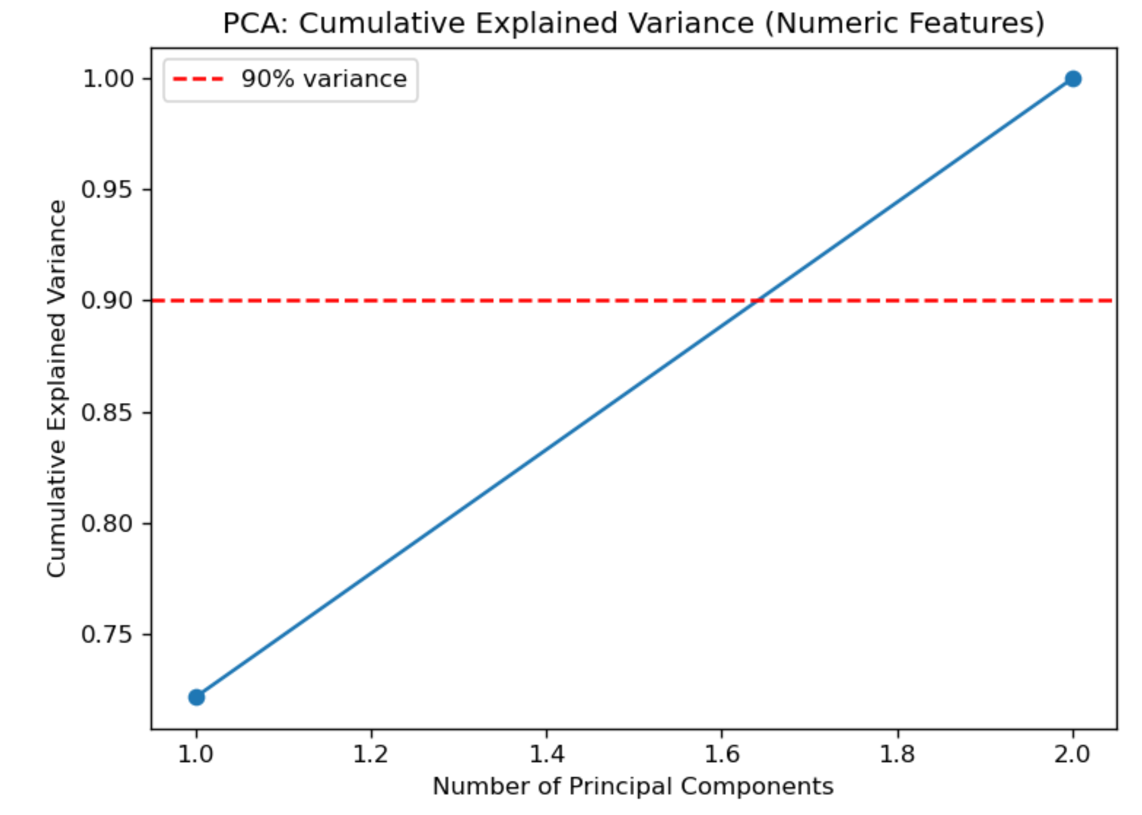
Figure 2. Cumulative explained variance for PCA components derived from AUC and Z_SCORE. Two components capture 100% of the numeric variance, supporting their use as compact numerical inputs to the neural network.
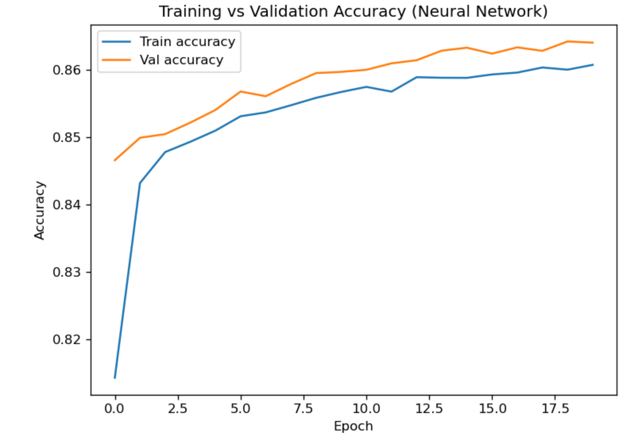
Figure 3. Training and validation accuracy over 20 epochs for the neural network model. The close alignment of the curves indicates stable learning and minimal overfitting.

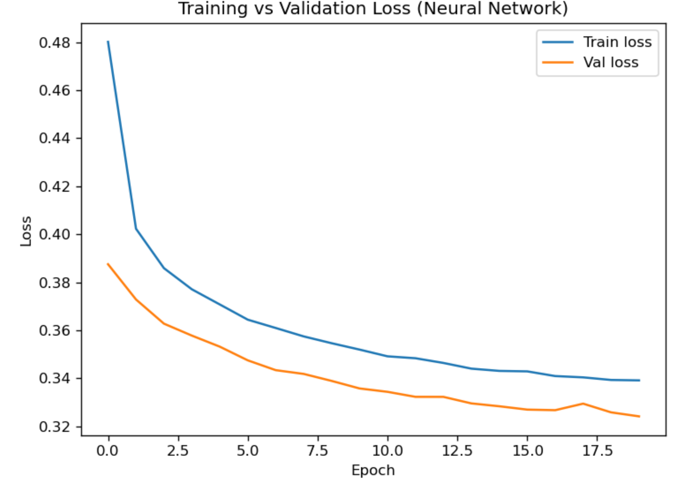
Figure 4. Training and validation loss curves for the neural network. The steadily decreasing loss shows proper convergence throughout training.
Neural networks were chosen for this project because drug sensitivity is controlled by complex, nonlinear biological relationships that linear models cannot capture. Logistic regression, used earlier as a baseline model, assumed linear separability and as a result struggled with intermediate classes like Average Sensitivity. In contrast, neural networks can model nonlinear interactions through layered transformations, allowing the representation of intricate decision boundaries. Their flexibility makes them better suited for biological datasets where multiple pathways, cellular conditions, and experimental contexts jointly determine drug response.
The model incorporated both numeric and categorical biological features to capture multiple dimensions of drug response. The numeric variables, AUC and Z_SCORE, quantify aspects of the dose–response relationship and were transformed using PCA to produce the principal components representing the dominant patterns in drug performance. These numeric representations were combined with a set of categorical predictors. The categorical features included the tissue descriptor of the cell line, the biological pathway targeted by the drug, microsatellite instability status (MSI), screen medium used in the experiment, growth properties of the cell line, and molecular indicators such as copy-number alteration (CNA) flags, gene expression flags, and methylation flags. After imputation and one-hot encoding, these categorical variables expanded into a set of binary indicators that allowed the model to use diverse biological signals when predicting the sensitivity class.

Evaluation

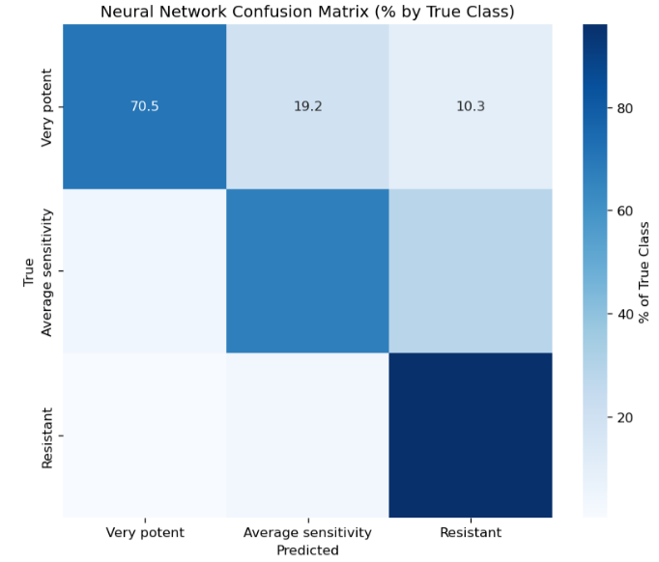
Figure 5. Confusion matrix for the neural network model showing percent of correct predictions for each true class. The model performs very well on Resistant samples and shows improved classification of the Average Sensitivity group compared to logistic regression.

The performance of the neural network model was strong and demonstrated clear improvements over the baseline logistic regression approach. With a final test accuracy of 86.4%, the model generalized well to unseen data while maintaining a balanced performance across all three drug-sensitivity categories. The neural network displayed a high recall for Resistant cell lines, it correctly identified more than 96% of cases. The Very Potent class also achieved excellent precision, indicating that when the model predicted a strong drug response, it was highly likely to be correct. Most notably, the neural network substantially improved the classification of Average Sensitivity, raising recall from 0.382 in the logistic regression model to 0.672. This improvement shows that the neural network’s advantage in separating biological signals that were not captured by the linear baseline.
Key evaluation metrics show that the neural network provided a more effective predictive solution for this dataset. The macro F1-score of approximately 0.81 indicates strong balanced performance despite the dataset’s class imbalance, while the weighted F1-score reflects high overall predictive ability. The comparison with logistic regression supports the conclusion that nonlinear modeling methods are better suited for drug-response prediction tasks that involve complex interactions between genomic, phenotypic, and pharmacological variables. Overall, the neural network approach was both effective and appropriate for this project, providing deeper insight into drug sensitivity patterns and delivering a more reliable prediction than the baseline model.

