Esmeralda Urena

CS478

May 3, 2021

README- Assignment 6

1. ML Web Server Description
   * This web server opens up for connections and waits for a client to connect. The client then sends specific images to the server so the server identifies what kind of object is in the image. Once the server (which is using my local IP to host the server) uses the trained model (which was provided by the professor) to identify the object it sends the output to the client to let them know. I used an image of a hand doing a rock symbol, a scissor symbol, and a paper symbol.
2. Testing the Web Server and Clients
   * To test the web server and client you can do 2 things:
     1. Open up anaconda and do cd /path/ (the path to the folder with the client server ipynb files), then do “jupyter notebook server.ipynb” and jupyter notebook should open that file. Then you do “jupyter notebook client.ipynb” and it’ll open the client. Then run the server first THEN the client second and you can input stuff to the server from the client side.
     2. If that doesn’t work, you need to create an environment. Open anaconda prompt terminal and write:
        1. conda create --name tf2.3
        2. y
        3. conda activate tf2.3
        4. conda install python
        5. y
        6. pip install jupyter
        7. cd \path (the path to the folder called CLIENT_SERVER)
        8. pip install pywin32==225
        9. jupyter notebook
     3. Then you open server.ipynb and run it, then open client.ipynb and run that after. Then input “client” into client prompt, or “client rock.png”.
3. Screen Captures of Test Run

**This is the CLIENT output:**

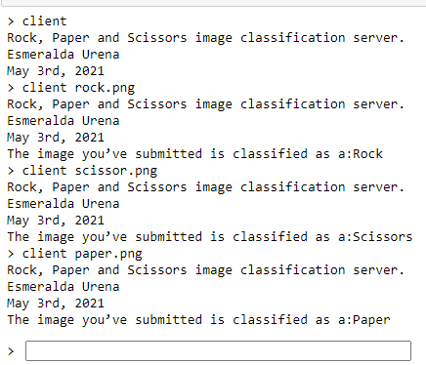

**This is the SERVER output:**

