FYI -3 weeks of frustration

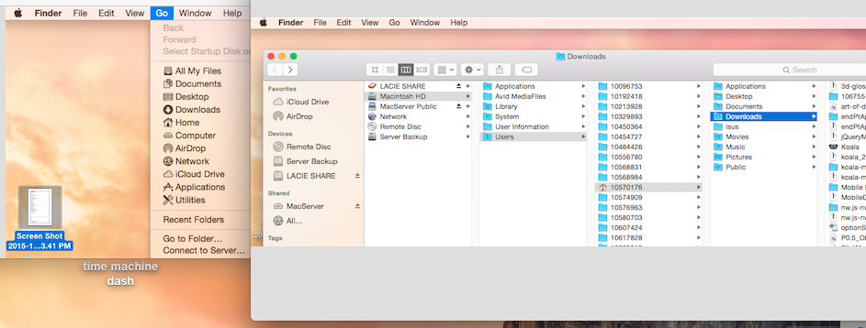

The applications opened through finder vs mac server would not recognize/share my desktop files even though the paths both went to the same app on the mac harddrive.

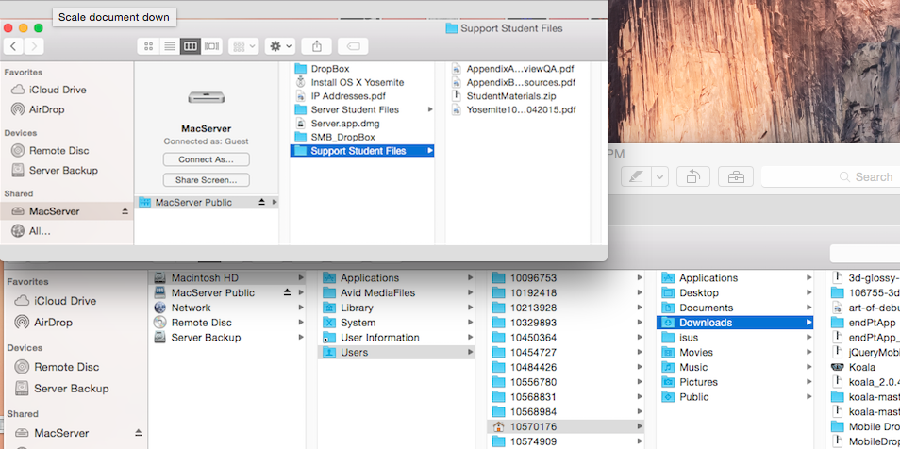

2

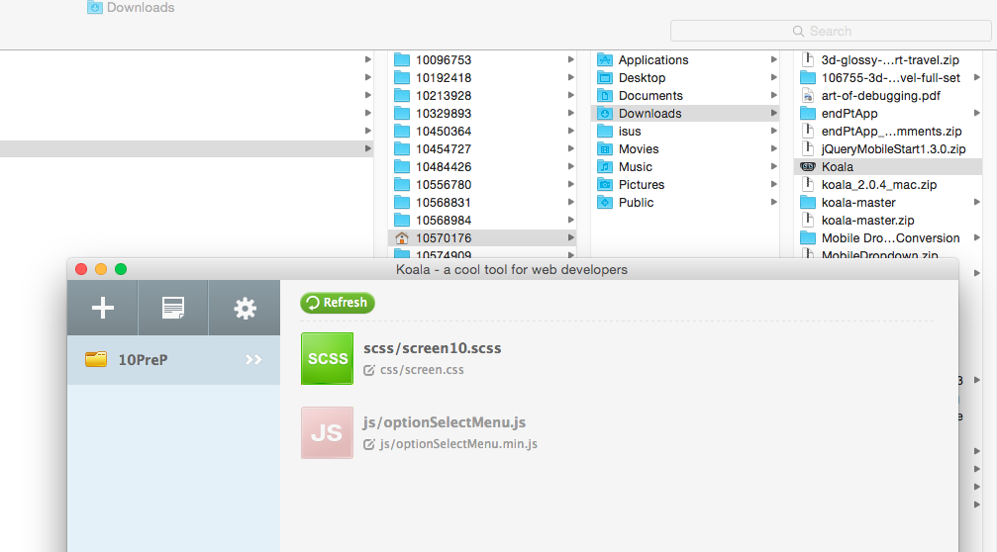

Hence this koala app on the mac hd would not communicate with the files on my lacie hd either. Sooo depending on which path the computer was using, it would insert the files it recognized – not what I was doing.

Evidently this is what was happening with the computer in 514 too. The koala app would not download to my lacie hd, But it did transfer from the mac hd to the lacie hd.

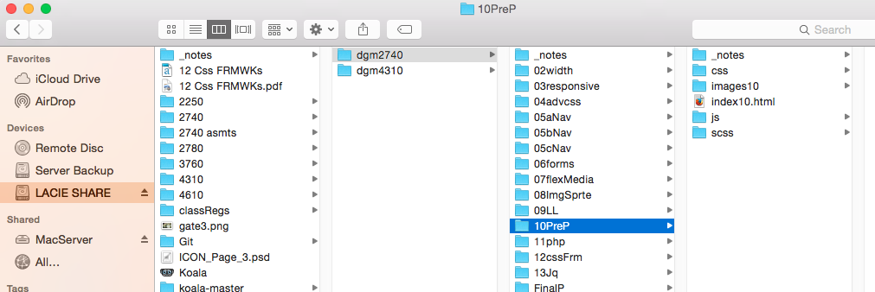

I think Cheney just thought I wasn’t watching the videos and doing it right, or paying attention. He figured out there was two mac paths yesterday, and showed me the mac server path. Maybe I can make some progress now. Also. . .

MY brand new two month old DOMAIN has been hi-jacked by a Spanish agency(theirs is growing exponentially too), hence none of my social media assn will Work. I was being to think I am just dense. Glad to know I’m not.

Only one of these listings is mine – no others existed when I got it. You should see what happened to my old domain.

