Beer Awards Analysis

Adriana Picoral

November 10, 2020

Table of Contents

# 1 Text Formatting

## 1.1 Examples of Text Formatting

You can format words in *italics* or **bold**.

* first item of a list
* second item of a list

1. first item in numbered list
2. second item in numbered list
3. third item in numbered list

This is quote

# 2 Beer Awards Analysis

Here’s what my data like (displaying first six rows).

|  |  |  |  |  |  |  |  |  |  |  |  |
| --- | --- | --- | --- | --- | --- | --- | --- | --- | --- | --- | --- |
| medal | beer_name | brewery | city | state | category | year | macro_category | state_area | region | state_name | state_division |
| Gold | Volksbier Vienna | Wibby Brewing | Longmont | CO | American Amber Lager | 2020 | lager | 104247 | West | Colorado | Mountain |
| Silver | Oktoberfest | Founders Brewing Co. | Grand Rapids | MI | American Amber Lager | 2020 | lager | 58216 | North Central | Michigan | East North Central |
| Bronze | Amber Lager | Skipping Rock Beer Co. | Staunton | VA | American Amber Lager | 2020 | lager | 40815 | South | Virginia | South Atlantic |
| Gold | Lager at World’s End | Epidemic Ales | Concord | CA | American Lager | 2020 | lager | 158693 | West | California | Pacific |
| Silver | Seismic Tremor | Seismic Brewing Co. | Santa Rosa | CA | American Lager | 2020 | lager | 158693 | West | California | Pacific |
| Bronze | Lite Thinking | Pollyanna Brewing Co. | Lemont | IL | American Lager | 2020 | lager | 56400 | North Central | Illinois | East North Central |

My data questions are as follows:

1. Which region in the US has received the most beer awards?
2. Which beer type has won the most awards across different regions in the US?
3. Which beet type has won the most awards across different years?

## 2.1 Awards per Region

First, we need to count how many beer awards per region.

# start with beer awards data, filter out DC  
# count awards (rows) per region  
beer_awards %>%  
 filter(region != "District of Columbia") %>%  
 count(region) %>%  
 arrange(-n) %>%  
 kable(col.names = c("Region in the US", "Total Number of Awards"),  
 caption = "Total number of awards per region (1987-2020)")

Total number of awards per region (1987-2020)

|  |  |
| --- | --- |
| Region in the US | Total Number of Awards |
| West | 2659 |
| North Central | 983 |
| South | 787 |
| Northeast | 537 |

We might need to consider the different number of states per regions.

# start with beer awards data, filter out DC  
# count awards per state and region  
beer_awards %>%  
 filter(region != "District of Columbia") %>%  
 count(state, region) %>%  
 group_by(region) %>%  
 summarise(average_awards = mean(n)) %>%  
 arrange(-average_awards) %>%  
 kable(col.names = c("Region in the US", "Average Number of Awards"),  
 digits = 2)

|  |  |
| --- | --- |
| Region in the US | Average Number of Awards |
| West | 204.54 |
| North Central | 81.92 |
| Northeast | 59.67 |
| South | 52.47 |

Going back to our data question (*Which region in the US has received the most beer awards?*), I would say that it is the West.

## 2.2 Analysis of Beer Types

Here’s a dictionary of beer types. Macro categories (also referred to as beer type) was defined by the words used in the variable category. See Table 1 for a reference of what categories are included into each beer type.

|  |  |
| --- | --- |
| Macro-Category | Explanation |
| Aged | Aged beers such as Fruited Wood- and Barrel-Aged Sour Beer |
| Ale | Ales such as American-Style Cream Ale |

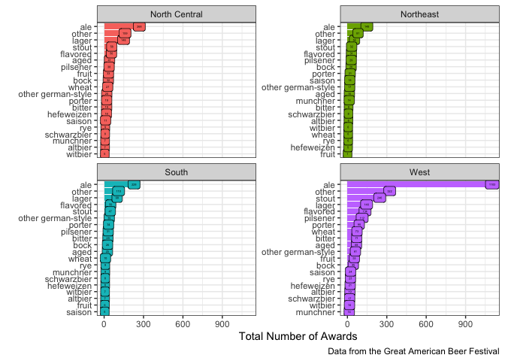

# get 5 types with the most awards  
beer_awards %>%  
 filter(macro_category != "other") %>%  
 count(macro_category) %>%  
 arrange(-n)

## # A tibble: 19 x 2  
## macro_category n  
## <chr> <int>  
## 1 ale 1750  
## 2 lager 447  
## 3 stout 383  
## 4 flavored 272  
## 5 pilsener 210  
## 6 porter 164  
## 7 aged 150  
## 8 other german-style 137  
## 9 bock 131  
## 10 bitter 128  
## 11 wheat 116  
## 12 fruit 93  
## 13 saison 58  
## 14 hefeweizen 52  
## 15 rye 47  
## 16 munchner 44  
## 17 altbier 41  
## 18 schwarzbier 41  
## 19 witbier 34

# count macro_category and year  
# draw line plot with x mapped to year, y to n, color to macro_category  
beer_awards %>%  
 filter(macro_category %in% c("lager", "stout", "flavored", "pilsener", "porter")) %>%  
 count(macro_category, year) %>%  
 ggplot(aes(x = year,  
 y = n,  
 color = macro_category)) +  
 geom_line(aes(linetype = macro_category))

