Analysis of Beer Awards in the US

Adriana Picoral

November 10, 2020

Table of Contents

# Formatting

## Text Formatting

You can make words **bold** or *italics*.

You can also underscore for **bold** or *italics*.

## Lists

There are two types of lists

* first bullet list item
* second bullet list item

1. first numbered list item
2. second numbered list item
3. third numbered list item

## Quotes

This is a quote from someone

# Beer Award Analysis

## Data Description

The data comes from the [Great American Beer Festival](https://www.greatamericanbeerfestival.com/the-competition/winners/).

# read data in  
beer_awards <- read_csv("data/clean_beer_awards.csv")

## Parsed with column specification:  
## cols(  
## medal = col_character(),  
## beer_name = col_character(),  
## brewery = col_character(),  
## city = col_character(),  
## state = col_character(),  
## category = col_character(),  
## year = col_double(),  
## macro_category = col_character(),  
## state_area = col_double(),  
## region = col_character(),  
## state_name = col_character(),  
## state_division = col_character()  
## )

#beer_awards <- read_csv("https://raw.githubusercontent.com/esoc214/fall2020_002_class_scripts/main/data/clean_beer_awards.csv")

## Data Questions

My data questions are as follows:

1. Which region in the US has the most beer awards?
2. Which type of beer gets the most awards across different regions in the US?
3. Which type of beer gets the most awards across different years?

## Number of Awards per Region

# start with beer_awards data and then  
# filter District of Columbia out and then  
# count region  
beer_awards %>%  
 filter(region != "District of Columbia") %>%  
 count(region) %>%  
 arrange(-n) %>%  
 kable(col.names = c("Regions in the US", "Total Awards"),  
 caption = "Total number of beer awards per region in the US.")

Total number of beer awards per region in the US.

|  |  |
| --- | --- |
| Regions in the US | Total Awards |
| West | 2659 |
| North Central | 983 |
| South | 787 |
| Northeast | 537 |

Regarding my first data question (i.e., *Which region in the US has the most beer awards?*), the West has the most awards.

## Beer Type per Region

There is a total of 515 categories of beers in this data. These categories were re-coded into 20 beer type (also called macro-categories). See table below for an explanation of these beer types.

|  |  |
| --- | --- |
| Beer Type | Explanation |
| Ale | Ales are any beers that have “ale” in their category name |
| Aged | Aged beers are beers that have “aged” in their category name |

As show in the figure below, the type of beer that gets the most awards across different regions in the US is *ale*.

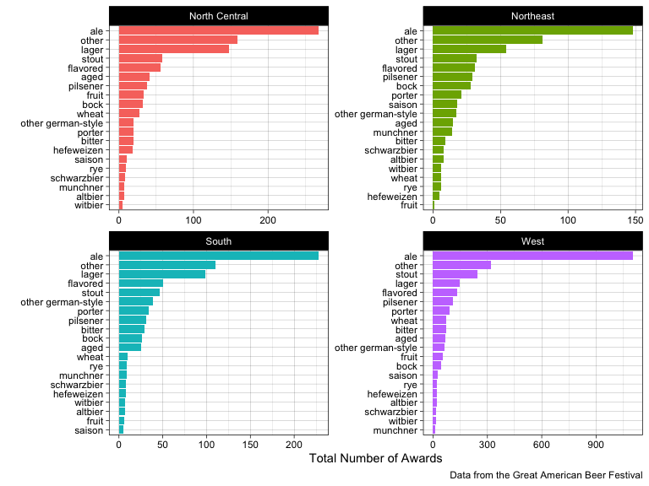

As shown in the figure below, the type of beer that gets the most awards across different years is Ale by far. For comparison, the plot also displays the beer types with the second and third most awards.

## Selecting by n

## # A tibble: 5 x 2  
## macro_category n  
## <chr> <int>  
## 1 ale 1750  
## 2 flavored 272  
## 3 lager 447  
## 4 other 672  
## 5 stout 383

