COMP3059 Capstone Project I
Sprint 4 (20%) - Due: Sunday, Nov. 29, 2020 (11:59 pm)
PART I -- MockUp/Prototype
Check Attachement

PART II -- Technology Requirements (as a Word document or a pdf)
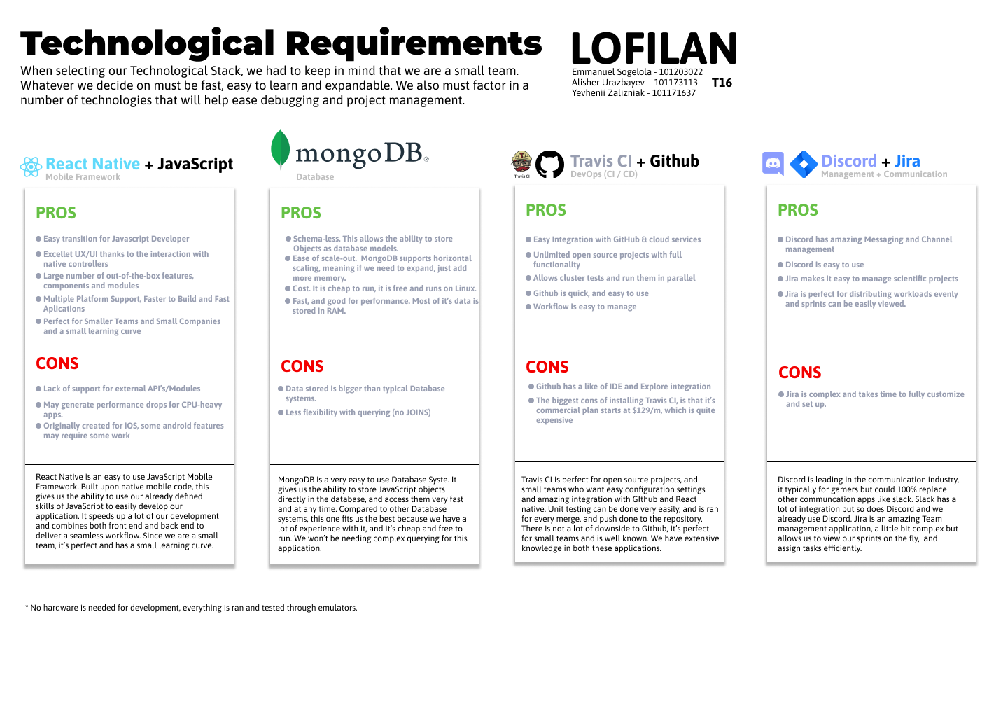
- Technological Requirements

- Learning Plan

Learning plan
Full Name | Yevhenii Zalizniak
Learning Plan Duration | Start: 18 November 2020 , End: 18 April 2021
Purpose | The main goal of the current task is to create a working prototype of the Lofilan Mobile Application
Technical Skills | Strong knowledge in Mobile application development with the following technologies: React native, JavaScript and TypeScript.  Understanding of DevOps principles (Travis CI and GitHub).
Responsibility | 1)Creating working porotype of Lofilan Mobile Application  2)Implementing features described in project outline and other referenced documents using React Native and JavaScript programming language.  3)Responsible for project management and overall development cycle management using Jira

Full Name | Emmanuel Sogelola
Learning Plan Duration | Start: 18 November 2020 , End: 18 April 2021
Purpose | The main goal of the current task is to create a working prototype of the Lofilan Mobile Application
Technical Skills | Strong knowledge in Mobile application development with the following technologies: React native, JavaScript and TypeScript  Understanding of DevOps principles (Travis CI and GitHub).  Experience working with design tools for web and mobile development such as Figma and Zeplin
Responsibility | 1)Creating working porotype of Lofilan Mobile Application  2)Implementing features described in project outline and other referenced documents using React Native and JavaScript programming language.  3)Responsible for front-end development and overall design of the current project

Full Name | Alisher Urazbayev
Learning Plan Duration | Start: 18 November 2020 , End: 18 April 2021
Purpose | The main goal of the current task is to create a working prototype of the Lofilan Mobile Application
Technical Skills | Strong knowledge in Mobile application development with the following technologies: React native, JavaScript and TypeScript.  Understanding of DevOps principles (Travis CI and GitHub).  Experience with Database script languages such as SQL and MySQL and MongoDB
Responsibility | 1) Creating working porotype of Lofilan Mobile Application  2) Implementing features described in project outline and other referenced documents using React Native and JavaScript programming language.  3) Writing queries, initializing and maintaining Database using MongoDB.

Evaluation guidelines:
Design of Mockup –> 20%
Functionality of Mockup –> 20%
Technology Requirements, Learning Plan 20%
Team Work (based on Peer Evaluation) –> 40%

For any documents submitted on Blackboard, use the following naming convention “F20_T<your team number>_<appropriate name>”. For example, F20_T33_MockUp.pdf, F20_T33_TechReq.doc

Only 1 submission per team is required.

