Project Identification

Project: | Lofilan Project
Prepared By: | Alisher Urazbayev
Document Version: | Version 1.01
Published Date: | October 06 , 2020

Contributors
The following individuals contributed to this document.
Name | Title
Alisher Urazbayev | High level requirements of Lofilan project(Version 1.01)

Distribution
This document is distributed to all the following people.
Name | Title
Emmanuel Sogelola | High level requirements of Lofilan project(Version 1.01)
Yevhenii Zalizniak | High level requirements of Lofilan project(Version 1.01)

Referenced Documents
This document refers to the following materials
Version number | Title | Author | Date | Source / Location
1.1 | Project Summary | Alisher Urazbayev | October 06,2020 | https://www.dfl.com/projectcontent/
1.2 | Project Vision | Yevhenii Zalizniak | October 06,2020 | https://www.dfl.com/projectcontent/

Revision History

Version Number | Revision Date | Summary of Changes | Modified by
1.01 | October 06,2020 | All major and minor changes | Alisher Urazbayev
[Note: It is recommended that drafts be numbered 0.1 to 0.9, and that the first approved version be numbered 1.0. Thereafter, new version numbers will depend upon changes: 1.01, 1.1, etc for minor updates, 2.0, 3.0 etc for major changes.]

TABLE OF CONTENTS
1. Business Context Diagram 3
2. REquirements Scope Statements 4
3. High Level Business Requirements (HLR) Traceability 4
4. High Level Business Requirements Sign-Off 5

- Business Context Diagram
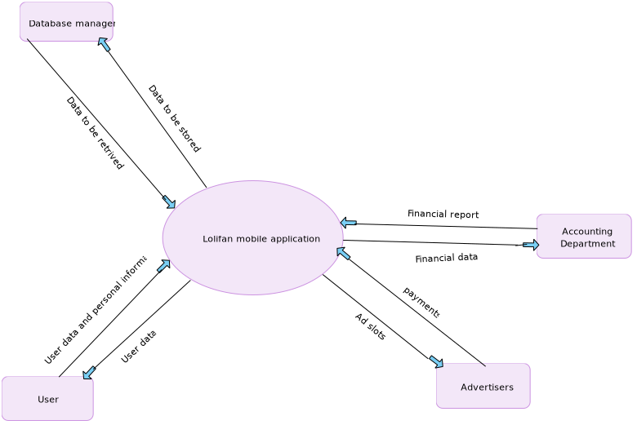

Requirement Scope Area | Description
Lolifan mobile application | This area is responsible to provide a mobile version of social network(posts, comments, user data, etc)

External Entity | Description
User | User can create a profile, share posts, likes and comments and able to use any social-network functionalities(designed for user’s use only)
Accounting department | Responsible for making financial reports, statements based on given data
Advertisers | Advertisers are a third party, which willing to pay in order to post an advertisement on mobile app in any way(short video, picture or gif)
Database manager | Responsible for storing , updating, retrieving and deleting user data or any data in general related to the project.

Information Flows | Description
User data | User data might represent personal information, posts, likes , videos, photos which are managed by user through Lolifan mobile app.
Payments | Payments received by a company for hosting ads on Lolifan mobile app. Payments might be received via checks , online transfer and direct deposit
Ad slots | They are provided by company, so third party can post ads on Lolifan mobile app in exchange for money.
Financial data | It provides important data in order to create financial reports and statements
Financial report | Financial report is a summary of given raw financial data.
Data to be stored | Important data which need to be stored or archived(might be user data, financial data, third party related data and so on)
Data to be retrieved | Archived or stored data , which need to be retrieved by user, any departments or by request of third party.
- Requirements Scope Statements
HLR# | Description | Priority  (H, M, L)
 | User must be able to sign up or sign in via gmail, mail . | H
 | User can create a personal profile , edit and design it as he wants. | H
 | User can share posts, likes , upload video materials and audio files. | H
HLR04 | User must be able to view any public posts , videos , and have access to audio files if it is matched by restriction parameters. | H
HLR05 | User can subscribe to any other users , invite to public or private groups and share files within it. | H
HLR06 | User can view likes, comments on his posts. | H
HLR07 | User can have access to local search engine in order to find necessary information. | H
HLR08 | User must be able to become admin of local group after creating public or private group. | M
HLR09 | Admin of group can delete and modify any data within his local group | M
HLR10 | Admin can invite and kick any users , who is part of the group , or wants to become. | M
HLR11 | User can provide or deny access to his location via app | L

- High Level Business Requirements Sign-Off
The undersigned acknowledge their agreement with the contents of Version 1.01 of the High-Level Requirements document for Lofilan Project.

Following approval of this document, requirements changes will be governed by the project’s change management process, including impact analysis and appropriate reviews and approvals, under the general control of the Project Plan and according to company policy. Approved Change Request Documents, if present, will be attached to this Requirements Document as updates.

Name | Project Role and  Functional Area | Date Signed
Alisher Urazbayev | Co-founder/CEO | October 06 ,2020

* Note: physical signatures are not required. Email approvals are acceptable and should be appended to project documents.

