Humana Kleidersammlung GmbH
Geo – user manual

motivation
The clothes collection operation uses different information systems and applications in order to maintain site-, tour- and adhering data relevant to the coordination of activities. Currently, the main database application (Coffee) is written around a set of IBM Lotus Approach (TM) views including procedural macros and scripts; all underlying databases use a dBase (TM)-compatible storage format.
This system has seen continual, successful use for many years, even though it suffers from limited capabilities in certain functional areas. Specifically, these are graphical planning tools, enhanced possibilities for distributed cooperation, interfaces for data export and applications as well as additional tooling.
The solution documented here enhances the existing system utilising free software and technologies such as the Google maps API (TM) and supporting javascript libraries; thusly introducing versatility renders the system more flexible overall.
Seen from a current standpoint, the implementation realises initial steps towards a migrative solution. While integrating more modern aspects of current information technologies (e.g. a partially decoupled user interface), it leverages the legacy static file-based data storage and lacks state-of-the-art networking capabilities, a more distributed data management and interfaces to third-party applications – further development work might focus on these areas.
One definite advantage of the chosen approach lies in its bridge function, as it can be used parallel to the installed system without a separate data storage. Overhead introduced by synchronisation of indispensable cache data has been automated and is scheduled regularly, although it can be triggered manually as well.

functionality
All implemented functionality is grouped roughly into aspects of site maintenance and the planning of established tours. Supplementing basic maintenance functionality, additional features include route optimisation and planning tools, site-related information (e.g. statistical evaluations, photos, shop- and warehouse locations, etc.) and address resolution.
- site-related features
- site maintenance
- retrieval and selection of established sites using different search criteria
- adding a contact
- display of supplemental information

- tour-related features
- tour maintenance
- visualisation and optimisation of established tours
- generating plans
- entering site yield data

- supplemental tools
- address search
- (manual) synchronisation of data
- export of geographical data (KML)
- generating yearly reports

site administration
- site maintenance
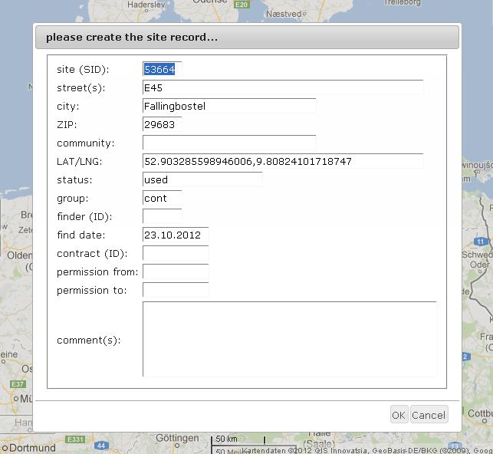
To add a new site, push, hold a shift-key and left-click on a location on the map. A dialog window presents relevant input fields or stored information, respectively. Note that the site identifier (SID) needs to be unique; the proposed input satisfies this requirement. Also, some fields need to be filled before a new record can be accepted.
Before editing a site, a selection must have been made. Push, hold a Ctrl-key while clicking on a site marker. Selected sites are displayed in grey colour. Stored site data may be edited by selecting the wrench from the toolbar.
In order to select multiple sites at once, an area must be defined first. Hold a Ctrl-key while clicking left on the map. Define an area by moving the cursor and left-click again to confirm your intention. Release the Ctrl-key first to cancel the procedure.
To delete a site, make a selection first. Select the rubbish can from the toolbar and confirm your intent in the following dialog.

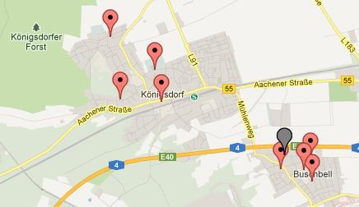
- retrieval of established sites using different search criteria
Use the search toolbar to query the database for sites by specifying a ZIP code, name of a community, or an identifier (either site- (SID) or container-specific (CID)). To use the latter option, the corresponding radio-button needs to be activated first.
Search result are displayed on the map with markers. Left-click on a site marker to bring up a window with further information. Also, the magnification glass in the toolbar triggers a search for nearest sites corresponding to a specified address.

- adding a contact
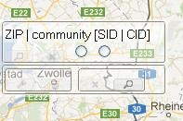
Use the contact record card in the toolbar to add a new contact. Note that not all of the form fields need to be completed in the ensuing dialog window; however, the specific identifier needs to be unique.

- display of supplemental information
Use the toolbar in the upper right corner. It offers useful information to be displayed on the map.

tour administration
- tour maintenance
Prior to establishing a new tour, a selection of sites must have been made. Note that unassigned (and therefore available) sites appear after using the magnification glass from the toolbar. Also, the search can be restricted using the database by providing a ZIP code, name of a community, a SID or CID (see above). Once a selection has occurred, click on the document in the toolbar. Provide a new identifier and confirm your intent.
To select an established tour, first select the corresponding tour-set from the list. Edit selected tours using the wrench from the toolbar. In the following dialog window, change the site order or (re)move sites between tours. To rename a tour, select the tour in question by double-clicking on it and providing a new identifier.
Selected tours are removed by using the rubbish can from the toolbar.

- visualisation and optimisation of established tours
Once a tour has been selected, start an optimisation cycle by clicking on the cogwheel icon. Decide whether the optimised site order should be stored immediately by activating the check-box first. Note that the calculation takes a while to complete (the complexity increases with the number of sites) and pertinent information will be displayed on the lower right hand side on the map afterwards.

- generating plans
After selecting a specific tour, use the clipboard function from the toolbar to download a corresponding tour sheet. Note that generating any particular tour-sheet for the first time takes some time to complete.

- entering site yield data
Upon completion of a tour, individual container yields may be entered by selecting the tour in question and clicking on the plus button in the toolbox. Make sure the correct calendar week has been selected before confirming any input.

additional tools
- address search
To zoom the map to a particular region, use the address bar and specify a location or address. Note that it is also possible to zoom-in on an area by using the controls in the upper-left corner (plus/minus) or by lassoing an area while holding down the Alt-key. Using the latter method will open a pop-up window with information about any enclosed sites.

- (manual) synchronisation of data
Should a manual synchronisation be necessary due to underlying changes in the database (through the legacy system or otherwise), reprocessing of specific data can be triggered manually. Choose a specific task (i.e. site, toursets, images) from the list. Note that due to reasons of efficiency, only a basic synchronisation is performed here.

- export of geographical data (KML)
Use this tool to download a data file containing specific information that can be visualised and processed further in various third-party applications (e.g. Google Earth (TM)).

- generating yearly reports
Use this tool to download a detailed report of collected amounts.

