Humana Kleidersammlung GmbH
Geo Search – user manual

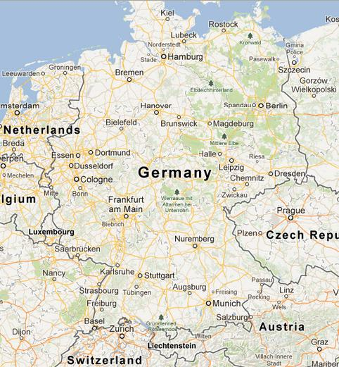

motivation
The clothes collection in Germany maintains a large number of containers. This application allows easy queries for site locations on the Internet.

functionality
The search function requires little explanation. Additionally, a search can be conducted on the basis of geo-coordinates.

site query
- address search
