Legal issues
Unit 3
Magistrates and small claims court


Contents

Unit 3: Magistrates and small claims court – teacher’s notes

Unit 3: Magistrates and small claims court – answers and transcript

Unit 3: Magistrates and small claims court – classroom resources

Unit 3: Magistrates and small claims court – audio

Copyright - please read
All the materials on these pages are free for you to download and copy for educational use only. You may not redistribute, sell or place these materials on any other website without written permission from the British Council. If you have any questions about the use of these materials please email us at: esolnexus@britishcouncil.org
Legal issues: Unit 2 magistrate’s and small claims courts – teacher’s notes
This unit focuses on common courtroom vocabulary. There is assistance with language to do with taking a case to the small claims court.

Level: Entry level 1-3 / Scottish Access 2 - Intermediate 1 / CEFR A1 - B1
Time: Approximately 95 minutes plus extensions. Timings are flexible and teachers can break down the units into smaller chunks of learning and build in revision as required.

Aims
- To further develop vocabulary related to the court and legal system.
- To be able to explain a case related to a small claims application and understand what is said to them.
Objectives
All learners will be able to:
- recognise a number of commonly used general legal terms relating to the courts –barrister, defendant, magistrate/ Justice of the Peace, claimant, small claims court, defence lawyer, prosecutor
- listen to and read a text for gist and detail
- recognise and use the phrase What does ...mean?
Some learners will be able to:
- recognise the words clerk and witness.(E3)

Preparation
You will need:
- a whiteboard, flipchart or interactive whiteboard (IWB)
- Resource 1: 1 copy for each learner to fill in and one blank for each pair of learners or display on IWB
- Resource 2:1 copy of both word and numbers cards cut up per pair of learners
- Resource 3: 1 per learner; part A one copy cut up per pair of learners
- Resources 4: 1 per learner
- Resource 5: 1 copy per E3 and Part A for E1/2 learners
- Audio: Legal Court System
- Resources 6: 1 per learner
- Transcript: 1 copy per learner (extension)
Tip! If you are teaching in a prison in Scotland, Justice of the Peace is the equivalent of a magistrate – please use this term if you are in Scotland.
For more background information to the lesson, you could look at the following websites
- http://www.scotland-judiciary.org.uk/38/0/Justices-of-the-Peace
- https://www.gov.uk/make-court-claim-for-money/overview
- http://www.adviceguide.org.uk/wales/law_w/law_legal_system_e/law_taking_legal_action_e/small_claims.htm
Procedure
Warmer (15 minutes)
- Focus your learners’ attention on resource 1 (courtroom scene). Elicit any court and legal vocabulary your learners already know. if you have completed Unit 1 and 2 of Legal issues, your learners should have come across these words e.g. guilty/ not guilty, appeal, arrest, sentence, court, solicitor, judge, case, legal aid.
- Write up on the board with a simple definition.
Differentiation
- Higher level learners: ask them to write definitions of the vocabulary they know on A4 or A3 sheets. Stick these on the wall then get learners to read, explain and ask questions to each other.
- Lower level learners: provide definitions for learners of the words used in previous units and ask learners to match them in pairs.
Activity 1: Courtroom vocabulary (15 minutes)
- Put learners in groups with others of the same level.
- Display resource 1 picture and give learners a copy of resource 2 (word cards) point to number 1 (defence lawyer) and elicit the answer.
- Ask learners in pairs to discuss possible matches with the word cards.
- Feedback by eliciting possible answers. If not known, provide support by saying a number and giving two word options and learners have to opt for the one they think is correct.
- Finally ask which people in the room are barristers (5) and learners can note that on their sheet also.
- Drill the words and make sure learners can say them clearly, with appropriate word stress on longer words.
- Ask the learners to write the words in the correct boxes.
- Display resource 3 and elicit the answer to one definition.
- Give learners the cut up words and definitions ask them to match them.
Differentiation
Literacy learners: read the words to learners or ask learners who can read to do so.

Activity 2: courtroom vocabulary consolidation (15 minutes)
- Use the cut up five numbers on resource 2. Give a set to each pair. Also give a blank copy of resource 1 or show it on an IWB. Tell learners to cover their version of resource 1 with the answers.
- In pairs, one learner should turn over a number card and their partner has to look at resource 1 and say the vocabulary item which corresponds with the number on the courtroom picture. Work through all the numbers with one partner before swapping over.
- Look at resource 3 part B. Learners should read each box and decide which person or thing in resource 1 it is describing. Using the words on resource 1, match the corresponding word to the description.
Differentiation/ extension
- Learners who are already working confidently with the vocabulary from Activity 1: give the following task instead of or in addition to learners have completed resource 3 part B, write down the words witness and clerk and ask them to look it up and the dictionary, write down the definition and then try to match to appropriate people in the picture.
- Ask learners to write sentences using the new vocabulary items.
Activity 3: reading – using the small claims court. (10 minutes)
- Display resource 4. Discuss what items they can see in the pictures: the pictures tell a story about a prisoner but are not in order.
- Group learners with others of the same level Put stronger learners in pairs and ask them to fold over the text and look at the pictures only. Ask them to tell their partner what they think happened in the story.
- Now ask learners to read the story of the prisoner. You may need to regroup learners at this stage (see differentiation below).
- Then learners should then match the numbers in the text to the corresponding picture.
- Group learners with others of the same level, ask learners to fold the text under again and retell the story in the correct order. Listen to them afterwards to check for past tense and appropriate vocabulary.
- Ask the class if they have any knowledge or experience of the small claims court and ask what differences they know about the small claims and a magistrate’s court. Try to elicit how they think they can go about making a claim and who can help them.
Tip! If learners do not know much, explain that the prisoner will probably not have a solicitor to help (unless he or she wants to pay for one). Prisoners can fill in the form themselves and post it to start the process. He or she may appear by video link from the prison with a judge.
Differentiation
- Telling the story stage: once stronger learners are telling the story, support weaker learners to do the same.
- Reading the story stage: pair weaker and stronger readers to read aloud, if necessary.
- If learners finish quickly, they can answer the comprehension questions about the story at the bottom of resource 4.
- Retelling the story stage: while stronger learners are telling the story, weaker learners can answer the comprehension questions about the story at the bottom of resource 4.
Activity 4: listening – a small claims court form (20 minutes)
- Group learners with others of the same level then ask learners where they might go for help if they haven’t got a solicitor: the prison librarians can help with some issues (see Unit 2: Making a complaint)
- Tell learners they’re going to listen to Aleks asking the librarian for help. Listen to the audio the first time and ask learners gist question: ‘What does he want help with and why?’ (answer: help to fill in a form for small claims court because he didn’t get his sister’s money)
- Hand out resource 5 (small claims court form). Ask the learners to listen and fill in the missing details as indicated on the form. Play as often as required.
- Go over the answers and deal with any listening issues arising. See transcript for answers.
Differentiation/ extension
- E1/2 level learners can fill in part A and E3 can fill in both parts.
- Higher level learners: give a copy of the transcript to read. They could read and listen and/ or act out the story.
Activity 5: Small claims role play (10 minutes)
- Look at resource 6 role play resources. This builds on Unit 1 and 2. One learner should be the prisoner and the other the librarian. The librarian should help the prisoner to fill in the form with his or her own details. Swap roles.
Differentiation
Pair weaker and stronger learners to do this once then pair learners of the same ability so that all learners get a chance to practise at their own level.
Cooler: What does ..... mean? (10 minutes)
- Listen to the audio recording again and elicit from the learners the phrase used to ask for a meaning. Write the four examples on the board and drill briefly.
- Hand out the word cards from resource 2 to six different learners in the class.
- Ask the learners with a card to ask another member of the class what it means using the phrase with correct word order i.e. not What does mean defendant?
Extension: Form filling
- Learners could fill in their own small claims court form about some money that has gone missing but they have been unable to get it back through the normal prison procedures.
Suggested answers
Resource 1
1. defence lawyer | 2. magistrate/ Justice of the Peace | 3. prosecutor | 4. defendant | 5. barrister
Resource 2 Part A
1. barrister | b) the name for lawyers and prosecutors who work in court
2. magistrate | e) he or she is like the judge and decides if he/ she is guilty
3. prosecutor | d) he/ she tries to make the defendant be found guilty
4. defence lawyer | a) he/ she helps the defendant not to go to prison (when the magistrate find them not guilty)
5. defendant | c) he/ she does the crime
Resource 2 Part B
1. magistrate / JP | 2. defendant | 3. prosecutor | 4. defence lawyer
Differentiation: the witness is in the witness box (left) and the clerk is woman sitting centrally.
Resource 4
  4 |  |   2 | 
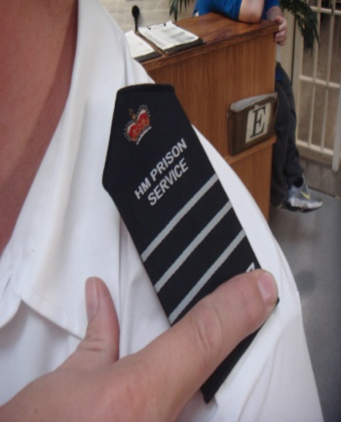 | 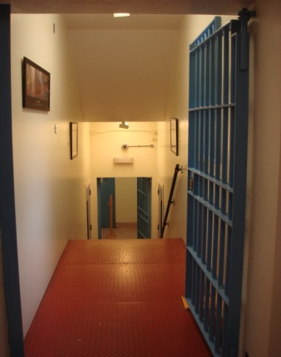  1 |   3

Activity 5 – Asking for meaning
- What does ‘claimant’s name’ mean?
- What does ‘defendant’ mean?
- What does ‘brief details of claim’ mean?
- And what does ‘value’ mean?

Transcript
Activity 4 – Aleks and the librarian
Aleks: Can you help me fill in this form?
Librarian: What are you doing?
A: I want to go to the small claims court.
L: Why?
A: My sister sent me some money in a cheque but I didn’t get it. It isn’t in my account. I think the prison have lost it but they say they haven’t. I want a judge to help me get the money back.
L: OK, I can help you with the form.
A: What does ‘claimant’s name’ mean?
L: You are the claimant so put your name and address here.
A: OK My name: Jin J-I-N Jun J-U-N Park P-A-R-K. How do you spell the address?
L: The prison address is H-M-P Rye that’s spelt R-Y-E, West Hill, that’s spelt W-E-S-T- H-I-L- in York Y-O-R-K and the postcode is YO20 5TH
A: Thanks. What does ‘defendant’ mean?
L: That means the other person, not you – the person who has your money. In your situation that is the Ministry of Justice. Their address is 102 Petty France London SW1H 9AJ
A: What does ‘brief details of claim’ mean?
L: Brief means short. You need to write short details of the problem.
A: OK. My sister sent me a £50 cheque in October but I didn’t receive it. Great. And what does ‘value’ mean?
L: Value is how much money your sister sent you.
A: Well, that’s £50.
L: Good. Well you’ve only got a little bit more to fill in now.....

Resource 1
2
4

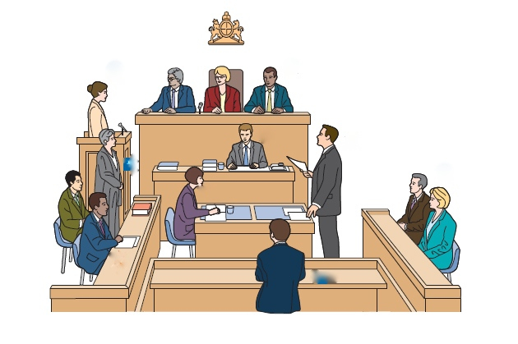
3

1

5
4

Resource 2

prosecutor | magistrate | defendant
Justice of the Peace | barrister | defence  lawyer
1 | 2 | 3
4 | 5

Resource 3
A
1. barrister | a) he/ she helps the defendant not to go to prison because the magistrate find them not guilty
2. magistrate | b) another name for defence lawyers and prosecutors who work in court
3. prosecutor | c) he/ she does the crime
4. defence lawyer | d) he/ she tries to make the defendant be found guilty
5. defendant | e) he or she is like the judge and decides if he/ she is guilty

2. I did the crime. Maybe I will go to prison.
1. I make the decision about the defendant – guilty or not guilty.
B

3. I don’t help the defendant. I am against the defendant.

4. I help the defendant.
Resource 4
 |  |  | 
 |  | 
Fold here

I left my last prison (1) a year ago. I had lots of things to take home with me like my bedding and a TV (2). The prison said the bedding and the TV did not belong to me because they were not on my property sheet. They took them away from me and it was difficult to get them back. So I filled in a form (3) for the small claims court and a judge (4) helped me to get my things back from the prison.
Story adapted from Inside Time article ‘Confiscated Property’. Jan 6th 2015

1. Is the man in prison now?

2. What two things did the prison keep?

3. How did he get them from the prison?

4. What was the name of the court that helped him?
Resource 5
A. Claimant(s) name(s) and address(es) (including postcode)

Jin ..........................................................................................................................................

HMP ........................................................................................................................................

Defendant(s) name(s) and address(es) (including postcode)

Ministry of Justice, 102 Petty France, London SW1H 9AJ

Brief details of claim

My ............................... sent a cheque in ................................... but I didn’t receive it.

Value ...........................

N1 Claim form
B. Claimant(s) name(s) and address(es) (including postcode)

.................................................................................................................................................

.................................................................................................................................................

Defendant(s) name(s) and address(es) (including postcode)

............. Petty France ,..............................................................................................................

Brief details of claim

My sister .................................................................... but ........................................................

Value ........................

N1 Claim form

Resource 6
A. Claimant(s) name(s) and address(es) (including postcode)

..................................................................................................................................................

..................................................................................................................................................

Defendant(s) name(s) and address(es) (including postcode)

Ministry of Justice, 102 Petty France, London SW1H 9AJ

Brief details of claim

........................................................................................................................................................................................................................................................................................................................................................................................................................................................Value ...........................

N1 Claim form
Roleplay card A  You are the librarian. Help the prisoner to fill in the form. Ask questions to get the information to fill it in. | Roleplay card B  You are the prisoner. You did not get a £20 cheque for your birthday from your friend. The librarian will help you fill in the form.

