Using the library

Topic: Making the most of the prison library
Level: Entry 1 - Entry 3 / National 2 - 4
Time: minimum 90 minutes

Aims
- To develop students’ ability to read and understand information about library services in prison
- To take part in a discussion about different services and activities in the library
- To ask for information about library services

Objectives
All learners will be able to:
- understand vocabulary for talking about different services on offer at the library
- read a library newsletter and answer simple comprehension questions
- exchange opinions about library services
- ask for information in the library

Entry 2 and above learners will be able to:
- answer detailed comprehension questions about a newsletter
- exchange more complex opinions about the library services
- ask more detailed questions about the library services

Introduction
This lesson is about using the library in prison. It provides students with authentic reading practice, in the context of a library newsletter and prepares them for a visit to the library, to explore what there is for ESOL learners.

Tip! When booking a library visit, be careful with the time – you may get caught on lined route if you stay too long in the library. Be aware of how long library sessions are allowed to last and be realistic about whether your learners will be able to do everything in one visit.
You will need:
- Realia: gather a variety of material available from your own prison library – e.g. talking books, readers, graphic novels , information about different services
- A large cloth to cover the realia for the memory game
- Resource 1: to display on interactive whiteboard, overhead projector or A3
- Resources 2a and b: 2a is Entry 2 and above, 2b is for Entry 1 – 1 copy per learner according to level
- Resource 3a and b: 3a is Entry 2 and above, 3b is for Entry 1 – 1 copy per learner according to level
- Resource 4: 1 copy for extension
- Resource 5: 1 copy cut up for each pair or group of three

Procedure

Warmer (10 minutes)
- Display resource 1 on the interactive whiteboard, overhead projector or A3 sheet.
- Elicit what the pictures show: the library, CDs and DVDs and bilingual dictionaries.
- Ask the learners: ‘Apart from reading books, what else can you do or get in a library?’ Allow 2 minutes for brainstorming in groups, and then ask them to share their ideas.

Activity 1 – Pre-reading vocabulary and reading (20 minutes)
- Focus learners' attention on the pictures and look at the pictures together. Elicit what they could be referring to.
- Put learners into groups according to their reading level, so that you can manage the instructions and feedback more easily then hand out Resource 2a.
- Learners read through the subheadings 1-6 and write the number of the subheading next to the picture.
- Next, focus learners on the Library News text and the spaces for the subheadings.
- Model the first one together as an example then ask the learners to individually skim read the paragraphs and write the subheadings in the correct spaces.
- Ask learners to compare their answers then feedback to the group.
Differentiation
- Entry 1 learners have a simplified version of the activity (Resource 2b) which is very similar to the higher level one. Allow the learners to work in pairs if need be.
- At the feedback stage, use the lower level version to check as the higher level learners will be able to match it more easily.

Activity 2 – Reading (20 minutes)
- Display resource 3b (lower-level version), task 1: true/ false questions and explain that sentence 'a' refers to paragraph 'a' in the Library News text, sentence 'b' to paragraph 'b', etc.
- Model the first one together as an example.
- Hand out resource 3a and tell learners to read the sentences, underline the key words and decide if they are true, according to the text.
- They should write T for true, F for false.
Differentiation
- Entry 1: there is a simplified version of the questions (Resource 3b).
- Literacy: read the Library News text together as a class. You could ask more confident readers to read a section each aloud, to practise literacy skills. This allows weaker readers to follow while listening.
- Point out the text features that help them find important information e.g. bold subheadings, bullet points, italics.
- If you have a peer mentor in class, he could support beginner readers with practising reading skills.

Extension / homework
- If learners finish quickly or for homework, hand out resource 4. Learners can look at the pictures and complete the words with the missing letters. Afterwards, encourage them to copy and say the words.
- Focus learners' attention on the summaries in resource 4, task 1.
- Read the first one and elicit which paragraph it matches.
- Now tell them to match each summary to a paragraph
- Focus learners' attention on the comprehension questions in task 2.
- Check they understand what to do and encourage them to work independently here.
- They can check their answers together afterwards.

Activity 3 – Speaking (10 minutes)
- Display the questions and answer speech bubbles from task 2 on resource 3 (a or b depending on the overall level of the group on the board) and ask learners to read the speech bubbles and match the questions and answers.
- Drill the question and answers for pronunciation.
- Ask the questions to one or two learners to elicit different ways of completing them e.g. 'I think it's a good idea to…'; 'Are you interested in….?'; 'I like……'.
- Ask somebody else to respond, to generate a bit of discussion.
- Focus their attention on the Library News – many of the subheadings are questions. Tell the learners to discuss the questions in groups. They can use the phrases in the speech bubbles for support.

Differentiation
Pair weaker learners with stronger learners.

Activity 4 – Vocabulary memory game (Kim's game) (10 minutes)
- They can play in pairs or teams and you can demand as much detail as appropriate (e.g. film titles).
- Use the realia you put on a table with a cloth over it. Tell the learners you will take the cloth away for 1 minute, then replace it.
- They should have a good look at the things and try to remember as many as possible.
- They get one point for each thing they remember correctly.

Activity 5 – Grammar game (10 minutes)
- Tell the learners they are going to visit the library and ask for information, but first they have to make the questions.
- Put question verb forms on the board: do you; can you; is there; are there;
- Elicit some question words/phrases - e.g. where, when etc.
- Focus learners' attention on the example in Resource 3, task 3 (reordering activity). Use 3a or b depending on the overall level of the group. Check they understand they must use each word one time.
- Check the answers as a whole class afterwards.
Tip! You could make this into a game. Put the learners into teams and make them race to get the correct word order.
Differentiation/ Extension
- Use Resource 3a, task 3 with lower learners.
- Challenge higher level learners to make more questions and then exchange to do some peer corrections for word order or auxiliary verbs. They can use the realia to help them think of ideas for what to ask about.

Extension – Library visit
- The class should ideally then visit the library and ask their questions. Make sure they write their answers down during the visit.
- If this is their first visit, Encourage learners to join the library and borrow something.
Tip! If you couldn't arrange a library visit for this session, use the realia to set up a librarian / learner role-play.
- Put the learners in pairs and get them to take turns to ask and answer the questions they have prepared, using the items on the table. Model the role-play first with a volunteer learner.
- Allow confident learners the chance to ‘perform’ their role-play in front of the class.

Cooler (10 minutes)
- Learners look at the resources they brought back from the prison library, individually or in pairs. They can tell each other or the class what they chose and why.
- Learners then compare answers to their questions, in groups. They feed back to you about their opinion of the different services available.

Extension activities/ homework
- Watch a DVD, listen to a story or borrow a book and write about it: include the title, the main characters' names and their opinion of it.
- Write a story about a dream.
- Make a poster for the library, to put on the wing, with details of services and opening times.
- Find out what other things you can do in your prison library and inform learners (see list in answers). If you arrange another trip to the library encourage learners to do some of the activities.

Answer key
Warmer
This is a list of things your learners may be able to do in the library. Please check with your prison library which ones are available in their library.
Read and borrow books; read magazines and newspapers; get information and help from the librarian; watch and borrow CDs and DVDs; look up information from reference books e.g. dictionaries and legal publications; study lots of subjects e.g. history; use a computer, other activities – you may not be able to print.

Activity 1
1b; 2f; 3c; 4a; 5d; 6e

Activity 2
a F; b F; c F; d T; e T; f T

Activity 5
- Are there any competitions?
- Where are the magazines?
- Do you have any talking books?
- What different services are there?
- How many books can I borrow?
- Are there any books for ESOL learners?

Resource 4: Extension
Task 1: 1. a 2. f 3. e 4.d 5. b 6. e

Task 2:
a. under 10 b. posters on the wings c. photograph it for you
d. every year e. monthly f. information about life in prison and on release

Extension activity
This is a list of things other things you may be able to do in the library.

Attend a 'story book dads'; make photocopies e.g. from legal reference books – you may have to pay for this; learn a new language; do crafts; find a best seller; get help about jobs; create a CV; study in a (relatively) quiet place; get books in large print or easier reading books; read graphic novels; join a book discussion group; read a local newspaper; reserve books that you want; find information from the Notice Board; order things you want which are not in the library.

Resource 1: Picture warmer

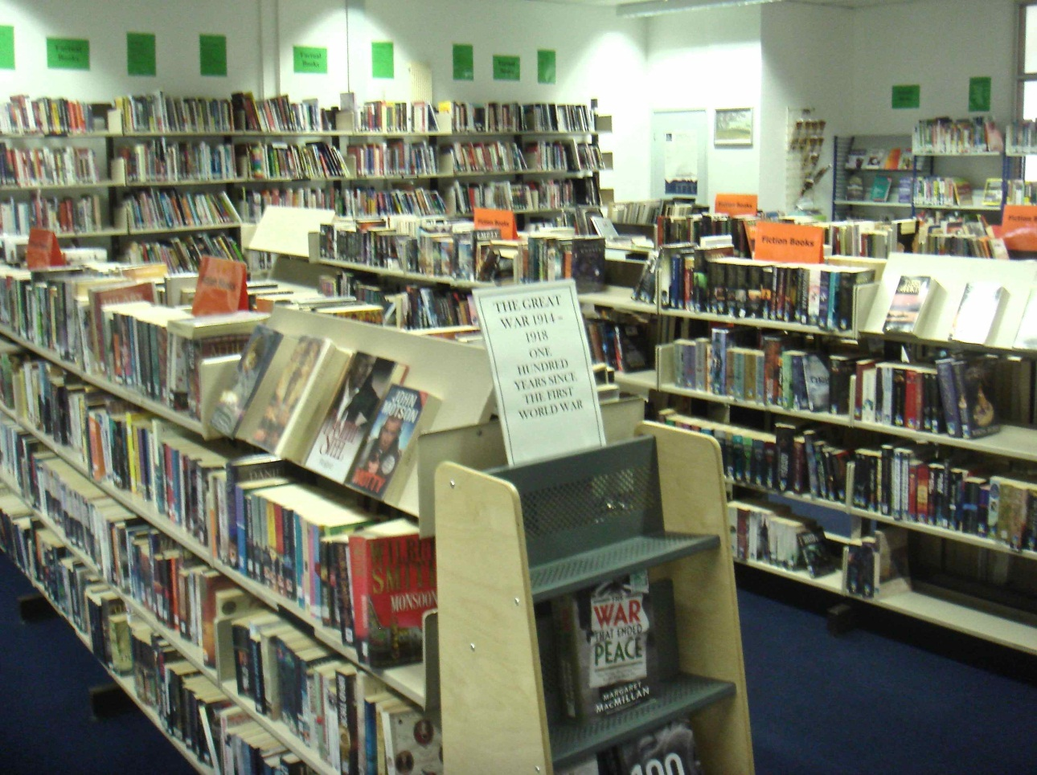
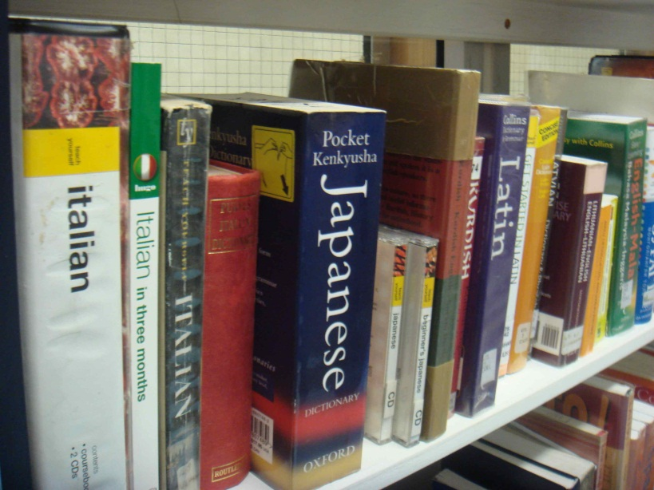
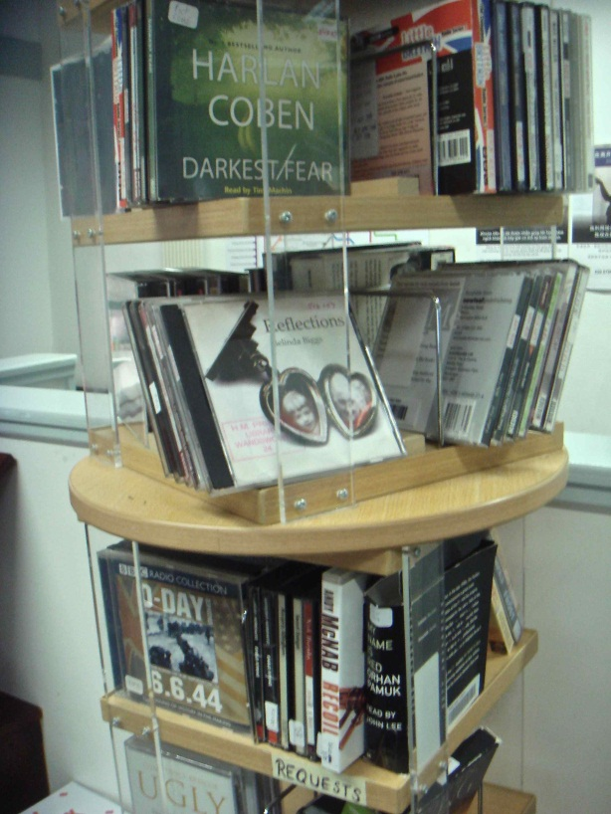

Resource 2a: Reading
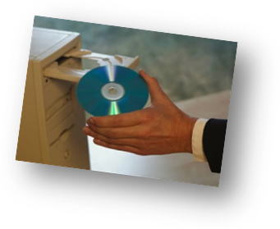
- Library services: more than just books!

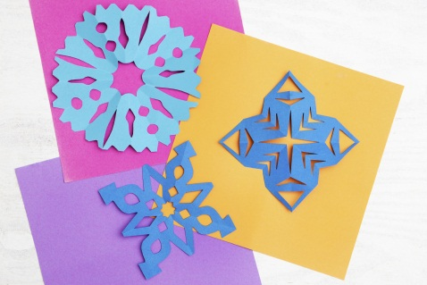



- Cards and crafts
- News and information
- Library magazine
- Storybook parents
- CDs and DVDs
- Win a prize

Library News  a. ________________________  Are you a parent? Do you have children under ten?  Now you can make a story CD for them, so they can hear your voice. Record a bedtime story and send it to them on a CD. Ask in the library for more details. | b. ___________________________  Do you want to make a card for your loved one?  Come to one of our craft classes in the library- we offer card making, model making, puppet making and much more. Look out for posters about classes on the wings.
c. ________________________  Do you have a story, something funny or a picture to share? Why not put it in our monthly prisoner magazine?  Please give your work to our librarian. If your art is too big or 3D, we will photograph it for you. | d. _____________________________  We have a large selection of talking books on CD, if you like listening to stories.  We also have DVDs you can watch on one of our computers  Enhanced prisoners only.
e. __________________________  Do you enjoy writing, drawing or making things? Do you want to win something?  Then enter our annual Arts competition! This year's theme is 'dreams': write or draw your dream.  - Ask the library staff for an entry form.  - Closing date 14th April. | f. ______________________  We also offer up to date prison newspapers and information about life in prison and on release. Ask an orderly for help.


Resource 2b: Reading

- Library services: more than just books!





- Making things
- News and information
- Prisoner magazine
- Stories for children
- Competition
- CDs and DVDs
Library News  - ________________________  Are you a parent?  Record a bedtime story on a CD. Ask in the library for more details. | b. ___________________________  Do you want to make a card for your loved one?  Come to our card making classes. Look for posters about classes.
c. ________________________  Do you have a good story or picture?  Why not put it in our monthly prisoner magazine?  Please give your work to our librarian. | d. ___________________________  We have lots of books on CD, if you like listening to stories.  We also have DVDs you can watch on one of our computers
e. __________________________  Do you enjoy writing, drawing or making things?  Then enter our Arts competition! This year write or draw your dream.  - Ask the library staff.  - Closing date 14th April. | f. ______________________  We also have newspapers and information about life in prison and after. Ask an orderly for help.

Resource 3: Comprehension questions (Entry 2 +)
Resource 3a: Comprehension questions

- Read the sentences about the Library News. Are they true or false?

- Storybook parents is for mothers and fathers.
- Card-making classes are on the wings.
- You can only send writing in to the magazine.
- Only enhanced prisoners can watch DVDs.
- You need to fill in an entry form for the arts competition.
- If you want other information, an orderly will help you.

- Talk to your group
Storybook parents looks good…
What are you interested in?

Why?
It's a good idea to make a CD for your kids.
My kids like stories
Do you enjoy writing, drawing or making things?

Not really. I'm not good at Art. I like music.

- Work in pairs. Reorder the words to make questions to ask in the library for more information.
Example:
card /here /Do/ have/ making /any/ you/ classes/?/
Do you have any card making classes here?

- competitions/ are/ any/ there _______________________________________
- the / where/ magazines/ are ________________________________________
- any / you/ talking / do/ books/ have __________________________________
- different/ what / are / services/ there _________________________________
- many/ I/ how/ books/ borrow/ can ___________________________________
- any/ learners/ are/ for/ there/ ESOL/ books ____________________________

Resource 3b: Comprehension questions

- Read the sentences about the Library News. Are they true or false?

- ‘Stories for children’ is for mothers and fathers.
- You can only send writing in to the magazine.
- You need to fill in a form for the competition.

- Talk to your group
Storybook parents looks good…
What are you interested in?

Do you enjoy writing, drawing or making things?

Not really. I like music.
Why?
It's a good idea to make a CD for your kids.
My children like stories

- Work in pairs. Make questions to ask for more information in the library.
Example:
card / here / Do/ have/ making / any/ you/ classes/ ?/
Do you have any card making classes here?

- the / Where/ magazines/ ? / are
_____________________________________________
- any / you/ talking / Do/ books/ have/ ?
______________________________________________
- many/ I/ How/ books/ borrow/ can/ ?
______________________________________________
- any/ learners/ Are/ for/ there/ ESOL/ books/ ?
_______________________________________________

Resource 4: Extension/ homework

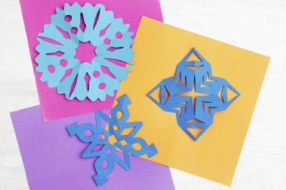


D_D


c_rds and cr_fts


_nformation w_n a pr_ze

r_ _ d a story b_ _k m_g_zine

- Read the Library News text and match the summaries below to the paragraphs. Write the paragraph letter next to the summary.

- Make a bedtime story CD for your children.
- There is also other information at the library.
- Enter a competition about 'dreams'.
- You can borrow audio and video discs.
- There are different craft activities you can do.
- You can do something for the prisoner magazine.

- Now answer the questions about the library services.

- How old should the Storybook dads' children be?____________________

- How do you find more information about the cards and craft classes?
__________________________________________________________

- What will the library staff do if you want to show your 3D model in the magazine? ____________________________________________________________

- How often is the Arts competition?________________________________

- How often is the prisoner magazine printed?_________________________

- What other information can you get in the library? ____________________

Resource 5: questions to ask in the library - to cut up

Are | there | any | competitions | ? | Where
are | the | magazines | ? | Do | you
have | any | talking | books | What | different
services | are | there | ? | How | many
books | can | I | borrow | ? | Are
there | any | books | for | ESOL | learners
? | ?

