1. Main Screen of the game

* 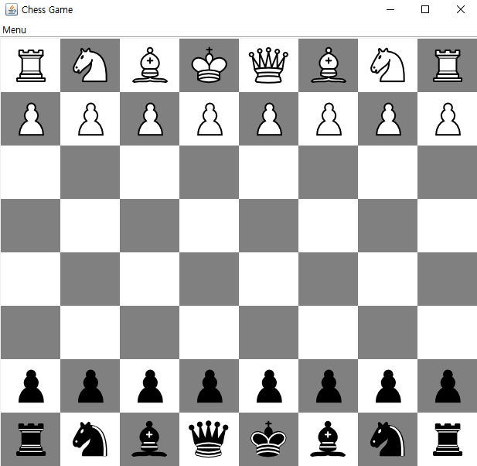Main screen of the game should look like this: minimize, maximize and close button at top right corner, Menu bar at left corner.
* The main screen should contain total 32 chess pieces, 16 black pieces and 16 white pieces, at standard chess pieces’ location like the screenshot at left.
* Size of the chess board should be 8 x 8.

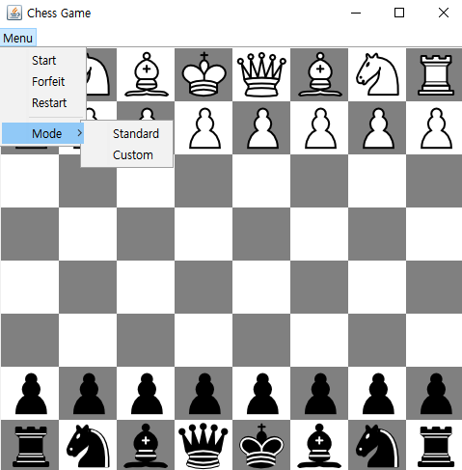2. Menu bar

* If a user clicks a menu bar, it shows 4 menus: Start, Forfeit, Restart and Mode menus in that order.
* Under the mode, there are two modes, Standard and Custom.
* Any other settings remain the same

3. Standard and Custom

* Clicking Standard menu set up standard chess pieces like this
* 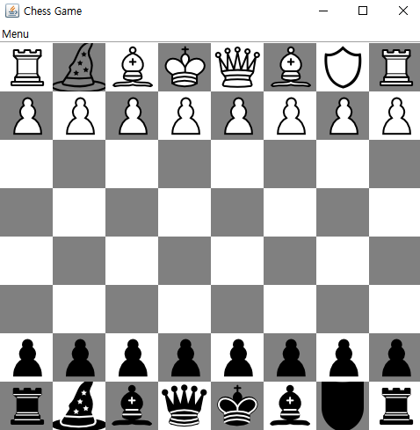Clicking custom menu replace the knights with witches and guardians like the left screenshot.

4. Menu items’ click event

* 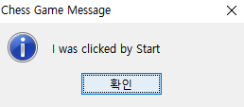When a user clicks items following three message boxes must be popped up.

↑ When Start menu is clicked

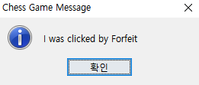

↑ When Forfeit menu is clicked

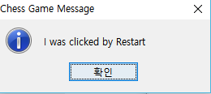

↑ When Restart menu is clicked