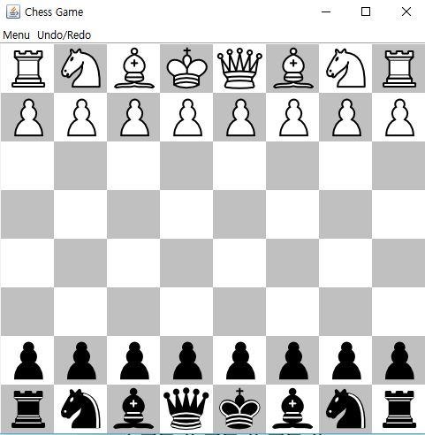1. Main Screen of the game

* Main screen of the game should look like this: minimize, maximize and close button at top right corner, Menu bar at left corner.
* The main screen should contain total 32 chess pieces, 16 black pieces and 16 white pieces, at standard chess pieces’ location like the screenshot at left.
* Size of the chess board should be 8 x 8.

2. Menu bar

* 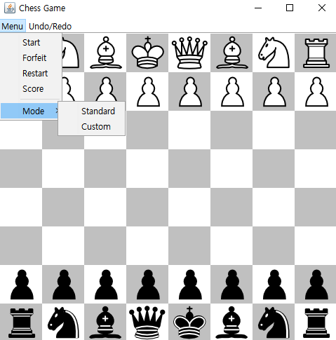If a user clicks a menu bar, it shows 4 menus: Start, Forfeit, Restart, Score and Mode menus in that order.
* Under the mode, there are two modes, Standard and Custom.
* Any other settings remain the same

2.1 Start

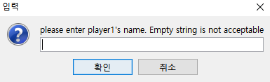

* If a user clicks the start button, input dialogue pops up and asks to put the name of the player.
* 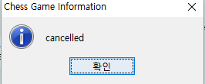If a user enters empty string or the name of the other player, it asks to re-enter the name.
* If a user clicks cancel button, it displays cancelled dialogue.

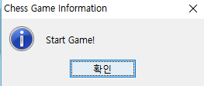

* After entering names, it displays “Start Game!”
* If players repeat the game after the first game, the game do not ask for name of the players anymore.

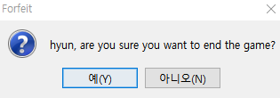2.2 Forfeit

* If a player clicks forfeit button, the game waits until the player answers the question.
* 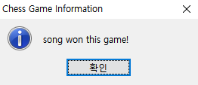If the player clicks (Y), then other players win the game and the winning information dialogue pops up
* And then, score of the winner increase by 1.
* 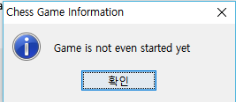If a player tries to forfeit the game when the game is not started yet, then the dialogue at left pops up.

2.3 Restart

* 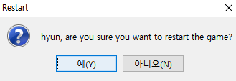When restart button is clicked, the game asks for both players.
* 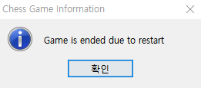If both players agree to restart the game, “Game is ended due to restart” message is displayed
* If a player tries to restart the game when the game is not started yet, then the “Game is not even started yet” message is displayed.

2.4 Score

* 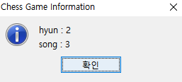If score button is clicked, the system displays the score of both players.

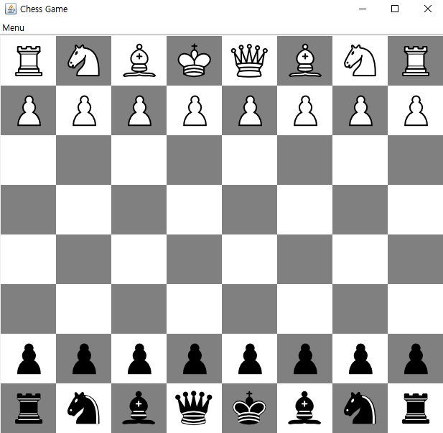3. Standard and Custom

* Clicking Standard menu set up standard chess pieces like this
* 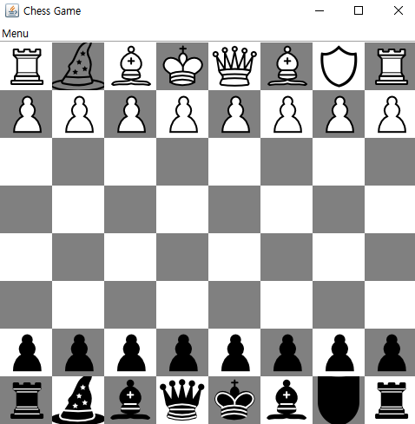Clicking custom menu replace the knights with witches and guardians like the left screenshot.

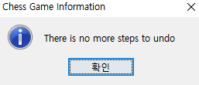3. Undo/Redo buttons

* 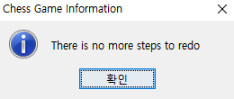If a player clicks a undo or redo button, then the system undo the player’s last move. However, if there is no more undo or redo step, then the message dialogues like the left screenshots are displayed to players.

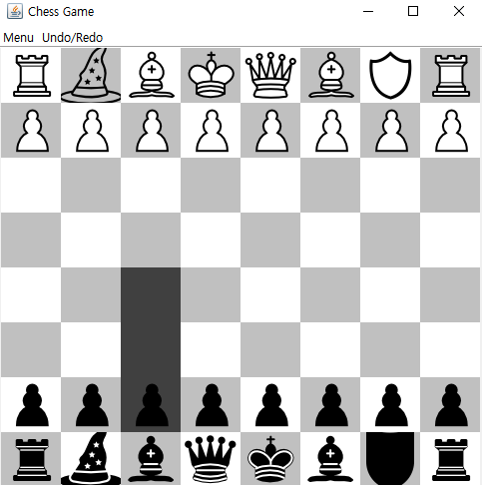4. Show valid move

* If a piece is clicked, valid locations are displayed with dark grey color.
* 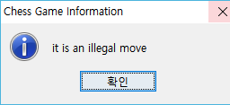However, if a player tries to move a piece to invalid location, the message like left screenshot is displayed to the player.

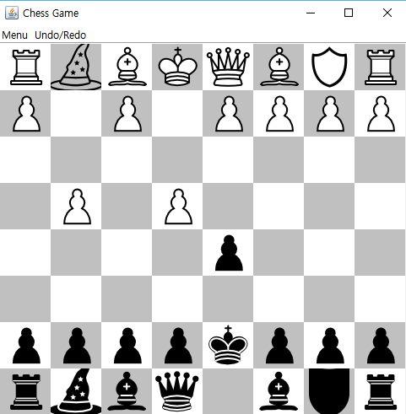5. Undo function

* There is an undo function. A player can undo his or her last move in any condition.
* Let’s say the left screen shot is the current game situation and black player moves his or her king forward.

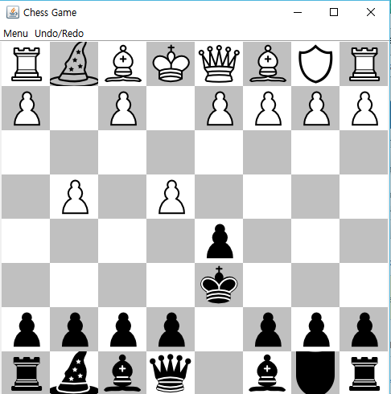

* However, black player wants to undo his or her king’s move. Then, the player can just click the undo button and undo the movement.
* After clicking the undo button, the king is now at original position like the screenshot at left.

6. Redo function

* Redo function is for undo players last undo.
* Let’s say the screenshot at left is current game situation

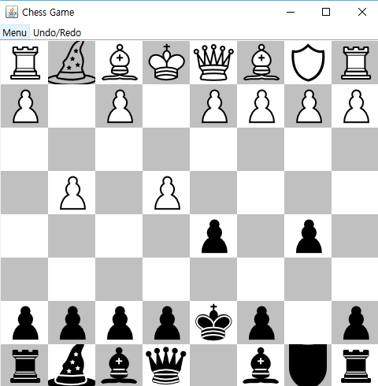

* Black player moves his pawn to (4,6) position. (x-axis start from 0 at top, y-axis start from 0 at left)
* The player undo the last move.
* After undo the last move, the pawn at (4,6) position moves back to (6,6).
* However, if the player clicks redo button, then it moves to (4,6) again.
* 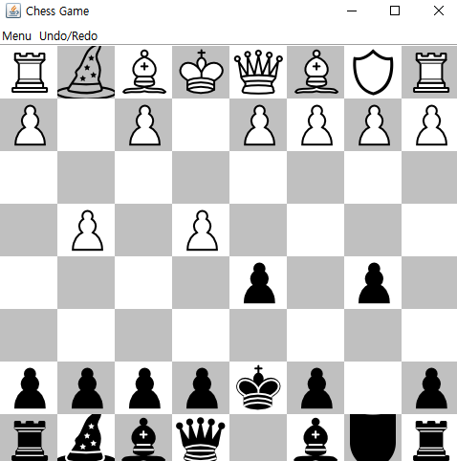The screenshot at left is the situation after clicking redo button

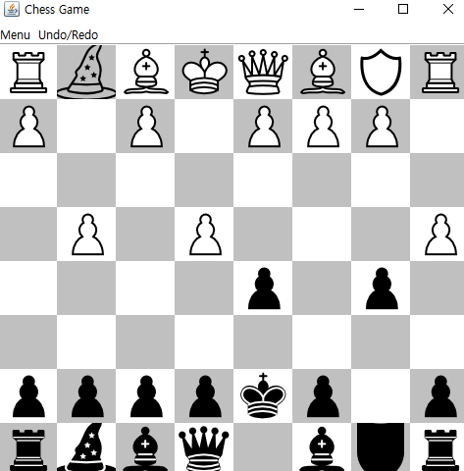

* If white player moves any piece, system clears all information stored in redo stack. Therefore, there is no movement that can be redo.
* White player moves the pawn at (1,7) to (3,7).
* 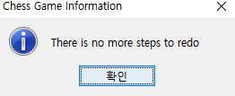Since the white player moved the pawn, there is no more steps to redo. Thus, the warning dialogue like the screenshot at left is displayed to the player.