**Differences between this model and Ferrario et al. 2020.**

|  |  |  |
| --- | --- | --- |
| Item | Description | Reason |
| Solar irradiance | Ferrario uses 2016 PVGIS data. I had to use 2005. | PVGIS (as suggested by author) does not have data available for anything other than 2005. |
| Wind speed | As above | As above |
| Temperature | Ferrario uses 2016 PVGIS. I’m using 2016 European commission PVGIS because it’s a better fit than 2005’s PVGIS data. | Unable to access 2016 normal PVGIS data. |
| Electrolyser model | Model may be slightly inaccurate. | Author did not provide electrolyser data, only a graph. I used the power vs current graph to extrapolate points. |
| EMS logic | Battery strategy has some guess work in terms of upper and lower limits of SOC. | Logic presented in figure 17b. Hydrogen systems in battery priority utilises “SOC” instead of “p_tank”. See next section for more info. |

**Discrepancies in the paper**

* Input
  + Timing*:* Author assumed that the first three months of the year is winter, when it should be the first two months.
  + Solar panels: Author did not provide total number of panels, only max power output. With this information, I assumed there are 21 poli-si panels, but there could be 22.
  + Load data: 35 kWh per day for a university building is quite low, even for a small standalone building
* Model
  + Wind turbine: author developed an equation that does not work. Power generated at windspeeds between 3-4m/s is less than that generated at 2m/s. Instead, separate equations should be derived for each wind speed, such as a piece wise function, for higher accuracy and less computational time.
* Logic
  + Hysteresis: There are 4 state of charge values (min, max, low, high) and 2 tank pressure values (min, high). During hydrogen strategy, the backup battery has a range from SOC_min to SOC_max (20-80%). However, during battery strategy, the battery range is utilised from SOC_low to SOC_high (30-70%) instead. Unsure why hydrogen strategy use min-max and not low-high. Also, unsure if both cases should use low-high to preserve battery health?
  + Error in battery strategy: Author made a mistake when showing us the logic. “SOC” (battery) parameters are used for hydrogen tank, when it should only be used for the battery. Instead, “p_tank” should be used for hydrogen.

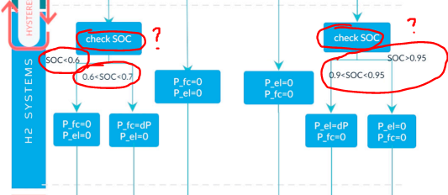

First image, h2 system parameters in hydrogen strategy. Second image, h2 system parameters in battery strategy.

* Results
  + Hydrogen strategy: Hydrogen strategy is when the hydrogen system is prioritised before the battery. The hydrogen system is the first to be used and the first to charge. The battery is used if the tank is empty, and charged if the tank is full. This logic is not consistent with figure 20a. At hours ~100, ~1050, ~6000, ~8500, battery is being charged even when tank is not full.

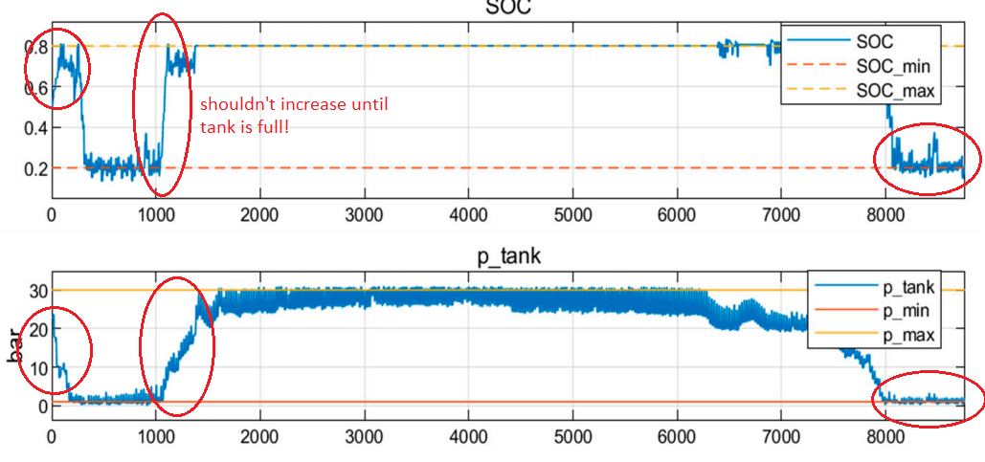

* + Battery strategy: this strategy is when the battery is prioritised over the hydrogen system. The electrolyser will only operate when the battery is over 70-80% SOC. For hours 1 to ~1800, and >8000, the electrolyser is filling the tank when the battery is not full.

