Rapport Projet Court :

Projet n° : ASSIGNATION ET DETECTION DES PARTIES TRANSMEMBRANAIRES D'UNE PROTEINE

Emma SOUFIR

M2 BI

Introduction

Matériels et Méthodes

Hiérarchie des classes (graphe XML)

The algorithm :

Firstly, the PDB file is checked and parsed to create and initialize the Protein object, using AminoAcid objects to encapsulate information on residues. The solvent accessibility of each residue is computed using the DSSP (?) algorithm. A residue is considered accessible if its DSSP solvent accessibility is above 0.3. The coordinates of the Cα are also registered in each AminoAcid object.

The center of mass of the chain A of the protein is calculated. From this center, N points equally distributed on a demi sphere using the … method (?) are generated. Therefore, there are N vectors generated between the center of mass and each point. For each of those vectors, two orthogonal planes are generated, separated by a certain gap (14 °A by default). Those information are stocked in an Axis object.

For each of those axis, the two planes are slided firstly above then below. After each slide (1 A by default), the relative hydrophobicity of the residues located between the two planes is calculated, using the formula :

$$hydrophobicity= \frac{n polar out of planes}{n polar residues}+ \frac{n hydrophobic between planes}{n hydrophobic residues}$$

If the relative hydrophobicity is higher than the best match yet, this axis is more advantageous. It is stocked in an object. This step is repeated again until there are no more atoms in between the two planes, updating the value of the more advantageous axis if necessary. This sliding is also performed in the other direction of the axis.

At the end, for one axis, the best positions for the planes is stocked.

This step is repeated for each point on the half-sphere.

Then the axis with the best hydrophobicity ever is conserved.

Finally, the width of the membrane is adjusted by exploring the best axis step by step above and below for each plane.

A protein is simplified here as a unique chain.   
The center of mass of the chain is computed.

Results and Discussion

Comparaison entre l’algo et la publi dans l’article + le serveur :

In order to compare our results, we used the tool (?)

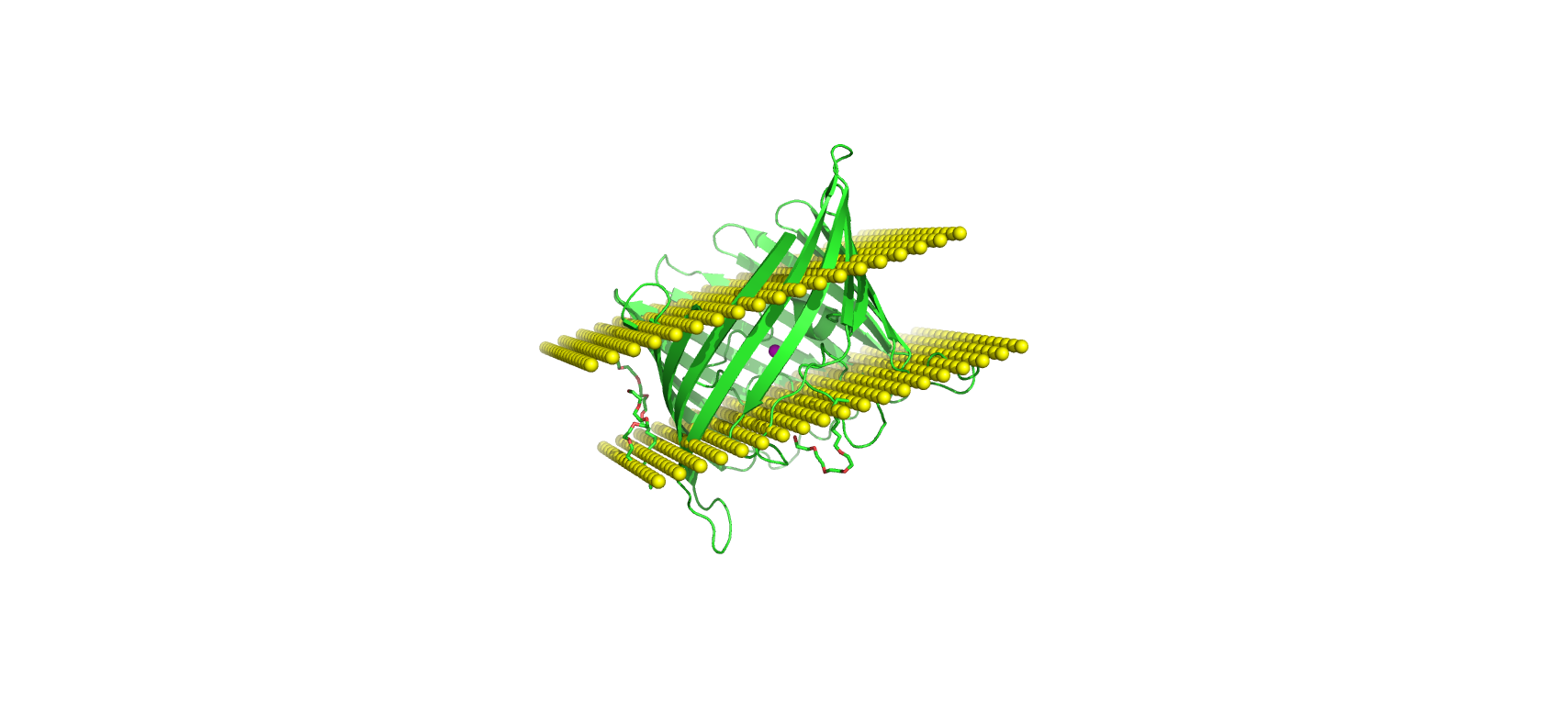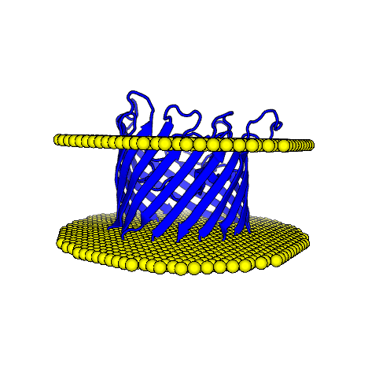

python TM_detect.py ../data/1prn.pdb -n 30

Limites and perspectives : une chaine seulement

Reported bugs :

The choice of the number of points affects

References :

<https://www.dsimb.inserm.fr/dsimb_tools/OREMPRO/en/index.php>

PyMol

Annex :

Use of the program